The importance of reflective practice as a professional practitioner
Why is reflective practice important in early years?
Pacey (2016) says that reflective practice is important in early years settings because first it will help the practitioner professionally and says that constant reflection will come with constant improvement, and it will then be a better outcome for the setting and the families, carers, and children. Studyprism (2023) also says that reflective practice is important because the staff can see if they are getting to their own standers of work and if not where they are going wrong and where they can do better in their work and practice and then they can achieve the outcomes they have made for themselves by reflection. It is also important when working in reflective practice that there is communication and that meaning communication with other staff member, families and careers and the children because communication is a skill that all staff need and can reflect on because communication is key in a lot of settings (Brock, 2015). Brock (2015) also says that when communicating with children and families that the staff need to be approachable and have effective communication skills. When reflecting in practice one of the most important things staff are doing when reflecting is developing, they are developing on their skills and learning more skills and they are more capable than to manage with challenges or tasks that are given that will also help them develop further (AMP 2022). HCPC (2023) says that by doing regular reflection it is supporting the staff and encouraging them be more confident and develop more and then can make a better team with being supportive in they do reflective practice and can help and provide information to other staff to support them and help them develop more.

what is reflective practice?
Participatory methods (no date) says that reflective are skills and abilities that help a group or an individual to reflect on themself and can see how they are developing and where they can improve. Lindon (2012) says that there are also different types of practice like good practice which is just a standard practice that will meet the child's needs. There is also best practice when they improve as much as they can from the good practice there is also minimum standers practice which is when they only do the basics of what they must do and lastly there is continuing professional development practice which is when their practice is on-going and improving knowledge (Lindon, 2012).

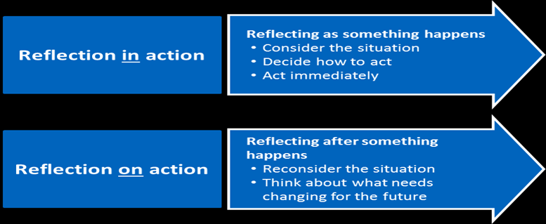
Discuss the theory (Schon) and some reflective models.
Schon is a theorist that did the theory of reflection in action and reflection on action but before he produces the theory, he was first a lecture in UCLA in philosophy (Studyprism 2023). Schon most known book is “The reflective practice: How practitioners think in action” and this came out in 1983 and he also came out with the turn “thinking on ones' feet” (Studyprism 2023). The first part of the theory that Schon has theorist is reflection in action which is when the problem is being addressed and it's during the doing stage and reflection in action is carried out in practice not reflection and reflecting what you could have done and its good reflection because it allows the staff to deal with incidents or changes that may happen and also allows the staff to be responsible in the new knowledge and can apply it to practice and new skills (Nursing Answers 2023). Studyprism 2023 also agrees by saying that it will help their knowledge and making decisions on things. Reflection in action is after it has staff will reflect on what they did and how could they have done better to help staff to develop and reflection on practice also helps motivate staff things that could be changed if it happens again (Nursing Answers 2023). With many theories there are always advantages of the theory and disadvantages (Studyprism 2023). The advantages of Schon theory are that staff can reflect when they are on the job, and it can also help staff member in a situation where they do not know what they are doing but another staff member has reflected on it and can give advice on it and lastly it help and benefit on time skills with the staff or practitioners (Studyprism 2023). The disadvantages are that reflection in practice can take away from what they are supposed to be doing and can distracted them from the task and it can also take more time to do them as well and the ideas should be used in other models not just that module (Studyprism 2023).

ResearchGate (2023)
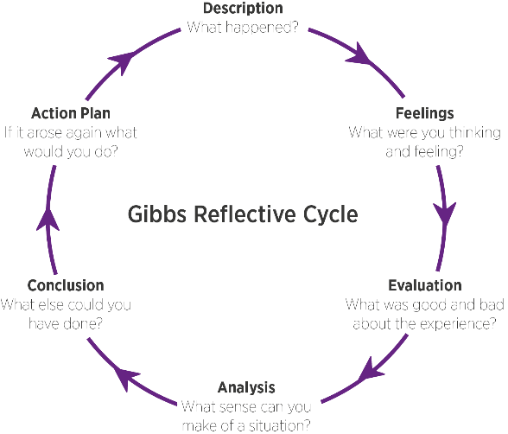
Discuss how reflective practice can improve quality in early years. When it comes to reflecting to improve in settings its first important that all staff and practitioner know that the practice will benefit them but also benefit the children, families and carers and it will also help maintain a good improvement and good relationship with the families and carers (Pacey 2016). When reflecting in an early year setting it will not just help and improve the staff and but also then have a better outcome for the children they are working with because by reflecting they are first meeting all the children needs in a group and the individual child (Pacey 2016). Staff's self-esteem and their confidents will improve a lot by reflecting because first they are developing, and they are also talking to other staff and the staff are giving the children a suitable environment for the children to play indoor and outdoor (Pacey 2016). The benefits for the setting and staff are first skills will be enhanced and the staff will have more motivation to develop better, and it also supports the staff to hit the targets they made in the reflection and all this benefits then will help the setting and help the reputation of the setting in good ways by reflecting and developing on things that need more attention. Pacey (2016) also says that having a reflective diary can be good for settings or the staff themself so they can reflect on themself and how they can do better in the setting or activity's they are doing with children to make it better.

Discuss how it can support EYP to develop as a professional. Longford County Children Committee (2023) says that reflective practice allows early years professional to reflect and develop on their work and on their own practice and insure they are developing the skills, knowledge and activities to unsure that the professional is having the best outcome for the children. Pacey (2016) also says that talking and asking their peers or other worker to help with support for them and help in their work to ensure they are doing the right thing and developing as much as they can. Pacey (2016) also suggest having outside views like the children’s parents or carers to ensure that the professional is doing the best they can to ensure the best outcome for their children. Nursery world (2023) also suggest that professional set their own goal and not goal that everyone has because reflective practice is to support the professional and help them develop to their full potential not anyone else. Interactive Learning Diary (2022) say that also identify the strength and weaknesses as a professional and ensure that they are working on the weaknesses with the reflective practice to develop and learn the new skills that is needed to support the professional and the children at the same time. Interactive Learning Diary (2022) also says that they should reflect on their teaching, planning and methods that they use in the nursery or school and the reflective practice then will help see what went well when doing the activity or something else and what can the professional improve on to ensure the development for the children are good and the support of the reflective practice is good for the professionals.
Reflective Modules
Reflective module is a guide of personal and professional reflection and help improve them they also help improve professionals' performances and their knowledge and experiences while it is happening (MBM 2023). One of the most famous and known reflective module is the Gibbs module and his module is a cycle that will repeat itself over and over and will help with experiences and helps develop new skills and information by covering the 6 stages of the cycle (The University of Edinburgh 2023). The 6 stages of Gibbs cycle are description of what happened then there is how the practitioner felt in the moments it happened and their thoughts on what had happened after feelings come the evaluation which is what the practitioner did good in what happened and what they could improve on (The University of Edinburgh 2023). After the evaluation the practitioner needs to analyze what happened and understand why the satiation happens then they conclude of what they learnt about what happened and how cand they improve if it happens again and could they have done something differently and lastly is an action plan if the situation happened again how would the practitioner deal with it differently and could the practitioner change anything they did to stop the situation and if not was there anything that could be changed if happened again (The University of Edinburgh 2023). Gibbs isn't the only one that has done a reflective module there are more as well such as Kolb’s experience learning cycle that talks about the concrete experience like Gibbs dos of what actually happened then they talk about reflective observation then the abstract conceptualization and lastly is the active experience it is like Gibbs but put in different ways that maybe helps other people more than the Gibbs one and doesn’t have as much to evaluate like Gibbs ( University of Cambridge no date). There is also the Driscoll’s what module that contains of what? So just like the other what happened then it goes to so what? What did they do and what could have been done and lastly is now what? What can they do know to help develop all the reflective module need the same information they are just put in different words to help different people understand the reflective module (University of Cambridge no date).

Leap Like a Salman (No date
Briefing Paper
AMP (2022) Reflective practice CPD, Available at: https://www.apm.org.uk/blog/reflections-on-cpd/#:~:text=Reflective%20Practice%20is%20an%20essential%20part%20of%20developing,emotions%2C%20conduct%20productive%20relationships%20and%20cope%20with%20stress [Accessed:7 of May 2023]
Brock (2015) The early years reflective practice handbook, Available at: https://ebookcentral.proquest.com/lib/trinity/detail.action?docID=1744144&pq-origsite=primo [Accessed:7 of May 2023]
HCPC (2023) Reflection is a process which helps you gain insight into your professional practice by thinking analytically about any element of it, Available at: https://www.hcpc-uk.org/standards/meeting-our-standards/reflective-practice/what-is-reflection/#:~:text=Reflection%20allows%20you%20to%20identify%20and%20appreciate%20positive,helping%20you%20to%20process%20and%20learn%20from%20them [Accessed:7 of May 2023]
Interactive LearningDiary (2022) Benefits of reflective practice, Available at: https://www.interactivelearningdiary.co.uk/benefits-of-reflective-practice/ [Accessed:10 of May 2023]
Jennie Lindon (2013) Reflective Practice and early years professionalism (2nd edition). London: Sage. [Accessed:5 of May 2023]
Leap Like a Salman (No date) Image, Available at: https://www.leaplikeasalmon.com/reflection-is-it-a-skill/[Accessed:10 of May 2023]
Longford County Children Committee (2023) Reflective Practice in early years, Available at: Reflective Practice in the Early Years - Longford Childcare Committee [Accessed:10 of May 2023]
MBM (2023) Gibbs reflective cycle: Feel the benefits of experiential learning, Available at: https://www.makingbusinessmatter.co.uk/gibbs-reflective-cycle/#:~:text=A%20reflective%20model%20is%20a%20structured%20process%20used,experience%20helps%20improve%20our%20performance%20while%20it%E2%80%99s%20happening [Accessed:9 of May 2023]
Nursing Answers (2023) Schon reflective model, Available at: https://nursinganswers.net/reflective-guides/schon-reflective-model.php [Accessed:9 of May 2023]
Nurseryworld (2018) Training today: Reflective practice- see for yourself, Available at: https://www.nurseryworld.co.uk/features/article/training-today-reflective-practice-see-for-yourself [Accessed:10 of May 2023]
Pacey (2016) Supporting member to provide the highest standards of care and learning for children, Available at: https://www.pacey.org.uk/Pacey/media/Website-files/PACEY%20member%20practice%20guides%20(PDFs)/PG04-self-reflective-practice.pdf#:~:text=Reflection%20is%20an%20important%20part%20of%20your%20practice,improvement%20you%20will%20achieve%20better%20outcomes%20for%20children [Accessed: 7 of May 2023]
Participatory methods (no date) Reflective practice, Available at: https://www.participatorymethods.org/method/reflective-practice [Accessed:5 of May 2023]
ResearchGate (2023) image Available at:https://www.researchgate.net/figure/Reflective-practice-Schoen-1991_fig3_350373202 [Accessed:9 of May 2023]
Studyprism (2023)A Reflective practice for early years practitioner, Available at: https://studyprism.co.uk/reflective-practice/professions/reflective-practice-for-early-years-practitioners/[Accessed: 7 of May 2023]
Studyprism (2023) B Schon’s model of reflection, Available at: https://studyprism.co.uk/reflective-practice/models/schons-model-of-reflection/ [Accessed:9 of May 2023]

The University of Edinburgh (2023) Reflection toolkit, Available at: https://www.ed.ac.uk/reflection/reflectors-toolkit/reflecting-on-experience/gibbs-reflective-cycle [Accessed:9 of May 2023]
University of Cambridge (No date) Study skills, Available at: https://libguides.cam.ac.uk/reflectivepracticetoolkit/models [Accessed:9 of May 2023]
Presentation
Birth to 5 Matter (No date) Observation, assessment and planning, Available at: https://birthto5matters.org.uk/observation-assessment-and-planning/ [Accessed: 17 of May 2023]
Cambridge Dictionary (2023) Available at: https://dictionary.cambridge.org/dictionary/english/professional [Accessed: 12 of May 2023]
CFBT (2007) Multi-agency working and its implications for practice, Available at: https://www.nfer.ac.uk/publications/mad01/mad01.pdf [Accessed: 17 of May 2023]
Coursera (2023) Important communication skills and how to improve them, Available at: https://www.coursera.org/articles/communication-skills [Accessed: 15 of May 2023]
CPD (2023) Why is professional development important? Available at: https://cpduk.co.uk/news/why-is-professional-development-important [Accessed: 16 of May 2023]
Gov.UK (No Date) Relationships, Available at: https://help-for-early-years-providers.education.gov.uk/personal-social-and-emotional-development/relationships#why-relationships-are-important [Accessed: 16 of May 2023]
High-speed Training (2021)Promoting effective communication in health and social care, Available at: https://www.highspeedtraining.co.uk/hub/effective-communication-in-health-and-social-care/ [Accessed: 15 of May 2023]
High-Speed Training (2023) What is safeguarding training & why is it important? Available at: https://www.highspeedtraining.co.uk/hub/what-is-safeguarding/#:~:text=Regular%20safeguarding%20training%20helps%20to%20ensure%20that%20all,need%20to%20take%2C%20including%20how%20to%20escalate%20concerns. [Accessed: 16 of May 2023]
In the Loop (2020) Why is professional communication important in the workplace?, Available at: https://www.opencolleges.edu.au/blog/2020/06/05/professional-communication-in-the-workplace/ [Accessed: 15 of May 2023]
Iriss (2018) Relationship-based practice: emergent themes in social work literature, Available at: https://www.iriss.org.uk/resources/insights/relationship-based-practice-emergent-themes-social-work-literature [Accessed: 16 of May 2023]
National Design Academy (No Date) What is Professional practice?, Availabel at: https://www.nda.ac.uk/blog/what-is-professional-practice/#:~:text=Professional%20Practice%20is%20a%20term%20used%20to%20describe,knowledge%20to%20your%20industry%2C%20job%20role%20or%20workplace [Accessed: 12 of May 2023]
PSCP (2023) A child-centred approach to safeguarding, Available at: https://hipsprocedures.org.uk/ykyyhy/assessing-need-and-providing-help/a-child-centred-approach-to-safeguarding#:~:text=A%20child%20centred%20approach%20means%20keeping%20the%20child,working%20in%20partnership%20with%20them%20and%20their%20families [Accessed: 16 of May 2023]
Social Work England (2023) Subject knowledge and awareness of current issues, Available at: https://www.socialworkengland.org.uk/cpd/subject-knowledge-and-awareness-of-current-issues/ [Accessed: 16 of May 2023]
TBSI (2023) What are professional values? Why are professional values important?, Available at: https://www.theblacksheep.community/professional-values/#:~:text=In%20short%2C%20professional%20values%20are%20essential%20because%20of,3%20Accountability%204%20Responsibility%205%20Quality%20work%20standard [Accessed: 15 of May 2023]
The General Teaching Council for Scotland (No Date) Professional Values, Available at: https://www.gtcs.org.uk/professional-standards/key-cross-cutting-themes/professional-values/ [Accessed: 15 of May 2023]
The Hub (2019) Observation, assessment and planning cycle, Available at: https://thehub-beta.walthamforest.gov.uk/observation-assessment-planning [Accessed: 17 of May 2023]
The University of Edinburgh (2023) Reflection toolkit, Available at: https://www.ed.ac.uk/reflection/reflectors-toolkit/self-awareness/values [Accessed: 15 of May 2023]
UNICEF (No Date) How we protect children’s rights, Available at: https://www.unicef.org.uk/what-we-do/un-convention-child-rights/ [Accessed: 16 of May 2023]
Virtual College (2021) Why does multi-agency work reduce the risk of abuse? Available at: https://www.virtual-college.co.uk/resources/how-does-multi-agency-work-reduce-the-risk-of-abuse [Accessed: 17 of May 2023]
West Sussex County Council (2021) Effective practice: observation, assessment and planning, Available at: https://www.westsussex.gov.uk/media/5555/effective_poa_and_planning.pdf [Accessed: 17 of May 2023]

