

Analysis and Simulation of a Centrifugal Clutch
Course: BEng Mechanical and Manufacturing Engineering
Module: Stress Analysis and Dynamics, (ACMA5010)
Aneurin Bamsey (2014505)
Rob Goodson
Friday, 15th of October 2021
Contents
1
List of figure 2
Task A 3
1.0 Introduction 3
2.0 Main Body 3
2.1 Development of centrifugal clutches 4
2.2 Materials used for centrifugal clutches 5
2.3 Typical applications 5
2.4 Typical operating conditions 5
2.5 Advantages and disadvantages 5
2.6 Applications of electromagnetic clutches in modern automation of manufacturing processes 6
3.0 Conclusion 6
Task B 7
Q.1 7
Q.2 7
Q.3 8
Q.4 8
Q.5 9
Q.6 10
Q.7 12
Q.8 12
References 13

List of Figure
Fig.1 ……………………………………………………………………………………………………. [Diagram of Centrifugal force]
Fig.2 ……………………………………………………………………………………………..…… [Diagram of Centrifugal Clutch]
Fig.3 ………………………………………………………………………………………[Table of Speed, rad/s, Torque for 0.35]
Fig.4 ………………………………………………………………………………………….. … [Graph of data from table before]
Fig.5 …………………………………………………………………………………….. [Table for figures for coefficient of 0.4]
Fig.6 …………………………………………………………………………………………………….. [Graph for Coefficient of 0.3]
Fig.7 …………………………………………………………………………………………………….. [Graph for Coefficient of 0.4]

Task A

1.0 Introduction
A Centrifugal Clutch is a device that uses both centrifugal force and friction to transfer torque from one body to another which has been drawn from a driving speed. The clutch allows users to start or stop the driven shaft on demand without having to put stop to the driving shaft. Crane stated “Centrifugal force is a phrase that is used because it provides an intuitive way to considers normal accelerations due to constant rotational velocity” (Crane, 2003). This Essay will discuss the development, materials, applications, and operating conditions regarding centrifugal clutches, highlighting advantages and disadvantages throughout. It will also delve into understanding electromagnetic clutches and how they are utilized in modern automation manufacturing processes.

2.0 Main Body
Centrifugal force is the science in where a mass of an object is under rotational motion, forcing the mass object to move in an outward direction. The best used example of this would be a ball (mass) on one side of a string being swung around by an individual (force). The natural tendency of the ball is to continue in a straight line, but due to the centripetal force (string) acting upon it inwards the mass results in centrifugal force. For the ball to come to a stop, either the force continues to increase breaking the string allowing the ball to leave its state as a centrifugal force and continue in a straight line until Newtons second law stops it or the force enters a stage of retardation bringing it to a hold.
(Talley, et al., 2011)(Talley, et al., 2011)

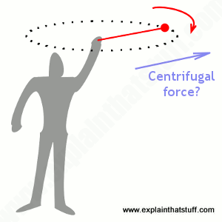

Fig.1 (Woodford, 2021)
To get the Clutch to operate the construction of the centrifugal clutch must have both a driving shaft (Input) and driven shaft (Output). The driving shaft is fitted with a spider and clutch shoes which has a layer of friction lining on the outer end and springs on the inner end connecting to the spider. The spider provides a guide to the shoe as the springs extend in and out. The driven shaft is connected to the drum which has a layer of friction lining on the inner diameter. When engine has increased speed to meet the required RPM. The springs would have fully extended outwards due to the mass of the shoe resulting in both friction lining coming into contact transferring torque from the driving shaft to the driven shaft.
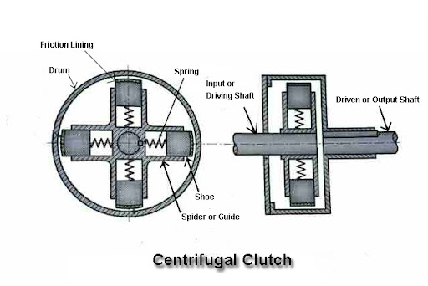

Fig.2 (Rashid, 2019)

2.1 Development of centrifugal clutches
The first appearance of the centrifugal clutch was given by Armstrong Siddley and Thomas Forgery who is titles inventor of the clutch in 1936 for small motor applications. The Clutch was then used in 1958 by a company called locomotives. Since the 19th century the clutch has been exposed to development to achieve it current design. The compliant mechanism has been modified to make it simpler and more compatible with wider applications. (Anon., n.d.)
One example of a development made to the centrifugal clutch over the years has been modifying the clutch to allow easier access when adjusting the engagement speed without having to disassemble it. This is done by having an outer drum join connected to the driven shaft. The reason for this development is because adjusting the point of engagement has proven to be very challenging and requires disassembling of the clutch which can result in a lot of time wasted disassembling and reassembling and may not be right afterwards. In many applications being able to adjust the engagement point specifically is essential to get the desired results whereas other applications may not be so specific. (Bystrom, 1972)

2.2 Materials used for centrifugal clutches
Material choice is critical when it comes to a clutch as it determines the performance and life expectancy expected. The friction lining is what is used to secure engagement and prevent slippage, material used would be Ceramic due to it roughness and high friction properties helping against slippage between the shoe and drum. Steel material is used for the springs inside the clutch. The reasoning for this is because steel delivers properties of hardness and resistance to deform (stiffness). Down to the nature of centrifugal clutch temperature can change material properties, Steel being no exception. Some application requires the clutch to engage for a long period whereas others might be shorter. If the clutch was to run for a long period and get hot, once disengaged the cooling rate should be controlled if not the iron and carbon atom’s structure may deform which will affect its property lowing stiffness and to weaken in hardness. The springs then are no longer able to resist against the centrifugal forces rapidly wearing away its friction lining. (O'Keefe, 2013)

2.3 Typical applications
Centrifugal clutches have become heavy employed in several applications due to the ability to start up an engine with no initial demanded load. Perfect example being a Go-Kart when the engine is started the Kart stays stationary as it is in an idling state. Once acceleration is applied through the form of a pedal which increases the RPM, the clutch will engage resulting in movement due to transfer of torque. Using these clutches decreases the chances of stalling as load is smoothly applied. Therefore, it is used in so many industries and applications such as Chemical industry which uses mixers, Logging industry uses chainsaws and mill-saws and the largest, Manufacturing industry which uses machinery like conveyors and compressors and other engine devices. (Baksiin, n.d.)

2.4 Typical operating conditions
The centrifugal clutches are expected to deliver smooth start safely to its system without damaging any other part of the system even while transferring it maximum torque output. If under correct operating conditions the centrifugal clutch will provide efficient results between the speed and torque relationship while maintaining low to no slippage. But if not under correct operating conditions, then slippage will happen preventing parts external such as motors from the clutch being damaged. (Crane, 2003)

2.5 Advantages and disadvantages
There are many advantages that the centrifugal clutch has over other clutch designs given specific applications. First benefit is cost efficiency, due to its initial well-built simplistic design the centrifugal clutch has a much lower likelihood of breaking down or fatiguing its system. This is because the clutch utilizes the laws of physics, whereas others depend on additional components to deliver the same results. Having less parts also leads to cheaper maintenance and servicing costs as there will not be a demand to constantly change parts such as, batteries and other mechanical components.
Another distinct advantage is that the centrifugal clutch operates automatically thus not requiring any mechanical control making the process safer and less prone to stalling. Initial progressive engagement smoothly transmits load to prevent damage to the engine also increase torque. These characteristics allowing the clutch to access a longer lifespan and increases energy efficient on start-up. (Mecholic, 2015)
There are just as many disadvantages limiting the clutch from being used on other applications. These applications may require a higher loading or torque capacity that the centrifugal clutch may not preform correctly causing the clutch to slip. Slippage can lead to other major faults such as damage to the engine or overheat damage to the clutch (Springs). Must bear in mind overheating can still occur in normal high-powered operations. Friction alongside with slippage can cause power loss in performance. After continuous slippage chances are the linier has worn away and shoes or the clutch will need to be replaced. (Baksiin, n.d.)

2.6 Applications of electromagnetic clutches in modern automation of manufacturing processes
An electromagnetic clutch is a clutch design that utilizes electromagnetic to engage and disengage torque mechanically. This is achieved by a current being sent through a coil which sends magnetic lines to actuate the clutch engagement. The advantages of using this clutch would be it ability to have Remote operations (automation) which is a faster and easier. These are used in several applications on machines used for packing, food processing and printing. Factory automation is another application as they can be used for conveyor systems to move product down a production line which can be controlled using PLC systems to send a current when engagement is required. Other manufacturing processes that use Electromagnetic clutches are CNC Machines such as Lathes and milling machines. (Kalyani, 2021)

3.0 Conclusion
To conclude the centrifugal clutch is a respected clutch due to its simplistic design and ability to allow the engine to have a soft start with no initial load. The clutch provides many advantages and many disadvantages that makes it easy to identify suitable applications. If correct operating conditions are maintained the clutch can be very efficient in transferring torque.

Task B

Q.1
$Shoe=95mm$
$Clearence=9mm 95+9+4=108$
$Wall Thickness=4mm 108×2=216mm$

Q.2
$$ω= ? Fs=kNm m=1.1kg x=9mm r0=95mm$$
a)
$F=FS × x$
$$F=(7.5 ×10³×9 ×10¯³)$$
$$F=67.5N$$
b)
$$ω=\sqrt{\frac{F}{m(r0+x)}}$$
$$ω=\sqrt{\frac{67.5}{1.1(95×10¯^{3}+9×10¯³}}$$
$ω=24.39 Rad$/s
$$ω=24.29 ÷ \frac{2×π}{60}$$
$$ω=232.91RPM=233RPM$$

Q.3
a)
$Convert RPM to Rads Per Second: 550 ×\frac{2π}{60}=57.6$Rad/s
b)
$$ΣF=m × a$$
$$FR=m×\frac{v²}{R}$$
$$FR=m×\frac{ω^{2}×R²}{R}$$
$$FR=m × ω² ×R$$
$$FR=1.1×{57.6}^{2}×0.104$$
$FR=379.55$N/m
$FR=0.37955$kN/m

Q.4
$N=4 μ=0.35 m=0.275g\left(Per shoe\right) ω=57.6 Rads r0=95mm$
$$x=9mm F=67.5N Radius to inner drum=104mm$$
a)
$$F=FS × x$$
$$F=(7.5 ×10³×9 ×10¯³)$$
$$F=67.5N$$
b)
$T=nμ[mω^{2}\left(r0+x\right)-F]\frac{D}{2}$
$$T=4×0.35[1.1×{57.6}^{2}\left(95×10¯³+9×10¯³\right)-67.5]\frac{208×10¯³}{2}$$
$$T=1.4×(312.05)×0.104$$
$$T=45.43Nm$$

Q.5
a)
$$450RPM ×\frac{2π}{60}=47.123rad/s$$

$$T=4×0.35[1.1×{47.123}^{2}\left(95×10¯³+9×10¯³\right)-67.5]\frac{208×10¯³}{2}$$
$$T=1.4×(186.53)×0.104$$
$$T=27.16Nm$$

b)
$700RPM× \frac{2π}{60}=73.303rad/s$

$$T=4×0.35[1.1×{73.303}^{2}\left(95×10¯³+9×10¯³\right)-67.5]\frac{208×10¯³}{2}$$
$$T=1.4×(547.209)×0.104$$
$$T=79.67Nm$$

Fig.3

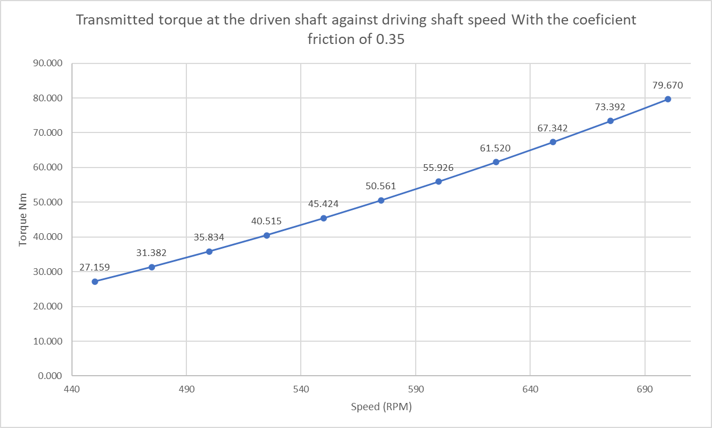
Fig.4

Q.6

Fig.5

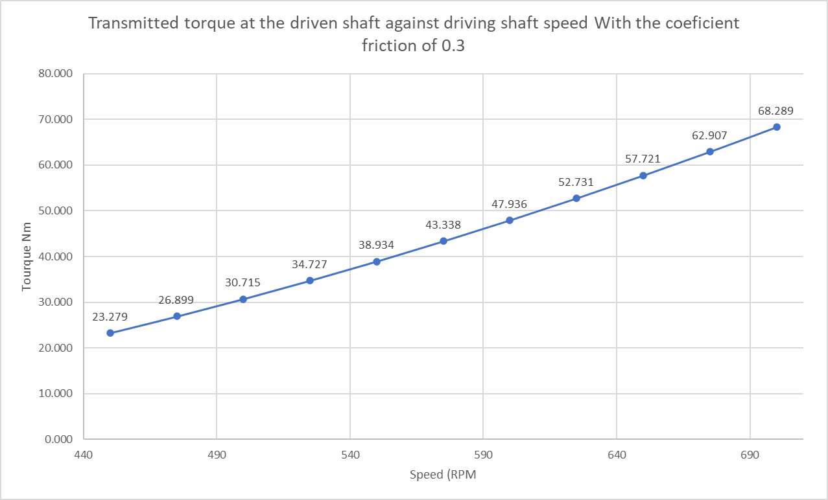
Fig.6
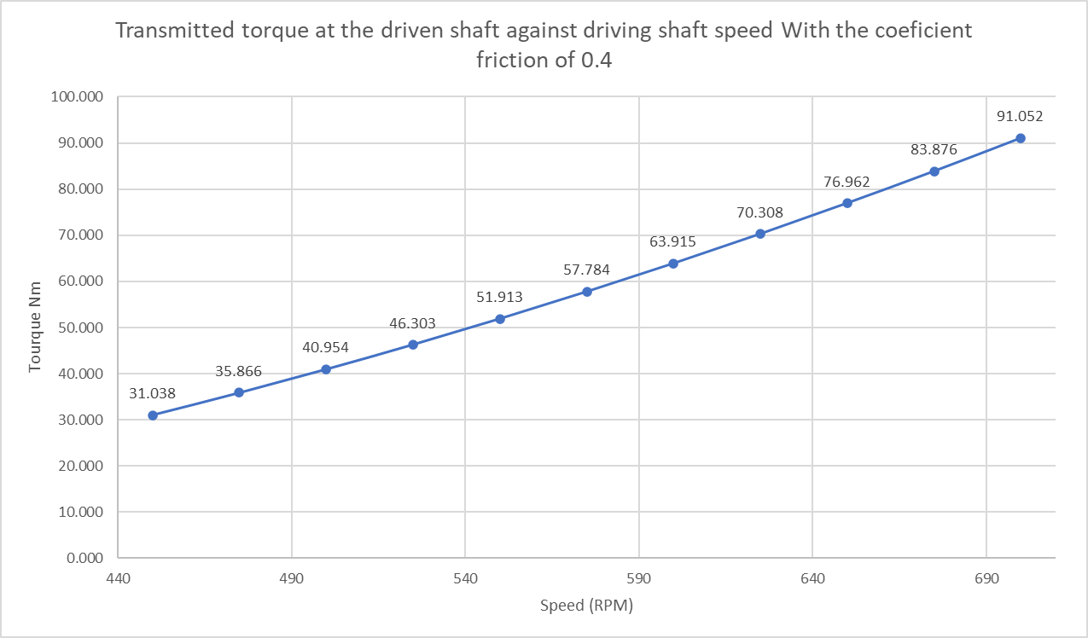
The graph (Fig.3) above shows that when the coefficient of friction is changed from 0.35 to 0.3, the maximum valve for torque has lowered by 11.372Nm because the friction lining has less material resulting in restricting the efficiency of transfer.
Fig.7
The graph (Fig.4) above shows that when the coefficient of friction is changed again to 0.4, the Maximum valve has now changed to 91.052 which is 11.382Nm higher than 0.35. and 22,763Nm higher that when the coefficient is 0.3, this is because the layering of friction lining is larger creating a better transfer of torque.

Q.7
$$T=79.69Nm \left(Question 5\right) m=0.75kg r=0.104 F=? α=?$$
a)
$$T=r ×F$$
$$F=\frac{T}{r}$$
$$F=\frac{79.69}{0.104}$$
$$F=766.25$$
b)
$$α= \frac{F ×r}{\frac{1}{2}×m×r²}$$
$$α= \frac{2×766.25}{0.75×0.104}$$
$$α=19647.44 Rad/s$$
$$α=\sqrt{19647.44}$$
$$α=140.17Rad/s$$

Q.8

$$ω=700RPM number of shoes=4 a=20mm×50mm$$
a)
$700RPM=\frac{2π}{60}$ = 73.304
$σ=\frac{F}{a}$
$$σ= \frac{73.304}{(0.02×0.05)×4}$$
$$σ=18325$$
$$σ=\sqrt{18325}$$
$$σ=135.37nm²$$

The Direct stress is not considered complex because the stress acting on the shoe is perpendicular at a 90◦ angle from the shoe surface.

References
Anon., n.d. MechStudies. [Online]
Available at: https://www.mechstudies.com/centrifugal-clutches-parts-types-working/#History_of_Centrifugal_Clucthes
[Accessed 18 September 2021].
Baksiin, S., n.d. Learn Mechanical. [Online]
Available at: https://learnmechanical.com/centrifugal-clutch/
[Accessed 26 September 2021].
Bystrom, R. H., 1972. CENTRFUGAL CLUTCH , Chicago,: United States Patent .
Crane, N. B., 2003. Compliant Centrifugal Clutches: Design, Analysis, and Testing, s.l.: Brigham Young University.
Kalyani, U., 2021. Electromagnetic Clutch Applications. [Online]
Available at: https://www.autoprotips.com/electromagnetic-clutch-applications/#Applications_Of_Electromagnetic_Clutch
[Accessed 3 October 2021].
Mecholic, 2015. Centrifugal Clutch Working, Applications, Advantages and Disadvantages. [Online]
Available at: https://www.mecholic.com/2016/01/centrifugal-clutch-working-applications-advantages.html
[Accessed 2 October 2021].
O'Keefe, P. J., 2013. Centrifugal clutch. [Online]
Available at: http://www.engineeringexpert.net/Engineering-Expert-Witness-Blog/tag/centrifugal-clutch
[Accessed 25 September 2021].
Rashid, 2019. Centrifugal Clutch. [Art] (Mechanical Walkins).
Talley, L. D., Patrick, G. L., Emery, W. & Swift, J., 2011. Descriptive Physical Oceanography: An Introduction, s.l.: Academic Press.
Woodford, C., 2021. Centrifugal Force. [Art] (Explainthatstuff).

Acknowledgement
I would like to Acknowledge my Co-workers/ fellow student Ben Shears and Ieuan Morgans in regard to this assignment as they have proof read and discussed opinions on my content of the assignment.

Appendices

