Website building
/www.weebly.com/editor/main.php#/

Group (3) individual work.
My email to access the website : osolam238@gmail.com. Password : sherbel8.

Wedding planner

Screenshots of some items on the pages:


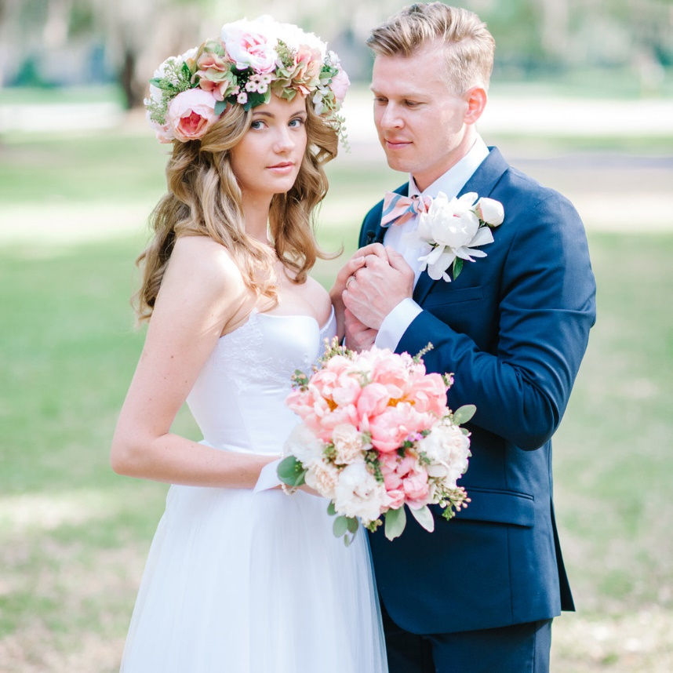

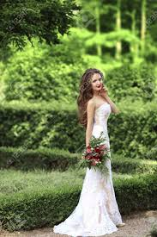

Sample of outdoor ceremony venues:
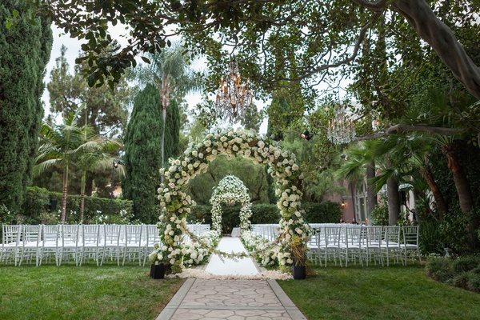

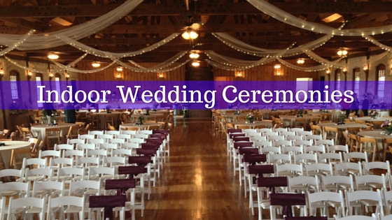

My rationale behind designing the website :.
The website is built to show and present the services that the business provides to the clients in order to attract them, as they are looking for wedding planners companies that can please them and record their memories. I am trying the best to present what I hear and listen from the client.
Our contents on the website are based on what we find, that could be the desirable magical images of flowers, dresses, packages, decorations, indoors and outdoors events.
I am presenting the best ever services to ease the stress of our clients. I give the clients the opportunities to share with us the ideas that can produce the best image of their special days. they would expect on the wedding days, the excitement that could be on that day. We want our website to be one of the world recognized wedding planner that will be always recommended to couples for their dream and lasting memories.
I am updating the website according to the local market needs. I am reflecting the feedback of the clients into practicalities that could keep the changes to let it be the targeted wedding planner website. I must do what is possible to meet the desire for my visitors. As it is the first time to build the website, I find it not easy to satisfy all, but I have to do my best to be at the level that could make profit for the my business and sustain.
The images on the website are attractive and impressive, and reflective enough for visitors make up their mind and decide to make the contact.

Notes: I am the only one left in my group. All what on the web are done individually. Only the questionnaires ,some questions ( 3 ) are contribution of Shahida two weeks ago.

