University of Wales Trinity Saint David
School of Engineering



Failure Mode & Effects Analysis – Technical Report
Joe Shankland
231772
BEng Mechanical Engineering
02/01/2024

Engineering Application & Study Skills – ACMA4007(PT)

1.0 Contents
1.0 Introduction 1
1.1 Aims and Objectives 1
2.0 Literature Review 2
2.1 iMechE Code of Conduct 2
2.2 ISO 9000 2
2.3 ISO 31000 3
3.0 FMEA 3
3.1 Severity Ratings 4
3.2 Detection Ratings 5
3.3 Recommended Actions 6
4.0 Conclusion 7
5.0 References 9
6.0 Appendix 10
6.1 Personal Development Plan 10
6.2 Technical Poster 10

Introduction

Manufacturing in the 21st Century has allowed the growth of the economy as well as the population, it also allows for improvements to quality of life and for steps in modern innovation. This report will give an example FMEA, using a Fume Extraction Fan from the Port Talbot TATA Steel site, it will be used to assess each component, how it can fail, the effects this can have, and the preventative measures which can be put in place. Referencing the relevant ISO Standards, we will also be able to see how risk analysis methods such as FMEAs are regulated across the manufacturing industry.

1.1 Aims and Objectives

- Introduce the FMEA method of risk analysis and its importance.
- Explain the importance of risk analysis is legislation.
- Conduct an FMEA on the chosen Fume Extraction Fan
- Calculate the potential failure modes which pose the greatest risk to the process.
- Analyse the Results.
- Decide on relevant Control Measures.

2.0 Literature Review

The Fume Extraction System referenced in this review is currently in use on the Port Talbot, TATA Steel site, where it is used to extract harmful gases, which are a bi-product of the Basic Oxygen Steelmaking (BOS) plant. The extraction of these gases is essential for the continued running of the BOS plant as a lot of these areas are still manned. The Fume Extraction Plant is essential to ensure that, not only the BOS can run, that the plants emissions are kept at a regulated level so that we comply with pollution standards, ISO 14000.
The importance of this system shows the need for a detailed risk analysis method such as an FMEA, where all the potential failure modes can be taken into consideration, ranked, and control measures can be considered. The FMEA method is also needed to comply with ISO standards, such as ISO 31000:2018, Risk Management, and ISO 9000:2015, Quality Management Systems.

2.1 iMechE Code of Conduct

According to the iMechE Royal Charter and By-Laws document, by-law 30 states, “All members shall conduct their professional work and relationships with integrity and objectivity and with due regard for the welfare of the people, the organisations and the environment with which they interact.” (Institution of Mechanical Engineers, 2021). In terms of manufacturing, risk must be assessed to ensure welfare of all those involved is considered to a high enough standard to be able to say that the work is conducted with integrity.

2.2 ISO 9000

ISO 9000 outlines the best practices of Quality Management in a wide range of industries and organisations. The adherence to this standard is important in manufacturing especially to convey high quality and care, as is summarised below by Polinska et al. (2003).
- “Internal performance benefits (cost reductions, environmental/quality improvements, increased productivity, improved employee morale)
- Relations benefits (improved relations with communities and authorities)
- External marketing benefits (improved corporate image, increased market share, increased customer satisfaction, increased on-time delivery)”
(Polinska et al. 2003)
Another benefit of ISO 9000 which can partially be achieved with the use of aids such as FMEAs is to “manage risks which can affect outputs of the processes and overall outcomes of the QMS” (International Organization for Standardization, 2015).

2.3 ISO 31000

ISO 31000 outlines the best practices for risk management, including setting and achieving objectives and improving performance in organisations (International Organization for Standardization, 2018). As well as improving Management Systems, risk analysis is needed for organisations to comply with legislation surrounding Health and Safety, for example the Health and Safety at Work Regulations 1999 which states that,
“(1) Every employer shall make a suitable and sufficient assessment of-
(a)the risks to the health and safety of his employees to which they are exposed whilst they are at work; and
(b)the risks to the health and safety of persons not in his employment arising out of or in connection with the conduct by him of his undertaking.
To comply with these regulations, organisations need to implement detailed and iterative risk assessments, an FMEA is a great example of this which is used to evaluate every possible risk at each stage of a process. “
(The management of Health and Safety at Work Regulations 1999)

3.0 FMEA

The first process in completing the FMEA was to identify the parts of the process that could fail, in my example the process was a Fume Extraction Fan, and the parts that could fail were the components. Using the given template, as shown in Table 1, all the potential failure modes for each component were documented, for some this was covered by just one, but for others, the FMEA allowed me to go further in depth of potential failure modes and explain multiple for some of the components.

Table 1 – First half of Fume Extraction Fan FMEA
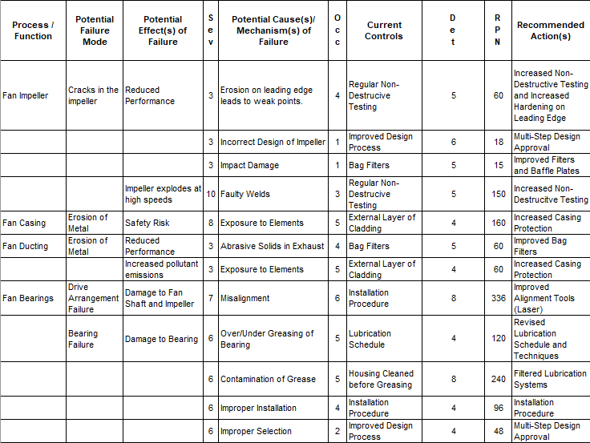
As shown above, we first evaluated the potential failure modes of each component as well as their potential effect of failure, which is multiple in most cases, before looking into the possible cause of these of these failure modes. It was common to see multiple failure modes that could be caused by the same thing, for example the bearing failures, which could also happen to multiple components of the system, such as the fan bearings and the motor. As these components had similar failure modes, their potential causes were overlapping, as seen with ‘Over/Under Greasing of Bearing’ and ‘Misalignment’.

3.1 Severity Ratings

In selecting the severity ratings for the FMEA, the long term effects had to be considered as well as the immediate ones, such as the selection for Fan Bearing Failures, the Drive Arrangement Failure had a severity of 7 while the Bearing Failure had a severity of 6. The reason for this selection is both of these failures fall under the criteria of the 4-7 rating, which states ‘Machine can still be run with reduced performance but parts must be replaced/ fixed before damage increases.’, as shown in Table 2. Both of these failures are serviceable items which can be replaced if needed, however, a failure of the Fan Shaft and Impeller would not only be much more costly to replace than the bearing, but it would also effect all the other components in the system, as the misalignment issues would travel through couplings and put other components at risk. This is also true for possible unbalance that could be caused by this failure as it would create increased vibration through the whole system, where as a bearing failure is often kept localised to the bearing.

Table 2 – Severity Rating Criteria
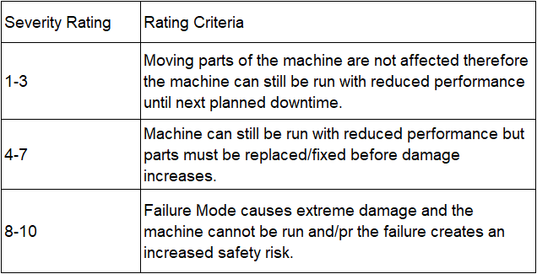

3.2 Detection Ratings

A similar method was used for selecting the Detection Rating of each of these failure modes, as shown in Table 3, the rating was dependant on the method which could be used to detect the failure. An example of this is shown with the Failure Modes for the Motor Bearings in Table 4, the same failure mode could have multiple reasons for failure, both with different detection ratings. The first possible reason for failure being ‘Over/Under Greasing of Bearing’, which had a detection rating of 8, this is because a bearing failure can only be diagnosed a lubrication issue after an analysis of the failed bearing. The second possible reason for failure was ‘Misalignment’ with a detection rating of 4, this was because misalignment can be detected in bearings through vibration sensors and analysis before the failure of the component.

Table 3 – Detection Rating Criteria
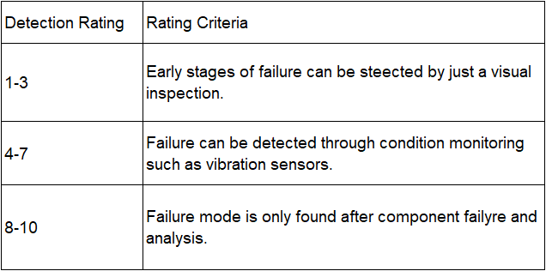

3.3 Recommended Actions

The majority of the recommended actions for these failure modes are improved versions of the control measures already in place, this can be seen especially in Failure Modes which can stem from installation issues. An example of this is the coupling, one of the failure modes being coupling fracture, two of the recommended actions were ‘Improved Installation Procedure’ and ‘Improved Alignment Tools (Laser)’. These are control measures which are already in place but are the most reliable, and as new technology is introduced where installation or alignment can be made much easier and more accurate, these control measures must change too until there is no risk of this failure mode occurring or the detection rating is 1. There are also recommended actions, such as ‘Multi-Step Design Approval’, which had to be used for failure modes that were caused by errors outside of the physical process. Due to this failure mode being caused prior to the physical process, the only control measure can be to get multiple approval checks to ensure that the component is fit for purpose.

Table 4 – Second half of Fume Extraction Fan FMEA
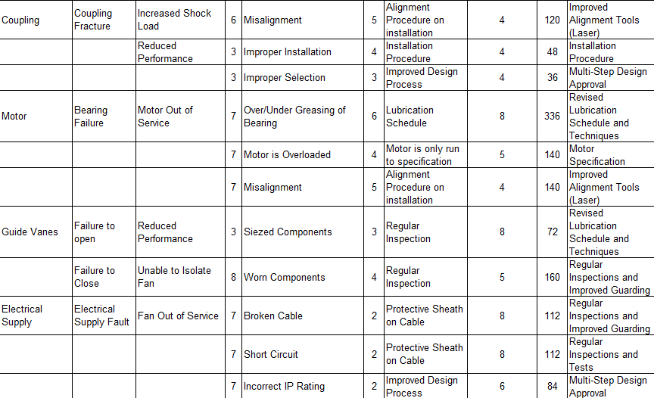

4.0 Conclusion

The main findings from this FMEA, show that the failure modes that are of the greatest concern are those related to Bearing Lubrication, this detailed analysis of various effects and possible causes has allowed for appropriate and detailed Control Measures to be considered and planned for the future. The design of the FMEA, with the Severity Rating, Occurrence Rating, and Detection Rating, allows for the easy calculation of an RPN number which then means that the failure modes can then be considered quantitatively, allowing for easier comparison. In the example of the Fume Extraction Fan, it was found that the potential failure modes with the highest RPN were both Bearing Failures.
Due to the analysis that the FMEA allows, it was discovered that these Bearing Failures only had the highest RPN when caused by Over/Under Lubrication, this being because this is currently much harder to detect, and cannot be detected by condition monitoring. The control measure that was decided on for these failures was an improved Lubrication Schedule, which means that the component would always have the correct amount of lube depending on its running hours. The analysis stages of the FMEA also means that this control measure can even be monitored after implementation and the iterative process would simply further improve this process until the Occurrence is 0 or the Detection is 10, meaning it would always be avoidable.
This iterative nature of an FMEA ensures that the risk analysis process is the most effective it can be. A loop is created where a risk is found, a control put into place, the risk is then reassessed to see whether the initial risk has changed.

5.0 References

Poksinska, B., Jörn Dahlgaard, J., & Eklund, J. A. E. (2003). Implementing ISO 14000 in Sweden: motives, benefits and comparisons with ISO 9000. The International Journal of Quality & Reliability Management, 20(5), 585–606. https://doi.org/10.1108/02656710310476543

International Organization for Standardization. (2015). Quality management systems - Fundamentals and vocabulary (ISO Standard No. 9000:2015)

International Organization for Standardization. (2018). Risk management — Guidelines (ISO Standard No. 31000:2018)

The Management of Health and Safety at Work Regulations 1999, c.3. Available at: https://www.legislation.gov.uk/uksi/1999/3242/regulation/3/made (Accessed: January 23rd 2024)

Health and Safety Executive (2022). Managing Risks and Risk Assessment at Work. [online] Hse.gov.uk. Available at: https://www.hse.gov.uk/simple-health-safety/risk/index.htm. (Accessed: January 20th 2024)

Fernando, J. (2021). Corporate Social Responsibility (CSR). [online] Investopedia. Available at: https://www.investopedia.com/terms/c/corp-social-responsibility.asp#:~:text=Corporate%20social%20responsibility%20is%20a. (Accessed: January 30th 2024)

6.0 Appendix

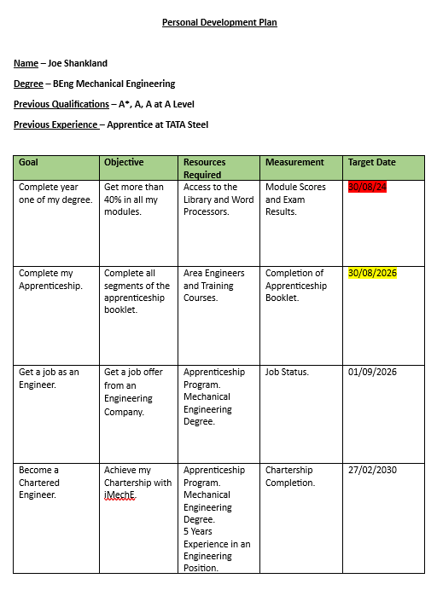
6.1 Personal Development Plan

6.2 Technical Poster



