

PROGRAMME: MSC ENGINEERING PROJECT MANAGEMENT

MODULE: RESOURCING AND FINANCIAL MANAGEMENT FOR PROJECTS

MODULE CODE: ACHA 7028

Assessment Component: 2

Student Name & ID: Aminur Islam Tonmoy 2522779

Declaration
Use of Generative AI in Assessment
RESEARCH | For this assessment, you can use Generative AI to support you in research, including searching for bibliography, using tools to summarise, compare and interrogate materials. | Yes  No
STRUCTURE | For this assessment, you can use Generative AI to support you in structuring your submission, including creating a draft argument structure, identifying parts and headings, etc. | Yes  No
PROOFREADING | For this assessment, you can use Generative AI to check your own text/creation for grammatical and syntactical mistakes, including rephrasing of your own work within specific standards. | Yes  No
WRITING | For this assessment, you can use Generative AI to create text for submission. | Yes  No
CREATIVE | For this assessment, you can use Generative AI to create creative materials, such as images. | Yes  No
PROGRAMING | For this assessment, you can use Generative AI to create and check code. | Yes  No
NONE | For this assessment, you are not allowed to use any type of Generative AI support. This includes research support, structure support, writing/proofreading support and creative support. | Yes  No

AI Acknowledgement
I confirm that I have not present any AI-generated materials as my own work in this portfolio. However, I acknowledge that I have used or may have used the AI in the research and proofreading of my portfolio.
Name…Aminur Islam Tonmoy ....
Student ID.......2522779.....

Executive Summary
The report highlights financial feasibility of the community health clinic, a not-for-profit healthcare provider based in the UK. Key findings observed within this assignment are the benefits of equity financing in long-term planning and constitutes around 50% of the total project’s budget, that is, £25 million. Base case and best case scenarios are profitable outcomes for the projects due to positive NPV and higher IRR values. Cost control plan requires contingency budgeting, earned value management and cost monitoring to manage any unforeseen expenditure. Elements such as schedule variance, cost variance, monthly financials and cost reports are useful for avoiding any financial losses and tracking any delays in project activities.

Table of Contents
1. Introduction and Project Overview 7
2. Section A: Sources of Financing 7
2.1 Equity Financing 7
2.2 Government grants 8
2.3 Internal financing 8
3. Section B: Capital Budgeting Analysis 9
3.1 Clear assumptions 9
3.2 Base, best and worst case scenarios 9
3.3 Analysis of calculations 13
3.4 Discussion on uncertainty affecting decision-making 14
4. Section C: Cost Control Plan 14
4.1 Contingency budgeting 14
4.2 Earned Value Management (EVM) indicators 15
4.3 Cost-monitoring processes 16
4.4 Methods to prevent scope creep 16
4.5 Risk mitigation strategies 17
5. Section D: Reporting Framework 17
5.1 Report types and frequency 17
5.2 Key financial KPIs 17
5.3 Roles in Governance structure and use of financial software tools 18
5.4 Reporting supporting decision‑making, transparency, and accountability 18
6. Conclusion and Recommendations 18
References 19

1. Introduction and Project Overview
The chosen project is a community health clinic, which belongs to the healthcare sector. Community health is a not-for-profit healthcare provider that provides affordable care for low-income populations in London, United Kingdom. The report aims to cover a feasibility analysis for community health clinics by outlining ways through which the organisation can finance, report and control its outcomes. The first two sections of this report will provide an evaluation of sources of finance and capital budgeting techniques such as NPV, IRR, Payback period and profitability index. The last two sections will outline mechanisms for controlling costs and a financial reporting framework for the project’s lifecycle.

2. Section A: Sources of Financing

2.1 Equity Financing
Equity financing includes raising capital by selling stakes of ownership to investors who are venture capitalists, private equity firms and institutional investors. According to Brown and Volckmann (2024), equity financing is useful in sharing risks and long-term alignment through mechanisms of sharing profits. Investors involved in construction of the community health clinic can gain benefits of long-term planning since equity funding does not provide immediate returns on an investment. Total equity finance for limited companies comprises share capital, capital and revenue reserves (Atrill and Mclaney, 2022). Risks involved in equity financing for the community health clinic are giving up company ownership, which ranges from 30% to 50% for substantial investments which significantly reduces future profits. Some examples include angel investors taking around 30% stake of company ownership for an investment of £1 million and venture capital firms acquiring 25% for expansion funds. Equity financing can be suitable for a £50 million community health clinic since it provides an establishment of debt repayment which allows the firm to focus on sustainability and growth. Key trade-offs in equity financing related to risk and control includes massive dilution and trade-off for strategic expertise.
Cost of equity (Estimated) = Risk Free rate + Beta * (Market risk premium)
3% + 1.5 * (7%) = 3.105%

2.2 Government grants
Government grants are non-payable financial awards such as tax credits, cash and assets which are provided by government agencies to organisations. Government grants, which aim in stimulation and economic growth, are considered to be a bigger part of the landscape (Adeboye et al., 2022). Receiving a government grant can improve organisational reputation for the community health clinic. However, government grants can be risky since imposing any operational requirements such as local hiring and labour policies can hinder management practices. Being heavily reliant on government funding can introduce several vulnerabilities to policy and budgetary changes (Mwale et al., 2025). The total cost of government grants for the community health clinic project is £15 million (30% of total project’s budget). Government grants have a positive impact on WACC implications based on the company’s financial position by reducing WACC which reduces cost of capital on a further basis. Relating to trade-offs, its financial risks are low but operational risks are high which also results in autonomy loss and slowdown of decision-making.

2.3 Internal financing
Internal financing is funding for a business' overall growth by using internal resources instead of relying on external capital requirements. Naomi et al. (2023) stated that internal financing helps organisations in reducing any requirements for disclosing sensitive information to external investors. Some examples of internal financing are retained earnings and working capital reallocation. Increase in retained earnings for a private company results in higher payment of dividend amounts to investors (Cadenovic et al., 2024). Working capital reallocation may involve using cash for increasing inventory levels for a holiday season. To maximise profitability, firms need to prioritise on maintaining optimum level of working capital (Kotcharin and Jantadej, 2024). However, risks associated in internal financing are depletion of working capital, which creates liquidity problems and limited potential for growth due to reliance on internal funding. The total cost of internal financing in the form of working capital reallocation and retained earnings can be 20% of total investment (£50 million) which is £10 million. For retained earnings, WACC can serve as a lower cost alternative to equity funding which influences overall capital structure. Relating to trade-offs, it has lower financial risks but is susceptible to limited growth potential due to funding large projects.

3. Section B: Capital Budgeting Analysis

3.1 Clear assumptions
Assumptions | Values
Cash flows | £18 million (Per year excluding tax)
Discount rate (Nominal) | 8%
Project life | 5 years
Inflation | 3%
Table 1: Assumed values
(Source: Self-developed)

3.2 Base, best and worst case scenarios
Real discount rate and real cash flows have been adopted based on the actual and assumed inflation rates.
Base Case
Nominal discount rate | 8%
Inflation rate | 3%
Real discount rate | 4.85%
Table 2: Relevant details for the base case
(Source: Self-developed)
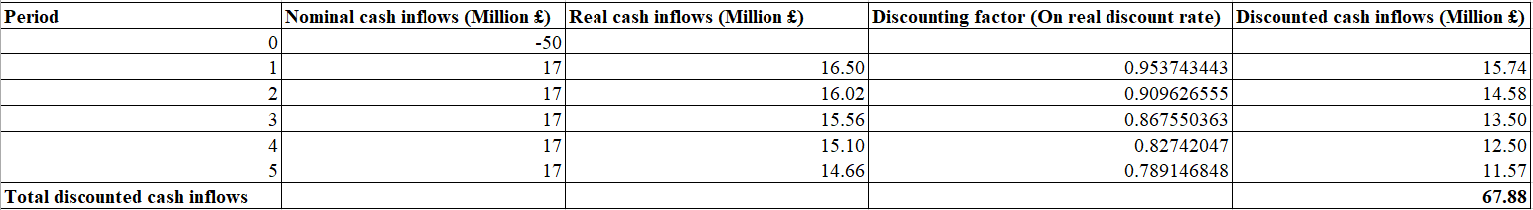
Figure 1: Discounted cash inflows (base case)
(Source: Self-developed)
Techniques | Formulas
Net Present Value | Sum of discounted cash flows - initial investment
Payback period | Number of years + (Cost not recovered in that year / Cash inflow in that year)
Profitability Index | Sum of discounted cash flows / Initial investment
Real discount rate | {[(1 - nominal discount rate) / (1 - inflation rate)] - 1} * 100
Real cash inflows | Nominal Cash inflows / (1 + inflation rate) ^n) where n = number of years
Table 3: Relevant formulas
(Source: Self-developed)
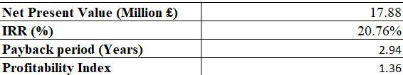
Figure 2: Capital budgeting techniques
(Source: Self-developed)
Years | Cash flow (Million £) | Cumulative cash flow (Million £)
0 | -50 | 0
1 | 17 | -33
2 | 17 | -16
3 | 17 | 1
4 | 17 | 34
5 | 17 | 34
Table 4: Detailed calculations for payback period
(Source: Self-developed)
Best Case
The best case scenario includes a reduction in nominal discount and inflation and tax rates at 6% and 2% respectively.
Nominal discount rate | 6%
Inflation rate | 2%
Real discount rate | 3.92%
Table 5: Relevant details for the best case
(Source: Self-developed)
It is also assumed that in the best case scenario, cash inflows increase to £18 million per year for the next 5 years.
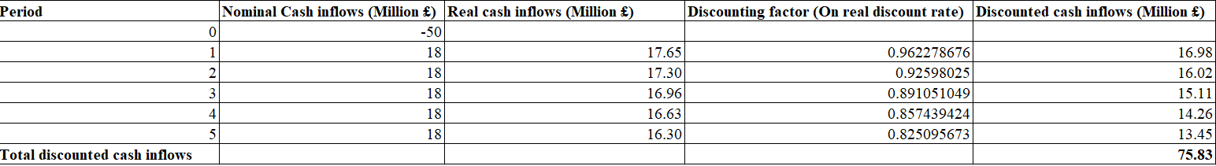
Figure 3: Discounted cash inflows (Best case)
(Source: Self-developed)
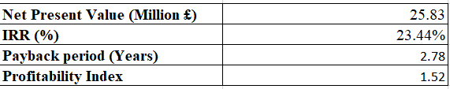
Figure 4: Capital budgeting techniques
(Source: Self-developed)
Years | Cash flows (Million £) | Cumulative cashflows (Million £)
0 | -50 | 0
1 | 18 | -32
2 | 18 | -14
3 | 18 | 4
4 | 18 | 36
5 | 18 | 36
Table 6: Payback period calculation in details
(Source: Self-developed)
Worst Case
The worst case scenario assumes an increment in nominal discount and inflation rates at 12% and 5% respectively followed by decrease in cash inflows at £15 million per year.
Nominal discount rate | 12%
Inflation rate | 5%
Real discount rate | 6.67%
Table 7: Relevant details for the worst case
(Source: Self-developed)
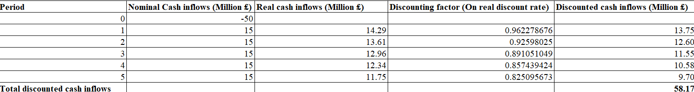
Figure 5: Discounted cash inflows
(Source: Self-developed)
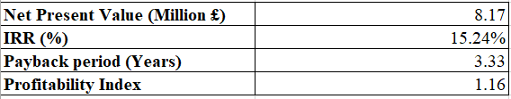
Figure 6: Capital budgeting indicators
(Source: Self-developed)
Years | Cash flow (Million £) | Cumulative cash flow (Million £)
0 | -50 | 0
1 | 15 | -35
2 | 15 | -20
3 | 15 | -5
4 | 15 | 30
5 | 15 | 30
Table 8: Payback period detailed calculations
(Source: Self-developed)

3.3 Analysis of calculations
NPV, IRR, profitability index and payback period are the highest in the best case scenario. The figures were observed at £25.83 million, 23.44%, 1.52 and 2.78 years respectively. It justifies that the project is feasible and can yield profits for the organisation since higher NPV signifies a greater creation of wealth and an effective return on investment. NPV allows a comparison to be made for the money that needs to be paid in order to recover a specific investment amount in future (Dobrowolski and Drozdowski, 2022). At the base case scenario, the project is acceptable due to an NPV of £17.88 million and IRR of 20.76% making it an attractive investment option. It indicates that the base case can also be considered for the process of decision-making since the project is feasible. However, the worst case scenarios yield lower NPV values (8.17 million), lowered IRR rate (15.24%) and lowest profitability index (1.16). It can hinder the process of decision-making (worst-case scenario) since current market conditions are unfavourable towards inflation and tax rates thus making the project unattractive.

3.4 Discussion on uncertainty affecting decision-making
Uncertainty affects decision-making in financing construction projects which relates technical risks and risks related to higher inflation rates that drives up material prices. As per the statement of Girdzijauskas et al. (2022), inflation is percentage change on a yearly basis in the general price index, which is also known as the consumer price index (CPI). Higher inflation impacts decision-making by distorting projections for the community health clinic’s cash flows can also result in conservative and short-term decision-making. Technical risks also create uncertainty in the process of decision-making for investments due to lack of data, unpredictable future consequences and unknown probabilities. For the community health clinic project, chances of potential system failures, which can restrict the organisation for the community health clinic to make accurate forecasts.

4. Section C: Cost Control Plan

4.1 Contingency budgeting
Contingency budgeting can be useful for mitigating financial risks by setting aside dedicated funds to create a safety cushion. It is a reserve, which is set aside in a project’s budget for providing any risk-response actions in scenarios of cost overruns (Capone and Narbaev, 2024). It helps the organisation to cover unforeseen expenses, delays in the community health clinic and emergency fund requirements. For the project which is worth £50 million, an overall contingency of £5 to £7.5 million is appropriate which can have higher percentages. There can be several risks within the project such as complex infrastructure, specialist equipment followed by regulatory changes.

4.2 Earned Value Management (EVM) indicators
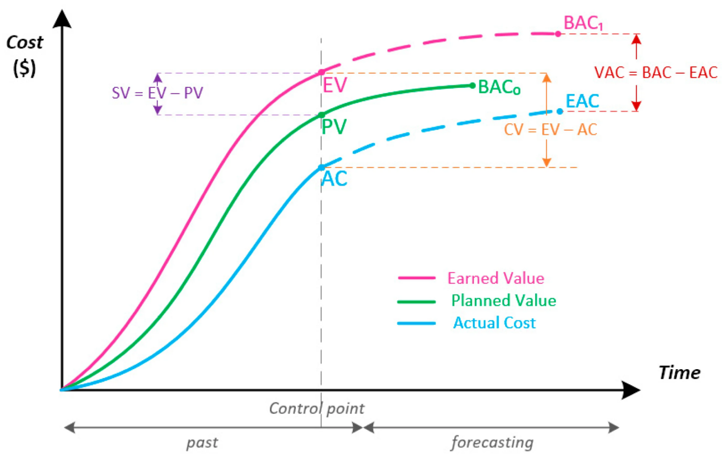
Figure 7: Metrics of “Earned Value Management”
(Source: Proaño-Narváez et al., 2022, p.5)
Earned value management indicators relevant for the community health clinic project are planned value (PV), earned value (EV) and cost performance index (CPI). Cost overruns are detected through CPI where a value of less than 1 implies that for every pound spent on the project, less than one pound of productivity within the project is being accomplished justifying increased expenses. “Planned Value Method” concentrates on cost-based schedule performance by using planned values as a metric (Elsaid et al., 2025, p.23606). Comparison of EV and PV can help project managers of the community health clinic for determining if delays in project's activities are taking place or not. EVM functionality over the clinic’s construction timeline includes planning and design, monitoring, risk detection and forecasting.

4.3 Cost-monitoring processes
Cost Budgeting
Cost Estimating
Cost Monitoring Processes
Cost Control
Figure 8: Cost monitoring processes
(Source: Self-developed)
Processes for monitoring costs can be helpful in managing financial risks by providing visibility on the expenses through real-time data. Companies seeking investment or capital opportunities may face time and cost issues (Schroeder et al., 2022). The cost-monitoring process allows detection of budget overruns and allows the management team to implement any corrective actions. Automated approaches through AI can be useful in managing long-term costs of monitoring (Ditria et al., 2022). Data on the cost drivers and spending patterns can facilitate better and informed decision-making, which is also followed by sound strategic adjustments.

4.4 Methods to prevent scope creep
For preventing scope creep risks in the community health clinic project, it is important in developing a detailed statement of work (SOW) by outlining specific deliverables and milestones to ensure that the project is on track. Managers can use several methods such as involvement of stakeholders and strict levels of change control systems for managing scope creep problems (Okafor and Odubade, 2022). Effective communication is also important in preventing scope creep risks by consistently communicating with the project’s stakeholders to ensure that they are informed regarding any changes to be made.

4.5 Risk mitigation strategies
Some mitigation strategies for managing the cost control system are hedging, fixed price contracts and procurement controls. Cost controlling can be mitigated through Hedging which uses derivative contracts for balancing potential losses in an investment. Firms can use derivatives for creating a hedge towards exposure to fluctuations in interest rates and currency values (Alfaro et al., 2024). Fixed price contracts are also useful in implementing cost control mechanisms by transferring risks of cost-overrun from the buyer to the seller. Procurement controls establish cost control through auditable and structured processes which can help in preventing excess budget variances by implementing contract management and supplier due diligence.

5. Section D: Reporting Framework

5.1 Report types and frequency
Monthly financials can be used by project workers to keep a track of its current performance and make any data oriented insights. Cost discrepancies can result in financial losses, cost overruns and project delays (Ayob and Ilhamullah, 2024). Cost reports can be used for managing resource allocation and adjusting project plans for ensuring profitability. CAPEX dashboards are used in visualising the budget consumption and highlighting variances between actual and budgeted values. The frequency of reporting can be centered on the construction and operational phases. Project threshold for escalation relates to a delay in the project exceeding a specific number of days, variances in budget (above 10%) and technical failures. Reports are fed into the discussion meeting through the agenda item table, meeting documentation and action oriented reporting. Some examples of template formats that are to be used are RAG Status, project dashboard status, issue logs and critical milestones.

5.2 Key financial KPIs
Project workers of the community health clinic to measure performance can use schedule variance and cost variance by highlighting efficiency levels. Immediate visibility into cost variances can allow organisations in reducing financial risks and improving decision-making processes (Olajide et al., 2023). Budget utilisation is monitored by using burn rate for monitoring the speed at which the project team is able to consume hours for story points by adjusting to sprint scope. Cash flow forecasts outlines expected inflows and outflows for ensuring that there is enough cash in hand for meeting future obligations.

5.3 Roles in Governance structure and use of financial software tools
Governance structure includes project sponsor and project managers who need strategic reports for approving budgets in order to make decisions on project feasibility. Financial software such as ERP systems includes various modules that are required for operations such as production, work progress and managing inventory levels (Boutros et al., 2024). Project accounting systems within project management helps in keeping a track and measurement of financial health for the project through real-time monitoring of costs and revenue.

5.4 Reporting supporting decision‑making, transparency, and accountability
Reporting for project workers supports decision-making by providing critical metrics and data oriented insights such as adherence to timeline and usage of budget. It is useful for reallocation of resources and addressing any issues before it escalates. Transparency in reporting requires regular status reports and real-time dashboards by ensuring that project’s workers have a clear viewpoint on the project’s status. Transparent data accountability framework supplemented by reporting tools and management dashboards for assisting data oriented decisions and monitoring progress (Zdybicki, 2025). Reporting ensures accountability by tracking both team and individual performance against any planned efforts within the operation phase of the construction. Accountability and transparency relates to PRINCE2 and PMBOK approaches through project board and project sponsorship.

6. Conclusion and Recommendations
It can be concluded that the best case scenario is profitable for the community health clinic. It is due to higher NPV and IRR values implying that the project can be accepted. Cost control plan includes contingency budgeting and earned value management, which are useful metrics for mitigating cost overrun problems. Reporting framework includes monitoring overall project performance through cost variance, schedule variance and capex dashboards. Therefore, it is recommended for sound contingency planning, allocation of risks and value engineering by finding cost-effective alternatives for reducing any upfront costs.

References
Adeboye, E.O., Ifeanyi, E.V. and Labisi, G.B.E.M.I.S.O.L.A., (2022). The policy-startup feedback loop: How tech entrepreneurs can shape better grant programs. Iconic Research and Engineering Journals (IRE Journals), 5(10), pp.373-379.
Alfaro, L., Calani, M. and Varela, L., (2024). Firms, currency hedging, and financial derivatives. In Handbook of Financial Integration (pp. 340-370). Edward Elgar Publishing.
Atrill, P. and Mclaney, E., (2022). Accounting and Finance for non-specialists. 12th edition. Pearson Education.
Ayob, A. and Ilhamullah, M., (2024). The differences in the cost of labor wage between the contract document and on-site contractor cost analysis: a case study. Journal of Sustainable Civil Engineering Insights, 1(2), pp.1-10.
Boutros, M.B., El Hajj, C., Jawad, D. and Martínez Montes, G., (2024). Diffusion of ERP in the construction industry: An ERP modules approach: Case study of developing countries. Buildings, 14(10), p.3224.
Brown, G. and Volckmann, W.M., (2024). Unpacking private equity performance. The Journal of Portfolio Management, 50(7), pp.100-115.
Cadenovic, J., Deloof, M. and Paeleman, I., (2024). Do dividend policies of privately held firms follow a life cycle?. The European Journal of Finance, 30(5), pp.457-480.
Capone, C. and Narbaev, T., (2022). Estimation of risk contingency budget in projects using machine learning. IFAC-PapersOnLine, 55(10), pp.3238-3243.
Ditria, E.M., Buelow, C.A., Gonzalez-Rivero, M. and Connolly, R.M., (2022). Artificial intelligence and automated monitoring for assisting conservation of marine ecosystems: A perspective. Frontiers in Marine Science, 9, p.918104.
Dobrowolski, Z. and Drozdowski, G., (2022). Does the net present value as a financial metric fit investment in green energy security?. Energies, 15(1), p.353.
Elsaid, M., Nassar, K., Alqahtani, F.K. and Abotaleb, I., (2025). Comparative analysis of earned value management techniques in construction projects. Scientific Reports, 15(1), p.23606.
Girdzijauskas, S., Streimikiene, D., Griesiene, I., Mikalauskiene, A. and Kyriakopoulos, G.L., (2022). New approach to inflation phenomena to ensure sustainable economic growth. Sustainability, 14(1), p.518.
Kotcharin, S. and Jantadej, K., (2024). Behavior of small and medium shipping enterprises’ working capital management: moderating role of firm-specific characteristics in times of crises and geopolitical risk. Cogent Business & Management, 11(1), p.2396544.
Mwale, B.J., Ntsobi, M. and Nyamkure, B., (2025). Maximizing Educational Impact: A Mixed-Method Analysis of Strategic Funding Pathways for Sci-Bono Discovery Centre in South Africa. European Journal of Business and Management, 17(4), pp.73-83.
Naomi, I.W., (2023). Effects of Debt Financing on Financial Performance of Manufacturing Firms in Kenya. African Journal of Commercial Studies, 3(2), pp.86-95.
Okafor, I. and Odubade, O., (2022). Factors affecting scope creep in project management: Identify the key factors contributing to scope creep and explore strategies to prevent it. International Journal of Engineering Technology and Management Sciences, 6(11), pp.10-5281.
Olajide, J.O., Otokiti, B.O., Nwani, S., Ogunmokun, A.S., Adekunle, B.I. and Fiemotongha, J.E., (2023). Real-Time Financial Variance Analysis Models for Procurement and Material Cost Monitoring. Gyanshauryam, International Scientific Refereed Research Journal, 6(5), pp.115-125.
Proaño-Narváez, M., Flores-Vázquez, C., Vásquez Quiroz, P. and Avila-Calle, M., (2022). Earned value method (EVM) for construction projects: Current application and future projections. Buildings, 12(3), p.301.
Schroeder, R.G., Clark, M.W. and Cathey, J.M., (2022). Financial accounting theory and analysis: text and cases. John Wiley & Sons.
Zdybicki, T., (2025). Project-Lifecycle Data as the Conceptual Basis for Data-Driven Governance in Global IT Programmes. European Research Studies Journal, 28(3), pp.1518-1537.

