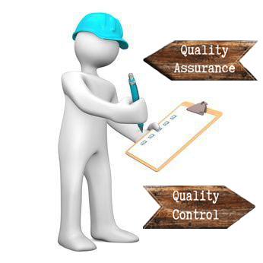
Student name: Antonio Joseph
Student ID number: 2113837
Module: Project Planning for Construction
Module code: ACBA5001
Assignment Title: Management and quality management in construction
Lecturer: Rhodri Thomas

Table of contents
Abstract…………………………………………………………………………………………………………………………………………………..1
Introduction…………………………………………………………………………………………………………………………………………….2
What is Quality………………………………………………………………………………………………………………………………………..3
How is Quality attained……………………………………………………………………………………………………………………………3
Quality Assurance (QA)……………………………………………………………………………………………………………………………4
Quality Control (QC)………………………………………………………………………………………………………………………………..5
Similarities between QA and QC………………………………………………………………………………………………………………6
Differences between QA and QC……………………………………………………………………………………………………………..7
Conclusion……………………………………………………………………………………………………………………………………………….8
References………………………………………………………………………………………………………………………………………………9

Abstract
For some times, the development sector has plodded with quality difficulties, and the cost to our frugality has been significant. The price might be greatly lowered if the assiduity espoused the notion of quality assurance, which has been employed successfully by numerous other areas of the frugality. Structure possessors must also be forced to learn about quality assurance so that they may use their voice to endorse the relinquishment of this fashion to cover their means and drop construction costs. The quality control (QC) and quality assurance (QA) problems in project management are becoming more critical. It is possible for built-in facilities to malfunction or break down, resulting in exorbitant prices. The operation of a facility is impacted by even small flaws, requiring rehabilitation. The result is an increase in expenses and delays. To ensure the quality and consistency of any building project, quality assurance and quality control are essential parts of the process. Recently, QA and QC in building projects have become increasingly important as a result of developments, technological advances, and increasing customer expectations. Through quality assurance and quality control, the building process becomes more regular, resulting in lower material consumption and more cost savings for the customer. It is perfectly proportional to the benefits of performing quality assurance and quality control to incur additional expenses. A technique for QA and QC has been developed for the housing industry. Through the use of this technique, the construction process can be achieved with the desired quality. Finally, it is critical that quality be present. We can define the standard in numerous ways, such as: Conformance to standards or specifications is defined as quality. The ability to use something defines its quality. Quality refers to the extent to which a set of inherent characteristics meets standards.

Introduction
The building sector has struggled with quality issues for many years, resulting in huge economic costs. If the industry adopted the concept of quality assurance, which has been used successfully by many other sectors of the economy, the price could be greatly reduced. Since the development sector is exclusive, establishing quality assurance requires a strategy that meets the standards of the industry. Additionally, building owners need to be educated about quality assurance to place their voices behind the adoption of this method to protect their assets and lower construction costs. Different industries have different definitions of Quality control and Quality assurance. In order to understand this concept of quality, we often pose the following four questions.
- What is Quality?
- How is Quality attained?
- What is Quality Assurance?
- What is Quality Control?

What is Quality?
At its core, the term "quality" relates to how good something is in comparison to other comparable items. To put it another way, its level of excellence. However, the term "quality in construction" refers to a project's completion within the parameters specified in the Scope of Work. Based on the owner's expectations, this document acts as a set of guidelines for the project and provides guidance on how to carry out the project in a way that complies with these standards. One of the first tools you can use to guarantee your project is on the path to success is the scope of work for every task. It serves as your road map for getting the greatest construction quality outcomes.
The impact of building quality on the bottom line may be the most important. High-quality project completion may lead to repeat business and shield you from costly errors that need task rework. Contrarily, poor quality construction projects can harm your reputation and cause you to lose future business from both prospective repeat customers and anybody else who hears about the unsatisfactory nature of your work.
How is Quality attained?
To attain quality, everyone in an organisation or business must collaborate toward similar goals. This entails mutual support throughout the company, rather than turf wars, envy, or unneeded rivalry. But in terms of construction, there are usually several things to examine when judging the quality of a building job. Among these are whether you completed the job on time and within the agreed-upon budget, as well as if you met the owners' needs. Furthermore, whether you have met the parameters given in the project contract and avoided disagreements during the process is critical in assessing building quality. Finally, once you've completed a task and turned it over to owner, ensuring that your finished product serves its intended purpose is a crucial aspect in building quality.

Quality Assurance
Quality assurance (QA) examines the entire process of a project rather than just the end product. QA refers to the planned and systematic operations carried out over the course of a task in order to meet the project's quality criteria.
It is well acknowledged in the construction business that more time is being spent on the preparation or assessment of contractual claims. The rising complexity of customers in implementing the requirements of conventional forms of construction contracts is a crucial factor in this. These contracts plainly lay the burden of evidence on the contractor. The effort of producing this proof, which is typically in the form of documentary evidence, is frequently hindered by a lack of appropriate documents. To make matters worse, economic loss is frequently followed with loss of good will. Examining project documents reveals that questions were not asked when they should have been, and issues were not identified until after they had happened. Typically, the persons engaged do not lack skill or initiative. More often than not, they are pressured for time by other priorities, causing them to give these difficulties minimal consideration.
An additional obstacle occurs when an individual's lack of experience limits their personal horizon and dims their vision of the problems ahead. Poor quality crises have frequently overwhelmed contracts that looked to be moving satisfactorily, resulting in time and cost, negating the ostensibly earned gains.
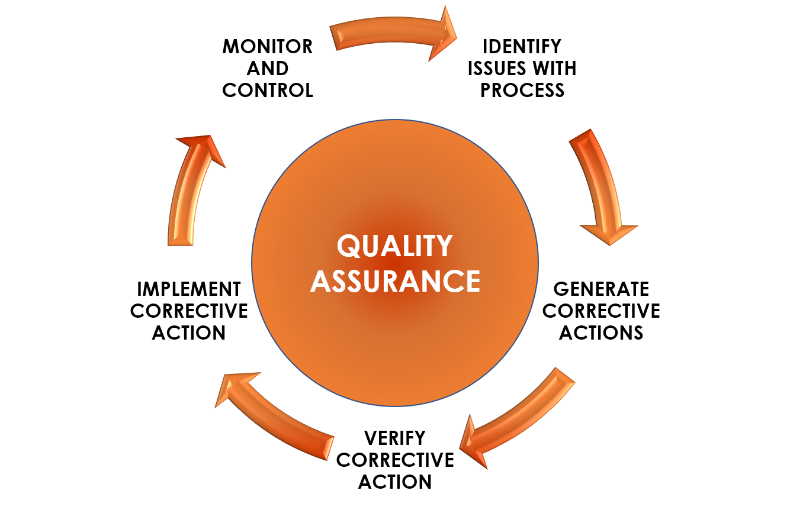

Quality control
Quality control (QC) is focused with the end result of a project rather than the process. QC evaluates if a task was performed correctly and whether a project was completed in accordance with the stated requirements. The QC process compares the quality features of a finished task to the agreed-upon project criteria, then analyses any variations between the achieved and desired outcomes to determine if changes are required.
This control guarantees that the work done is of the requisite quality and durability. This may be accomplished by performing inspections from the point of material supply all the way to the completed product. Verifications of soil qualities, drawings and designs, structural safety, durability, checking the quality of materials, requirements, testing of materials, and equipment inspection are major issues of control before and during construction. Quality control is a multi-directional area that includes testing of materials to be included, field and laboratory tests on mixed materials, and executive staff/contractor adequate understanding of methods/techniques. Precautions should be taken and the frequency of certain tests to begin, materials to be used in construction should conform to standards.
Quality control comprises quality planning, training, making clear judgments and giving clear directions, on-going monitoring, reviewing finished operations for correctness and completeness right away, and documenting all decisions, assumptions, and suggestions. During the creation of the construction plan, it is the designer's explicit responsibility to ensure that all aspects of the project are affordable, correct, appropriately planned, coordinated, verified, and completed. It is important to maintain quality as much as time and money in order to meet and exceed the expectations and demands of the client. In order for design products to be produced and reviewed correctly, employees must adhere to specific design rules, methods, standards, and guidelines. Design consultants are project agents who are primarily responsible for preparing building blueprints. According to the specifications set forth by consultants, quality must be ensured, and certain design principles must be followed.
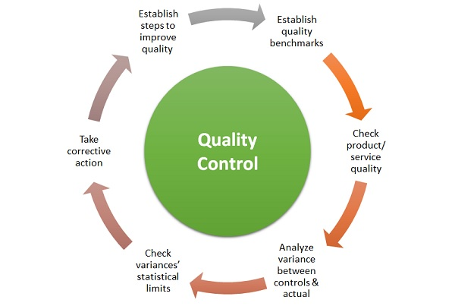
Similarities of QA and QC
- Ensure a high-quality product
It is not enough for a company to release a product and hope for the best. Businesses can use QA to strategize how to approach digital quality. It is the responsibility of QC to ensure that the final product meets expectations. Quality control and quality assurance play an integral role in getting a decent product into customers' hands and ensuring the business's financial success.
- Mitigate major issues and costs
An interruption in business can range from a minor annoyance to a severe, business-threatening problem. It is easier and less expensive to correct a flaw if it is detected early. The danger grows by orders of magnitude as problems are brought closer to the customer. As QA and QC work together to save expenses, the former aims to set up procedures for early detection, and the latter aims to find and fix as many faults in a product as possible.
- Improve how the organization makes products
The concept of feedback loops is well-known among engineers. It is important for organisations to implement continuous learning, increasing efficiency and success with each iteration. As a result of quality control and quality assurance, a firm can identify areas that can be improved in areas such as issue identification, test automation, collecting requirements, and providing better customer service.

Differences of QA and QC
- Proactive vs. Reactive
QA is essential to keeping products on scope and testable from the very beginning of any project. The purpose of QA is to minimize defects from the beginning, and it even impacts the way programmers work. Quality assurance (QA) determines how quality is included and ensured in a product, whereas quality control (QC) reacts to the generated product by discovering and either correcting or triaging residual problems.
- Process vs Product
The emphasis of the job is one of the key differences between QA and QC. Quality assurance is largely concerned with the processes and procedures that increase quality, such as training, documentation, monitoring, and audits. QC examines the product to identify faults that remain after development. These flaws are discovered by QC specialists in a number of methods, including software testing and beta or canary testing.

Conclusion
It is acknowledged throughout the implementation of the quality assurance and quality control system that quality cannot be left to chance; rather, it must be managed at each level of the production process. To manage both quality control and quality assurance together perfectly, Total quality management must be implemented.
The idea behind total quality management is to continuously enhance an organization's capacity to achieve quality and provide the expected output to the customer. Total quality management guarantees both quality and productivity in the construction sector. It essentially represents a method of approaching the ideas of goal setting, vision, and success. Construction varies from manufacturing in a way that makes implementing overall quality control more complex.
The implementation of total quality management requires a change in employee attitude from monitoring to continually looking for possibilities to improve, even if delays and errors are inherent in construction, much more so than in a highly controlled industrial setting. Total quality management, which emphasises innovation and new technology, may be utilised in the construction industry to assure quality and productivity by approaching goal formulation, visualisation, and achievement.
It must be understood that implementing total quality management in a business will not result in instantaneous benefits; it will take time for everyone to become used to the new setup and atmosphere. Total quality management demands an organisational transformation that modifies an organization's culture, priorities, procedures, and beliefs. Along with being involved, top management should work to inculcate in the workforce a feeling of the value of the system.
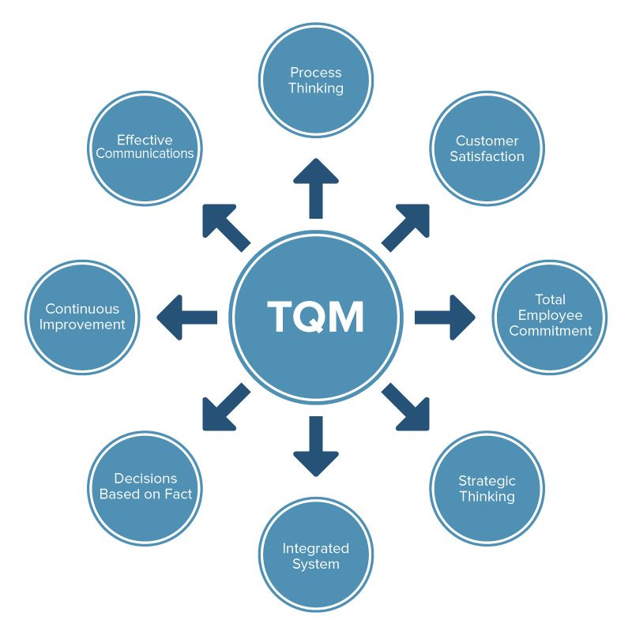
References
Admin (2022). Total Quality Management-TQM in Construction Industry. [online] Construction Placements. Available at: https://www.constructionplacements.com/tqm-in-construction/#gsc.tab=0.
David, Carty. (2021). Quality Assurance vs. Quality Control (QA vs. QC). [online] Available at: https://www.applause.com/blog/quality-assurance-qa-vs-quality-control-qc#:~:text=QA%20primarily%20focuses%20on%20the.
Ellis, G. (2021). Construction Quality Management 101. [online] Digital Builder. Available at: https://constructionblog.autodesk.com/construction-quality-management-101/.
Nordqvist, C. (2018). What is quality? Definition and... [online] Market Business News. Available at: https://marketbusinessnews.com/financial-glossary/quality/.
Alexander, Gillis. (2019). What is Quality Assurance? - Definition from WhatIs.com. [online] Available at: https://www.techtarget.com/searchsoftwarequality/definition/quality-assurance.
www.assignar.com. (2017). Quality Assurance (QA) And Quality Control (QC) On Construction Projects – Assignar. [online] Available at: https://www.assignar.com/articles/quality-assurance-qa-quality-control-qc-construction-projects/.
David, Jung. (2017). Quality Assurance and Quality Control in Construction. [online] Available at: https://www.sablono.com/en/blog/quality-assurance-quality-control-construction.

