Major Depressive Disorder: Classification, Care and Provision in the UK
Component 2 – Written Report
BSc Health and Social Care | BMHP6029_BIRM

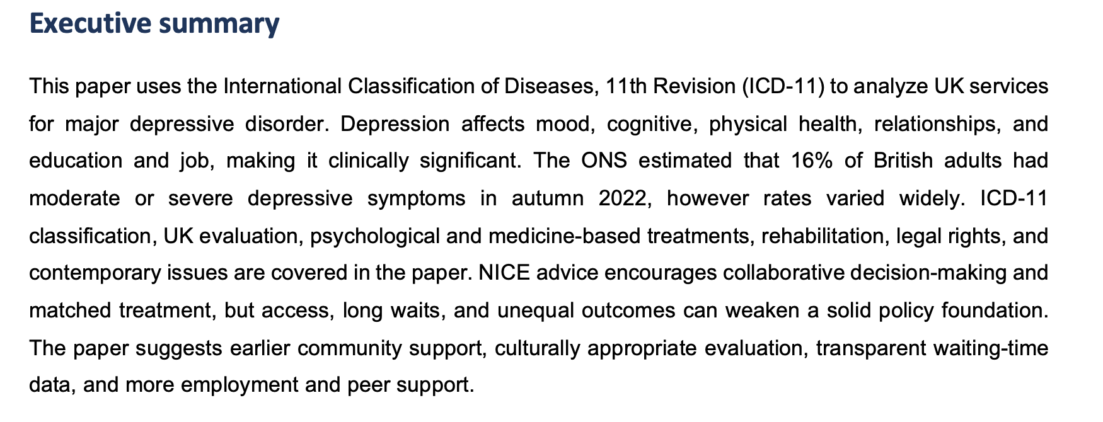

Table of Contents
Executive summary 1
1. Introduction 2
2. Classification and diagnosis 2
3. Treatment approaches and service access 3
4. Rehabilitation and long-term management 4
5. Current debates, policy and legal framework 5
6. Recommendations 6
7. Conclusion 6
References 6

Introduction
Depression goes beyond mood swings. Daily life is influenced by sadness, loss of interest and associated emotional, cognitive and physical problems. This paper is aimed at major depressive disorder, which will also be referred to as recurrent episode or depressed episode in ICD-11. Syndrome is basically created by poverty along with conditions under which chronic illness, discrimination and service access can lead to risk so that you have always limiting your own self-care, causing disruption in the social relationships of yours hence developed a suicide risk (UK Parliament, 2025). In autumn 2022, moderate or severe depression symptoms were reported by 16% of British adults overall, 28% of young adults and in the case of economically inactive due to long-term illness, was at a alarming rate of (59 per cent) (NHS England, 2019). These discrepancies show why a single individuals explanation is not enough.
Moving from diagnostics and diagnosis, the report analyzes therapeutics and long-term rehabilitation. We conclude with recommendations after a presentation of debates and legal-policy context (ONS 2021). The analysis integrates ICD-11, NICE, and NHS evidence because (a) a global classification supplies a common clinical language and (b) UK policy dictates the delivery of care.

Classification and diagnosis
In ICD-11 the grouping of depression is under ‘mood disorders'. Most newly depressed men must have previously low mood or irritability, either with loss of interest or pleasure, or reduced energy, plus at least some degree of inattention, guilt and hopelessness changepsycho motor functioning changes sleep (hypersomnia) and appetite changespsychomotor change thoughts of suicide that last for two weeks at minimum. In the ICD-11, mild, moderate, and severe episodes are classified by number (one to three), severity (subthreshold or moderate vs. current episode with endogenous features), and impairment in function.[19] Psychotic symptoms are also recorded. Episodes of recurrent depression are separated by periods without mood disturbance. This layout enables service-oriented communication and displays severity clinically. Whilst categories may create the appearance of a clear limit to distress, individual experiences vary over time (World Health Organisation, 2024).
Diagnosing in the UK goes beyond a simple checklist Somatic symptom disorder: Symptoms, duration, impact on job and relationships; whether it has occurred before (if so, like this/with what symptoms); physical health; medicines; alcohol or drugs; trauma (eg stress-related disorders); risk of self-harm;bipolar illness. Research may therefore be required to rule out physical causes such as thyroid disease, or anemia (Mental Health Act. 1983). NICE (2022) emphasises that clinicians should consider preferences, social issues and comorbidities. Avoiding the label taking precedence over the person is a strength (ONS, 2023) Although this process may be superficial due to the impact of time constraints on patients and uneven specialist assessment (Care Act, 2014).
In the UK, clinicians use questionnaires such as the Patient Health Questionnaire-9 (PHQ-9) to measure and monitor change, but scores do not constitute a diagnosis of depression. The drawback is that, although questionnaires are valid and comparative, they do miss cultural distress, language needs and bereavement [18]. So, rather than saying that they experience a low mood – someone might come to you with complaints of headaches and fatigue or problems at home (NICE, 2022). Hence, it needs clinical judgement and delicate communication. The term ‘disorder’ is disputed. Can legitimatize care and so positive adaptations, but what about blocking out some EXPLICITLY misunderstood. So, person-sensitive language should be.
Diagnosis relies on risk assessment but it should be an empathic not a checklist based exercise -Overwhelm during diagnosis Professionals need to explicitly ask about suicidal thoughts, self-harm, intent and plans, protective relationships and imminent safety. It enables the individual to be honest without glorifying suicide. Also, risk prediction is poor. A low score does not equate to being safe, and a high score is never an excuse for the use of coercion. November 24, In line with NHS England (2024), best practice includes current risk assessment, clinical history, the lived experience of the individual and a collaboratively agreed safety plan with rapid access to support.

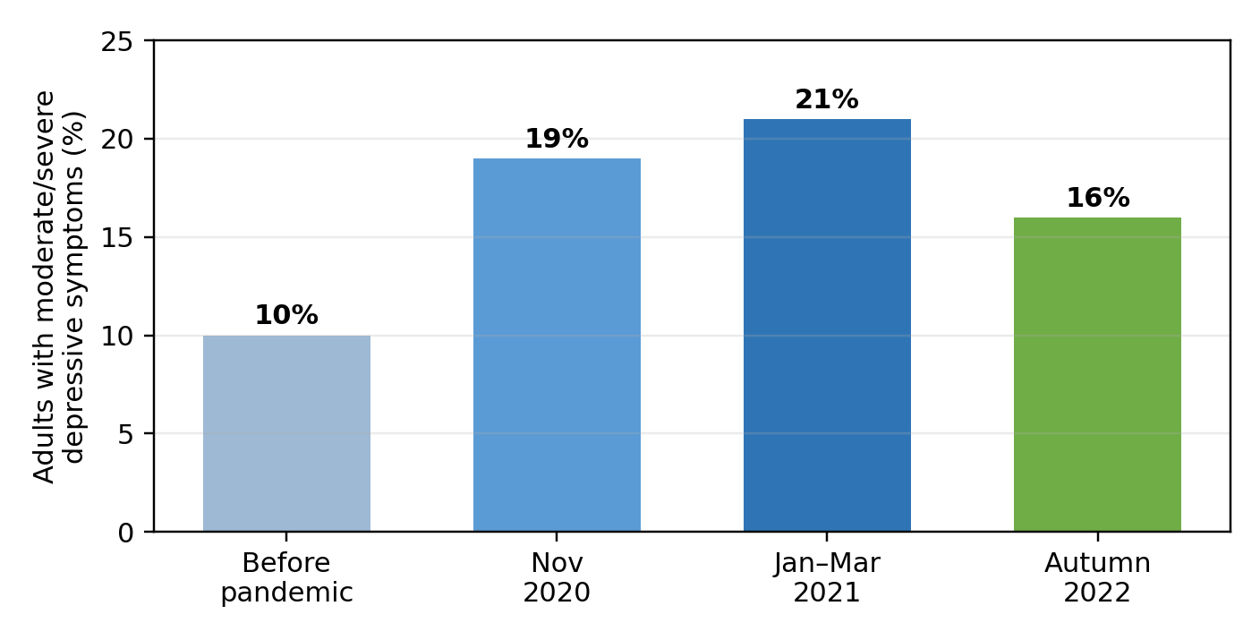
Figure 1. British moderate/severe depressive symptoms. Source: ONS. Figures are not continuous clinical prevalence series due to varied survey periods.

3. Treatment approaches and service access

877, p. 8 NICE [2022], page 242 For a different episode of milder depression [NICE 2020] no more than collaboration and minimal investigation It could be guided Self-Help, Group Exercise, Group CBT, Behavioural Activation, Mindfulness or an individual treatment. Behavioural activation helps people re-engage with things that matter, and CBT works on thoughts, feelings and actions. Such approaches build agency and mitigate overmedicalization. Their limitation is that tired, lonely or homeless people might find attending sessions hard (Equality Act 2010) Digital services are convenient for some but digital exclusion, confidentiality breakdowns and internet black spots can exacerbate existing inequities (NHS 2023).
For severe depression based on need and preference, NICE recommends individual CBT, behavioural activation (BA), counselling, interpersonal psychotherapy (IPT), antidepressant medication or both. SSRIs are used because they have a safer profile in overdose than older antidepressants (Rethink Mental Illness, 2025). Medication can alleviate more serious symptoms but also make every day living easier, although the need to describe and review side effects, withdrawal symptoms as well as response must be balanced (Mind 2025). Antidepressants should also not be presented as a chemical answer to social despair (NHS England, 2024).
Electroconvulsive therapy (ECT) cures severe depression without risk of damaging and is used when no other therapies have worked/ whenever the illness is life-threatening. It is useful in severe or psychotic depression but it requires consent except under certain legal circumstances and may have short-term memory impairment (Care Act, 2014). The balance between saving a life from major injury and the right to self determination. When the person desires, being trauma-informed explains and advocates for family engagement.
Treatment should address physical health. Moods are affected by pain and chronic disease, but similarly the opposite is true: depressed people have decreased activity, poorer sleep and find it more difficult to cope with long-term morbidities (ONS, 2021). Therefore, the psychiatry common can coordinate psychiatric leadership, medicine evaluation, drowse recommendation, cigarette help and physical activities. This more natural approach is typical of the mind-body divide. But at the same time, practitioners should not normalize lifestyle change or blame people for symptoms that are largely shaped by illness and adversity.
NHS Talking Therapies in England provided self-referral to anxiety and depression treatment based on NICE-recommendations. It provided high-level national pathway support for 2023/24 and annual recovery and access metrics. This data enables early help without GP visit, and so it is valuable (ONS, 2023). But local availability is not uniform, and a national program cannot promise anybody will receive suitable therapy in a reasonable time (ONS, 2021). National Institute for Health and Care Excellence, 2022), although the NHS Long Term Plan seeks to avoid this—or the risk of reduced access due to increasing demand outpacing workforce growth (or mortality). Tumors are associated with economic, staffing and clinical management issues that can be managed rather than clinical choice alone.
Shared decision-making should be part of each treatment discussion. According to NICE (2022), practitioners should outline expected advantages, risks, practical requirements, and options in the language of the individual. A person with mild signs, but a most excessive trouble of loneliness may choose to engage in organizations and social prescribing over medication. The one with the recurrent severe episodes may be treated with medicine and therapy because experience suggests that this works. This principle is based on lived experience which may contribute to increasing adherence (UK Parliament, 2025). When there is a single locally provided intervention, waiting lists may constrain choice when it limits this opportunity (Care Act 2014). Whether any form of a formal offer of option would have value in the specific circumstance (Care Act, 2014).

Rehabilitation and long-term management
Depression recovery involves more than the absence of symptoms. Rehabilitation aids in achieving social inclusion, education, employment and physical health while promoting autonomy (Mind, 2025). According to NICE (2022), high-risk individuals should identify early warning signs, establish helpful practices and come to an agreement about a supportive plan of action in the circumstances where deterioration occurs. Data from particularly case studies show that antidepressants may be continued depending on their effectiveness, side effects and how are they prioritised after a person is in remission (Equality Act, 2010). This avoids stopping both abruptly and without limits.
Reliability can be improved by using written care plans. It might log chosen contacts, disaster plans, early warning signs such awful sleep or avoidance, and constructive responses (NHS England 2024). Updating the Plan After Major Life Changes This enables the person to forecast a relapse. A plan doesn't compensate for no appointments, safe housing or social support if symptoms erupt again.
Community support is most vital for recovery. Social prescribing (UK parliament, 2025) may have practical exercise groups, debt guidance or arts and volunteering as options. Mind and Rethink Mental Illness charites give information, peer support and advocacy (Care Act, 2014). These services go a long way toward reducing stigma and isolation. Not all communities have access to such volunteer organisations and some are dependent on time-limited funding (ONS, 2021), and these cannot provide an alternative for statutory mental-health and social-care services.
Employment matters too. The depression and unstable job might lead to loss of peakWork performance with aggravated symptoms. Under the Equality Act 2010, if depression has a substantial and long-term adverse impact on normal day-to-day activities, employers must make reasonable adjustments. Ehancements such as the flexible hours, gradual return, modification of tasks and supportive meetings (ONS, 2023). These changes can help to uphold dignity and skill, but they need public disclosure, effective management, and workplaces free from the stigma of mental illness. Hence, health and social-care providers should inquire about, practical goals or relevant symptoms.
Training, caution and privacy (consent) are needed when it comes to getting family and carer involved in recovery. This is an opportunity to discuss warning signs of relapse and what family members can do (if given permission) without seizing control. However, it may be that the stress and repeated crisis situation can leave your carers in need of support (Rethink Mental Illness, 2025). Carers need not be asked for explicit permission to talk about broad information with staff [ONS 2023]. This balanced approach recognizes the importance of autonomy among adults while recognizing that depression usually affects the entire family (NHS England, 2024).

Types of current debates, policy and legal framework in
A fundamental question is if depression itself is a type of medical disease or response to life circumstances. The medical model lends itself to treatment, research funding, and legal protections. Those include underplaying, bereavement abuse racism debt and inequity (ONS, 2021) The biopsychosocial model becomes more balanced when biological predispositions are intertwined with psychological patterns and social factors. The real-world problem is, however, that services may identify sociological factors but not alter rent or wages. Therefore, NHS, local authorities and voluntary agencies are required to work together for good care (Mental Health Act 1983).
Other discussions involve language used in diagnosis and co-occurrence, both of which are affected by neurodiversity. People with autism or ADHD — who might have been depressed, but simply manifest their pain instead through anger — (ONS, 2023). This phenomenon, known as 'diagnostic overshadowing', can lead doctors to attribute all a person's problems simply to a neurodevelopmental difference (NHS England 2019). Assessment should fit communication circumstances and neither assume nor deny depression. While ICD-11 categories are structured, they should be used pragmatically with cultural humility to assure coherence (NICE, 2022).
England and Wales accept treatment for people who are examined and judged to meet certain criteria (specified in the revised Mental Health Act 1983; Department of Health 2007). This is essential for those with severe depression at high risk, but detention involves a serious infringement on liberty and must be justified as necessary, proportionate and accompanied by rights of information, representation and review. The amendments to the Mental Health Act 2025 are designed to maximise freedom, autonomy and safety but #beyond081029 Bundesregierung. Local governments are also given duties under the 2014 Care Act for eligible health and care and support needs. The following are key rules, which demonstrate treatment as not simply a medical decision but also about rights, consent and participation in `society' (NHS England 2019).
Also, interpret prevalence estimates cautiously. As shown in figure 1, prevalent growths of the epidemic are very high and it still significant estimate during autumn 2023 decile( NHS England,2019). Note these are estimates of depression symptoms based on surveys, not counts of diagnoses by anyone. But they identify an unmet public-health need and inequitable social restrictions. It is difficult to compare numbers across countries because of variation in surveys, criteria, help-seeking and diagnostic systems (NHS, 2025). It must therefore be up to local levels of inquiry, rather than presuming the entire UK is the same (NHS, 2025) and as such should dictate policy by data.

UK framework | Practical contribution | Limitation / issue
NICE NG222 (2022) | Shared decisions and matched treatment options for adults | Recommendations depend on a trained workforce and local capacity.
Mental Health Act 1983 / 2025 | Safeguards for detention, treatment and patient rights | Coercive care remains ethically contentious.
Care Act 2014 | Wellbeing and social-care assessment duties | Eligibility thresholds can limit support.
Equality Act 2010 | Reasonable workplace adjustments | Rights depend on disclosure and implementation.
Table 1. Key UK frameworks shaping depression care and participation.

6. Recommendations

Integrated early support – Primary care, Talking Therapies and partnerships in the voluntary sector need to be strengthened This means that services should provide self-referral, on the phone and in-person options, interpretation and translated information (Mental Health Act 1983).

Assessment must be based on validated measurements and sociocultural frame of references. NHS providers should better report and engage local communities with waiting-time and result data by race, age, disability and deprivation to address equity (UK Parliament, 2025).

• Housing, debt, employment and peer-support goals need to be incorporated into rehabilitation planning. Local authorities and NHS teams must use Care Act and Equality Act duties to offer practical assistance rather than merely tracking symptoms (Equality Act, 2010).

Conclusion

Major depressive disorder is a common and disabling illness ICD-11 communicates for clinicians. In the UK, NICE provides evidence-based psychological, social and pharmacological treatments, whilst NHS Talking Therapies facilitates access to these interventions. Classification is only helpful when assessment pays attention to the person, and treatment. For each individual, the human rights of long-term recovery – practical help and social inclusion and civil rights – are just as good if not better than symptom scores in summing recovery. Better early access to care, equitable evaluation and integrated rehabilitation provision would result in improved patient care and a more humane system.

References
Care Act 2014, c.23. Available at: https://www.legislation.gov.uk/ukpga/2014/23/contents (Accessed: 20 July 2026).
Equality Act 2010, c.15. Available at: https://www.legislation.gov.uk/ukpga/2010/15/contents (Accessed: 20 July 2026).
Mental Health Act 1983, c.20. Available at: https://www.legislation.gov.uk/ukpga/1983/20/contents (Accessed: 20 July 2026).
Mind (2025) Depression. Available at: https://www.mind.org.uk/information-support/types-of-mental-health-problems/depression/ (Accessed: 20 July 2026).
NHS (2025) Depression in adults: overview. Available at: https://www.nhs.uk/mental-health/conditions/depression-in-adults/overview/ (Accessed: 20 July 2026).
NHS England (2019) The NHS Long Term Plan. Available at: https://www.longtermplan.nhs.uk/ (Accessed: 20 July 2026).
NHS England (2024) NHS Talking Therapies annual reports, 2023/24. Available at: https://digital.nhs.uk/data-and-information/publications/statistical/nhs-talking-therapies-annual-reports/2023-24 (Accessed: 20 July 2026).
NICE (2022) Depression in adults: treatment and management (NG222). Available at: https://www.nice.org.uk/guidance/ng222 (Accessed: 20 July 2026).
ONS (2021) Coronavirus and depression in adults, Great Britain: January to March 2021. Available at: https://www.ons.gov.uk/peoplepopulationandcommunity/wellbeing/articles/coronavirusanddepressioninadultsgreatbritain/januarytomarch2021 (Accessed: 20 July 2026).
ONS (2023) Cost of living and depression in adults, Great Britain: 29 September to 23 October 2022. Available at: https://www.ons.gov.uk/peoplepopulationandcommunity/healthandsocialcare/mentalhealth/bulletins/costoflivinganddepressioninadultsgreatbritain/29septemberto23october2022 (Accessed: 20 July 2026).
Rethink Mental Illness (2025) Depression. Available at: https://www.rethink.org/advice-and-information/about-mental-illness/learn-more-about-conditions/depression/ (Accessed: 20 July 2026).
UK Parliament (2025) Mental Health Act 2025. Available at: https://www.legislation.gov.uk/ukpga/2025/33/contents (Accessed: 20 July 2026).
World Health Organization (WHO) (2024) ICD-11 for mortality and morbidity statistics: depressive disorders. Available at: https://icd.who.int/browse/2024-01/mms/en (Accessed: 20 July 2026).

