The Inspiration for Viking Monster

Acknowledgements

I would like to acknowledge the works of Adrienne Mayor as her book was the inspiration and the source of the methodology for this investigation. Along with Ros Coard and Martin Bates who’s recommendations and guidance were always useful and appreciated in steering the report in the correct direction.

Contents
Report on whether Viking sea monsters could have been inspired by fossils found in the area: 1
Acknowledgements (especially if you relied on other people for help or information) 1
Abstract or summary (should include a summary of you findings) 1
Introduction 1
Aim, and objective 1
Methodology (what you looked for specifically, how many, where, anything that is relevant to your sample used) etc. 2
Data Set 1 2
Data Set 2 3
Results or findings (what did you actually find - did it 'work' remember it does not have to work) 3
Discussion (should include some evaluation of your results AND of your methodology) 3
Conclusion and recommendations 3
References (as a reference list) 3
Appendices (put any recording sheets, endless photos, etc. use this to keep the raw data). 3

Summary
Whilst searching for the inspiration behind Viking sea monsters I found that there are very few detailed depictions of sea monsters that can be accurately dated to the Viking age and that there is very little in the way of iconography that is definitely depicting sea monsters. The depictions of monsters I settled on were found on a ship (see figures 2 and 3) and thus it is assumed that they are of sea monsters rather than terrestrial monsters. These were then compared to fish and aquatic faunal remains, namely whales, from the known range of the Vikings in order to attempt to prove a correlation or visual similarity between the remains and the iconography.
The results of this comparison are that the remains I was able to find that had been discovered and excavated were not the origins of these carvings, but that other animals may well have been.

Introduction

Aim, and objective
In this investigation I will be attempting to emulate Adrienne Mayor’s research into the origins of Greek and Roman myths and monsters but for the Viking myths and monsters instead. In doing so I hope to prove that the myths and monsters of the Vikings were actually misinterpreted fossil remains or misidentified animals that lived alongside them. I will be focusing on sea monsters and attempting base their origins in actual animal remains.
There were several problems facing my research into the origins of Viking monsters, one of which was that there is a decided lack of actual imagery and because a large amount of the Viking myths and monsters were oral traditions many of them may have been lost.
I intend to compare the remains of fish and aquatic fauna with the depictions of monsters and attempt to draw parallels along with any similarities between the depictions of monsters and the fish and aquatic faunal remains being found.

Methodology (what you looked for specifically, how many, where, anything that is relevant to your sample used) etc.
The methodology used to approach the question of whether or not the Viking mythos, in particular the question of whether any sea or river monsters could have been inspired by fish and aquatic animal remains that are within the known Viking range, is in large part inspired by the works of Adrienne Mayor, specifically The First Fossil Hunters published in 2000. In this volume Mayor describes how the Roman and Greek myths and monsters could have been influenced by an early version of palaeontology. Mayor states that fossils such as mammoths and dinosaurs could be the source of the myths of Satyr’s and Centaurs that pervade much of Greek and Roman myths (Mayor. A, 2000, p3)
The methodology being used here is similar to Mayor’s in that I will compare fossil evidence to descriptions of mythical creatures to be found largely in literature. The difference however is that I will make the comparison with fish and aquatic fauna fossil remains to be found Scandinavia and Britain with descriptions of sea monsters in the Viking Sagas. Originally, I had hoped to use iconography of Viking sea monsters as my second data set, as Mayor had used ancient Greek and Roman iconography to explore relationships between fossils and mythos, but after conducting some research into this it became clear that there is less relevant imagery to be found in the Viking material culture, and many of the images that can be used are of land-based monster.

Data Set 1
In undertaking the comparison there were several parameters that needed to be established and data sets defined. Data set one is Iconography found in ships such as the Oseberg ship found in 1904 in Oseberg, Norway (Colm, World Archaeology, 2012).
Originally, I was going to use pictorial evidences such as images on maps. A quick google search will reveal many pictorial sea monsters dotted around maps, however only one of these images could be found to be an actual map having been showcased in the tv show “River Monsters with Jeremy Wade” however the map is mentioned once; as is its age being 400 years old. Which despite the map being covered with the monsters being investigated and being of the correct area, means that the map is not contemporary with the Viking time period and thus not a good source of data.
Once it became apparent that these sources were not reliable I shifted my attention to textual evidences, drawing on the Viking sagas to look for any mention of sea or river monsters in any of the sagas, the saga I looked at was The Viking Saga by Peter Brent however, I struggled to find any mention of monsters and those that I did were only brief an with no real description of the physical attributes of the supposed monster.
This lack of any real descriptions of monsters put my comparison of skeletal aquatic faunal remains (see data set two) at a serious disadvantage and posed many problems to the research I was attempting to produce. Knowing this would raise many issues in my comparison and therefore impact my results I once again shifted my data set one, this time to any mention of Viking sea or river monsters that could be found to be contemporary with the Viking time period. This means that data set one would still comprise of only written accounts of monsters and no pictorial data. This put the investigation at a serious disadvantage when comparing it to the works of Mayor and her investigation into the source of the Roman and Greek mythos, which has many well documented images and iconography depicting mythological creatures. Whereas Investigating Viking mythos origins leaves us with a decidedly smaller number of images and iconography and only written accounts and descriptions that do not adequately describe the physical attributes of any monsters mentioned.
However, despite there being fewer examples of iconography and imagery that are contemporary with the Viking time period, there are still some well-preserved Viking remains. The Oseberg ship was a ship discovered in 1904 in Oseberg, Norway and was remarkably well preserved. The ship contained the remains of two women and an assortment of grave goods (Colm, World Archaeology, 2012). The main Items I decided to look at from the Oseberg ship was that of the animal head posts (see figure 1 and 2) of which there are five, these posts have the heads of different animals atop them and are somewhat monstrous in their appearance although exquisitely carved. These carved animal head posts and their respective iconography would be my data set one.

Data Set 2
Data set two is based on fish and aquatic faunal skeletal evidence and consists of reference to the remains of fish and aquatic fauna fossils such as whales. The data set had to be limited to the known range of the Vikings such as Scandinavia, Britain and northern islands such as Iceland and Greenland (see figure 3). I chose to focus on Scandinavia and Britain rather than include the latter two islands due to the lack of evidence in the form of fish fossil remains. However, these remains don’t survive very well and when they are found it is normally in such large quantities that they are simply labelled ‘fish remains’ rather than identified to a species. The Nottingham Archaeological fish resource is an online database which showcases a large amount of identified fish remains found in and around Britain and is one of the sources of my data set two.
There are multiple sites that I decided to include in my research depending on what animals were found at said sites, along with an article that detailed the skeletal remains of Wales from Northern Scandinavia and documented the possibility of large-scale whaling going back to the 6th century (Kofmar, L. Uppsala University, 2018) Skeletal remains that this report detailed were actually gaming pieces made of whale Bone which suggests whaling going on at the time the game pieces were made.
However, there are actual sites of skeletal remains that aren’t in the form of game pieces these include the Norwich archaeological fish resource but also an excavation at Ludlow in Shropshire which found several fish bones and scales (Carrot, J. Hall, A. Johnstone, C. Kenward, H. 2000/7) However, these fish remains were not ever identified to a species and were not overly useful to my investigation as without being able to identify the bones I was unable to compare them to the carved animal head posts of the Oseberg Ship.

Results
The results of my research were inconclusive, I could not prove any direct correlation or inspiration from fish and aquatic faunal remains to that of depictions of monsters. However, my findings do not disprove the existence of such a relationship between the aquatic faunal remains and Viking monsters.
I found several sites that had fish and evidence of whale remains, which suggests that there were large amounts of fishing and therefore a large amount of skeletal remains. However, many of these fish remains were not identified to a species and were just labelled as fish remains and were therefore not overly useful in identifying and comparing more complete skeletons to the Oseberg ship animal head posts.
There is no identifiable correlation between where the iconography I chose to look at and the aquatic faunal and fish remains I researched were found either (see figure 4). The only site relatively close to the iconography I was trying to compare to is that of Uppsala and its evidence of early whaling. Whilst whales are large creatures and some can be seen as monstrous such as the grey whale which was known as the devil fish for its aggression once having been harpooned, they do not actually bare any resemblance to the Oseberg ship’s iconography.

Discussion (should include some evaluation of your results AND of your methodology)
The investigations results were inconclusive at best, this could likely be improved by changing the search for Viking monsters to that of land and aquatic monsters as opposed to focussing only on the sea monsters and their iconography. Of course, there is no way to prove that the Oseberg ship’s animal head posts are of sea monsters in the first place.
I would suggest that the research itself is not a bad idea but that it was rather hindered by its reliance on pictorial evidences and iconography, of which there is very little. I would suggest finding a middle ground and attempting to find pictorial evidences depicting monsters described elsewhere so that there are two different forms of evidence for the monsters themselves. I would also suggest that data set two could be expanded to include prehistoric animal remains that may have been uncovered in the Viking period and also including land animals alongside the aquatic faunal and fish remains that I did. Another potential change I would make would be to look at semi aquatic and aquatic fauna that were alive during the Viking period to see if misidentification could have played a part in the origins of myths and monsters
The methodology I employed has been proven to work elsewhere in the word, namely Greece and Rome. However, this may have been part of the problem I encountered as the methodology was already specialised into comparing to particular things that I did not have adequate access to, mainly pictorial evidences along with large amounts of written descriptions to accompany those pictorial evidences.

Conclusion
In conclusion there is not enough evidence to say either way whether the aquatic faunal remains and the fish remains could have been the origins of the sea monsters of Viking myth and legend. However, there is certainly no relationship between the fish records I used, or the site’s fish remains in Ludlow and the Oseberg ships animal head Posts. Even the evidence of whaling and therefore the catching of large animals cannot be claimed to be the origins of the iconography that I was researching. Perhaps a seal skeleton or an ancient prehistoric animal remains could have inspired the carvings in the Oseberg Ship however, I could not find a site where these animals were uncovered in the right area.

References

Carrot, J. Hall, A. Johnstone, C. Kenward, H. (2000/7) Assessment of Biological remains from Corve Street, Ludlow, Shropshire (site code: B1910A) Available at: https://www.york.ac.uk/inst/chumpal/EAU-reps/eau00-07.pdf (Accessed on 7/11/2018)
Colm (2012) Irish Archaeology. Available at: http://irisharchaeology.ie/2012/09/the-oseberg-viking-ship-burial/ (accessed on 9/11/2018)
Koffmar, L. (2018) Uppsala University. Available at: https://www.uu.se/en/news-media/news/article/?id=10954&area=2,6,10,16,22,34,42&typ=artikel&lang=en (accessed on 7/11/2018)
Mayor, A. (2000) The First Fossil Hunters Dinosaurs, Mammoths, and Myth in Greek and Roman Times. New Jersey: Princeton University Press.

Appendices (put any recording sheets, endless photos, etc. use this to keep the raw data).
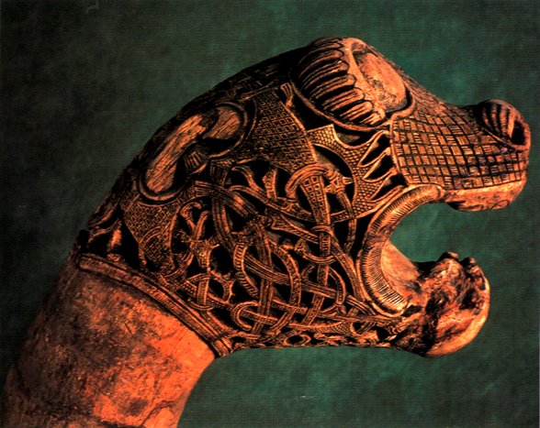

Figure 1 Oseberg Ship animal head post
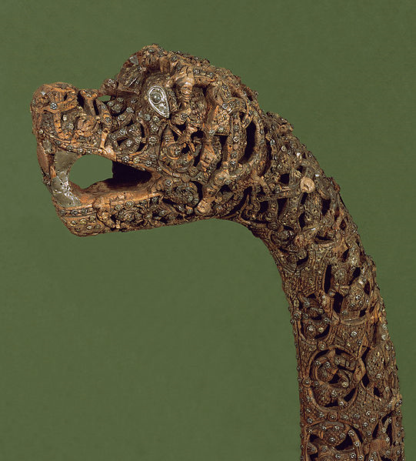
Figure 2 Second animal head post from Oseberg Ship

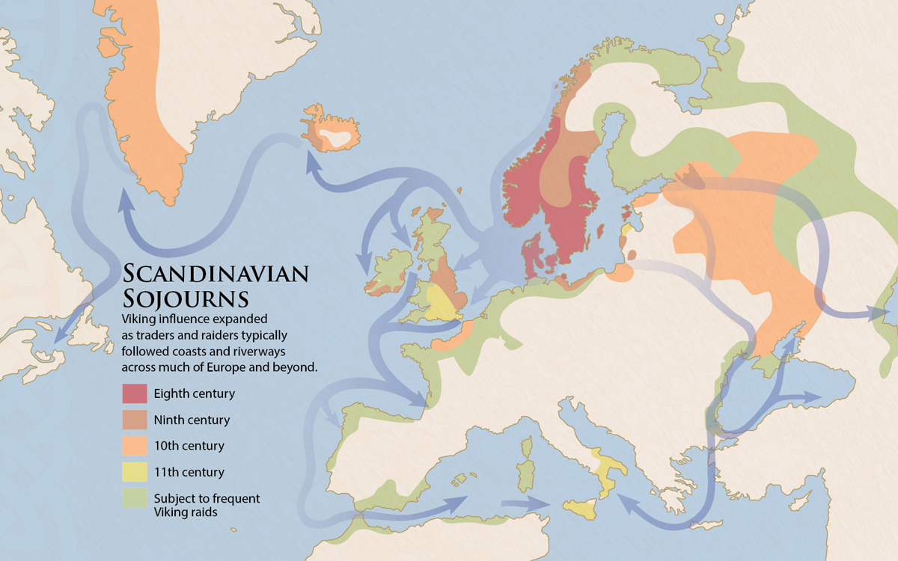
Figure 3 Map of Viking empire throughout the 8th to 11th century
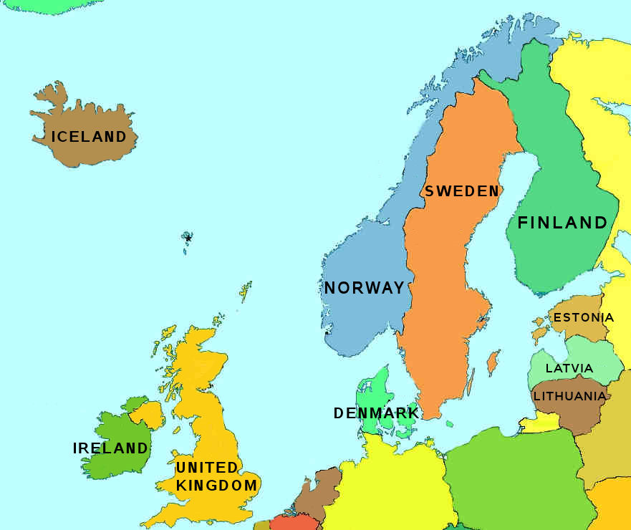
Norwich
Uppsala
Ludlow
Oseberg
Figure 4 map of sites

