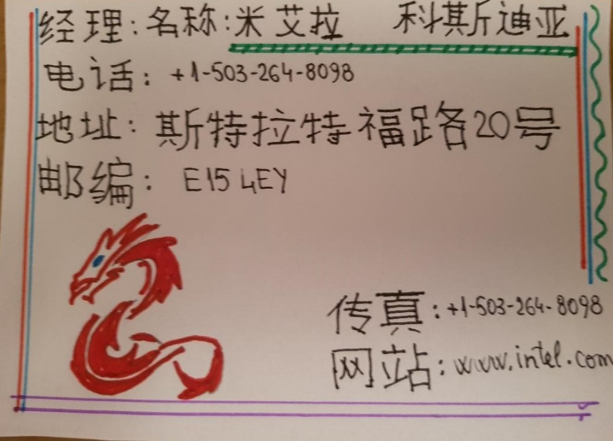

Chinese business card
Student name: MIHAELA COSTEA
Student number: 1815099
Lecturer: Jinping Li
UNIVERSITY OF WALES TRINITY SAINT DAVID
London Campus

