6/2/2022
James Brearley (2110919)
UWTSD
Designing a tanker propeller Fluid Flow Assessment
Structural & Fluid Analysis
Contents
Introduction 3
Task 1: Reynolds number 4
What is Reynolds number? 4
Flow types 4
Reynolds number equation 4
Calculating the Reynolds number of the ship propeller 5
Assumptions 6
Calculating the propeller Reynolds number 7
Task 2: Boundary flow 8
What is boundary layer? 8
Propeller boundary layer 8
What else can influence the propeller boundary layer? 9
Propeller design 9
Why is it so large? 9
Why 5 blades? 9
What is important about the shape of the blades? 10
What is the pitch and why is it important? 10
Task 3: Propeller material 11
What is a propeller and what is its purpose? 11
Benefits of using CFRP 11
Negatives of using CFRP 11
Findings based on applications of CFRP propellers 11
Industry standards 12
Task 4: Modelling techniques 13
Physical modelling and CFD modelling 13
Physical creation and testing of prototypes 13
What is CFD (Computational fluid dynamics)? 13
Advantages of CFD 13
Disadvantages of CFD 14
Modelling of the propeller 14
Task 5: Prototype testing 15
Problems related to prototype testing 15
Schematic for prototype testing 16
Conditions for test rig and prototype 16
Measurable data using proposed test rig 17
Future adaptations possible for rig 18
Conclusion 19
Bibliography 20

Introduction

During this report I will be using calculations to estimate the Reynolds number of seawater around a marine propeller, using this calculation I will state what flow type is present. I will also be discussing the boundary layer around the propeller and how it affects the performance.
Furthermore, I will be researching the implications of manufacturing the propeller out of CFRP (Carbon fibre reinforced plastic), and discussing the modelling techniques that can be used to simulate the fluid flow around the propeller during its operation.

Task 1: Reynolds number

What is Reynolds number?
Reynolds number is a figure with no units used to determine the behaviour of a flowing fluid, it is the ratio of a fluid inertial forces to its viscous forces. The Reynolds number was created by a British engineer and physicist, Osbourne Reynolds, who demonstrated the parameters that causes laminar flow to transition into turbulent flow (The editors of encyclopedia Britannia, 2019). Laminar and turbulent flows can be defined as below:

Flow types
- Laminar flow characteristics are smooth flowing fluid in parallel lines without any chaotic currents, it can also be known as streamline flow. Laminar flows have a Reynolds number up to 2000.
- Turbulent flow characteristics are more chaotic with Eddie currents affecting the streamlines, causing variations in both velocity and pressures. Turbulent flows have a Reynolds number greater than 4000.
- There is also a middle stage, known as transitional flow, this stage contains characteristics of both laminar and turbulent flow. Transitional flow has a Reynolds number between 2000 and 4000.

Reynolds number equation
The equation used to calculate a fluid Reynolds number is:

$$Reynolds number, Re= \frac{inertial forces}{viscous forces}= \frac{ρυd}{η}$$

Where:

$$ρ=Fluid density \frac{Kg}{m^{3}}$$
$$υ=Fluid velocity \frac{m}{s}$$
$$d=Diameter or L=Characteristical length m$$
$$η=Fluid dynamic viscosity \frac{Pascal}{s} or \frac{Newton-second}{m^{2}}$$

Calculating the Reynolds number of the ship propeller
Calculating the Reynolds number of fluid flow around a propeller is more complex than calculating it for fluid flow through a pipe, there are multiple methods used for this calculation however I believe the most suitable are the equations below from (Hufford, 1992), I have come to this conclusion because of the multiple equations I have found from my research, these are the only ones that take into account both the ship velocity and the rotational velocity of the propeller.
The equations used for the Reynolds number calculation of the propeller are as follows:
$${Re}_{D}= \frac{V_{s}.D}{ν}$$
Where:
$$V_{s}=Ship speed, inflow of water$$
$$D=Propeller diameter$$
$$ν=Kinematic viscosity$$

$${Re}_{c}= \frac{V_{r}.C}{ν}$$
Where:
$$V_{r}=Resultant inflow velocity$$
$$C=Chord length$$
$$ν=Kinematic viscosity$$

$$V_{r}= \sqrt{{V_{s}}^{2}+{(2π.n.r)}^{2}}$$
Where:
$$n=Revolutions per second$$
$$r=radius of propeller$$
The following equation relates the diameter Reynold number and the chord Reynolds number together whilst considering the advance coefficient calculated.
$${Re}_{c}= {Re}_{D}\left[\frac{c}{D}.\frac{1}{J}.\sqrt{J^{2}+π^{2}.{\left(\frac{r}{R}\right)}^{2}}\right]$$
Where:
$$R=maximum radius of propeller$$
$$J=\operatorname{advance}{coefficient/ratio= \frac{V_{s}}{n.D}}$$

Assumptions
For completing these calculations there are a number of assumptions that have had to be made:
- The ship is used in saltwater so the density of the fluid is 1026 Kg/m^3 (Engineering toolbox, 2005)
- The dynamic viscosity of the salt water is 0.00122 Ns/m^2 (Engineering toolbox, 2005) giving a kinematic viscosity of 1.189x10^-6 (Calculated using $ν= μ/ρ$ )
- The ship is travelling at 15 knots with a propeller speed of 95RPM, these assumptions are based on typical tanker vessels of similar dimensions according to (MAN Energy solutions, 2019)
- The surface finish of the propeller blades is smooth enough that the effects of friction are negligible
- The CAD drawing given is accurate and to scale, so the chord length is 3.0352m, and the blade length is 2.979m
- From the image, the centre hub diameter has been estimated as 0.75m, this makes the overall propeller diameter 6.7m (rounded down from 6.708m)
- The sea water is steady with no significant waves or tides, so the velocity calculated from the propeller speed is unaffected
The radius used for the following calculations was at 0.7r, this is based on estimations from the supplied CAD drawings, being the chord length is shown at approximately 70% of the blade length.

Calculating the propeller Reynolds number

$$V_{s}=15Knots=7.7 m/s$$
$$ν=1.189X{10}^{-6}$$
$$D=6.7m R=3.35m$$
$$C=3.035m$$
$$n=\frac{95}{60}=1.583$$

$${Re}_{D}=\frac{V_{s}.D}{ν}= \frac{7.7 X 6.7}{1.189X{10}^{-6}}=43,389,402.86$$

$$J=\frac{V_{s}}{n.D}= \frac{7.7}{1.583 X 6.7}=0.726$$

$$V_{r0.7}= \sqrt{{V_{s}}^{2}+{(2π.n.r)}^{2}}=\sqrt{{7.7}^{2}+{\left(2πX1.583X\left(3.35X0.7\right)\right)}^{2}}=24.57m/s$$

$${Re}_{c}=\frac{V_{r}.C}{ν}= \frac{24.57 X 3.035}{1.189X{10}^{-6}}=62,716,526.49$$

$${Re}_{c}= {Re}_{D}\left[\frac{c}{D}.\frac{1}{J}.\sqrt{J^{2}+π^{2}.{\left(\frac{r}{R}\right)}^{2}}\right]$$
$${Re}_{c}=43,389,402.86\left[\frac{3.035}{6.7} X \frac{1}{0.726} X \sqrt{{0.726}^{2}+π^{2}X{\left(\frac{3.35X0.7}{3.35}\right)}^{2}}\right]=62,696,344.36$$

With a Reynolds number of 62,696,344.36, it is safe to confirm that the fluid flow around the propeller is turbulent in nature.

Task 2: Boundary flow

What is boundary layer?
(Nuclear power, 2022) define the boundary layer as “the region in which flow adjusts from zero velocity at the wall to a maximum in the mainstream of the flow”. When a fluid flows over a surface, be it stationary or moving, the fluid is brought to a stand still at the surface because of the shear stresses at the wall, the thickness of this layer and its characteristics are influenced by the Reynolds number. The figure below shows the characteristics and stages of boundary layer flow.
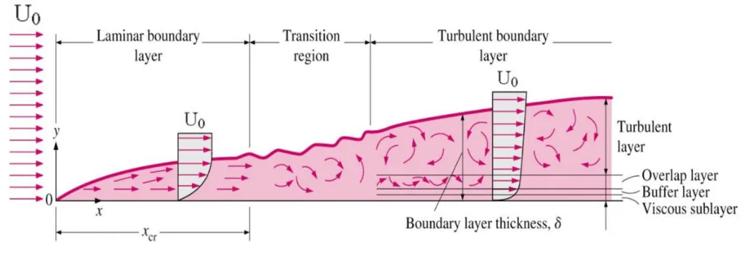
(Nuclear power, 2022)
As can be seen above, the more turbulent the flow, the thicker the boundary layer. A turbulent boundary layer is unpredictable in its behaviour, the flow of fluid here are in random directions and swirling, and there will be pressure differences throughout it.

Propeller boundary layer
From the calculations used to estimate the Reynolds number for the propeller, it is safe to assume that the boundary layer will be turbulent. However, in the case of a propeller this isn’t necessarily a bad thing, the purpose of a propeller is to provide energy to the fluid in order to create pressure changes to push the ship forward, if the Reynolds number was very low for this propeller, the blades would behave as if they are almost slicing through the fluid and provide no axial thrust, making the propeller useless.
From the figure shown above, the turbulence of the flow can also be seen to affect the thickness of the boundary layer, it is possible to calculate an approximate thickness. For a turbulent flow, the calculation is as follows (Nuclear power, 2022):
$$δ= \frac{0.37}{{Re}_{x^{\frac{1}{5}}}}X x= \frac{0.37}{{62,696,344.36}^{\frac{1}{5}}} X 3.035=0.031m$$
From this calculation, it is estimated the boundary layer thickness is 31mm for the propeller.

What else can influence the propeller boundary layer?
The propeller blades are not flat, they are slightly curved, this is primarily there to increase the pressure of the fluid as it travels up them but it will also aid in preventing early separation within the boundary layer as the blade is being pushed into the fluid as it rotates.
The fluid at the propeller must first travel along the hull of the ship, this will alter the flow of fluid to the propeller and the ships hull will have its own boundary layer and Reynolds number. To a certain extent this has been accounted for in the calculation of the Reynolds number of the propeller, as the formulas used consider the propeller velocity as well as the ships velocity, and an advance coefficient was calculated from the two.

Propeller design
From analysing the CAD drawing and the image of the propeller, some characteristics of the design stand out, they are;
- It is large, with a diameter of approximately 6.7m
- It has 5 fixed pitch blades
- The blades are of a curvy shape with no sharp edges
- The blades have quite a large pitch because of the way they are mounted to the centre hub

Why is it so large?
Being designed for a tanker vessel, it is likely that it was designed with as large a diameter as possible to take advantage of the powerful engines that are typically fitted in these types of vessels. With a larger diameter propeller, it can run at a lower speed providing the engine is powerful enough to turn it, and still provide enough thrust as a smaller propeller with a higher rotational speed (Covarrubias, 2022).
With regards to the affect this can have on boundary flow, both the RPM and diameter size will have an effect on the Reynolds number, they both contribute to the inertial forces, so the higher the RPM (velocity) then the higher the number, and the same applies to the diameter. According to (Techet, 2005), ships that operate below 35 knots will usually have a larger diameter propeller with a slower rotational speed in order to achieve a higher torque.

Why 5 blades?
The number of blades is a critical design aspect for an efficient propeller, typically the fewer the number of blades then the more efficient the propeller is, but the vibrations caused by the propeller throughout the vessel will decrease with more blades. So selecting the number of blades is often a compromise between comfort and efficiency.

What is important about the shape of the blades?
According to (Killcaremarina, 2022), there are 3 common types of propellers (Shown below), from left to right they are called: Conventional or round eared blade, weedless blade, and cleaver blade.
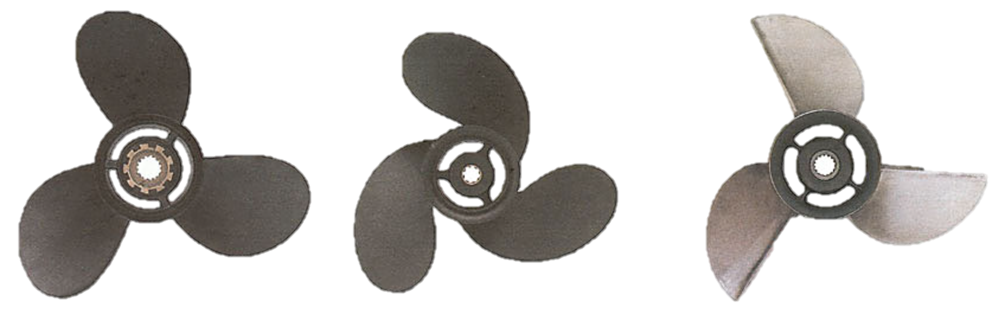
(Killcaremarina, 2022)
The design that the propeller this report is based on falls into the first category, conventional or round eared blade. This is the most common type of propeller used, it is designed to operate whilst fully submerged underwater, but can run whilst surfaced providing the load is light. According to (Covarrubias, 2022), having a rounded edge to the blades also reduce cavitation.

What is the pitch and why is it important?
According too (Boating mag, 2019), propeller pitch is defined as “the distance a propeller would move in one revolution if it were moving through a soft solid, like a screw through wood.”, so the larger the pitch, the more water it will displace per revolution and the further it will push the boat forward. It is similar in principle to the pitch of a thread, however the actual dimension of the pitch of a propeller isn’t exact like on a thread as the propeller runs in water, not a solid.
Pitch is important because it is effectively the final gearing of the boats drivetrain, a larger pitch requires more torque but will push the boat further forward, so with the estimated speed of 95 RPM for this propeller, it is likely the coarse pitch is in order to make the most of the engines high power at low speed whilst also achieving the required speed, a finer pitch would require less engine power but would have to be turning at a higher speed in order to achieve the same travelling speed of the boat.

Task 3: Propeller material

It is proposed that the ship propeller be manufactured using carbon fibre reinforced plastic (CFRP), firstly a brief definition of what a ship propeller is and its purpose.

What is a propeller and what is its purpose?
A propeller on a ship is a round fan-like object that uses a rotational motion from a ships engine to propel the ship in an axial direction. The ships engine drives a prop shaft with the propeller on the end, the rotational movement of the propeller provides energy to the water by physically pushing it, this pushing motion then provides thrust to the ship and propels it in the desired direction. (Marine Insight, 2021)

Benefits of using CFRP
According to (Pegorari, 2018), the benefits of using CFRP for a ship propeller are:
- Significantly lighter than traditional metals
- Noise reduction during operation
- Lower stresses in the transmission line
- Reduced energy consumption
- Resistant to corrosion
- Higher specific stiffness
- Four times higher dampening ratio

Negatives of using CFRP
There are however some negative points to the material:
- It’s expensive
- Cavitation can cause surface erosion (This will increase friction and affect the flow characteristics of the fluid)

Findings based on applications of CFRP propellers
Another key benefit of CFRP suggested by (Yamatogi, 2015) during the installation of one mentioned below, is that under sudden increase in loads, the propeller can flex and absorb the energy, thus protecting the driveline and engine, this is particularly desirable as sea conditions can be aggressive and unpredictable, a sudden change in acceleration due to stormy conditions can cause significant stress to the entire drivetrain of a ship.
CFRP propellers are still relatively new, especially for larger designs, historically these items have been made from metallic materials. According to (Workshop insider, 2021), common materials for manufacturing ship propellers are cast copper alloys (Various grades), Stainless cast steel alloys (Various grades), and cast iron containing either nickel or silicon.
However, there have been propellers manufactured using CFRP and a lot of research and testing has been carried out on them.
In 2014, a CFRP propeller was installed as the main propulsion for a large merchant vessel, and also for the side thrusters, the project was completed by Class NK and Nakashima Propeller (Yamatogi, 2015). The propeller had 4 blades and was 2.12m in diameter. It replaced a nickel aluminium bronze impeller which was a 1.95m diameter. The original impeller weighed 715Kg, the replacement CFRP propeller weighed 422Kg. Because of this weight difference, the stresses on the engine were significantly reduced due to the lower moment of inertia (36.8Kg-m^2, down from 112Kg-m^2). During a test run of the vessel at the design ship speed of 11.5 Knots, a 9% reduction in shaft power was recorded. This means less power is required to propel the ship which results in a lower energy requirement. With the reduced stresses on the ships engine, there will also be less wear and tear meaning lower maintenance costs.

Industry standards
When designing and manufacturing a propeller there are a number of industry standards to be followed:
- Manufacturing accuracy, ISO 484/1 – 1981 (CE).
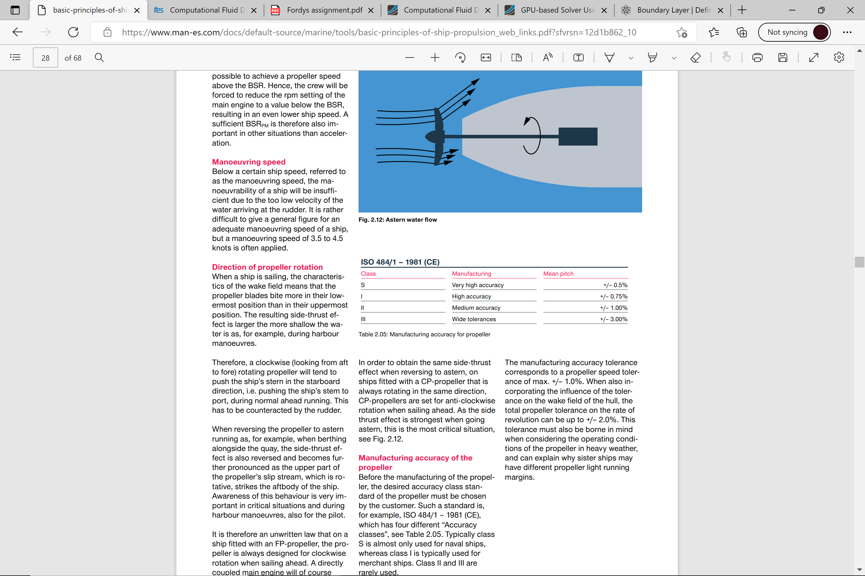 (MAN Energy solutions, 2019)
- ISO 19030-1:2016, Measurement of changes in hull and propeller performance
  - (ISO, 2016) states that this “outlines general principles for the measurement of changes in hull and propeller performance and defines a set of performance indicators for hull and propeller maintenance, repair and retrofit activities.”
- ISO 22554:2015, Propeller shaft revolution indicators — Electric type and electronic type
  - This standard sets out guidelines for how the RPM of a propeller shaft is measured and monitored
- ISO 22098:2020, Full-scale test method for propeller cavitation observation and hull pressure measurement
  - This standard sets out guidelines for measuring cavitation of the propeller and how it affects the ships hull
- ISO/DIS 23453, Guidelines for the design and manufacture of the hub cap with fins for a fixed-pitch marine propeller.
  - This standard is still under development so is likely to be released in the future, however its purpose is for a hub vortex device used on fixed pitch propellers to increase efficiency and energy savings.
- ISO 18352:2009(en), Carbon-fibre-reinforced plastics — Determination of compression-after-impact properties at a specified impact-energy level
  - This standard sets out guidelines for testing and monitoring the strength of CFRP after it has received impacts

Task 4: Modelling techniques

Physical modelling and CFD modelling
Simulating fluid flow around objects is an essential stage of product development, knowing how a fluid will behave around an object can highlight key issues at the design stage before any money is spent on physically manufacturing a product.
There are two main methods used for modelling fluid flow around and object:
- Creating and testing of physical prototypes at either scale or full scale models, this method is discussed further in this report, Page 15 onwards.
- Using CFD (Computational fluid dynamics)

Physical creation and testing of prototypes
This method involves creating a physical prototype, either full size or to a scale, and placing it in a rig such as a wind tunnel and attempting to simulate real-world fluid flow around it and measuring various data points such as flows, pressures and temperatures. This data can then be assessed and used in order to make modifications to the design.

What is CFD (Computational fluid dynamics)?
According to (simscale, 2021), CFD is the process of modelling the fluid flow around a physical object using mathematical models, and then solving it numerically using computers.
There are multiple methods used during CFD, but they are all based on the Navier-stokes equations. These are a set of coupled differential equations which are used to describe the relationship between velocity, pressure, temperature and density of a moving fluid (Nancy Hall, 2021).
Due to the advancements of modern computing power, it is now possible for computers to be used to solve approximations of these equations using a number of different methods, these methods are finite difference, finite volume, finite element and spectral methods.
According to (Pretechnologies, 2022), there are many advantages of CFD of physical prototype testing;

Advantages of CFD
- Reduction of costs at the development stage
  - Building physical prototypes and test rigs can become expensive
  - CFD simulations are relatively inexpensive and are likely to get cheaper as technology advances
- Quick assessments of designs
  - CFD simulations can be completed in a short period of time, especially in comparison to how long prototypes can take to manufacture
  - Modifications can be made at the early stages based on the data gathered from the simulations
- The data can be far more comprehensive
  - With a physical test, there are only so many parameters that can be measured due to limitations on where instruments can be placed
  - With a CFD simulation, the programmer can simulate measurements at any number of positions they desire
- Many different conditions can be simulated
  - The programmer can create an infinite number of scenarios for the simulation
  - Physical testing is limited with what can be measured and simulated
  - A specific phenomenon can be isolated and simulated, for example a wave hitting the propeller during operation
It’s clear that there are many advantages of CFD, however it still has it’s limitations and disadvantages according to (Ifes-Koeln, 2022);

Disadvantages of CFD
- Errors may occur if the flow models are simplified for example around the mesh size at the boundary layer
- If an error is made at the simulation and not spotted, it can become costly if a prototype is built based on that simulation
- Larger designs can take a considerable amount of time and processing power which leads to increased cost

Modelling of the propeller
CFD is no doubt a powerful tool for any engineer tasked with designing a product, and in modern times is the go to option at the early development stage, this is also applicable to designing the propeller in this report. The standout issue with this propeller however is it’s size, any errors made when simulating this design at full size can become extremely costly. CFD should still be used before any prototype is built and physically tested, however I believe it would be beneficial to first start with a smaller scale model to highlight any major design flaws such as poorly designed blade shape or angles, as this is likely to still apply at full size. By doing this the simulations will be significantly cheaper and quicker, and the physical testing mentioned later in this report will also be simpler and cheaper.
Once a scale model has been simulated and tested, any major design flaws can be corrected and a full size model can be progressed.

Task 5: Prototype testing

Problems related to prototype testing
Testing of a propeller so large presents a number of problems, the main problem being cost, in an ideal world a full size model would be tested in order to achieve the most accurate results, however because of the size of the propeller and the material it is being made of, the cost of manufacturing the propeller alone would be massive, furthermore the size of the test rig and the components required would also become very expensive, and that is just the building of it, actually running it would require enormous amounts of energy.
This dilemma presents multiple scenarios based on the proposed schematic on the following page:
- Build everything at full size, this will ensure the most accurate results but will by far be the most expensive
- Build everything at a scale model, then increase the fluid velocity to the propeller by the same scale, for example if the propeller is 1/10th of the size, the velocity has to be increased by 10 times to accommodate the lower dimension value D/L used for calculating the Reynolds number. This has it’s merits however boosting the velocity from 7.7m/s to 77 m/s using pressure will present its own challenges, the knock on effect will require materials that can withstand the high pressures as well as the recirculation pump will need a discharge pressure high enough to overcome the supply tank pressure whilst also having a flow rate high enough to maintain the levels of both tanks.
- The third option, build everything at a scale model and carry out all calculations and computer simulations based on the scale model, using this method an accurate comparison can be made between the computer simulation and the actual testing, from this a margin of accuracy can be calculated, for example if the results from both are within 5% of each other, an assumption can be made that similar results would be achieved at full size. This option does present its own problems though, it is impossible to say that a scale model will behave the same as a full size one, so there is definitely room for error here, however it is safe to assume any major errors found at this scale based on the design, would also be relevant at full size.

Schematic for prototype testing
Below is a proposed schematic of a test rig that can be used to simulate fluid flow around the prototype propeller, this is based of option 3 mentioned previously.
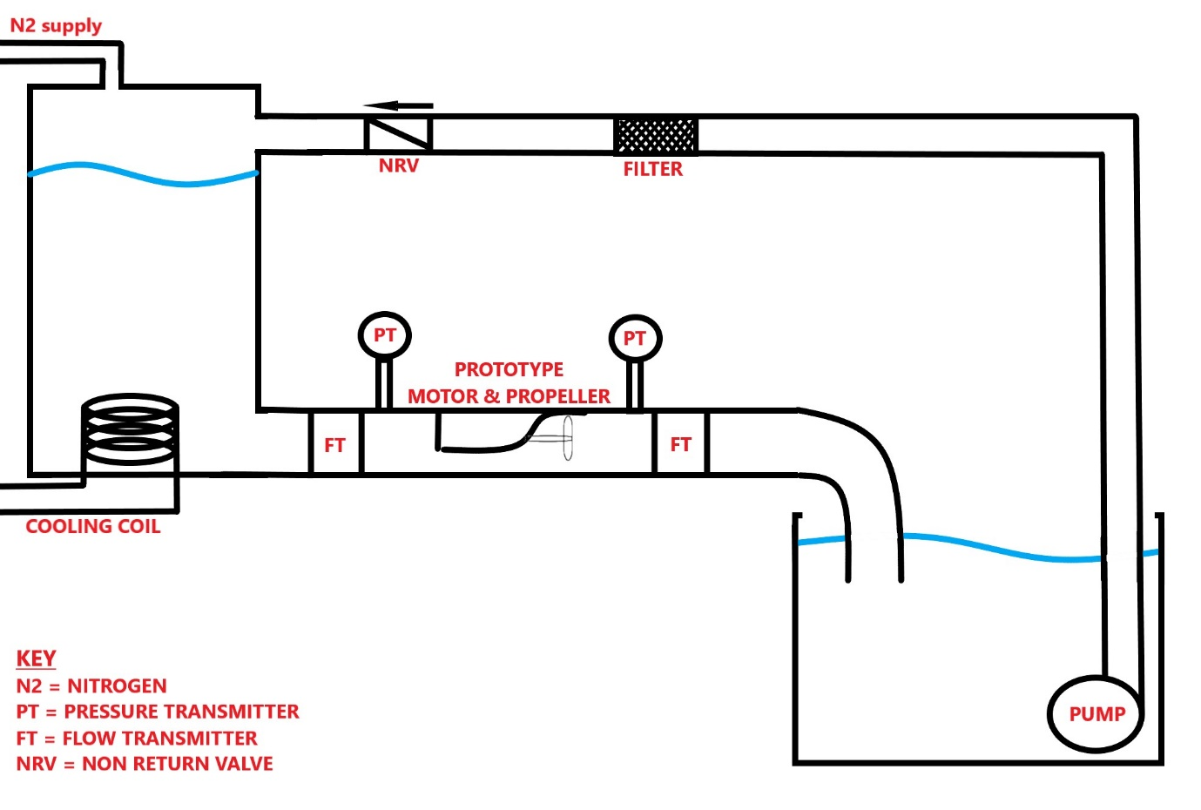

Conditions for test rig and prototype
- Manufacture a prototype propeller at 1/10th of the scale, a 6.7m propeller would not be cost effective for testing in a laboratory
- Mount the prop on the end of a VSD motor, which will be inside a 1/10th scale model of the rear of the ship’s hull, the motor will turn the propeller at the speed used in the calculations, 95 RPM
- Vibration monitoring probes mounted on VSD motor
- Mount inside of a clear Perspex pipe of large enough diameter that it won’t influence the fluid flows boundary layer, the propeller would be in open water in real use
- Use a header tank with a N2 supply to pressurise above the water level, to create a 7.7m/s flow at the first flow transmitter, this will simulate the ships speed
- After the propeller, the water is to be fed into an open reservoir where a recirculation pump will feed the water back into the supply tank with a non-return valve in the line
- The supply tank should ideally be fitted with a cooling coil to maintain the water temperature, otherwise the viscosity of the water could change with an increase in temperature caused by the friction from the rotating propeller and the recirculation pump
- The flow and pressure can be monitored via the transmitters fitted either side of the propeller, these instruments should be spec’d so that they cause as minor fluid flow changes as possible
- A dye can be injected upstream of the propeller to help the rig operator to see the turbulence and fluid flow, because this is likely to be highly turbulent, a suitable filter will be installed in the return line back to the supply tank which can filter out the coloured dye, but not the salt. This will allow the rig to run for a long period of time, without it the fluid would change to the colour of the dye in the supply tank in a short period of time
- Where possible, all parts should be made of clear Perspex or similar, whilst still being safe for the pressures of the rig. Due to the non-conductive nature of the Perspex it is also necessary to ensure the system is adequately earthed to prevent the build-up of static electricity
- The model of the ships hull, should be fabricated based of the geometry of the actual ship the propeller will be used on
- The fluid used should be seawater with a density of 1026 Kg/m^3 (Engineering toolbox, 2005)

Measurable data using proposed test rig
By using this rig design, the following data will be measurable:
- Fluid flow either side of the propeller via the 2 flow transmitters
- The pressure differential across the propeller via the 2 pressure transmitters
- Visual representation of the characteristics of the fluid flow via the coloured dye injection upstream of the propeller
- Whether severe cavitation is occurring at the propeller using the vibration monitoring probes

Using this data, a comparison can then be made between this test and the data provided by the computer simulation. There is likely going to be minor differences between the 2 and also in the real world application of the propeller, but this is to be expected. Any major differences should be investigated to find the route cause, this could be an error in the test rig design/operation or an error in the simulation such as the mesh used around the boundary layer. After the comparison, design changes can also be made to the propeller design if required.

Future adaptations possible for rig
There is also the opportunity to adapt this rig to measure other variables, not specific to fluid flow, if required such as:
- Strain gauges could be fitted to the propeller blades to measure the load and any deformation/warping of the blades
- The differential pressures and flow across the propeller could be used to measure the thrust created by the propeller
- The current of the motor could be used to measure the resultant load required to power the propeller
- Temperature transmitters could be used to monitor heat transfer to the fluid caused by the propeller, this could then be used to calculate the efficiency

Conclusion
To finish this report, I have successfully calculated the Reynolds number of seawater around the propeller during its operation, confirming it is turbulent in nature. I have examined the boundary layer around the propeller and how it will affect its performance.
I have also considered how using CFRP (Carbon fibre reinforced plastic) will influence the performance of the propeller, and successfully reviewed different techniques for simulations and prototype testing.

Bibliography
Boating mag, 2019. Propeller pitch explained. [Online]
Available at: https://www.boatingmag.com/how-to/understanding-propeller-pitch/#:~:text=The%20pitch%20of%20a%20propeller,would%20a%20car's%20axle%20ratio.
[Accessed 1 June 2022].
Covarrubias, E., 2022. 5 Best Practices for Marine Propeller Design. [Online]
Available at: https://www.mpofcinci.com/blog/best-practices-for-marine-propeller-design/#:~:text=The%20Basics%20of%20Propeller%20Design,and%20pushes%20the%20boat%20forward.
[Accessed 30 May 2022].
Engineering toolbox, 2005. Seawater - Properties. [Online]
Available at: https://www.engineeringtoolbox.com/sea-water-properties-d_840.html
[Accessed 20 May 2022].
Hufford, G. S., 1992. Viscous flow around marine propellers using boundary layer strip theory. [Online]
Available at: https://dspace.mit.edu/bitstream/handle/1721.1/42543/27480320-MIT.pdf?sequence=2
[Accessed 25 May 2022].
Ifes-Koeln, 2022. Computational fluid dynamics (CFD). [Online]
Available at: https://www.ifes-koeln.de/en/services-20-years-project-experience/simulation-analysis/computational-fluid-dynamics-cfd.html
[Accessed 2 June 2022].
Killcaremarina, 2022. Basics about propellers. [Online]
Available at: http://www.killcaremarina.com.au/commonly-asked/61-about-propellers
[Accessed 31 May 2022].
MAN Energy solutions, 2019. Propulsion of 46,000-50,000 dwt MR Tankers. [Online]
Available at: https://www.man-es.com/docs/default-source/document-sync/propulsion-of-46-000-50-000-dwt-mr-tankers-eng.pdf?sfvrsn=c58f03f3_0
[Accessed 28 May 2022].
Marine Insight, 2021. Propeller, Types of Propellers and Construction of Propellers. [Online]
Available at: Propeller, Types of Propellers and Construction of Propellers
[Accessed 15 May 2022].
Nancy Hall, N., 2021. Navier-stokes equations. [Online]
Available at: https://www.grc.nasa.gov/www/k-12/airplane/nseqs.html
[Accessed 2 June 2022].
Nuclear power, 2022. boundary layer. [Online]
Available at: https://www.nuclear-power.com/nuclear-engineering/fluid-dynamics/boundary-layer/
[Accessed 2 June 2022].
Nuclear power, 2022. Critical Reynolds Number. [Online]
Available at: https://nuclear-power.com/wp-content/uploads/2016/05/Reynolds-Number.png
[Accessed 15 May 2022].
Pegorari, S., 2018. carbon fibre composite propellers. [Online]
Available at: https://www.metstrade.com/news/construction-and-material/carbon-fibre-composite-propellers/
[Accessed 15 May 2022].
Pretechnologies, 2022. Advantages of computational fluid dynamics. [Online]
Available at: http://www.pretechnologies.com/services/computational-fluid-dynamics/advantage
[Accessed 2 June 2022].
simscale, 2021. What is CFD | Computational Fluid Dynamics?. [Online]
Available at: https://www.simscale.com/docs/simwiki/cfd-computational-fluid-dynamics/what-is-cfd-computational-fluid-dynamics/
[Accessed 28 May 2022].
Techet, P. A., 2005. 2.016 Hydrodynamics. [Online]
Available at: http://web.mit.edu/2.016/www/handouts/2005Reading10.pdf
[Accessed 31 May 2022].
The editors of encyclopedia Britannia, 2019. Reynolds Number. [Online]
Available at: https://www.britannica.com/science/Reynolds-number
[Accessed 15 May 2022].
Workshop insider, 2021. Ship Propeller – An Overview Of Types, Material, And Inspection Criteria. [Online]
Available at: Ship Propeller – An Overview Of Types, Material, And Inspection Criteria
[Accessed 15 May 2022].
Yamatogi, 2015. Benefits of carbon composite marine impeller. [Online]
Available at: https://www.classnk.or.jp/classnk-rd/assets
[Accessed 15 May 2022].

