How Do Internet Memes Shape and Disseminate Brand Image Among Generation Z Audiences?
Lei Mao

Abstract: This study investigates how internet memes shape and disseminate brand image among Generation Z audiences. Memes, as a significant cultural phenomenon in the digital era, have emerged as a powerful marketing communication tool for brands. This research specifically focuses on Generation Z, a demographic deeply engaged in meme culture, actively utilizing memes for social interaction and identity expression. The core exploration centres on: how memes function as symbolic content within brand communication; how the emotional expressions embedded in memes resonate with Generation Z; and how participatory meme culture reshapes brand perception and user experience. Examining these key elements is essential to understanding contemporary shifts in brand communication and optimizing marketing strategies. The study proposes adopting a hybrid ethnographic approach, combining online and offline participant observation, semi-structured interviews, surveys, and multimodal data collection. Through qualitative analysis of meme-driven brand communication on social platforms such as TikTok and Twitch, the study aims to uncover how symbolic expressions, emotional resonance, and participatory remixing within memes drive Generation Z to reconstruct brand meanings and establish cultural identity. While memes have gained widespread application in brand marketing, academic research exploring their specific impact on brand image construction remains limited, particularly from a user-generated content (UGC) perspective. This study, therefore, seeks to fill this theoretical gap, offering practical guidance to businesses aiming to innovate their communication approaches in ways that effectively resonate with younger consumers.
Keywords: Internet memes, Meme marketing, Gen Z, Advertisement, Brand Image

Introduction
Elon Musk, CEO of Tesla, once remarked in a Clubhouse interview, “A picture says a thousand words, and maybe a meme says 10,000 words.” This comment vividly illustrates the immense power memes hold in the digital age. As Rathi and Jain (2024) noted, memes possess the potential to influence the world on multiple levels and have already permeated nearly every aspect of our daily lives. With the growing accessibility of meme-making applications, memes and stickers appear to have taken over livestreaming platforms, social media platforms, chat windows, and online conversations. This seemingly simple yet highly contagious form of expression is becoming an unignorable cultural language of the digital era.

Naturally, the cultural potential and communicative power of memes have attracted widespread attention from both academia and the advertising industry. Memes have become one of the most successful marketing communication tools and are even regarded as the simplest way to interact with target audiences (Malodia et al., 2022). Many brands have not only integrated memes into their marketing strategies and viewed them as shortcuts for cross-cultural dissemination but have also begun appointing Chief Meme Officers (CMeOs), who work with dedicated content creators to produce brand texts and communication strategies aimed at meme-savvy younger audiences (Lemée, 2021), thereby accelerating the establishment of brand image among younger consumer groups. Similarly, a case study by Leistadius and Vall (2017) on KFC revealed that 5% of user-generated brand-related posts appeared in meme form, further confirming the significant potential of memes in brand promotion. These studies collectively suggest that memes have surpassed their function as a mere communication medium among young people, becoming a vital force in participatory brand construction.

However, despite the increasing popularity of memes as a branding strategy, their underlying mechanisms of virality and influence remain under-researched in academic discourse. In simple terms, current literature has not yet clearly identified what types of meme content are most likely to contribute to brand image building and achieve widespread user engagement. At the same time, with the continuous evolution of digital business models, many “internet-native” brands (such as Twitch and TikTok live broadcasts) have emerged based on social media and livestreaming ecosystems, constantly reshaping the logic and media structure of brand communication.

The carriers of brand image have thus become increasingly diversified, no longer limited to product logos or advertising language, but including brand-associated influencers, short video accounts, live streamers, and similar figures. This diversification of carriers has blurred the boundaries of brand image, further intensifying the complexity of meme dissemination in the digital era and making it both more difficult and more necessary to explore the mechanisms by which meme marketing influences brand perception.

Based on the above background and research gap, the core research question of this study is:
How do internet memes shape and disseminate brand image among Generation Z audiences?

This exploratory study focuses on members of Generation Z who naturally engage with meme culture in emerging internet contexts. Through participant observation, it seeks to examine the symbolic functions, participatory roles, and identity-related dynamics of memes within brand communication. The study aims to uncover which content features and emotional stances in internet memes are more likely to resonate with users, ultimately influencing Generation Z’s perceptions and attitudes towards brand image and thereby filling a gap in the current literature.

To address this research question, the study will adopt the following theoretical frameworks:
First, based on Shifman’s (2013, 2014) three-dimensional model of memes—comprising content, form, and stance—alongside her typology of meme dissemination (remix, mimicry, and memetic phrases), this study will analyse internet memes from the perspective of their symbolic content and emotional expression. On the branding level, it draws on Keller’s (1993) Customer-Based Brand Equity (CBBE) model, which emphasises that brand recognition is gradually built through consumers’ perceptions, associations, and experiences. Although the model does not directly address the role of internet memes, it provides a useful lens for analysing how memes may influence Generation Z’s brand cognition process.

Meanwhile, to understand the psychological motivations behind Generation Z’s active engagement with meme dissemination, this study incorporates Social Identity Theory and the concept of virtual community belongingness (Kozinets, 2010). Memes are viewed as a means of expressing group identity, cultural belonging, and self-representation. In this process, memes serve as emotional bridges connecting brands, users, and communities, as audiences engage in brand-related remixing and co-creation through meme participation.

Literature review
Theoretical Origins of Memes
Defining Memes
Defining Memes The term "meme" was first conceptualised by British evolutionary biologist Richard Dawkins in his seminal work The Selfish Gene (1976). Drawing explicit parallels with biological evolution, Dawkins defined memes as "units of cultural transmission" that replicate through imitation, spanning both tangible forms (e.g., melodies, clothing styles) and intangible ideologies (e.g., religious doctrines) (Dawkins, 1976).

Memes, much like genes, function as replicators that experience variation, competition, selection, and retention. This biological analogy posits that memes undergo Darwinian evolutionary processes: variation emerges through imperfect replication (e.g., regional adaptations of folk tales), selection occurs via social reinforcement mechanisms (e.g., algorithmic amplification on digital platforms), and retention depends on cultural embeddedness (e.g., enduring proverbs).

However, as academic scrutiny of this conceptual framework intensifies, scholars such as Sperber (1996) have challenged the equivalence between genes and memes. Sperber specifically argues that this analogy neglects human agency in consciously modifying cultural content during transmission—a process he terms "cultural reconstruction" rather than passive replication.

Meanwhile, a similarly marked divergence persists between the colloquial usage of "meme" among internet users and its academic conceptualisation. In cyberspace, the term "meme" primarily describes concepts presented through imagery, text, video or other cultural formats that experience rapid acceptance and dissemination (Shifman, 2013). This consequently leads us to posit that within popular discourse, memes typically denote ephemeral trends characterised by accelerated propagation.
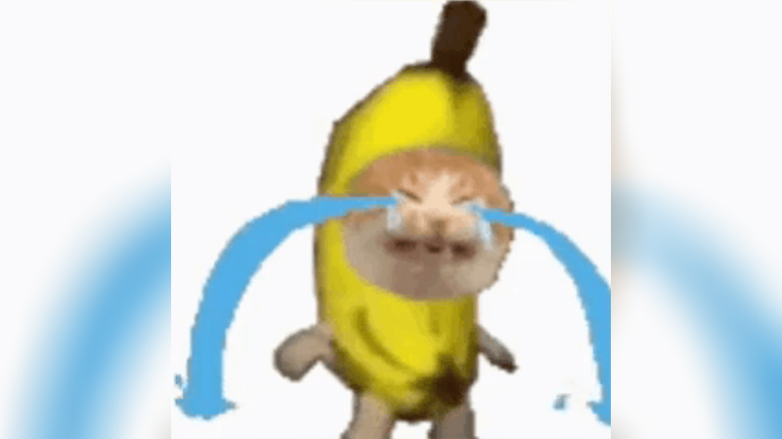
Source: https://knowyourmeme.com/memes/sad-banana-cat
(Accessed: 3 May 2025)
For instance, the widely circulated meme template "Banana Crying Cat" (KnowYourMeme (2021)) demonstrates this phenomenon. Originating from a Facebook post uploaded by user Sin Achilles on 3 March 2021, which featured a compilation of cats wearing banana costumes, this meme template accumulated over 7,700 comments and 26,000 shares within two years. Its viral propagation primarily manifested through cross-meme hybridization—frequently co-occurring with the established "Happy Happy Cat" meme in fan-generated content—and contextual repurposing via text overlays (e.g., superimposing existential crisis captions).

Conversely, scholarly discourse predominantly focuses on memes exhibiting cultural persistence and enduring sociopolitical influence. For example, Brubaker et al. (2018) discuss the dissemination of political issues at a macro level through memes. Furthermore, although academic research treats memes as abstract and contested units of cultural analysis, internet users typically associate memes with tangible audiovisual forms, such as humorous images or videos shared online.

This perspective particularly influences Generation Z (Gen Z), who are digital natives (Dimock, 2019). According to Vogels, Gelles-Watnick and Massarat (2022), most Gen Z own smartphones (95%) and/or desktop or laptop computers (90%). Additionally, 97% use the internet daily, with 35% using social networking services "almost constantly" (p. 2).

Defining Internet Memes
To further clarify the phenomenon of memes in digital contexts, Limor Shifman (2014) proposes a distinct definition tailored specifically for internet memes. Shifman characterises internet memes as: (a) groups of digital items sharing identifiable commonalities in content, form, or stance—for example, the LOLCats meme category consistently demonstrates a specific theme (cats), a recognisable format (photographic images with humorous captions), and a comedic stance; (b) items produced with explicit awareness of preceding memetic examples, such as creators of "cat-caption" images deliberately building upon established formats to continue cultural dialogues; and (c) digital items undergoing widespread distribution, imitation, or transformation via internet users, exemplifying a participatory mode of cultural expression.

Shifman situates internet memes within socially constructed public discourse, where different variants represent diverse voices and ideological positions. She emphasises that understanding memes requires analysing three replicable dimensions: content (ideas and ideologies), form (physical/aesthetic presentation including audiovisual elements), and stance (creators’ positioning relative to content, language, and audience). While Dawkins originally framed memes as units of cultural imitation, Shifman’s contemporary perspective highlights their shared attributes, mutual creative awareness, and participatory circulation—distinguishing them from mere viral content.

Theoretical Frameworks of Brand Image
Defining Brand Image
Given the defining characteristics of internet memes, their application in marketing communication strategies has garnered increasing attention beyond academia. As highlighted by Teng et al., (2022), effective marketing strategies necessitate both consumers' comprehensive comprehension of brand messages and the widespread dissemination of such information—dual objectives that align intrinsically with the participatory and replicative nature of memetic content. Keller and Swaminathan (2019) define Brand Image as "consumers' perceptions about a brand, as reflected by the brand associations held in consumer memory," emphasizing that these associations are formed through direct experiences, marketing activities, and social interactions. This perspective aligns with Aaker’s (1996) brand equity model, which positions brand image as a "mental representation" encompassing both functional attributes (e.g., product quality) and symbolic values (e.g., identity projection) (Aaker, 1996, p. 142 Building Strong Brands).

Just as the digital age has catalysed novel analytical perspectives in meme studies, it has introduced new dimensions to brand image research. The borderless nature of the internet environment allows consumers to interact more easily, hence information spreads faster and reaches wider audiences online compared to traditional methods. Coupled with the rapid development of social media and user-generated content (UGC), consumers have become co-creators of brand image. Based on this phenomenon, online word-of-mouth (eWOM) and brand community interactions have significantly reshaped consumer perceptions, which requires enterprises to actively monitor and engage to maintain brand image consistency (Hennig-Thurau et al., 2010, p.312).

As illustrated in the figure below, in 2017, the fashion brand GUCCI launched its first meme campaign on Instagram, creating a series of memes through collaborations with other meme creators to celebrate the launch of GUCCI's new watch collection. The campaign utilised the hashtag #TFWGucci (That Feeling When Gucci), achieving exceptional online dissemination effectiveness. This marketing case has been regarded as a classic successful example of corporate proactive engagement in meme marketing.
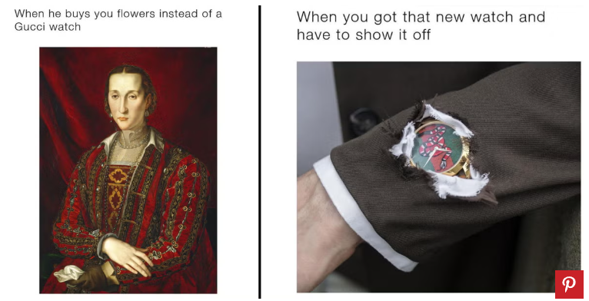
Source:https://www.harpersbazaar.com/fashion/designers/news/a21477/gucci-memes/
(Accessed: 3 May 2025)
Both academia and the marketing sector have long focused on online marketing-related domains. If campaign planners repurpose advertisements into internet memes, the viral popularity of such memes can achieve effective promotional outcomes and naturally drive customer engagement (Bury, 2016; Williams, 2000). However, this strategy is overly idealistic and positions consumers as passive recipients. Unlike traditional online marketing communication channels, internet memes are user-generated with active consumer participation, thereby overturning the brand-dominant position posited by traditional brand image theories. Given their intertextuality, remix culture, and humorous characteristics, the disseminated information is predominantly user-generated and consumer-initiated (Brubaker et al., 2018). Although the GUCCI meme campaign exemplified brand-orchestrated participation, the production of certain meme assets relied on @beigecardigan—a prominent meme creator on Instagram with 3.9 million followers—thereby ensuring organic cultural resonance of the meme content within target audiences.

Frameworks of Brand Image
Currently, the predominant theoretical frameworks on brand image are anchored in Kevin Lane Keller's Customer-Based Brand Equity (CBBE) Model proposed in 1993. This theory, evolving from the foundational premises of the Associative Network Memory Model proposed by Anderson and Bower (1974), posits that brand equity originates from consumers' cognitive architecture—specifically, the brand node and its associative network in memory, where functional attributes (e.g., product reliability) and symbolic meanings (e.g., lifestyle alignment) coalesce to form brand knowledge.

With the advent of digitalization, subsequent models have emerged to address evolving market dynamics: Brand Personality Theory (Aaker, 1997) introduces anthropomorphic dimensions (sincerity, excitement, competence, sophistication, ruggedness) to operationalize emotional differentiation. The Brand Resonance Model (Keller, 2001) structures brand building as a phased process through consumer interactions, while emphasising its emotional connectivity and the Brand Value Chain Model (Keller, 2001) traces the financial transduction of brand equity, mapping how marketing investments shape customer mindset (awareness, associations) to drive market performance metrics.

Although these theories collectively provide multidimensional framework for brand image construction, current literature remains limited in discussing user-generated and consumer-driven communication channels, such as memes and their impact on brand image. As synthesised by Laestadius and Wahl (2017), as well as Teng et al., (2022), existing studies have yet to clarify the role of media-related factors—such as dissemination strategies—in the viral spread of memes. Their analyses indicate a reliance on qualitative approaches, while calling for further investigation into the concrete outcomes of viral internet memes.

Gen Z's Psychological Motivations in meme marketing
Although the aforementioned classical theories related to brand image do not directly address internet memes, they unanimously emphasize that the psychological dimension of participants in meme marketing plays a significant role in the successful construction of brand image. This is especially relevant for Generation Z, those born between 1997 and 2012, as over half of internet users under the age of 35 frequently create and engage with memes (Ypulse, 2019). Scholars generally agree that this behaviour is largely influenced by the rapid technological advancements of the early 21st century (Autry & Berge, 2011; Akçayır et al., 2016). Of course, it would be reductive to treat the entire Generation Z as a monolithic group with identical characteristics, but in the context of meme marketing research, it can be considered a key demographic. According to a 2021 study by Katz et al., a considerable portion of individuals born in the late 1990s and early 2000s tend to integrate their online and offline lives. Thus, the psychological motivations of this group can reflect their perceptions of social reality, ultimately shaping consumer behaviour and becoming a decisive factor in marketing success.

From the perspective of Social Identity Theory, Gen Z’s active engagement with meme marketing can be understood as a form of social identity signaling and in-group affiliation, aimed at achieving social positioning within online communities. Sharing memes, in this context, functions as a means of reinforcing in-group identity while differentiating from out-group members.

Kozinets’ (2010) theory of virtual community belongingness further emphasizes the agency and participatory nature of individuals within online communities. For Generation Z, social media platforms offer participatory spaces that allow users to actively create, remix, and disseminate meme content, thereby enhancing their sense of belonging and identity within digital communities. Through the sharing and engagement with memes, Gen Z not only expresses individual characteristics but also reinforces group cohesion and cultural affiliation. Moreover, since an individual’s social identity and self-concept are known to strengthen the connection between consumers and brands (Fournier & Alvarez, 2019), the alignment between the characteristics of meme marketing and the psychological motivations of Gen Z suggests that brands are likely to allocate increasing portions of their marketing budgets toward meme-based campaigns targeting younger audiences.

Methodology
Research Approach: Qualitative Study
Based on the current stage of progress, this study plans to adopt a qualitative research approach, aiming to explore how internet memes influence the construction and dissemination of brand image among Generation Z audiences. Given that this research needs to document brand marketers’ perspectives on the role of memes in shaping brand image, and to understand the interactions between social media users—especially Gen Z—and internet memes, while attempting to identify patterns therein, a qualitative approach is deemed the most suitable perspective for analysing this phenomenon.

Moreover, an overview of existing literature on internet memes and related advertising studies reveals a prevailing tendency—most of the research adopts qualitative case study methods (Laestadius and Wahl, 2017; Teng et al., 2022). A small number of scholars have adopted mixed methods. For example, Suresh Malodia et al. (2022) first conducted in-depth interviews with various stakeholders involved in meme dissemination to gain insights; on this basis, they developed a theoretical model of meme virality, which was later validated through four quantitative studies. For the purposes of this study, whether qualitative or mixed methods are adopted, qualitative research remains indispensable. Therefore, at this stage, this study is planned to proceed with a qualitative approach. Rather than pursuing statistically generalisable results, it aims to understand how memes shape the relationship between Gen Z and brands through symbolic mechanisms and participatory behaviours.

Methodologies and Methods
Given that Generation Z are representatives of a demographic highly engaged with memes in the digital marketplace (Vardeman, 2023) and demonstrate high levels of digital immersion and participatory behaviour, this study adopts hybrid ethnography as its methodological foundation. The definition of “hybrid ethnography” varies slightly in academia. For instance, Przybylski (2020) proposes that hybrid ethnography should be conducted simultaneously across digital (online) and physical (offline) spaces. In contrast, Seim (2021), while also employing the term “hybrid ethnography,” emphasises a methodological integration of participant observation and observant participation, whereby the researcher both observes and deeply participates as an active role within the field, without necessarily involving online interaction or digital media platforms.

This study plans to adopt the former type of hybrid ethnography, integrating both online and offline spaces. It focuses not only on documenting Gen Z behaviour in real life but also on examining the content they generate as internet participants.

Przybylski, in her book Hybrid Ethnography: Online, Offline, and In Between (2020), details how digital and real-world cultural practices intersect in her study of Native American hip-hop communities, constructing a hybrid space of performance and identity. Similarly, this study regards memes as expressive cultural symbols that span across social media platforms, integrating online and offline environments, and influencing how Gen Z individuals express themselves, remix content, and connect with brand meaning. Therefore, in terms of methodological design, this study draws on her research processes accordingly.

This study will adopt the following methods:
- Online participant observation: Actively engaging with platforms where memes thrive, such as TikTok and Twitch; and regularly reviewing relevant web-based platforms, such as RED and Instagram.
- Offline field engagement: Participating in youth gatherings such as comic conventions, board game competitions, and e-sports venues, and observing performance activities primarily attended by young audiences.
- Interviews: Conducting semi-structured interviews with brand planning personnel, including meme creators and those involved in community operations.
- Questionnaire surveys: Collecting feedback from Gen Z participants, while also establishing broader interpersonal networks ahead of interviews to facilitate contact with more experienced participants.
- Media collection and processing: Recording or gathering relevant videos, audio recordings, images, and other data.

Data types include:
- Screenshots and recordings of brand-related memes, as well as records of user interactions on social media, such as comments and remixed versions.
- Observation records and field notes from offline engagement with Gen Z groups.
- Motivations, strategic logic, and platform selection reasons provided by brand personnel.
- Gen Z’s levels of awareness, participation frequency, and engagement preferences regarding branded memes.
- Modes of meme dissemination and source materials found in both online and offline videos.

Given that this study is primarily qualitative in nature and seeks to explore in depth how Gen Z participants perceive the connection between internet memes and brand image, non-probability sampling will be adopted. More specifically, the study will use a combination of purposive sampling and snowball sampling strategies.

Initially, the study will deliberately select samples that are either highly representative or highly active, particularly those with experience in meme culture and brand communication. This includes Gen Z meme creators, young marketing professionals involved in community operations, and key figures active in relevant online communities or offline events (such as comic convention organisers and streamer groups).

Subsequently, through snowball sampling, the researcher will ask interviewees to recommend individuals from within their networks, such as meme production groups or other active users, to gain deeper access to the internal structure of meme communities and expand the sample network.

In terms of data analysis, based on the types of data to be collected, this study plans to adopt Multimodal Analysis. As Przybylski notes, “Researchers must learn to listen with the ear, eye, and body—to interpret not only the words of participants, but also the rhythms and cultural semiotics embedded in performance.” (Przybylski, 2020, p. 85). Since internet memes are not always presented in static image form but may also appear as videos (with music) or animated images (GIFs), the combined analysis of visuals, sound, and text is essential for this research. Other analytical approaches, such as Thematic Analysis and Reflexive Analysis, may also be adopted in subsequent stages of the study.

Alternative Methods and Methodologies
Although this study plans to adopt hybrid ethnography as its core methodological approach, several alternative research paths could also be considered in exploring how internet memes influence Gen Z’s perception and construction of brand image. For example, netnography, proposed by Kozinets (2010), focuses on online community interaction records and could help understand how memes circulate within online platforms. Similarly, case study methodology could be used as an alternative, allowing for in-depth analysis of specific meme marketing campaigns (such as Gucci’s #TFWGucci campaign, mentioned in earlier sections of this study), and exploring their impact on brand image.
However, by comparison, hybrid ethnography has the unique advantage of simultaneously capturing both the online media engagement behaviour and the offline purchase behaviour of Gen Z—a group with highly distinctive characteristics. It enables an in-depth reconstruction of the meanings and cultural significance of branded memes across different fields. Therefore, at the current stage, hybrid ethnography is considered the most appropriate method for this study.

Ethical Considerations
This study involves both publicly and semi-publicly accessible online spaces, as well as offline locations, and therefore requires consideration of a range of ethical issues in its research design. Firstly, in the online domain, this study will only analyse publicly accessible content (e.g., memes posted by open accounts) without the need to contact content creators directly. Screenshots from social media will be blurred or anonymised if permission has not been obtained. For private groups or closed communities, explicit consent from content creators must be secured before their content is used.

Secondly, in the offline context, all interview participants and observed individuals will be required to sign or verbally confirm informed consent forms, specifying how data will be used, including permissions for audio-visual data collection, anonymisation protocols, and the right to withdraw at any time. All participants will be assigned pseudonyms for confidentiality.

Finally, this study will adhere to the ethical review procedures of the University of Wales Trinity Saint David, and follow ethical guidelines established by relevant professional associations in the United Kingdom.

Discussion and Analysis
Alignment between Research Methodology and Research Question
This study intends to adopt the methodology of “hybrid ethnography”, which is highly consistent with the proposed research question — “How do internet memes influence and disseminate brand image among Generation Z audiences?” This methodology emphasises that the researcher should carry out long-term observation and deep participation in both digital and offline spaces (Przybylski, 2020), which provides methods and procedures for examining Gen Z’s participation and identity formation in meme culture. Unlike traditional ethnography, hybrid ethnography is capable of capturing the representation of memes in real-life contexts, as well as integrating online observation with interactions in everyday cultural practices.

For example, when Gen Z users acquire, share, and adapt brand-related memes on live-streaming platforms (such as Twitch) or social media (such as TikTok), they are essentially redefining the cultural meaning of the brand symbol. Qualitative research methods enable this study to deeply document these acts of contextual recreation, to explore how memes influence cognition, emotion, and social identity. This perspective is consistent with the nature of the research question and provides methodological support for theoretical frameworks that may be developed in later stages.

Potential Research Findings and Theoretical Contributions
Based on existing observations and preliminary analysis, internet memes may possess the following deeper functions in brand communication: First, different types of memes (such as self-deprecating, satirical, or cute) may have differentiated effects on the emotional positioning of brand image and the construction of social identity; second, the linguistic style, performative gestures, and subcultural tendencies demonstrated by Gen Z in meme dissemination may serve as key reference dimensions for brands when constructing “cultural resonance”.

At the same time, this study is expected to provide empirical foundations and framework extensions for current research related to memes and advertising. Firstly, by building upon Shifman’s (2013) theoretical basis of the three-dimensional meme model—content, form, and stance—this study incorporates analysis of advertising effects, thus enhancing its application within the perspective of commercial communication and brand cognition. In addition, it extends the CBBE model (Keller, 1993) by constructing a framework to examine how user-generated content (UGC)-based meme dissemination influences the building of brand equity, which may provide a certain theoretical contribution.

Theoretical Frameworks: Interpretive Pathways and Application Value
Based on the literature review compiled at the current stage, this study plans to integrate several theoretical frameworks mentioned in the previous chapters for data analysis and research interpretation. Among them, Shifman’s three-dimensional meme model will assist this research in comprehensively and systematically interpreting the phenomenon of memes. Under this model, Shifman proposes three dimensions for meme analysis: content (textual/visual elements), form (structure/propagation mechanisms), and stance (attitude/emotion).

This method can assist the present study in the initial categorisation of memes, thereby providing a foundational condition for subsequent analysis related to advertising effects. As shown in the examples below, certain memes structurally adopt the format of “contrasting images + inverted text”, which more easily stimulates user participation, discussion, and secondary creation; while memes with a positive, humorous, or self-deprecating stance are more likely to reduce psychological distance with the audience, especially improving the “brand likability” among younger user groups. As noted by Teng et al. (2021), the primary characteristic of internet memes is humour, and this feature can enhance brand image.
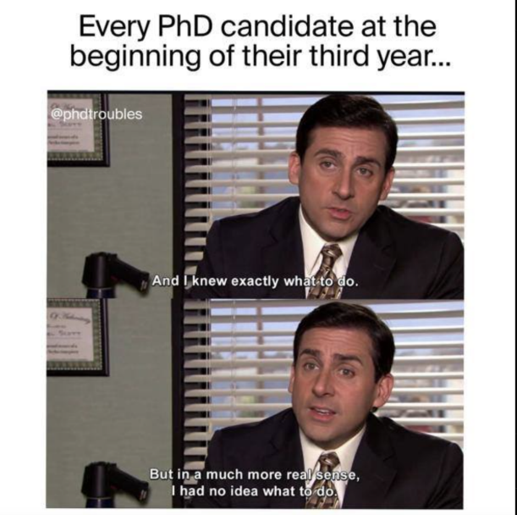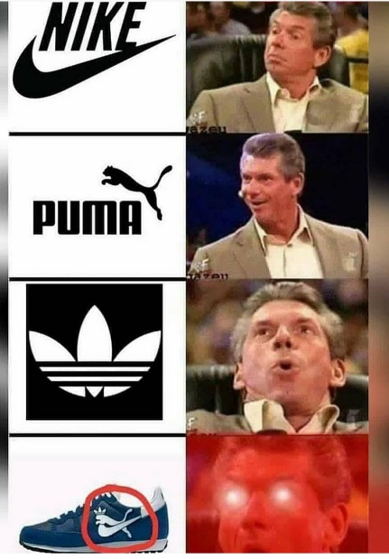
Contrasting Image + Inverted Text Meme Humorous Stance Brand Meme
Source: https://www.beyondphdcoaching.com/dissertation/dissertation-memes/
(Accessed: 3 May 2025)
Source: https://www.memedroid.com/memes/detail/2654474/Thats-the-brand
(Accessed: 3 May 2025)
In terms of brand theory, the CBBE model emphasises that brand equity is built upon the cognitive structure of consumers, including brand associations, perceived quality, and resonance (Keller, 2001). Brand image cognition is the first stage in consumer adoption of innovative products and services (Gokerik et al., p. 1224), thus memes, as a particular form of user-generated content, may significantly accelerate this cognitive process in the digital era. Especially when memes frequently circulate as “cultural symbols” within Gen Z’s online communities, they may influence systematic recognition of brand symbols in real life, which also deeply aligns with the structure of users’ identity recognition.

Meanwhile, just as social media is inherently a globalised product, internet memes also provide the possibility of transcending national boundaries and achieving cross-cultural communication. This also offers new options for multinational corporations in communicating with global markets.

In addition, Social Identity Theory and the theory of Virtual Community Belonging (Kozinets, 2010) offer perspective support for analysing the psychological motivations behind user meme behaviours in this study. Gen Z constructs a sense of “we-ness” through internet memes, thereby reinforcing group identity, boundary consciousness, and cultural belonging. This cultural practice not only reflects Gen Z’s distinct self-expression compared to other groups but also reveals why brands need to integrate into community contexts via memes to adapt to brand meaning construction in the digital age.

Extended Questions and Future Research Directions
While this study intends to explore the mechanisms through which memes influence the construction of brand image, several significant issues still warrant further exploration as the research progresses. From the current stage, these can be summarised as follows:

First, internet memes are characterised by a short lifecycle and extremely rapid content turnover. In such a fast-changing meme trend environment, how can a brand maintain sustainable communicative power and cultural relevance? If a brand fails to respond to emerging trends in time, it may lose visibility within community discourse; yet overly pursuing trends may also lead to accusations of opportunism, thus undermining the brand’s cultural stance.
Second, with the rapid development of generative artificial intelligence (Generative AI), AI-generated memes have gradually entered the field of advertising. This trend may change the audience’s basic perception of memes. When memes are no longer user-generated but are instead produced in mass by algorithms, the core values of memes—participation and authenticity—may no longer resonate with Generation Z. In fact, during the early development of social media, the advertising industry held high expectations, but as platforms became more commercialised and content-saturated, attention to advertisements declined sharply. Most online consumers today tend to skip or scroll past advertisements (McDonald, 2018, p. 75). This past lesson offers an important warning for brand strategies in the current AI-meme era.

Lastly, although many memes are image-based with minimal textual content and are suited for cross-cultural communication, the condensed semantics and visual dominance of memes mean that audiences from different cultural backgrounds may still interpret the same meme very differently. These differences in symbolic interpretation may lead to misunderstandings, emotional misalignment, or even brand crises in cross-cultural contexts.

Based on these problems, brands using memes for brand image construction must not only consider the mechanisms of meme dissemination but also consider ethical boundaries and cultural differences across various audiences. These are topics worth pursuing through future interdisciplinary research across fields such as AI ethics, intercultural pragmatics, and digital semiotics.

Critical Reflection on Research Design
This study plans to adopt hybrid ethnography as the core methodology, but several foreseeable problems may arise during implementation:
First, the researcher’s frequent role-shifting in participant observation may introduce bias. It stresses that the researcher is neither a complete outsider nor an unconditional insider but rather exists in a boundary zone as a “hybrid presence”, enabling a more flexible perspective. However, as Seim (2021) warns, over-immersion in specific subcultures may lead to emotional or cultural inclination, thereby affecting critical judgement. Especially when the researcher is long involved in specific meme subcultures, cultural resonance may blur their analytical boundary.

Second, some meme content involves ambiguous ethical boundaries during creation and dissemination, complicating data usage. For instance, many brand memes that remix the images of internet influencers, streamers, or public figures may involve sensitive legal issues such as image rights and reputation. If researchers use such meme content without obtaining explicit consent, ethical risks may arise.

In addition, memes often undergo extensive secondary creation during their dissemination path, resulting in potential deviation between original intent and actual audience interpretation. Moreover, during cross-contextual transmission—especially when it involves translation, cultural references, or local adaptation—the original humour structure or emotional stance may be misunderstood, affecting the accurate perception of the brand message.

To mitigate these risks, this study intends to introduce reflexive practice as proposed by Przybylski (2020), including documenting role-shift notes, tracking self-participation impact, and negotiating calibration through participant feedback. Additionally, for meme materials involving controversial content, the researcher will critically assess their appropriateness and submit them for ethical review or avoid usage when necessary.

Conclusion
This study demonstrates the key role of internet memes in shaping and disseminating brand image among Generation Z audiences, highlighting their significance not only as vehicles of cultural expression but also as critical tools for social identification and digital storytelling. By adopting a hybrid ethnographic methodology that integrates both online and offline fieldwork, the study seeks to provide an in-depth analysis of how memes facilitate participatory interactions between users and brands within everyday digital practices. The theoretical frameworks employed—including Shifman’s meme model, Keller’s Customer-Based Brand Equity (CBBE) model, and Social Identity Theory—effectively explain how meme content, structure, and stance influence emotional resonance and brand perceptions among users.

The potential outcomes of this research will deepen academic understanding of user-generated content (UGC) within brand communication and offer valuable insights for brand marketers seeking to leverage meme culture effectively for brand building and promotion. Additionally, future studies might further explore the impact of AI-generated memes on brand authenticity and examine the transmission mechanisms of memes across diverse cultural contexts. For brand practitioners, this research offers actionable guidance on engaging audiences through culturally embedded digital participation and collaborative brand value creation. Overall, the study expands our understanding of memes as symbolic tools within contemporary communication, emphasizing their strategic importance within brand communication and the digital media ecosystem.

References
Aaker, D.A. (1996) Building Strong Brands. New York: Free Press.
Aaker, J.L. (1997) ‘Dimensions of brand personality’, Journal of Marketing Research, 34(3), pp. 347–356.
Anderson, J.R. and Bower, G.H. (1974) Human Associative Memory. Washington, DC: Winston & Sons.
Autry, A.J. and Berge, Z.L. (2011) ‘Digital natives and digital immigrants: Getting to know each other’, Industrial and Commercial Training, 43(7), pp. 460–466.
Akçayır, G., Dündar, H. and Akçayır, M. (2016) ‘What makes you a digital native? Is it enough to be born after 1980?’, Computers in Human Behavior, 60, pp. 435–440.
Brubaker, J.R., Ananny, M. and Crawford, K. (2018) ‘Departing glances: A sociotechnical account of “leaving” Grindr’, New Media & Society, 20(6), pp. 1886–1903.
Bury, B. (2016) ‘Creative use of Internet memes in advertising’, World Scientific News, 57, pp. 33–41.
Dawkins, R. (1976) The Selfish Gene. Oxford: Oxford University Press.
Dimock, M. (2019) ‘Defining generations: Where Millennials end and Generation Z begins’, Pew Research Center. Available at: https://www.pewresearch.org/short-reads/2019/01/17/where-millennials-end-and-generation-z-begins/
Fournier, S. and Alvarez, C. (2019) ‘Brands as relationship partners: Warmth, competence, and in-between’, Journal of Consumer Psychology, 29(3), pp. 285–298.
Gokerik, M., Gurbuz, A., Erkan, I., Mogaji, E. and Sap, S. (2018) ‘Surprise me with your ads! The impacts of guerrilla marketing in social media on brand image’, Asia Pacific Journal of Marketing and Logistics, 30(5), pp. 1222–1238. https://doi.org/10.1108/APJML-10-2017-0257
Hennig-Thurau, T., Malthouse, E.C., Friege, C., Gensler, S., Lobschat, L., Rangaswamy, A. and Skiera, B. (2010) ‘The impact of new media on customer relationships’, Journal of Service Research, 13(3), pp. 311–330.
Katz, V.S., Jordan, A.B. and Ognyanova, K. (2021) ‘Digital inequality, digital inclusion, and COVID-19: Research findings from the field’, International Journal of Communication, 15, pp. 3758–3772.
Keller, K.L. (1993) ‘Conceptualizing, measuring, and managing customer-based brand equity’, Journal of Marketing, 57(1), pp. 1–22.
Keller, K.L. (2001) ‘Building customer-based brand equity: A blueprint for creating strong brands’, Marketing Management, 10(2), pp. 15–19.
Keller, K.L. and Swaminathan, V. (2019) Strategic Brand Management: Building, Measuring, and Managing Brand Equity. 5th edn. Harlow: Pearson.
KnowYourMeme (2021) ‘Banana Crying Cat’. Available at: https://knowyourmeme.com/memes/sad-banana-cat (Accessed: [insert date]).
Kozinets, R.V. (2010) Netnography: Doing Ethnographic Research Online. London: SAGE Publications.
Laestadius, L.I. and Wahl, M.M. (2017) ‘Mobilizing social media users to become advertisers: Corporate hashtag campaigns as a public health concern’, Digital Health, 3. https://doi.org/10.1177/2055207617710802
Lemée, C. (2021) ‘Who is the Chief Meme Officer?’, Contagious. Available at: https://www.contagious.com/news-and-views/who-is-the-chief-meme-officer
Malodia, S., Gupta, S., Alalwan, A.A. and Singh, J. (2022) ‘Meme marketing: How can marketers drive better engagement using viral memes?’, Psychology & Marketing, 39(9), pp. 1751–1766. https://doi.org/10.1002/mar.21698
McDonald, S.C. (2018) ‘What do we really know about attitudes toward privacy and advertisement avoidance?’, Journal of Advertising Research, 58(1), pp. 75–76. https://doi.org/10.2501/JAR-2018-010
Przybylski, L. (2020) Hybrid Ethnography: Online, Offline, and In Between. London: SAGE Publications.
Rathi, S. and Jain, A. (2024) ‘The persuasive power of memes: A semiotic and cultural analysis’, Media & Communication Studies, 14(2), pp. 87–102.
Seim, J. (2021) ‘Participant observation, observant participation, and hybrid ethnography’, Sociological Methods & Research, 50(2), pp. 837–861.
Shifman, L. (2013) Memes in Digital Culture. Cambridge, MA: MIT Press.
Shifman, L. (2014) ‘The cultural logic of photo-based meme genres’, Journal of Visual Culture, 13(3), pp. 340–358. https://doi.org/10.1177/1470412914546577
Sperber, D. (1996) Explaining Culture: A Naturalistic Approach. Oxford: Blackwell.
Teng, H., Lo, C.-F. and Lee, H.-H. (2022) ‘How do internet memes affect brand image?’, Online Information Review, 46(2), pp. 304–318. https://doi.org/10.1108/OIR-05-2020-0192
Teng, H., Lo, C.-F. and Lee, H.-H. (2021) ‘How do internet memes affect brand image? An investigation into the roles of humor and brand message congruency’, Online Information Review, ahead-of-print. https://doi.org/10.1108/OIR-05-2020-0192
Vardeman, A. (2023) ‘Advertising to Gen-Z college students: Engagement and authenticity in a digital era’, Journal of Current Issues & Research in Advertising, 44(2), pp. 123–135.
Vogels, E.A., Gelles-Watnick, R. and Massarat, D. (2022) ‘Teens, social media and technology 2022’, Pew Research Center. Available at: https://www.pewresearch.org/internet/2022/08/10/teens-social-media-and-technology-2022/
Williams, R. (2000) ‘The business of memes: Memetic possibilities for marketing and management’, Management Decision, 38(4), pp. 272–279. https://doi.org/10.1108/00251740010371748
Ypulse (2019) Gen Z and Memes: Why They Love Them and What Brands Can Learn. Available at: https://www.ypulse.com/article/2019/06/17/gen-z-and-memes/

