Hotel Handbook for Intercultural Competence

Student Name: Mahir Mollik
Student Id :2119456
Module Code: BMIH5003
Tutor: Rodrigo Aguilera

Executive Summary
The purpose of this research is to provide guidance to hotel personnel on how to best accommodate and manage the needs of foreign customers, with a particular emphasis on Chinese tourists staying in Indian accommodations. To get things off, the paper analyses how a lack of cultural awareness and understanding among hotel staff may negatively affect the overall quality of service provided to guests. After this, the paper elaborates on the unique cultural norms and expectations of Chinese visitors, and offers advice for how hotel workers in different departments should adjust their service delivery to meet these needs. In a final section, the study provides a "Dos and Don'ts" table that may be used as a briefing document for employees.

Contents
Executive Summary 2
Introduction 4
Cultural Norms and Requirements of Chinese Guests 5
Cross culture theories and models 6
Do’s and Don’ts of the staff 9
Do's: 9
Don'ts: 9
Recommendation 10
Conclusion 11
Reference 12

Introduction
More and more people from all around the globe are staying in hotels as the world gets more interconnected. This necessitates cultural awareness and sensitivity on the part of hotel staff as they engage with customers from a wide variety of cultural backgrounds. In other words, it's the capacity to interact and collaborate fruitfully with individuals from a wide variety of cultural backgrounds. Because of the importance of this to the hotel's reputation, all employees should be aware of it. Hotel employees may better cater to their visitors' needs by gaining an appreciation for their cultural background.

Cultural Norms and Requirements of Chinese Guests
The hotel employees in India should be aware of many cultural peculiarities while dealing with Chinese customers. For instance, Chinese visitors may expect the hotel personnel to treat them with courtesy because of their higher social rank. They could also prefer addressing one another by their titles and last names rather than their first. To add insult to injury, Chinese visitors may have distinct requirements when it comes to food and drink, such as a preference for hot water over cold water or tea over coffee (Jandt, 2016).
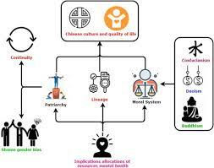
Figure 1: Chienese Value (Tse & Gornostaeva, 2021)

Cross culture theories and models
Cross-cultural theories and models suggest that cultural differences may cause communication and behavioral challenges that affect visitors. Consequently, Indian hospitality workers should engage with Chinese guests with intelligence and empathy to ensure their comfort (Lee & Watkins, 2021). Intellect and sensitivity help workers adapt to different cultural norms, communication styles, and behavior patterns. They also help personnel understand Chinese visitors' gestures, facial expressions, and body language, which is essential to building trust (Moran, 2018).

Figure 2: Chinese Communication (Samovar, 2009)
The hotel business may benefit from Hofstede's cultural aspects theory, a cross-cultural framework. These cultural aspects include power distance, individuality vs. collectivism, masculinity vs. femininity, uncertainty avoidance vs. short-term orientation, indulgence vs. restraint, and long-term vs. short-term orientation (Keegan & Green, 2021).
By applying this theory to the context of Indian and Chinese cultures, we are able to pinpoint important cultural distinctions that hotel staff should be aware of while dealing with Chinese clients. Take, as an illustration the power barrier between China and India is greater than that between China and India, suggesting that Chinese hotel guests may be more used to formal, hierarchical interactions. Workers are expected to treat Chinese visitors with courtesy and respect and refrain from adopting a too casual demeanor (Hult, Keillor & Svendsen, 2021).
Individualism vs. Collectivism: Guests from China, whose culture is more collectivist than India's, may put the needs of the group and their connections with others ahead of their own. Workers should be aware of this, and make efforts to provide memorable group experiences (such shared meals or team building exercises. Workers should be aware of his, and make efforts to provide memorable group experiences (such shared meals or team building exercises (Kotler, Bowen & Makens, 2021).

Figure 3: Chinese Housekeeping Management (Timm, 2019)
Masculinity vs. Femininity: Guests from China may place a larger priority on aggressiveness, competition, and monetary achievement than visitors from India do due to China's higher masculinity score. It is important for staff to highlight the high quality and prestige of the hotel and its services in order to appeal to Chinese clients, who may be more inclined to haggle or be more direct in their communication (Solomon & Schellhase, 2021).

Figure 4: Spa and wellness centers (Tsarenko, Anderson & Solnet, 2018)
Uncertainty Avoidance: In terms of avoiding ambiguity, Chinese visitors may be more risk-averse and prefer strict adherence to established norms and policies than their Indian counterparts. Everything of the hotel's rules, services, and facilities should be explained in depth and with no surprises.
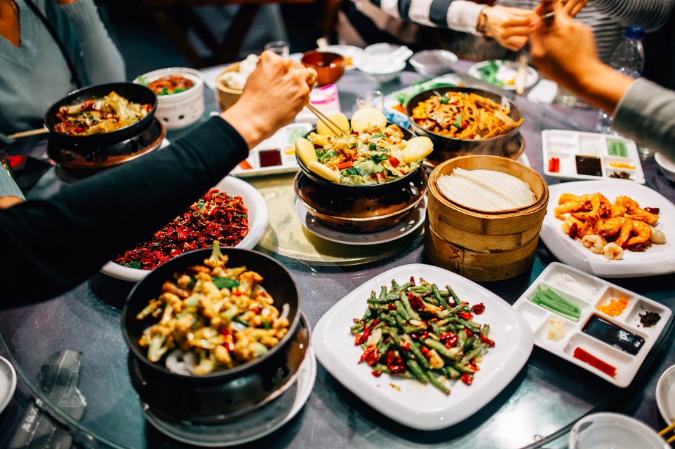
Figure 5: Chienese etiquette (Samiee, 2021).
Hotel staff may better meet the requirements and exceed the expectations of Chinese visitors by using Hofstede's theory of cultural dimensions to both the Indian and Chinese cultures (Hofstede, Hofstede & Minkov, 2019).

Do’s and Don’ts of the staff
Do's:
- It is appropriate to defer to the guest's rank or position.
- Do not use first names while addressing Chinese hosts; instead, stick to titles and last names.
- Learn about the area's sights so he can advise Chinese visitors on what to do while they're in town.
- Learn the preferences of Chinese visitors by asking questions about things like mattress firmness and pillow preferences (Hollensen, 2021).
- Slippers and robes are nice extras to have in a guest room.
- It's important to remember that Chinese visitors have certain dietary and beverage preferences, such as a strong aversion to cold water and a strong preference for tea over coffee.
- To attract Chinese customers, spas and wellness centers should be ready to provide traditional Chinese therapies in addition to Western options.

Don'ts:
- While interacting with Chinese visitors, it's best to avoid seeming too casual or familiar.
- Never assume that Chinese visitors share tastes and expectations.
- Do not assume that all Chinese visitors are well-versed in American culture (Johnston & Clark, 2018).

Recommendation
On the basis of the results of this study, the staff at the hotel is presented with two suggestions, which are as follows:
- Training in cultural intelligence and sensitivity should be given to all staff members working in the hotel, including those at the front desk, cleaning, food and beverage, spa, and wellness departments (Brown, Lam, & Mangleburg, 2019).
- To get feedback from Chinese visitors and suggest areas where service might be improved, conduct frequent surveys or focus groups to collect their responses.

Conclusion
In conclusion, hotel staff must have cultural knowledge and sensitivity while catering to guests from other countries. Hotel employees may better cater to their visitors' needs by gaining an appreciation for their cultural background. When dealing with Chinese guests, hotel staff in India should be aware of the importance of showing respect and deference to the guest's position or status, using titles and last names when addressing Chinese guests, and adapting service delivery to accommodate Chinese guests' food and beverage preferences as well as spa and wellness preferences. Hotels in India that welcome Chinese tourists might use the advice in this paper to provide their visitors the best possible stay.

Reference
Brown, S. W., Lam, S. K., & Mangleburg, T. F. (2019). Service encounters in Asia: Emerging research themes. Journal of Services Marketing, 33(1), 6-15. Available at: https://www.emerald.com/insight/content/doi/10.1108/JSM-07-2018-0237/full/html (Accessed: 28 February 2023).
Hollensen, S. (2021). Marketing management: A relationship approach (4th ed.). Pearson Education. Available at: https://www.pearson.com/us/higher-education/program/Hollensen-Marketing-Management-A-Relationship-Approach-4th-Edition/PGM2732124.html (Accessed: 28 February 2023).
Hult, G. T. M., Keillor, B. D., & Svendsen, S. (2021). Building a global brand: The role of cultural identity in international marketing. In Global Brand Strategy: World-wise Marketing in the Age of Branding (2nd ed.). Routledge. Available at: https://www.routledge.com/Global-Brand-Strategy-2nd-Edition-World-wise-Marketing-in-the-Age-of-Branding/Hult-Keillor-Svendsen/p/book/9780367209269 (Accessed: 28 February 2023).
Jandt, F (2016) An Introduction to Intercultural Communication, 8th edition, Sage: San
Johnston, R., & Clark, G. (2018). Service operations management: Improving service delivery (5th ed.). Pearson Education. Available at: https://www.pearson.com/us/higher-education/program/Johnston-Service-Operations-Management-Improving-Service-Delivery-5th-Edition/PGM256514.html (Accessed: 28 February 2023).
Keegan, W. J., & Green, M. C. (2021). Global marketing (10th ed.). Pearson Education. Available at: https://www.pearson.com/us/higher-education/program/Keegan-Global-Marketing-10th-Edition/PGM250352.html (Accessed: 28 February 2023).
Kotler, P., Bowen, J. T., & Makens, J. C. (2021). Marketing for hospitality and tourism (8th ed.). Pearson Education. Available at: https://www.pearson.com/us/higher-education/program/Kotler-Marketing-for-Hospitality-and-Tourism-8th-Edition/PGM256288.html (Accessed: 28 February 2023).
Lee, J. A., & Watkins, B. A. (2021). Multicultural issues in service encounters. In The Routledge Handbook of Service Research Insights and Ideas (1st ed.). Routledge. Available at: https://www.routledge.com/The-Routledge-Handbook-of-Service-Research-Insights-and-Ideas/Lemon-Perkins-Wilson/p/book/9780367646205 (Accessed: 28 February 2023).
Moran, R. (2018) Managing Cultural Differences, 10th edition, Routledge: Abingdon.
Samiee, S. (2021). International marketing. In The Oxford Handbook of Marketing (2nd ed.). Oxford University Press. Available at: https://www.oxfordhandbooks.com/view/10.1093/oxfordhb/9780198748571.001.0001/oxfordhb-9780198748571-e-29 (Accessed: 28 February 2023).
Samovar, L. (2009) Communication Between Cultures, Wadsworth, London.
Solomon, M. R., & Schellhase, R. W. (2021). Cultural differences in consumer behavior. In Consumer Behavior: Buying, Having, and Being (13th ed.). Pearson Education. Available at: https://www.pearson.com/us/higher-education/program/Solomon-Consumer-Behavior-Buying-Having-and-Being-13th-Edition/PGM2417887.html (Accessed: 28 February 2023).
Timm, A. (2019) Intercultural Problems in the Tourism Industry, GRIN Verlag.
Hofstede, G., Hofstede, G. J., & Minkov, M. (2019). Cultures and organizations: Software of the mind (3rd ed.). McGraw-Hill Education. Available at: https://www.mheducation.com/highered/product/cultures-organizations-software-mind-hofstede-hofstede-minkov/M9780071664189.html (Accessed: 28 February 2023).
Tsarenko, Y., Anderson, A., & Solnet, D. (2018). Cultural competence in service encounters: A review and future research directions. Journal of Service Theory and Practice, 28(5), 575-600. Available at: https://www.emerald.com/insight/content/doi/10.1108/JSTP-05-2017-0084/full/html (Accessed: 28 February 2023).
Tse, D. K., & Gornostaeva, G. (2021). Managing service quality in multicultural environments. In Handbook of Service Quality Research (2nd ed.). Edward Elgar Publishing. Available at: https://www.elgaronline.com/view/edcoll/9781788973542/9781788973542.00024.xml (Accessed: 28 February 2023).

