Fieldwork Report Blaenafon

2011226 Anne-marie Thomas

Blaenafon and Becoming Distinctly Prosperous

Blaenafon became a World Heritage site in December 2000, there are many reasons for this one of them being The Industrial Revolution and production of iron and the ability of dephosphorisation of iron to make steel. Blaenafon became a Worldwide name dating back as early as the eighteenth century and into the nineteenth century, the iron works was known at the time as largest Iron Works in the World, Iron and coal were the materials that were the backbone of the first Industrial Revolution in Britain. Blaenafon is said to be known as the birthplace of the Industrial Revolution. As the heart of the World Heritage Site, Blaenafon Ironworks is internationally recognised as representing South Wales’ pivotal role in the Industrial Revolution.
Blaenavon’s reach was global. Its iron was used to manufacture rails that carried trains across countries such as India, Russia, and Brazil. It was also a hotbed of innovation and technological change. And it all began with a simple bar of iron known as a “pig”. (Taylor-Davies R May 2013).
Iron and Coal where the main products produced in the South Wales Valleys, the valleys held all the ingredients to produce iron, coal and limestone in abundance, and had a plentiful amount of water. The area also had clay for making bricks to line the furnaces and sandstone for building. The collieries and ironworks in the valleys were of international importance for more than 150 years, production grew from 39,600 tons of pig iron in 1796 to 666,000 tons in 1852. [cadw.2020]. Pig iron was aptly named by ex-farmers or workers with a farming history, they claimed that the iron looked like piglets feeding from their mothers, so came the name pig iron. The Iron supplied by Blaenafon iron works during the Industrial revolution was used mainly for Ships, railways and buildings and was supplied worldwide via steam ships, canals and horse drawn railways. Iron ore was extracted as early as 1675 from the hills and mountains of the Blaenavon area. The iron bar (pig iron) was 1.2 meters long and 80mm wide.
In 1788 Lord Abergavenny leased the Common Land to Thomas Hill and Benjamin Pratt who were businessmen from the midlands, the duo decided to build a major new iron works on the land, using the latest technology available to them.
By 1789 there would be three blast furnaces using steam power to run, producing iron and pig iron, due to this the little village of Blaenafon grew rapidly with people flocking in from rural Wales, Ireland, Scotland and rural England to work either the Iron works, or to build the houses for the workers, by 1812 the site had 5 furnaces running.

In 1817 was the opening of the new primitive tram way connection between Brecknock and Abergavenny allowing quicker and easier access to the canal to transport iron and coal. The tunnel was 2.4 meters long called Pwll Du Tunnel and was said to be the longest ever horse drawn tram way to ever be built in Britain.
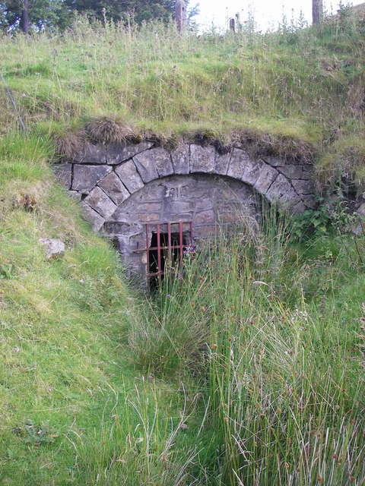[Bowring.A.2007]

Landscape and the community lives were evolving by 1851 there were more welsh people working in the iron industry than agriculture, while the increased production and work in the area made money for some it also bought squalor and poor living for many, trying to feed their families on the pittance they would earn, living in overcrowded and cramped houses. Although the way of living for most was slum like and poor, this did not stop people coming to the valley in the thousands to seek work and a new life seeking higher wages and a better life, Blaenafon was one of the fastest growing areas in Britain.

At the end of the 1875 Sidney Gilchrist Thomas the cousin of Percy Gilcrist whom which was the chemist for Blaenavon Iron works conducted large scale experiments at the iron works and created The Bessemer Converter, this was a method of producing steel from phosphoric ores by phosphorating iron for steel making. The production of Iron increased at a rapid pace, making the Blaenafon area continually increase its population from almost nothing to 11,452 in 1891 this increase was purely due to the Iron works and increase of work in the area. Blaenavon was now a thriving urban area with many chapels, pubs, schools and tradesmen with a workingmen's hall and Institute. Blaenavon was rich in work, workers and finances compared to the rest of the UK.

The workingmen’s club was built for all to use, this was the heart of the village. The workmen’s hall and institute were used to meet and socialise, read, play games, and hold various group one of which was a reading group and in 1860 had over 110 members, this was quickly to change as the club struggled to gain and hold onto financial support the groups quickly closed.
Nonetheless, it was agreed that there was sufficient demand for an institute and, to ensure success, the Blaenafon Company, the town’s main employer, pledged to take a subscription of a halfpenny out of each man’s weekly wage to support the new venture. [Culture and Recreation in Blaenavon p.1]

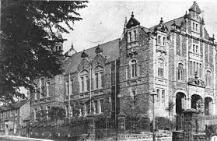
[Nationalmuseumwales2009]
Above: Blaenafon Ironworks in 1789

However, in 1878, the Blaenavon Iron & Steel Company Ltd went into liquidation because of the enormous cost of changing over to steel production. The Blaenavon site was bought for £75,000 by a new Blaenavon Company Ltd, incorporated in 1879. Around 1880, with Blaenavon's No.2 Furnace still producing cold blast pig iron, Furnaces No.4 and No.5 were refurbished to make iron ingots for the Forge side steelworks. [engineering times2020]

References

https://cadw.gov.wales/advice-support/historic-assets/other-historic-assets/world-heritage-sites/blaenavon-industrial [accessed 8 dec.2020].
http://www.engineering-timelines.com/scripts/engineeringItem.asp?id=1395 [accessed 10dec.2020]
Pwll du tunnel entrance Bowring. A [2007]https://www.geograph.org.uk/photo/504147[accessed 8 dec. 2020].
Photography by John Ball, 18th April 2001https://www.jlb2011.co.uk/walespic/archive/010608.htm [accessed 8 dec. 2020].
national museum wales 2009 https://www.peoplescollection.wales/items/9897[accessed 8 dec. 2020].

culture and recreation in Blaenavon - Blaenavon World
https://www.visitblaenavon.co.uk/en/Publications/Blaenavon-Story/Culture-and-Recreation-in-Blaenavon.pdf[accessed 8 dec. 2020].
Taylor-Davies,R.(2013)WelshHistoryMonth:Blaenafonironwales {online}available at:https://www.walesonline.co.uk/lifestyle/nostalgia/welsh-history-month-blaenavon-ironworks-3565549 [accessed 8 dec. 2020].
https://www.visitblaenavon.co.uk/en/Education/Education.aspx

