I can confirm that I have not used any AI in the presentation or the written text of my work. I can confirm that I have copies of my drafts and notes which I can provide as evidence.
Contents of Assignment:
Part 1: Business Plan
Part 2: Research
Part 3: Reference List

Guppies ALN Swim School

Contents Page

- Summary
- Business Objective
- Background & Importance of Service
- Market Analysis
- Value
- Services Offered
- Operational Plan
- Marketing & Outreach Strategy
- Financial Plan
- Inclusion & Safeguarding
- Evaluation & Monitoring
- Risk Analysis
- Long-Term Vision
- Why This Matters
- Conclusion

Summary
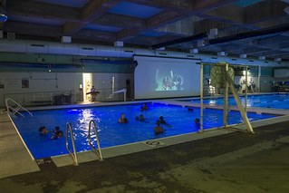
The Guppies ALN swim school will provide specialised, inclusive and adaptive swimming lessons and aquatic activities for children and young people with ALN aged 3-25. Our mission is to reduce barriers that children with ALN face in accessing safe, supportive aquatic education and to enrich their physical, cognitive, and social development through tailored swimming programmes. We will operate from an accessible pool facility in Port Talbot, collaborating with local authority education providers, health services and support organisations to ensure high quality, person-centred provisions.

Business Objective

- Deliver high-quality, inclusive swimming lessons tailored to ALN leaners within the first 12 months.
- To be a recognised centre of excellence in adaptive aquatic education by year 3.
- Partner with local authorities, schools and support services (e.g. ALN co-ordinators) to integrate swimming into IDPs (Individual Development Plans) wherever appropriate (NPTCBC, no date).
- Achieve financial sustainability within two years through diversified revenue streams (lessons, grants, partnerships, community programmes).
- Provide therapeutic and social opportunities that enhance confidence, independence and well-being for ALN children and young people.

Background & Importance of Service

- What are Additional Learning Needs (ALN)?
Within Wales, the ALN system identifies children and young people who experience a learning difficulty or disability that requires an additional learning provision (ALP); this refers to educational or training support that exceeds or differs from what is required by most learners. ALN encompasses learning and cognitive disabilities, communication needs, sensory processing disorder (SPD), SPD can appear in one or several sensory systems, either because of hypersensitivity or hyposensitivity (NHS Foundation Trust, 2026) or physical impairments, as well as social-emotional challenges. the planning and delivery of provision should be person-centred, involving children, parents, schools and other agencies in the process. Children and young people with ALN can often face challenges in accessing mainstream activities, including sport and recreation, that fail to incorporate appropriate adaptations, specialised instruction and inclusive environments. such obstacles can hinder physical development, social interaction, self-confidence and overall well-being (NSPCC, 2026).
- Why swimming and Aquatic Activities Matter?
Swimming is both a safety skill and a beneficial physical activity. The values includes:
Water Safety: Essential for reducing drowning risks, especially in an area such as Port Talbot and the surrounding areas, with ease of access to beaches and rivers. The gap is not just problematic, it is a safeguarding issues as mentioned in the local authorities revised safeguarding policy (NPTCBC, 2022).
Physical Health: Boots fitness, strength, co-ordination, and is helpful for children with physical or sensory ALN.
Psychological and Social Benefits: Enhances confidence, peer interaction and lowers anxiety for both parents and children, whilst they participate in a supportive settings.
Therapeutic Impact: Provides sensory regulation and low-impact exercise for children with varied needs. It will also incorporate physiotherapy plans from health, ensuring that the children are able to access their plans whilst in the pool.
Most mainstream swim instructors are not trained in ALN, therefore programs often lack adaptation, creating a gap that Guppies swim school aims to address.

Market Analysis

A. Target Population
- Primary Target: Children and young people aged 3-25 with ALN in Port Talbot and surrounding areas.
Thousands of learners are overlooked within extracurricular sport and rarely receive aquatic education tailored to their needs.
B. Competitive Landscape
Most swimming programs target the general population and lack:
- Staff trained in ALN methods
- Small-group or individual adaptive sessions
- Sensory-friendly facilities or teaching approaches
- Multi-disciplinary support (such as speech/language or occupational therapy)
A dedicated ALM swim school can offer and meet these requirements.

Value Proposition

Guppies swim school provides inclusive, specialised swimming education where:
- Every child, regardless of ALN, deserves the opportunity to feel safe, confident and successful in the water.
- Programming is individualised to the learner's pace, ability and learning profile and not forced to fit into a mainstream model but supported in a way that works for them.
- Teaching staff are trained in adaptive techniques, behaviour support and sensory informed approaches.
    - It will be a specialist service following the Swimming Teachers Association (STA) Penguin Series learn to swim program.
Our services reduce barriers to participation and extend beyond just swimming lessons to a holistic development experience (Teachkloud, 2023).

Services Offered
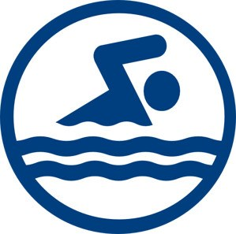
Core Services
- Structured learn to swim classes
    - Small groups (max 6 students)
    - Ages 3-18, plus young adult adaptive sessions
    - Curriculum adapted to cognitive, sensory and motor needs
2. 1:1 Specialist Sessions
    - Tailored for children who require individual support
    - Ideal for learners with communication or sensory profiles
3. Water Confidence & Social Swim Groups
    - Non-instructional sessions promoting play, comfort in water and social interactions
4. Therapeutic Aquatics
    - Movements and activities designed for physical and sensory regulation
    - Delivered in collaboration with health professionals (where possible)
5. Holiday & Weekend Inclusive Camps
    - Extended aquatic activities and social skill building

Operational Plan

Location & Facilities
A leased area within a leisure centre or pool partnership, featuring:
- Ramps, hoists, sensory aids, quiet rooms
- Swim platforms and adaptive equipment
Staffing & Training
Lead Adaptive Swim Instructors: Certified in swim teaching and trained in ALN techniques
Supportive Assistants: Skilled in communication, sensory adjustment and health needs
Volunteers/Work Placements: Opportunities for college and school students and student nurses, to gain experience
Partnerships: Working with
- Local schools & ALNCo teams
- Health Professionals
- Charities
- Families & Advocacy Groups

Marketing & Outreach Strategy

Brand Identity
Inclusive, respectful messaging focused on belonging and confidence.
Promotional Channels
- Schools, ALNCo lists
- Social media, community groups
- Posters in clinics, centres, support organisations
- Local newsletters, parent networks
Engagement and Education
Offer free events, tasters and workshops to raise awareness and build trust in the ALN community.

Financial Plan

Revenue
- Tuition Fees
    - Weekly sessions with pay as you go fees or block lesson pricing
    - Bursaries for low-income families
2. Contracts with Schools & Local Authorities
    - Inclusive extracurricular programmes within school grounds
3. Grants and Sponsorship
    - Funding from charitable trusts health partnerships and inclusion-focused grants (Welsh Government, no date).
Cost Structure
- Lease and facility fees
- Salaries and training costs
- Pool time and insurance
- Adaptive equipment and safety gear
Break-even & Sustainability
Financial projections show break-even within 12-18 months with stable environment and grant support, moving towards self-sufficiency through varied and retained expertise.

Inclusion & Safeguarding

Inclusion underpins every element:
Adaptive Instructional Design allows all students to participate, regardless of ability.
Person-Centred Approach tailors lessons to learners goals, supporting active involvement in planning (LD Network, 2023).
Safeguarding Protocols are comprehensive, with regular staff training and emergency planning.
Cultural and Linguistic Inclusion acknowledges diverse language needs, including Welsh medium support (Welsh Government, 2025a).

Monitoring & Evaluation

At Guppies Swim School, there will be :
- Skill Progression (water confidence, swimming ability) within the Penguin Series
- Attendance and engagement
- Parent and child feedback
Quarterly reports will guide curriculum changes and strategy.

Risk Analysis

Key Risks:
- Scheduling Pool Availability
- Recruitment of suitably trained adaptive staff
- Maintaining enrolment and funding
Improvement Strategies
- Competitive pay, ongoing training
- Flexible hours (morning, after school)
- Diverse funding and partnerships

Long-Term Vision
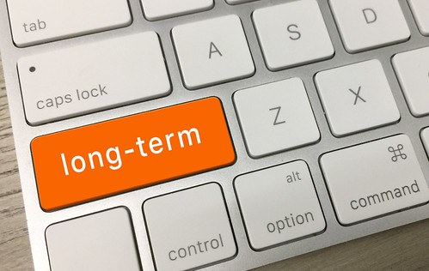
By its fifth year, Guppies ALN swim school plans to:
- Grow by adding satellite location in Neath Port Talbot
- Promote inclusivity aquatic programs through community backing
- Become a central consulting resource for best practices in inclusion across Wales

Why This Matters! (Research & Policy Context)
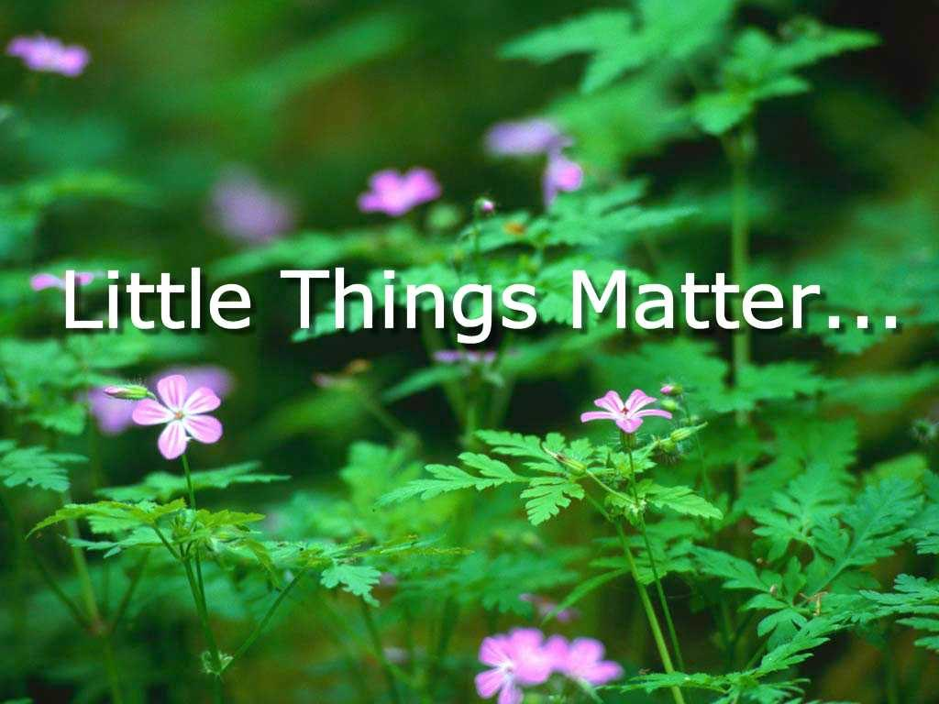
The Welsh ALN system prioritises learner’s needs and perspectives, placing them at the centre of planning and support. The system emphasises inclusive provision and early interventions to enable children to achieve their full potential.
Despite these objectives, numerous children will still encounter obstacles when accessing community activities as mentioned above.
This enterprise is more than a typical swim school; it constitutes an inclusive educational and developmental initiative that aligns with statutory policy priorities and broader community well-being objectives (Welsh Government, 2025b).
Challenges:
- There is a national shortage of swimming instructors with specialist training in ALN, inclusive pedagogy and adaptive aquatic instruction.
- Families of children with ALN often face financial pressures due to therapy cost, specialist equipment and transport needs.
- Swimming environments can feel overwhelming with appropriate support, which can have a negative impact and prevent engagement, reduce attendance and limit outcomes.

Conclusion
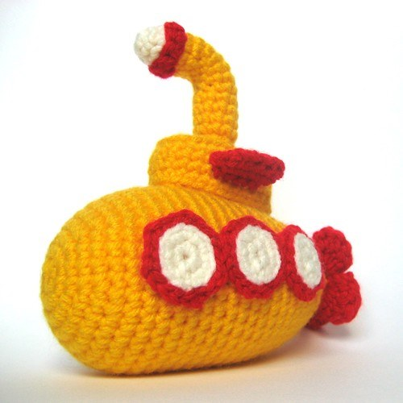
Guppies ALN Swim School will create inclusive, supportive and evidence-based environment that meets the unmet needs of children and young people with ALN. I have 20 plus years’ experience as a teaching assistant working in an ALN school and 2 years’ experience as a swimming instructor. I have seen the amazing results that swimming can do for children with ALN, whether they have a physical disability of neurodivergent ability such as autism or ADHD. Through the progression of the penguin series, and adaptive instruction, partnership and community engagement, the school will deliver meaningful impact-building confidence, skills, safety and belonging for all participants.

Part 2:

