Kamila Khalid – 1809606

BA Leadership and Management

Module: BMSW6101 - Emergent Leadership Skills in the Workplace

Assignment: Portfolio

Lecturer: Eric Osei

Due: 29 March 2021

Table of Contents
Page No.
Introduction 2
PART 1
Leadership Styles 2-7
Leadership Traits Analysis 7-9
Gender Stereotypes, Challenges and Solutions 9-11
Relationship between Transformational Leadership and Organisational Performance 11-12
Conclusion 12
PART 2
Reflections on Leadership 13-14
References/Bibliography 15-16
Introduction
The first part of this essay looks at the leadership styles and traits of a female leader, namely, Ursula Burns, the CEO of Xerox, an American print company, and the challenges faced by female leaders and solutions. The Traits theory is discussed and how this affects leadership styles.
The essay provides a list of leadership styles commonly applied in today’s society. Gender stereotypes, challenges and solutions are highlighted and how this impacted upon Ursula Burn’s career as a female leader. The final section of part one gives a critical analysis about transformational leadership and impact on organisational performance which is then followed by a conclusion.
The second part of the report is a reflective work which reflects on my personal knowledge, experience and learning about emergent leadership skills throughout this module.

PART 1

Leadership Styles
Leadership can be defined as a method to motivate groups of people to reach a common goal. Being a leader is a role with huge responsibilities and may not be ideal for everyone. In organisations leaders are seen as those who can direct workers and colleagues to achieve a company’s goals and be able to motivate people. Figure 1 gives details of different leadership styles.

Fig. 1 – Leadership Styles
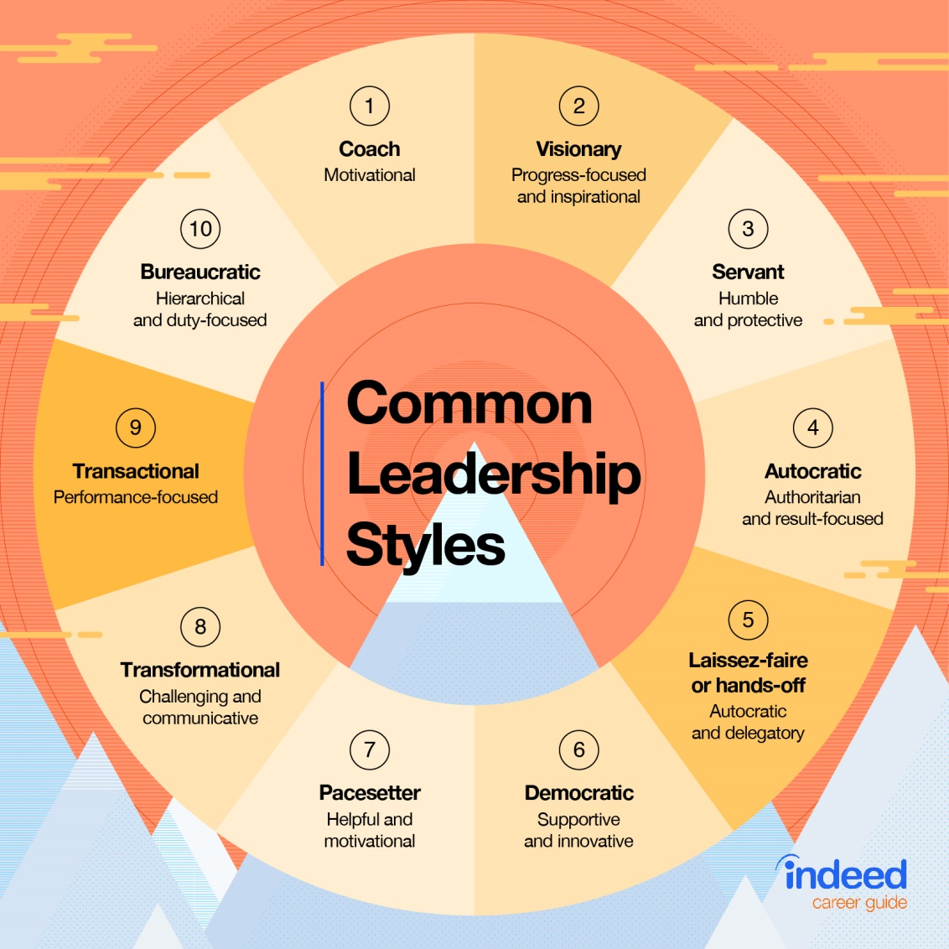
(Source: Indeed.com 2021)
Autocratic Leadership | This style is very controlling and directing. It works well in times of crisis and when you need to achieve results quickly..
Bureaucratic Leadership | Lead by procedures and work well in structured environments.  However flexibility is reduced and there is no room for change.
Charismatic Leadership | Inspire enthusiasm in their teams and are active in motivating others to move forward.  The success is down to the leader and therefore long term commitment is required.
Democratic/Participative Leadership | Democratic leaders make the final decisions, but they include team members in the decision-making process.  This style maybe quite slow in seeing results as it requires member participation which inevitably will take time.  .
Laissez-Faire Leadership | Laissez-faire, meaning “leave it be” leaders are focused on counselling, observing and participating. They tend to let employees have the freedom to do their own work and set their own deadlines  Laissez-Faire leadership style is not so good in terms of productivity and not good in competitive situations.
People-Oriented/Relations-Oriented Leadership | People-oriented leadership is focused on organising, supporting, and developing the people on their teams.  The benefit of this leadership style is that team members are often more productive and willing to take risks, because they know that the leader will provide support if they need it.
Servant Leadership | Servant leaders are people at any level within an organisation who lead simply by meeting the needs of the team.  This style is a bit like the democratic leader where the team tends to be involved in decision making. However, servant leaders often lead from behind as opposed to the front..
Task-Oriented Leadership | Task-oriented leaders are a bit like the autocratic leader. They actively define the work and the roles required, put structures in place, and plan, organise, and monitor work..
Transactional Leadership | This leadership style is more of a management style than leadership. It starts with the idea that team members agree to obey their leader when they accept a job. The transaction involves team members being paid for their performance in a particular role or task.
Transformational Leadership | Transformational leaders are inspiring because they expect the best from everyone on their team as well as themselves. This leads to high productivity and engagement from everyone in their team.  The disadvantage of transformational leadership is that while the leader's enthusiasm is passed onto the team, the leader needs to be supported by key people.

From the leadership styles mentioned above, Ursula Burn’s leadership style is not limited to one style. According to her characteristics she is a charismatic leader as her beliefs are that success is built on honest communication and being straightforward. She believes in the power of people, therefore she is also a democratic leader, where she values other’s opinions. Ursula can also be seen as a transformational leader as her employees feel valued and inspired and motivated to achieve goals set by the organisation. (Gaille, 2013)
It is beneficial for organisations to have leaders that have adaptable styles in order for them to be able to make the right decisions at the right time. Ursula Burns has shown that she was able to do that throughout her career even prior to her role as a CEO, when she was asked to work with a new CEO and the effective mode of communication they had with each other was the key player in their success. (Crainer and Doherty 2012)
Leadership Traits Analysis
According to the Trait Theory leadership can be defined as enduring characteristics of behaviour. Some of the typical traits found in leadership are confidence, enthusiasm, integrity, positive, warmth, resilience, to name a few. (Armstrong, 2016, p7). Further traits for successful leadership are shown at Figure 2 below. However, just having traits was later found to be not sufficient enough to be a successful leader. Although it is important to have some strong traits embedded in an individual, that, in and of itself is not sufficient to be a good leader. Further training would be required to ensure leaders are at the top of their game and are adaptable in different situations.
Fig.2 Traits for successful leadership
Trait
Self Managing | To be an effective leader you must be able to manage your time, emotions and attention as well as being aware of your strengths and weaknesses.
Strategic | Must be open-minded and forward-thinking, be prepared to change to adjust strategies to suit circumstances.
Effective Communicator | Be able to communicate at all levels and know when to speak and when to listen.
Responsible | Take responsibility for own mistakes and be accountable.
Clear Goal Setter | Be confident, clear and realistic when setting goals. Be prepared to keep going when things get tough.
Forward Thinking | Effective leaders must have a vision for the future and be able to manage change to ensure stability for the company’s future.
Problem Solver | Being able to lead in complex environments and be able to assess situations and choose the appropriate course of action.
Innovative/Creative | Leaders must be prepared to take risks as well as being flexible when pursuing goals.
Team Building | Being able to recruit the right team and motivating the team is a key skill of a good leader.
Motivating | Have the ability to make employees feel valued and appreciated.
Agile | Being able to suddenly adapt in changing circumstances.

(Source: Patel 2017)
The traits mentioned above are ones that can be learned by leaders if they are already not a part of their character. According to a study by Rausch and Allio (2005) leadership is not something that can be taught but it is something that is learned. So an individual can be put into a leadership role because of certain characteristics that they possess but to be an effective leader they learn how to improve themselves over time by deliberate acts of leadership, such as paying attention, listening, staying calm etc.
There are also person oriented and task orientated traits. Person orientated traits focus on the relationship side with employees, ensuring they are motivated, they are being listened and so on. Whereas task oriented traits are focused more about achieving goals and ensuring the organisation is moving forward.
With regards to Ursula Burns leadership traits and the Traits theory, she possesses some of the traits mentioned above, such as being empathetic, a charismatic speaker, approachable and compassionate. However once she was in the leadership role she learned to manage her emotions which helped her to develop social-awareness. A leader who is socially aware is emotionally intelligent and therefore is able to demonstrate an understanding of fellow employees.
Ursula’s traits tend to be more person oriented given her nature which was inherited from her mother. Fowlie and Wood (2009) state that, “A leader rated highly in relationship management and social awareness competences makes employees feel ready to give their best, they feel motivated and appreciated, optimistic and safe.” It is evident that Ursula Burns’ approach to leadership was such where she was able to gain the trust of employees and able to make appropriate decisions for the success of Xerox.
Gender Stereotypes, Challenges and Solutions
Gender stereotypes has been around for centuries and still exists today, although as a society great changes have been made, but equality is still far from reality. According to Ellemers (2018) stereotyping is part of human nature. Humans tend to categorise individuals, albeit unconsciously, into certain groups by ascribing some general attributes just by the mere fact that an individual is a member of a certain group. For example by the mere fact someone is female they should be assigned more domestic roles because that is what has been done for generations. Also the pay gap in senior leadership roles for women is still to date questionable.
Crainer and Doherty (2012) state that according to BusinessWeek in 2010, women were more likely than men to start their first post-MBA on a lower rate of salary. Even now move than ten years on, there has not been a huge shift in the pay gap between men and women especially in the senior management positions. According to Partridge (2021) of the Guardian newspaper, “Female directors at financial service companies are paid 66% lower than their male counterparts.” Although consideration has to be given to the fact that there are less women than men in the senior management roles and therefore this figure may seem slightly disproportionate. However, the women that have made it to the top are not treated with equality when it comes to pay.
Equal pay is just one of the challenges faced by women, there is also the case of those women who choose to have children and need to take a break before returning to work. Although a lot of women would prefer to give 100% attention to their new-born, they still would like to continue with their career when possible. Firms should take this into consideration when re-hiring women and more support should be given to allow them more flexibility to return to work. Okimoto and Heilman (2012) state that organisations assume that mothers, in particular, are seen to lack commitment and are less capable as employees than non-working mothers, particularly in predominantly male-type roles. This assumption prevents women who wish to raise children to further their career in organisations where flexibility does not exist. However, from an organisation’s point of view if a role commands full time commitment, it may not be ideal for them to employ someone who is unable to provide the full commitment.
In the case of Ursula Burns, who came from a humble background but with her commitment to her career and being exposed to different styles of leadership in her role as an executive assistant at Xerox and the company giving her the opportunity to flourish, she became one of the top female CEOs in the country. Even after having children, Ursula still pursued her career despite the family and financial challenges that she faced.
As mentioned above one of the solutions that organisations can provide for females in leadership positions to thrive is to offer equal pay, flexibility and opportunities to grow. Schrouff et al (2019) propose a couple of solutions to combat gender discrimination in the work place, such as having quotas for men and women within certain positions. This can be also at the level of senior management positions to ensure equal numbers of men and women within a certain role. Organisations can also arrange training sessions to raise awareness of work-life balance environment and take into account child-bearing when hiring individuals.
Applying quotas may seem unfair at the leadership level as highly experienced individuals are required for such roles and sometimes there is just not enough interest from women to undertake roles especially when they are trying to maintain a work-life balance. However, training people and making them aware of the gender bias may help when recruiting for senior level positions.
Relationship between Transformational Leadership and Organisational Performance
According to Bass and Riggio (2006) transformational leaders are those who help their followers to develop as well as developing their own leadership capabilities. They do this by empowering their followers to align their individual objectives and goals thus allowing people to meet or exceed the expected goals. Another common definition for transformational leadership is to emphasise on emotions and values and fostering capacity to develop higher levels of commitment to goals of an organisation. Higher level of commitment would help to achieve greater productivity. (Leithwood and Jantzi 2005)
Given the above definitions transformational leaders are those that help to change the way something is being run in order to reach an objective. Hitler could be considered a transformational leader with the way he was able to lead people towards a goal which he thought would be best for his people. According to Staats (2016) in order for transformational leaders to achieve their desired outcome they can at times put significant pressure upon their followers which can lead to unethical actions taken by followers. Transformational leaders always need to be mindful of how their decisions will impact their followers.
Organisational performance is activities carried out by a company or its members in terms of reaching its objectives and goals. Elena-Iuliana and Maria (2016) describe performance as something that is focused on the future and reflects behaviours of performance as future-oriented and designed to reflect characteristic of an organisation.
The diagram bellows shows how teams are linked to transformational leadership. The social elements and the task based elements impact team performance. With regards to task-relevant information the diversity in exchanging information, discussion and sharing ideas has a positive effect on team performance. With regards to the social element and the different characteristics this can have low level collective team identification in diverse teams and disrupt team performance. (Kearney & Diether 2009)
Fig.3 Proposed relationships among the variables.
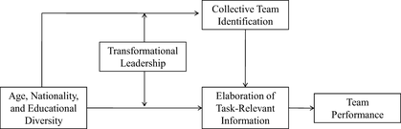
(Source: Kearney & Diether. 2009).
Some of the traits of a transformational leader, as described by Montgomery (2018) are charismatic, visionary, communicative, curiosity, interpersonal and risk tolerant. All these traits will help a transformational leader motivate their team towards the goals of the organisation and help improve performance.
Ursula Burns can be said to be a transformational leader as she is people focused but also task driven, which are elements of a transformational leader.
Conclusion
The main issues covered in this essay are those of female leaders and the challenges faced by them. The case study is that of Ursula Burns, who is a successful black female CEO of Xerox. The essay discussed the Traits theory and the fact that just because you have certain characteristics embedded in you from birth does not necessarily make you a good leader. However having both characterises of a leader and learning along the way and by listening to others can help one to be a successful leader.
The issue of gender stereotypes was discussed and the challenges faced by women and how these can be solved in the future. One solution was to have more awareness of issues that women face especially after child-birth and have more flexible opportunities for women to achieve roles that are at the managerial position and to have equal pay.
Transformational leadership and organisational performance were discussed. Some analysis of how transformational leaders role can have an impact on the performance of a team and then that of the whole organisation and the importance of having diversity within the teams.

PART 2
Reflections on Leadership
Upon reflection of this module of emergent leadership skills I have learnt different styles of leadership and traits. It is important to be a leader that is adaptable to different situations. As described by Sawtelle (2016) it is important to evolve leadership styles which can effectively respond to any situation with preparedness. The evolvement of leadership comes with time and experience and by putting oneself quite deliberately in different or difficult situations.
With regards to my own leadership style, initially I felt I had a Laissez-Faire style where you leave people to make the decisions. However upon reflection and completing the Conceptualising Leadership Questionnaire I have found that my leadership style, albeit within the family home as a parent is more of a democratic style but with some elements of Laissez-Faire. As I had described in my presentation I believe leadership styles do need to change given the situation one is in. The example I had given was that of raising children, when they are young toddlers you need to adopt the autocratic style as they need to be told what to do and what not to as they are too young to make their own decisions. When they are slightly older, say, the age of seven you can use the democratic style where you can ask for their opinions on things but not necessarily let them make the decisions. When they are at the adolescent age you can adopt the Laissez-Faire style where you are there to guide and counsel them but they can also make their own decisions.
It was interesting throughout lectures to listen to other students’ views on leadership styles and what each student felt their own style was. It would appear that most people have more than one style and they would adopt the necessary style according to the circumstances.
My own traits are that I am a good communicator, understanding, self-aware, capacity to build social relationships, friendly, honest, have strong principles and diplomatic. These traits can fall into most leadership styles. My feelings during this module were trying to understand what my styles were and whether my inherent traits fit well within a certain style and whether I should change my style. I feel there are times where I can be autocratic when I need to be but it is a style which I would prefer not to take. I believe in giving people opportunities to voice their concerns or suggestions as it helps making more informed decisions. For example as a director of a sports coaching academy when I wish to make a change or a suggestion I will always discuss with other directors and also ask opinions of parents if it is something that concerns them.
Lister’s (2004) suggests involving people who are in poverty to be involved with the organisations who make decisions with regards to targets and management of strategies as this affects the lives of those in poverty directly. I also believe that if my decision is going to impact others then it is important their opinions are heard.
With regards to what went well within this module I feel I learnt a lot about the different styles and how certain traits determine the type of leadership styles you have but which can also be changed along the way when individuals are put into different circumstances and are almost forced to change the way they lead in order to be successful.
In conclusion I believe I have become more self-aware of my traits and how I manage myself and those around me. I am now consciously trying to assess the situation ahead and think about what the best way is to deal with it by applying the appropriate style. I have become more confident in my decision making and have at times said, “This is what we are going to do?” as opposed to saying, “Is it okay if we do this?” An example of this was we run weekend sports sessions for children and due to a shortage of staff I made the decision to cancel the event altogether rather than risk having too many children with insufficient number of staff. I believe given the circumstances that was the right decision to make.
My action plan now and for the future is to keep assessing situations and being prepared to change my style to fit the circumstances.

References/Bibliography
Armstrong, M (2016) Armstrong's handbook of management and leadership for HR: developing effective people skills and better leadership and management. Fourth Edition, Kogan Page.
Bass, B.M. and Riggio, R.E., (2006). Transformational leadership.
Crainer S., Doherty P. (2012). Leading the way: Ursula Burns. Available at: https://www.london.edu/think/leading-the-way-ursula-burns. (Accessed 26 March 2021
Elena-Iuliana, I. and Maria, C., (2016). Organizational Performance-A Concept That Self-Seeks To Find Itself. Annals of Constantin Brancusi' University of Targu-Jiu. Economy Series, (4).
Ellemers, N., (2018). Gender stereotypes. Annual review of psychology, 69, pp.275-298.
Fowlie, J. and Wood, M., (2009). The emotional impact of leaders' behaviours. Journal of European Industrial Training.
Gaille B (2013). Xerox CEO Ursula Burns’ Leadership Style and Traits. Available at: https://brandongaille.com/xerox-ceo-ursula-burns-leadership-style-and-traits. (Accessed 26 March 2021)
Indeed, (2021). 10 Common Leadership Styles (Plus How To Find Your Own). Available at: https://www.indeed.com/career-advice/career-development/10-common-leadership-styles. (Accessed 25 March 2021)
Kearney, Eric, & Gebert, Diether. (2009). Managing Diversity and Enhancing Team Outcomes. Journal of Applied Psychology, 94(1), 77–89. https://doi.org/10.1037/a0013077
Leithwood, K. and Jantzi, D., 2005. Transformational leadership. The essentials of school leadership, pp.31-43.
Lister, R., (2004). A politics of recognition and respect: Involving people with experience of poverty in decision-making that affects their lives. In The politics of inclusion and empowerment (pp. 116-138). Palgrave Macmillan, London.
Montgomery A (2018). Transformational Leadership Style: 7 Traits Of Transformative Leaders. Available at: https://eml.usc.edu/blog/transformational-leadership-style (Accessed 27 March 2021)
Okimoto, T.G. and Heilman, M.E., (2012). The “bad parent” assumption: How gender stereotypes affect reactions to working mothers. Journal of Social Issues, 68(4), pp.704-724.
Partridge J (2021) Women paid two-thirds less than men in top finance roles – report, The Guardian. Available at: https://www.theguardian.com/business/2021/mar/01/women-still-earning-two-thirds-less-than-men-top-finance-roles. (Accessed 27 March 2021)
Patel, D (2017) 11 Powerful Traits Of Successful Leaders. Available at: https://www.forbes.com/sites/deeppatel/2017/03/22/11-powerful-traits-of-successful-leaders. (Accessed 25 March 2021)
Rausch, E. and Allio, R.J., (2005). Leadership development: Teaching versus learning. Management decision.
Sawtelle, J.D., (2016). Resilient Effective Adaptable Leadership. AIR UNIV MAXWELL AFB.
Schrouff, J, Pischedda, D, Genon, S, Fryns, G, Pinho, A.L, Vassena, E, Liuzzi, A.G, & Ferreira, F.S. (2019). Gender bias in (neuro)science: Facts, consequences and solutions. The European Journal of Neuroscience, 50(7), 3094–3100. https://doi.org/10.1111/ejn.14397
Staats, C., (2016). The adaptable emphasis leadership model: A more full range of leadership. Servant Leadership: Theory & Practice, 2(2), p.2.

