University Of Wales Trinity St. David Swansea
Impacts that temperature has on the through process of steelmaking in the Basic Oxygen Steelmaking Plant (B.O.S)
Iestyn Thomas 1809101
Beng Advanced Manufacturing Operations
2023

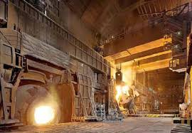


Student et al. (2022) (Vessel Operations Port Talbot Steelworks) Ferriman, J. (2019)

‘This Thesis is the result of the author’s original research. It has been composed by the author and has not been previously submitted for examination which has led to the award of degree’

Signed: Dated:

Abstract
The purpose of this project is to determine why, in the BOS plant, temperature is lost in a steelmaking through process whilst simultaneously investigating the teeming ladle process. I will analyse what we can do to perform more efficiently and how to better maintain the through process temperature from when the crude iron is brought into plant to when it leaves secondary steel to go to the continuous caster. If we could make this a better process, then we can have a better understanding of why we lose temperature and how we can have an improved through process temperature. It is important to note that the major reasoning for this is to save money on raw materials and oxygen, this is due to when it is too hot, we must cool it back using raw materials but if it is too cold, we have to use oxygen which has effects on other equipment as well as the teeming ladle and cost. It is essential to understand the converter sub lance, such as, what it is and how much of a major effect it has on the systems that we use. From a process control perspective all the way to the cold face side and the output that it provides, due to this being a vital component to the steelmaking process within Port Talbot. Additionally, gaining a better knowledge in thermocycling of ladles is necessary to consider what stages mostly and why we lose temperature at these sections, therefore this can have a positive impact on steelmaking in the BOS plant. Moreover, this will allow me to understand why this is so important to be maintained and monitored, which leads to the industry benefitting from a better process and understanding. Finally, this can create a pathway for a more efficient steelmaking process, making it an easier process to sustain such as, if one area is performing, it will follow suit on the next section to the process.

Introduction
Port Talbot as a steel plant was built and created in 1901 by Christopher Rice Mansel Talbot and his family, the creation took around 4 years which, initially, was the steel mill. Continuing to grow the work in 1923 Margam iron and steel opened, The Abbey works was created and opened by Chancellor Hugh Gaitskill in 1951 with around 20,000 employees (Georgia Yates, 2018). 1953 Margam iron and steel works closes and 1961 the steel mill spoken of previously has been closed. (Birchall, B. 2016) In 1967 the old steel company of Wales which ran the plant was nationalised and formed a part to of British steel, “later purchased by Corus group” (Browne et al, 2020) Tata, the major Indian company, that owns numerous other major businesses bought out Corus “in a Debt fuelled deal for 6.7bn in 2007”. (Browne) et al., 2020). The Basic Oxygen Steelmaking (B.O.S) plant was named in Port Talbot in the 1970s and it became the predominant way of steelmaking and led to the closing of the Abbey works. This is where we remain today and are continuing to create steel with this process. Currently TATA steel remains as “the largest in the UK and one of the biggest operations in Europe. The works still produce 3.5m tonnes of steel coil each year, almost half of the UK’s annual output, and directly employ 3,500 of the town’s 37,000 residents.” (Dawson, D, 2017). The effect of this could be still imminent and are still battling due to “cheap Chinese steel imports continue to prevent the price of steel from fully rebounding and it is unlikely that the Port Talbot steelworks will again enjoy the type of success they did half a century ago, the works reputedly are still losing £1m each week, according to Bleddyn Penny, a Swansea University historian who specialises in Port Talbot and its steelworks.” (Dawson, D, 2017) “Tata, the Indian conglomerate that also owns Tetley Tea and Jaguar Land Rover, snapped up Corus in a debt-fuelled deal for £6.7bn in 2007.” (Turner, R. 2016) reports that it is now more than ever we must ensure cost effective steel remains, which brings us to the reasoning of the project.

Aims and Objectives

The aims and objectives of this project being carried out is to effectively reduce the potential cost of spending on materials and through process spendings, predominantly analysing the areas of Primary Steelmaking and Secondary Steelmaking. We will further understand the Steelmaking process within the B.O.S plant and detail the key points. Furthermore, we will comprehend why, at these points in the process, we have particular issues surrounding the cost and where we can save money. Moreover, we will observe what we can do to assist with saving money, as well as look back at where we were in previous months and compare progress between now and in the past.
The first objective of this task is to understand the sub lance issues with the vessel operations and how it is currently performing. Furthermore, I will explore what we can do, as it is affecting the through process and how fixing the issue will benefit the business by comparing historical and new data.
The second objective is to know why we are losing a large amount of heat through the ladle process in Secondary steelmaking. However, not only through the ladle process, but the process within secondary steel itself, and how we can reduce this. This is due to heat being a significant cost to the business, for example, during the steelmaking process there is an element of reheating but also cooling back down. This will involve work around the thermocycling of a teeming ladle.
The final objective is to begin and to continue to work with the ladle watcher and the re-introduction of the system. With this system we can monitor the temperature of ladles closely and track all information within the heats due to the current system being outdated and failing. The aim and objectives have been brought to attention in order to fall in line with the number 2 in the B.O.S senior management vision steel and slab non negotiables, seen in Figure 2 below :-

- Health and Safety of our people
- Quality, Cost and effective tonnes
- Willing to sweep the floor
Figure 2
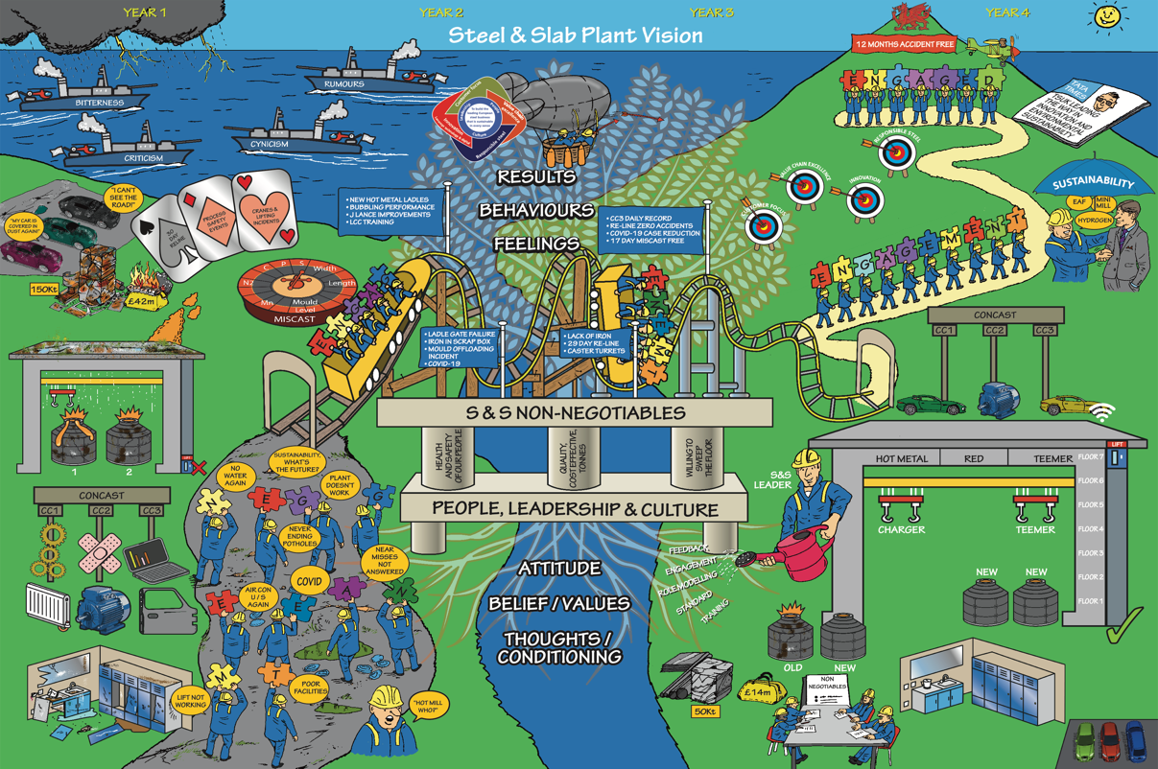
(Image of the Steel and Slab Vision) (Davies, 2020)

The Vision
The Vision is an image that was created by the team at Steel and Slab (A name to describe the B.O.S and continuous caster in one name) The vision commenced in 2020, when a leadership team was brought in to Unleash and Engage a team. This was to support us as an area and to improve the ways we currently engage and solve small issues, such as structures around meeting but also the larger picture of how to improve the maintaining of the process. By this the image above was created so that we had a picture to fall back on to see where we are and where we wanted to be within the time frame that can be seen across the top of figure 1. Year 1 through to year 4. To describe the vision, you can see below year 1 where in 2020 was a difficult time where there was bitterness, criticism, rumours being thrown around the rooms and no one understood the situations going through. Issue with material e.g dust and lime falling onto vehicles from the process due to it not being looked after. Fighting battles all the time to keep the process going very poor stability at the time in the process of manufacturing. The roulette table shows an example that we were always having miscasts but what miscast was next to arise for us. Not making the grades that were required. The poor conditions of the plants issues with the vessels, leaking roofs and more. Issues with other equipment on plant all coming together causing a big issue in the steelmaking plant. Issues with the Casters that we were just putting plasters across them and not making the major change that was required and rectifying the faults in total. All of this can be seen on the left side. We then make our way over and onto the train and this shows to take some steps and its going to be a rollercoaster of having ups and downs which can be helped by engaging, the train is being held up by the three non-negotiables Health and safety of our people this comes from safety events that have occurred and it is the main priority to make sure employees get home to their families. Quality cost and effective tonnes comes from getting it right first time getting away with the miscasts and ensuring that we are bettering the process and how we can spend money in the right places to return the quality we need to be meeting. Finally willing to sweep the floor this comes from wanting everyone to join in and do their piece and all will come together if everyone was to play a part within the area of steel and slab, we will benefit in the long run working as a team. Behind the tracks can be seen a tree and by adding this tree we must grow the values attitude, belief values, thoughts and conditioning, results, behaviours, and feelings. The flags represent hurdles that we have dealt with on the way and have gotten through them. Year 3 where we are beginning to see now in current date, we have replaced vessel 2 and is all in and in working order of operations. We are working more together as a team and as you can see the gentleman watering the tree this shows that we are looking after our beliefs and all above within the tree to show that we are making progress and giving feedback, making positive changes to intervene with the past. The roof can be seen to be repaired and working in a dry environment the new charger crane has been placed in the building and is working. The tick next to the lift showing that it is working. New locker rooms this increase the morale within the teams. We are now on the way top year 4 where we are aiming for 12 month accident free. 3 casters operating and making the most tonnage they can. Be seen leading the way to other areas in port talbot works. But all this can only come from the centre and within the centre is the 3 non negotiables that have been discussed. This is the reasoning behind the project to aim at the number two non-negotiable and try and understand why and make the correct changes that need to be seen in the steel and slab. To provide a good view on our area to the business to show that we are doing all that we can to improve the areas but also save the cost in the right places to allow for more improvements to take place.

The BOS Process

The entire B.O.S (Basic oxygen steelmaking) (Port Talbot (2023) begins with based on estimated iron chemistry and temperature, and the aim chemistry and temperature of the steel, a calculated amount of hot metal is poured from torpedoes into a hot metal ladle. The chemistry and temperature are then measured. This ladle is then either charged directly to the vessel or goes to the iron desulphurization unit dependent on Sulphur levels required for the through process.
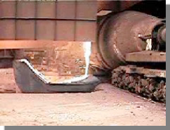
(Pouring Hot Metal from torpedo)

Based on the chemistry and temperature of the iron to be used and the aim chemistry and temperature of the steel, a calculated tonnage of scrap is loaded into a box using a magnet crane with the correct independent scrap types that are in the menu for each specific grade this will go alongside the iron that is poured off at the hot metal.
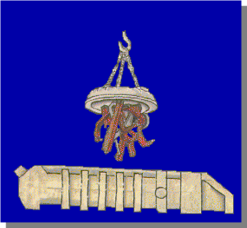
(Magnet crane loading scrap into box)

The iron from the hot metal in next transferred to the desulphurisation unit Lime (CaO) and/or Magnesium (Mg) are injected in the steel to react with Sulphur to form a slag. To make sure the Sulphur does not revert to the hot metal, the slag is skimmed off using a rabbler. The next step is to charge the vessel which follows a certain set of operation The vessel is turned towards the charging stage to a fixed angle and the scrap is poured into the vessel. Approximately 80 % (270 - 310t) of the charge is Hot Metal and 20% (60-90t) is scrap. The vessel is then turned to a different angle and the iron is charged.

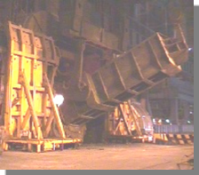
(Charging Operations left image charging scrap and right image charging hot metal)

Next is the blowing operations and this is where the iron and the scrap is mixed to create a steel and we see the use of the sublance that is previously mentioned with technical issues that are to be resolved. Before starting the blow the operator will charge materials required, Lime is added to form a slag which will hold the impurities from the hot metal. Doloflux and dolomet are added to help protect the basic refractory lining. A calculated amount of Iron ore is added as a coolant to help achieve the correct end point temperature. Now the blow can begin A copper tipped, water cooled lance is lowered into the vessel and oxygen is blown at a rate of 1000m³/min. The oxygen reacts with the impurities (Si, C, P, S and Mn) and to produce oxides. The Carbon reacts to produce CO which leaves as a gas and the lime based slag absorbs the other oxide impurities. Below can be seen a graph of the impurities at what stage there is a reaction occurring and their removal.
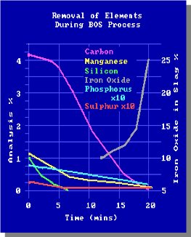

During the blowing there is numerous chemical reactions taking place in the bath which are shown below
- Si + 2O > SiO₂ - Silicon combines oxygen to produce Silica
- C + O > CO - Carbon reacts with oxygen to produce Carbon Monoxide which leaves the vessel as a gas
- Mn + O > MnO - Manganese is oxidised to produce Manganese oxide at the end of the blow
- 2P + 5O > P₂O₅ - The Phosphorus oxidises to produce Phosphorus pentoxide which is absorbed by the slag (when slag is fully developed and is rich in iron oxide)
- Fe + O > FeO - When the carbon content is low iron is oxidised and iron oxide is lost to the slag - reducing yield. (Satyendra, 2023) )
Below I have created a graph that can show an example of reductions in blowing procedure with a key below
C – Carbon
Si – Silicon
Mn – Manganese
S – Sulphur
P – Phosphorous
T - Temperature
(Graph to show example of reaction of elements throughout primary process has effect on temperature)

Just before the end of the blow a disposable probe is sent into the vessel to measure the bath temperature and carbon content and take a steel sample. This allows fine tuning of the blow and gives improved process control. This sample is called the TSC (it can take a carbon measurement). Here is the beginning of the issues that have been arising recently with the increase in spend on reheat and scrapping back (cooling down) and will be discussed further through the project. At the end of blow, the sublance sends in a probe which measures temperature and the oxygen activity of the steel, and also takes a steel sample. This is called a TSO sample (oxygen reading). The information from the TSO probe is used to decide whether the vessel can be tapped or a reblow is needed before tapping. Here is another issue that we are currently seeing as we are having rogue results, we are having to try a decipher whether the readings are incorrect or correct.
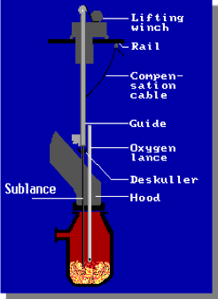
(drawing of vessel with annotation)

The vessel is tilted back so the steel flows out of the taphole into a teeming ladle. Near the end of the tapping process a slag dart is inserted which sits on the slag/metal interface. The dart helps cut off the flow through the taphole and minimizes slag carryover into the ladle. Slag carryover is minimised because Phosphorus can revert back from the slag into the steel. Slag is “generated as a by-product from ironmaking and steelmaking processes” (Sichen, D. and Wang, G. 2005) The vessel is then turned upside down once all the metal is drained into a ladle and the slag is poured into a slag pot. This is the end of the cycle and the vessel can now be used again. Repeating above process and this is what occurs in primary steelmaking.

The next stage to the process is Secondary steelmaking we have a secondary steelmaking because there are grades within the requests of customers that are unable to be achieved during the BOS vessel operations. For example, car manufacturers require ultra low carbon steels, therefore secondary steelmaking is required to further refine the steel and to remove the carbon from the steel. The functions of secondary steelmaking are the adjustment of steel chemistry to meet the chemical specification of the customer. Secondary steelmaking units can adjust the temperature of steel to enable the ladle to be cast successfully and within temperature specification. Ensure that the steel in the ladle is homogenous before sending to the caster to be casted. Another function for secondary steel is temperature control as heat is lost through secondary steelmaking via conduction / radiation from ladle and alloy additions have cooling effect also. There are minimal ways to maintain heat. This will be discussed with the issues around reheating and adding additions to cool back further on in the project investigation. This shows that secondary steelmaking is a key factor in the process of steelmaking. The facilities that secondary steelmaking provides is accurate weighing and effective feeding systems for alloy materials going into the ladle with ability to stir the steel whilst directly feeding into the ladle. The area is made up from four steelmaking units. Two Recirculating degasser units the RH and the RD. and two CASOB units, CAS1 and CAS2. CAS - Compositional Adjustment by Sealed argon bubbling Oxygen Blowing. Is usually the cheaper method of steel refining. Steel is mixed by bubbling from bottom plug / argon lance. A Bell is lowered over this slag free zone. Alloys are added into the steel through this slag free zone. Steel temperature can also be increased by use of oxygen lance (Scheffer , C. 2023) Bubbled though bottom. Hood / Snorkel lowered into steel through slag layer, giving inert atmosphere for alloy addition.
(image of CASOB diagram)

Many different alloys can be added to steel, depending on specification Carbon and manganese levels can be increased other alloys can be added nickel, silicon, titanium, aluminum Most of these are added in the form of ferroalloys.

RH and RD degassers are the other form of secondary steelmaking units we have in Port Talbot which are recirculatory degassers which a Vacuum is formed. Injected argon gas lowers the density of the steel - forcing it circulate up through the ‘up leg’ and down through the ‘down leg’.
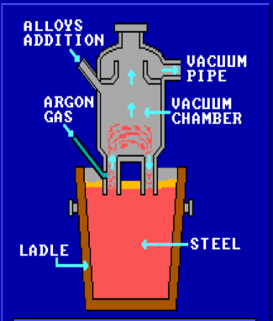
(Diagram of degasser)
Mixing and deoxidation / decarburisation occurs simultaneously. Alloy trimming is carried out after the de-carb process. Heating / Cooling takes place. Vacuum systems are used to remove certain gasses.
- hydrogen (dehydrogenation)
- oxygen (deoxidation)
- carbon (decarburisation)
Reheating is carried out by means of oxy blowing if and when required and the temperature in the ladle is not hot enough. In the opposite term we can add scrap to cool it which has been spoken about previously. During the secondary treatmenst here are some chemical reactions that are carried out and take polace throughout the process.
- Decarburisation / Deoxidation C + O -> CO (carbon monoxide)
- Reheating with aluminium 2 Al + 3 [O] -> Al₂O₃ (alumina)
- Carbon monoxide gas is removed via the offtake.
Alumina forms inclusions which need to be floated out from the steel and this is classed as a slag and is removed from the process and recycled elsewhere on site. Non metallic inclusions are formed from reactions of sulphur and aluminium in the steel. Inclusions reduce the quality of the rolled steel slabs. Inclusions will float to the top of the steel and be absorbed into the slag and removed from the process as discussed. The Ladle is moved around the process via large 500t cranes and the use of transfer cars into each part of the process from Primary steelmaking into Secondary Steelmaking and finally to the Continous Caster.

The Caster is the final section within the steelmaking process in Steel and slab In Port talbot. There is 3 casters. Caster 1, caster 2, caster 3. Below is a tale created to show most of the stand out characteristics and differences between each caster that is in the area. This table shows the exact information that is needed to understand the difference between each.

The process at the caster is once the ladle is sent through from secondary steelmaking using a transfer car into the caster area. A 500T crane will then pick up the ladle and place on the back arms of the caster and turn its arms around to begin the process of Casting. Once the ladle has turned a shroud is attached to the bottom of the ladle to create an inert atmosphere between the ladle and the tundish to reduce nitrogen pickup. The ladle is then opened and the stee begins to flow and fill the tundish around 40t – 45t dependantg to which caster, once the correct weight in the tundish is met they can then start to cast the slab and as below can be seen moving down the zonez through the segments. It will then be cut to customer length at the the torch cut of unit. It the correctly cut slab is then removed and taken to the hot mill. Below is an image to show a design of a caster.
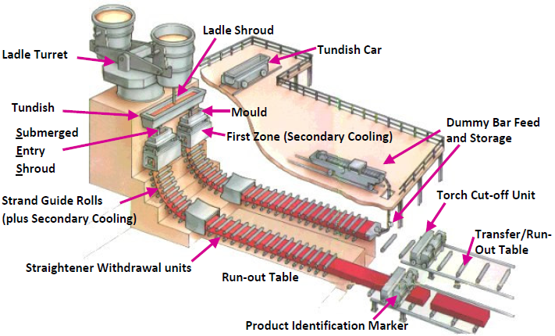
(image design of a Caster)
Timeline

The importance of following in a timeline in certain instances is very critical to do with ensuring that work and progress is continuing to be made because this if not followed can cause “delay’s progress in one’s work” (Biljon, L.V. 2021) Using timelines can have improvising factors such as improved communication this can allow us to stay in touch with all parties involved and ensure everyone is still making progress and provide help as required. Prioritisation to ensure if anyone else in a team is working on something then they are aware what is a priority task to be worked on. “Role defining” (Martins, J. 2022) this allows each member of the team to understand what their task are in the aim set of the project that there would be no duplication or anything of the sort withing the project. Working within a team can contribute towards “team building” (Rob et al. 2022) and must assemble the project team in order for them to concentrate on the shared objective because the success of the project depends on many distinct team members. The project could stagnate or churn if there are disagreements, personal agendas, or competing desires. A skilled project manager knows how to unite the team behind a shared goal. “helps improve performance” (Pandey, S. 2023) ) working in a team can boost morale but also offer friendly competitive situations to ensure the task Is completed and you can be pushed to the limits with the aid of the team from influencing. For example, if the member of the team has come across this before then they would be able to guide to improve the performance.he final project management skill would be “Don’t lose sight of time, budget and quality”. (Ahn, L. 2023) foundation does not change. A project is successful when it is finished on schedule, on budget, and with deliverables that the owner is happy with or an outcome has come from the project. The primary responsibility of the project manager is to keep the entire team informed about these three important factors: time, budget, and quality. The timeline to be followed for the problem solving will not be as such a set period but tasks will be carried out on the subject until we can see the return or that the asset is showing clear signs of improvement or the area being problem solved which would include the sublance and is in a stable state there will be continuous efforts to improve as it is a critical piece of plant equipment and has numerous effects throughout process this will be ongoing every day until return and starting investigation from January 2023. During the investigation the timeline will be spoken and constructed throughout due to there will be new aims throughout within the objective. The plan to return the sublance to its full state by the month of April is a realistic set zone due to the numerous issues being caused. The second objective of secondary steelmaking timeline will be slightly more planned due to the problem solving to be carried out throughout. Beginning from January 2023 and continue again to make progress throughout the plant on what can be improved within the area of secondary steel with aims throughout the months to ensure targets are set and can be achieved so that they do not drop off the radar with other ongoing work within the plant. The final objective on the use of ladle watcher and re-introduction is underway as of December 2022 with progress being made and planned to be continuing throughout the year of 2023 with a set of pieces that require work on and also a set of targets that will be discussed further down the problem solving on the system that is ladle watcher with targets to be hit every month to ensure that the system/programme is on track to be returned by a set date to ensure it doesn’t fall off the agenda.

Sublance
The Sublance as spoken previously is a key component and to re iterate its key parts in the BOS process in the vessel operations it takes a temperature reading and a carbon reading. (Team, E. 2021) If these reading are incorrect on the in blow dip then the system will not know what to do to for example giving it the correct amount of further oxygen required to blow out all the carbon or even hit the right temperature. This is causing issues of the vessel overblowing which is causing the temperature to be increased and being too hot for secondary steelmaking. But also, on the other hand it is causing the vessel to be underblowing which coincides and if that is the case then this will create a colder end temperature.

To describe the above diagram to put into context above text as the C decreases the temp rises & ideally would follow the ideal trajectory ending up in the target window. At the in blow sublance measurement the temp & C should be in the window indicated. The Model then calculates forward to predict what the temp will be at the aim C content & calculates the amount of oxygen or coolant required to correct the C and temp. If the bath is too hot I.e. above the ideal trajectory line A-B then the amount of coolant required to achieve the aim temp is calculated. If it is too cold I.e. below the ideal trajectory line C-D then the volume of oxygen to reach the aim temp is calculated. But this will be at the expense of ending lower than the aim in C. The EBM (End Blow Model) will not be accurate if no IB dip is taken or if the IB dip fails for quality. In these cases the EBM will default to 0.4%C. This could be completely wrong, resulting in the wrong oxygen being required by the EBM. This can result in over blowing, leading to Nitrogen miscasts which again leads to loss of money. Also the EB (End blow) Temperature may be too hot or too cold. Care must be taken especially on low Nitrogen grades when an IB dip is not taken or if it fails.
(Diagram of vessel with sublance operation)

Some of the issues that we have been facing is that the sublance has not been working to its optimal / failing once a new instrument management system was fitted due to previous out of date and not fit for purpose any longer. In most cases this is picking a good value however it is still failing. no bath depths are being recorded. We’re still not getting a calculated bath height on vessel 1. The calculated bath height is currently 2.79m for every blow, despite getting immersion depths.This will affect our process control the longer this goes on.

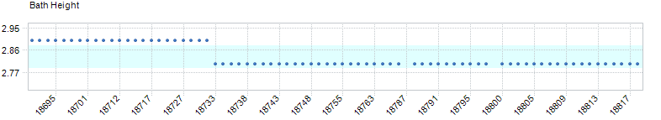

Due to this the power supply was switched out as possibly there is not enough power going into the system as it is possibly not rated high enough for the new system.
Below is an example from a TSC dip at 19:05 heat 18969. You can see the lance height has gone down to take a dip but no measurement was taken. When looked on viewer (See screen below) the heat number hadn’t updated and the blue light was indicating.
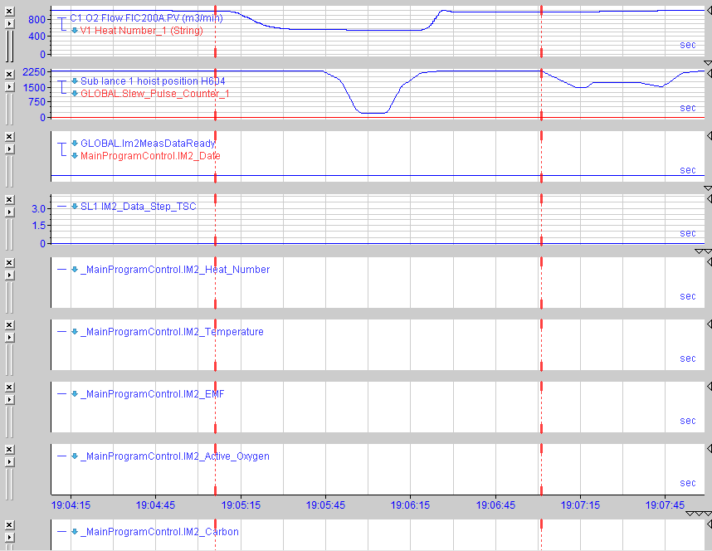

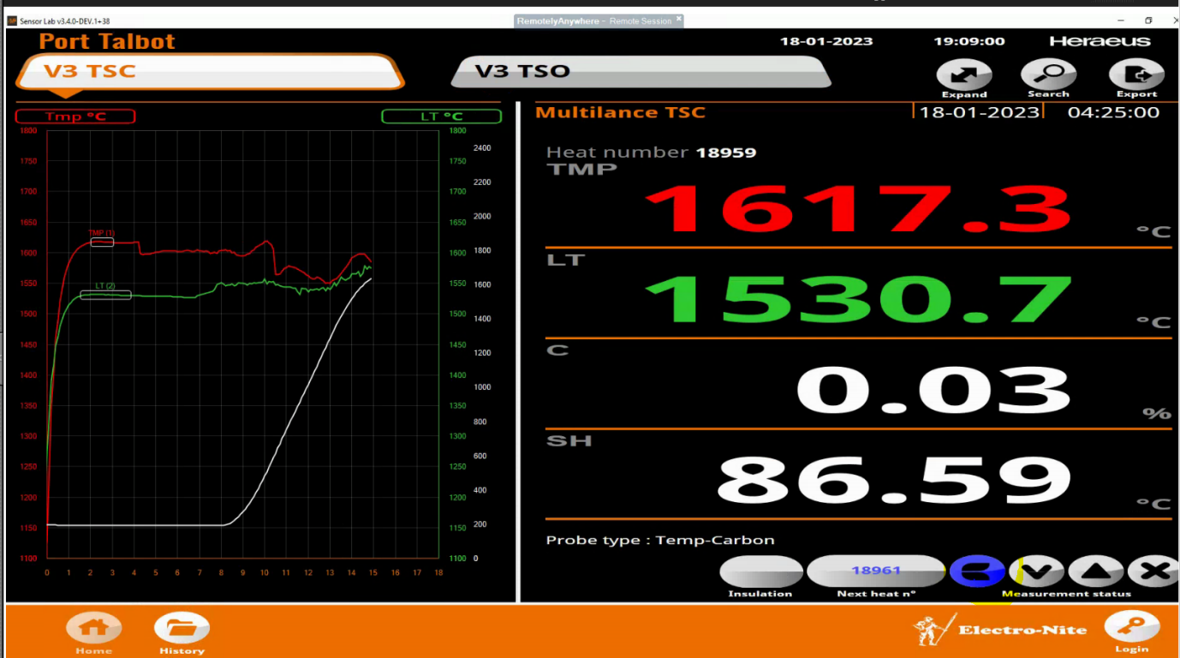

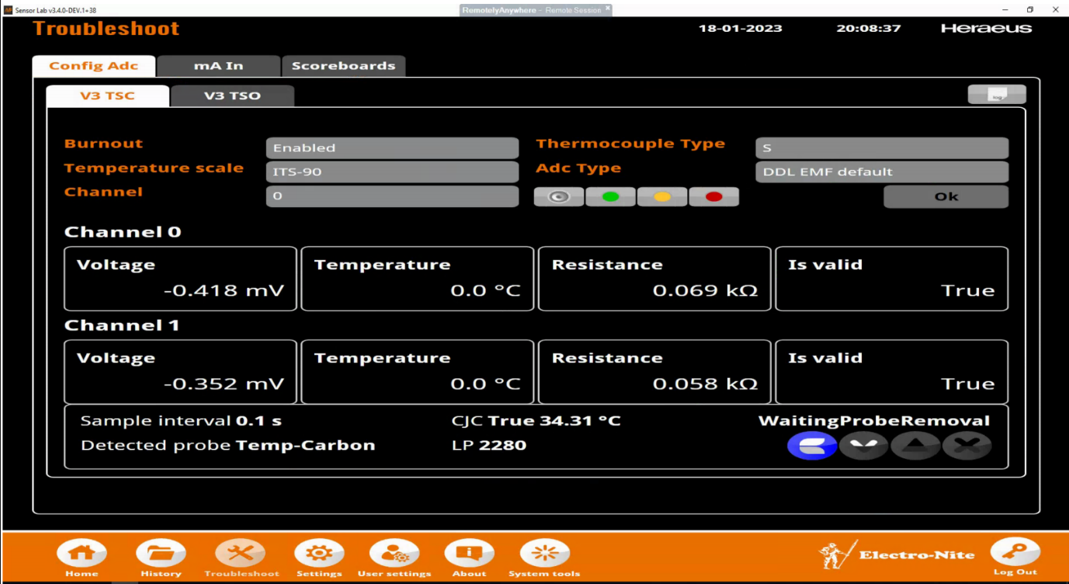

On the next blow 18970 the TSC screen didn’t update and a dip was performed and no results were measured same as before.

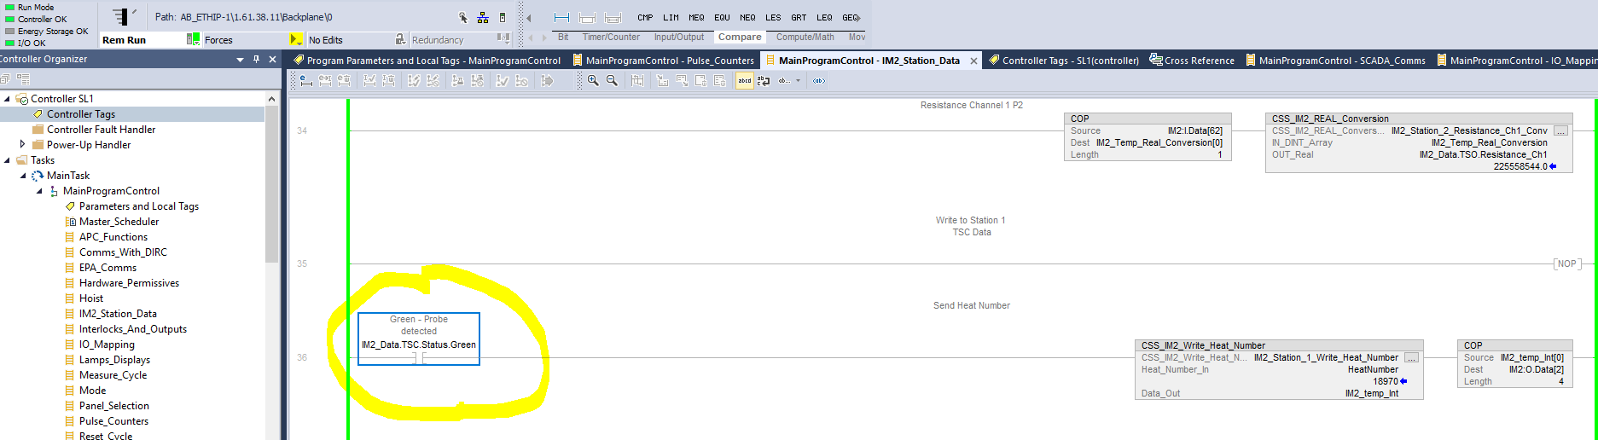

Power cycled the IM2 to try and resolve this issue with the TSC measurement. This issue seems to have occurred since the sublance was bent suspected a hardware issue. TSO measurements updating/recording results for heat 18969 so the PC hadn’t crashed completely. The 23m cable found the plug at the top on the 6 floor to be damaged inside.
The indication on the IM2 viewer is now as expected showing a temperature and carbon probe connected. On the picture below blue is carbon measurement, green is temperature Measurement
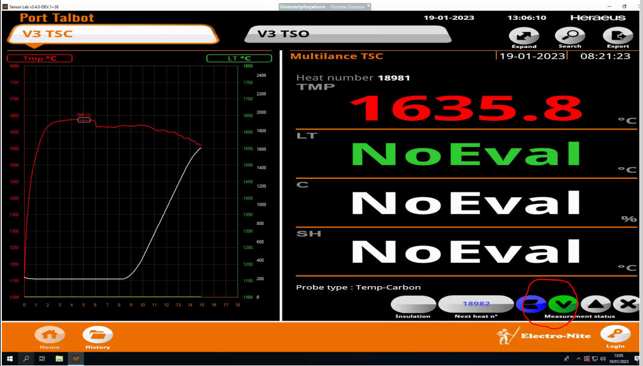
With work carried out still seeing issues such as. Poor connection bottom of sublance. Poor connection top of sublance. Too high nitrogen purging pressure down the sublance. Large skulls on the sublance.

Trial on heat by taking 2 TSO dips sequentially (one after another). Due to what we are seeing is a difference in immersion depth dependent on the type of probe, therefore if we take 2 TSO’s it may give a more like for like comparison when investigating the temperature variation. Ht. 19608 x2 TSO taken. We are seeing no bath heights due to the unstable bath conditions – the Stir is still on during single vessel operation. See the Green line below very unstable. We do sometimes get a bath height so this will be updating the bath level on level 2.
Another trial carried out by taking TSO’s as normal. Can then compare the traces with the TSO’s sent in faster today to determine whether the unit is more sensitive to unstable bath conditions. Found that bath levels are working, less noise on the green Oxygen trace providing a steady trend. 6 x TSO results with bath levels. every time we get a lower Carbon on the in blow we see a struggle to get end blow temperature pickup. Graph below highlighting this. We have picked above and below 0.2% Carbon and as can be seen the temp pickup is lower.

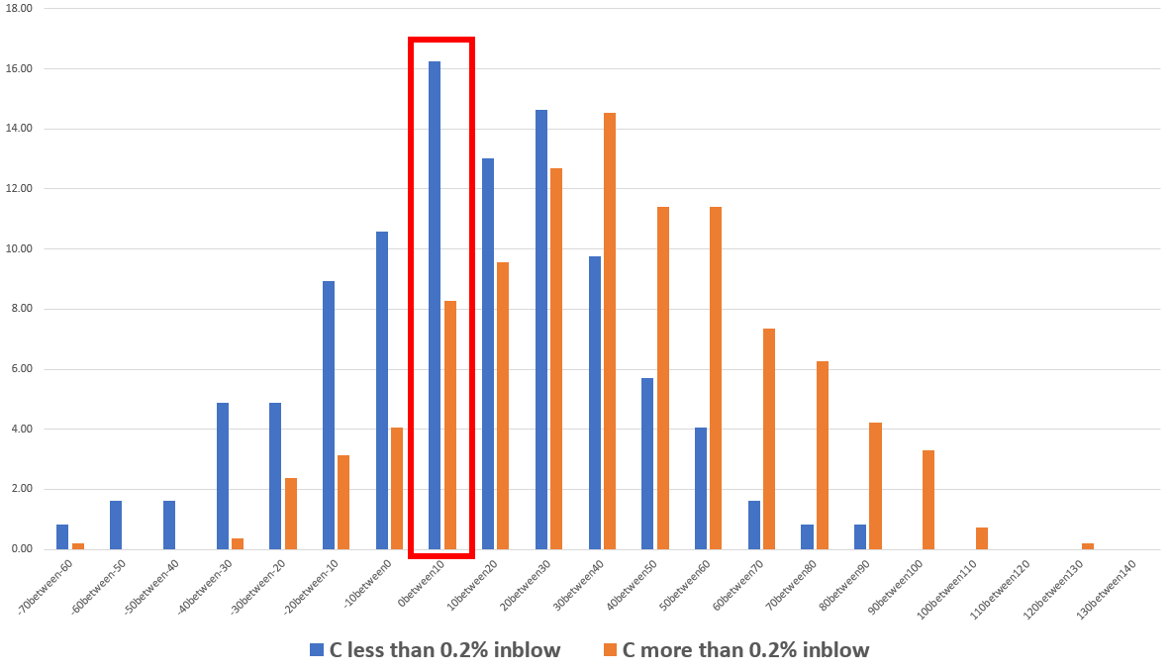

Sublance Skulling issues evident - Large skulls coming within 2 / 3 heats - Oxy @ dip is around 550 / 570 m3/hr – previously reduced oxy flows @ dip to around 500 m3/hr or just below in the 400's now seem to have crept back up to the latter 500's at dip. TSO time to go in after Oxy off had been increased, that the traces have improved on Oxy and temp. see below some examples Heat 42 fail – we noticed lots of slag on the sublance present. Oxygen unstable due to the bath agitation or dipping too soon after blow has finished.

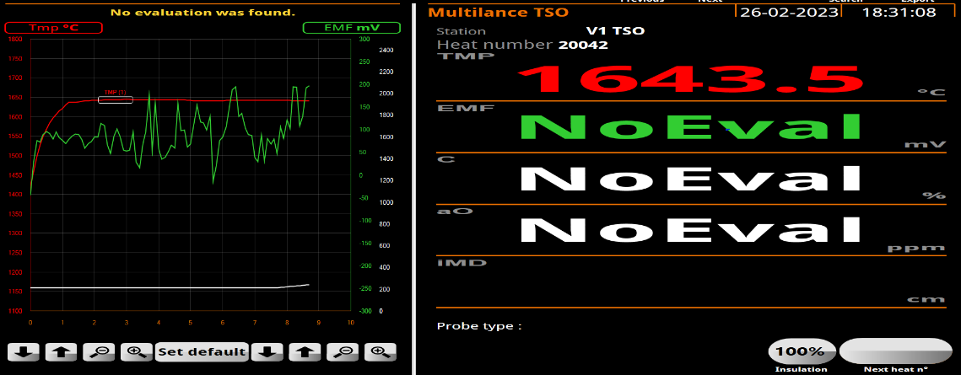

Heat: - 73 - Struggled to connect EB X 4 tapped out and checked sublance over during tap.
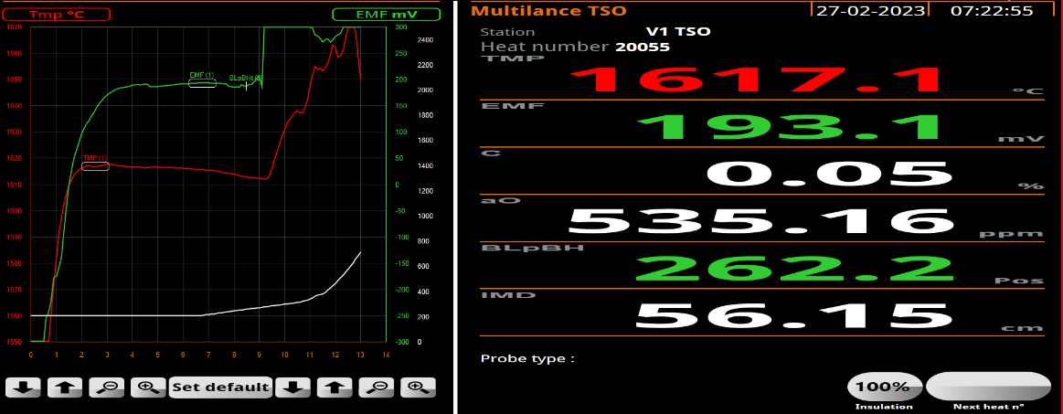
Sublance -unable to connect TSC as chamber 2 not closed. Issue found TSC probes have nipple on tip of lance which is catching when probes drop on to tilt arm. No further problems.

Examples are below shown seen where a cause of reheat is occurring and issues are raised, Ht. 20013 - issue with Sublance dips, IB Dipped 1682 Q1 .227% C - Heat blew on 1300 m3/min around 40c pick up, EBM Requested 1.1t of coolant around 9c - EB Dipped 1671c Q1. colder than the IB causing reheat.
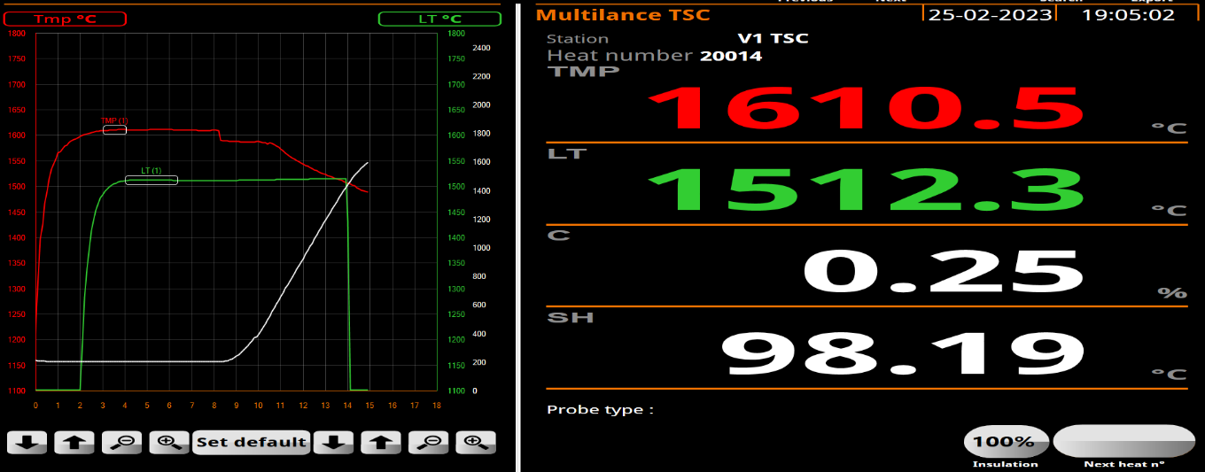
Ht. 20014 - Sublance issues IB Dipped 1610c Q1 .239% C - Heat blew on 1000 m3/min around 30c pick up, EBM Requested no coolant - EB Dipped 1640c- operator reported the model is not asking to blow on enough to achieve EB aim. Model
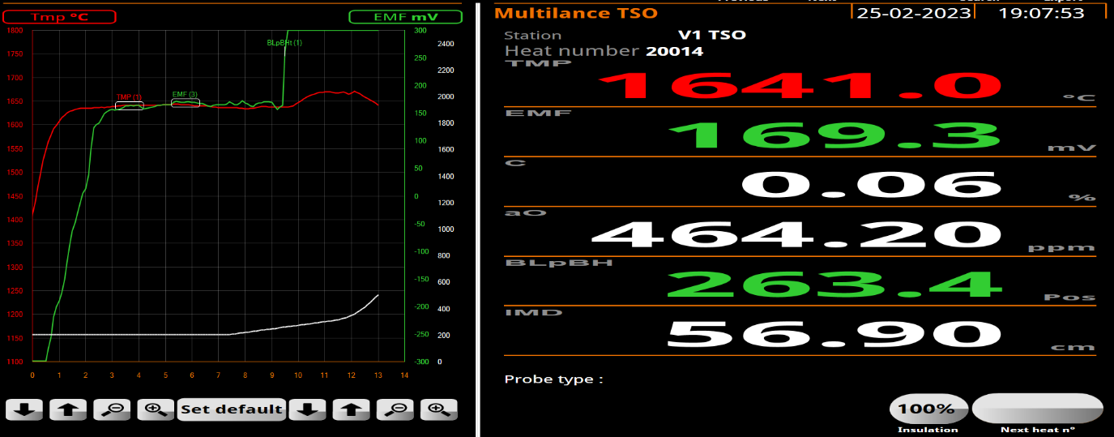

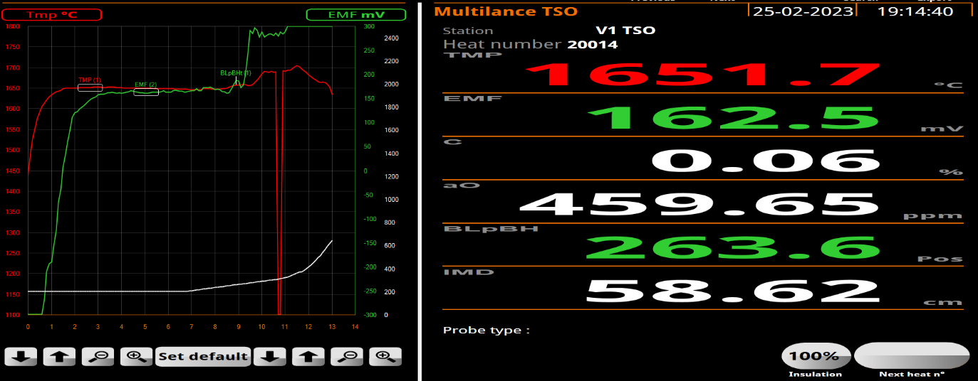

Ht. 20017 - IB Dipped 1656 Q1 .221% C - Heat blew on 1300 m3/min around 40c pick up, EBM Requested 1.3t of coolant around 11c - EB Dipped 1640c Q1, colder than the IB, Reblown and tapped - IB Temps issue.

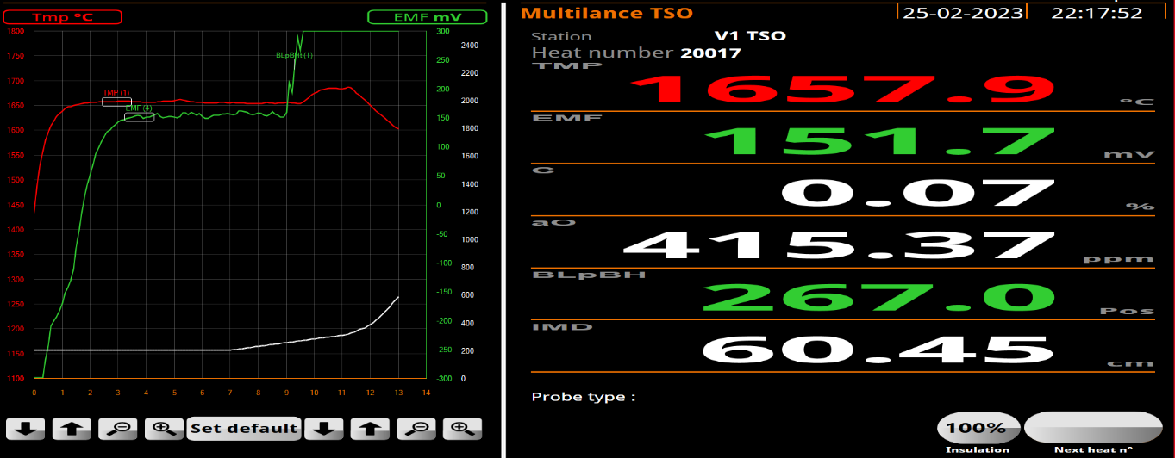
Ht. 20021 - IB Dipped 1649 Q1 .181% C - Heat blew on 1300 m3/min around 40c pick up, EBM Requested no coolant- EB Dipped 1649c Q1. exactly same temp with no pickup.

The next step is to revert back to the old system that had become to old and no new parts can be sourced this will provide us information such as

- TSC -Liq & Bath temp comparisons visible in the control room with the instrument being on the network simple downloading of data for comparison analysis.
- Visual traces and results from both instruments.
- Start to build up confidence in the results.
- If there is still a desire to change the instrument for the old multilab this can be perform during 2 vessel operations.
- Start to run a sensor lab on vessel 2 in parallel to check instrument performance before any discussions about replacing the old multilab on vessel 2.

By continuously checking the instrument loop / there is no further tests to perform on the measurement loop. Below are initial calibration results alongside with some examples of test results and findings.

Calibration tests
- Old unit = 1501.4 Bath temp and 1501.5 liq channel.
- New unit same input – 1501.1 bath temp and 1500.8 liq channel
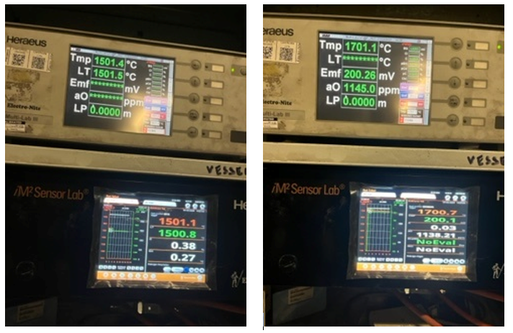

Heat 20119 TSC - Old Multilab TSC = 1612 bath temp and 1507 liq
New Sensor lab TSC = 1612.5 bath temp and 1507.4 on liq
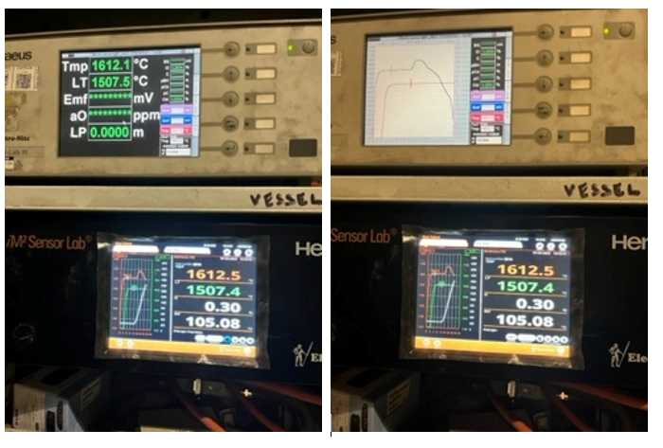

Heat 20119 1st TSO - TSO old multilab = 1683.7 bath temp 225mV and 1426 ppm very unstable Oxygen trace. TSO new Sensor- lab =1684.2 bath temp 221mV and 1349ppm also very unstable Oxygen trace.
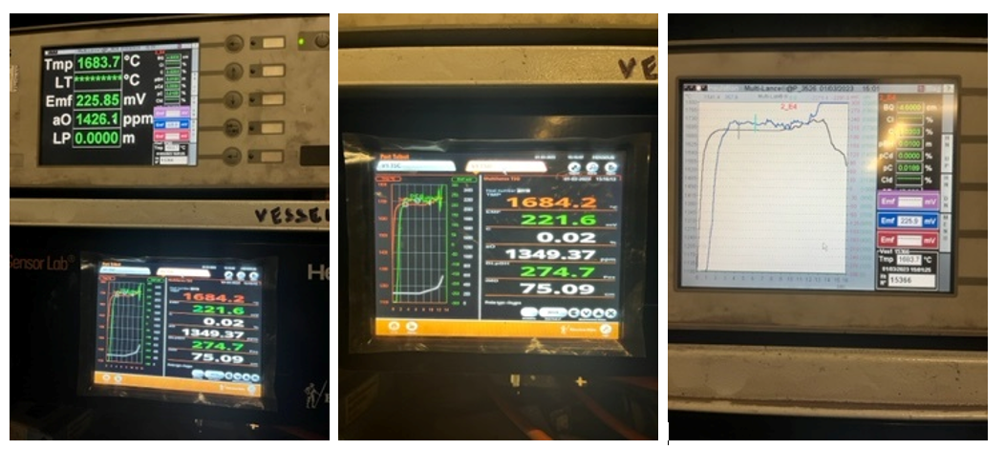
Heat 20119 2nd TSO - TSO old multilab = 1647.2 steel temp 204mV and 793 ppm .
TSO new Sensor- lab =16847.6 steel temp 204mV and 792ppm .

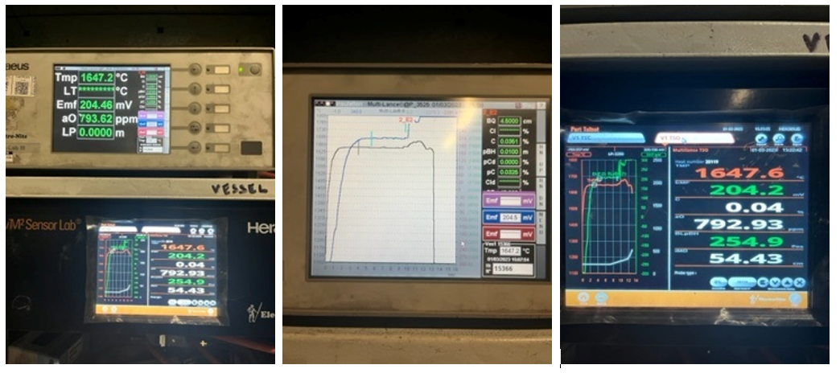

With the above information we can see that measurements from the Sublance have much improved since the devices were piggybacked in week 9. The decision made due to this isto leave as is until V2 returns, but sill monitor within the process control meetings to ensure it is not left to slip and it is kept on top of. Once the old removed issues seen already but with findings that the old model had switched itself off from the system. Only running on the new screen, On checking that the old system was still on but it wasn’t and are unable to connect. We have also had issues arise again. Example of which is Heat: - 61 - IB Dipped 1621c Q1 Blown on 1200 m3/min - EB Dipped 1628 Q1 for 1660c aim. 7c pickup from IB to EB - Reblown - 1650c and tapped

The next step again is to reset the old server but unable to connect on the screen in pulpit so that we can compare. In addition, changes made to in with regards to Ht 20473 which gave an IB temp of 1111°C (Q1) and resulted in significantly adjusting the HLRM from 5 to the max value of 20, it had wanted to move +42. There are no limits to the adaption on HLRM. (Heat loss running mean) which allows us to know how cold the vessel is and it will then calculate a running mean for if extra temp is required if the vessel is colder. Due to o these rogue temperatures changes made are that any temperatures outside of 1500-1800 wont get saved to the system because this could have negative effect on reheating but also other scenarios also such as the refractory of the vessel integrity.

The MultiLab (Old system) is still connected in parallel to the Im2, found that the display is not working in the pulpit due to a network issue which have been unsuccessful in resolving the issue. The device on the network but for some reason the data is not being received by the PC. As the multi lab is still working in parallel it is still logging all the results, I have compared the results for the heats in question to the Im2 and both sets of readings are the same. The data off the Multi lab to analyse again. Numerous sublance data errors and info still used to update CBM parameters making the HLRM jump from 5 to 20, confirmed there were no limits to adaptions. A temp range in the cbm has been placed to ignore temps outside of 1500-1800 as a quick fix to ensure no mishaps during the period of completely resolving the issues. Now with the issues on vessel 1 there is major concerns about V2 sublance return from reline due to vodafone firewalls, and cointinue to progress finding the root cause to sublance issues on V1 but carry on as usual for now and let us know of any issues. With changes now made a further examples listed below –

Ht 20490 / 94 & 95 – TSC failed to send across to the EBM as it was flagged as a “Wire break” on the Heraeus system. (See image below) loose connection found, some wear on the cable. Water ingress would flag this up.
Traces do look better than some of the Q3 traces seen and use to update the EBM but still there is not have enough experience with these to say if we are still better off having some data.
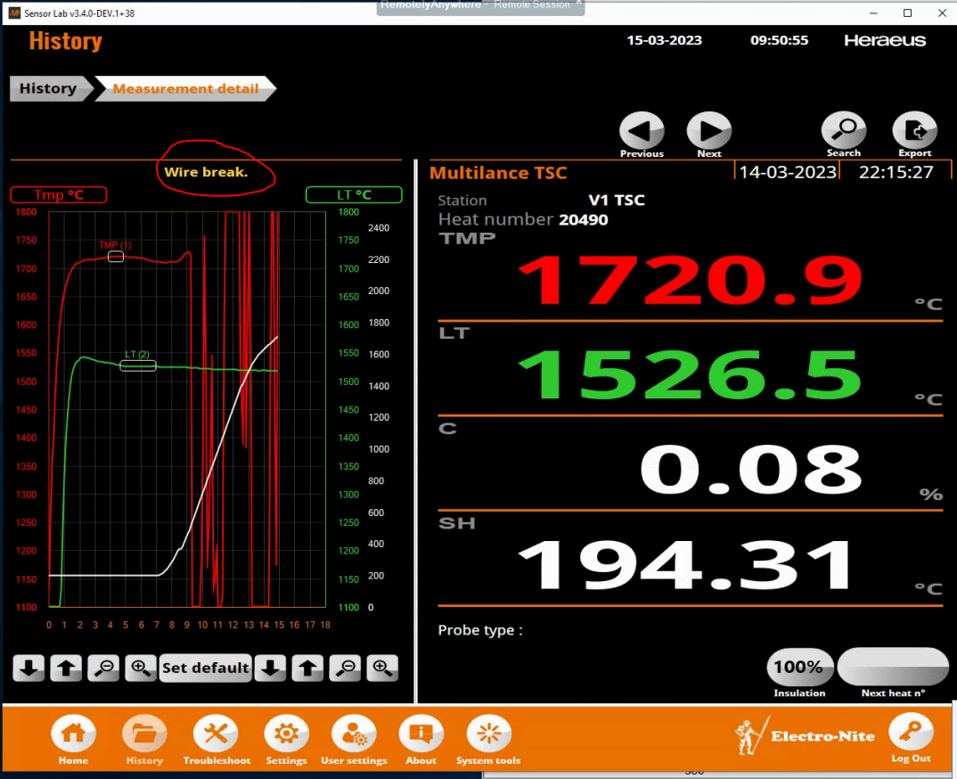

Ht 20492 – Recycle – Oxy figure did not update in time of EB.
EBM did run and produce results but it was delayed, it was triggered immediately after IB Dip but the EBM took 2mins to run. In terms it appears to be an issue where the EBM is not ready to measure due to other information cycling and noticed on Full recycles and where we send the sublance in earlier. 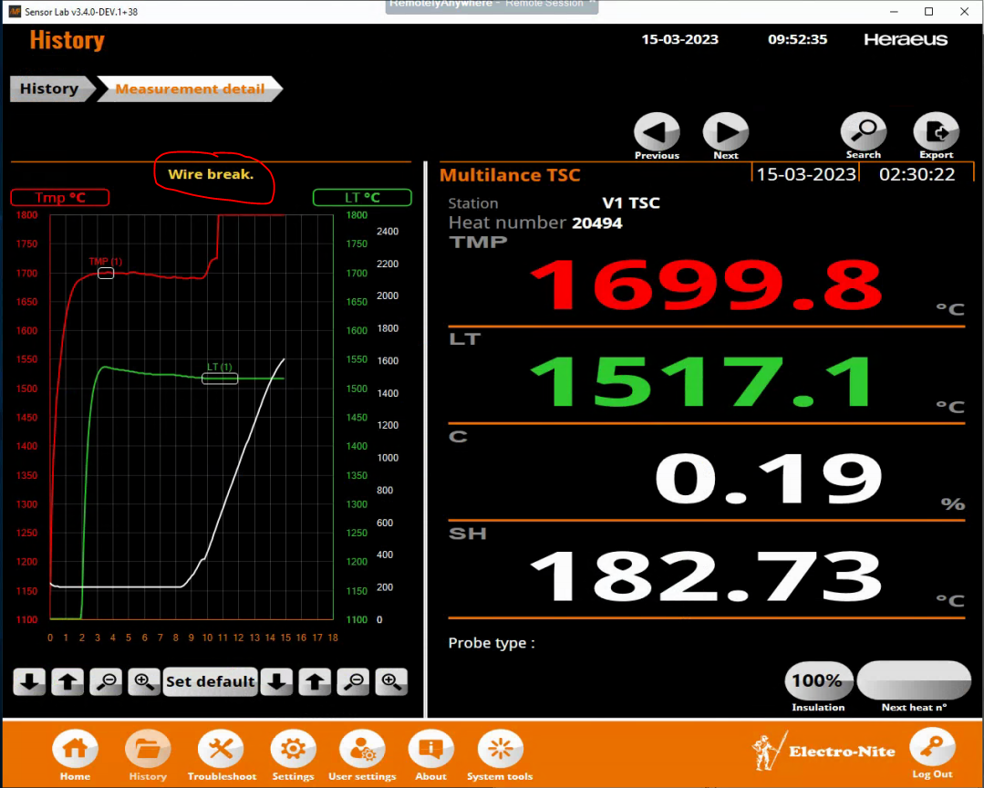
Ht 20491 – all over at IB. Very high CBM demand Oxy at 19794m³. all to check samples but came back as expected. Some runs of the model indicated this was balanced for the recycle initially but then diverted to Ht92, the oxy seems to jump up after reverting back to a normal balance but this is also along with a significant increase in Aim EB Temp for a 3335 grade, Not sure if this has played a part. Also noted a large swing in the HM Ratio from 80% to 89% as per QA to max HM for Ca grades, never considered this to be an issue previously and would expect the model to deal with it but something noted as occurring at the same time, Tap Wgt 323t.
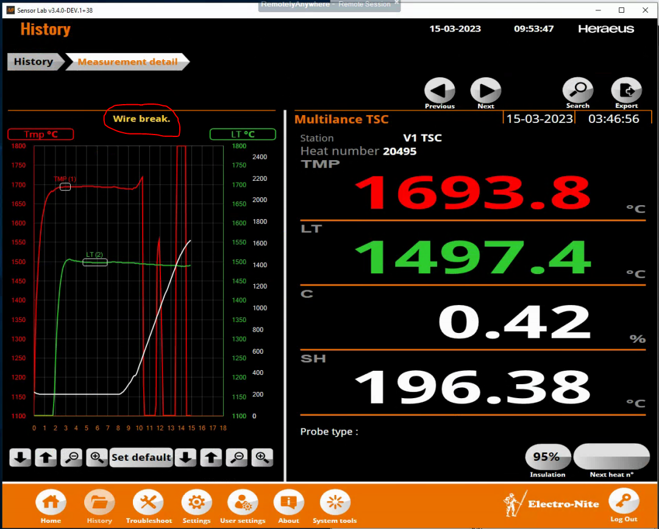

With continued issues going through over a period of 3 months during the end it was found that with Vodafone there were network changes carried out and IP addresses checked and found that not all info was on the same IP server this therefore not allowing all the information to be used causing reheat and scrapping back issues and causing through process issues. With the IP addresses adjusted to match the new IM2 server and all parameters switched to avoid the Vodafone firewall which is the case blocking some information going over. Which seemed to be the information that we were missing and was not updating. In a last attempt the old system was removed and run on just the new server. There is a much better steady performance with the reliability, and this was counterchecked with operators. There is much more reliable data reading from the sublance now and seeing the positive effects within secondary steelmaking. Further in the project I will discuss the weeks of reheating throughout the issues rising with the sublance and the effects that it has had on the process during the time before the issues and during the issues and finally discuss after the issues that show a steadier process.

Ladle Effects
One of the biggest costs in the BOS plant is through temperature stability. Significant benefits can be had by regularly lidding teeming ladles, lids can reduce temperature losses by 5-10°C which could be worth over £500K/annum (reheat aluminium) with further potential gains in vessel additions, process stability/quality and vessel lining life
To unlock these savings we will need to use RFID tags. To accurately track when lids are used on teeming ladles and keep production supplied with enough lids for the ladle fleet. The ladle can also be a negative factor due to if the ladle is to cold then it will chill off the steel quicker and therefore can effect the through process. The goal is to maintain as much temperature within the ladle as this then takes the factor away from a cold ladle removing the temperature from the steel than what it predicts it will do. We can then maintain temperature through the process. This will then allow us to calculate the heat lost from the teeming ladles and remove the uncertainty associated with temperature losses and achieve the savings above. There can be negative effects for poor temperature control in secondary steelmaking. If the temperature is to low this can result in some grades not being suitable for the customer as it is not to its exact requirements within the through process. It can also cause the caster to freeze up and solidify which would have further process issues. But on the other hand there can be consequences if the temperature is to warm whilst casting and can cause the shell of the slab to break in casting – this can cause break out which again can lead to further issues at the caster. Being to warm can also slow the throughput down at the caster. To quantify the effect of refractories in the teeming ladles in terms of °C that they have a positive and can have a negative effect on the steel they transport within secondary steelmaking is a key part to the through process as the steel is moved around by the ladle and in there for a duration of time. To do this it will first quantify the effects of the current, showing us that lids aren’t used and then compare these results to the following scenarios. Various lidding strategies based on turnaround times from plant data and then follow up and continue to work towards maintaining through process temperature. The modelling strategy has had to use a number of assumptions to get the temperature values, these are combined of. The ladle refractories are of their installed thickness on the barrel, justified by the lack of wear in the barrel. The cooled refractories are compared to a fully saturated ladle to give a consistent comparison throughout the process of testing and comparing. The barrel refractories are only considered in the cooling effects, the bottom refractories are not taken into account as after 8 hours of cooling the bottom had an effect of 6 ehich provides us that there in no major effect on the bottom of the ladle itself and we are losing the heat elsewhere through the ladle. Because of these assumptions the values given are conservative and likely to be a minimum cooling effect in most of the applications. The reliability of the model has been compared to previous thermocouple trials and models and found to have a strong correlation, because of this there is a high confidence in the values gathered. Below is an image of a make up of the bottom of the ladle and the barrel

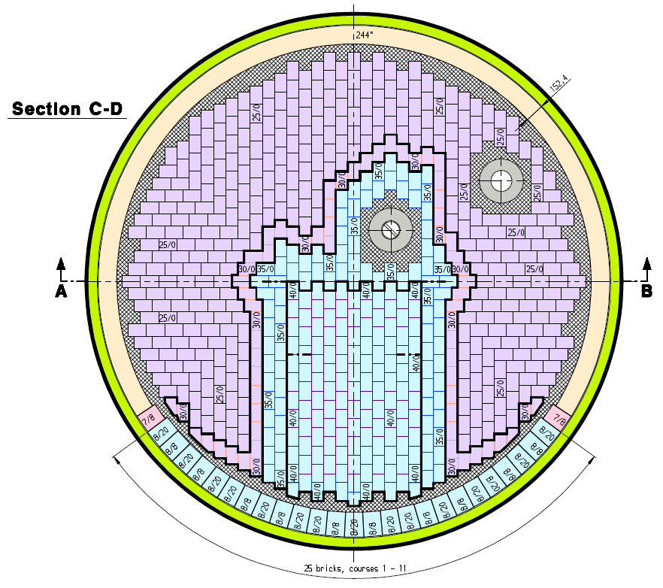
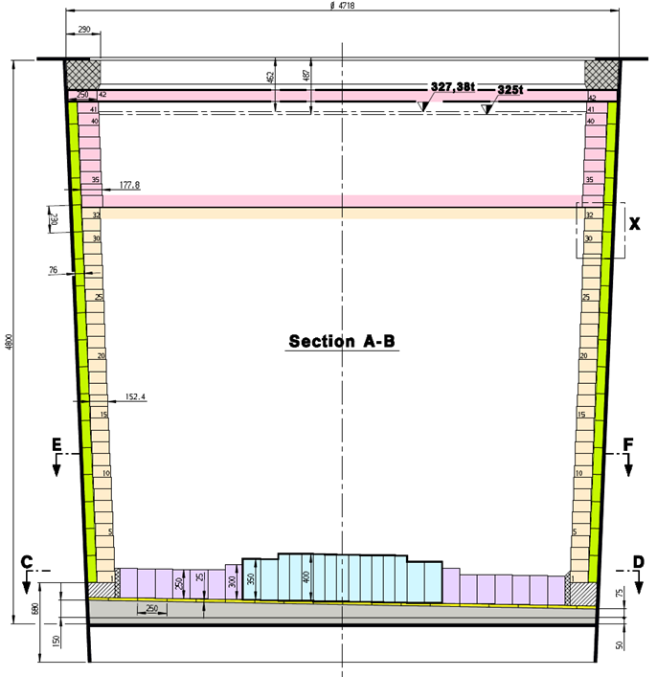

Below is a graph that will show the cooling effects of refractories on steel and unlidded ladles
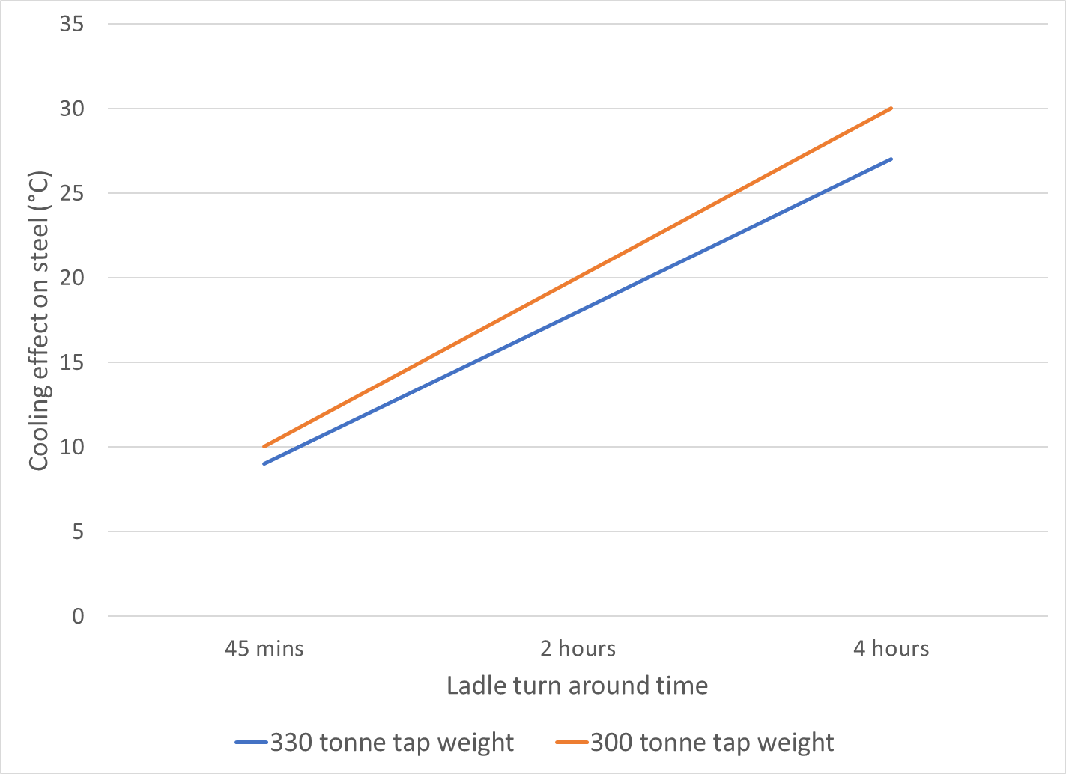
(Cotton. L, 2021)

The graph above shows us that if there is more steel in a ladle and the weight is higher but this will have many variables within the steel process on tap weights. This will come from the inititial balance at primary with how much iron and how much scrap is placed and charged into the vessel. Tapping will then have a factor because of slag bulk and draining the metal into the teeming ladle. Above is two of the most average tap weights that we see in the steel plant from one end of the scale to the other end of the scale. The more weight of steel in the ladle the less temperature we will see lost from the ladle in total as can be seen from the comparison. We see the biggest change when there is a contact of 2 hours or more with steel to the ladle for temperature loss of an unlidded ladle.

Above is a different comparison to show when the ladle is emptied of steel to when it gets a lid put on in a period of 40 minutes, 30 minutes and 60 minutes. This comparison shows the benefit of utilising lids and enforcing the use of them to make our steel temperature through process better. With the use of a lid we can maintain the temperature of an empty ladle for longer therefore when the steel makes contact it will not cool it down as quickly.

The temperature benefits from the above show that It was found that refractories have a considerable cooling effect on steel in teeming ladles and lids are the most effective way to mitigate this. From these findings it demonstrates the importance of a robust tracking system for when ladles are lidded i.e. RFID tags which is an ongoing project being introduced and will require further work to be at an operational use and be able to make use of the readings to ensure that they are precise and accurate for the Steel plant. Temperature losses up to 27°C have been seen for ladles cooling for 4 hours without a lid which is then reduced to 15°C when lids are used giving a 12°C benefit. By lidding a ladle within 40mins instead of 60mins the potential savings are £174K/annum Below is a table that shows the benefits of lidding compared to ladle cooling time in the left section and the benefits of lidding sooner in the right section. This table was created from an average readings of results from the process.
 | Benefit of lidding (°C) |  |  | Benefit of lidding quicker (°C)
Cooling time | 30mins unlidded | 40mins unlidded | 60mins unlidded | 30-40mins diff | 40-60mins diff | 30-60mins diff
1.5hrs | 11 | 9 | 5 | 2 | 4 | 6
2hrs | 13 | 12 | 9 | 1 | 3 | 4
2.5hrs | 17 | 15 | 10 | 2 | 5 | 7
3hrs | 19 | 17 | 13 | 2 | 4 | 6
4hrs | 14 | 12 | 9 | 2 | 3 | 5
 |  |  | Average | 1.8 | 3.8 | 5.6
The key finding to the above would be that :

Average cooling time (hours) | Benefit from lidding (°C)
1.5 hours | 3
3 hours | 10

These findings will allow production control to be simpler as predictable temperature losses have been found giving more stable process and optimisation of fleet use. This can then be used to reduce tapping temperatures and/or reduce reheating, currently we chemical reheat by reducing this we get the following benefits: Less aluminium used creating cost benefit of £62k/°C which is made up from Heats per year 11000 x 40% ladles that need reheating x 10°C which is average reheat x 11kg aluminium per °C reheat x Aluminium = £1.28/kg = 11000*0.4*10*11*1.28 = £620k across the through process per year as of 2022.

Now with the updated figure of 2023 the price per kg of aluminium is £2. It is now ever more critical to ensure that we help stop reheating through the process at all costs. This equation is Heats per year 11000 x 40% ladles that need reheating x 10°C which is average reheat x 11kg aluminium per °C reheat x Aluminium = £2/kg = 11000*0.4*10*11*2 = £969k this creates a much bigger area for cost saving.

Greater predictability also reduces clogging effects, steel cleanliness, volume issues and scrapping back which are extra factors to cost saving for a future task. Combined benefits gives 7°C for high production rate and 15°C benefit for slow production rate. Improved lidding practises can save between £186k - £620 per year whilst also enforcing the simple task of lid utilization we will proceed to see continued benefits and positive effects on reheating. With these improved practises we can remove the majority of extreme reheating and bring greater predictability to the process and better inform production for reheating and management of the teeming ladles ladle process.

Graph trending

There are a number of graphs across the few weeks that issues have been seen with through process temperature in steel and slabfrom the issues that have been discussed above and below is where in week 48, 2022 the amount of reheat is at. This is at a high amount and required to be reduced and a change made to coincide with the project and the reasoning of it.
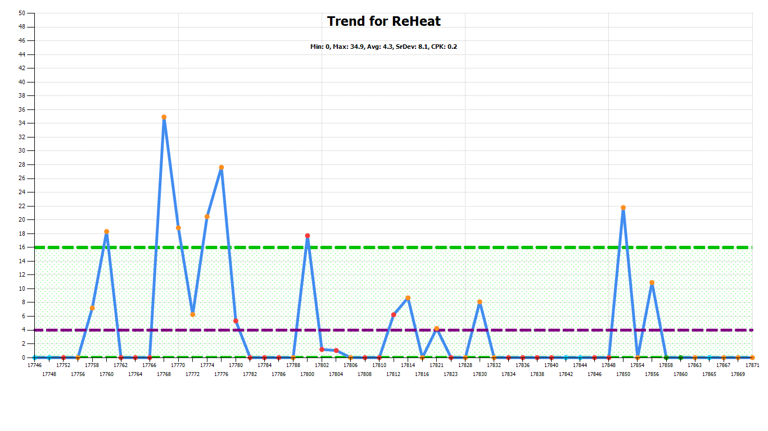
The below graph shows the reheating for week 1 2023 which is when we first developed the issue on the sublance and can see that there is numerous peaks of times that we have reheated in secondary steelmaking and throughout the process of the heat. This is where a issue was raised and investigation began to the issues occurring and we were seeing.
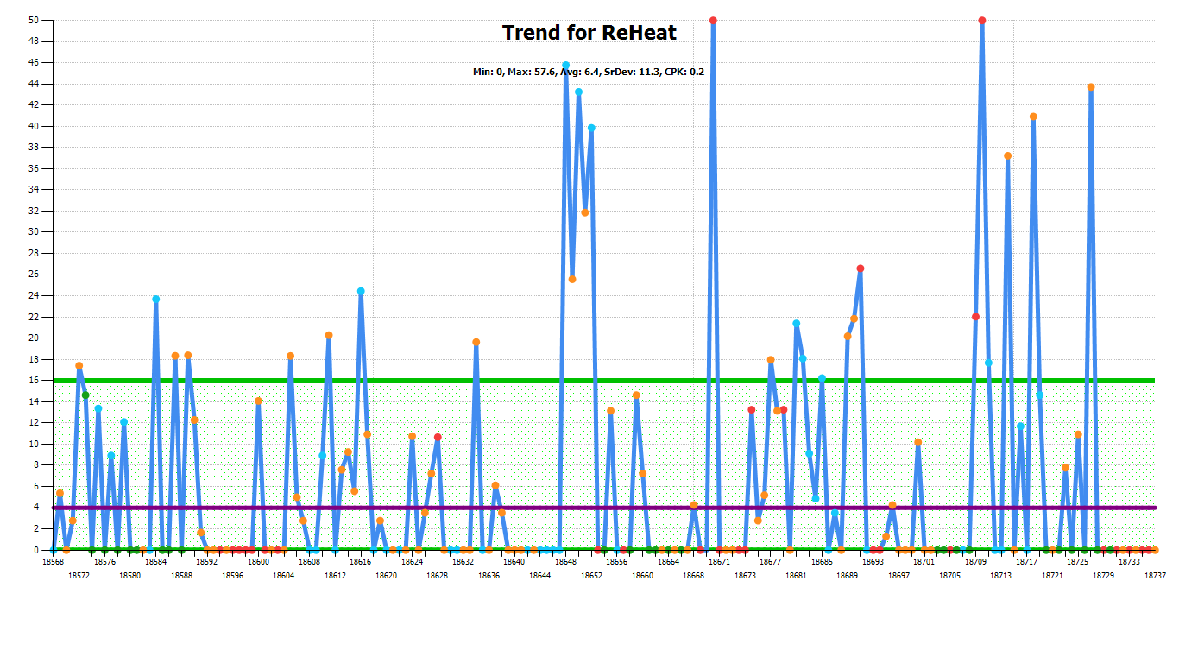
Below during week 6 we see a number of abnormal reheats but there is progress with the ongoing issues as spoken above with the timeline of the issues that were being rectified and continued being worked on at the time. The amount of reheat here shows that not on a whole that all heats required reheating.
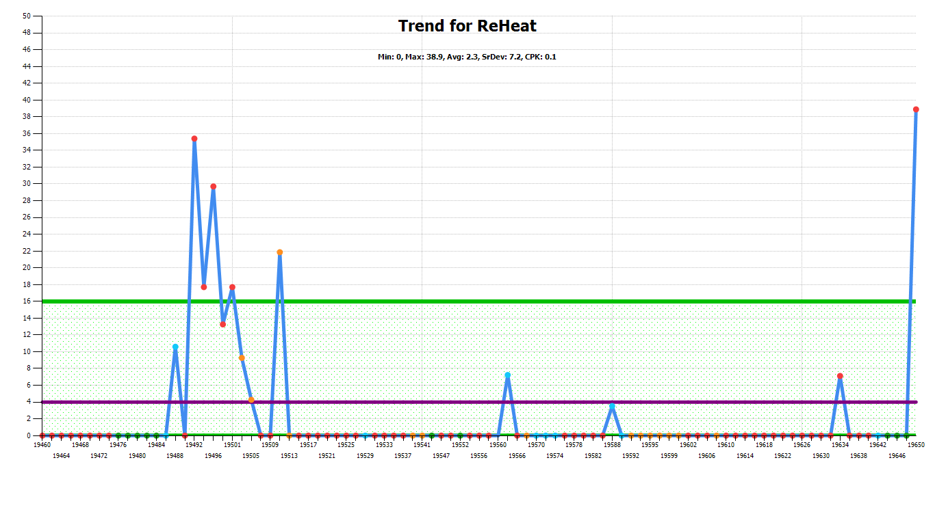
Underneath we see that the trends continue to improve by week 9 and the piggyback system is removed to test the work that has been carried out and we are still seeing a steady decreasebut some spikes in high reheating. This shows that there is progression being made but further work to be carried out.
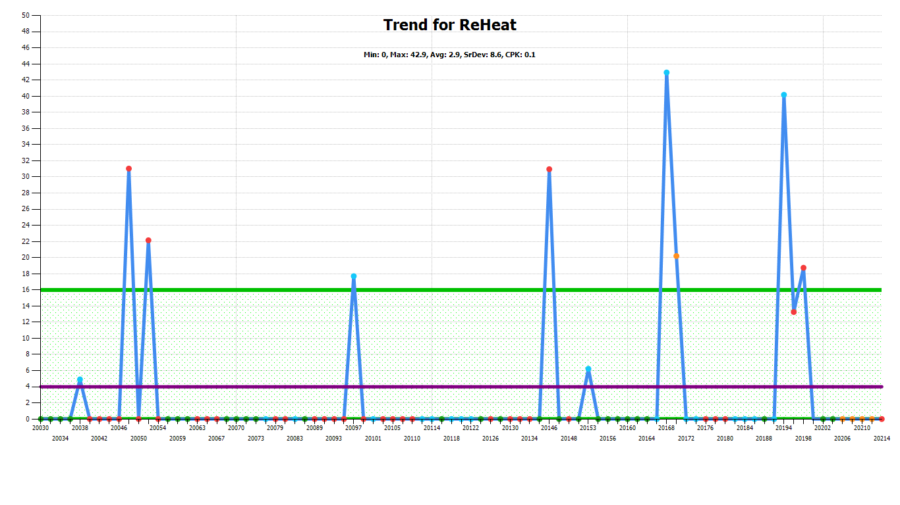
Below in week 11 where the old unit was removed and running on the IM2 we see a big increase in total reheating for the week. This has shown a negative effect on the process for cost overall and has impacted the process.

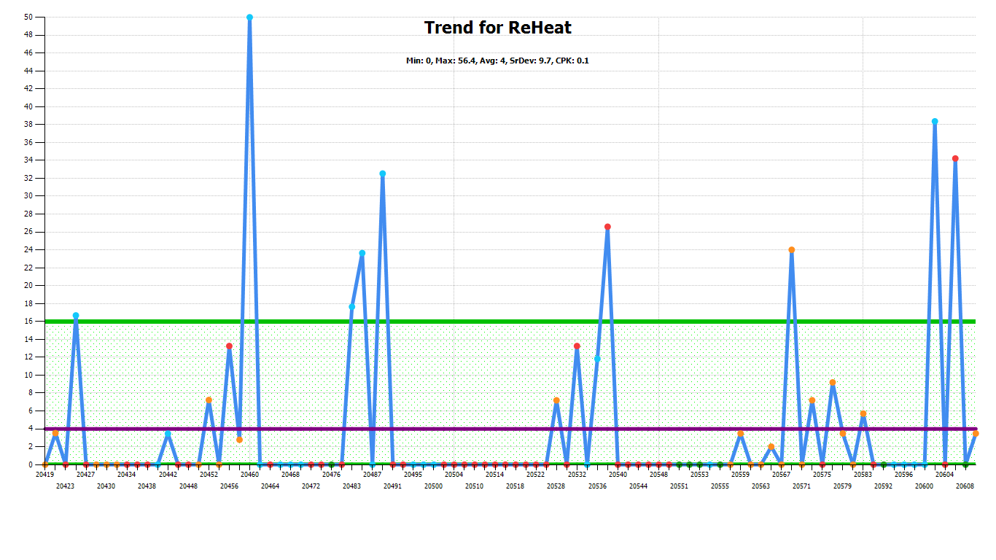
The current trend below shows that there has been barely any reheating carried out and with all the progress and updates carried out to the system we are seeing consistent improvement for the overall week that the total work carried out on the investigation was stopped and returned to standard with the new IM2. It shows 3 abnormal heats which can occur and this could be from other variables within the steelmaking process.
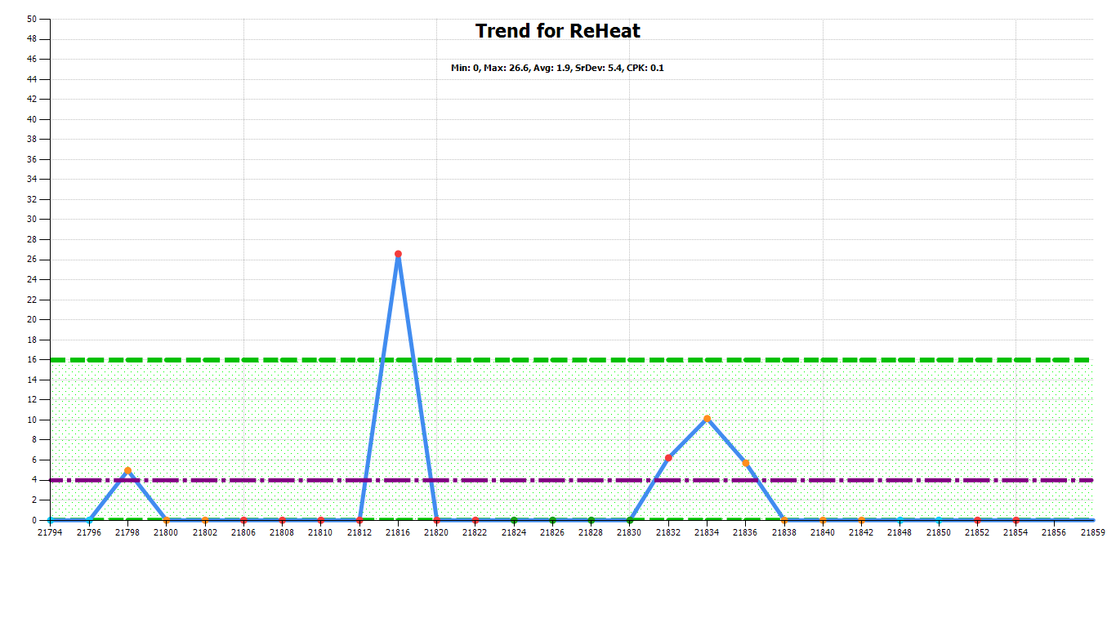

Further work

With knowing that greater predictability of temperature also reduces clogging effects, steel cleanliness, volume issues and scrapping back which are extra factors to cost saving for a future task. There is a numerous amount of trends that can be carried out to get to a more precise again value by Temperature loss curves for ladle scenario, empty ladle no lid trend, calculate projected temperatures based on the volume differences within a ladle using software. Temperature loss curves based on tap temperature. Enforcing lidding within the bay that is possible and making sure at every given time that we can use a lid we do utilise the lid. This will also require further training to operators to provide the understandings why and what the reasons are for this. Below there can be seen the effects of a lid vs no lid and the temperature savings

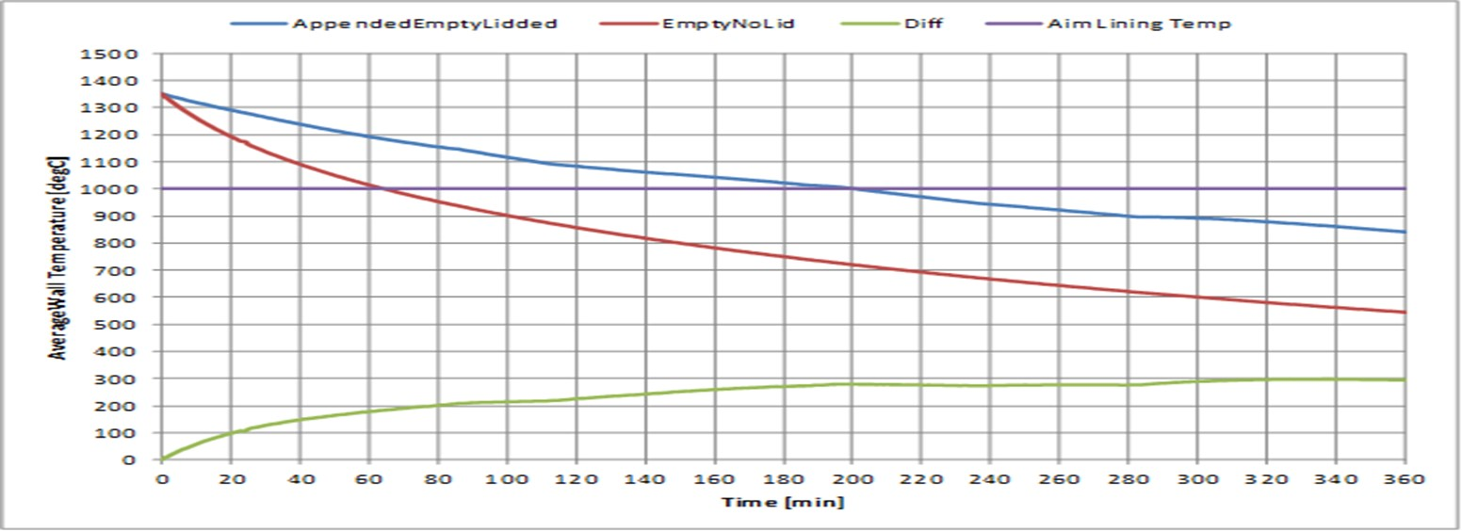

This can be monitored by the RFID tag that has been discussed but the carried out work was to be stopped to investigate the sublance due to the gain of having a working sublance and the gain of a RFID tag system. The RFID task will continue the current progress of the project is that they are on site and fitted to the lids but not the ladles. The next step will be to validate the data coming from the readers. Implement the change to the tags and then integrate into the current steel and slab systems. There is a calculated total of 8 weeks work. There is an opportunity to continue pushing forward overall with the temperature through process by weekly meetings this can lead to other further work that can create more savings for the company by looking into the other variables that are discussed already and brought up previously.

Conclusion
To conclude the project carried out shows an in depth and understanding what we can do to perform more efficiently and how to better maintain the through process temperature from when the crude iron is brought into plant to when it leaves secondary steel to go to the continuous caster. It has known that it has a wide range of significant effects. Additionally, gaining a better knowledge in thermocycling of ladles is necessary to consider what stages mostly and why we lose temperature at these sections therefore this can have a positive impact on steelmaking in the BOS plant. However as discussed above there are a number of ways that we have and can mitigate the temperature loss. The Aim and Objectives have been brought to attention to fall in line with the number 2 in the B.O.S senior management vision steel and slab non negotiables that is quality, cost and effective tonnes. Which has been met throughout the project of improving the issues of through process temperature. Throughout the discussion on the sublance, losing a large amount of heat through the ladle process in Secondary and ladle watcher/RFID. However there are also many other ways that can be taken tioo mitigate temperature loss as can be seen by the further work to be carried out. It is essential to continue to improve the ongoing battle with achieving a stable through process temperature. Not only does it have a positive effect on the process but has additional benefits as well such as cost saving, improved energy efficiency.
Overall the issue around temperature loss / gain is very complex and is difficult to hold at a steady without any sporadic readings. However with careful attention and commitment by all working around to continue with the best practices it is possible to mitigate many variable and continue to see the benefits of effective temperature control. By taking a pro active and comprehensive approach to the issue, as a company can ensure that the process of monitoring remains efficient, safe and reliable over the long term by continuing to follow improvement plan.

References
(Browne), (Image: Rob et al. (2020) The endless troubles of the Port Talbot Steelworks, WalesOnline. Available at: https://www.walesonline.co.uk/news/local-news/rollercoaster-story-port-talbot-steelworks-19307489 (Accessed: 23 February 2023).
Georgia Yates (2018) The opening of Abbey Steelworks: How the ‘city of steel’ symbolised Wales in the 1950s, Wales since 1945. Available at: https://walessince1945.wordpress.com/2018/03/22/the-opening-of-abbey-steelworks-how-the-city-of-steel-symbolised-wales-in-the-1950s/ (Accessed: 17 April 2023).
Student et al. (2022) University of Wales trinity saint david: Latest reviews: Student Reviews & University Rankings Eduopinions, EDUopinions. Available at: https://www.eduopinions.com/universities/universities- in-united-kingdom/university-of-wales-trinity-saint-david (Accessed: 12 April 2023).
Ferriman, J. (2019) ‘Blast furnace 5 back on stream’, 19 January.
Davies. J (2020) email to MSPT&All January 2020
Birchall, B. (2016) Port Talbot and its long tradition of steel-making, ITV News. Available at: https://www.itv.com/news/wales/2016-01-19/port-talbot-and-its-long-tradition-of-steel-making (Accessed: 18 March 2023).
Turner, R. (2016) A history of the Port Talbot Steelworks, WalesOnline. Available at: https://www.walesonline.co.uk/news/wales-news/port-talbot-steelworks-industrial-leviathan-10702555 (Accessed: 17 May 2023).
Port Talbot (2023) Tata Steel in Europe. Available at: https://www.tatasteeleurope.com/construction/sustainability/performance-at-our-sites/port-talbot (Accessed: 17 March 2023).

Dawson, D. (2017) A brief history of steel in Port Talbot, Medium. Available at: https://medium.com/@dmdawson91/a-brief-history-of-steel-in-port-talbot-bcdd0c6b587a (Accessed: 17 January 2023).
Metal Courses – Steelmaking & Casting (Swansea University)

Metal Courses – The Process evolution of steel (Swansea university)

Steel and Slab Vision – Easily accessed within the Steel and Slab database
Biljon, L.V. (2021) Home, UASA Trade Union. Available at: https://www.uasa.co.za/importance-of-timelines-in-project-management-part-1/#:~:text=A%20timeline%20helps%20to%20set,may%20need%20to%20be%20done (Accessed: 17 May 2023).
Martins, J. (2022) What is project management and its benefits? [2023] • asana, Asana. Available at: https://asana.com/resources/benefits-project-management (Accessed: 17 January 2023).
Pandey, S. (2023) 5 benefits of project management to organizations, Project Central. Available at: https://www.projectcentral.com/blog/project-management-benefits/ (Accessed: 17 May 2023).
Rob et al. (2022) 15 powerful benefits of Project Management, Project Bliss. Available at: https://projectbliss.net/benefits-of-project-management/ (Accessed: 17 March 2023).
Ahn, L. (2023) 10 rules of Highly Successful Project Management, Project Smart. Available at: https://www.projectsmart.co.uk/role-of-the-project-manager/10-rules-of-highly-successful-project-management.php (Accessed: 14 March 2023).
Team, E. (2021) Steelmaking / bos plant, Eurotherm Limited. Available at: https://www.eurotherm.com/en/heat-treatment-articles-en/steelmaking-bos-plant/ (Accessed: 17 May 2023).
Edwards, L 2020, RFID
Satyendra (2023) News, IspatGuru. Available at: https://www.ispatguru.com/chemistry-of-steelmaking-by-basic-oxygen-furnace/#:~:text=During%20the%20BOS%20process%2C%20around,Fe%20content%20of%20the%20slag (Accessed: 17 April 2023).
Sichen, D. and Wang, G. (2005) Steelmaking slag, Steelmaking Slag - an overview | ScienceDirect Topics. Available at: https://www.sciencedirect.com/topics/engineering/steelmaking-slag (Accessed: 17 May 2023).
Scheffer , C. (2023) Basic oxygen process, Encyclopædia Britannica. Available at: https://www.britannica.com/technology/basic-oxygen-process (Accessed: 17 March 2023).

