

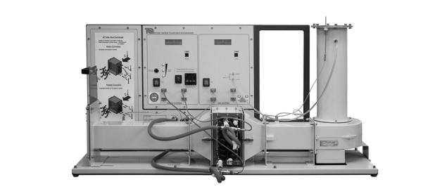

TD1007 Water to Air Heat Exchanger Experiment
  - To demonstrate the effects of Varying temperatures and air and water flow rates on a steady flow, cross flow heat exchanger system
Paul Gormlie (P149642) | BEng Motorcycle Engineering | 04-04-2019
Lecturer: Rob Goodson
Experiment carried out: 12-02-2019
Contents:
1. Introduction: 2
2. Apparatus and materials: 3
3. Methodology: 5
i. Experiment 1 – The effect of varying water flow rate: 5
ii. Experiment 2 – The effect of a varying air flow rate: 6
iii. Experiment 3 – The effect of varying temperature: 7
4. Results: 8
i. Overall results analysis. 8
ii. Experiment 1: 9
iii. Experiment 2: 12
iv. Experiment 3: 13
5. Conclusion: 15
6. Appendix: 16

Figure 1: TD1007 Heat Exchanger apparatus in experiment configuration. 5
Figure 2: Chart comparing Heat emitted by water circuit and power absorbed by air 10
Figure 3: Temperature efficiency comparison chart. 11
Figure 4: Heat transfer co-efficient vs water mass flow rate. 12
Figure 5: Heat transfer co-efficient vs Air mass flow rate. 13
Figure 6: Heat energy lost by water and gained by Air in exchanger Exp. 2 14
Figure 7: Heat energy lost by water and gained by air Exp. 3. 15
Figure 8: Chart showing Temperature efficiencies vs Air mass flow rate. (Exp. 2) 19
Figure 9: Chart showing heat transfer co-efficient vs Air mass flow rate. (Exp. 2) 19
Figure 10: Temperature efficiencies vs air mass flow rate (Exp. 3) 20
Figure 11: Heat transfer co-efficient vs Air mass flow rate. (Exp. 3) 20

Introduction:
For the second semester of Thermo-fluid and Mechanics studies, all students were assigned the task of carrying out a number of laboratory experiments, relating to the operation and thermodynamic principles of water to air style, steady flow heat exchanger systems.
Overall, three different experiments were carried out, each performed to demonstrate the effects of variations in temperature, variations in mass air flow and variations in mass water flow rates had on the system respectively.
These three experiments were carried out in pre-assigned groups of approximately 5-6 students, using university supplied equipment in accordance with supplier guidelines.
The results of each experiment were recorded and then used to calculate various data pertinent to the study of these varying effects. A workbook was generated in MS Excel and a series of charts compiled to graphically demonstrate the effects of these changes. These results were then analysed and will be discussed in the remainder of this report.

Apparatus and materials:
In order to carry out the aforementioned experiments, students made use of the TD1007 water to air heat exchanger apparatus from TecQuipment, this apparatus consisted of a large metal frame, to which a large rectangular duct was mounted horizontally. At one end of the duct, a fan is mounted in such a way that it can blow air through the ducting and heat exchanger assembly, approximately half way along the ducting, the heat exchanger is mounted. This heat exchanger consists of a series of copper pipes fitted in a parallel arrangement, through which water can be pumped at a varying rate of flow.
There are three optional types of exchanger that can be fitted to the apparatus, a 32 tube parallel arrangement, a 16 tube parallel type and also a 16 tube finned style exchanger. For the purpose of this series of experiments, the 32 tube type exchanger was used.
At the furthest away end of the ducting (from right to left looking at the apparatus) a slide valve was fitted to the output allowing the user to control the mass air flow within the duct.
Also fitted to the apparatus, was a water tank fitted with a heater allowing the user to heat the water to a desired temperature, before it is then pumped through the exchanger and then fed back to the tank. The mass flow rate of water can be set using the water supply valve fitted to the piping from the tank.
Fitted at each end of the exchanger there are two temperature sensors, these are used to measure the input and output temperature of the water respectively.
Also fitted along the ducting are 3 temperature sensors, one measuring the ambient temperature and two further sensors measuring temperature at the inlet and the outlet of the air duct.
Finally, just below the orifice into the fan housing, an air pressure sensor is fitted allowing the mass air flow rate into the system to be measured also.

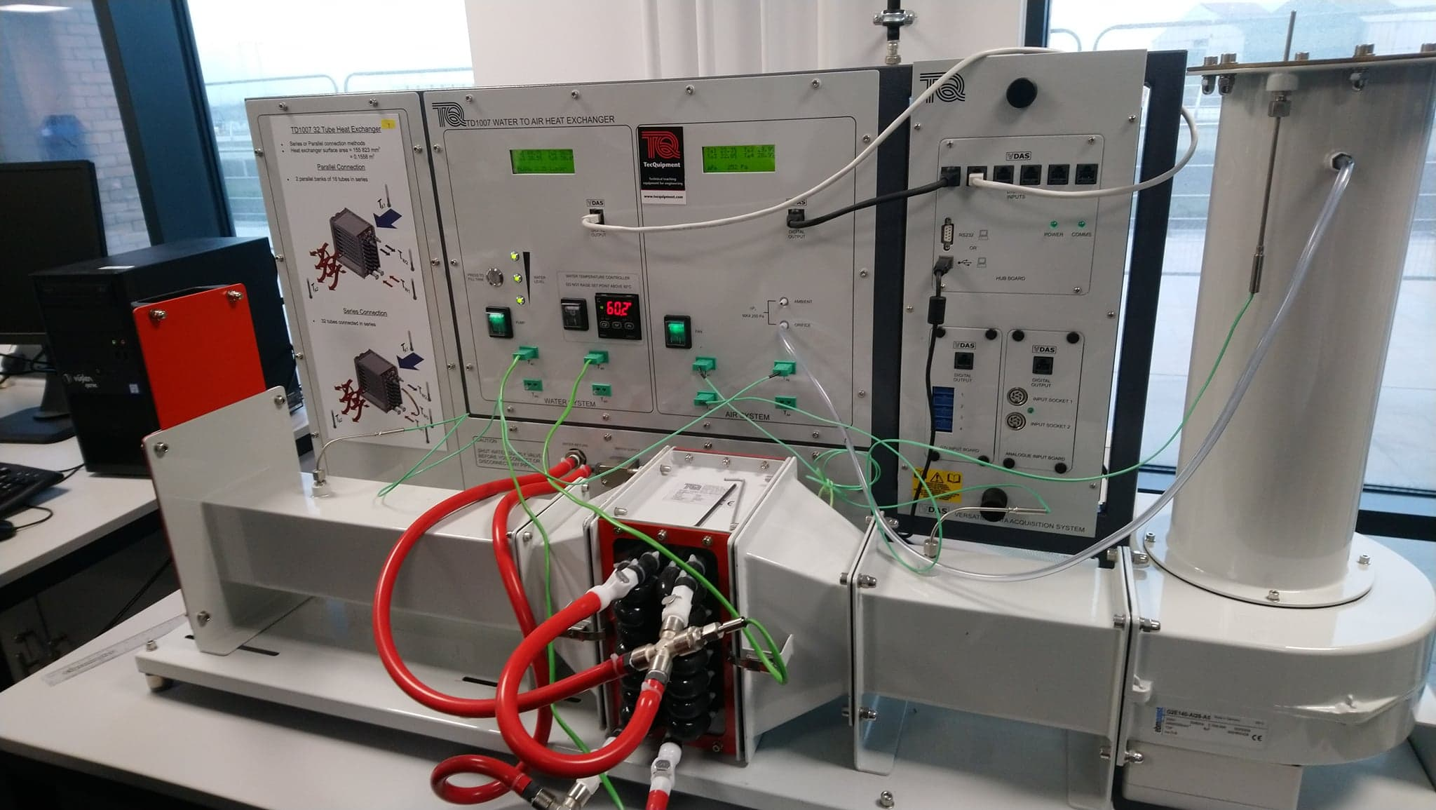
Figure 1: TD1007 Heat Exchanger apparatus in experiment configuration.

Other apparatus required to carry out the experiment included:
- A timer to measure time between adjustments.
- A device for measuring the ambient pressure in the room – in this case a mobile phone app was used.
- Readings from each stage of the experiment were also noted by a colleague on their laptop.
- A camera was used to take photographs of the readings as they were produced also.

Methodology:

Experiment 1 – The effect of varying water flow rate:
To begin the first experiment, the heater is switched on and the temperature set to 60 Degrees C. This temperature will remain set for the first two experiments.
The ambient pressure was then measured in the room using an application on a mobile phone belonging to a colleague, this figure for ambient pressure was then used throughout the remaining experiments as the figure was unlikely to change in the time period required to complete all 3 experiments. This was measured as 1.031 BAR
The diameter of the inlet orifice was also then checked and noted, this also remained the same for the following experiments. The diameter of the orifice in this case was noted as 100.11 mm
Following this, the fan was switched on and the air flow was set to give an orifice pressure drop of 250 Pascals. This was set using the slide valve at the end of the ducting.
Now, the water pump is turned on and the mass flow rate of the water can be set to 2.25 l/min using the water supply valve.
A time period of approx. 5 minutes was then observed to allow the temperatures and pressures to stabilize. The first set of results can now be recorded for inlet and outlet of air and water respectively.
The experiment is then repeated with the mass flow rate of the water being lowered in 0.5 l/min increments, again, observing a 5 minute period between adjustments to allow stabilization within the system.
The results were recorded for all steps of the experiment with care taken not to allow the flow rate to deviate more than +/- 0.01 l/min.
This concluded experiment 1.

Table 1: Example of results table from experiment 1.

Experiment 2 – The effect of a varying air flow rate:

To begin experiment 2 it is first ensured that the temperature of the heater is still set to 60 Degrees C from the previous experiment.
The fan is again turned on and the pressure drop set to 250 Pascals once again.
The water pump is again switched on, but this time the flow rate is kept at the lowest flow rate from the previous experiment at 0.25 l/min.
The 5 minute waiting period is observed to allow the system to stabilize and the results noted from the first part of the experiment.
Now, the pressure drop is reduced in 50 Pascal increments down to 50 Pascals with the 5 minute waiting period observed to allow stabilization between measurements. A final reading is now taken with the pressure drop set to 25 Pascals.
This reading then concludes the 2nd experiment.

Table 2: Example of results table from experiment 2.

Experiment 3 – The effect of varying temperature:

In order to carry out the 3rd experiment, the temperature of the heater tank must now be set to 45 degrees C, to allow this temperature to be reached from the previous experiment, the apparatus was left to cool for approx. 10 minutes.
When the tank was set to 45 degrees, the same procedure as experiment 2 was carried out to demonstrate the effect on performance of the heat exchanger due to a lower temperature water supply.
So, the flow rate was set to 0.25 l/min and the pressure drop was set to 250 Pascals, the pressure drop was then reduced by 50 Pascal increments, again observing the stabilization period between readings and once again, the final reading taken at 25 Pascals pressure drop to conclude experiment 3.

Table 3: Example of results table from experiment 3.

Results:

Overall results analysis.

Upon completion of the three experiments, all collected data was used to compile a table in Excel, whereby recorded figures could be used to calculate sets of figures as per the TD1007 guidelines, these calculation parameters are listed below:
- Change in water temperature.
- Average water temperature.
- Water density.
- Mass flow rate of water.
- Specific heat capacity of water at a constant pressure (Cp_{w})
- Heat energy transfer of water
- Temperature efficiency of water.
- Change in air temperature.
- Average air temperature.
- Air density.
- Mass flow rate of Air.
- Heat energy transfer air (Power).
- Temperature efficiency air.
- Mean temperature efficiency.
- Logarithmic mean temperature difference (LMTD).
- Heat transfer co-efficient.
The value of the specific heat capacity of air (Cp_{a}) was assumed for this calculation as per experiment handbook. This value was assumed to be 1005 J/Kg.K
All of these parameters were calculated using equations provided in the experiment guidelines.
Copies of the data tables and charts generated will be provided for reference also.
Also worth noting, is that the area of the inlet orifice had to be calculated in order to complete certain calculations at this stage of the experiment, this was calculated using area of a circle formula: $\frac{πd^{2}}{4}$

Experiment 1:

Upon completion of this experiment, it can be seen from the data firstly, that the most effective cooling of the water circuit takes place at the lowest mass flow rate in the water circuit. (0.0034 Kg/s), where there is an overall temperature drop of approx. 21 Deg. C. This temperature drop occurs where the heat transfer is at its lowest from the water to the air circuits.
The reason for this is due to the amount of time for the heat transfer to take place is greatly increased due to the mass flow rate of the water being so low. The trend does continue as the flow rate of the water increases and even though the rate of heat transfer is higher, it can be seen that the temperature of the water does not change as drastically as the flow increases.
Figure 2: Chart comparing Heat emitted by water circuit and power absorbed by air

Further analysis of the above chart reveals that the system is operating well within the 2nd law of thermodynamics where the cooler system is absorbing the heat from the hotter system.

The law of conservation of energy states that:
Total energy in a system = Energy lost + Energy gained
As we can see in this example, some energy is lost across the boundary of the system as energy lost is not equal to energy gained, therefore, this is not an example of an ideal heat exchanger.

Figure 3: Temperature efficiency comparison chart.
In the above chart the temperature efficiencies of water, air and their mean is shown, this chart confirms the thermodynamic principles taking place, whereby the efficiency of the water is highest at the lowest flow rate and lowest at high flow. The air efficiency remains relatively linear throughout and is likely attributed to the small change in temperature and thus density of the air flowing around the pipes.

Figure 4: Heat transfer co-efficient vs water mass flow rate.
From the final chart generated in experiment 1 it can be seen that the heat transfer co-efficient rises noticeably over the first three increases in flow rate but then reaches a point where the increase becomes negligible. This is concurrent with greater change in temperature at the lower flow rates as discussed earlier and thus proves the thermodynamic principle of the heat exchanger.

Experiment 2:

In experiment 2 the effects of the varying air flow rate were analysed and from the data generated it was seen that, as expected, the higher air flow rates yielded the most favourable results.
It was also noted that the incremental adjustments provided more linear changes in the temperature of the water. This was most likely attributed to the fact that the flow rate of the water remained steady throughout the experiment and relatively low, thus giving a more reliable method of regulating the temperature of the water circuit.

Figure 5: Heat transfer co-efficient vs Air mass flow rate.
Looking at the above chart it is clear to see that the heat transfer co-efficient is much more linear than that from the varying water flow experiment.

Experiment 3:

In experiment 3 the results discovered were almost identical to those of experiment 2 with the exception of a decrease in the heat energy transferred. This was most likely due to the lower initial heat energy contained within the system to begin with. This is shown in a comparison between the two charts generated below:
It can be clearly seen that the heat transfer from the 60 degree tank is far greater than that of the 45 degree tank.

Figure 6: Heat energy lost by water and gained by Air in exchanger Exp. 2

Figure 7: Heat energy lost by water and gained by air Exp. 3.

It can also be noted that there is a greater range of heat transfer co-efficient in experiment 3 as opposed to 2.

Conclusion:
After conducting the experiments a greater understanding of the operating principles of cross flow, steady flow heat exchangers has been attained. Analysis of the data has provided a statistical proof of the advantages and disadvantages of the variation of water and air flow control through the heat exchanger system and how this may be useful in a real world application.
Take for example, an engine cooling system, in order to provide effective cooling of the engine, the thermostat closes thus reducing flow in the radiator, cool air from the travelling vehicle or from the radiator fan is passed over the core of the radiator causing a reduction in coolant temperature. A larger surface area exposed to flow would have the same effect as this and conversely a reduction in area would cause the engine to overheat.
This application is used widely in the automotive industry and throughout engineering in general, and the understanding and application of its uses have become apparent through the conducting of this experiment.
Most of the results attained from the experiment were in line with guidelines set by the apparatus manufacturer, thus also proving the experiment to be a success.

Appendix:

Table 4: Results table for water circuit of heat exchanger.

Table 5: Results from air circuit of heat exchanger.

Figure 8: Chart showing Temperature efficiencies vs Air mass flow rate. (Exp. 2)

Figure 9: Chart showing heat transfer co-efficient vs Air mass flow rate. (Exp. 2)

Figure 10: Temperature efficiencies vs air mass flow rate (Exp. 3)

Figure 11: Heat transfer co-efficient vs Air mass flow rate. (Exp. 3)

