HOW TO CREATE A CHART USING MS WORD
There are several steps in creating a chart using MS Word.
This step-by-step guide will enable anyone to create a chart in MS Word.
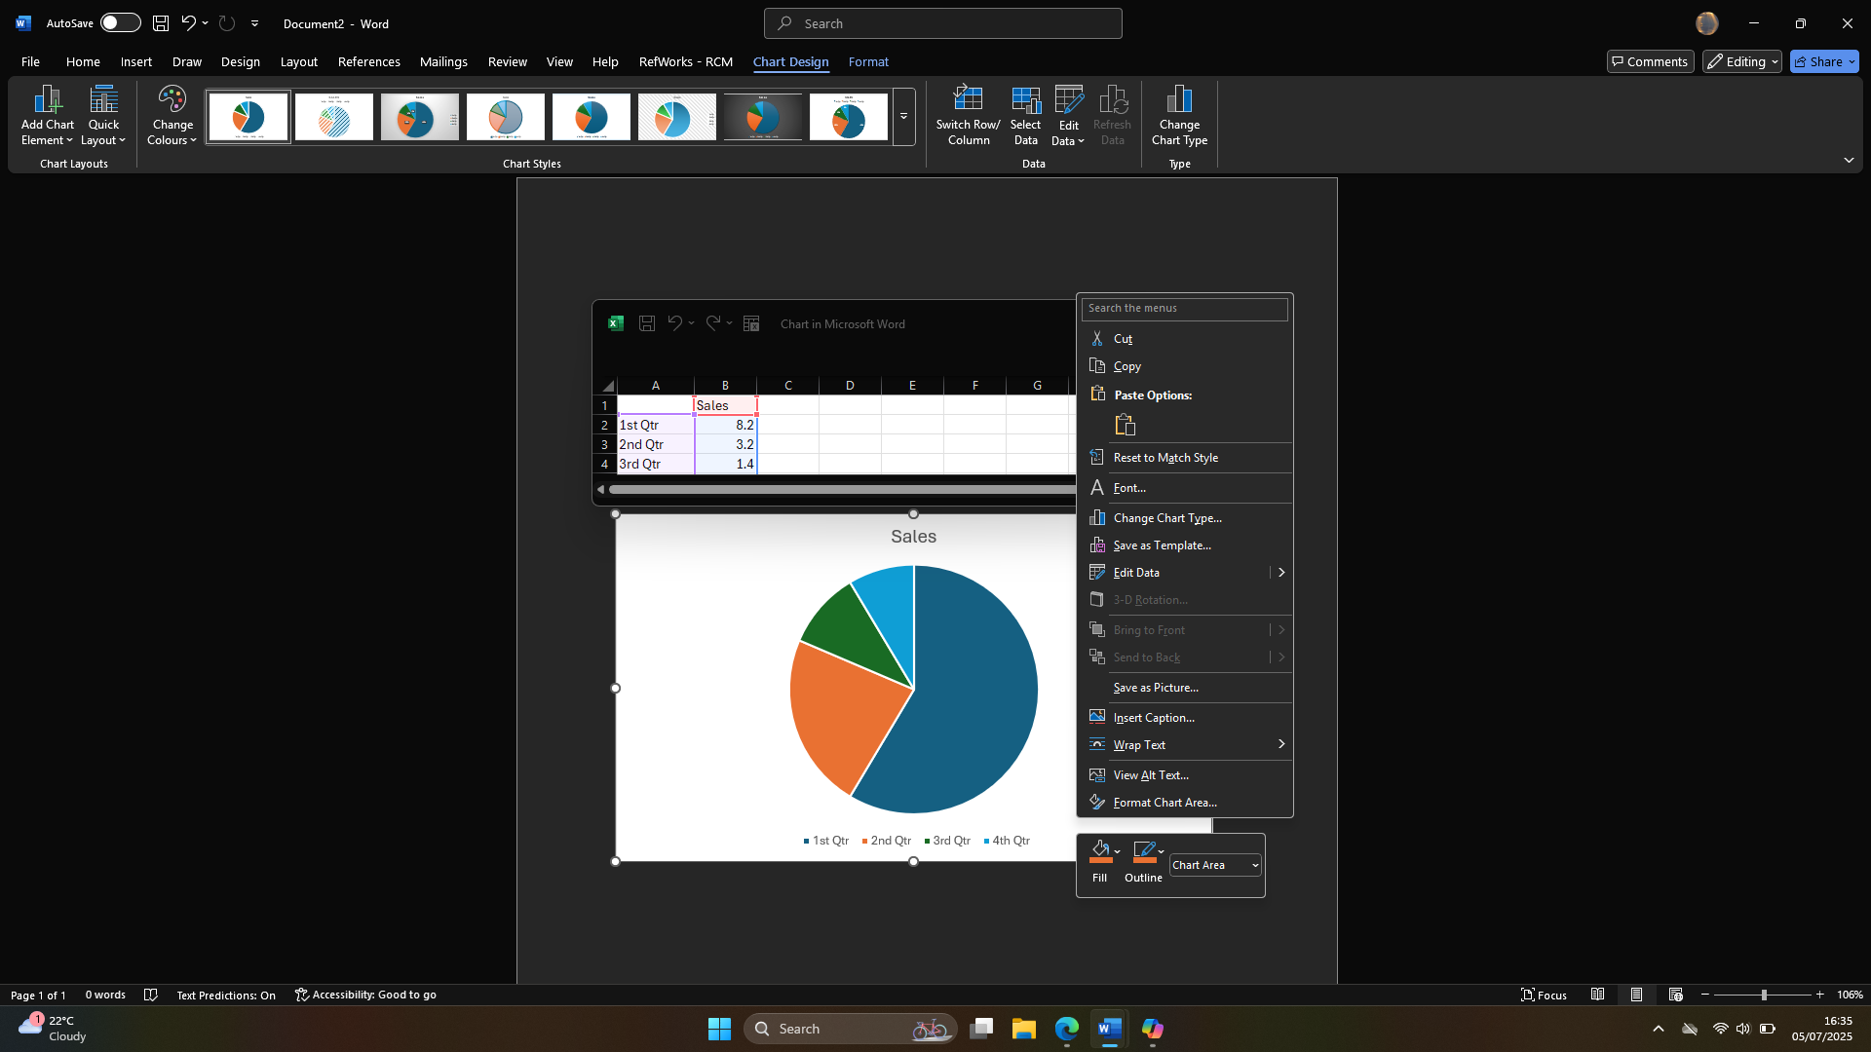
Step 6
From basic to advanced adjustments, right clicking on the chart enables the user to make many adjustments with adding or editing data changing colours and changing fonts + much more

Step 5
Adjustments can be made by right clicking on the chart
Step 4
A small sized Excel sheet will appear. This is where you can directly enter the relevant data/text for your task

Step 1
Open MS Word and select BLANK DOCUMENT
Step 2
On the blank document use the TABS menu at the top of the screen. Click on INSERT and then click on the CHART icon

Step 3
A box will open where you can select the type of chart that is relevant to your task. There are more than fifteen variations of charts available
Microsoft Word – For All Your Professional Requirements
Step 5

Step 5

Step 5

Step 5

Step 6

Step 5
To make any adjustments on the chart you need to click on the chart and that will enable you to add colour to the chart, as well as adding labels and adjust the layout to your liking

