Joshua J Port 2114468

BEng Embedded Electronic Systems

University of Wales Trinity St David’s

Radio Frequency (RF)

(ACDC5019)

Table of Contents
Introduction 4
Background Research 4
Task 1 Amplitude Modulation (AM) 4
Task 2 Double Side Band – Suppressed Carrier (DSB-SC) 5
Task 3 Frequency Modulation (FM) 5
Block Diagrams - Transmitter and receiver Architectures 6
Task 1 Amplitude Modulation (AM) 6
Task 2 Double Side Band – Suppressed Carrier (DSB-SC) 6
Task 3 Frequency Modulation (FM) 7
Simulated Outputs and Results 8
Task 1 Amplitude Modulation 8
Task 1 (a) (i) Student Number Modulation Index 8
Task 1 (a) (ii) 9
Task 1 (b) (i) 11
Task 2 (A)Double Side Band – Suppressed Carrier 13
Task 2 (B)(C) 16
Task 3 Frequency Modulation 17
Task 3 (B) 20
Task 3 (C) 21
Conclusion and Recommendations for Future Work 22
References 23

Figure 1 - Modulation Golden reference 4
Figure 2 - Categories of Modulation 5
Figure 3 - Amplitude Modulation Block Diagram 6
Figure 4 - DSB-SC Block Diagram 6
Figure 5 - Frequency Modulation Block Diagram 7
Figure 6 - AM Modulation with Student Number Index 8
Figure 7 - Spectrum Capture of AM with 0.7 as the Mod Index 8
Figure 8 - Under Modulation AM Oscilloscope 9
Figure 9 - Under Modulation AM Spectrum Analyser 9
Figure 10 - Critical Modulation AM Oscilloscope 10
Figure 11 - Critical AM Spectrum Analyser 10
Figure 12 - Over Modulation AM Oscilloscope 11
Figure 13 - Over Modulation AM Spectrum Analyser 11
Figure 14 - Message and Demodulated Signal 12
Figure 15 - Modulated and Demodulated Signals 12
Figure 16 - DSB-SC - Noise Level at 0dBs 13
Figure 17 - DSB-SC - Noise Level at -10dBs 14
Figure 18 - DSB-SC - Noise level at -20dBs 14
Figure 19 - DSB-SC Oscilloscope with -20dBs Noise 15
Figure 20 - DSBSC - Multimedia Input and Output – 100dBs 16
Figure 21 - DSBSC - Multimedia in the Frequency Domain 16
Figure 22 - FM - Noise Level at 0dBs 17
Figure 23- FM - Noise Level at -10dBs 17
Figure 24 - FM - Noise Level at -20dBs 18
Figure 25- Modulation Oscilloscope 19
Figure 26 - Demodulation Oscilloscope 19
Figure 27 - m(t) and Filtered Signal 20
Figure 28 - Multimedia Attempt with FM 20
Figure 29 - Multimedia FM Spectrum 21
Figure 30 - Multimedia with -10dBs 21
Figure 31 - Multimedia Spectrum with -20dBs 22

Introduction

The task set is to examine the changes when white gaussian noise is added to three specific modulations. One test will be in the Amplitude Modulation (AM) time and frequency domain, the second test will be using a Double Side Band – Suppressed Carrier (DSB-SC) to test the noise effect and third is to use a modulation and demodulation technique to check the distortion levels before and after filtering and demodulating the Frequency Modulated (FM) signal. Each structure will be designed with blocks in an online simulation software – Simulink.
The models consist of:
- Using the same formatting.
- Using the same components.
- Using the golden reference (figure 1).
- Adding noise to check the time and frequency domains.
- Checking the efficiency of the filter.
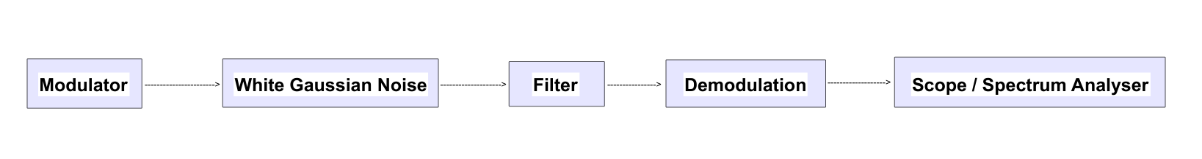
Figure 1 - Modulation Golden reference

Background Research

Task 1 Amplitude Modulation (AM)

Amplitude Modulation is when a signal / wave is transmitted Over the Air (OTA) by modulating the amplitude of this signal [1]. AM is generally used for transmitting information via radios and is a form of analogue modulation which is split into two categories: Amplitude Modulation and Angle Modulation. AM sits within the Amplitude side of these two categories alongside three other Amplitude modulation techniques. These other AM modulation techniques are Double Side Band – Suppressed Carrier (DSB-SC), Single Side Band – Suppressed Carrier (SSB-SC) and Vestigial Side Band – Suppressed Carrier (VSB-SC). The tree of modulation types is shown below in figure 2.
Amplitude Modulation is when the carrier wave and the modulating signal join and fall in order with one another. This process creates a sort of envelope. The envelope is when the carrier wave (which is continuous) changes its amplitude to match that of the modulating signals amplitude. During this the amplitude of the modulating signal does not change its form however, in reverse the carrier frequency changes its amplitude [2].
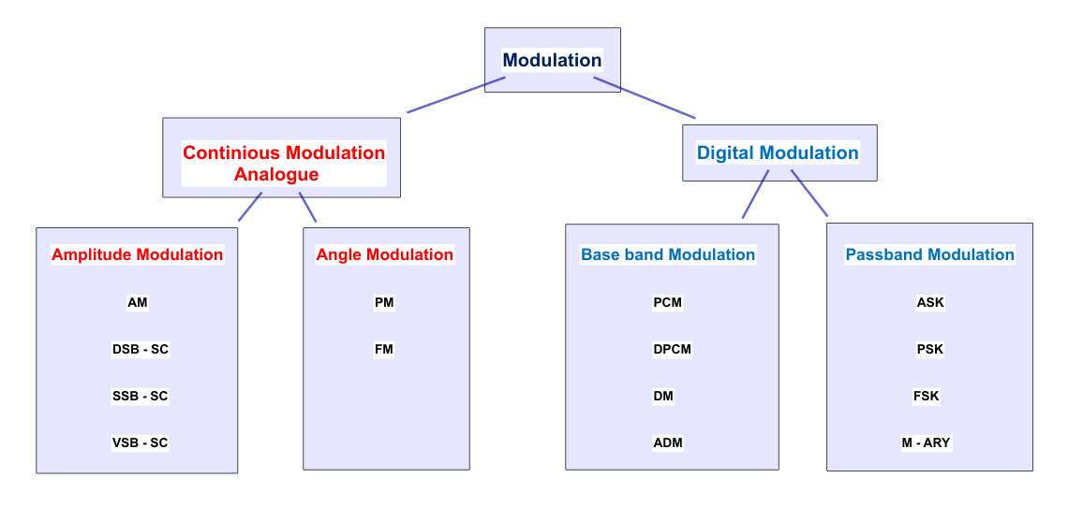
Figure 2 - Categories of Modulation

Task 2 Double Side Band – Suppressed Carrier (DSB-SC)

DSB-SC is a form of amplitude modulation which is comprised of two side bands named the Lower Side Band (LSB) and the Upper Side Band (USB) but no carrier signal [3]. Both sidebands are also set in symmetry and regardless of where they are placed, they will always be the same as one another. The DSBSC signal is produced by modulating the signal to get a negative and a positive signal creating the side bands. Noise is then added to this and a carrier to show to effects when transmitting the signal over the air. Once this has been done, the signal which has been modulated and added with noise, is then multiplied by the original carrier frequency, and pushed through a variable Finite Impulse Response filter to produce the original transmitted signal.

Task 3 Frequency Modulation (FM)

Frequency modulation uses changes in the frequency domain to encode / couple the information being sent into a carrier wave for transmission OTA [4]. When using Frequency Modulation both the amplitude and the and the phase are unchanged allowing the signal to be altered only using a variation in the frequency levels. Unlike Amplitude Modulation (AM), frequency modulation has 5 to 10 times more bandwidth.
Frequency Modulation is primarily used for FM radio broadcasts however, it can be used for radar, telemetry, and seismic prospecting and many more capabilities [4]. It is mainly used for FM Radio due to its high quality audio qualities. Due to the fact it can emit on higher frequencies, it is generally clearer and more precise than that of other modulation methods.

Block Diagrams - Transmitter and receiver Architectures

Task 1 Amplitude Modulation (AM)

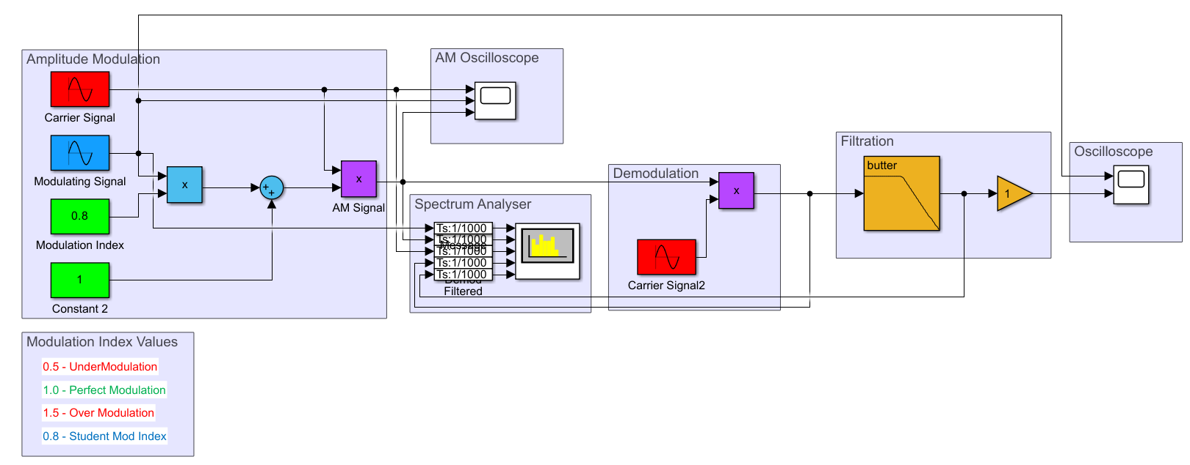
Figure 3 - Amplitude Modulation Block Diagram
Amplitude modulation uses an input sine wave multiplied with a modulation and added using the sum block to finalise the message signal. This message signal is now multiplied by a carrier signal with a frequency of 2*pi*20 creating the overall modulation signal. The signal is then multiplied by the carrier signal once again to demodulate the message before filtering any noise. Altering the modulation index will change the matching of the message signal to the carrier signal creating either under modulation at 0.5, perfect modulation at 1 and overmodulation at 1.5. By using the gain at the end of the model a change can be made to the amplitude of the output demodulated signal.

Task 2 Double Side Band – Suppressed Carrier (DSB-SC)

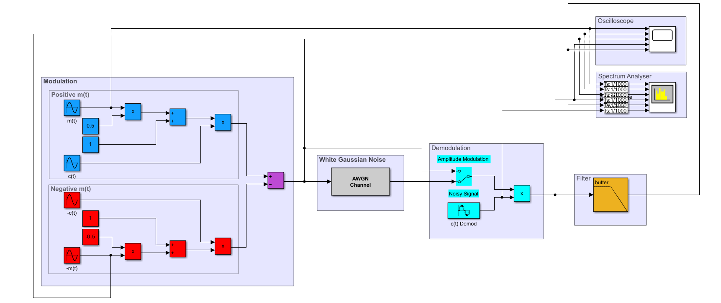
Figure 4 - DSB-SC Block Diagram
DSB-SC is set up using two specific message signals. These message signals are set in a way which is they are 180 degrees out of phase. This is done by using the same sine wave twice but inverting it using a negative creating one signal being positive message signal marked m(t) and one negative signal marked as -m(t) as shown in figure 4. These signals, when constants are added, are used to create the two side bands which can be clearly shown in figure 9 below. An AWGN Block is the used to add noise. To create a demodulation of the DSB-SC, the original carrier wave is multiplied by the modulated signal.

Task 3 Frequency Modulation (FM)
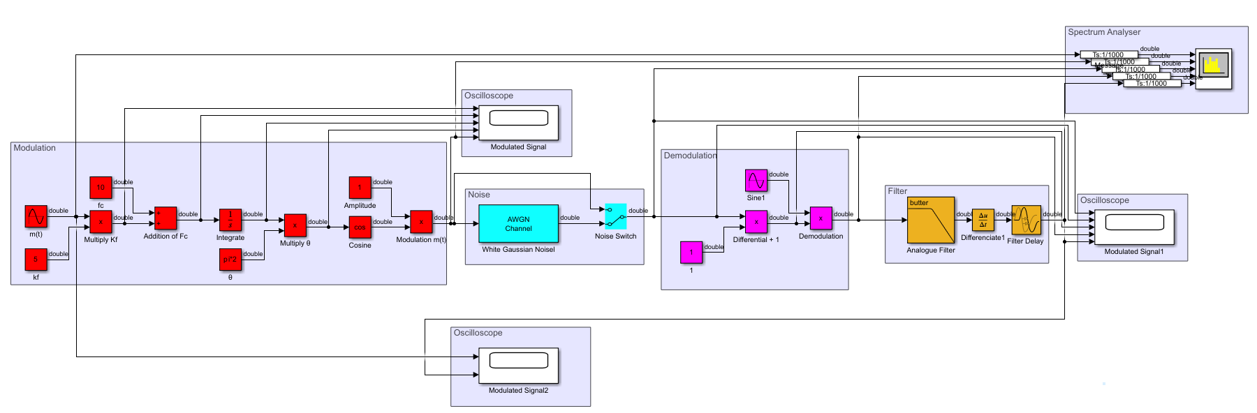
Figure 5 - Frequency Modulation Block Diagram
To create a frequency modulation signal two components are required. These components are the fi value which is the instantaneous frequency and Omega which is the specific angular frequency of the FM wave. When the values from Fi and Omega are input into the FM frequency calculation an FM signal is produced. Below in the equation chain explains how the process is completed.

$$f_{i}= f_{c}+k_{f}m\left(t\right)=Instantaneous Frequency$$
$$f_{c}=Carrier Frequency$$
$$Kf=Frequency Sensitivity$$
$$m\left(t\right)=Message Signal$$
$$ω_{i}=Angluar Frequency$$
$$θ_{i}\left(t\right)=Angle$$
$$ω_{i}=dθ_{i}(t) dt=2πf_{i}$$
$$2πf_{i}dt=θ_{i}(t)$$
$$θ_{i}t=2π[f_{c}+k_{f}mt]dt$$
$$s(t)= A_{c}cosθ_{i}(t)$$
$$s(t)=A_{c}Cos[ 2πf_{c} dt+2π k_{f}m(t)dt]$$
FM Equation
$$s(t)=A_{c}Cos[ 2π\int{f_{c}}+2π k_{f}\int{m(t)}dt]$$
The block diagram as displayed in figure 5 shows the full process of using this equation to create the modulation aspect of FM. Each block used is a direct representation to that of the frequency modulation diagram including using integration blocks to simulate the integration of the message signal.

Simulated Outputs and Results

Task 1 Amplitude Modulation

Task 1 (a) (i) Student Number Modulation Index
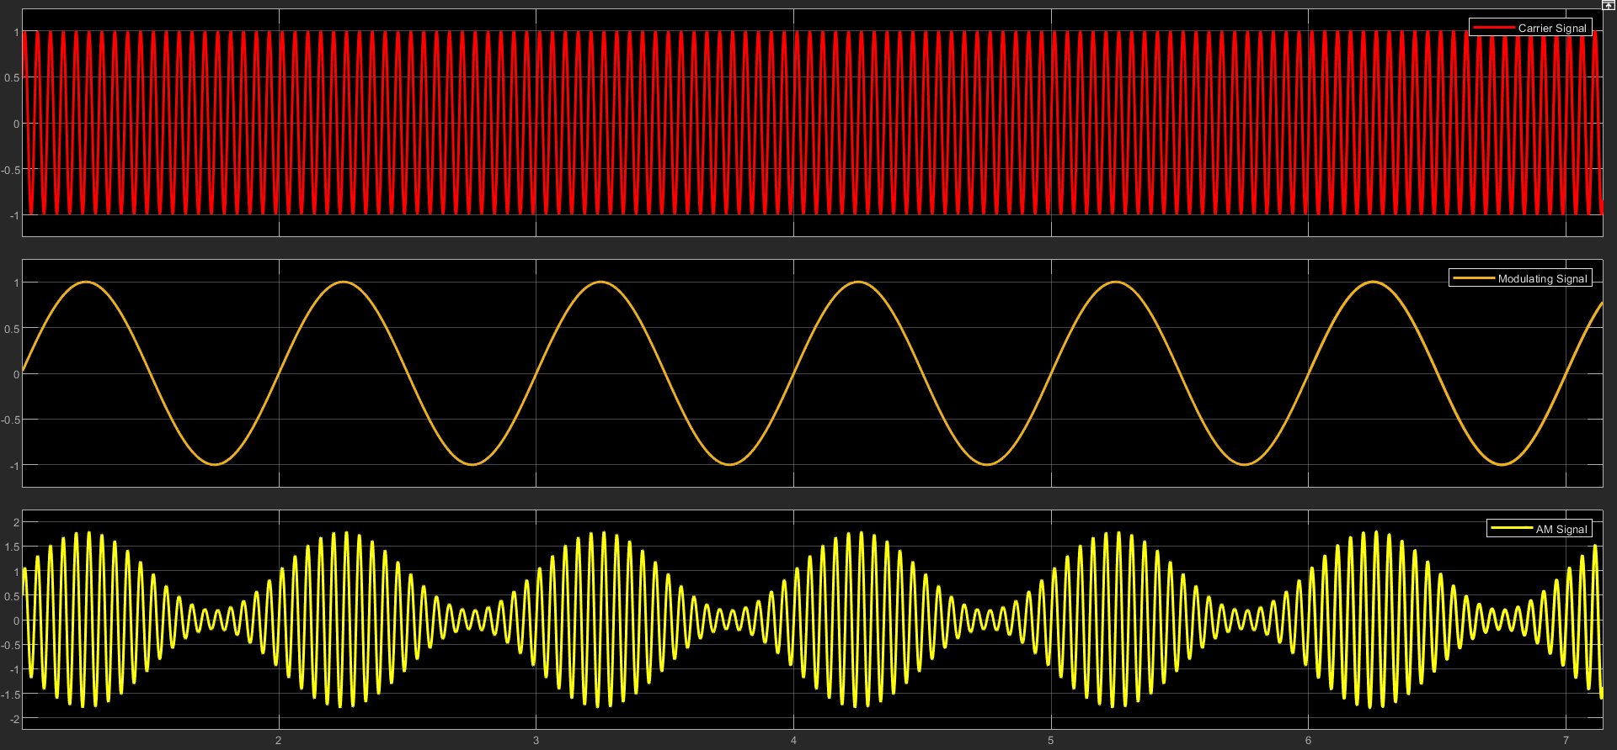
Figure 6 - AM Modulation with Student Number Index
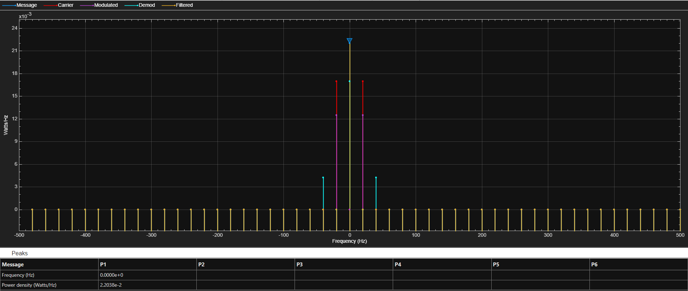
Figure 7 - Spectrum Capture of AM with 0.7 as the Mod Index
Figure 6 shows the Am signal when the modulation index is 0.8. There is a slight under modulation aspect to this specific modulation. This is because a modulation index of 1 is classified as a perfect (critical) modulation and anything under means that the amplitude of the carrier wave is more than that of the message signal [5]. This is understood by looking at the troughs of the signal when it is modulated. On the third oscilloscope it can been seen that the signal does not return to its origin 0 and instead goes to an amplitude of around 0.2. This confirms that slight under modulation has occurred.

Task 1 (a) (ii)

Under Modulation
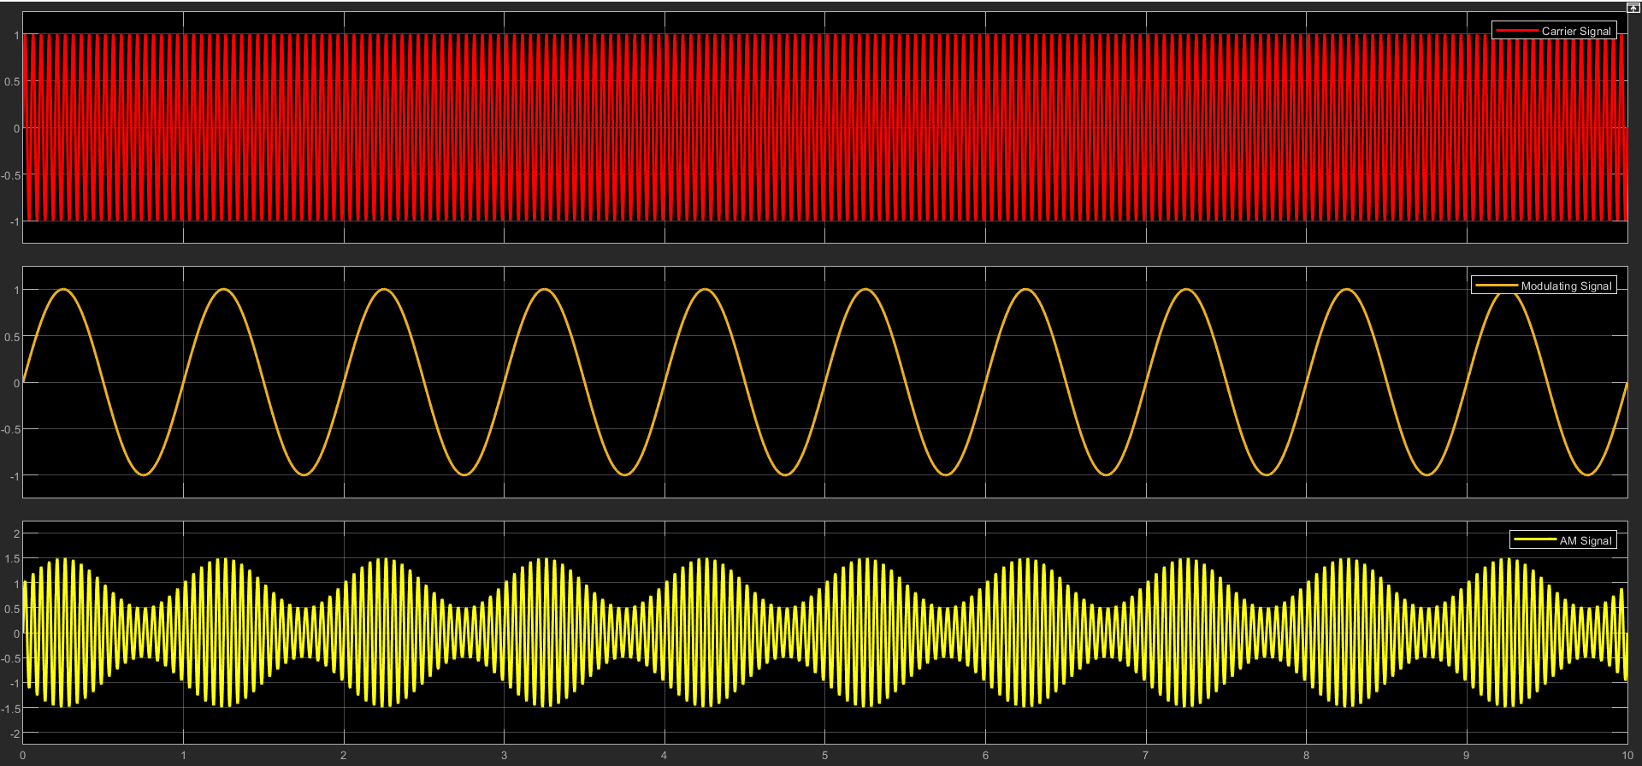
Figure 8 - Under Modulation AM Oscilloscope
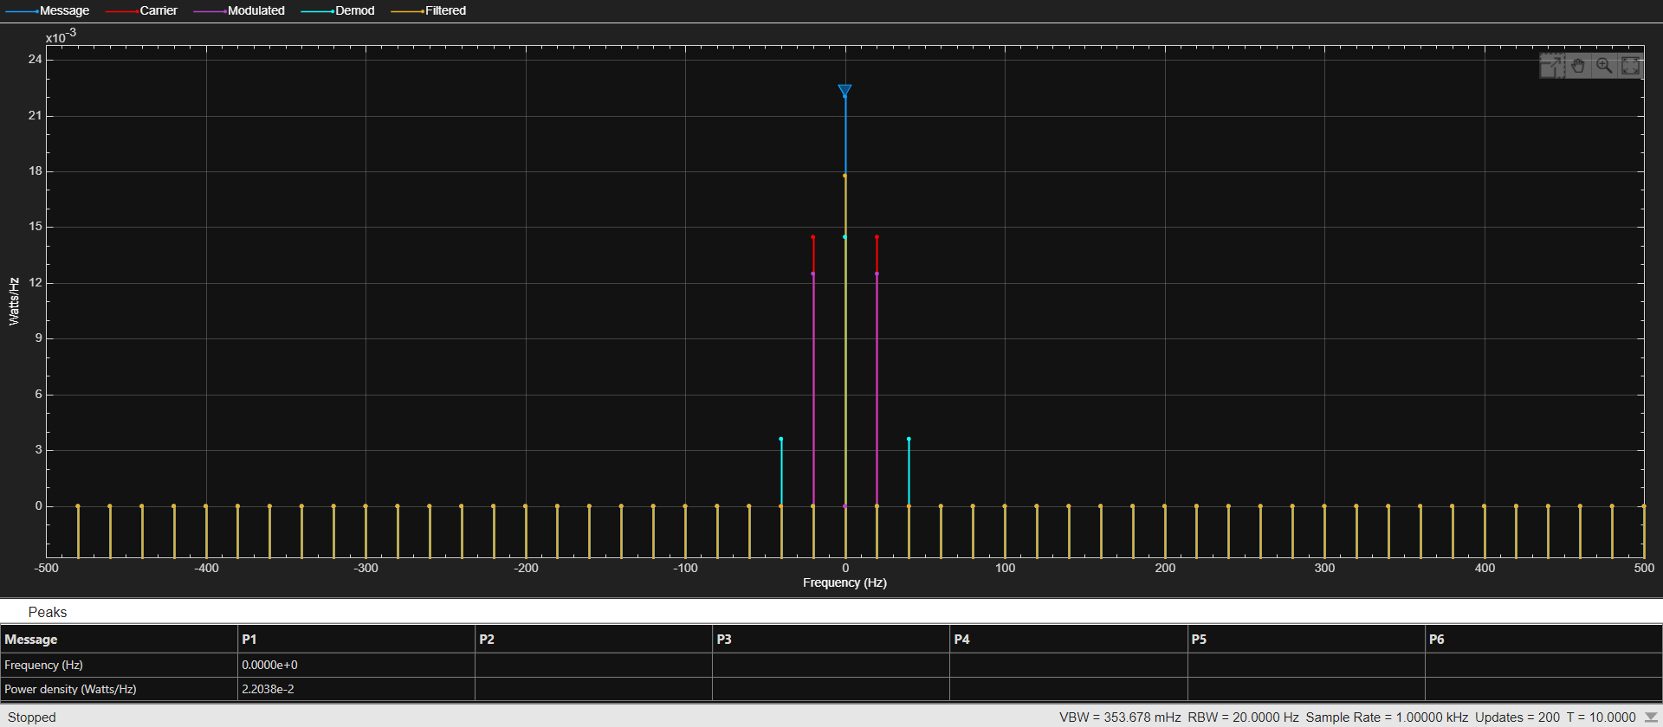
Figure 9 - Under Modulation AM Spectrum Analyser
Shown above in figure 8 is under-modulation by using an index of 0.5. Under-modulation is when then maximum amplitude of the message is less than the carrier [5]. The lower the index value is, the higher the power is which in turn means the filter is less effective as shown by a lower power density of the signal after the filter.

Critical Modulation
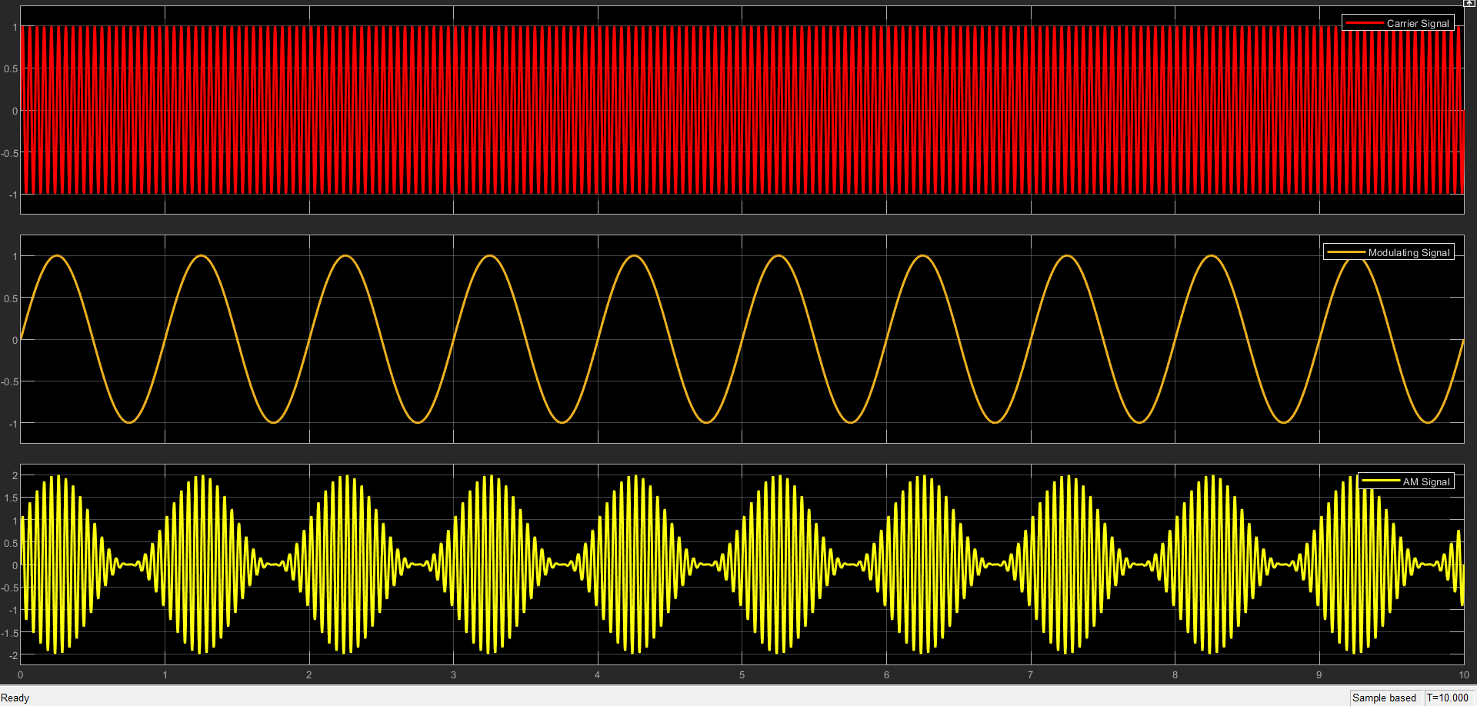
Figure 10 - Critical Modulation AM Oscilloscope
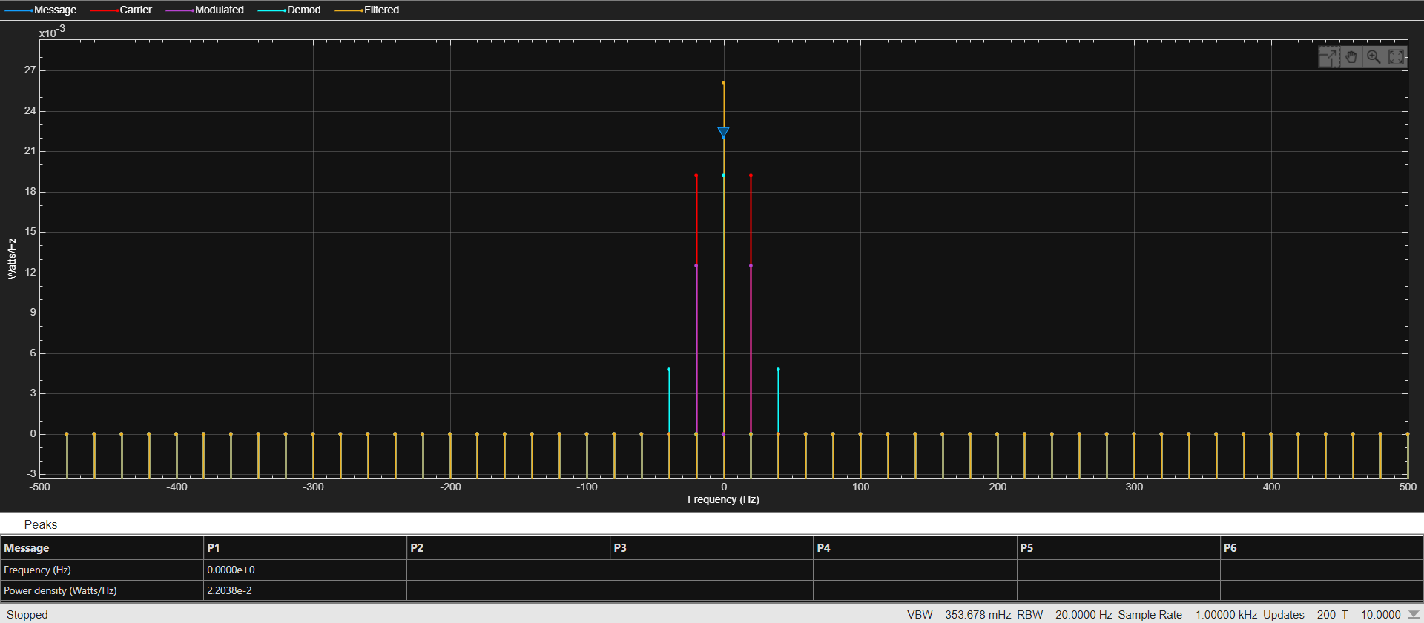
Figure 11 - Critical AM Spectrum Analyser
Critical modulation as shown in figure 10 is when the message signal and the carrier signals amplitude match at 0. This is important as it creates a clear signal which can be used for radio and speech communication via a transmitter and receiver. When the signal matches, the message is not lost or distorted by itself causing the clearest signal transference. The spectrum shown in figure 11 confirms this by deducing that the signal emitted (m(t)) is nearly a direct match to that of the filtered signal.

Over Modulation
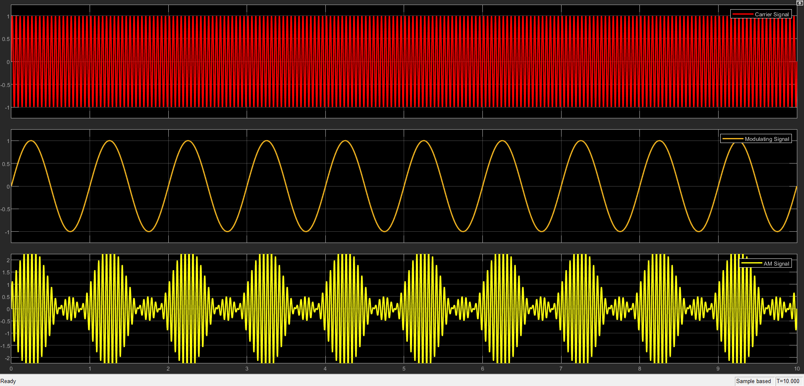
Figure 12 - Over Modulation AM Oscilloscope
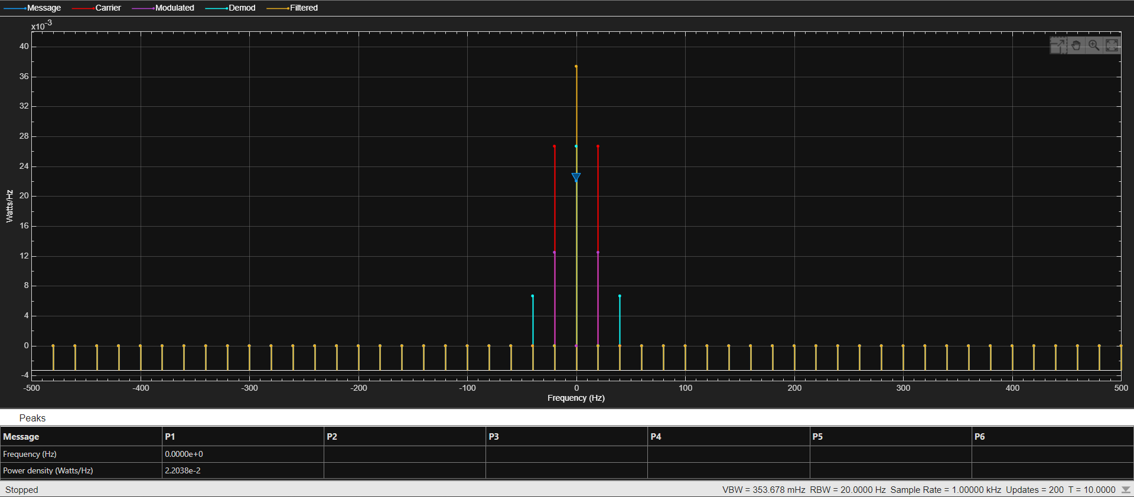
Figure 13 - Over Modulation AM Spectrum Analyser
Figure 12 shows an index of 1.5 causing a high overmodulation within the model. When over modulation occurs, the signal is spaced too far apart and is not matched. Because of this, the signal gets more inputs than it is needed causing a distortion effect when transmitting and receiving the required signal. In addition to this, it can be shown in figure 13, that the message signal is below the level of the filtered signal. This shows that more information is being transmitted than the originally emitted signal.

Task 1 (b) (i)

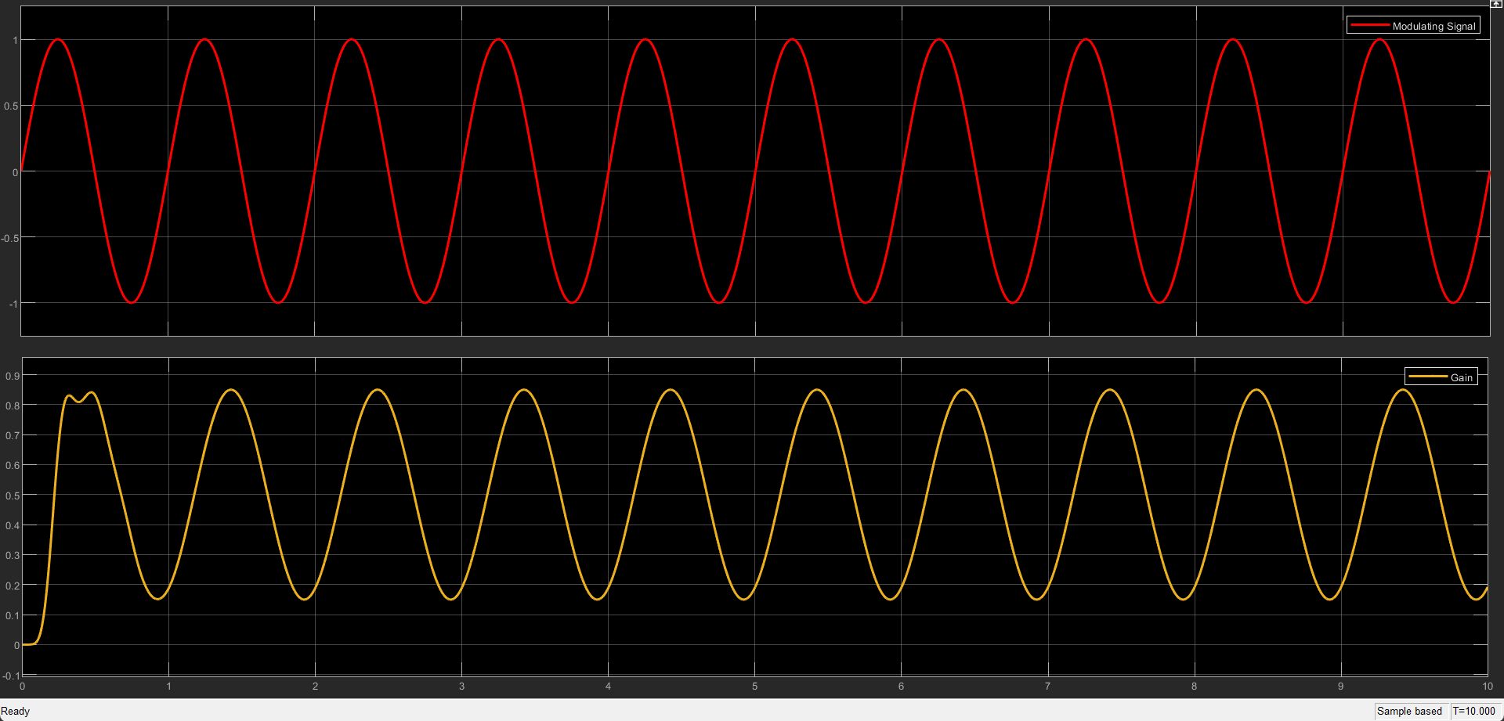
Figure 14 - Message and Demodulated Signal
Figure 14 above shows that the modulation and demodulation of the signal has worked shifting the amplitude of the wave to between 0.9 and 0.1. The reason this scope was used was to determine if a sine wave could be seen after the demodulation and the message received. Figure 15 shows the modulated AM signal (red) and the demodulated sine wave (orange).
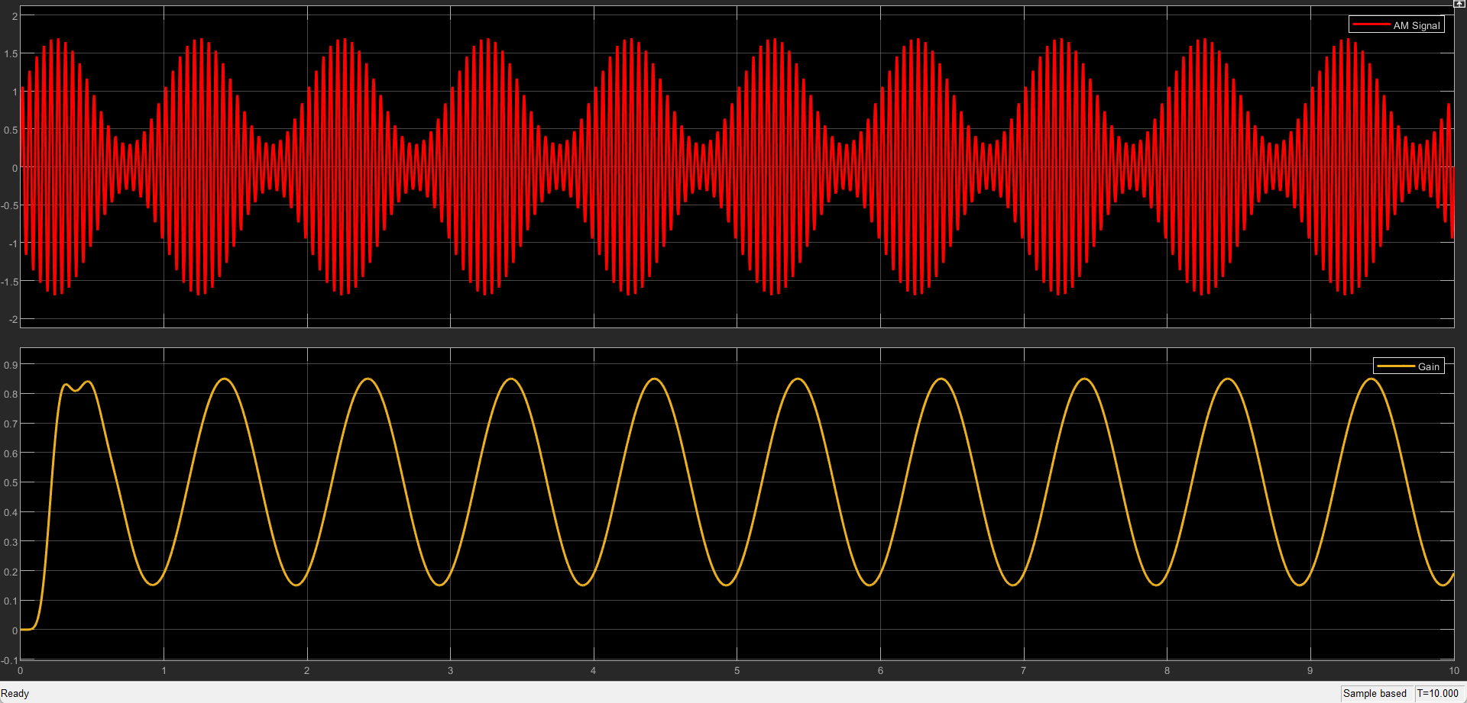
Figure 15 - Modulated and Demodulated Signals

Task 2 (A)Double Side Band – Suppressed Carrier
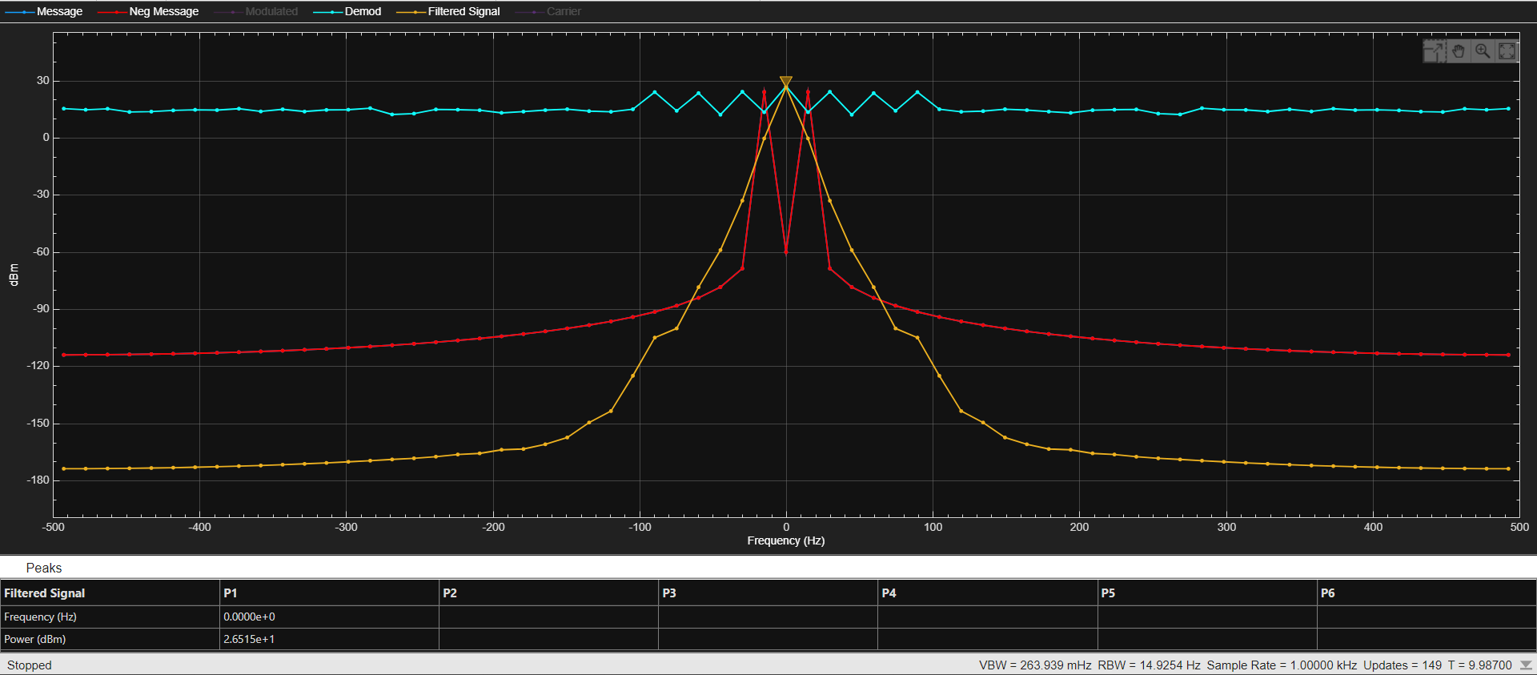
Figure 16 - DSB-SC - Noise Level at 0dBs
Figure 16 shows that the level of noise in DSB-SC is the same as the modulated signal which is expected from the calculation below yielding 0 dBs SNR and a noise power of 2.
$$0=\log_{10}(\frac{2}{np})$$
$$\frac{0}{10}=log(\frac{2}{np})$$
$${10}^{0}=(\frac{2}{np})$$
$$1= (\frac{2}{np})$$
$$np= \frac{2}{1}=2$$
$$0=\log_{10}(\frac{2}{2})$$
The average Noise level at 0 SNR when modulating is 25 dBs when using DSB-SC.

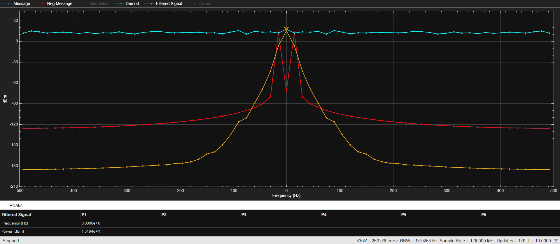
Figure 17 - DSB-SC - Noise Level at -10dBs
When the noise level is changed to -10 dBs, a change can be noticed as shown in figure 17 above. The average SNR of this test was 15 dBs however, the level of noise is now higher than that of the message signal.
$$-10=\log_{10}(\frac{2}{np})$$
$$\frac{-10}{10}=log(\frac{2}{np})$$
$$-1=(\frac{2}{np})$$
$$0.1= (\frac{2}{np})$$
$$np= \frac{2}{0.1}=20$$
$$-10=\log_{10}(\frac{2}{20})$$

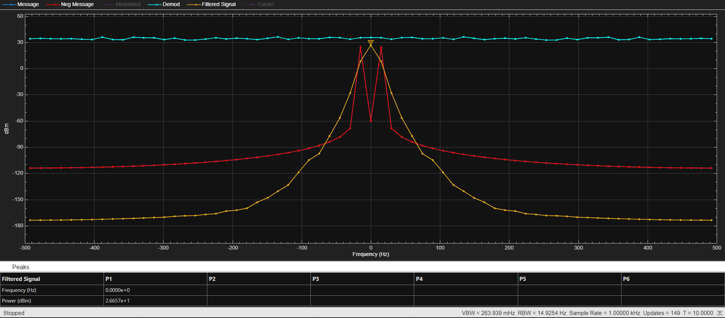
Figure 18 - DSB-SC - Noise level at -20dBs
Using the same equations written above it can be found that the noise power of DSB-SC at -20 dBs is 200 watts.
$$-20=\log_{10}(\frac{2}{np})$$
$$\frac{-20}{10}=log(\frac{2}{np})$$
$${10}^{-2}=(\frac{2}{np})$$
$$0.01= (\frac{2}{np})$$
$$np= \frac{2}{0.01}=200$$
$$-20=\log_{10}(\frac{2}{200})$$

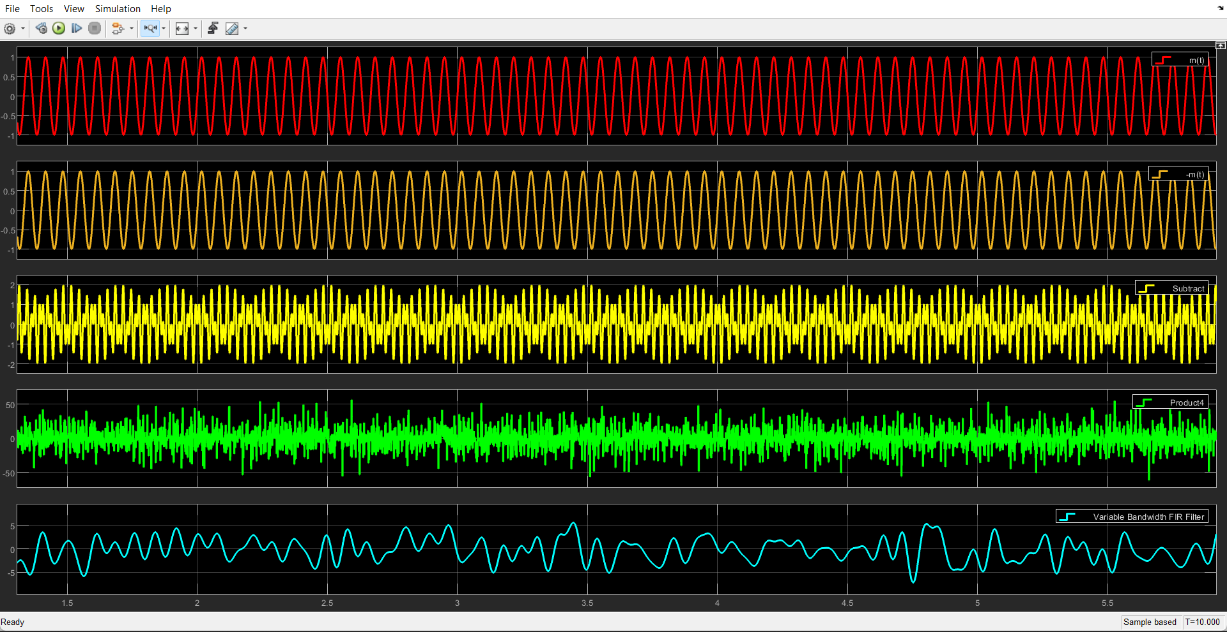
Figure 19 - DSB-SC Oscilloscope with -20dBs Noise

$${Modulation Power= P}_{m}= \frac{A_{m}^{2}}{2}= \frac{1}{2}=0.5$$
$$\frac{p_{m}}{2}=\frac{0.5}{2}=0.25= P_{Sidebands}$$
$$P_{c}= \frac{A_{c}^{2}}{2}= \frac{4}{2}=2$$
Pc is the power of the carriers which can be used to find the amplitude of the carriers.
$${Power DSB-SC= P}_{DSBSC}=2*Sidebands=2 x 0.25=0.5$$
$$BW=2*FM=2*15=30$$
Shown above is the bandwidth used for this modulation.
Based on the figure shown above, the noise input from the AWGN block remains in a constant form and uses the same power across all frequencies. This explains why it is near enough a straight line across the model. In addition to this, the modulated signal has a spike in the power and surges which creates this side band shown by the red lines on the spectrum figures. This is due to the power being constricted in a narrow band in turn causing a rise in the modulated power level.

Task 2 (B)(C)
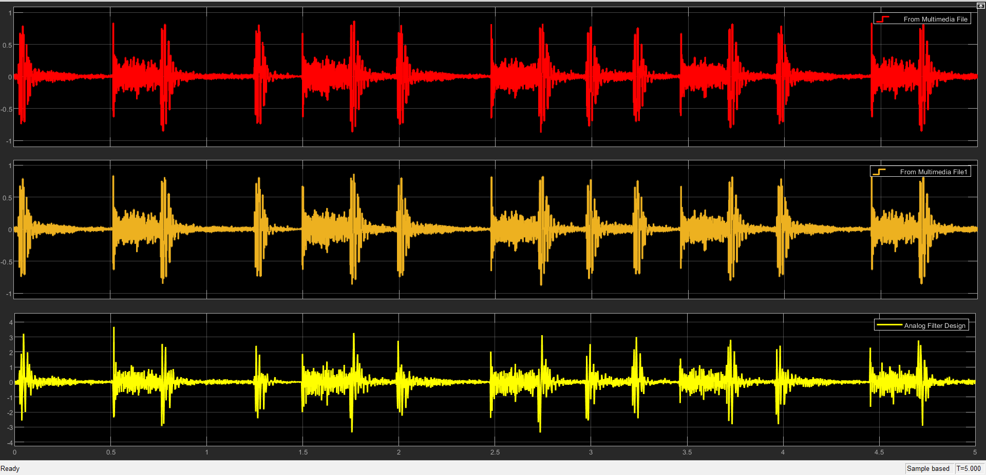
Figure 20 - DSBSC - Multimedia Input and Output – 100dBs
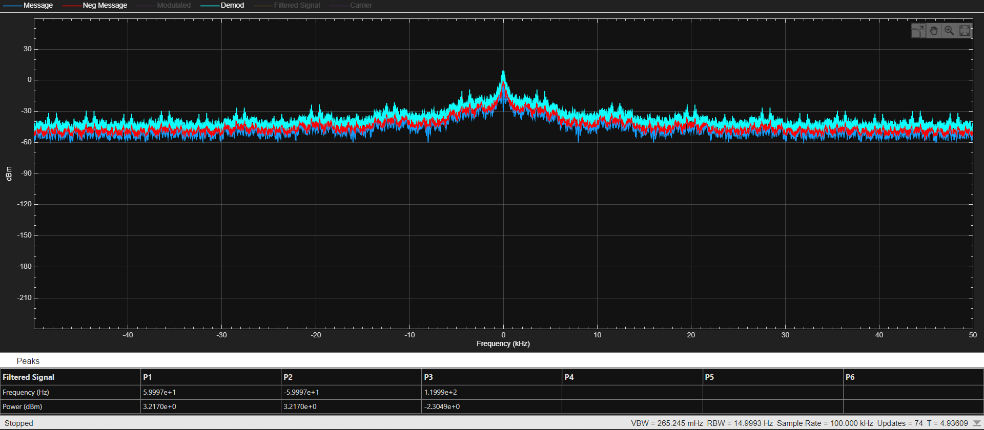
Figure 21 - DSBSC - Multimedia in the Frequency Domain

Task 3 Frequency Modulation
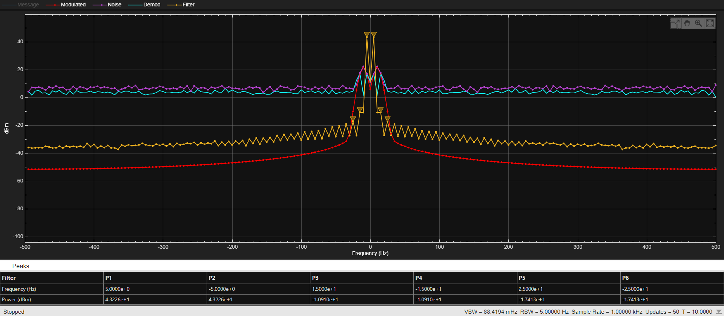
Figure 22 - FM - Noise Level at 0dBs
Below is the method of finding the noise power of the test above in figure 20. When the noise power is substituted back into the equation the value of SNR is 0 confirming the noise power of 1 is correct.
$$0=\log_{10}(\frac{1}{np})$$
$$\frac{0}{10}=log(\frac{1}{np})$$
$${10}^{0}=(\frac{1}{np})$$
$$1= (\frac{1}{np})$$
$$np= \frac{1}{1}=1$$
$$0=\log_{10}(\frac{1}{1})$$
The average Noise level from using 0 SNR when modulating using Frequency Modulation is 5 dBs.
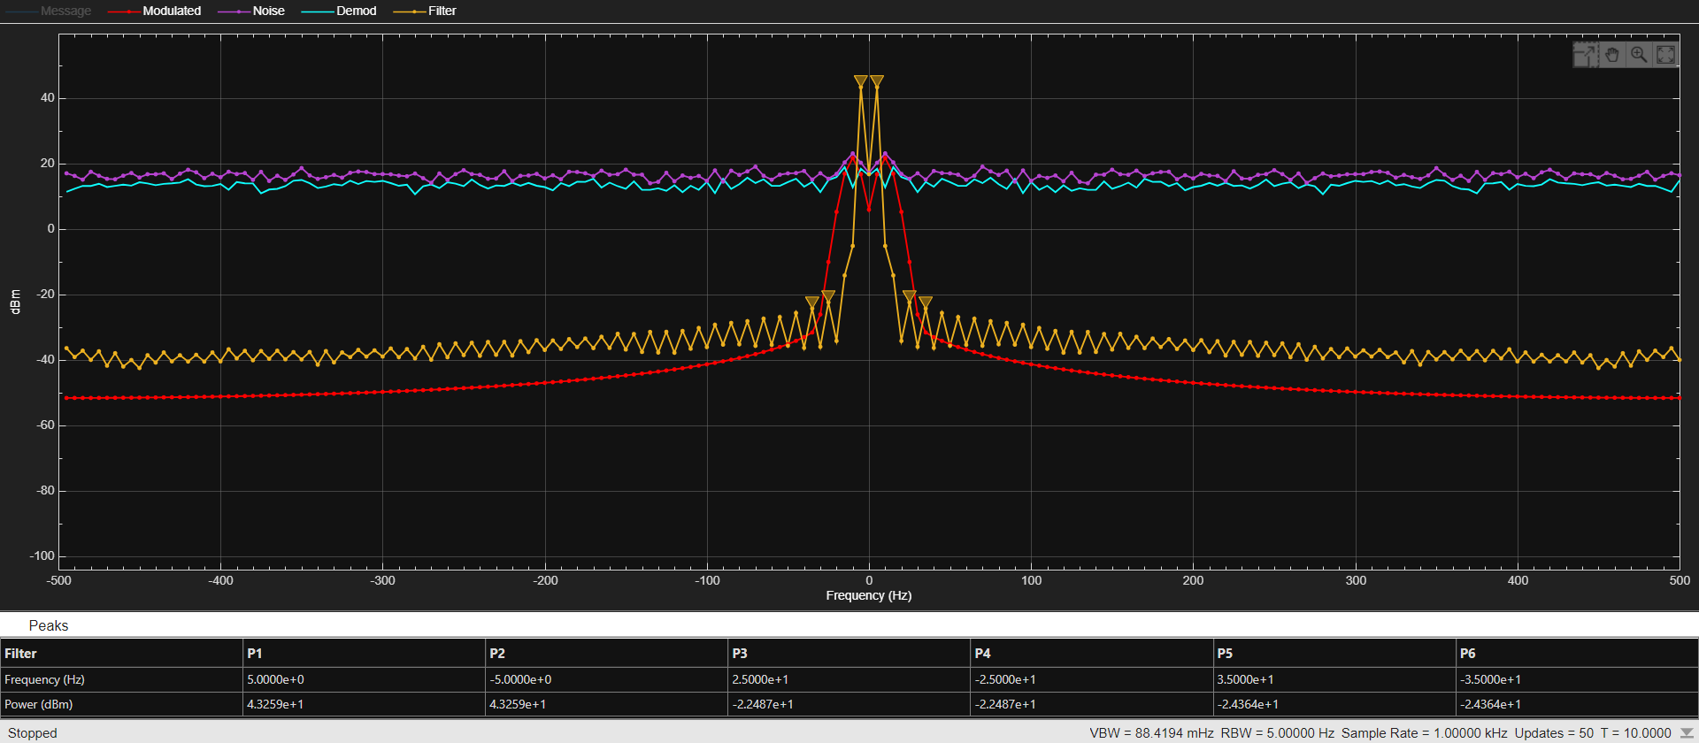
Figure 23- FM - Noise Level at -10dBs
$$-10=\log_{10}(\frac{1}{np})$$
$$\frac{-10}{10}=log(\frac{1}{np})$$
$${10}^{-1}=(\frac{1}{np})$$
$$0.1= (\frac{1}{np})$$
$$np= \frac{1}{0.1}=10$$
$$-10=\log_{10}(\frac{1}{10})$$
From figure 23, it can be determined that the noise floor is centred around 15dBs. In addition to this, the noise is now at a higher level than that of the modulated signal confirming that the noise power is now greater than the signal power.

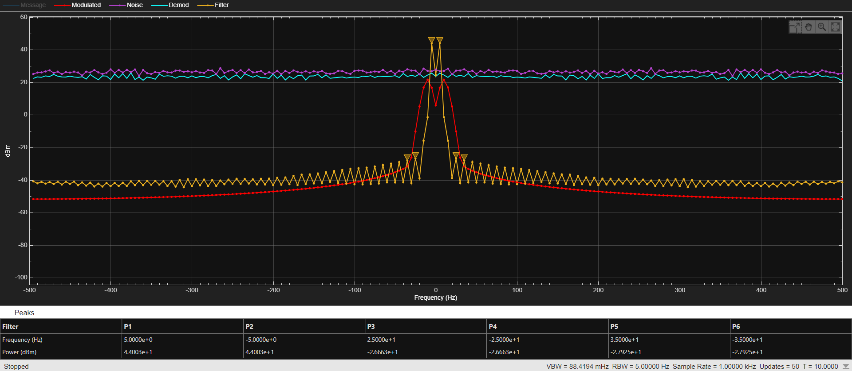
Figure 24 - FM - Noise Level at -20dBs

$$-20=\log_{10}(\frac{1}{np})$$
$$\frac{-20}{10}=log(\frac{1}{np})$$
$${10}^{-2}=(\frac{1}{np})$$
$$0.01= (\frac{1}{np})$$
$$np= \frac{1}{0.01}=100$$
$$-20=\log_{10}(\frac{1}{100})$$
In figure 24 the noise floor is raised higher which matches the increasing SNR value of -10 to -20dBs.
In all three models the filter is still working to a reasonable degree however the output waves of the demodulation show there is a fair bit of distortion when this occurs which is to be expected when simulating in such a noisy environment.

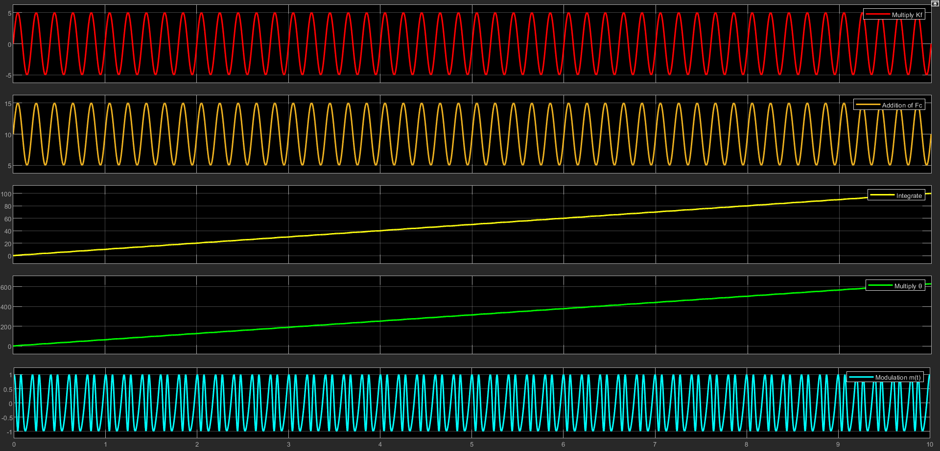
Figure 25- Modulation Oscilloscope
Figure 25 shows the whole modulation process. The red and orange signals are the signals which should also be displayed after the demodulation. The finalised FM Modulation is shown in Blue.
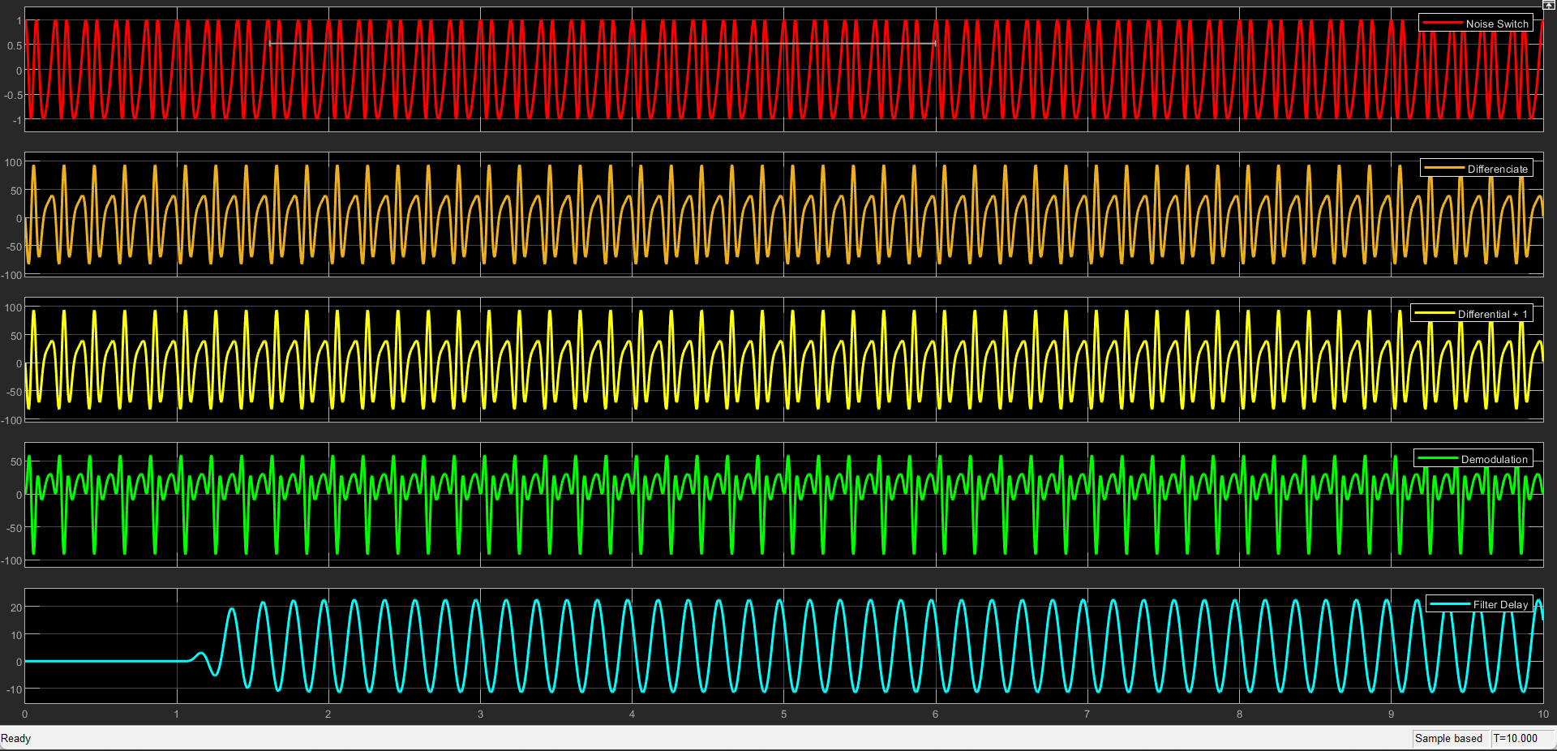
Figure 26 - Demodulation Oscilloscope
Figure 26 show the demodulation of FM.
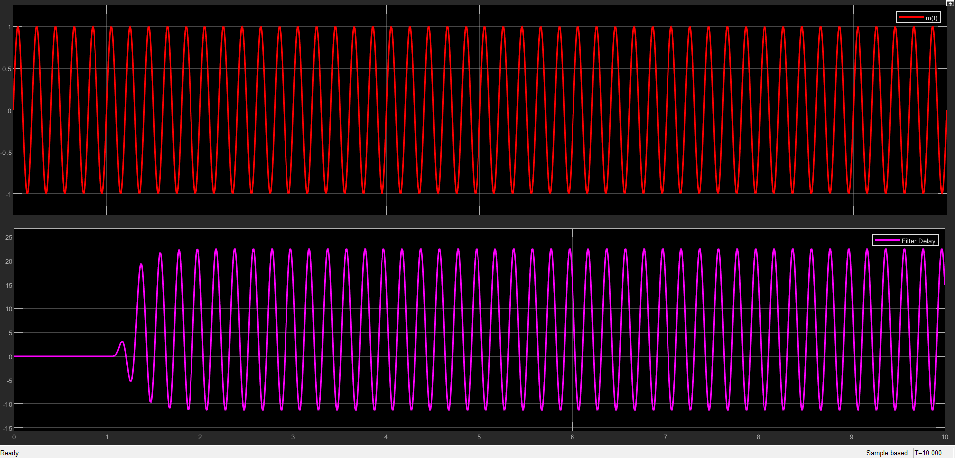
Figure 27 - m(t) and Filtered Signal
Figure 27 shows that the input and the output of FM nicely match and are the same signal showing the model is functioning to a high degree of accuracy.

Task 3 (B)
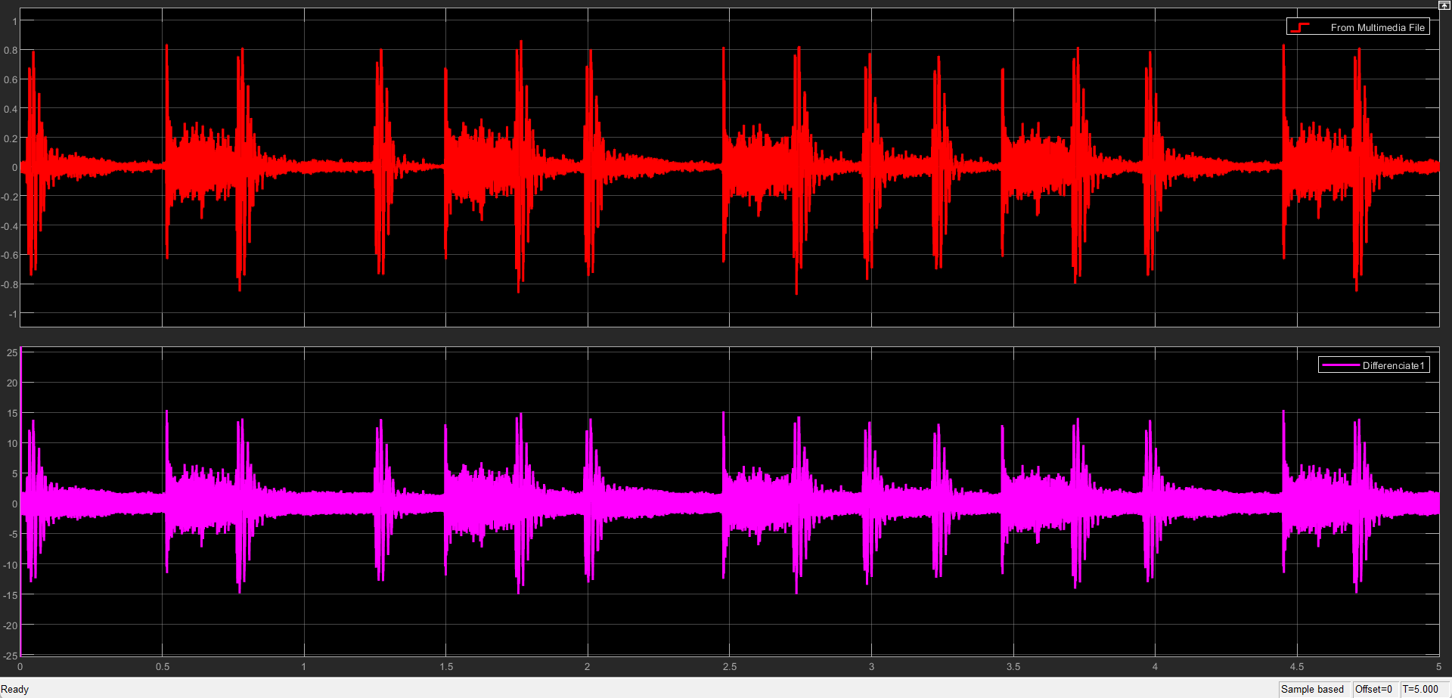
Figure 28 - Multimedia Attempt with FM
Figure 26 shows the input multimedia block signal (red) and the output audio file (purple) when transmitting using frequency modulation. As shown above the signal has a small amount of noise as the AWGN block was set to 100 SNR.
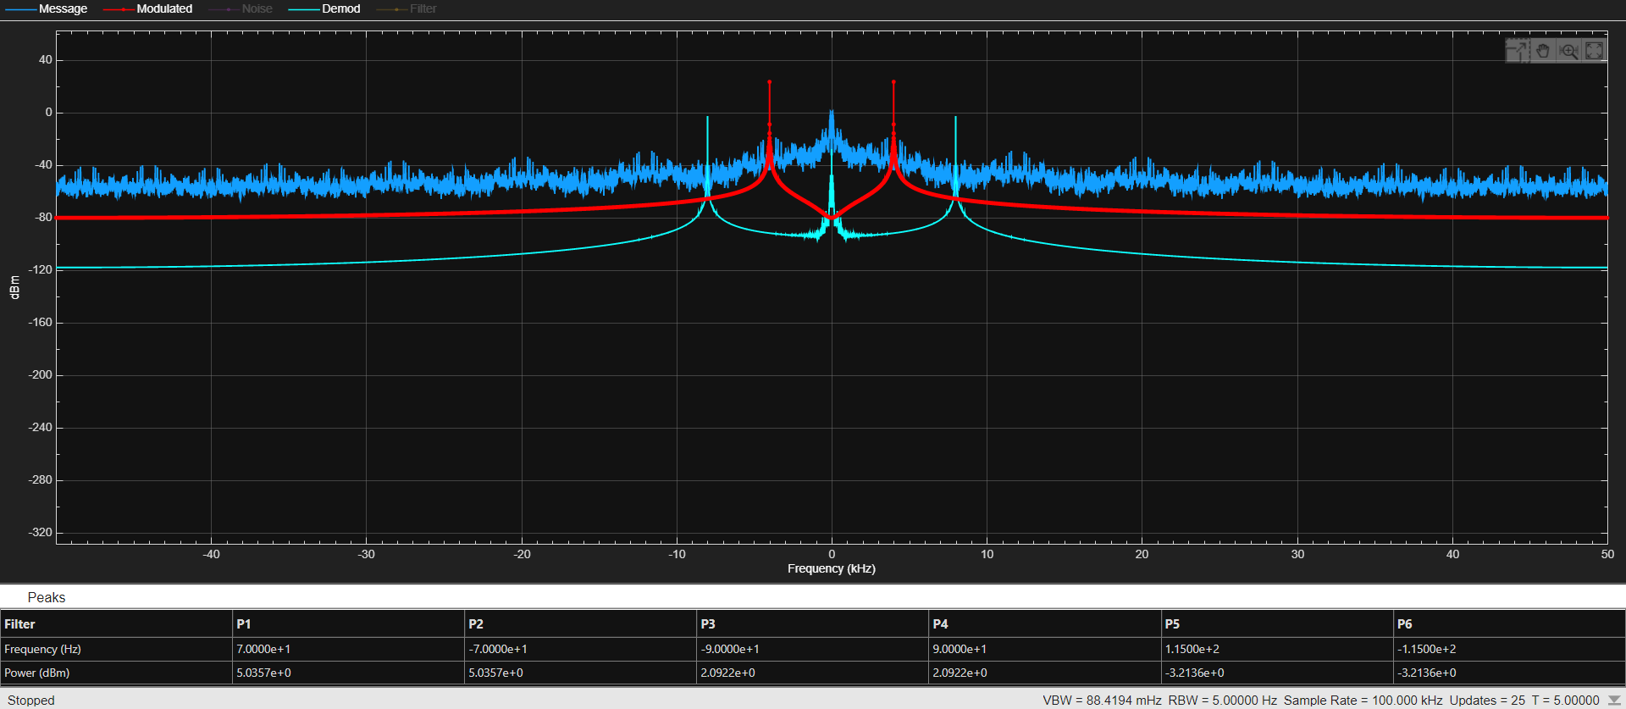
Figure 29 - Multimedia FM Spectrum
Shown above is the spectrum of the multimedia block using FM. The Message frequency peaks at both 70 and -70 Hz meaning the transmission to the finalised signal is not working as it should however, it is close to correctly transmitting. The peaks should be ay 4 kHz.

Task 3 (C)
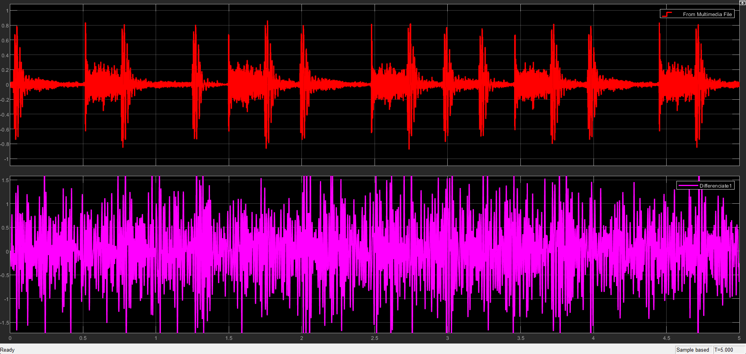
Figure 30 - Multimedia with -10dBs
Shown Above in figure 28 is the message signal from the multimedia block once noise has been added. The signal is extremely distorted by just adding -10 dBs from the previous 100dBs in figure 26.
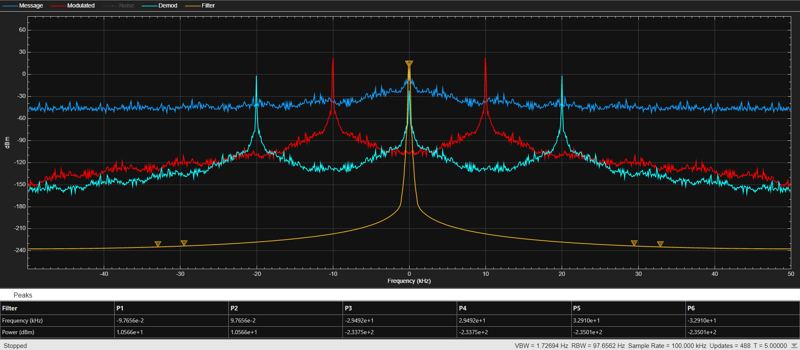
Figure 31 - Multimedia Spectrum with -20dBs
The addition of AWGN noise is shown above in figure 29. The modulated signal after the noise is added is severely distorted by -10dBs however the signal is still present.

Conclusion and Recommendations for Future Work

When comparing DSBSC and FM modulation techniques in the time and frequency domain, it was clear that when adding audio noise and white noise that FM performed better at filtering to the original message signal. The comparisons have been made using 0, -10 and -20 dBs as standard. When checking the differences between FM and DSBSC, it can clearly be shown that at 0 dBs The noise level of DSBSC is averaging at 15 compared with 5 from FM. This is a major change and shows the effectiveness of FM modulation. At -10 SNR a change happens when FM has a higher noise level by 3 dBs over the 15 dBs of DSBSC however, again remains quite high for both modulations. Finally, when changing the levels to simulate a noisy environment, both noise floors moved up however, DSBSC had an increasingly high noise floor at 35 dBs opposed to 28 with FM.
Overall, it can be determined that the addition of noise increases the strain on the filter which in turn is causing the modulated signal to be distorted after noise and filtration has taken place. This can also be demonstrated in the time domain in figure 30 when noise was added to an audio signal and the lower frequencies could no longer be heard. This is the distortion on a moderately high noise environment.
FM is a type of angular modulation and DSBSC is a form of Amplitude modulation. For future work, testing the other angular modulation technique (Phase Modulation) could help confirm which modulation technique is better again increasingly noisy environments. In addition to this, having more tests at different noise levels can also help with the overall comparison.

References

[1] | BYJU's, “Amplitude Modulation,” BYJU's, 2023. [Online]. Available: https://byjus.com/jee/amplitude-modulation/#:~:text=Amplitude%20modulation%20is%20a%20process,through%20a%20radio%20carrier%20wave.. [Accessed 2 November 2023].
[2] | BYJU'S, “Amplitude Modulated Waveform,” BYJU'S, 2023. [Online]. Available: https://byjus.com/jee/amplitude-modulation/#:~:text=Amplitude%20modulation%20is%20a%20process,through%20a%20radio%20carrier%20wave.. [Accessed 3 November 2023].
[3] | S. Hafizovic, “Double Sideband - Suppressed Carrier Modulation,” 28 August 2013. [Online]. Available: https://www.zhinst.com/europe/en/blogs/double-sideband-suppressed-carrier-modulation. [Accessed 14 November 2023].
[4] | HEAVY.AI, “Frequency Modulation Definition,” HEAVY.AI, 2022. [Online]. Available: https://www.heavy.ai/technical-glossary/frequency-modulation. [Accessed 14 November 2023].
[5] | A. Shaik, “Amplitude Modulation,” Physics and Radio-Electronics, 2023. [Online]. Available: https://www.physics-and-radio-electronics.com/blog/amplitude-modulation/#:~:text=Under%2Dmodulation%20occurs%20when%20the,maximum%20amplitude%20of%20carrier%20signal.. [Accessed 23 November 2023].

