
University Name: the University of Wales Trinity Saint David
Cloud Computing Architecture
ACCA_5025

Student’s name: Diana Cretu
Student’s ID: 2112907
Lecturer’s Name: Suneth Fernando

Submission deadline: 06.04.2023

Table of content
Introduction 2
Description, Analysis and Evaluation 2
Virtualisation 2
Virtual machine 3
Evaluation of Cloud Benefits 4
Infrastructure as a service benefits and Drawbacks 5
Platform as a service benefits and Drawbacks 1
Software as a service benefits and Drawbacks 3
Evaluation of Availability 3
Security Considerations 6
The differences between authorisation and authentication. 6
Conclusion 7
References 8

Introduction

In this report, I’m going to cover Cloud Computing architecture aspects. In Cloud Computing the key features consist of virtualisation, virtual machines, and a variety of cloud computing services, availability and security characteristics. In this context, I have to demonstrate of understanding the deployment of applications and evaluate and make a decision on the most suitable cloud computing infrastructure. Also, will define some basic terminology and usefulness of Microsoft Azure and its service types. During this report, I also, I will include some benefits descriptions of virtualisation within small organisations and enterprises.

Description, Analysis and Evaluation
According to a generalisation, cloud computing services are a large-scale distributed computing paradigm driven by economies of scale, in which a pool of abstracted, virtualized, dynamically expandable computer resources is offered on demand as a service through networks to external clients.
An active study topic has been formed because "a thorough evaluation of Cloud service performance is necessary and useful to both service providers and consumers" [1]. Cloud service evaluation would be advantageous for suppliers as well as service users (such as during service selection) (e.g., areas for improvement)
Amazon Web Services (AWS), Microsoft Azure, Google Cloud Platform (GCP), IBM Cloud, and Oracle Cloud Infrastructure are a few well-known cloud service providers (OCI).

Virtualisation

Virtualization is a fundamental technology in cloud computing that enables better hardware utilization and more efficient use of computing resources. It allows multiple virtual machines (VMs) or containers to run on a single physical machine. In the context of cloud computing, virtualization refers to the creation of virtualized computing resources such as virtual machines, virtual networks, and virtual storage devices that are used to provide services to users over the internet. Cloud service providers can create a pool of computing resources that can be dynamically allocated to different users.

One of the huge company examples of cloud service providers is Microsoft. Microsoft Azure is providing a good experience in terms of virtualisation as a service. virtualization in cloud computing includes several types such as server virtualization, storage virtualization, network virtualization, desktop virtualization, application virtualization, and operating system virtualization. Each type of virtualization has its own unique benefits and use cases.

Virtual machine

In cloud computing, a virtual machine (VM) is a digital representation of a physical computer that can carry out nearly all of the same tasks as a computer, including running operating systems and applications. The two types of virtual computers that are generally available are single-tenant and multi-tenant. Many users share a single physical infrastructure with multiple tenants of public virtual machines. A VM encapsulates an operating system, applications, and data into a single package, which can be moved or replicated across different physical machines. It is created by the virtualization layer that runs on top of the physical hardware.

A virtual machine (VM) is a software-based representation of a physical machine, such as a server, desktop, or laptop. In the context of cloud computing, VMs are the building blocks of cloud services. Cloud service providers offer VMs as a service, allowing customers to provision and manage VMs as needed to host their applications and services.

Here are some examples of virtual machines:
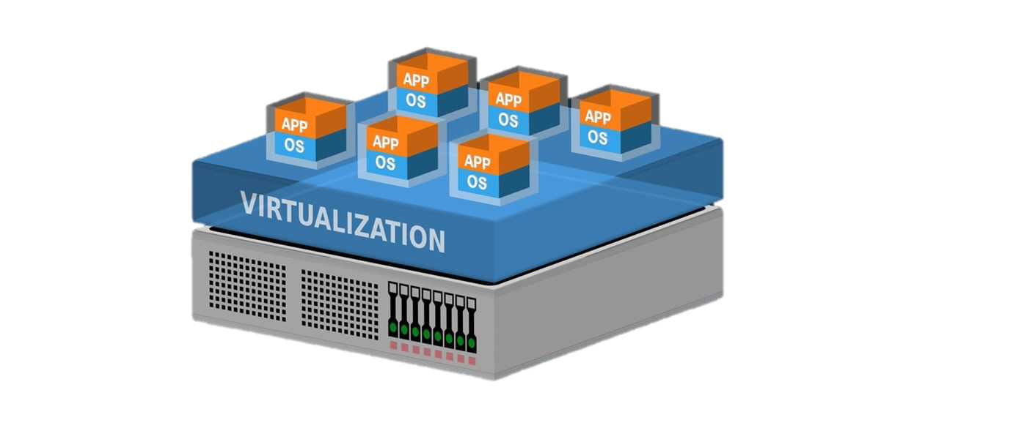
- VMware Workstation Player
- Parallels Desktops
- VirtualBox
- OracleVM VirtualBox
- Citrix Hypervisor
- Red Hat Virtualization
- Hyper – V
- Kernel Virtual Machine (KVM)

Building and delivering apps to the cloud, testing out new operating systems, including beta releases, setting up a new environment to make it easier and faster for developers to execute development-test scenarios, and backing up your current operating systems are all possible with virtual machines.

Evaluation of Cloud Benefits

Based on the scenario, we need to evaluate and provide some expertise on how to move to the cloud-based infrastructure of the business. So, moving an eCommerce website to the cloud has several benefits such as increased scalability, flexibility, and reliability. It also allows for better disaster recovery and security.

Cloud migration requires expertise in cloud computing and web services. It is important to have a team with experience in cloud migration to ensure a smooth transition4. Cloud providers such as “Amazon Web Services (AWS) offer professional services that can help supplement your migration and cloud adoption efforts.” [2]
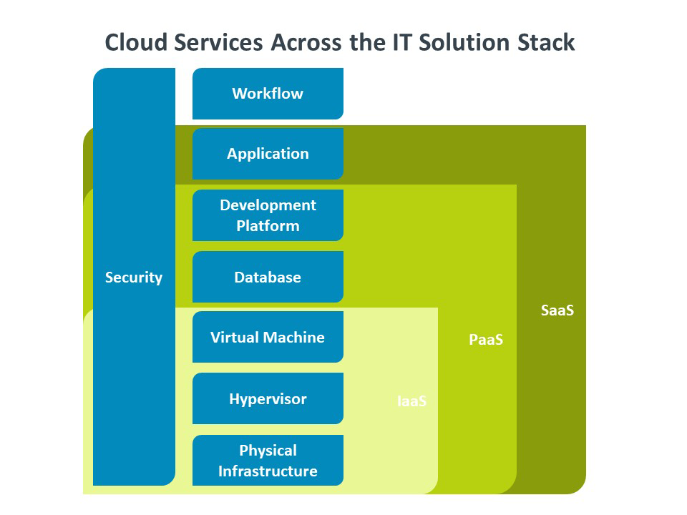

Some general benefits of cloud-based services include:

- Reduced hardware costs
- Improved resource utilization
- Increased flexibility and agility
- Reduced energy consumption
- Improved disaster recovery
- Simplified management

Infrastructure as a service benefits and Drawbacks

The cloud service known as "Infrastructure as a Service" (IaaS) makes virtualized computing resources available online. In place of conventional on-site data centre equipment, it offers computation, memory, storage, networking, and related software, such as operating systems and databases, as a cloud service.
Some advantages of IaaS are reduced infrastructure expenses, easier and more cost-effective scaling, flexibility to work anywhere, future-proof, increased security,” and the capacity to launch new projects quickly are a few advantages of IaaS.” [3] With IaaS, businesses can deploy and manage their applications and services on the cloud without having to purchase and maintain physical hardware.

Here are more details of the benefits of IaaS:
- Flexibility: IaaS enables businesses to scale their computing resources up or down as needed, providing greater flexibility in responding to changing business needs.
- Cost Savings: IaaS eliminates the need for businesses to purchase and maintain costly physical hardware, reducing capital expenditure and operational costs.
- Security: IaaS providers offer a range of security features and services to help businesses secure their applications and data on the cloud.
- Scalability: IaaS enables businesses to easily scale their computing resources up or down as needed, allowing them to respond quickly to changing business needs.
There are some disadvantages to consider, though:
    - Complexity: IaaS requires businesses to have some level of technical expertise to manage and configure the infrastructure on the cloud.
    - Control: IaaS requires businesses to take on more responsibility for managing their applications and services on the cloud, including configuring and maintaining security settings and access controls.
    - Performance: IaaS can sometimes suffer from performance issues due to the shared nature of the underlying infrastructure.

Platform as a service benefits and Drawbacks

Software as a Platform (PaaS) is a kind of cloud service that offers organisations or developers a platform for developing applications. “This platform offers various app development services as well as computation, memory, storage, and databases.” [4]

PaaS offers many benefits for developers, such as:
- Faster and easier development: PaaS provides ready-made tools and frameworks that simplify and accelerate the development process. Developers can focus on the core functionality and features of their applications, rather than on the technical details and configuration of the platform.
- Scalability and elasticity: PaaS allow developers to scale their applications up or down according to the demand and performance requirements. PaaS also enables developers to access additional resources and services on demand, such as storage, databases, analytics, etc.
- Cost-effectiveness and efficiency: PaaS reduces the upfront and operational costs of developing and deploying applications, as developers only pay for the resources and services they use. PaaS also eliminates the need for purchasing, installing, and maintaining hardware and software for the platform.
- Innovation and collaboration: PaaS enables developers to leverage the latest technologies and innovations offered by the cloud provider, such as artificial intelligence, machine learning, blockchain, etc. PaaS also facilitates collaboration among developers, as they can share code, data, and resources through the cloud platform.

However, PaaS also has some drawbacks that developers should be aware of, such as:
- Vendor lock-in and dependency: PaaS limits the choice and control of developers over the platform and its components. Developers may become dependent on the cloud provider's services and tools, which may not be compatible or interoperable with other platforms or providers. Developers may also face challenges in migrating their applications from one PaaS provider to another or a different cloud model.
- Security and compliance risks: PaaS exposes developers to potential security and compliance risks, as they have to rely on the cloud provider's security measures and policies. Developers may not have full visibility or control over the data and processes that are handled by the platform. Developers also have to comply with the regulations and standards that apply to their applications and data in the cloud environment.
- Performance and availability issues: PaaS may affect the performance and availability of the applications, as they are subject to the network latency and bandwidth limitations of the cloud provider. Developers may also experience downtime or service disruptions due to the cloud provider's maintenance or failures. Developers have to ensure that their applications are designed and tested for high availability and resilience in the cloud.

Software as a service benefits and Drawbacks

A cloud computing approach known as "software as a service" (SaaS) enables users to access software applications via the internet without having to download, manage, or update them on their own devices. We will go through some of the various advantages and disadvantages of SaaS in this section for both users and service providers.
One of the main benefits of SaaS is that it reduces the upfront cost and complexity of software deployment. Customers can pay a subscription fee based on their usage or needs, instead of buying expensive licenses and hardware. Providers can also scale up or down their resources according to demand and deliver updates and patches automatically to all users. SaaS also enables customers to access software from any device and location if they have an internet connection. This increases productivity, collaboration, and mobility.

However, there are also some drawbacks to consider. “These include vendor lock-in, limited control over the infrastructure, potential security risks, and potential downtime” [5]
If the internet connection is slow or interrupted, or if the provider experiences downtime or security breaches, customers may lose access to their data and applications. Customers also have less control over their data and software customization, as they have to comply with the provider's policies and standards. Additionally, SaaS may pose some challenges in terms of integration, compatibility and compliance with other systems and regulations.

Evaluation of Availability

In this paragraph, will be some general information about cloud service providers I will make some comparisons on the market and generate some suggestions for companies that decide to move two big projects to Cloud-based services. The table below is represented some data That I found to explore and decide on which provider will fit the given scenario.

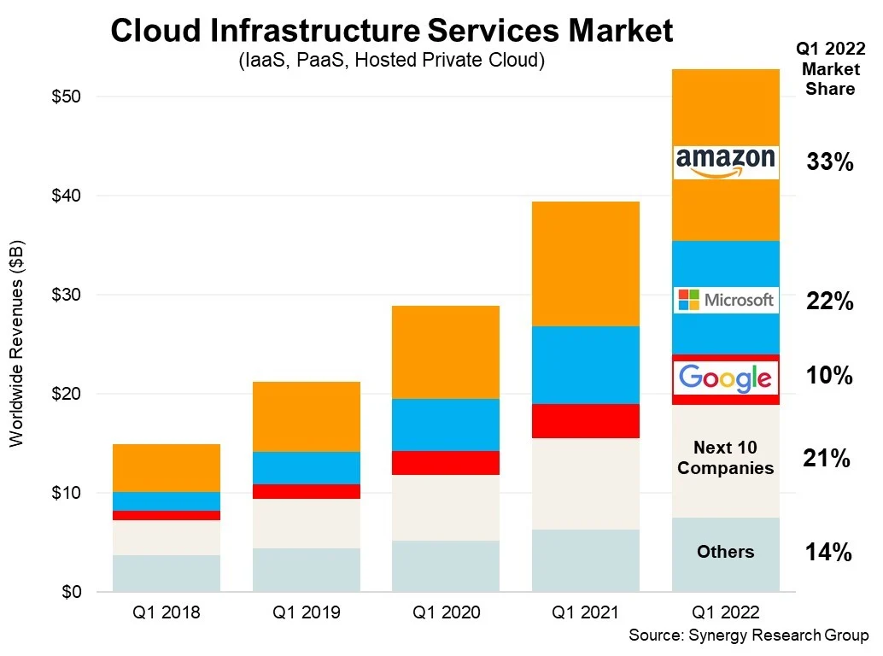

However, it is important to consider the costs of cloud migration which can range from $5,000 for smaller workloads up to $500,000 and beyond for larger tasks2. The migration costs are $5,000 – 15,000 for small workloads and $20,000 - $500,000 for medium/large workloads.
Azure divides resources across “locations”, “availability zones” and “resource groups”. A location is a geographical area containing one or more data centres. An availability zone is a physically separate data centre within an Azure region that has independent power, cooling, and networking. Resource groups are containers that hold related resources for an Azure solution.
Evaluation of Moving to Cloud Benefits:

Costs:
One of the primary benefits of cloud computing is cost savings. By leveraging cloud services, SMEs can reduce their capital and operational expenses. Cloud services offer a pay-as-you-go model, where customers only pay for what they use. This eliminates the need for SMEs to invest in expensive hardware and infrastructure, reducing their upfront costs. Cloud services also provide cost savings by offering economies of scale, allowing SMEs to access enterprise-level technology and resources at a lower cost.

Support:
Cloud service providers offer robust support services to their customers, including 24/7 technical support, monitoring, and management services. This eliminates the need for SMEs to hire dedicated IT staff and allows them to focus on their core business operations. Additionally, cloud service providers offer built-in security and compliance features, reducing the burden of SMEs to manage these critical functions.

Expertise:
Cloud computing requires specialized expertise to design, deploy, and manage cloud services. Cloud service providers offer this expertise as part of their service, eliminating the need for SMEs to develop these capabilities in-house. This allows SMEs to focus on their core competencies and leverage the expertise of cloud service providers to deliver reliable and scalable cloud services.

The benefits of cloud computing for SMEs can be evaluated based on the costs, support provided, and expertise required.

- For the first case with no cost limit, I would recommend using Azure Availability Zones to ensure the high availability of virtual machines. This would provide redundancy across different data centres in case of any failure in one of them. Additionally, I would recommend using Azure Site Recovery to replicate virtual machines to another region for disaster recovery purposes.

- For the second case with a medium budget, I would recommend using Azure Availability Sets to ensure the high availability of virtual machines. This would provide redundancy within a data centre in case of any failure in one of them. Additionally, I would recommend using Azure Backup to back up virtual machines to another region for disaster recovery purposes.

Security Considerations

In today's digital world, cloud computing has become a critical technology for organizations to host and manage their applications and services. “Cloud computing provides flexibility, scalability, and cost savings to organizations by leveraging virtualization technology.” [6] Virtualization technology has been around for decades, but its use in cloud computing has accelerated its adoption.

The differences between authorisation and authentication.


The process of confirming a user's or system's identification is known as authentication. Granting access to resources based on the authenticated identity is known as authorization. Multifactor authentication (MFA) adds an extra layer of security by requiring users to provide two or more forms of authentication before accessing resources. Applying least-privilege permissions means granting users only the minimum permissions required to perform their job functions. As a result, it is more challenging for an attacker to impersonate a user and access a system.

A virtual network's resources can have their inbound and outbound traffic managed by network security groups (NSGs). They can be used to isolate systems within their virtual network that could pose a larger risk to the organisation and adequately safeguard them using an NSG. Network security groups are used to filter network traffic to and from Azure resources in an Azure virtual network. Bastions (aka Jump boxes) are used as secure entry points into a virtual network from which administrators can connect to virtual machines.

Bastions, often referred to as Jumpboxes, are safe, fortified servers that give users-controlled access to other servers or network gadgets. By restricting direct access to sensitive systems, they add an extra degree of security. When deploying a public service to the cloud, it is important to consider cyber security risks and take appropriate measures such as applying MFA, least-privilege permissions, network security groups and Bastions.

Conclusion

Based on the Amazon Web Services “Business runs better in the cloud.” [2]
According to the information on the Microsoft Azure web page, “migrating to the cloud offers many benefits, including reduced IT costs and improved performance.” [7] However, the migration process itself presents some challenges, such as planning and cost. Some of the key benefits of cloud migration include optimized costs, flexibility and scalability, enhanced security, compliance, backup and recovery capabilities, and simplified management and monitoring. Despite these benefits, there are also challenges to consider when migrating to the cloud. These include the need for extensive planning across the organization, cost considerations for planning and implementing a migration, potential security and compliance considerations, and the need for careful planning to minimize downtime for businesses.

References

[1] | Borko Furht, Armando Escalante, Handbook of Cloud Computing, USA: LexisNexis, Boca Raton, USA, 2010.
[2] | T. H. Group, “Migrate with confidence,” Amazon Web Services, Inc, 2022. [Online]. Available: https://aws.amazon.com/cloud-migration/.
[3] | W. I. IaaS?, “What Is IaaS?,” CompTIA, Inc, [Online]. Available: https://www.comptia.org/content/articles/what-is-iaas.
[4] | N. L. Romero, “Cloud computing” in library automation: benefits and drawbacks,” The Bottom Line, vol. 25, pp. 110-114, 26 October 2012.
[5] | M. V. Thanawin Ratametha, Department of Informatics Lund University, Sweden, 2009.
[6] | El Mhouti, A., Erradi, M. & Nasseh, A, “Using cloud computing services in e-learning process: Benefits and challenges.,” SpringerLink, pp. 893-909, 2018.
[7] | “Benefits of cloud migration,” Microsoft Inc., 2023. [Online]. Available: https://azure.microsoft.com/en-gb/resources/cloud-computing-dictionary/benefits-of-cloud-migration/#benefits.

