L4 – Quality & Business Improvements
ACMA4004

Page 1- introduction
Page 2- data collection
Page 3- data analysis
Page 4-5 route cause analysis
Page 6-7 action plan

Introduction
I am creating this report to investigate and put together an improvement plan for a job that is currently being completes at my work place and the processes and procedures that we use to get the job done. I will be writing on a job I have completed on my current section, CNC Milling. At FSG, my current place of work. Manufacturing is a very important aspect to our company as it’s the start of any jobs we take on here at FSG. We make all our parts within the factory that get used in every job that leaves the factory. At FSG we manufacture a lot of parts and tools for a company called xtrutech. Xtrutech produce many different products and often use methods of heating and cooling plastic. All the parts we make for xtrutech have to be very accurate. In my report I will look into the most recent part I have machined for them which are the liners. Xtrutech are one of FSG most frequent customers and there is always work coming through the door from them. Therefore we are always looking at ways how to reduce machining time, reduce errors and best tooling to use on these jobs. Some parts that we machine for them take a very long time therefore we fill in data collection sheets to track where things went wrong in the process so it can be changed for next time.

I produced this graph to compare the old process we used to use to manufacture these parts and the new process I came up with after changing tooling, programme changes, and overall efficiency changes in the process. The graph shows how many parts got made in certain amount of hours taken. It is clear to see that the new method allows for a lot more parts to be made in less amount of time as the old method. The changes I made increased efficiency of the process by cutters not burning up as quick leading to down time.

Data analysis
When these jobs were getting machined the operator was left with a data collection sheet where they had to fill in things like how long the job took, did it go overtime, why did it go overtime, reasons for stopping the machine and any other problems encountered. From the sheets we realised the job was taking a lot longer to machine and complete compared to the hours that were given to the operator on the route card. This led into looking at why the job was taking so much longer and what could be changed for next time to make the job quicker and more efficient. Problems such as cutters burning up and wearing very quickly were adding to time as in the original process things like normal ball nose end mill were being used which wore very quickly due to how tough the material was. I changed this ball nose to an inserted tip ball nose which was making double the amount of parts before burning up and needing to be changed. Also I changed the 32mm ajx to a 32mm moldino as the tips would last longer and produce more parts before wearing. When I also changed these cutters in the programme I adjusted the speeds and feeds as the new cutters could be run faster which shaved time off how long it took to machine each part which was my aim. The original cutters used had to be run a lot slower which was taking extra time to machine each part. Also set up time of each part was taking a long time by either probing or clocking every part that was getting set up in the machine to set the datum. In the new process I changed this by ensuring a stop was set up so each part could be slid in the vice up against this stop to make sure the datum was in the same place every time and stop the operator having to clock or probe every single part. This took a lot of time off the overall time to machine the parts.

Root cause analysis
Root cause analysis can be carried out to identify or locate the original problems in a process so that they can be investigated and eliminated the next time the process is used. One of the main methods used to locate the problems in a process is the 5 whys. This method involves sitting down and looking at your process and picking away at it asking questions why about the process until you get to a question you cannot answer and identifies a problem. A different method that can be used is the 5 ms method. This method looks into the machine, method, material, man power and measurement that are being used in your manufacturing process. Whilst researching into each of the 5 factors you may find problems that you once didn’t realise and can help when making your process more efficient.

5 m’s analysis
Machine-
Ball nose cutter was burning up very quickly when machining these parts. Tips were also burning up very quick on the 32mm ajx. This is due to the fact that there were alternative cutters that were better to use that we were not using in our process. Therefore the tooling we were using had to be run slower and not as effective which made the tips and cutters burn up.
Method-
The programming could have been better on some toolpaths of this job, such as it was programmed to use the 32mm ajx to rough the outside which was putting a lot of strain on the tips whereas we have cutters that are much more suited to that job. This was because the person programming the job had not been on the machine before running these parts so they did not fully understand the way the cutters and material worked together as the material being used was very hard and not something we often use. Speeds and feeds were slightly off from the programmer which wasted a lot of tips in the machining process which cost our company good money to purchase.

Material –
The material was an issue as it not a very common material. It is extremely hard and not easy to work with as it fights against cutters and chews up any tip tooling if speeds and feeds are not bang on. The material is not one we work with in any other job other than these parts so it can cause some problems in the programming stage to ensure everything is 100% correct.

Man power-
These parts are run for days if not weeks at a time on one machine without set up being broke down. Therefore lots of parts get run through the afternoon shift. In this shift there are less boys working on all the machines therefore they just want them set up to run. They would not be spending time looking for changes they can make and things they can do differently to make the process more efficient they just want them set up and easy running so that they can go and work on different machines. There is often not a team leader also on afternoon shift therefore there is no one to go to for guidance and help when wanting to change aspects of the programme or tooling as they all work the day shift.

Measurement
This part was easy to measure with a digital Vernier or probe so there was no problem on the measurement aspect of this job. Everything was in tolerance throughout the processes.

5 y’s analysis
My problem I was researching is why the parts were taking so long to machine and how to cut the time down.

Why did the original problem occur?
This is due to the fact that the programmer programmed the job using tools we already have in our library that are the most common. Which resulted in speeds and feeds being wrong as the material is one we never really work with.
Why did they do that?
This was because they did not follow the hand book we have which explains exactly how xtrutech jobs should be set up and completed due to the nature of the material and the customer. The programmer used tools that were not as efficient for the job as other tools we had here which slowed the process down massively. This also let to speeds and feeds being wrong which caused a massive delay in run time on the machine as there was a lot of downtime changing tips and cutters in the machine Aa they were getting burned up very quickly form the wrong speeds and feeds.

Action plan
I created and action plan to improve the manufacturing process for this job. By using all my resources and help from people such as our tooling suppliers from Mitsubishi who know everything about the best cnc tooling and what is most efficient for each job, my team leaders from my section and also people on the section who had also machined these parts before. I started by speaking to my team leader and putting across what I felt the issues were and what was happening when machining the parts. I explained how the tooling and programme was not using the most efficient techniques available and that changes were required. We changed the programme to use the most efficient cutters we have to avoid so many tip breaks and burn ups. When changing the programme we also involved our Mitsubishi rep that often attends our factory to help with tooling. We made him ensure all our speeds and feeds were dead on accurate in the programme before running parts. We also showed everyone the best way to set up a stop for these parts to reduce set up time. We trailed with a few parts by tweaking feeds and speeds and working out how many parts we could produce before having to change and check tooling. By working this out this improved efficiency by not having to check after every part, but we had a number of parts in our head before stopping to check tooling.

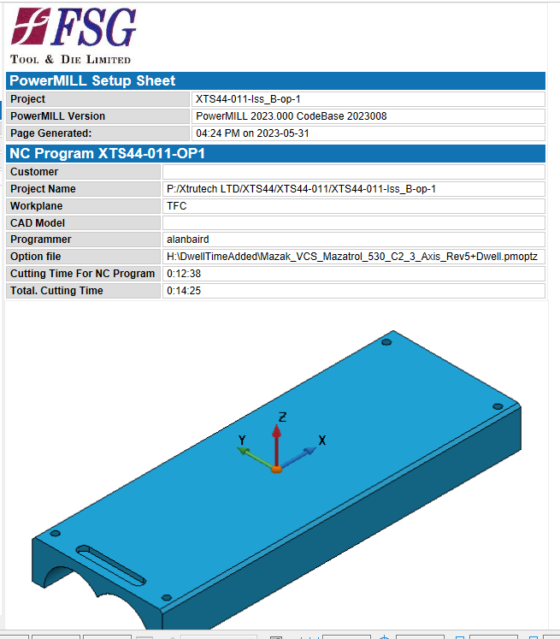
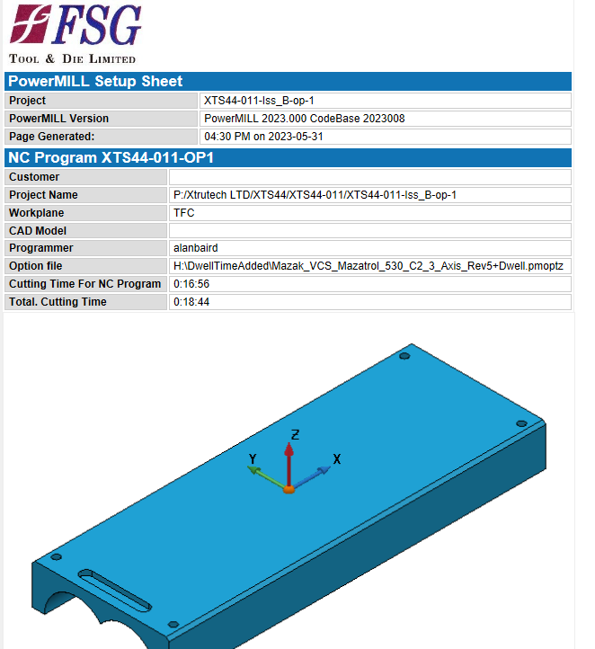

These two set up sheets show the difference in time this operation of the part takes just by changing the tools and speeds and feeds. It was taken off just short of 4 minutes of machining time which may not seem a lot but on average we manufacture 35 of these parts in one batch. So overall those 4 minutes would save about 140 minutes of machining time, so over 2 hours.

.

