
Development and application of manufacturing automation
Adam Evans 2005959 ACMA5001

April 16, 2023
University of Wales Trinity Saint David

Table of Contents
Table of Figures 1
Introduction 2
Main Project 3
History 3
Automation with the workplace 5
Fixed Automation 5
Programable automation 7
Flexible automation 8
Flat pack furniture manufacturer 10
Works Cited 12

Table of Figures
Figure 1 - industrial revolutions 2
Figure 2 - Intel 4004 3
Figure 3 - example of Ladder logic 4
Figure 4 - DCS and PLC 5
Figure 5 - Programable automation example 7
Figure 6 - types of Automation 9
Figure 7 - automation at Home 9
Figure 8- CNC pick and place robot 10
Figure 9 - CNC doors 11

Introduction

As manufacturing and industries become more advanced in, the way they work, they embrace new working methods and techniques which allow them to work smarter, allowing them to produce items cheaper, quicker, and more technical than ever before.
These advances in industries are titled industrial revolutions and provide landmark changes in the work environment which has shaped the world we live in today.
Shown below ( Figure 1 - industrial revolutions) are the four industrial revolution which have happened and what is currently happening today being the fourth.
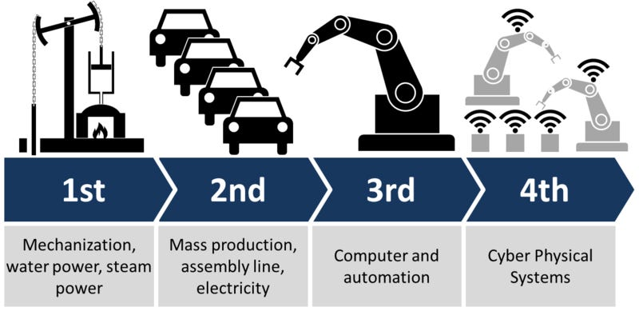
Figure 1 - industrial revolutions
This assignment is going to be focusing on what started in the third industrial revolution and how it has developed industries in the form of automation in the workplace in particular three types.
- Fixed Automation
- Programmable Automation
- Flexible Automation
The industries in which these three types of automations are best suited will be looking at the advantages and disadvantages to why each one suits different types of industries. Then a case study will be looked at to why a programable automation works well in a flatpack future manufacture.

Main Project

History
In 1969 the start of the third industrial revolution begun which has been tilted Computers and automation. However, revolutions don’t just happen overnight they take time, and they are constantly evolving to become more efficient and cost effective.
In 1971 the microprocessor was invented and was called the Intel 4004; this was invented by Marcian “Ted” Hoff (PhD '62 EE) and his intent actual was not to invent the chip but to fix a problem which had been proposed by a customer of a calculator.
(Anon., n.d.)

This microprocess which is the size of a fingernail (Figure 2 - Intel 4004) and had the same computing power as the first computer which was built in 1948 and filled an entire room. (Intel, n.d.)
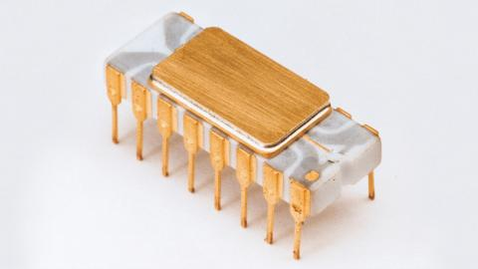
Figure 2 - Intel 4004
As a result of making something so small and powerful it could be utilized in environments where computers were previously not possible, the cost of this item was also dramatically less meaning that was now affordably to be used within an industrial environment in the form of personal computers or microcomputers.
This was also birth of the affordable PLC which is a programmable logic controller that is connected to machinery and triggered by sensors, limit switches or ball valves to name a few. These were used to replace previous technology for example hard relays and timers, with the first industry to introduce PLC into their operations was the automotive. This company was General Motors, and they came up with the Modular Controller which when it was tested it reduced down time of machinery by 60% (c3controls, 2023)
From this it is clear to see that the way forward was to start using PLC to remove current technology, but what it could also do is remove or reduce the number of operators required to perform a task by doing this automation could assist in new methods of performing a task which were previously too technical or dangerous to be performed by an operator.

The next advancement in PLC’s was the introduction of Ladder logic.
“Ladder logic is a programming language that is used to program a PLC (Programmable Logic Controller). It is a graphical PLC programming language which expresses logic operations with symbolic notation using ladder diagrams, much like the rails and rungs of a traditional relay logic circuit.”
(ladderlogicworld, 2021)
Due to this programable language being easy to understand and follow it soon became the main language for PLC programming, as previously Boolean Logic although worked it was difficult to understand for engineers who would now be using PLC’s, as previously computer scientist programmed as a specialty. This Ladder logic also resembles electrical schematic drawings which can easily be read in an engineering environment. As show in Figure 3 - example of Ladder logic
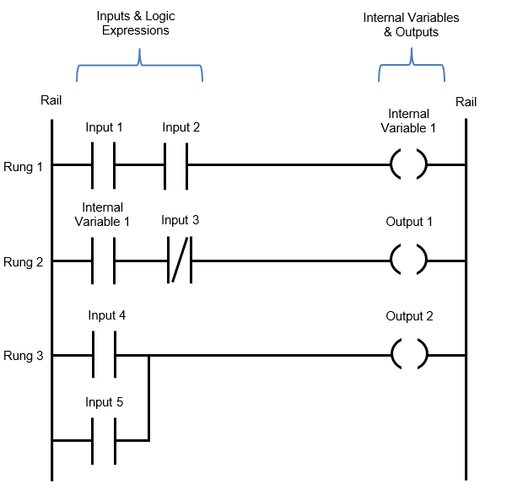
Figure 3 - example of Ladder logic

In 1975 distributed control systems or DCS for short came onto the scene, these however are very similar to PLC in what they do but they do it on a much larger scale. A PLC controls an isolated process where a DCS can control an entire factory. Below is an image which explains the difference between the two. Figure 4 - DCS and PLC
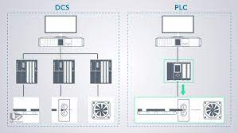
Figure 4 - DCS and PLC
Having this new technology knowing what it can do and how easy (yet you still need some training) it is to program, with a cost which will pay for itself with the money saved on over machine efficiency and overheads, all that is needed now is to understand where it can be used correctly within an industry.

Automation with the workplace

There are three main times of automation with the workplace these are.
- Fixed automation
- programmable automation
- Flexible automation
Each type of automation has its benefits and disadvantages making them suited for different types of operations within industries, so knowing and understanding what each type does and what it is best suited to is key to getting the most out of the automation.

Fixed Automation

Fixed automation is configured to run a single manufacturing process which stays fixed, this means it doesn’t perform any change overs and is relatively inflexible when a change is made to a product. A good example of this is paint primer spraying line where a product travels along a conveyor system entering a spray booth and exits on the same conveyor.

Car come out after being sprayed in its new colour.
Car travels on conveyor in one direction
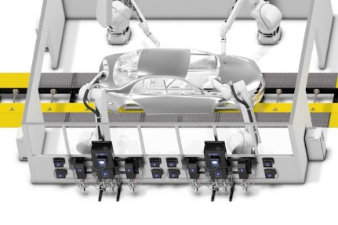
Car gets sprayed following a pre-set pattern.

This system is designed to accept one type of product which is the car body, spraying only one colour which is the white primer, mean this system can run all day at a steady flow as the process input is repeatable with no change.
Fixed Automation Examples
- Automated assembly machines
- Web Handling and converting systems.
- Chemical manufacturing processes
- Material conveyor systems
- Machining transfer lines
- Paint and coating automation processes
(eaminc, 2020)

This system can be expensive to install and set up initially but due to its nature of having robots and conveyor systems, but once it is running no other intervention is required and it can deliver high production rates. Another name for the fixed automation is hard automation.
Advantages for fixed automation
- Due to only one product being produced the output of the parts being produced is high.
- This is also reflected in the quality of the parts being produced, as once the system is set up it should repeatably produce the same thing over and over again.
- Although the initial cost high, the cost per unit being produced will be low.
- If the line malfunctions only one product is affected.
Disadvantaged for fixed automation.
- High initials start-up costs
- Difficult to change the process if the part changes.
- If the line goes down due to the output being high the over all machine efficiency can be highly effected.
So, in summary this type of automation best suits itself for products which are high in volume, generic products which don’t require any change.

Programable automation

Unlike fixed automation where only one product is being produced on a production line, programable automation can manage a multiple of products, however, change overs will need to be done which will slow the process down. This is all done automatically due to the process being programmed to detect key features on product, or through the programable logic when it has reached and passed the gate in the program the machine will adapt itself to perform the next part of the program.
This sort of automation is used for batch production, which the user can either make a dozen products at a time or thousands. An example of an industry which uses this type of automation is the food industry where different foods can be produced down the same production line. However, each change over although atomic will require the machine to purge itself out or self-clean before the next batch of produce could be produced.

This is shown below ( Figure 5 - Programable automation) example where 100 red jam jars are required before the machine will purge and self-clean before producing 100 yellow jams.
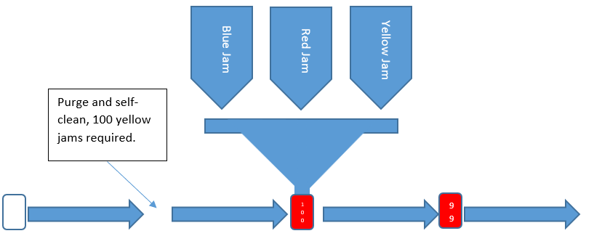
Figure 5 - Programable automation example

Advantages of programmable automation
- The production line can run a variety of products, as the process will change itself to suit what is required.
- The line can adapt to produce small or large batches of a product.
Disadvantages of a programmable automation
- Expensive to set up.
- Time consuming to perform change overs.
- Slower production output.
- Can generate waste through the purging operation or other forms of waste as a result of the change overs.
This type of automation is best suited to batch production at a steady speed.

Flexible automation

Flexible automation is very similar to programmable automation however it is much more complicated as this type of automation can handle changes within the cycle time and can also do them as frequently as every part. Another name for this type of automation is soft automation.
An example of an industry which uses this type of automation is the car industry where the production line can adapt itself depending on what car is being produced on the same production line at that time. For example, within Jaguar Land Rover FA02 building they produce 4 variants of cars on the same production line each with different specifications. When a Range Rover sport is being made the line will know the roof requires a full panoramic sunroof to being fitted and the robot will select the correct suction head for installation of this. The next can on the track could be a Jaguar F-pace which has a small sunroof the robot will then change the suction head to suit this operation, this is all done within the cycle time of the cars manufacture as the production line never stops as it is on a slow moving conveyor.
An ability which can be utilized on a flexible automated line is how it can be adapted to produce one off customised product, as the program can be altered offline and inputted to the machinery remotely, for example a customer may specially request the jaguar f-pace has a full panoramic sun roof.
(www.eaminc.com, 2023)

Advantages of flexible automation
- It can manage a large product range.
- There is no time lost in production when the changes occur.
Disadvantages of flexible automation
- The cost of the products being produced is going to be increased.
- The cost of the machinery required.
- If the line malfunctions multiple products are going to be affected
This type of automation is beat suited for a production line which has a large variety of products that are constantly changing.

To help choose what type of automation is best suited for your production needs the image below (Figure 6 - types of Automation) provides an easy and quick guide to help the user select the right one.

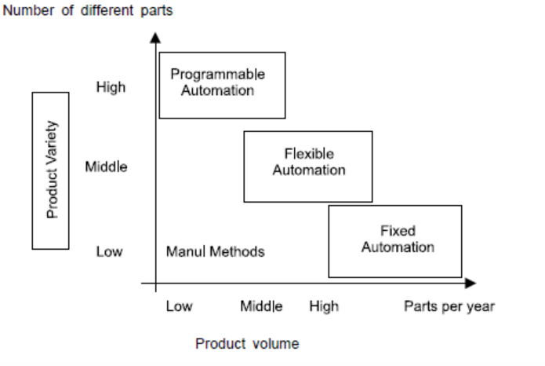
Figure 6 - types of Automation
Automation is constantly evolving and what can be seen within the fourth industrial revolution is the integration from industry into our homes. Where the programable logic controls are application on mobile phones which control almost everything within the house shown in Figure 7 - automation at Home.

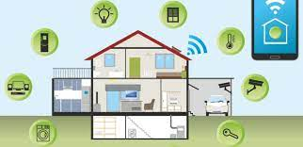
Figure 7 - automation at Home

Flat pack furniture manufacturer

Setting up a flat pack furniture manufacturing unit would benefit from automation to help speed up the process of producing each required items needed for the furniture. With reference to Figure 6 - types of Automation it is clear to see that the best automation to choose is the flexible automation process, as there are going to be multiple products being produced in batches on a small number of machines which will require a change of tooling throughout the process.
When looking at the types of machinery which is used it would typically be a form of a CNC machine which has been adapted into a production environment. Using pick and place robots’ material can be placed on the bed of the CNC, where the profile can be machined out and then the robot removes when the cycle time has been completed. Show below in Figure 7- CNC pick and place robot
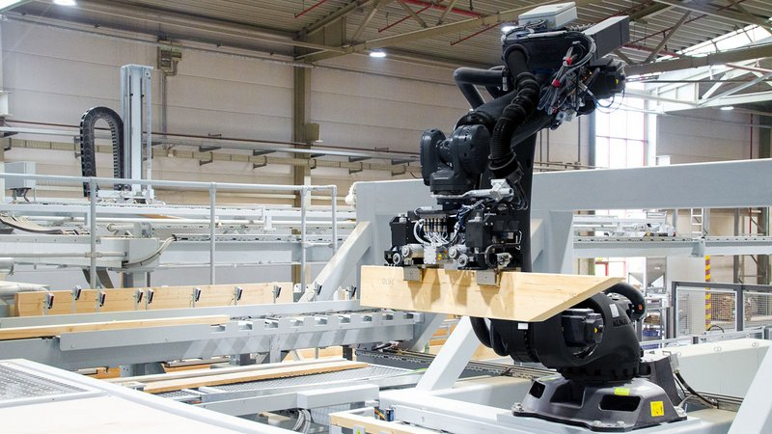
Figure 8- CNC pick and place robot

For example, doors for a chest of draws could be machined and the holes drilled for the knobs before the tooling is changed and the datums are reset to allow for a large bit of wood to enter the CNC to machine the back of the chest of draws. This can all be automatically however each changeover will require time to be performed.
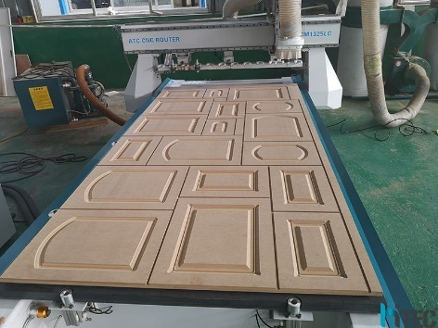
Figure 9 - CNC doors
This type of automation would lend itself so well to this type of automation as the products are being produced in batches, the machines can handle change overs to produce a variety of products which can be done with little to no human intervention.
If fixed automation was going to be used more machinery would be required as only one product could be produced on each machine and as flat pack furniture requires a lot of different types of products to create one item of furniture this would be very expensive to set up and just not practical.
Programmable automation could also be used for this type of process but as the type of manufacturing lends itself to batch production the on cost of installing a complicated automation process would justify itself with its extra cost.

Works Cited
Anon., n.d. https://engineering.stanford.edu. [Online]
Available at: https://engineering.stanford.edu/news/ted-hoff-birth-microprocessor-and-beyond
[Accessed 8 april 2023].
c3controls, 2023. https://www.c3controls.com/. [Online]
Available at: https://www.c3controls.com/white-paper/history-of-programmable-logic-controllers/
[Accessed 8 april 2023].
eaminc, 2020. www.eaminc.com. [Online]
Available at: https://www.eaminc.com/blog/automation-types/
[Accessed 8 april 2023].
Intel, n.d. https://www.intel.co.uk. [Online]
Available at: https://www.intel.co.uk/content/www/uk/en/history/museum-story-of-intel-4004.html
[Accessed 8 April 2023].
ladderlogicworld, 2021. ladderlogicworld.com. [Online]
Available at: https://ladderlogicworld.com/ladder-logic-basics/
[Accessed 8 April 2023].
Terry, K., 2022. https://www.isixsigma.com/new-to-six-sigma/dmaic/what-dmaic/. [Online]
Available at: https://www.isixsigma.com/new-to-six-sigma/dmaic/what-dmaic/
www.eaminc.com, 2023. https://www.eaminc.com. [Online]
Available at: https://www.eaminc.com/blog/automation-types/
[Accessed 8 April 2023].

