Contemporary Themes in the Hotel and Hospitality Sector
Student name: Ioana-Mirela Bumbu
Student id: 2227453
BMIH6001
Chris Wilkin
Year 6
Conference Research Paper
2,500 words

AI Declaration
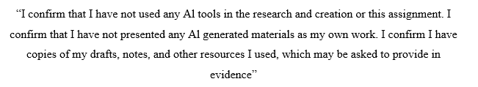

Abstract
The study examines how effective food waste reduction strategies are in the sustainability goal in the hospitality sector. The problem of food waste is a considerable burden to the hotels, undermining both the profitability of hotels and the encouragement of emissions of greenhouse gases as well as contradicts the sustainability strategies set by the world. Despite all this pressure on the hospitality organisations by the government, the consumers as well as other players in the industry, there is increasing expectation that the hospitality organisations should manage food waste in a cautious and transparent manner. The study use secondary research design because it entails industry reports and case studies of literature involved to determine the factors of food waste reduction.
With the use of different analytical frameworks, the study concludes that it is not only an environmental priority but a business strategic need to cut food waste among hospitality businesses. Hotels that are coming up with integrated and transparent strategies can be better placed in strengthening their profitability as well as customer loyalty, and make a considerable contribution towards global sustainability goals. The study provides viable recommendations on what the industry should do in future with the adoption of technology, enlisting the staff, networks of redistribution, and reporting visible sustainability.

Table of Contents
Abstract 2
1 Introduction 5
2 Literature Review 5
2.1 Food Waste as a Global and Hospitality Sector Challenge 5
2.2 Strategies for Reducing Food Waste 5
2.3 Barriers and Challenges in Implementing Food Waste Reduction 6
2.4 Efficacy of Food Waste Reduction for Sustainability Goals 6
3 Method 7
4 Theme Impact Analysis 8
4.1 PEAS Analysis 8
4.2 STAR Analysis 8
4.3 5Why Analysis 9
4.4 DPSIR Analysis 9
5 Conclusion 11
6 Recommendations 12
7 References 13
8 Appendix 17
8.1 EMBOK 17
8.2 STEEPLE Analysis 17
8.3 Swot 19
8.4 Strategy Clock 20

Introduction
Sustainability is a significant concern of the worldwide hospitality industry (Sharma. 2023). The hotel and hospitality industry generates a lot of food waste due to the specifics of their frequent activity, which is the presence of buffets, banquet service, and an unpredictable amount of guests, etc. Sustainability is a significant concept in the hospitality industry that is driven forward by extrinsic forces as well as necessities to maintain the sustainability. Such sustainability problems as food waste depend on the visibility and symbolic location of such a hospitality industry in the wider society (Khatter, 2023). The issue of food waste management not only needs to be a part of operational effectiveness but also leadership, the image, and association with environmental management in the global arena. An effective food waste reduction effort is explored, which supports the discussion in the study. Hospitality industry is traditionally very susceptible to international disasters like pandemics, terrorist acts and financial shocks that greatly interfere with operations and sustainability agenda (Costa and Costa, 2020).

Literature Review

Food Waste as a Global and Hospitality Sector Challenge
Food wastes have been established to be a complex concern in the globe since they are associated with extremely socio-environmental and economic deep impacts. A food waste is a noticeable issue in the hospitality business. Tribe (2009) writes that the philosophical views of tourism ethics emphasise that hospitality firms are morally obligated to be sustainable, which includes minimising food waste. Not only does such waste undermine the different aspects of environmental sustainability, it is also a colossal wasted money given that even the process of buying preparing and disposing costs some monies given the fact there are monetary bank offerings attached to it. According to the research of Omar et al. (2024), the hospitality sector as a sector that is more visible and consumer-oriented plays a strategic/ethical role in the issue regarding food waste as a part of their sustainability policy.

Strategies for Reducing Food Waste
Alsuwaidi et al. (2022) has distinguished a few strategies that are adopted by hotels and restaurants towards food waste reduction. Closely linked to digital tools and data analytics, it was pointed out that smart inventory management seems to be one of the methods to deliver food purchasing and demand forecasting into alignment. As Papargyropoulou et al. (2022) argue, redistributing excess food to charities and food banks has both environmental and social objectives, since it can lessen the amount of landfills by contributing to strategic disposal, as well as maximise benefits to the community. There is also local sourcing and advantageous menu planning that helps to eliminate waste by cutting down supply chains and lessening spoilage costs. The fact that big hotels can afford advanced systems is not always available to the small and medium-sized enterprises since they are often limited by their budgets, educational requirements, and technological restrictions (Damiani et al., 2021).

Barriers and Challenges in Implementing Food Waste Reduction
Although the challenge of how to deal with food waste is acknowledged as a sustainability issue, there is still the difficulty of implementing it. A key drawback raised is the cost, as the sophisticated technologies of waste tracking software and compost devices cost a lot at the start. Akkerman et al. (2023) notes that in the hospitality industry, the challenge is that SMEs are usually so limited that they cannot afford such a cost to justify the narrow profit margin. Waste management must be well-organised and have a strong organisational culture and a strong organisational leadership, as managerial practice has a direct influence on employee engagement with sustainability objectives (Ford and Sturman, 2020). Employee attitudes and organisational culture are also very important, since how the staff behave and other training programs can have an impact on the success of waste reduction programs. As Tanveer et al. (2023) found, even effective strategies can be weakened once the employees are not aware of the existing health care prevention strategy, the strategy is not monitored regularly, or the employees are not ready to get accustomed to current changes. As shown in figure 4, Strategy Clock by Bowman describes the way hospitality companies can make themselves competitive due to strategic pricing and value (Villagrasa et al., 2023). In the case of food waste reduction, the hotels may pursue differentiation approach, providing high environmental value by means of sustainability, local sourcing, and eco-branding. This provides a perceived high-quality that allows moderate prices. A differentiation strategy can be applied to eco-conscious customers, who want to experience genuine sustainable experiences.

Efficacy of Food Waste Reduction for Sustainability Goals
According to research Sobti et al. (2024), successful waste management will lead to less emission of carbon footprint, resources, as well as direct contribution to global climate objectives. Reduction in food waste has been associated with an increase in the profitability of a hospitality business in terms of reduced purchasing and disposal expenses. In addition to economic gains, efficacy is also looked at in terms of a better brand image and customer retention since the traveller with the sustainability mindset will choose hotels with apparent environmental investments (Tansel, 2021). Nonetheless, the literature has provided a warning that efficacy does not apply across all levels, as the effectiveness of strategies is dependent on the size of organisations, cultural orientation and adoption of technology. Modern research in the tourism industry emphasizes that the ever-present threats like terrorism and outbreaks affect consumer behavior, and this threatens demand toward clear and sustainable practices in the hospitality industry (Cooper and Hall, 2008). There is an opinion that the effectiveness of food waste minimisation in the hospitality industry also needs to be considered in social terms, especially with references to redistribution, which allows resolving the issue of hunger and community welfare (Achmad and Yulianah, 2022). As shown in figure 1, the Domains in EMBOK as applied to food waste reduction in hospitality are Administration (policy planning and budgeting), Design (developing sustainable menus), Marketing (classifying eco-conscious image), Operations (waste tracking) and Risk (legal and food safety compliance). Phases include initiation, planning, implementation, monitoring, and closure and it is aligned with the sustainability goals. Strategic and operational integration within hospitality management is ensured by processes such as evaluation and documentation, which ensure accountability, and core values such as ethics, sustainability, and transparency.

Method
The study is based on the secondary research which help to analyse achievements of minimizing food waste and implement one of the initiatives contributing sustainability of the hospitality industry. Secondary sources are peer-reviewed journal articles, government materials, industry reports of the hospitality industry and cases of the hospitality industry published materials (Cheong et al., 2023). The use of the secondary sources ensures that the study is founded on definitive and reliable evidence. Beyond the synthesis of the current knowledge, patterns, strategies and barriers concerning the reduction of the food waste in hospitality are determined (Afshar and Shah, 2025).
Different framework were used in order to provide a framework under which analysis can be made. As shown in table 1 of STEEPLE analysis, in which social, technological, economic, environmental, legal and ethical factors have been discussed. Furthermore, as shown in table 2, SWOT analysis has been discussed in which company strength includes sustainability and technology factor which enhance brand image. However, the weakness includes high cost and limited resources, whereas, the opportunities include consumers demands for the eco-friendly services.

Theme Impact Analysis

PEAS Analysis
Element | Explanation
Performance | - The aim of hotels is to achieve measurable sustainability outcomes, using the data-driven monitoring, intelligent inventory management, and sorting of waste.
Environment | - Hospitality industry is subject of a changing sustainability landscape due to the demands of guests, regulatory policies and global net-zero ambitions (Batabyal and Das, 2020).
Actuators | - The deployment of hotel management teams, chefs, and waste management staff is implemented as drivers who execute actions aimed at composting products, reallocating unwanted food, and buying the closest (Malik et al., 2024).
Sensors | - Data is gathered using the food waste tracking software, electronic inventory systems and performance audits and provide the feedback on the amount of waste and sustainability performance (Sharma et al., 2024).

STAR Analysis
Component | Explanation
Situation | - A big challenge in the hotel industry in relation to food wastage is mostly applicable to buffets, banquets, and unpredictability of the demand of a guest to an extent of producing more than expected (Wang et al., 2025).
Task | - Hotels are required to introduce structured sustainability practices that align with environmental objectives while maintaining operational profitability.
Action | - Many hotels have implemented smart inventory systems, AI-based forecasting, composting units, and partnerships with local food charities to manage surplus efficiently (Priestley, 2016).
Result | - These actions have reduced waste disposal costs, enhanced brand reputation, improved customer satisfaction, and contributed to sustainability reporting goals.

5Why Analysis
Question | Explanation
Why 1: Why do hotels produce large amounts of food waste? | - Because they frequently overproduce food to meet uncertain guest demand and maintain service quality (Kumari and Raghubanshi, 2023).
Why 2: Why does overproduction occur? | - Because forecasting and demand prediction systems are often inaccurate or underutilised.
Why 3: Why are forecasting systems weak or underused? | - Because many hotels lack access to advanced technologies or trained staff to analyse consumption patterns (Alsuwaidi et al., 2022).
Why 4: Why are training and technologies not prioritised? | - Because high installation costs and low awareness discourage investment in sustainability innovation.
Why 5: Why is sustainability under prioritised at management level? | - Because some hotel leaders still perceive sustainability as an expense rather than a strategic business advantage.

DPSIR Analysis
Component | Explanation
Driving Forces | - Growing global sustainability awareness, governmental environmental policies, and consumer expectations for ethical and eco-friendly hospitality practices.
Pressures | - Rising food and energy costs, limited resources, and the need for operational efficiency under tight profit margins.
State | - The industry has increased sustainability efforts, but adoption levels vary across hotel sizes, regions, and organisational cultures.
Impact | - Ineffective waste management leads to environmental harm, increased costs, and reduced brand trust among eco-conscious customers.
Response | - Hotels have responded through technology adoption, sustainability certification programmes, staff training, and collaboration with NGOs and local suppliers.

Food waste management sustainability initiatives have become prominent attributes of determining the way hotels conduct themselves, compete and communicate their values. The PEAS analysis demonstrates that contemporary operations in hotels have the tendency to become more of an intelligent system, in which the performance can be fuelled by quantifiable targets in terms of the sustainability. Strict government laws and consumer awareness are environmental factors that force hotels to organize their activities in accordance with the ethical expectations (Papargyropoulou et al., 2023). Digital waste tracking systems and real-time tracking of inventory increase the level of accountability and the accuracy of data. But, the analysis also points to the fact that the achievement is greatly pronounced by the efficiency of so-called actuators, i.e. managers and staff members, the motivation and training of which dictate the results of the operations. This implies that sustainability within the hospitality industry refers to behavioural change as much as the technological advancement.
Using the STAR analysis, it is find that food waste issue is brought about by the realities of running services that are not predictable. Hotels like Hilton and Marriott installed smart kitchen management systems and AI forecasting to ensure that they are able to overcome these challenges. Aligning eco-efficiency and profitability is a complicated task since it involves the balancing between satisfaction of the guests and reduction of waste (Omar et al., 2024). The measures implemented like redistribution partnerships and composting have an environmental and reputational advantage. Nevertheless, there are differing outcomes of different hotel types. The availability of resources can have a huge impact on luxury chains, and the independent hotels may lack the resources to continue with such plans in the long term (Malik et al., 2024). Therefore, the STAR analysis reveals one of the most significant drawbacks, which is that not all industries share the advantages of sustainability equally.
The 5 Whys analysis reveals the systematic problems related to the management of the hotel. The main cause of waste of overproduction is associated with forecasting flaws and non-investment of the technology. The solution to the underlying cause is hence cultural change- integrating sustainability in strategic planning, leadership values, as well as accountability mechanisms amongst the employees (Tanveer et al., 2023). This organisational gap could be overcome by means of training programmes and sustainability measures based on incentives that will make sustainability a central performance indicator and not a secondary objective.
The DPSIR framework is more socio-economic in view in that the behaviour in an industry is linked with external pressures and policy reactions. The promise of sustainability movement amongst individuals and government pressure on hotels would drive them to display their environmental responsibility (Wang et al., 2025). For example, global brands comprising well organized programmes like the IHG Green Engage are more accountable, whereas the small operators are lacking behind because of their inadequate technical and financial infrastructure. Cases where wasted management fails to succeed result in loss of reputation, lower competitiveness as well as environmental degradation. The best possible responses are those related to collaboration- cooperation with the local suppliers, NGOs, and administrative bodies to develop common sustainability infrastructures.
The STEEPLE analysis revealed that the UK hospitality industry, in reducing food waste as part of slimming down the industry in general, is one that is largely driven by political factors. The UK Government has reiterated over time that it is possible to both confront climate change and economic growth, with official data indicating that since 1990 and 2019, the country reduced its level of emissions by 44%, and its economy grew by 78% at the same time (GOV.UK, 2025).
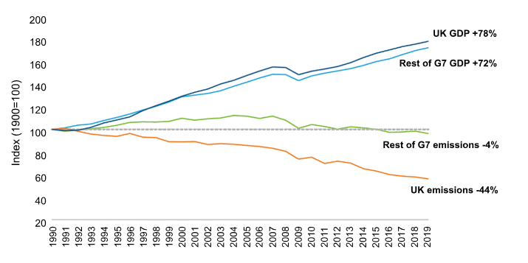

(Source: GOV.UK, 2025)
The financial innovations, such as Real Estate Investment Trusts (REITs) demonstrate how strategic investment models may be employed to improve the performance of hotels that are further applied to the sustainability investments, such as the food waste reduction (Batabyal and Das, 2020). A lot of production plants are also complicated by the rising inflation (3.8% in 2025) and gas prices as well (Statista, 2025). In terms of economics, larger hotel chains that have a higher financial strength are able to afford modern approaches related to waste management, and independent operators find it more challenging to strike a balance between sustainability and survival.
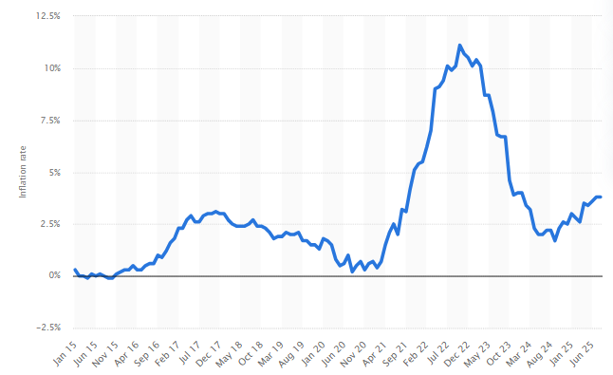
(Source: Statista, 2025)

Conclusion
Conclusively, food waste is not just a challenge on the operational level but also a burning environmental and reputational challenge for hotels. Using different framework, political regulation and economic pressure, coupled with social expectations and technological changes, have proved to be the determining factors on how well the hotels will respond to such a challenge when acted upon jointly.
In the case of the political component, it takes precedence over the fact that concerns the regulations, and the government policies possess opportunities and compliance pressures that the hotel industry must go through. Food waste minimisation can potentially save costs, but needs to be educated, and as such, the independent operators cannot avoid the expenses of investment, which is debated to be superior since the firms are bigger. The notion of social factors helps to understand the overall direction of heightened awareness of consumers and interest groups which demand more responsible and open hospitality businesses.

Recommendations
- Hotels should focus on the introduction of intelligence in inventory and waste management devices on the basis of AI. The purchasing behaviour can be reallocated automatically by the artificial intelligence, which can also process historical information on the consumption of products. Also, it gives purchase requests to decrease the overstocking based on the work of artificial intelligence.
- In addition, one of the main sustainability activities should be the development of the employees. The contribution of front-line employees, such as chefs, kitchen porters, and wait staff, on how to handle the food and prevent wastage. Such a combination of training programs should include components, harmless methods of meat storing and innovative layouts on the menu that will not modify the food qualities but rather reintroduce the older ones.
- Another recommendation is to form redistribution relationships with local charities and communities. Redistribution networks not only minimise wastage but also, in the presence of social responsiveness, show significant allegiance to the stakeholders interested in more than profitability.
- Furthermore, the hotels must proactively advertise their sustainability efforts to gain credibility among the eco-friendly customers and stakeholders. Credibility is promoted with transparency in reporting, i.e. the publication of annual sustainability reports, or the provision of real-time waste reduction information online, through electronic devices.

References
Achmad, W. and Yulianah, Y. (2022). Corporate Social Responsibility of the Hospitality Industry in Realizing Sustainable Tourism Development. Enrichment: Journal of Management, [Online] 12(2), pp.1610–1616. http://enrichment.iocspublisher.org/index.php/enrichment/article/view/447
Afshar, M.Z. and Shah, Dr.M.H. (2025). Strategic Evaluation Using PESTLE and SWOT Frameworks: Public Sector Perspective. SSRN Electronic Journal, 3(1). https://papers.ssrn.com/sol3/papers.cfm?abstract_id=5141505
Akkerman, R., Buisman, M., Cruijssen, F., de Leeuw, S. and Haijema, R. (2023). Dealing with donations: Supply chain management challenges for food banks. International Journal of Production Economics, [online] 262, p.108926. https://www.sciencedirect.com/science/article/pii/S0925527323001585
Alsuwaidi, M., Eid, R. and Agag, G. (2022). Tackling the complexity of guests’ food waste reduction behaviour in the hospitality industry. Tourism Management Perspectives, 42, p.100963. https://www.sciencedirect.com/science/article/pii/S2211973622000289
Batabyal, D. and Das, D.K. (2020). Global Trends, Practices, and Challenges in Contemporary Tourism and Hospitality Management. Amity University Kolkata & University of Burdwan.
Cheong, H., Lyons, A., Houghton, R. and Majumdar, A. (2023). Secondary Qualitative Research Methodology Using Online Data within the Context of Social Sciences. International Journal of Qualitative Methods, 22(1), pp.1–19. https://journals.sagepub.com/doi/abs/10.1177/16094069231180160
Cooper, C. and Hall, C.M. (2008). Contemporary Tourism: An International Approach. Routledge.
Costa, V. and Costa, C. (2020). Challenges in Times of Crisis and Pandemics in the Hospitality Industry: A Systematic Literature Review. Polytechnic Institute of Cávado and Ave & University of Aveiro.
Costa,, R. (2023). Hospitality sustainable practices, a global perspective. Worldwide Hospitality and Tourism Themes, 15(3). https://www.emerald.com/insight/content/doi/10.1108/whatt-02-2023-0022/full/html
Damiani, M., Pastorello, T., Carlesso, A., Tesser, S. and Semenzin, E. (2021). Quantifying environmental implications of surplus food redistribution to reduce food waste. Journal of Cleaner Production, 289, p.125813. https://www.sciencedirect.com/science/article/pii/S0959652621000330
EMBOK. (2019). EMBOK - Event Management Body of Knowledge - Afterburner2 — Free, GPL Template. Embok.org. https://www.embok.org/
Ford, R.C. and Sturman, M.C. (2020). Managing Hospitality Organisations. 2nd ed. Sage, London.
GOV.UK (2025). 1. Why Net Zero? [Online] Available at: https://www.gov.uk/government/publications/net-zero-strategy/1-why-net-zero [Accessed 25 Sep. 2025].
GOV.UK (2025d). Environment Act 2021. [Online] Legislation.gov.uk. Available at: https://www.legislation.gov.uk/ukpga/2021/30/contents [Accessed 25 Sep. 2025].
Ioannou, G. and Dukes, R. (2021). Anything goes? Exploring the limits of employment law in UK hospitality and catering. Industrial Relations Journal, [online] 52(3), pp.255–269. Available at: https://onlinelibrary.wiley.com/doi/full/10.1111/irj.12329 [Accessed 25 Sep. 2025].
Khatter, A. (2023). Challenges and Solutions for Environmental Sustainability in the Hospitality Sector. Sustainability, [online] 15(15), pp.11491–11491. https://www.mdpi.com/2071-1050/15/15/11491
Kumari, T. and Raghubanshi, A.S. (2023). Chapter 33 - Waste management practices in the developing nations: challenges and opportunities. [online] ScienceDirect. Available at: https://www.sciencedirect.com/science/article/pii/B9780323904636000178 [Accessed 25 Sep. 2025].
Malik, X., Smith, L., Stewart, I. and Burnett, N. (2024). Food waste in the UK. [Online] Parliament.uk. Available at: https://researchbriefings.files.parliament.uk/documents/CBP-7552/CBP-7552.pdf [Accessed 25 Sep. 2025].
Mark B. (2024). Available on https://mark-bridges.medium.com/crush-your-competition-with-bowmans-strategy-clock-9e0482974ac8. Accessible on 8th October, 2025.
Omar, I.A., Hasan, H.R., Jayaraman, R., Salah, K. and Omar, M. (2024). Using blockchain technology to achieve sustainability in the hospitality industry by reducing food waste. Computers & Industrial Engineering, [online] 197, p.110586. https://www.sciencedirect.com/science/article/pii/S0360835224007071
Papargyropoulou, E., Fearnyough, K., Spring, C. and Antal, L. (2022). The future of surplus food redistribution in the UK: Reimagining a ‘win-win’ scenario. Food Policy, 108(1), p.102230. https://www.sciencedirect.com/science/article/pii/S0306919222000136
Priestley, S. (2016). Food Waste: key facts, policy and trends in the UK. commonslibrary.parliament.uk. [Online] Available at: https://commonslibrary.parliament.uk/research-briefings/cbp-7552/ [Accessed 25 Sep. 2025].
Sharma, M., Singh, A.K. and Tyagi, P. (2024). Proceedings of the International Conference on Innovation and Regenerative Trends in Tourism and Hospitality Industry (IRTTHI 2024). Atlantis Press, Dordrecht.
Sobti, R., K, R., Kareem, H., P K, J., Dhamija, K. and Rao, A.L.N. (2024). Analyzing solid waste management practices for the hotel industry. E3S Web of Conferences, [online] 507, p.01073. https://www.e3s-conferences.org/articles/e3sconf/abs/2024/37/e3sconf_icftest2024_01073/e3sconf_icftest2024_01073.html
Statista (2025). Inflation rate for the Consumer Price Index (CPI) in the United Kingdom from January 2000 to January 2025. [Online] Statista. Available at: https://www.statista.com/statistics/306648/inflation-rate-consumer-price-index-cpi-united-kingdom-uk/ [Accessed 25 Sep. 2025].
Statista. (2023). Tourism sustainability concerns by age UK 2020. Statista; www.statista.com. https://www.statista.com/statistics/1135573/tourism-sustainability-concerns-uk-by-age/
Statista. (2023, February 28). Infographic: Digital transformation: what matters most to European hoteliers. Statista Daily Data; Statista. https://www.statista.com/chart/29350/leading-digital-transformation-topics-for-european-hoteliers/
Tansel (2021). Analysing Waste Management and Recycling Practices for the Hotel Industry - ProQuest. [Online] www.proquest.com. Available at: https://search.proquest.com/openview/49baf8ab1c5d484bbe67097e1741b432/1?pq-origsite=gscholar&cbl=466419 [Accessed 25 Sep. 2025].
Tanveer, M.I., Yusliza, M.Y. and Fawehinmi, O. (2023). Green HRM and hospitality industry: challenges and barriers in adopting environmentally friendly practices. Journal of Hospitality and Tourism Insights, [online] 7(1). https://www.emerald.com/insight/content/doi/10.1108/jhti-08-2022-0389/full/html
Tribe, J. (2009). Philosophical Issues in Tourism. Channel View Publications.
Wang, G., Qin, H., Tang, X. and Wu, L. (2025). Social Media Can Reduce Misinformation When Public Scrutiny is High. [Online] arXiv.org. Available at: https://arxiv.org/abs/2506.16355 [Accessed 25 Sep. 2025].

Appendix

EMBOK
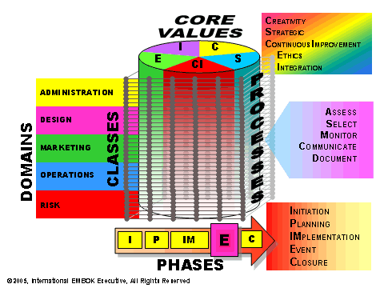
Figure 1: Embok
Source: (EMBOK, 2019)

STEEPLE Analysis
Table 1: STEEPLE Analysis
Factor | Impact on Hospitality Food Waste Reduction
Social | Growing environmental awareness among consumers especially Millennials and Gen Z—drives demand for sustainable hotels. Staff attitudes and culture significantly influence waste management success.
Technological | Use of AI, digital tracking, and inventory systems enables better demand forecasting and real-time waste monitoring. However, high technological costs limit smaller hotels adoption. The below figure shows that social media marketing have higher tendency as compare to other channels.  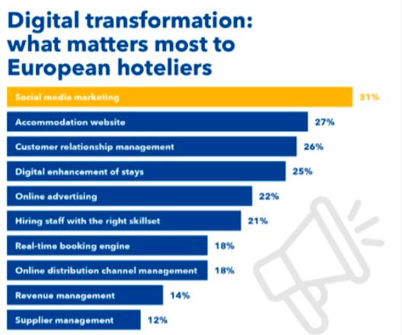  Figure 2: Digital transformation  Source: (Statista, 2023)
Economic | Inflation and rising energy prices raise operational costs. Yet, reducing food waste directly saves money through lower purchasing and disposal costs, improving profitability.
Environmental | Reducing food waste lowers carbon emissions and landfill use, contributing to the UK’s net-zero goals. Composting and anaerobic digestion create energy-efficient systems.  The below figure represent about the impact on destination and flying in which 36% of age from 25-34 years.  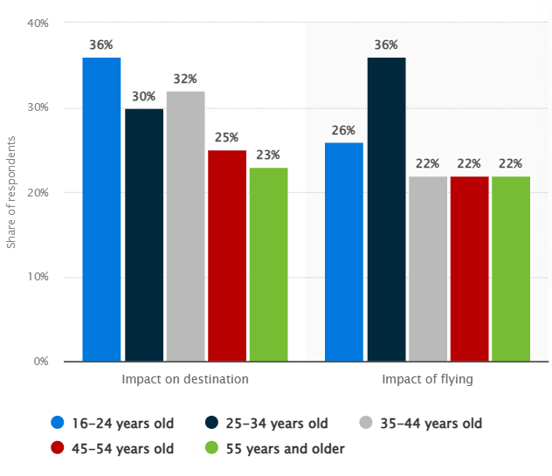  Figure 3: Concerns over the environmental impact of tourism among  Source: (Statista, 2023)
Political | UK government policies, including the Resources and Waste Strategy, promote sustainability and offer incentives for green technology investment. Political stability ensures consistent implementation.
Legal | Compliance with the Environment Act 2021 and Waste Regulations enforces waste segregation, recycling, and food redistribution standards. However, compliance adds administrative pressure.
Ethical | Ethical responsibility compels hotels to redistribute surplus food, prevent hunger, and demonstrate social care. Transparent sustainability reporting builds stakeholder trust and aligns with CSR goals.

Swot
Table 2: SWOT Analysis
Strengths  - Strong commitment to sustainability enhances brand image and customer trust.  - Use of smart technology and AI improves efficiency and waste tracking. | Weaknesses  - High initial cost of adopting green technologies and systems.  - Limited affordability and resources for SMEs to implement advanced solutions.
Opportunity  - Increasing consumer demand for eco-friendly and transparent hospitality services.  - Government incentives and support for recycling and food redistribution. | Threat  - Rising inflation and energy costs strain financial stability.  - Strict legal and environmental compliance adds operational pressure.

Strategy Clock

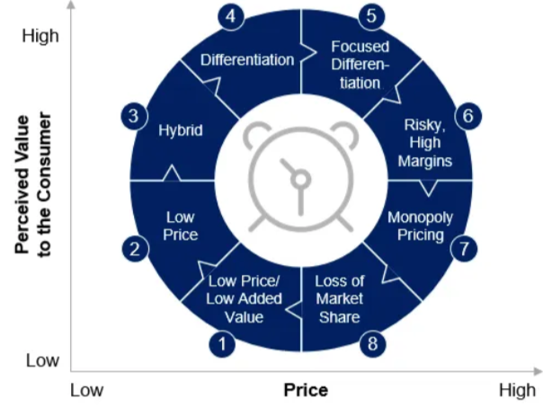
Figure 4: Strategy Clock
Source: (Mark, 2024)

