2 - PHP and mySQL

A basic database was set up as shown below:

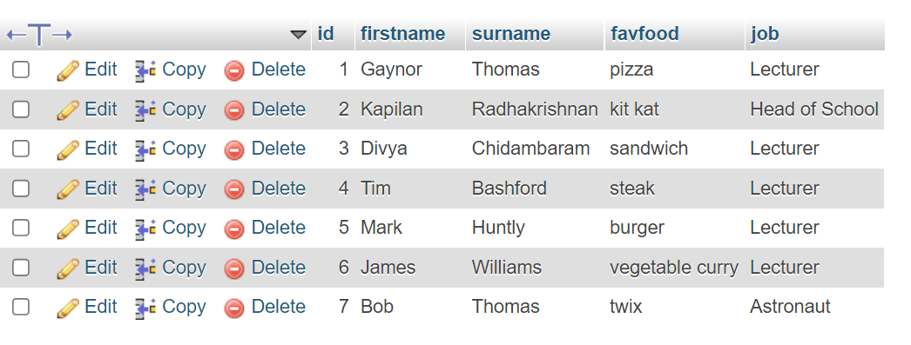
SQL

To retrieve data from the database, SQL (Structured Query Language) can be used

Some possibilities for basic queries include:

SELECT * FROM people

all fields name of table

SELECT * FROM people WHERE surname like ‘Thomas’

SELECT * FROM people WHERE surname like ‘Thomas’ ORDER BY firstname

SELECT * FROM people WHERE surname like ‘Thomas’ ORDER BY firstname DESC
Database Selection

To connect to a mySQL database from within a PHP page, we must set up variables to hold the connection details, and make a connection to the database:

conninfo.php

<?php
$strServer="localhost"; // Location of mySQL database
$strDatabase="gaynor"; // Database Name
$strUser="root"; // Username
$strPwd=""; // Password

$link=mysqli_connect($strServer,$strUser,$strPwd,$strDatabase)or die("Could not open database");
?>

Then, on the page on which we wish to connect to our database, we include the connection details at the top of the page

<?include("conninfo.php");

?>

Note: Previously mysql_connect was used rather than mysqli_connect, however the former was deprecated back in PHP version 5.5.1.
Next we retrieve data from the database via a query:

<?include("conninfo.php");

$query="SELECT * from people"; //set up the query

$result = mysqli_query($link,$query) or die("Couldn't execute query");
//execute the query,
// store result in $result

We can now use $result to print the data we selected on the screen.

while($r=mysqli_fetch_array($result)) //get the results
{
echo $r["id"];
echo $r["firstname"];
echo $r["surname"];
echo $r["favfood"];
echo $r["job"];
}

Finally, we can use HTML to present the results neatly on the screen. Below I have used . " " to put a space between the fields, and a <br> at the end of the record.

I have also used a <h2></h2> outside PHP tags to create a header at the top.

<?include("conninfo.php");

$query=("SELECT * from people");

$result = mysqli_query($link,$query) or die("Couldn't execute query");
?>

<h2>Results</h2>

<?
while($r=mysqli_fetch_array($result))
{

echo $r["id"]. " ";
echo $r["firstname"]." ";
echo $r["surname"]." ";
echo $r["favfood"]." ";
echo $r["job"]."<br>";

}

?>

A screenshot of the output:



