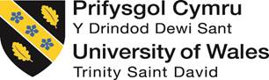

Marketing Plan
Student ID: 2243335
Student Name: Georgiana Manolache
Word count: 1250 words
Table of Contents
1 Introduction 4
2 Situation Analysis 4
2.1 5C’s 4
2.1.1 Company: SWOT analysis (Microanalysis) 4
2.1.2 Customers: Segmentation and Targeting 5
2.1.3 Competitors: Perceptual positioning map, Bowman's strategy clock 6
2.1.4 Collaborators 7
2.2 Climate: PESTLE (Macro analysis) 7
2.3 Marketing Mix 8
2.3.1 Product 8
2.3.2 Price 8
2.3.3 Place 8
2.3.4 Promotion 8
3 Objectives 8
4 Strategy 9
5 Tactics 10
5.1 RACE 10
5.1.1 Reach 10
5.1.2 Act 10
5.1.3 Convert 11
5.1.4 Engage 11
6 Action 11
7 Control 12
8 Conclusion 12
9 References 13
10 Appendix 15
10.1 Slides 15

Introduction
The primary purpose of this marketing plan is to provide marketing ideas and views in order to make a plan for a chosen hotel. The marketing plan will provide a methodical procedure for mounting customer-based marketing plans and marketing tactics, which counterpart an organisation (Ferrel et al., 2021). Hence, the hotel chosen is Cardiff Marriott hotel. Therefore, the whole marketing plan will include online and offline means in order to capture new and old customers in order to enhance the profit of the hotel. Therefore, this report will use frameworks such as SOSTAC, Ansoff matrix and others in order to provide a detailed and in-depth marketing plan.

Situation Analysis

5C’s

Company: SWOT analysis (Microanalysis)
SWOT analysis is a process by which strength, weaknesses, opportunities and threats can be analyzed to help a business in making decisions and establishing a strategy accordingly (Benzaghta et al., 2021).
Strengths  - The hotel has a strong brand image.  - It provides comfortable accommodation and attentive service with ideal pricing.  - Cardiff Marriot hotel offers excellent experience in vibrant Welsh capital city in style.  - It is situated in the heart of city Centre.  - The brand representation is high in regards to meeting to brunch, drink, and enjoy.  - It also provides affordable prices.  - Provides with unbeatable access to main attraction in the city to give unforgettable experience (Cardiff Marriott hotel 2023a)  - Its ranking has increased from 644 to 663.  - It has 24 hour room service, fitness area, dry cleaning area and meeting space as well (Cardiff Marriott hotel 2023b)  - It staff speak German, Romanian, Dutch and English making it easy to communicate with wide variety of people. | Weakness  - The weaknesses are in regard to many competitors in the market.  - There needs to be more marketing done for the hotel.  - It brings new values that disregard older adults.
Opportunities  - The hotel can work on its marketing strategies.  - It can work in order to increase revenue.  - The hotel can generate new opportunities for people and society. | Threats  - The marketing tactics also need to improve.  - There are many other good brands in the market.  - The hotel needs competent employees to work on their training.

Customers: Segmentation and Targeting
Segmentation and targeting is the process by which the potential customer of a company can be identified by which values can be created for the target market (Rosdiyah 2020). The customer representation in regard to this hotel is as follows:
Segmentation | Age, behavior, demographics, income
Target | It targets young and millennials with people wanting affordable rentals and hostels when single, pair or in group. It mainly targets individuals belonging to 25-34 years of age and its audience comprises mainly female.

Competitors: Perceptual positioning map, Bowman's strategy clock
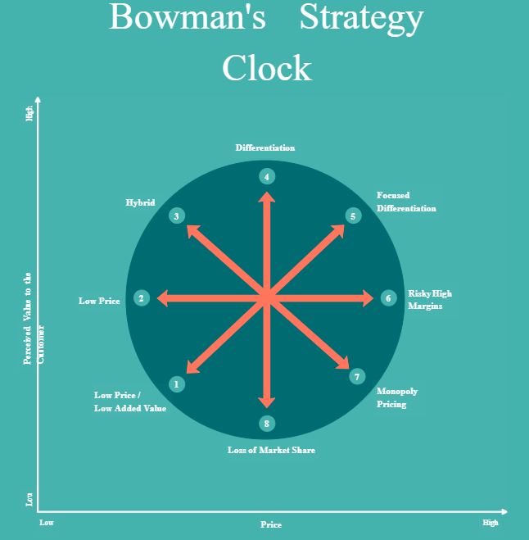
Figure 1: Bowman's strategy
Source: Creately, 2023
Cardiff Marriott Hotel, on the Bowman strategy among different competitors, is based on more perceived value as it gives affordable prices with reasonable accommodation and services to customers. The bowman strategy clock enables in understanding how companies compete in the market place but observing various combinations of price and perceived values (Almutairi 2023).
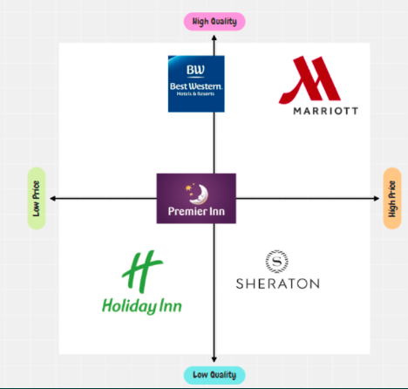
Figure 2: Positioning map of Cardiff Marriott Hotels

Collaborators
- The hotel collaborated with delta by Marriott brand for the restructuring of the hotel brand and it collaborates with serve 360 to contribute towards positivity and sustainable practices (Cardiff Marriott hotel 2023c)

Climate: PESTLE (Macro analysis)
Political:  - The political instability affects the business.  - The political scenario in the UK is stable, hence more tourists. | Economic  - Cardiff Marriott hotels are affordable in cities where the GDP is high.  - The inflation rate also affects it.
Social  - The affordability of the hotel engages more travellers.  - The services also affect the hotel customers.  - With family size and accommodations wanted, the services are provided by the hotel. | Technological  - The hotel is invested in research and development.  - Also, it is engaged in social media platforms with people.
Legal  - The hotel provides equality to all employees.  - It follows diversity and inclusion as well. | Environmental  - There needs to be more environmentally friendly products.  - However, it is working on sustainability.

Marketing Mix

Product
The main product is the hotel named Cardiff Marriott Hotel, which is mainly under the Marriott group. It provides reasonable services and accommodation with rentals and hostels at affordable rates. It provides with spacious accommodation and on site dinning.

Price
The price of the services of the hotel ranges from £70 to £80 per night that is fully refundable. Hence, there are fun shared dormitories to designer rooms with comfort and unusual design spaces.

Place
The hotels around the world are mainly in the Cardiff, Wales as there are many tourists with being at exotic locations (Cardiff Marriott, 2023).

Promotion
The hotel does not mainly uses different social media platforms in order to engage with customers. But the top traffic source of Cardiff is direct traffic on the website and referrals.

Objectives
- To increase customer engagement by 25% at the end of the year with the help of different marketing tactics, as mentioned.
- To increase customers’ (old and new) awareness and loyalty in regards to the hotel by 10% in 12 months.
- To maximise sales and generate revenue for the hotel by 10% in 12 months by increasing the customer base.

Strategy
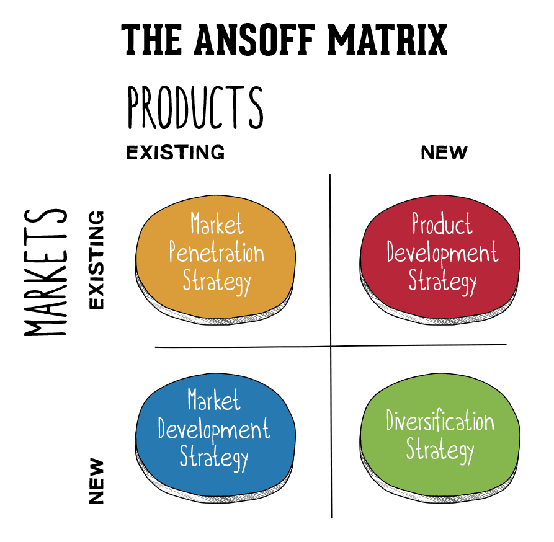
Figure 6: Ansoff Matrix
As narrated by Loredana (2016) The primary strategy is market development, focusing on different aspects by which people can be attracted and broader audience is attracted. Therefore, new style accommodations, interactive activities, and immersive local cultural experiences are just a few examples of Cardiff Marriott’s dedication to offering millennials distinctive and unforgettable travel experiences. As a result, the hotel can concentrate on altering room layouts, features, and technology to suit the tastes of the target market. Create immersive packages that offer access to nearby events, trips, and activities in addition to lodging. In order to offer reasonable rates based on demand, seasonality, and length of stay, employ dynamic pricing solutions. Hence, this primary strategy is to utilize a reputation management strategy to combat negative comments as it is another strategy for development of business (Zugay and Zakaria 2023). Encourage happy guests to submit good reviews on social media platforms, work with influencers to promote the updated hotel experience, and empower staff to go above and beyond for customers and make unforgettable experiences for visitors as customer word of mouth is a potential tool for making reputation of a business (Ngoma and Ntale 2019).

Tactics
The main strategy in regards to the hotel plan is to focus on different strategies at the same time. Therefore, there is a need to focus on email marketing while also using YouTube, Facebook and Twitter as it can create a significant impact on business performance by which loyal customers are attained (Ebrahim 2020). The hotel will also create memes as people find it funny to be similar to memes. Therefore, there will also be the creation of a schedule featuring a variety of aesthetically engaging articles, tales, and films that highlight Cardiff Marriott 's unusual travel adventures. The marketer will use several social media platforms to focus on blog posts, films, and infographics that convey engrossing tales about the locations, local culture, and distinctive features of staying at Cardiff Marriott hotels. The hotel will also monitor online feedback and reviews in regards to being in more positive limelight. As narrated by Xu (2019) feedback play crucial role because a considerable proportion of people look for reviews online before making purchase or plans.

RACE

Reach
Hence, there is need to reach a larger audience; social media advertising is used on Instagram, Facebook, and TikTok. Join forces with travel influencers who are well-liked by your target market. Consequently, search engine-optimised blog entries, videos, and infographics that are shareable and interesting tools for marketing that reach wider audience (Li et al., 2021)

Act
As a result, the hotel will ensure that the website is user-friendly and responsive on mobile devices to motivate visitors to take action, such as making a reservation or signing up for your newsletter. With this, email marketing will be carried out through email campaigns to persuade subscribers to take action, such as making a reservation or signing up for exclusive deals and highlighting the distinctive experiences provided by Cardiff Marriott in your email content. As email will help in reaching goals as it can help in customer engagement and creating brand awareness that is necessary to attain customer (Desai and Vidyapeeth 2019).

Convert
In this, the hotel will mainly segment email lists and website content to target certain client groups with customised offers and suggestions while showcasing pertinent material to improve conversion rates. As narrated by Chandra et al., (2022) customized offers and personalization can build a positive image among customers, and it is a process by which customers are retained. Hence, the booking procedure will be done in a more feasible way in regard to offering payment choices and giving in-depth details about rooms, services and other aspects. Therefore, A/B testing should be used to determine which aspects of the website, emails, and marketing initiatives are more effective at converting visitors into paying customers.

Engage
With the help of customer feedback, email engagement and social media platforms, the services will improve as digital marketing allowing in connecting to customer that is vital for awareness (Svahn et al., 2017)

Action
Figure 7: Gannt Chart
Hence, in regards to the chart, mainly this marketing will be provided in 12 months period with including sponsors, influencers and other aspects in order to show true marketing of the hotel. Therefore, the marketing will be conducted in three parts direct marketing, public relations and advertising using both offline and online means. Therefore, advertising will take up to four months with also working personal selling. Therefore, the achievement of the advertising plan will help regulate the clientele and profits. Advertisement can bring mass attention towards the hotel, and it also generates goodwill for the company by which more customers are gained (Lee and Cho 2020). As a result, Gant chart provides a time frame with each of the marketing actions that will take place and in what time.

Control
The success will be measured in regards to success factors in regards to the KPIs and metrics that are also mentioned in the grant chart. Therefore, the standard metrics in regards to this marketing plan are customer satisfactions, likes, reach and web traffic (Krizanova et al., 2019) on the hotel website in order to check with also the number of booking done of the hotel page. Thus, there will be enhancement of positive attitudes and increased profits with the help of working on customer loyalty and also attracting old customers. Hence, customer retention will also be focused on in regards to (both old and new) for the hotel.

Conclusion
In regards to Cardiff Marriott Hotel, the main recommendations are related to working on its marketing tactics in regards to focusing more on digital marketing and customer engagement with different tactics. Therefore, the hotel needs to be consistent on its plan with highlighting its affordability among customers in order to attract more new customers. The hotel should also hire competent people and train them in order to provide high-quality services in respect to engage in word-of-mouth among people. Hence, there is also need for work on positive reviews on many websites such as trip advisor and other websites.

References
Almutairi, M.M.Q., 2023. The Impact Of Market Analysis On The Company Strategy. Journal of Positive School Psychology, pp.401-412.
Benzaghta, M.A., Elwalda, A., Mousa, M.M., Erkan, I. and Rahman, M., 2021. SWOT analysis applications: An integrative literature review. Journal of Global Business Insights, 6(1), pp.55-73.
Cardiff Marriott hotel 2023a. Cardiff Marriott hotel overview.com [online] available at: https://www.marriott.com/en-us/hotels/cwldt-cardiff-marriott-hotel/overview/ (Accessed on 21 September 2023)
Cardiff Marriott hotel 2023b. Cardiff Marriott hotel events .com [online] available at: https://www.marriott.com/en-us/hotels/cwldt-cardiff-marriott-hotel/events/ (Accessed on 21 September 2023)
Cardiff Marriott hotel 2023c. We are Marriott International [online] available at: https://www.marriott.com/marriott/aboutmarriott.mi (Accessed on 21 September 2023)
Chandra, S., Verma, S., Lim, W.M., Kumar, S. and Donthu, N., 2022. Personalization in personalized marketing: Trends and ways forward. Psychology & Marketing, 39(8), pp.1529-1562.
Desai, V. and Vidyapeeth, B., 2019. Digital marketing: A review. International Journal of Trend in Scientific Research and Development, 5(5), pp.196-200.
Ebrahim, R.S., 2020. The role of trust in understanding the impact of social media marketing on brand equity and brand loyalty. Journal of Relationship Marketing, 19(4), pp.287-308.
Ferrell, O.C., Hartline, M. and Hochstein, B.W., 2021. Marketing strategy. Cengage Learning.
Krizanova, A., Lăzăroiu, G., Gajanova, L., Kliestikova, J., Nadanyiova, M. and Moravcikova, D., 2019. The effectiveness of marketing communication and the importance of its evaluation in an online environment. Sustainability, 11(24), p.7016.
Lee, H. and Cho, C.H., 2020. Digital advertising: present and future prospects. International Journal of Advertising, 39(3), pp.332-341.
Li, F., Larimo, J. and Leonidou, L.C., 2021. Social media marketing strategy: definition, conceptualization, taxonomy, validation, and future agenda. Journal of the Academy of Marketing Science, 49, pp.51-70.
Loredana, E.M., 2016. The use of Ansoff matrix in the field of business. In MATEC Web of Conferences (Vol. 44, p. 01006).
Ngoma, M. and Ntale, P.D., 2019. Word of mouth communication: A mediator of relationship marketing and customer loyalty. Cogent Business & Management.
Rosdiyah, A.N.H., Hamid, A. and Matondang, Z., 2020. Strategy Of Market Segmentation, Targeting, and Positioning In Increasing The Number Of Customers At PT. bank Muamalat Indonesia Tbk KCP Panyabungan. Journal Sharia Of Banking, 69.
Similar Web 2023. Marriott.com [online] available at: https://www.similarweb.com/website/marriott.com/#overview (Accessed on 21 September 2023)
Svahn, F., Mathiassen, L. and Lindgren, R., 2017. Embracing digital innovation in incumbent firms. MIS quarterly, 41(1), pp.239-254.
Xu, X., 2019. Examining the relevance of online customer textual reviews on hotels’ product and service attributes. Journal of Hospitality & Tourism Research, 43(1), pp.141-163.
Zugay, B. and Zakaria, R., 2023. Ansoff Matrix.

Appendix
Slides: 1
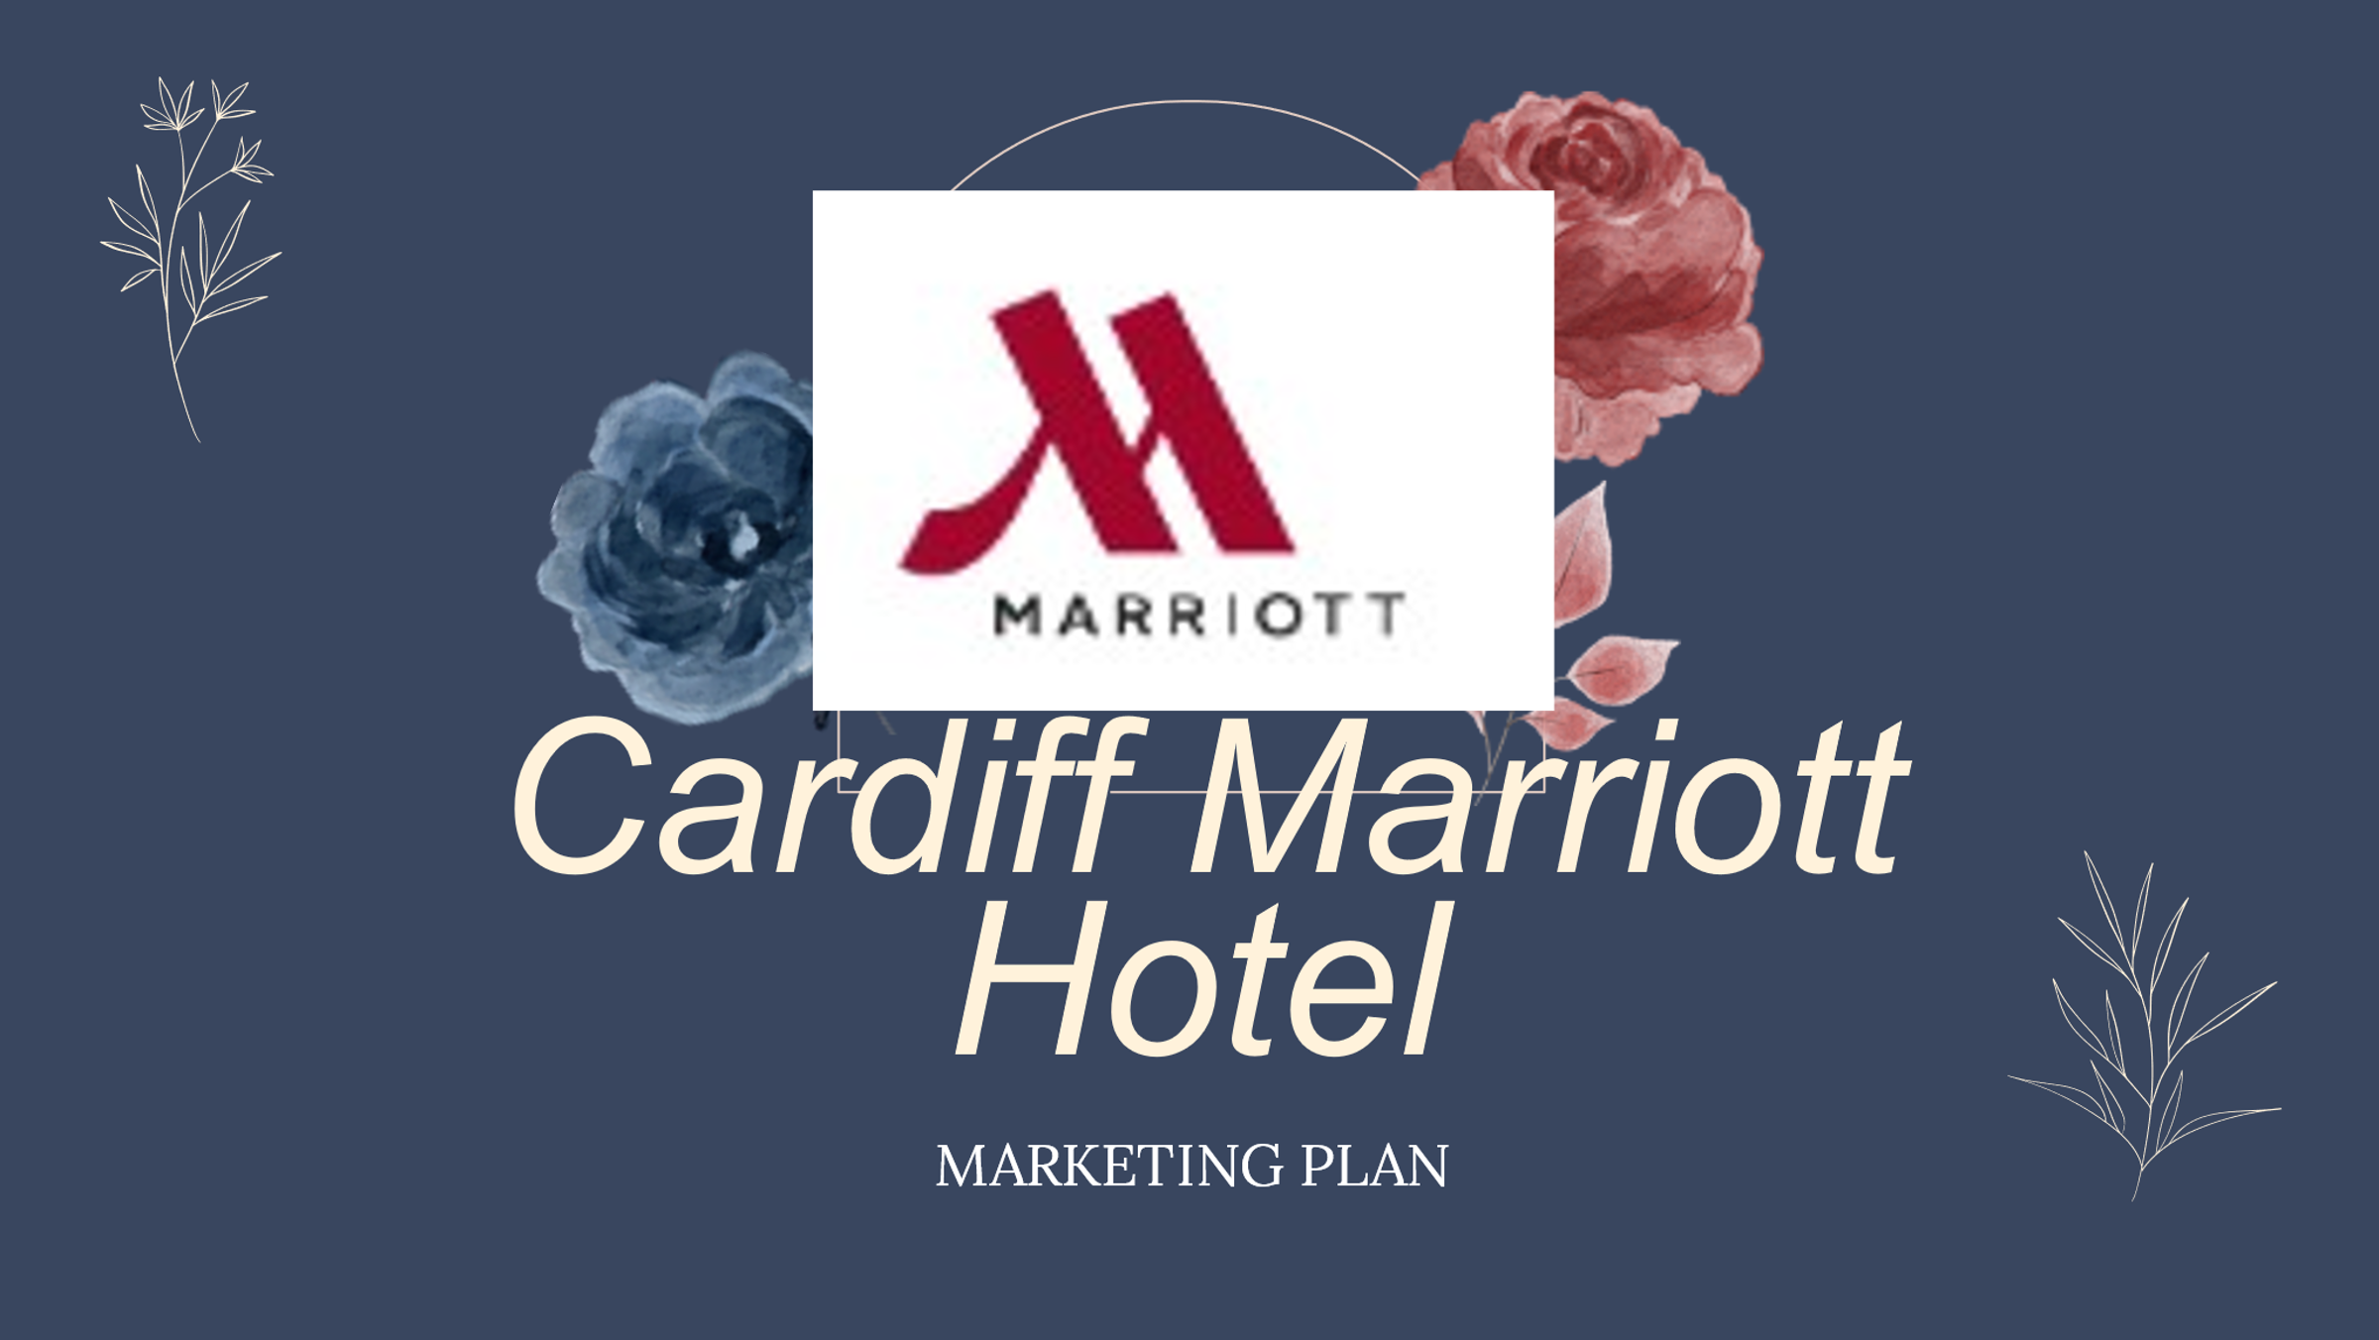
Slide: 2
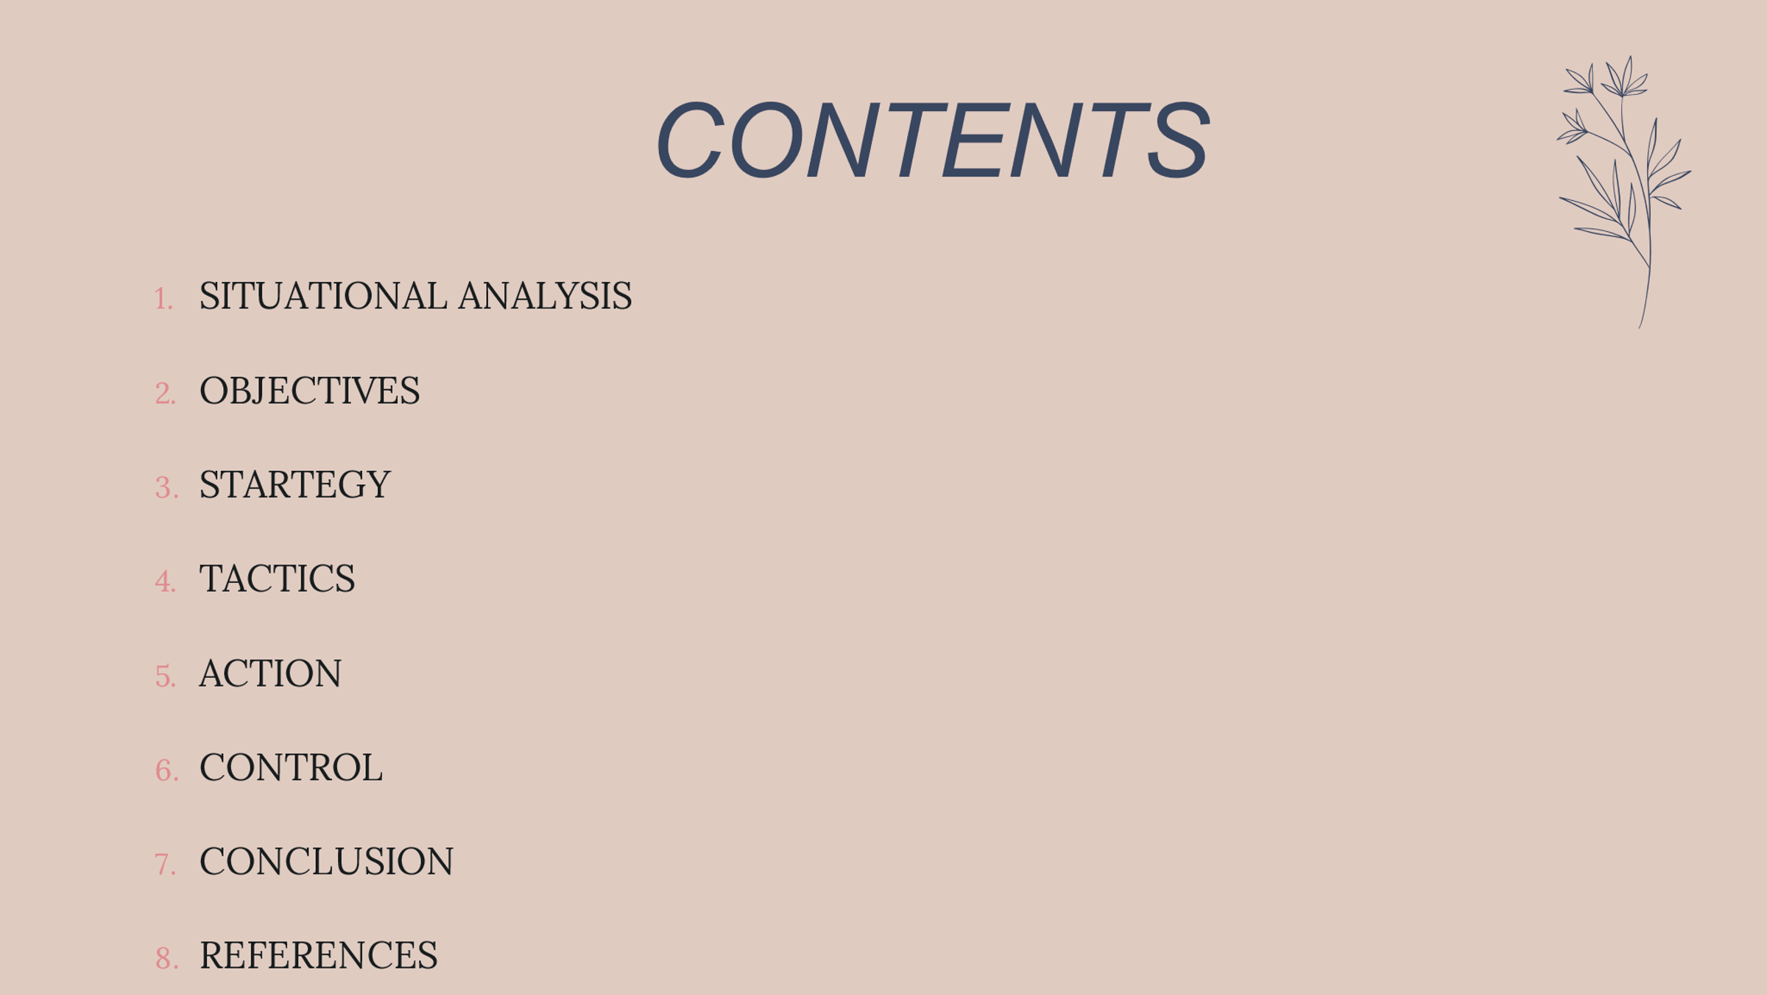

Slide: 3
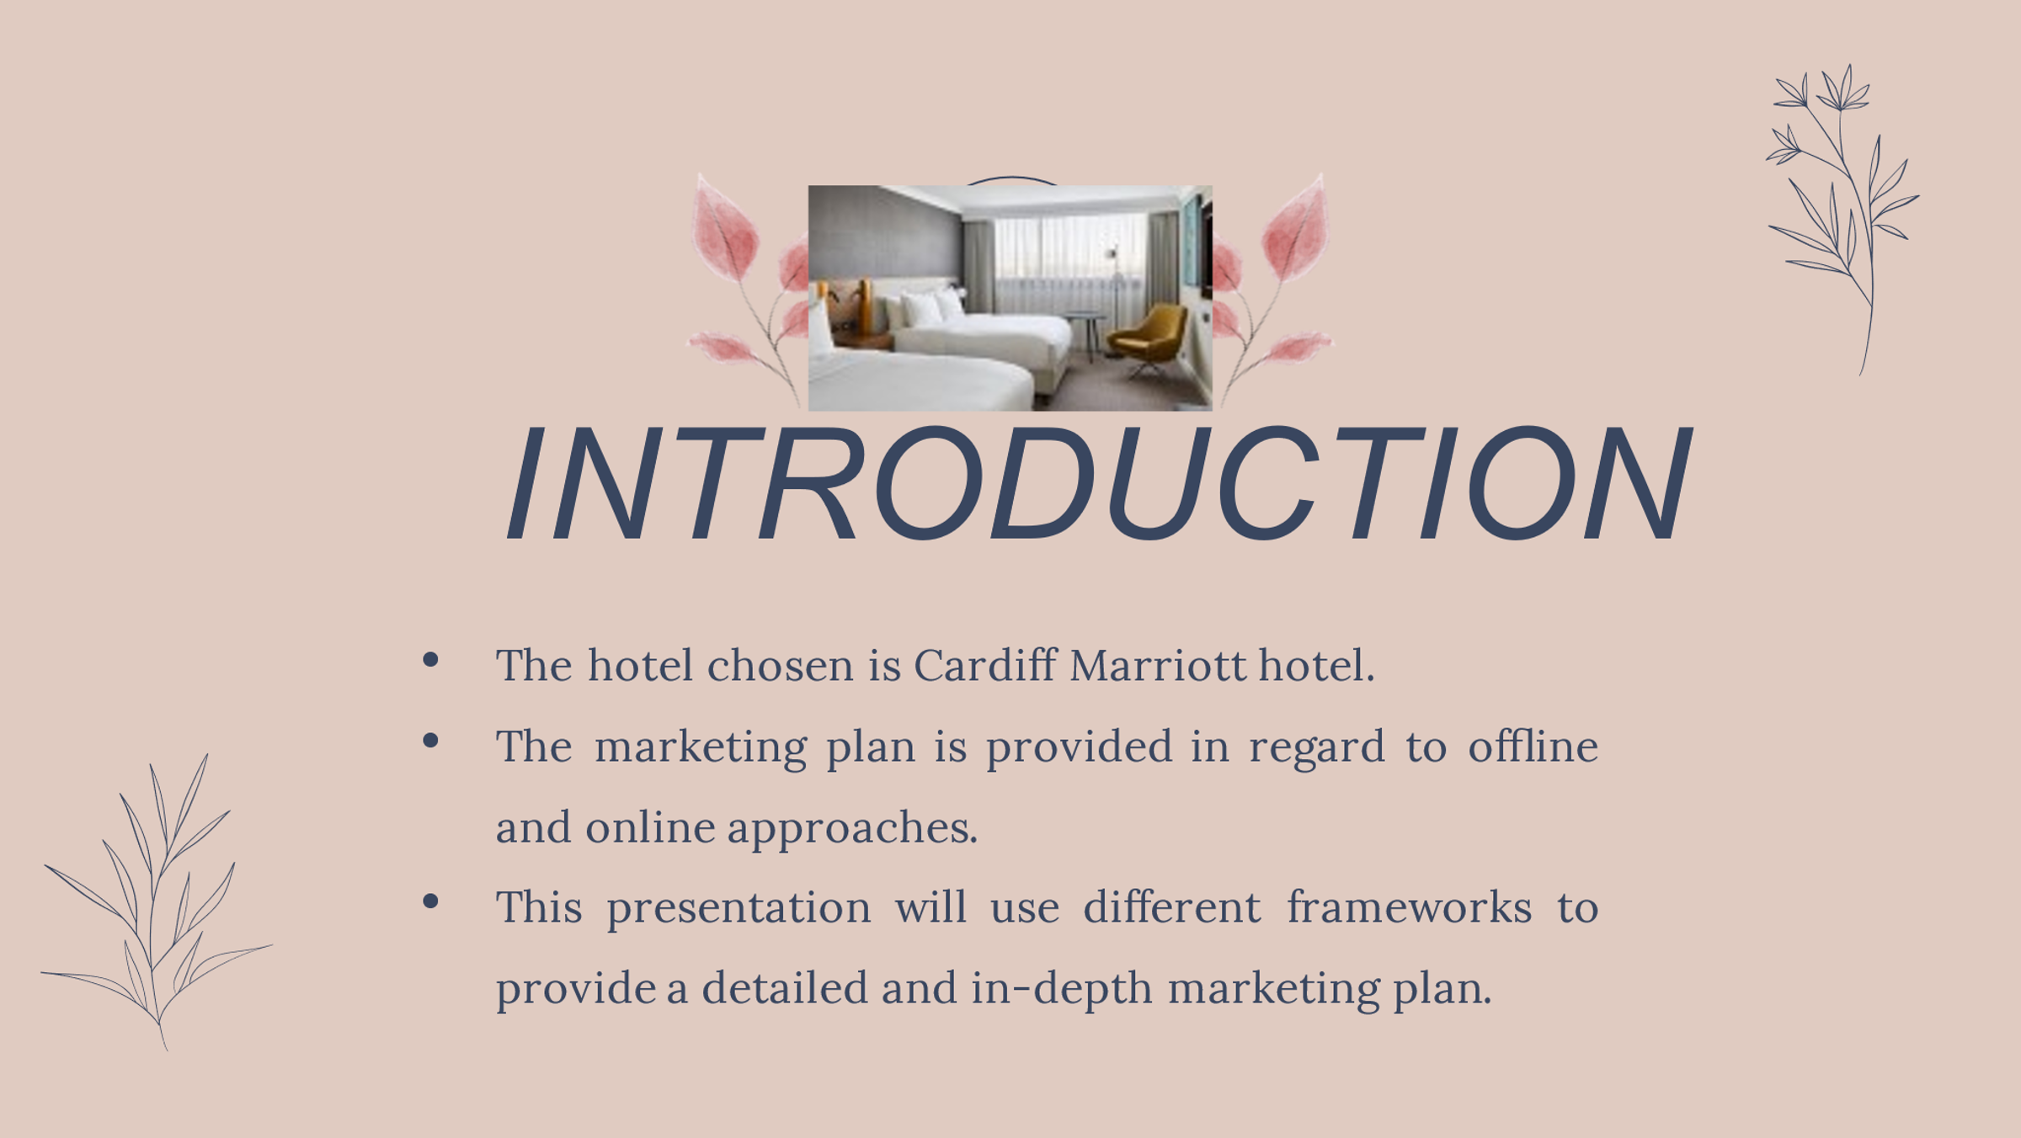
Slide: 4
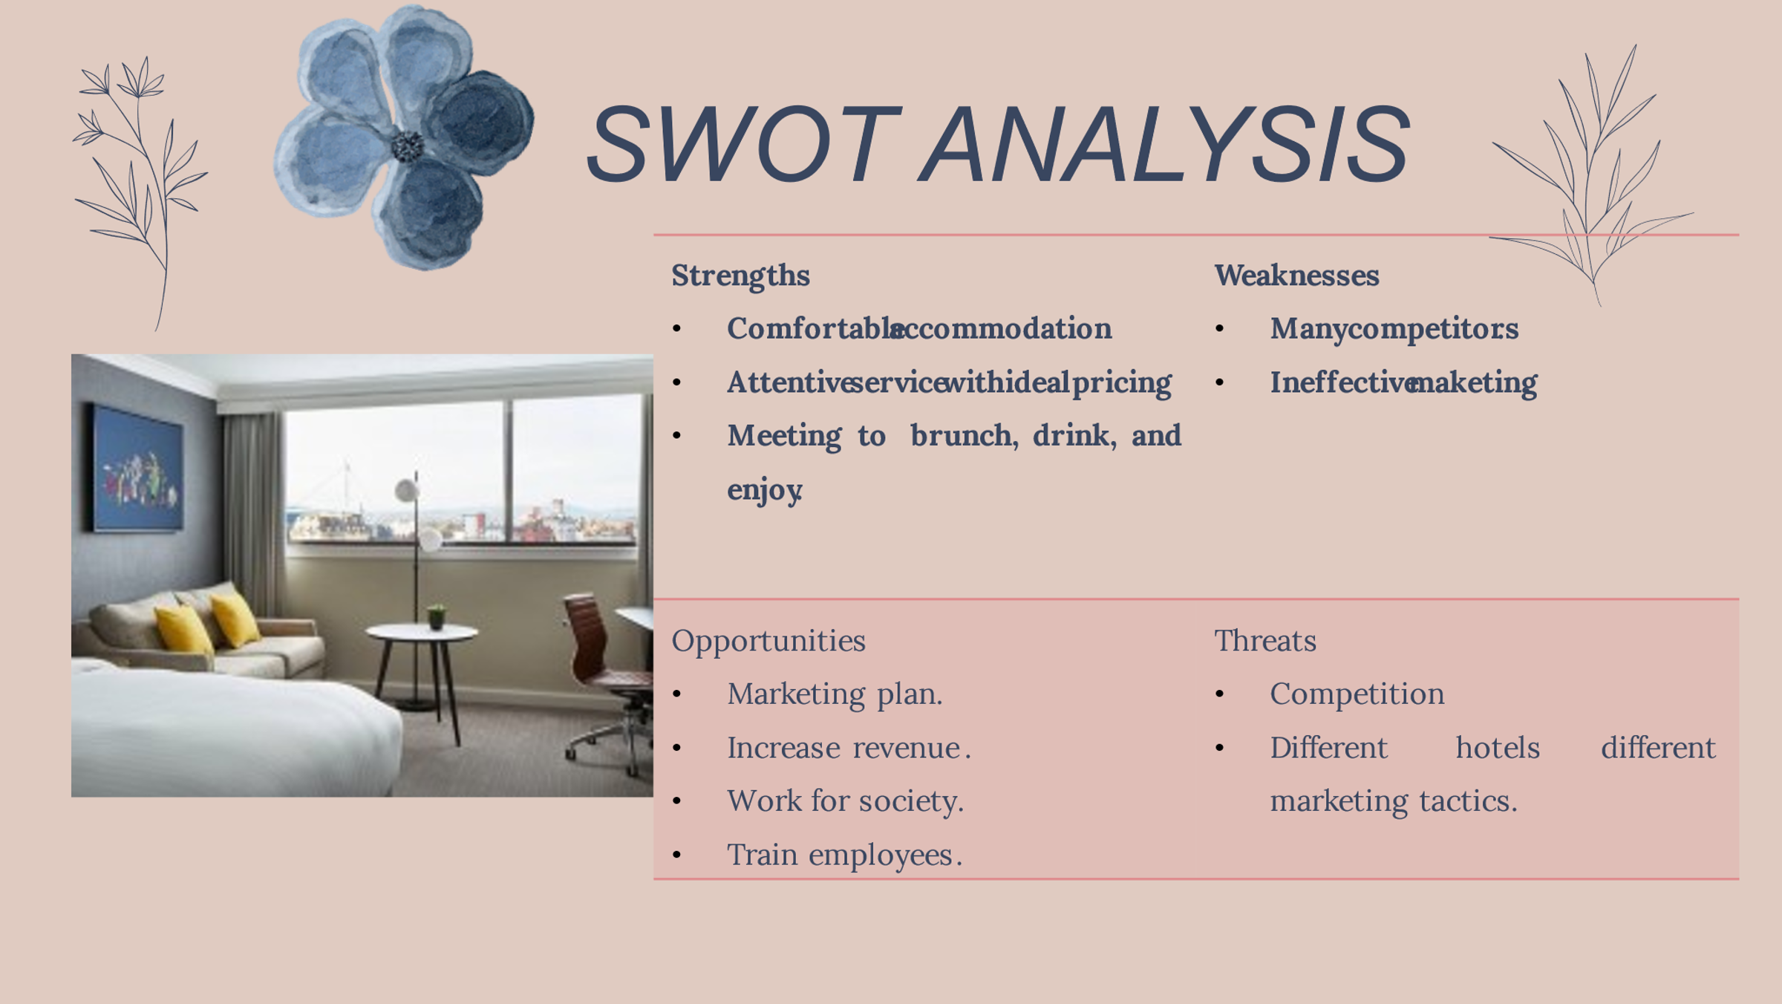
Slide : 5
Slide : 5
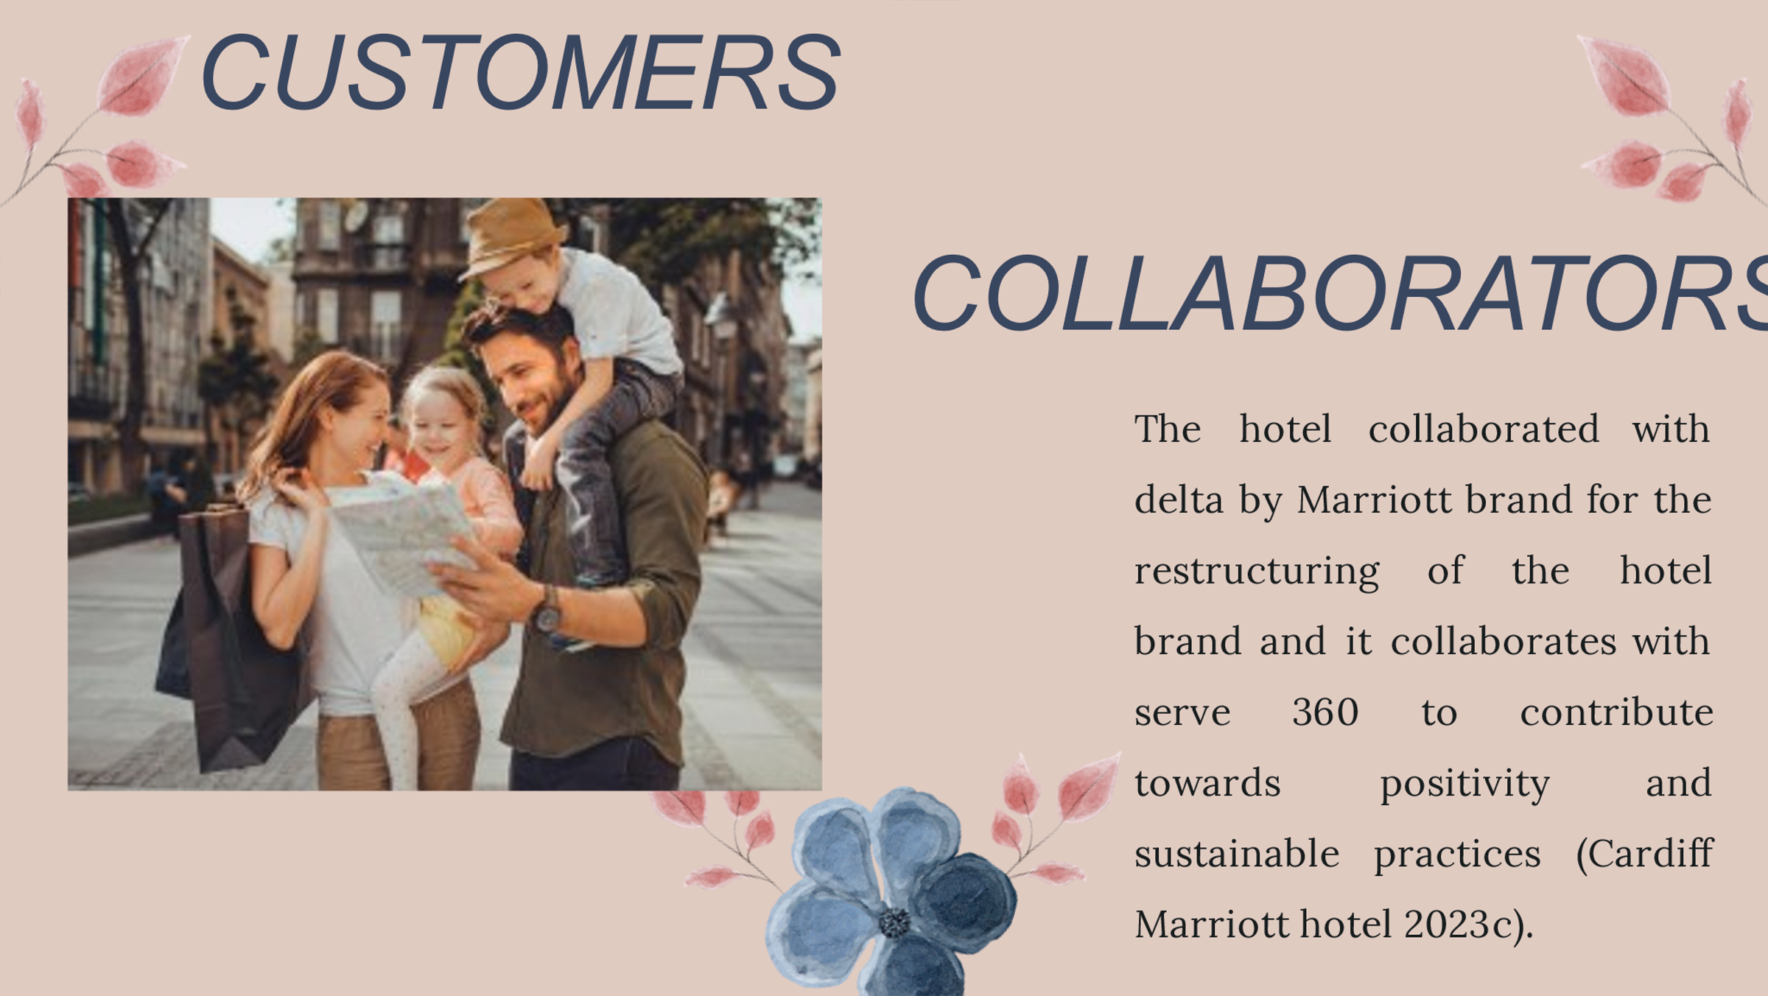

Slide : 6
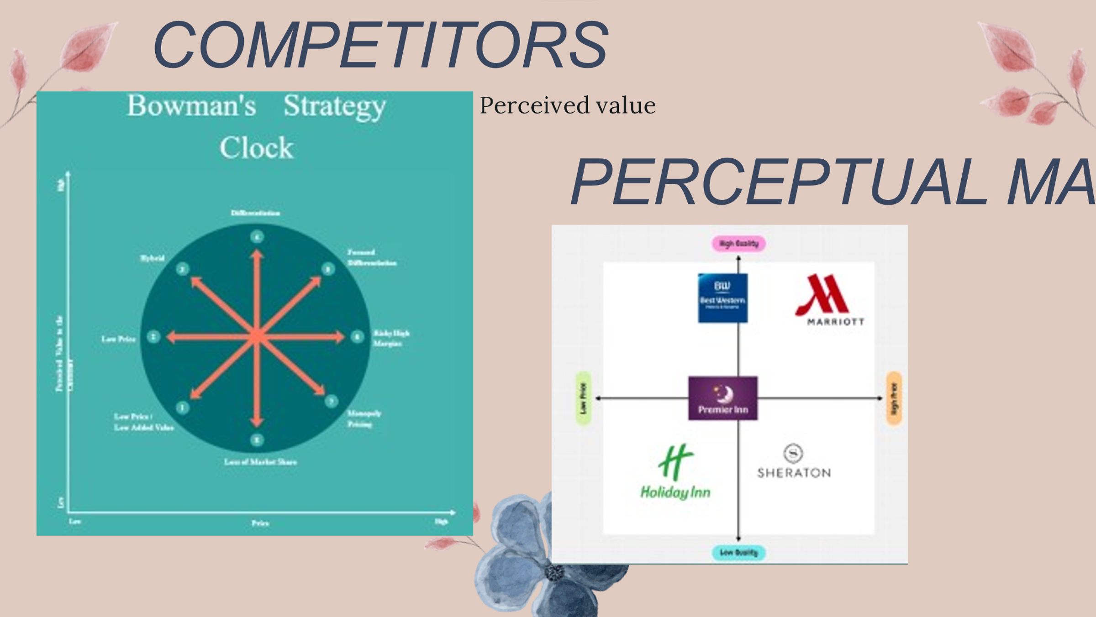
Slide: 7
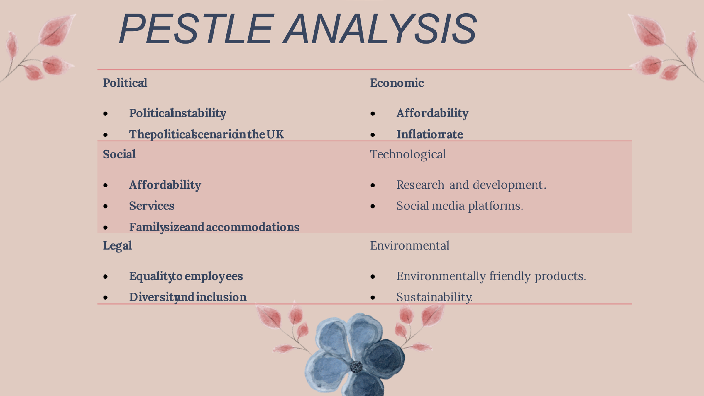
Slide: 8
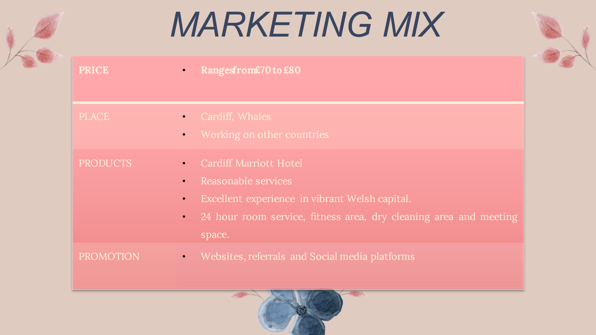
Slide: 9
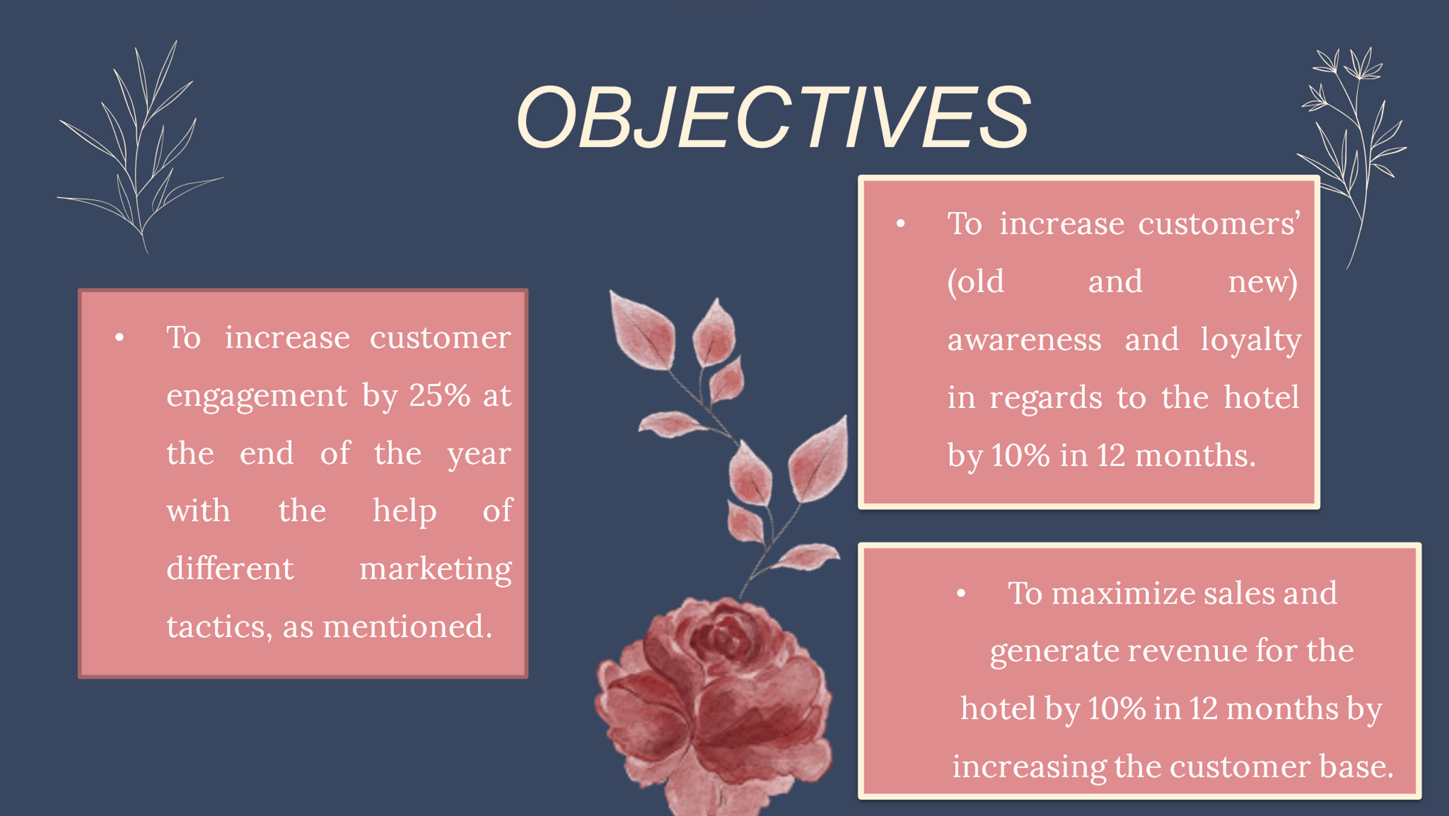
Slide: 10
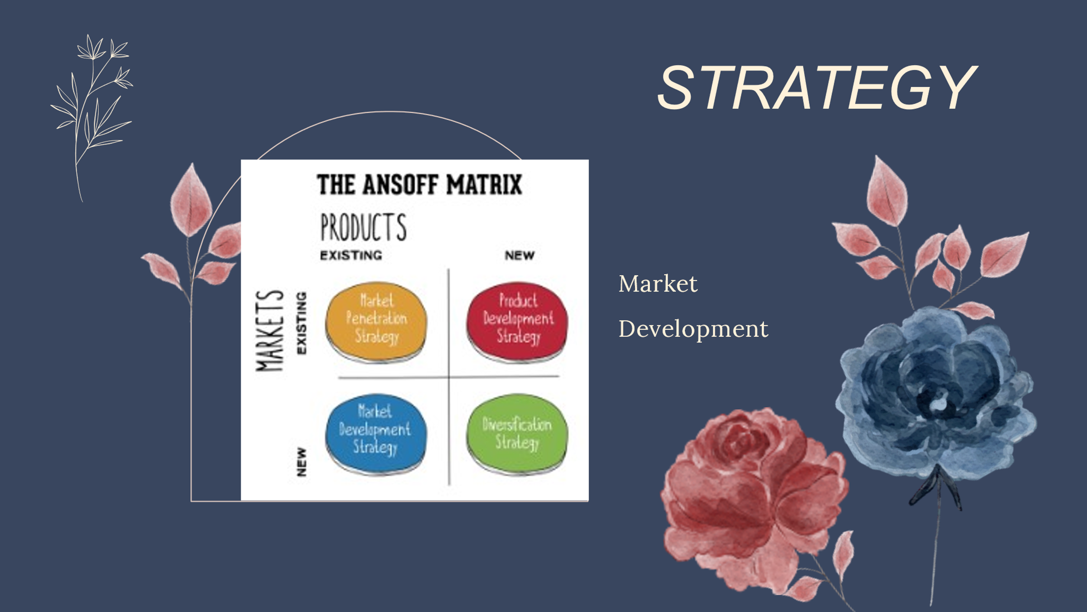
Slide: 11
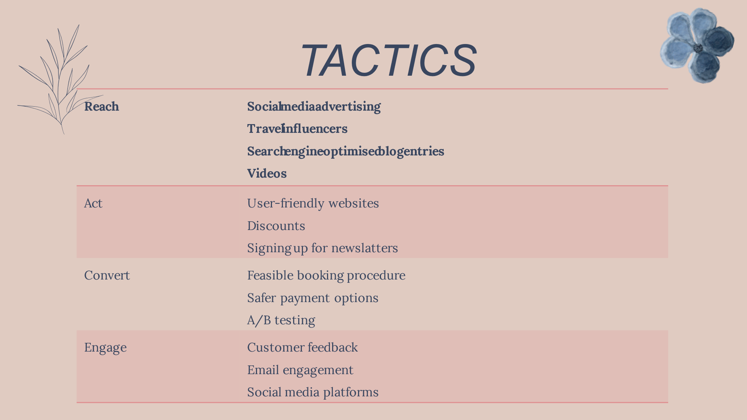
Slide: 13
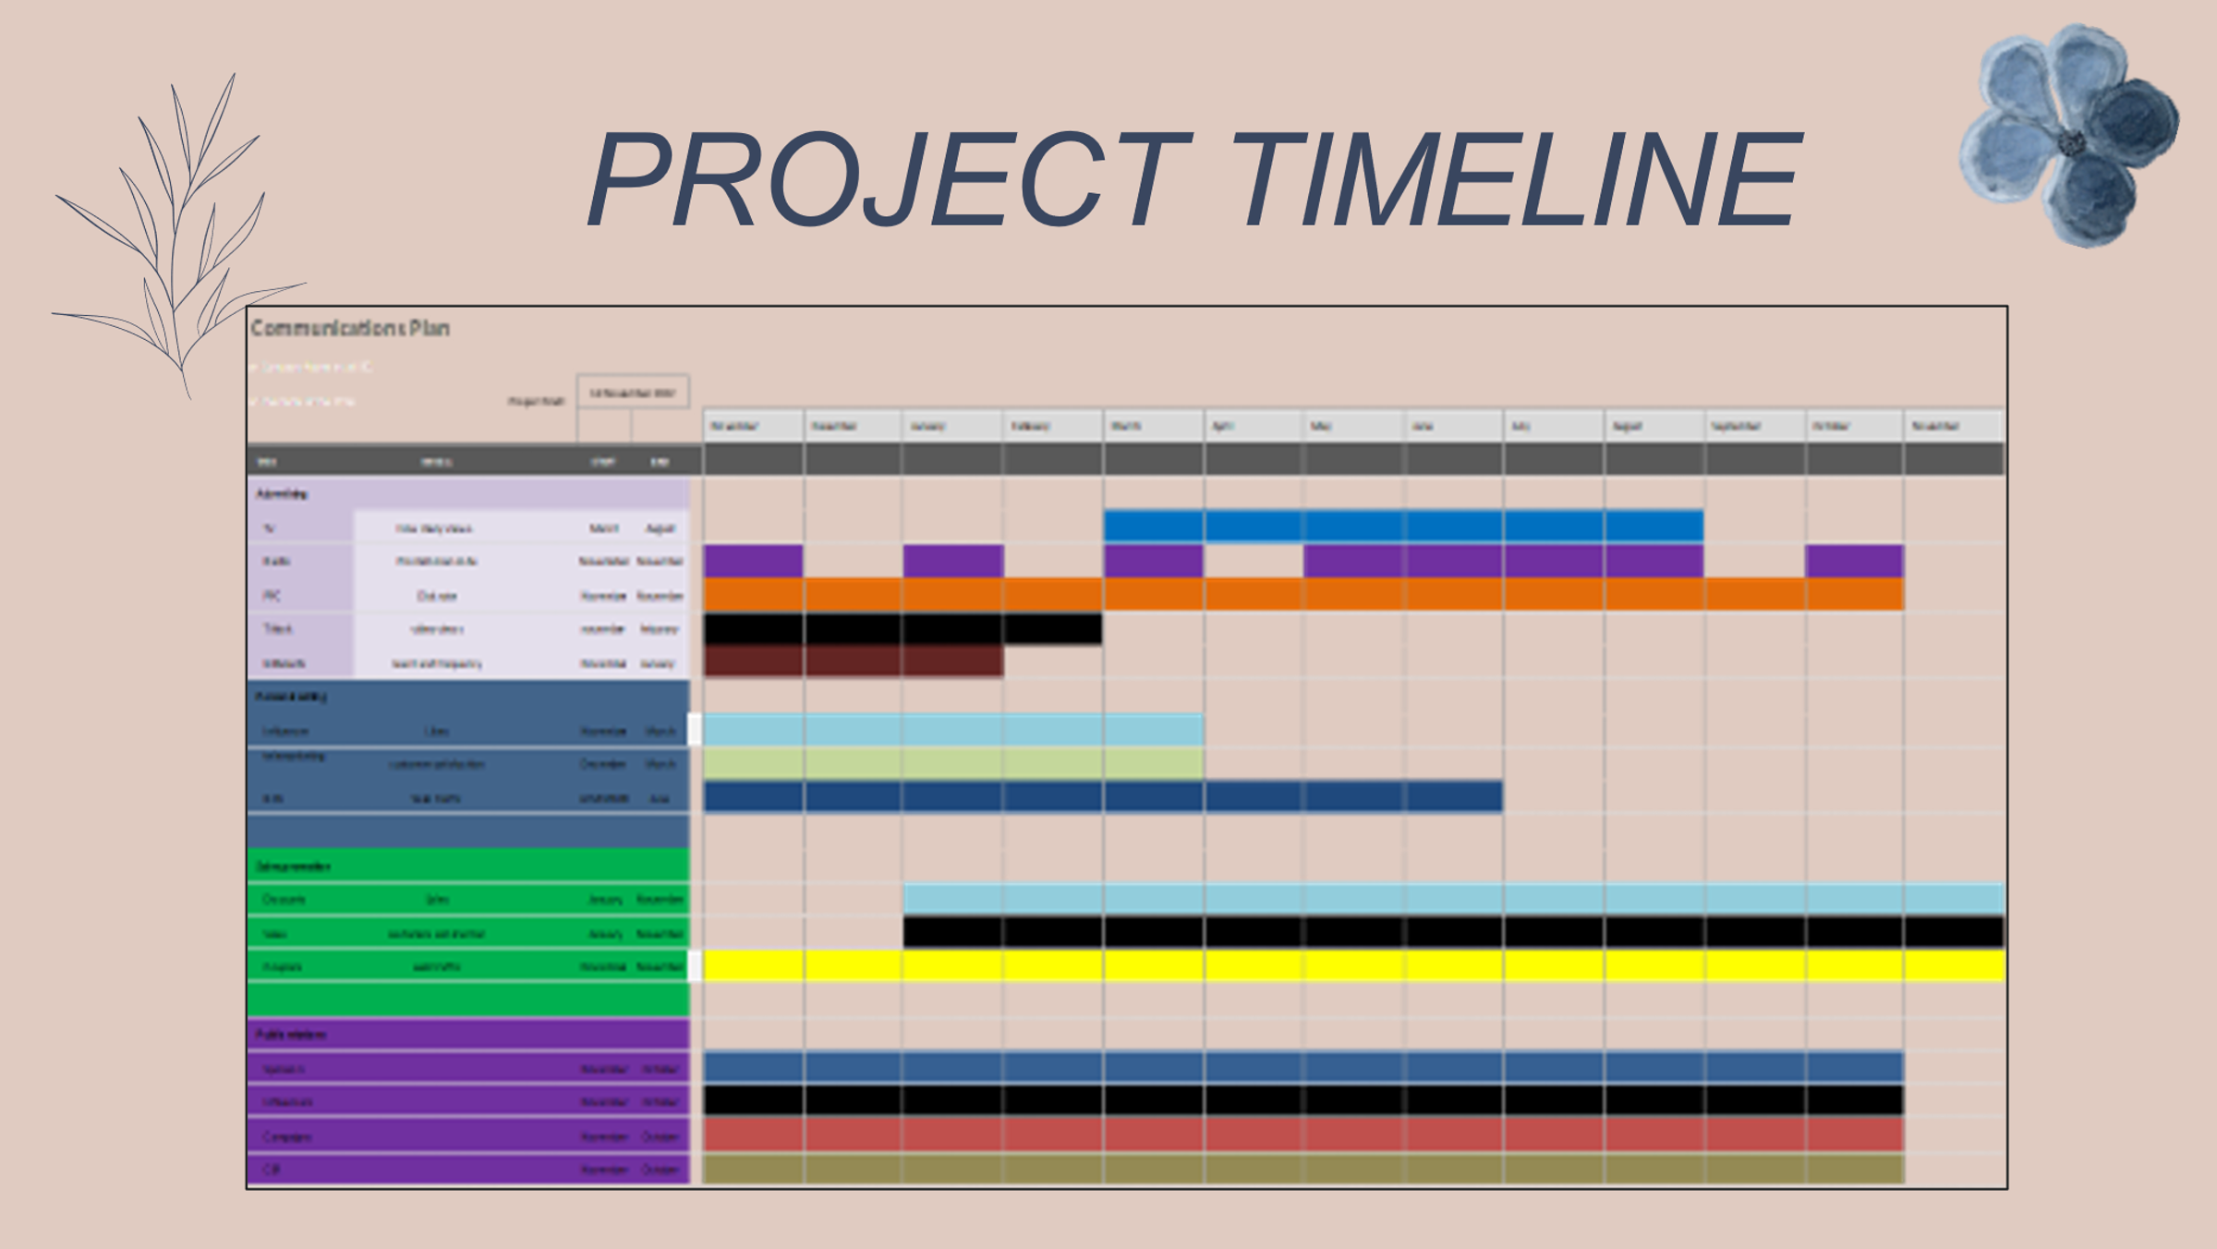
Slide: 14
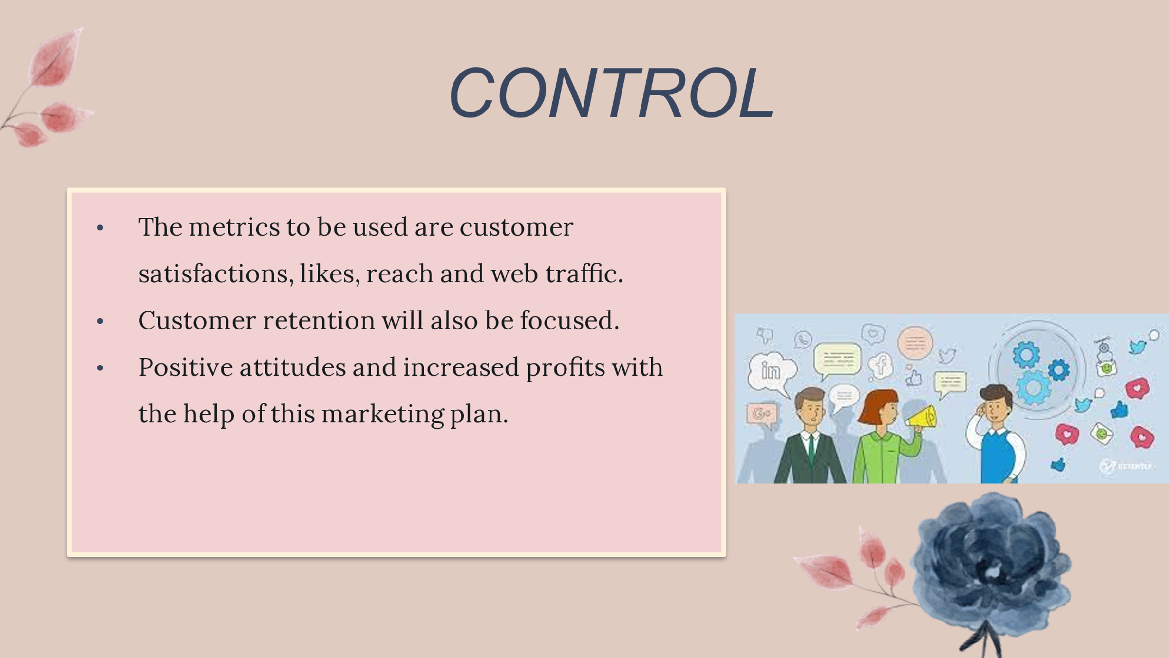
Slide: 15
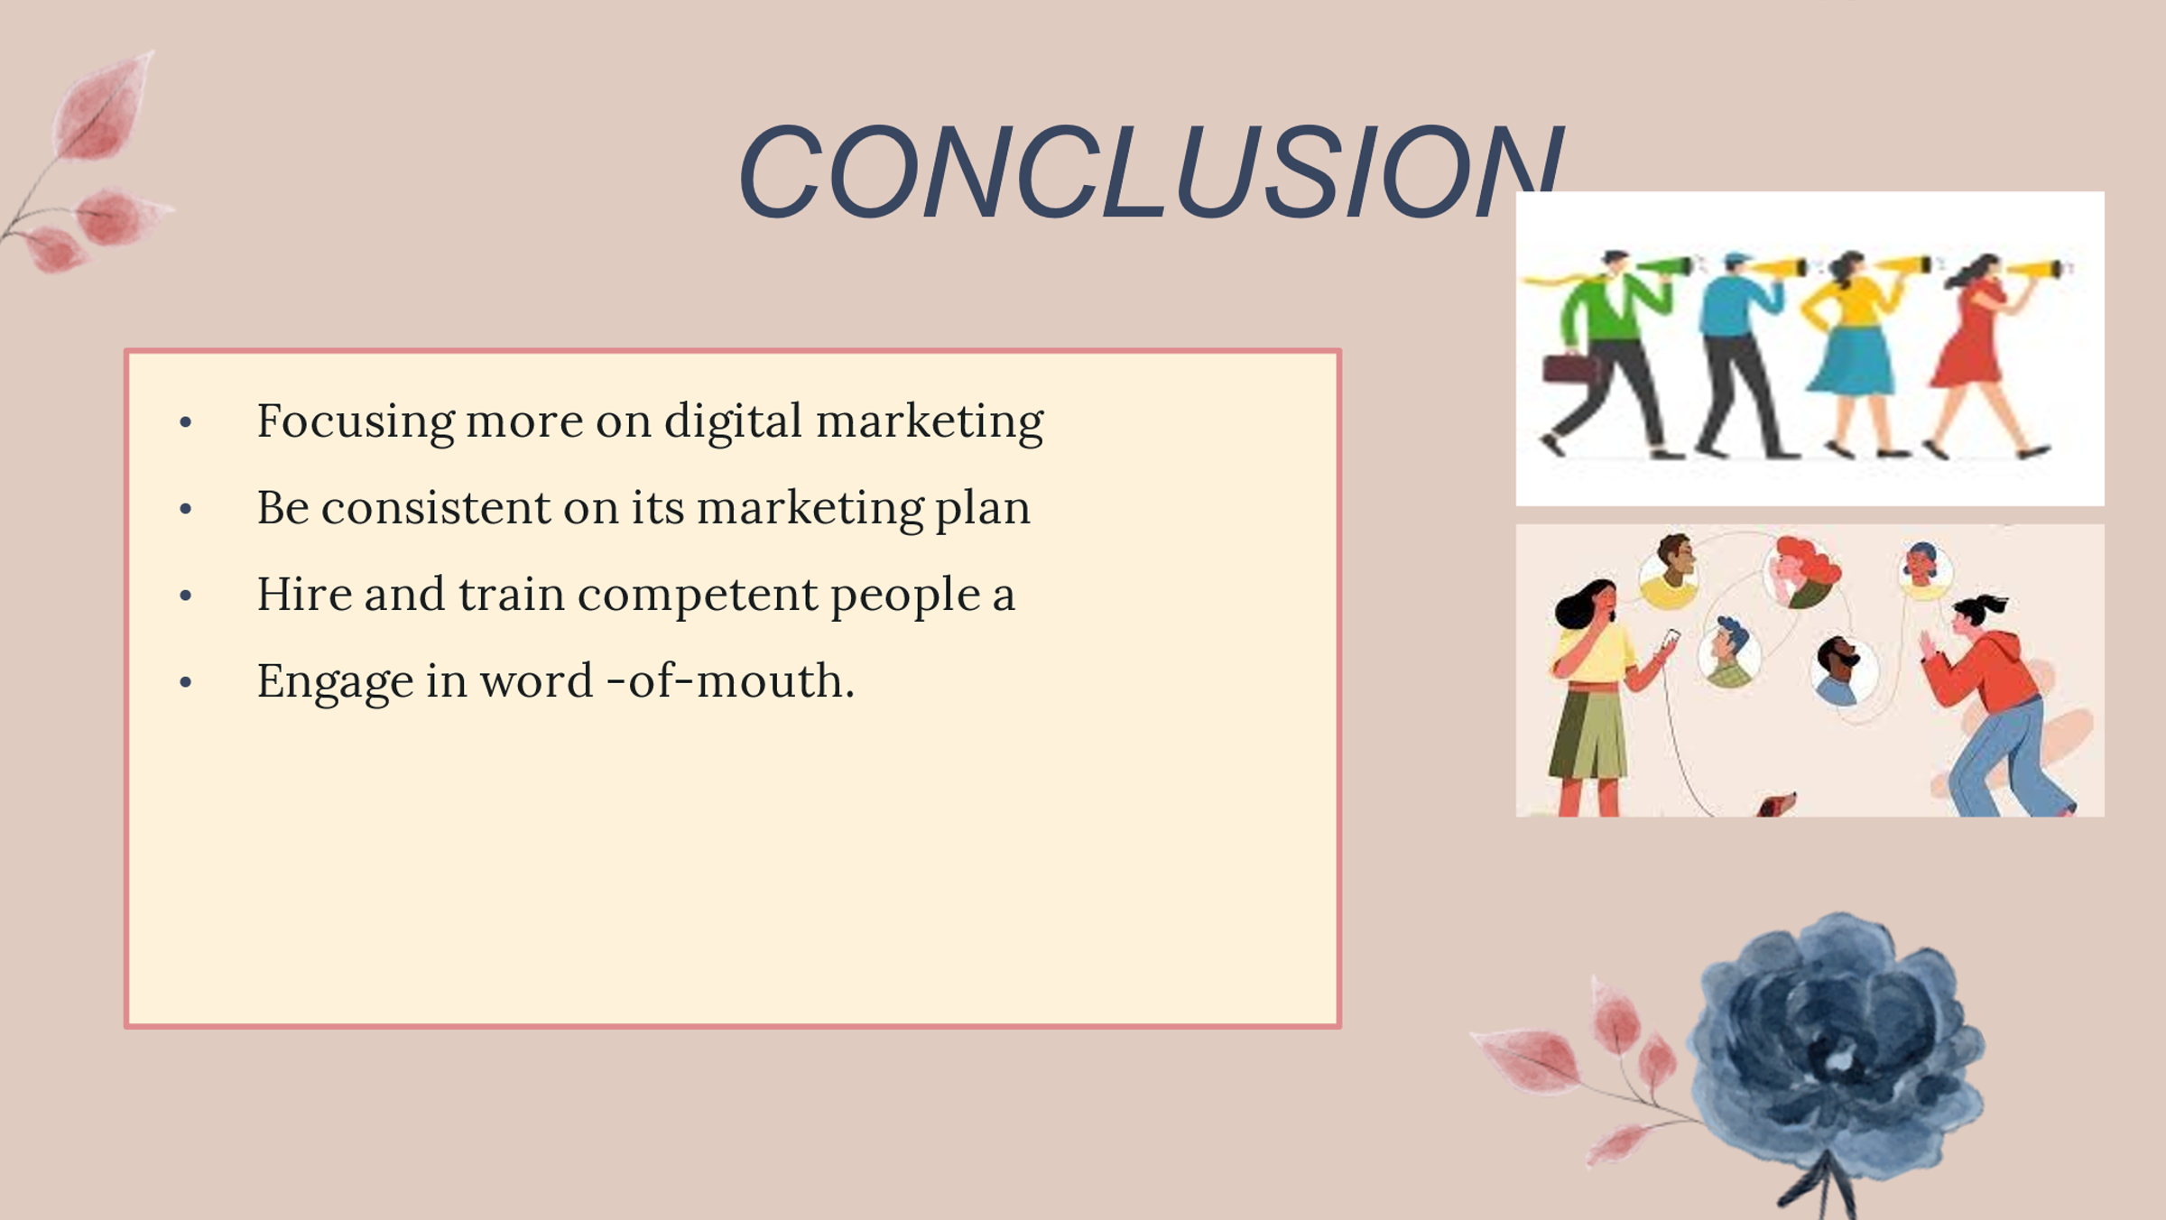
Slide: 16
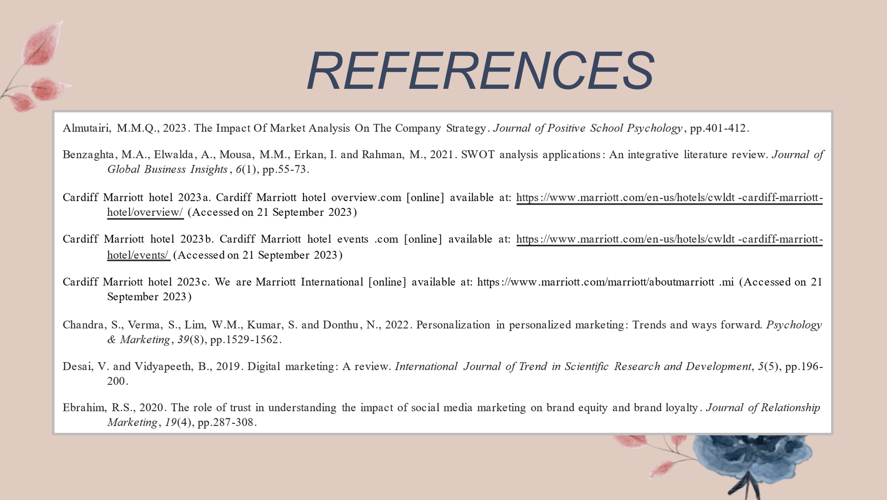
Slide:17


