Course: BA Computer Games Design
Module: Contemporary Challenge: Making a Difference
Assignment: Research Report & Poster
Name: Luke Thomas
Student Number: 2317980

Contents
An Inconvenient Truth 2
Introduction 2
What is Climate Change? 2
What has caused Global Warming? 3
The Consequences 3
How can we help? 4
Summary 5
BIBLIOGRAPHY 7

An Inconvenient Truth

Introduction
This report will explore the dangers of climate change and how it affects the world with a focus on Earth's flying wildlife. It will cover how Global warming has caused pattern shifts in hundreds of species of birds, changing their migration patterns for the worse, in addition to how the rising temperatures have affected species more acclimatized to winter temperatures. I will conclude by investigating long and short-term solutions the population can incorporate into their daily lifestyle that can prevent the potential extinction of our world’s flying wildlife.

What is Climate Change?
An Inconvenient Truth is a topic which explores climate change and global warming.
Climate change is defined by the United Nations as “Long-shifts in temperatures and weather patterns... primarily due to the burning of fossil fuels like coal, oil and gas” [1].
Looking at this graph that NASA has put together, you can see the global surface temperature has gradually increased over the past 100 years.
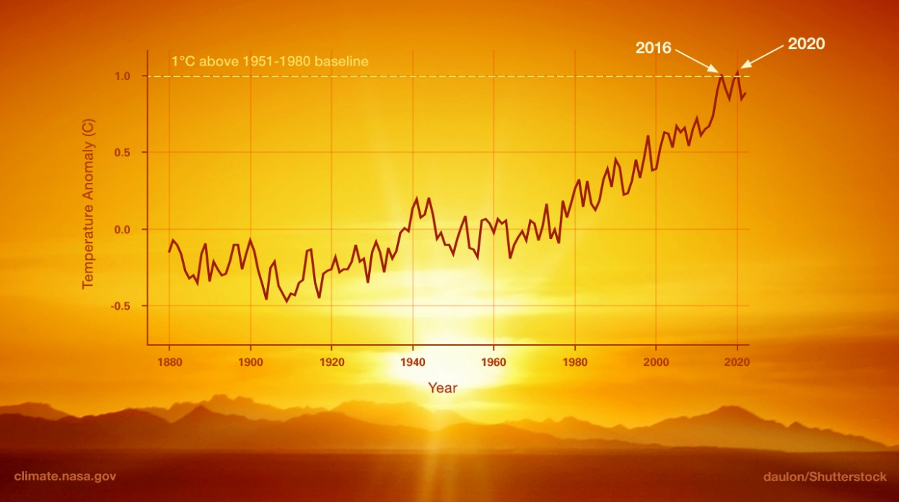
Figure 1, Nasa Climate Change, Source: [2]
We can see from this, that the earth is forecasted to continually get hotter by average if we continue to burn fossil fuels and cause greenhouse gas emissions. Greenhouse gases are gases in the earth's atmosphere that trap heat, produced when burning fossil fuels [3].

What has caused Global Warming?
The number one leading factor in greenhouse gas emissions is energy generation. Most of the world's electricity is still being produced using non-renewable energy sources, such as Coal and Oil [4]. Production of goods such as plastics, steel, iron and others, use similar methods to create essential materials for the population’s electronics, also contributing to the emissions [5].
Another major necessity for modern life which contributes to the global emissions problem is our Transport. Our transport systems are integral to our daily lives, allowing us to commute back and forth to work, school and home daily, whether by Bus, Car, or Train. Most road vehicles produce carbon dioxide due to gasoline or kerosine as a PowerSource [6]. With the increase of the population over the past 30 years, the roads have only gotten busier as owning a car has become easier and more convenient. This has led to transport becoming the fourth largest source of global emissions [6].

The Consequences
Climate change is a large-scale issue with countless consequences; however, I will be investigating the effects global warming has on the birds of Earth’s ecosystem.
According to the scientists at Audubon, 389 bird species in North America alone are at increasing risk of extinction due to the rise in global temperatures [7]. This statistic is the driving factor of my investigation, wishing to discover what it is about the increasing heat that's causing this travesty.
To begin, breeding and nesting are becoming more difficult for certain temperate reliant species. One of these species of birds is known as the Snowy Owl. The Snowy Owl thrives in colder climates and migrates north during summer. Research shows that climate change is the likely suspect of the declining population [15].
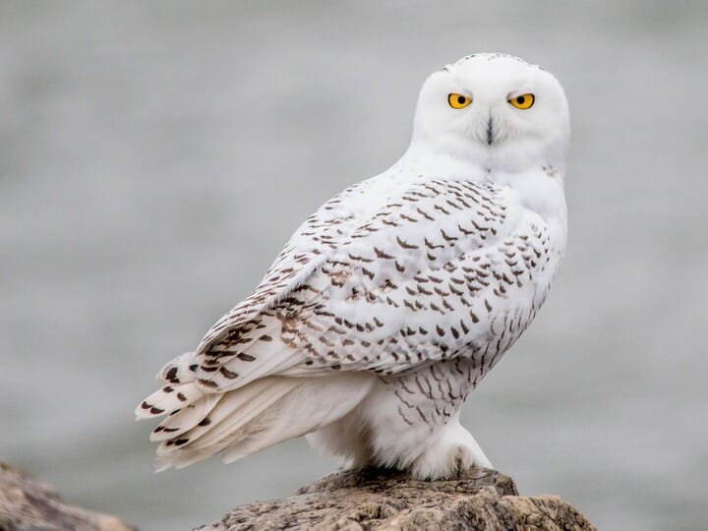
Figure 2, Snowy Owl, Source: [16]

PNAS studies show that rate of warming in breeding and wintering areas causes a phenological mismatch in breeding grounds, causing a decrease in bird population [8]. Phenology refers to the study of periodic biological events, life cycles, and habitat factors [9]. Due to this, larger birds are migrating earlier and travelling further which leads to another problem. RSPB discusses the migration of birds and its dangers, now that birds are travelling further in worse conditions, the risk of survival during migration is slowly worsening. There are natural issues to consider such as navigational or predators, but due to bad weather events such as heatwaves, storms, or snowfall, birds are put in life-threatening situations. Due to these long distances, unpredictable weather and additional stress factors, the chances of these birds surviving migration are much lower [10].
Droughts and Wildfires have become more common as the climate heats up. From the start of the year to September of 2020, 25 wildfires broke out in California alone causing 2.2 million acres of land to be burned [11]. To compare, 2.2 million acres equates to just under half the country of Wales which is five million acres [12]. These birds are all forced to flee their homes and find new habitats to nest. Unfortunately, many young and nestlings yet to learn to fly do not make it out of wildfires [11].

How can we help?
The world is already making changes to protect and mitigate damage to our environment, putting climate change at the forefront of a lot of issues. For example, the production of Electric cars for travel, solar panels and wind turbines for power [13]. However, these are expensive, and while living through the cost-of-living crisis, these options aren’t for the average homeowner, making these long-term solutions difficult to achieve at the current time. However, the average family can incorporate good habits into their daily lives to do their part in achieving long-term changes to the climate, such as leaving the car at home, taking public transport or cutting down on consumption and waste by recycling [14]. These are long-term solutions for long-term problems.
However, for immediate problems such as the potential extinction of hundreds of bird species, the best way for everyone to contribute to supporting our flying wildlife is by making your own garden a bird-friendly environment. You can do this by adding more bird feeders or a bird bath. If you own a cat, keep an eye on them while in the garden, to try and create a safe space [11]. Birds escaping their homes from wildfires or destroyed habitats need emergency space to rest or feed. By taking these steps you can assist our flying feathered friends in the most dangerous time of their lives and provide them the best possible chance to thrive.

Summary
To conclude, species of birds are at risk of extinction due to climate changes effects on their lifestyles. It has caused birds to migrate earlier, for longer. Cold temperate birds are not surviving the summer. There are fewer safe habitats for birds to thrive and more extreme weather conditions for birds to survive through.
Both long-term habits and short-term habits can be integrated to change the forecast of climate change and prevent the loss of further species of birds.

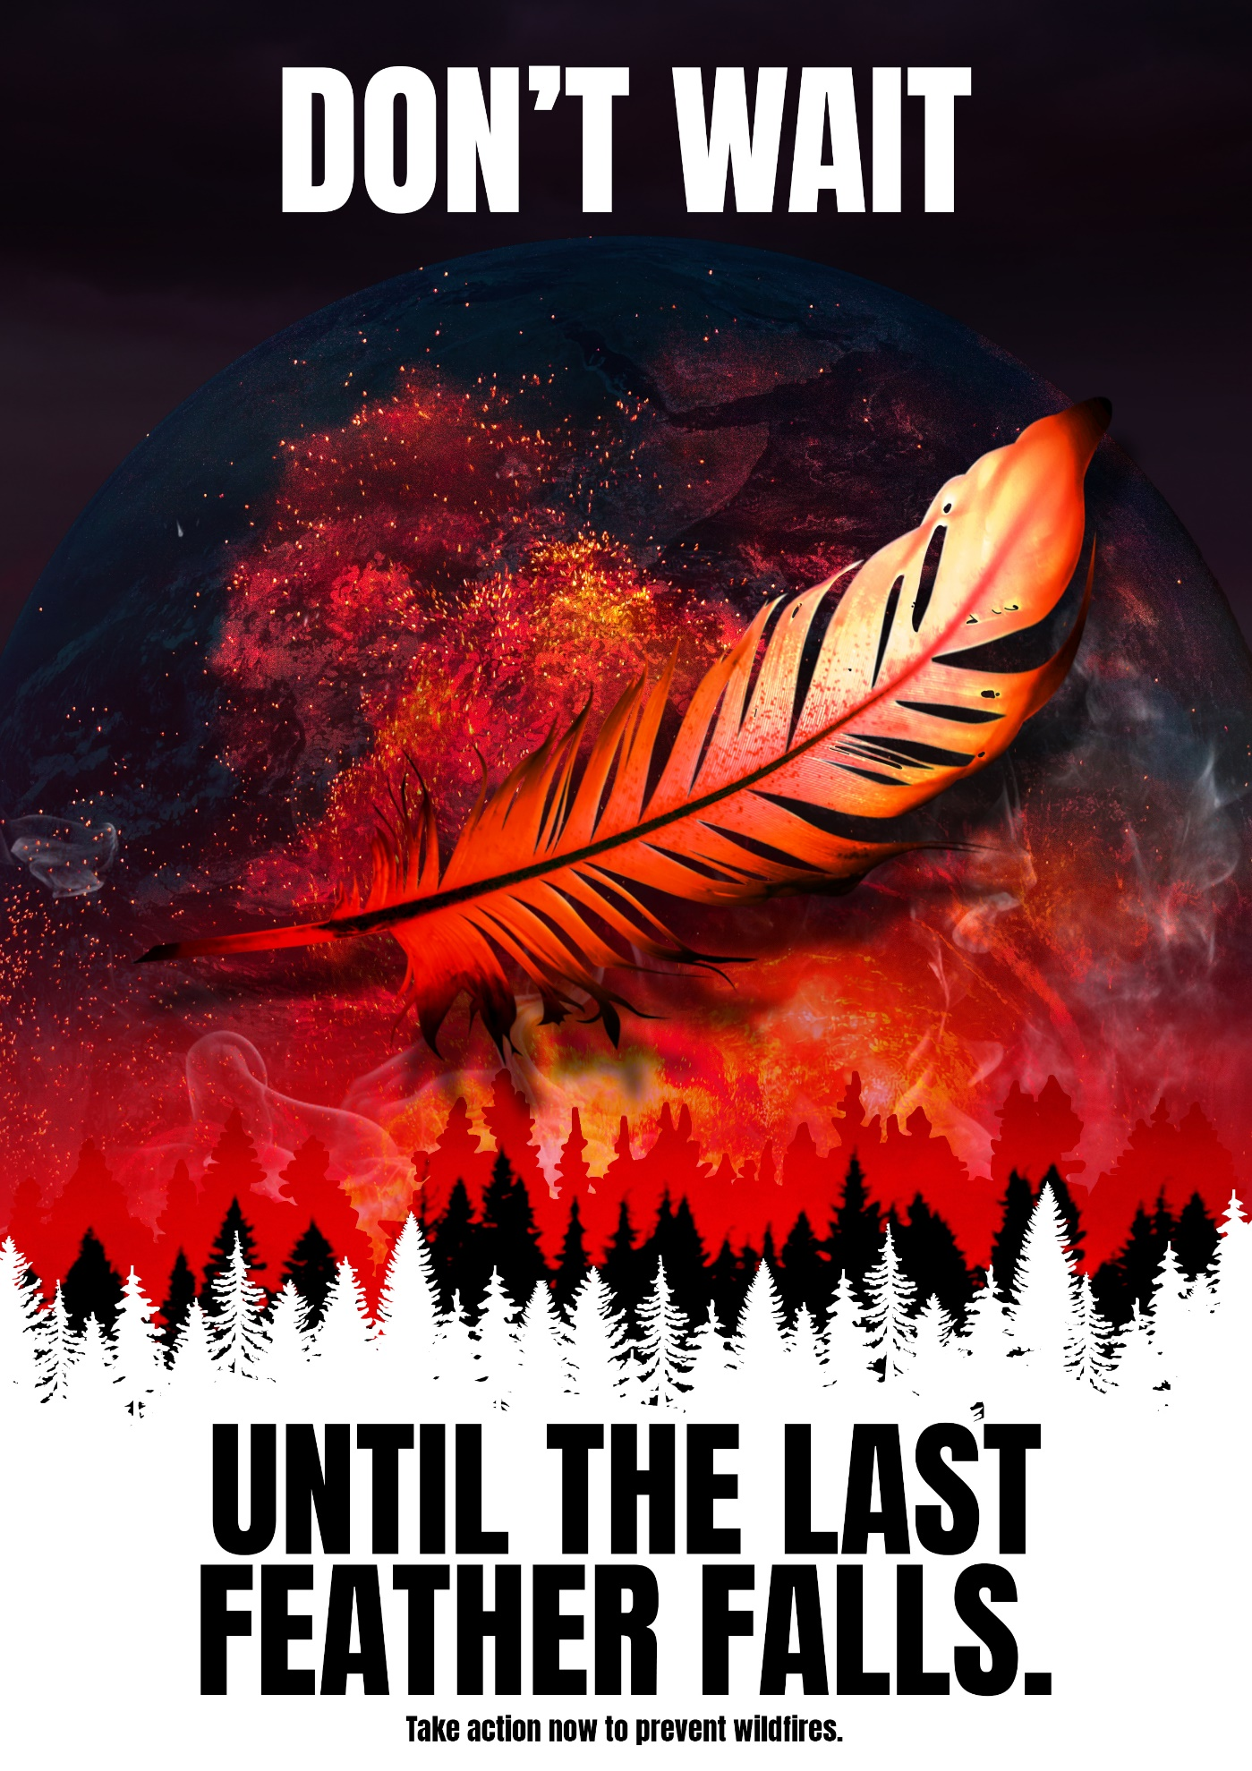

BIBLIOGRAPHY
[1] “What is climate change?,” United Nations, https://www.un.org/en/climatechange/what-is-climate-change (accessed Feb. 23, 2024).

[2] “What is climate change?,” NASA, https://climate.nasa.gov/what-is-climate-change/ (accessed Feb. 23, 2024).

[3] “What are greenhouse gases?,” GHGs explained | National Grid Group, https://www.nationalgrid.com/stories/energy-explained/what-are-greenhouse-gases#:~:text=Greenhouse%20gases%20(also%20known%20as,greenhouse%20gases%20in%20the%20atmosphere (accessed Feb. 23, 2024).

[4] “Generating power,” United Nations, https://www.un.org/en/climatechange/climate-solutions/cities-pollution (accessed Feb. 23, 2024).

[5] “Sustainable consumption and production,” United Nations, https://www.un.org/sustainabledevelopment/sustainable-consumption-production/ (accessed Feb. 23, 2024).

[6] “Key findings,” United Nations, https://www.un.org/en/climatechange/science/key-findings#transport (accessed Feb. 23, 2024).

[7] “Survival by degrees: 389 bird species on the Brink,” Audubon, https://www.audubon.org/climate/survivalbydegrees (accessed Feb. 23, 2024).

[8] L. Halupka, D. Arlt, and J. Tolvanen, “The effect of climate change on avian offspring production,” The effect of climate change on avian offspring production: A global meta-analysis, https://www.pnas.org/doi/10.1073/pnas.2208389120 (accessed Feb. 23, 2024).

[9] “Phenology definition & meaning,” Merriam-Webster, https://www.merriam-webster.com/dictionary/phenology (accessed Feb. 23, 2024).

[10] “Migration,” Bird Migration Facts and Information, https://www.rspb.org.uk/birds-and-wildlife/bird-migration (accessed Feb. 23, 2024).

[11] A. Krug, “How to help birds survive wildfires: Faqs and tips,” Chirp Nature Center, https://chirpforbirds.com/how-to/how-to-help-birds-survive-wildfires-faqs-and-tips/ (accessed Feb. 23, 2024).

[12] A. Krug, “How to help birds survive wildfires: Faqs and tips,” Chirp Nature Center, https://chirpforbirds.com/how-to/how-to-help-birds-survive-wildfires-faqs-and-tips/ (accessed Feb. 23, 2024).

[13] “What are the solutions to climate change?,” Greenpeace UK, https://www.greenpeace.org.uk/challenges/climate-change/solutions-climate-change/ (accessed Feb. 27, 2024).

[14] “9 things you can do about climate change,” Imperial College London, https://www.imperial.ac.uk/stories/climate-action/ (accessed Feb. 27, 2024).

[15] “Snowy owl,” Partners in Flight, https://partnersinflight.org/species/14386/#:~:text=Although%20it%20is%20notoriously%20difficult,%E2%80%9CVulnerable%E2%80%9D%20to%20global%20extinction (accessed Feb. 27, 2024).

[16] “Snowy owl identification, all about birds, Cornell Lab of Ornithology,” , All About Birds, Cornell Lab of Ornithology, https://www.allaboutbirds.org/guide/Snowy_Owl/id (accessed Feb. 27, 2024).

