

BUSINESS PLAN
for REBLOOM Hotel & Spa


GROUP 5
Student Names and ID Numbers: VICTORIA CHILIANU (2208500)
ANA PESCLEVEI (2208738)
CONSTANTIN-BOGDAN RUSU (2014305)
ALEXANDRA CRAESCU (2111926)
The Module Title: Entrepreneurship BMIH5001
Lecturer’s Name: CHARLOTTE JOYNER

Executive Summary
REBLOOM Hotel and Spa **** Partnership Limited is a United Kingdom-based hospitality enterprise situated in Witham, in the heart of Essex, near Chelmsford and Colchester, and is just over 36 miles from London.
The company is committed to delivering a comprehensive experience to clientele by combining four-star lodging with an assortment of revitalising amenities such as massages, athletic pursuits, and health-oriented facilities. REBLOOM endeavours to foster enduring relationships and maximise customer satisfaction under the direction of a group of seasoned professionals, each possessing a distinct set of abilities and knowledge. The aspiration is to establish as the preeminent establishment for individuals in search of rejuvenation, wellness, and relaxation.
REBLOOM Hotel & Spa is a partnership business with a capital of £4,000,000. Consisting of four members, each with an equal 25% (£1,000,000) share in the business (Table 15). At the end of the first year of activity, the company will experience a loss of (£4000) according to the forecast calculations (Table 14). The goals for the following years will be redirected to this aspect, to improve the profitability of the entity. Two of the main goals for revenue generation would be: implementing sustainable practises to reduce environmental impact and achieve cost savings and diversifying revenue streams by offering corporate wellness programmes and hosting events. REBLOOM Hotel and Spa can be distinguished from competitors by its commitment to providing exceptional service, organic farm food, personalised experiences, and a welcoming atmosphere that will leave guests feeling revitalised.
The new business is committed to maintaining the highest levels of professionalism and adherence to legal and regulatory obligations.

Business Plan Contents
Executive Summary 1
Business Details 3
Key Personnel 4
Vision 6
The Business Idea 6
Business Goals 6
Provided Services 8
Value Proposition 9
Legal Requirements 9
Marketing 10
Market Research 10
Customer Profiles 10
Competitor Profiles 11
Market Risks 12
Pricing 14
Promotion and Advertising 14
Running the Business 15
Staff 15
Premises 16
Suppliers 16
Equipment 17
Operational Risks 17
Finance 18
Start-up Costs 18
Profit and Loss Forecast 19
Finances 20
Financial Risks 20
Cash Flow Forecast 22
Conclusion 23
References 24
Appendices 30

Business Details
Company name:
REBLOOM Hotel & Spa  Partnership Limited
Address:
United Kingdom, Great Britain, England, Essex, Witham, CM8 1ZG
Figure 1. Location position on the map, REBLOOM Hotel & Spa
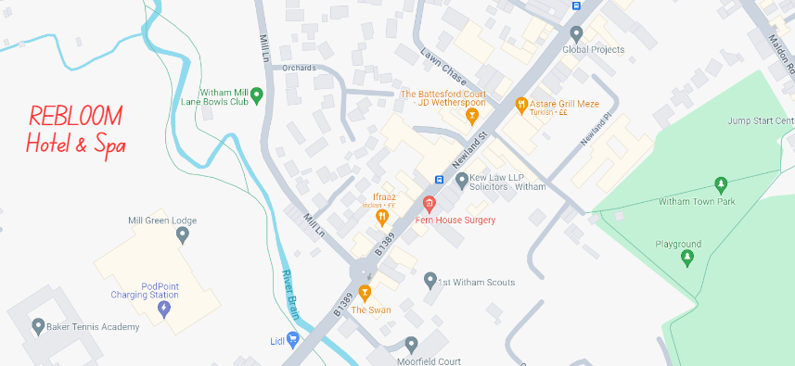
(Google Maps, 2024)
Primary contact methods:
Email: rebloom@gmail.com
Thone: +44 7397 575334
Website: rebloom.com

REBLOOM will provide customers with a lot of services to help them recover and at the same time become relaxed and satisfied thanks to the professionalism of the whole team. The highest level of services will be provided, such as 4-star accommodation, a variety of massages, sports activities, and other health-related facilities. To satisfy all the demands and needs of guests, the company relies on strong relationships with customers to make them come back as soon as possible.

Key Personnel
REBLOOM Hotel & Spa is a "Partnership Business" consisting of four (4) members who have an equal (25%) share in the business.
Table 1. Details of owner(s):
Name: | Mrs. Victoria Chilianu | Mrs. Ana Pesclevei | Mr. Constantin-Bogdan Rusu |  | Mrs. Alexandra Craescu
Position/main responsibilities: | General Director- full-time  Responsible for the company's operational and financial success, maximising all opportunities and resources. | Marketing Director- part-time  Prepares promotional materials, determines channels of communication, and creates partnerships. | HR Director-  part-time  Selects, recruits, develops, and retains the right personnel. |  | Account Director- part-time  Planning budgets, setting sales targets, producing reports, and managing accounts.
Experience and knowledge of the industry: | - Courses aimed at the hospitality industry, such as business skills, marketing essentials, hospitality and guest service management, food and beverage operations, hotel management and front desk operations, foreign languages and cultural awareness, human resources and development, entrepreneurship, and financial management;  - Enriching knowledge in the field through reading, training, or recorded video and audio courses, offered by the online environment.  - Staying updated with hospitality publications and reports (Amadeus, 2024).  - Knowledge of booking software, experience working with clients, handling money, and knowledge of COSHH risk assessment.  - Analysis of the evolution of competing companies on the market.
Previous employment: | Assistant Manager at ''The White Hart Hotel'' in Witham, Essex, England, UK (The White Hart Hotel, 2024). | Staff Nurse at ''Luton and Dunstable University Hospital'' (NHS) in Luton, Bedfordshire, England, UK (Bedfordshire Hospitals, 2024). | Machine Operator at ''Hexel Composites'' in Duxford, Cambridge, England, UK (Hexcel, 2024). |  | Picking Packing at ''Ocado Group'' in Dordon, Tamworth, England, UK (Ocado Group, 2023).
Key skills brought to the business: | - excellent organisational, communication, business, sales, negotiation, and problem-solving skills;  - a polite and diplomatic manner;  - stress and emergency resistance;  - be able to manage and motivate others. | - outstanding leadership and organisational skills;  - the ability to think analytically and creatively;  - excellent communication and interpersonal abilities;  - up to date with the latest marketing techniques and best practises. | - business knowledge and management abilities;  - the ability to form effective working relationships through interpersonal skills;  - computerised payroll management/ operation requires strong IT and numeracy skills;  - cultural awareness and language skills. |  | - a solid grasp of budgeting and progress reporting;  - understanding techniques and metrics for evaluating performance;  - skilled in both communication and interpersonal skills;  - working knowledge of relevant software.
Business experience and any training undertaken: | University placement at Premier Inn Chelmsford (Springfield) Hotel in 2023 (Premier Inn, 2024a). | University placement at Premier Inn Dunstable / Luton Hotel in 2023 (Premier Inn, 2024b). | University placement at Premier Inn Saffron Walden Hotel in 2023 (Premier Inn, 2024c). |  | University placement at Premier Inn Hatfield Hotel in 2023 (Premier Inn, 2024d).
Business experience and any training undertaken: | Whitbread software platform, Academy Online for Premier Inn hotels (Whitbread, 2024).
Academic/ professional qualifications: | 2022 – Present  Level 6 BA (Hons) International Hotel Management at the University of Wales Trinity Saint David, Swansea. (Estimated graduation date: July 2025) (UWTSD, 2024).
Academic/ professional qualifications: | 2013 - 2016 MARKETING AND LOGISTICS – Higher Education (Bachelor of Economic Sciences) at the Academy of Economic Studies of Moldova, Chisinau (ASEM, 2020). | 2009 – 2013  QUALIFIED NURSE – Professional Competence Certificate at ''Post-secondary School of Health'', Suceava, Romania (SPSS, 2023). |  | 2014 – 2018 ACCOUNTING –The baccalaureate degree at the National College ''Calistrat Hogaș'', Piatra Neamt, Romania (Calistrat Hogaș, 2024). | 2010 – 2014  ECONOMICS – The baccalaureate degree at Economic High School "Virgil Madgearu", Constanta, Romania (Virgil Mardgearu, 2024).
Salary expectations £/per year: | £80,000 | £30,000 |  | £20,000 | £25,000

(Source: Developed by Victoria Chilianu)

Vision

The Business Idea
The REBLOOM Hotel and Spa provides a distinctive fusion of opulent lodging and all-encompassing spa amenities to foster rejuvenation, relaxation, and general health. The business concept revolves around delivering a comprehensive experience to guests, encompassing their mental and physical well-being. The Business Model Canvas (BMC) was utilised to identify the essential elements of the business model, such as value propositions, customer segments, revenue streams, channels, and key resources (see Appendix 1). With an innovative approach to hospitality, strategic location, and talented staff, the company intends to distinguish itself in the market and cultivate a devoted clientele. Creating a holistic experience that nourishes the mind, body, and soul is the essence of this business concept, as opposed to merely offering accommodation or spa services.

Business Goals
- Achievements in the first year of business:
- The company intends to create a solid foundation for the future and generate a revenue of £500,000, in the initial year of activity.
- Constantly maintain a customer satisfaction rating of at least 80% based on feedback surveys.
- Establish partnerships with local businesses for cross-promotional opportunities.
- Implement sustainable practises to reduce environmental impact and achieve cost savings.
- Train and develop staff to deliver exceptional service and uphold the brand standards.

- Achievements in 3-5 years:
- Expanded presence by opening additional locations in key tourist destinations.
- Diversify revenue streams by offering corporate wellness programmes and hosting events.
- Develop a loyalty programme to reward repeat guests and encourage brand advocacy.
- Investing in technology to enhance the guest experience and streamline operations.
- Becoming a recognised leader in the hospitality and wellness industry in the area, known for our commitment to excellence, innovation, and sustainability.

Figure 2. REBLOOM's goals for the next 5 years, Klofsten Cornerstone
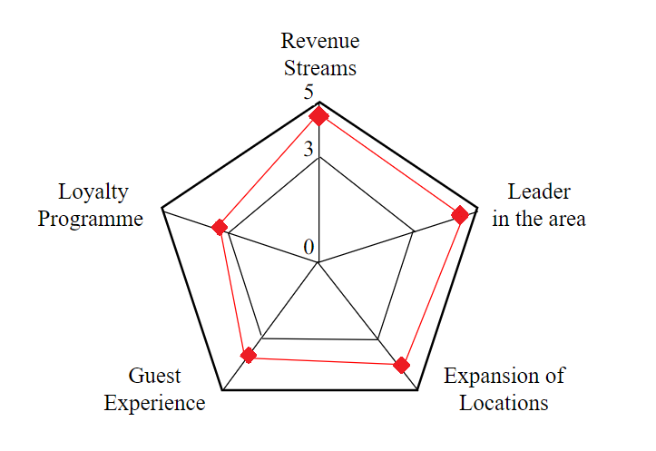
(Source: Developed by Victoria Chilianu)

Provided Services
Table 2.
Service | Features | Benefits
Accommodation | - 3 floors, 85 rooms, the maximum for 214 people  - 3 accessible rooms, 50 for 2 people, 20 for 3 people, 12 for 4 people | - Fully furnished with essential amenities such as plush beds, top-quality linens, minibars, and flat-screen televisions
Round-the-Clock Reception | - 24-hour reception desk | - Accessible to assist guests with any reservations or suggestions
Top-Notch Amenities | - 1 Swimming pool (10m/6m)  - 2 Changing rooms with showers  - 2 Saunas  (1 for men/ 1 for women)  - 1 Jacuzzi  - 1 Gym  - 4 Massage rooms  (2 Physiotherapy/ 2 Relaxation massage)  - 1 Yoga and meditation class (with monthly rent by a specialist in the field who gives personalised lessons) | - Swim lessons for mothers and children  - Relaxation and stress relief  - Rejuvenation of the skin  - Body detoxification  - Diagnostics  - Programmes  - Treatments  - Weight loss  - Dietary wellness  - Mental clarity
In-House Restaurant | - Organic farm-to-table food for breakfast (free), lunch, and dinner | - Healthy nourishment and wellness experience
Bar Service | - Hot Drinks  - Soft Drinks  - Alcoholic beverages  - Snack foods  (for consummations on-premises) | - Convenient option for customers  - Unique and elegant ambience  - Quiet and civilised atmosphere
Function Suite | - A special place for a special occasion | - An ideal venue for wedding receptions, birthday bashes, anniversary dinners, retirement celebrations, farewell parties, meetings and conference facilities
Wi-Fi | - Free Wi-Fi for wireless users  - A fee (£2 per hour) for wired internet access  (for business purposes) | - All-round communication  - Work and business  - On-trip planning  - Avoiding roaming charges
Free Parking | - 100 Parking spaces | - Sufficient parking spaces for hotel guests

(Source: Developed by Victoria Chilianu)

Value Proposition
REBLOOM Hotel and Spa sets itself apart from rival establishments by incorporating health into each facet of the guest experience, all-encompassing spa amenities, organic farm-to-table food experience, attention to detail, and personalised wellness experience by offering customised fitness programmes and massage therapies. The distinctive attribute is a steadfast dedication to delivering an unforgettable experience that nourishes the mind, body, and spirit of esteemed guests.

Legal Requirements
Table 3.
Legal Requirements | Insurance Requirements
Building Permit | Building Insurance
Business Permit | Business Interruption Insurance
Fire Safety Permit | Employer’s Liability
ESI Registration | Public Liability Insurance
GSI Registration | Accidental Damage Insurance
Police Licence | Hotel Contents Cover Insurance
Registration, Data Protection and Surveillance Regulations | Cyber Liability Insurance
Equality Act Obligations | Loss of Licence Insurance
Environmental Protection | Umbrella Liability Insurance
Health and Safety at Work Act | Commercial Crime Insurance
Alcohol, Entertainment, and Gaming Licence | Fidelity Cover Insurance
TV and Copyright Licences | Equipment Breakdown Insurance
Food Safety and Hygiene
Food Labelling
Signage Licence
(Visit Britain, 2024) | (Donut, 2024)

Health and safety rules are checked regularly during compliance audits (Clifton, 2023). Checks can be done on processes, structures, tools, and methods. Complaints are quickly taken care of to make sure everyone is safe. All staff must receive health and safety training to lower risks and make sure they follow the rules.
The company has all-encompassing public liability insurance to protect itself from lawsuits that could come from damage to property.
Insurance protects both the business and its clients financially and gives them peace of mind.
Legal advisors and compliance advisors are engaged to ensure compliance with the law and awareness of any new changes. They find and resolve legal issues before they happen.

Marketing

Market Research
Market research is necessary for the REBLOOM Hotel and Spa to be successful. The data provided has been the basis for the analysis that follows:
Assemble client profiles by identifying various customer groupings, such as families, executives in business, wellness aficionados, health-conscious individuals, and guests sent by employers. Knowing their preferences and needs will make it simpler to modify services and marketing strategies.
Competitive Headlines: Examine the benefits and drawbacks of competing properties like Holiday Inn Hotel, Stoke by Nayland Resort, and Greenwoods Hotel and Spa. Finding out what makes REBLOOM unique will make creating a unique value offer easier.
It is important to recognise any potential risks in the market, such as supply constraints, price pressure, and price increases. It is essential to grow.

Customer Profiles
Table 4.
Group | Number of customers | The price they might pay per unit
Tourists | 5000 | £10
Foreign Tourists | 2000 | £15
Families | 3000 | £12
Business Leaders | 500 | £25
Wellness Fans | 1500 | £20
Health-Conscious People | 1000 | £18
Employees sent by employers | 800 | £22

(Source: Developed by Ana Pesclevei)

Competitor Profiles
Table 5.
Competitor name | Strengths | Weaknesses
Greenwoods Hotel & Spa, Essex, Chelmsford  (Greenwoods Hotel, 2024) | - Prestigious brand with a  reputation for luxury and elegance;  - World-class amenities including luxurious spa facilities;  - Exceptional customer service and personalised experiences;  - Exclusive partnerships with  high-end brands and designers. | - Higher price points may limit accessibility for budget-conscious travellers;  - Limited availability due to high demand;  - Parking may be limited in urban locations;  - May lack accessibility features for disabled guests.
Stoke by Nayland Resort, Essex, Colchester  (Stoke by Nayland, 2024) | - Stunning natural surroundings with scenic views;  - Comprehensive wellness  offerings including spa treatments;  - Wide range of recreational  activities and facilities;  - Luxury accommodations and personalised service. | - Higher price point compared to budget accommodations;  - Limited availability during peak seasons;  - May not offer as many personalised services as boutique spas;  - Remote locations may require additional transportation for guests.
Holiday Inn Hotel, Essex, Colchester  (Holiday Inn, 2024) | - Convenient location near  transportation hubs;  - Affordable pricing for budget-conscious travellers;  - Straightforward  booking process;  - Family-friendly environment with practical amenities. | - Limited amenities and basic facilities;  - Less luxurious atmosphere compared to high-end resorts;  - Potential for noise and overcrowding due to large number of guests;  - Limited range of spa services and wellness programmes.

Market Risks
Table 6.
Risk | Description | Potential Impact | Mitigation Strategies
Pricing | Fluctuations in pricing may lead to customer  dissatisfaction, loss of competitive advantage, or revenue loss. | Decreased  revenue, loss  of customers  to competitors,  negative brand  perception. | Regularly monitor competitor prices and adjust pricing strategy accordingly.  Offer discounts or promotional offers to remain competitive.
Service | Variability in service quality may result in negative customer experiences, decreases in client loyalty, harm to brand reputation, and experiences. | Loss of customers, negative online reviews, decreased revenue. | Implement staff training programmes to maintain service standards.  Conduct regular customer satisfaction surveys and address any identified issues promptly.
Accessibility | Lack of accessibility features may exclude certain customer segments, such as individuals with disabilities, leading to potential legal issues and reputational damage. | Legal liabilities, negative publicity, loss of potential customers. | Conduct accessibility audits to identify and address any barriers.  Ensure compliance with relevant accessibility regulations and standards.
Competition | Intense competition from existing competitors or new market entrants may erode market share and profitability. | Decreased market share, reduced revenue, pricing pressures. | Differentiate the product or service offerings through unique features or value-added services.  Build strong customer relationships to enhance loyalty and reduce susceptibility to competitors.
Market  Demand | Changes in market demand or consumer preferences may result in decreased demand for the product or service, leading to excess inventory or underutilised capacity. | Excess inventory, underutilised capacity, revenue loss. | Conduct market research to identify emerging trends and anticipate shifts in consumer preferences.  Offer a variety of goods and services to appeal to a wider range of clients.
Economic  Factors | Economic downturns, inflation, or currency fluctuations may impact consumer spending habits and purchasing power, affecting business revenue and profitability. | Decreased consumer spending, reduced revenue, financial instability. | Maintain a diversified customer base to mitigate reliance on a single market segment.  Implement cost- saving measures and flexible pricing strategies to adapt to changing economic conditions.
Regulatory  Compliance | Legal penalties, fines, or sanctions, along with damage to reputation and loss of customer trust, can occur as a result of failure to comply with regulatory requirements. | Legal liabilities, fines, reputational damage. | Stay informed about relevant regulations and ensure compliance through regular audits and training programmes.  Develop robust internal policies and procedures to ensure adherence to legal requirements.
Technological  Changes | Quick improvements to current items or the need for pricey additions or expenditures to stay competitive. | Increased competition, decreased market share, revenue loss. | To remain ahead of technological changes and innovate, it's important to invest in research and development.  Continuously monitor industry trends and invest in technologies that enhance efficiency, productivity, and customer experience.
Supply Chain  Disruptions | Business operations and customer satisfaction may be affected by disruptions in the supply chain, such as natural disasters, transportation issues, or supplier failures, which may result in delays, shortages, or increased costs. | Delayed deliveries, increased costs, loss of customers. | Diversify the supply chain to reduce reliance on single suppliers.  Create contingency plans and establish alternative sourcing solutions to minimise the impact of disruptions.

(Source: Developed by Ana Pesclevei)

Pricing
Table 7.
Service | Price(s) | Range of competitor prices (per unit)
Hotel room (double) | £95 | £80-£120
Hotel room (family) | £120 | £100-£150
Accessible hotel room | £90 | £90-£130
Parking | £7 | £5-£10
Sports hall | £25 | £20-£30
Gym | £12 | £10-£15
Swimming pool (10/6) | £20 | £15-£25
Jacuzzi | £12 | £10-£15
Sauna (men/women) | £10 | £10-£15
Massage (physiotherapist) | £40 | £30-£50
Massage (relaxation) | £25 | £20-£30
Breakfast | Included | £5-£10

(Source: Developed by Ana Pesclevei)

Promotion and Advertising
Marketing Channels: Online platforms, social media, search engine optimisation (SEO), partnerships with travel agencies, and local advertising to promote services.
Sales Strategy: Offering competitive pricing packages, seasonal promotions, and loyalty programmes to attract and retain customers.

Running the Business

Staff
Table 8.
Role | Total cost  (per year) | Necessary experience | Specialist skills and/or qualifications
3 Receptionists | £73,655  (Glassdoor, 2024) | Minimum 6 months | Being certified in Office Management and having a high school degree are both advantageous (Workable, 2024)
3 Therapists | £109,988  (UK Indeed, 2024a) | Minimum 6 months | Licence (Indeed, 2023)
1 Spa Manager | £38,163  (UK Indeed, 2024b) | Administering therapies or positions where one may set budgets for spas, oversee facility upkeep, or oversee customer service (Hiring People, 2024) | Business Management or Spa Management Bachelor’s Degree (Hiring People, 2024)
4 Fitness Trainers | £133,604  (UK Indeed, 2024c) | Applicants should have prior gym or freelance personal training experience, along with client and employer references (UK Indeed, 2024d) | Level 2 Diploma in Instructing Exercise and Fitness, Level 3 Certificate in Personal Training, CPR, and First Aid certifications (UK Indeed, 2024d)
8 Spa Attendants | £183,568  (UK Indeed, 2024e) | Not required | GCSEs, Level 2 Certificate in Cleaning Principles, the Diploma in Customer Service, and the BTEC in Hospitality (UK Indeed, 2024f)
8 Beauty Therapists | £113,104  (UK Indeed, 2024g) | Minimum 6 months | NVQ Level 2 or Level 3 Diploma in Beauty Therapy (UK Indeed, 2024h)
2 Spa therapists | £73,332  (UK Indeed, 2024a) | Minimum 6 months | NVQ diploma in spa therapy at level 3 (Academic Course, 2024)
3 Security Guard | £61,881  (UK Indeed, 2024i) | Not required | Security Industry Authority (SIA) licence (SIA Licensing, 2024)
10 Housekeeping | £271,010  (UK Indeed, 2024j) | Not required | High school diploma or GCSE
10 Food and beverage assistants | £203,220  (UK Indeed, 2024k) | Not required | GCSEs in English and maths
1 Purchasing Officers | £30,147  (UK Indeed, 2024l) | Minimum 3 years in a similar position | Bachelor’s degree
1 Maintenance Engineering | £38,375  (UK Indeed, 2024m) | Minimum 3 years in a similar position. | Being in a relevant subject

Premises
Table 9.
Cost
(per room)
Premises required at start-up: | £323,500  (PDQ Funding, 2023)
Premises required in the future: | £0

(Source: Developed by Constantin-Bogdan Rusu)

Suppliers
Table 10.
Supplier | What we will buy from them | Number of days’ credit
Upsons Farm Shop & Country Store  Essex, Chelmsford  (Upsons, 2024) | Meat, Milk, Eggs | 15 days
Jamies Farm Shop  Essex, Chelmsford  (Jamies Fruit and Veg, 2024) | Fresh Fruits + Vegetables | weekly
Manor Farm Shop  Essex, Chelmsford  (Manor, 2023) | Frozen vegetables | weekly
Bidfood  Essex, Harlow  (Bidfood, 2024) | Dry Goods | 15 days
Booker  Essex, Colchester  (Booker, 2024) | Stationery kitchen equipment | monthly
Mathew Clark  Dartford, Crayford  (Mathew Clark, 2024) | Wines + Spirits | monthly
J&O Wholesale  London  (J&O Wholesale, 2021) | Beer + Soft Drinks | monthly
Alliance  Essex, Braintree  (Find the needle, 2023) | Consumables, Chemicals | 15 days
County Linen & Workwear  Essex, Chelmsford  (County Linen, 2018) | Laundry Service | 15 days

Equipment
Table 11.
Resource | When | How funded | Cost £ (per unit)
Spa | Start-up | Investment | £5,000 (Ortega, 2023)
Jacuzzi and Spa tubs | Start-up | Investment | £2,353 (Ortega, 2023)
Massage chairs, beds, treatment tables, and furniture | Start-up | Investment | £235 to £1,569 (Ortega, 2023)
Skincare treatment equipment and beauty equipment | Start-up | Investment | £800 (Ortega, 2023)
Furniture, fixtures, and equipment | Start-up | Investment | £29,100 (PDQ Funding, 2023)
Computers | Start-up | Self-Funded | £800
Printers | Start-up | Loan | £300
Office furniture | Start-up | Investment | £1000
Server | Start-up | Loan | £2000
Security cameras | Start-up | Grant | £600
Networking equipment | Start-up | Investment | £1500

(Source: Developed by Constantin-Bogdan Rusu)

Operational Risks
Table 12.
 | Risk | Solution
Staff | High turnover due to lack of  advancement opportunities | Provide ongoing training and career development opportunities;
Staff |  | Offer competitive salaries and benefits packages;
Staff |  | Implement retention strategies such as employee recognition programmes and performance incentives;
Staff |  | Conduct regular employee feedback sessions.
Staff | Lack of work-life balance leading to burnout | Provide resources for stress management and wellness programmes;
Staff |  | Implement flexible work arrangements;
Staff |  | Encourage time off and vacations;
Staff |  | Offer telecommuting options.
Suppliers | Reliance on a single supplier for critical materials | Develop contingency plans for supply chain disruptions;
Suppliers |  | Establish relationships with multiple suppliers;
Suppliers |  | Diversify the supplier base;
Suppliers |  | Regularly assess supplier performance and conduct risk assessments.
Suppliers | Poor supplier performance or quality issues | Establish clear quality standards and expectations;
Suppliers |  | Conduct regular audits and inspections of supplier operations;
Suppliers |  | Implement corrective action plans for non-compliance.

(Source: Developed by Constantin-Bogdan Rusu)

Finance

Start-up Costs
Table 13.
Estimated Cost (£)
IT and computers | £200,000
Telephones and broadband | £50,000
Equipment | £500,000
Stock | £150,000
Tools | £50,000
Vehicles | £300,000
Professional fees | £100,000
Insurance | £200,000
Rent/rent deposit | £1,000,000
Stationery | £300
Marketing | £500,000
Consumables | £50,000
Licences | £30,000
Training | £100,000
Association fees | £20,000
Wages/recruitment | £1,000,000
Security/health and safety equipment | £50,000
Market research costs | £50,000
TOTAL | £4,160,000

(Source: Developed by Alexandra Craescu)

Profit and Loss Forecast
Table 14.
 | Year 1 (£) | Year 2 (£) | Year 3 (£)
Total expected sales | £500,000 | £650,000 | £850,000
Variable costs | £175,000 | £210,000 | £262,000
Gross profit  (total sales – variable costs) = | £325,000 | £440,000 | £587,000
Gross profit margin  (gross profit / total sales * 100%) = | 65% | 68% | 69%
Salaries/wages  (survival income + any staff) = | £100,000 | £130,000 | £16,000
Premises  (including rent, rates, utilities) | £70,000 | £90,000 | £10,000
Telephone and broadband | £10,000 | £12,000 | £15,000
Printing, post, and stationery | £5,000 | £6,000 | £7,000
Advertising and promotion | £30,000 | £35,000 | £40,000
Bank charges | £2,000 | £2,500 | £3,000
Professional fees | £15,000 | £18,000 | £20,000
Insurances | £25,000 | £30,000 | £35,000
Bank/HP/Interest  (payable to our bank) | £14,000 | £15,500 | £20,000
Stock | £15,000 | £18,000 | £20,000
Consumables | £8,000 | £10,000 | £12,000
Equipment and vehicle leasing | £20,000 | £25,000 | £30,000
Depreciation | £15,000 | £18,000 | £20,000
Total fixed costs | £329,000 | £409,500 | £248,000
Net profit  (gross profit – fixed costs) = | (£4,000) | £30,500 | £339,500
Net profit margin  (net profit / total sales * 100%) = | (-1%) | 5% | 40%
Break-even  (variable costs + fixed costs) = | £675,000 | £860,000 | £510,000

(Source: Developed by Alexandra Craescu)

Finances
Table 15.
 |  | £
Start-up costs |  | 4,160,000
Personal start-up contributions | - | 4,000,000
Other start-up contributions | - | 4,000,000
Total required | = | 3,840,000
The assets available as security
 | = | 3,840,000

(Source: Developed by Alexandra Craescu)

Financial Risks
REBLOOM Hotel and Spa must manage financial risks to stay afloat. The financial forecast identifies five major risks:
Market Volatility: Economic and consumer trends affect the hotel and spa industry. Economic downturns or travel trends may reduce hospitality service demand and revenue expectations (Skoglund and Chen, 2015). Service diversification and cost adjustments reduce risk.
Interest Rate Fluctuations: Interest rate changes are problematic owing to bank loans and contributed money. Unexpectedly high interest rates could impact loan repayment and profitability. Interest rate hedging or fixed-rate borrowing minimises volatility.
Operational Disruptions: Global health issues and natural disasters can disrupt business. Disruptions can close enterprises and lower revenue (Brown, 2016). A comprehensive business continuity plan and insurance reduce disruption costs.
Competitive Pricing Pressure: The hospitality industry is competitive, and aggressive pricing can affect hotel and spa rates. Competitive pricing pressure can diminish revenue if not anticipated or managed. Regular market analysis and price strategy updates reduce this risk.
Regulatory Compliance Risks: Local and international rules apply. Tax, licencing, and health and safety changes may cause unexpected costs and legal issues (Park and Kim, 2020). Avoiding financial penalties requires legal guidance, audits, and regulatory updates.
Addressing these risks can boost resilience, financial interests, and hospitality market management at the REBLOOM Hotel and Spa.
Minimising Impact
- Revenue diversification lowers market risk. Multiple service and package alternatives decrease client preference changes (Hasan et al., 2020). Market research helps forecast trends and quickly adjust service offers.
- Hedge against interest rate changes by borrowing with interest rate swaps or fixed rates. Optimise debt costs and profitability by tracking interest rates and refinancing options.
- Business continuity planning is needed for operational disruptions. Consider distant operations, emergency response, and cash reserves for unanticipated expenses. Complete business interruption and property damage insurance lowers operational disruption costs.
- Monitor market developments and rival strategies to counteract competitive pricing pressure (Boisjoly et al., 2020). Market-responsive pricing may assist sustain profitability and competitiveness. Unique value propositions and customer experience can help avoid price competition.
- Regulation monitoring is essential to decreasing compliance risks. Establishing a compliance team or hiring lawyers can ensure new rule compliance. Communication with authorities and staff compliance training prevent fines.

Cash Flow Forecast
Table 16.
 | Q1 |  | Q2 |  | Q3 |  | Q4 |  | Y1 Total
INCOME | Forecast | Actual | Forecast | Actual | Forecast | Actual | Forecast | Actual | Forecast | Actual
Cash from sales  (Inc. VAT) | £120,000 |  | £140,000 |  | £150,000 |  | £120,00 |  | £530,000
Capital/loans received | £4,000,000 |  | £0 |  | £0 |  | £0 |  | £4,000,000
Other Payments | £5,000 |  | £5,000 |  | £5,000 |  | £5,000 |  | £20,000
TOTAL £ | £4,125,000 |  | £145,000 |  | £155,000 |  | £125,0000 |  | £4,550,000
EXPENDITURE
Wages to staff (incl. PAYE & NI) | £60,000 |  | £65,000 |  | £70,000 |  | £60,000 |  | £255,000
Premises (rent, rates, and utilities) | £30,000 |  | £35,000 |  | £30,000 |  | £30,000 |  | £125,000
Telephone and Broadband | £2,500 |  | £2,500 |  | £2,500 |  | £2,500 |  | £10,000
Printing, post, and stationery | £1,500 |  | £1,500 |  | £1,500 |  | £1,500 |  | £6,000
Advertising and promotion | £10,000 |  | £10,000 |  | £10,000 |  | £10,000 |  | £40,000
Bank charges | £1,000 |  | £1,000 |  | £1,000 |  | £1,000 |  | £4,000
Professional fees | £5,000 |  | £5,000 |  | £5,000 |  | £5,000 |  | £20,000
Insurances | £3,000 |  | £3,000 |  | £3,000 |  | £3,000 |  | £12,000
Bank/HP | £10,000 |  | £10,000 |  | £10,000 |  | £10,000 |  | £40,000
Equipment and vehicle leasing | £7,000 |  | £7,000 |  | £7,000 |  | £7,000 |  | £28,000
Payments relating to variable costs | £15,000 |  | £15,000 |  | £15,000 |  | £15,000 |  | £60,000
Capital Expenditure | £10,000 |  | £0 |  | £0 |  | £0 |  | £10,000
Other Payments | £2,000 |  | £2,000 |  | £2,000 |  | £2,000 |  | £8,000
VAT | £5,000 |  | £5,000 |  | £5,000 |  | £5,000 |  | £20,000
Owner’s wages/salary | £15,000 |  | £15,000 |  | £15,000 |  | £15,000 |  | £60,000
Owner’s NI | £3,000 |  | £3,000 |  | £3,000 |  | £3,000 |  | £12,000
Loan repayments  (Incl. interest) | £10,000 |  | £10,000 |  | £10,000 |  | £10,000 |  | £40,000
Stock | £2,000 |  | £2,000 |  | £2,000 |  | £2,000 |  | £8,000
Consumables | £1,000 |  | £1,000 |  | £1,000 |  | £1,000 |  | £4,000
TOTAL £ | £133,000 |  | £193,000 |  | £193,000 |  | £183,000 |  | £762,000
NET CASH FLOW  (Total Income –Total Expenditure) = | £3,992,000 |  | (£23,000) |  | (£8,000) |  | (£33,000) |  | £3,888,000

(Source: Developed by Alexandra Craescu)

Conclusion
REBLOOM Hotel and Spa will completely change the perception of the hotel industry in the region through its comprehensive wellness programmes. When it comes to starting a business, every founder wants income right from the first year of activity. A well-designed business plan with forecast calculations and well-defined strategies can predict the future of the business. REBLOOM Hotel and Spa must effectively manage financial risks such as market volatility, interest rate fluctuations, operational disruptions, competitive pricing pressure, and regulatory compliance risks. By implementing strategies such as revenue diversification, interest rate hedging, business continuity planning, market monitoring, and regulatory monitoring, the entity will be able to increase resilience, protect financial interests, and effectively manage the hospitality market.
REBLOOM's goal is to provide guests with a peaceful stay with friendly staff, state-of-the-art services, and ongoing changes.

References
Academic Courses (2024) 8 Course Programmes in Spa Therapy 2024. [Software]. Available at: https://www.academiccourse.co.uk/courses/spa-therapy (Accessed 20 February 2024).
Amadeus (2024) The Ultimate Hotel General Manager’s Guide. [Software]. Available at: https://www.amadeus-hospitality.com/hotel-manager-guide/#:~:text=The%20journey%20to%20becoming%20a,and%20food%20and%20beverage%20services (Accessed: 7 February 2024).
ASEM (2020) Academia de Studii Economice din Moldova. [Website]. Available at: https://ase.md/ (Accessed: 14 February 2024).
Bedfordshire Hospitals (2024) Information for Patients & Visitors – Luton and Dunstable University Hospital. [Website]. Available at: https://www.bedfordshirehospitals.nhs.uk/patients-visitors/information-for-patients-visitors-luton-and-dunstable-university-hospital/ (Accessed: 14 February 2024).
Bidfood (2024) Welcome to Bidfood Harlow. [Website]. Available at: https://www.bidfood.co.uk/get-in-touch/depot/bidfood-harlow/ (Accessed: 24 February 2024).
Boisjoly, R.P., Conine, T.E. and McDonald, M.B. (2020) ‘Working capital management: Financial and valuation impacts’, Journal of Business Research, [online] 108(1), pp. 1–8. Available at: https://doi.org/10.1016/j.jbusres.2019.09.025 (Accessed: 25 February 2024).
Booker (2024) Booker Colchester. [Website]. Available at: https://www.booker.co.uk/branch-locator/colchester/193-gosbecks-road (Accessed: 24 February 2024).
Brown, A. (2016) Financial risk management for dummies. New York: John Wiley.
Calistrat Hogaș (2024) Colegiul Naţional’’Calistrat Hogas’’, Piatra Neamţ. [Website]. Available at: http://www.calistrathogas.ro/ (Accessed: 14 February 2024).
Clifton, D. (2023) Hospitality Security: Managing Security in Today’s Hotel, Nightlife, Entertainment, and Tourism Environment. 2nd edition. Abington, Oxon: CRC Press.
Conceptboard (2024) Individual Business Model Canvas. [Visual Workspace]. Available at: https://conceptboard.com/blog/business-model-canvas-free-conceptboard/ (Accessed: 29 February 2024).
County Linen (2018) We are county linen. [Website]. Available at: https://countylinen.co.uk/ Available at: (Accessed: 24 February 2024).
Donut (2024) Hotel legal issues. [Website]. Available at: https://www.lawdonut.co.uk/business/sector-specific-law/hotel-legal-issues (Accessed: 21 February 2024).
Find the needle (2023) Alliance Online Catering Equipment. [Website]. Available at: https://www.findtheneedle.co.uk/companies/alliance-online-catering-equipment (Accessed: 24 February 2024).
Glassdoor (2024) How much does a receptionist make in London, United Kingdom? [Website]. Available at: https://www.glassdoor.com/Salaries/london-receptionist-salary-SRCH_IL.0,6_IM1035_KO7,19.htm (Accessed 20 February 2024).
Google Maps (2024) Witham. [Web mapping platform]. Available at: https://www.google.com/maps/@51.7978648,0.6365834,17.5z?entry=ttu (Accessed: 16 February 2024).
Greenwoods Hotel (2024) A hidden gem of Essex. [Website]. Available at: https://www.greenwoodshotel.com/ (Accessed: 24 February 2024).
Hasan, Md.M., Popp, J. and Oláh, J. (2020) ‘Current landscape and influence of big data on finance’, Journal of Big Data, 7(1), pp. 1–17. Available at: https://doi.org/10.1186/s40537-020-00291-z (Accessed: 25 February 2024).
Hexcel (2024) Hexcel Duxford. [Website]. Available at: https://www.hexcel.com/About/Site-Locations/1445/hexcel-duxford (Accessed: 14 February 2024).
Hiring People (2024) Spa Manager Job Description. [Website]. Available at: https://www.hiringpeople.co.uk/job-descriptions/spa-manager-job-description/ (Accessed 20 February 2024).
Holiday Inn (2024) Welcome to Holiday Inn Colchester. [Website]. Available at: https://www.hicolchesterhotel.co.uk/ (Accessed: 24 February 2024).
Indeed (2023) Therapist Job Description: Top Duties and Qualifications. [Website]. Available at: https://www.indeed.com/hire/job-description/therapist (Accessed 20 February 2024).
J&O Wholesale (2021) On Trade Drinks Distribution. Same Day Delivery Anywhere in Essex. [Website]. Available at: https://www.jandowholesale.co.uk/ (Accessed: 24 February 2024).
Jamies Fruit and Veg (2024) Jamies farm shop, always fresh fruit and vegetables. [Website]. Available at: https://jamiesfruitandveg.com/ Available at: (Accessed: 24 February 2024).
Manor (2023) Come visit us. [Website]. Available at: http://www.themanorfarmshopchelmsford.co.uk/contact%20us.htm (Accessed: 24 February 2024).
Mathew Clark (2024) Contact us. [Website]. Available at: https://www.matthewclark.co.uk/contact-us/ (Accessed: 24 February 2024).
Ocado Group (2023) Changing the way the world shops for good. [Website]. Available at: https://www.vmadgearucta.ro/ (Accessed: 16 February 2024).
Ortega, M. (2023) ‘How much does it cost to open a spa - The complete guide’, eposnow. Available at: https://www.eposnow.com/uk/resources/how-much-does-it-cost-to-open-a-spa/#:~:text=The%20average%20cost%20of%20installing,your%20spa%20apart%20from%20competitors. (Accessed 20 February 2024).
Park, H. and Kim, J.D. (2020) ‘Transition towards green banking: Role of financial regulators and financial institutions’, Asian Journal of Sustainability and Social Responsibility, 5(1), pp. 1–25. Available at: https://doi.org/10.1186/s41180-020-00034-3 (Accessed: 25 February 2024).
PDQ Funding (2023) How to Start a Hotel Business. Available at: https://pdq-funding.co.uk/how-to-start-a-hotel-business/#:~:text=When%20estimating%20the%20startup%20costs,a%20lifestyle%20full%2Dservice%20hotel. (Accessed 20 February 2024).
Premier Inn (2024a) Chelmsford (Springfield) hotel. [Website]. Available at: https://www.premierinn.com/gb/en/hotels/england/essex/chelmsford/chelmsford-springfield.html (Accessed: 12 February 2024).
Premier Inn (2024b) Dunstable / Luton hotel. [Website]. Available at: https://www.premierinn.com/gb/en/hotels/england/bedfordshire/dunstable/dunstable-luton.html (Accessed: 19 February 2024).
Premier Inn (2024c) Saffron Walden hotel. [Website]. Available at: https://www.premierinn.com/gb/en/hotels/england/essex/saffron-walden/saffron-walden.html?cid=GLBC_SAFWAL (Accessed: 14 February 2024).
Premier Inn (2024d) Hatfield hotel. [Website]. Available at: https://www.premierinn.com/gb/en/hotels/england/hertfordshire/hatfield/hatfield.html (Accessed: 16 February 2024).
SIA Licensing (2024) Security Guard Licence. [Website]. Available at: https://www.get-licensed.co.uk/licence/security-guard-licence#:~:text=To%20be%20eligible%20for%20an,is%20valid%20for%203%20years. (Accessed 20 February 2024).
Skoglund, J. and Chen, W. (2015) Financial risk management: applications in market, credit, asset and liability management and firmwide risk. Hoboken, New Jersey: John Wiley & Sons, Inc.
SPSS (2023) Școala Postliceală Sanitară Suceava. [Website]. Available at: https://scoalasanitarasv.ro/ (Accessed: 14 February 2024).
Stoke by Nayland (2024) A truly unique experience at Stoke by Nayland Resort. [Website]. Available at: https://www.stokebynayland.com/ (Accessed: 24 February 2024).
The White Hart Hotel (2024) The White Hart Hotel, Witham. [Website]. Available at: https://www.whitehartinwitham.co.uk/ (Accessed: 14 February 2024).
UK Indeed (2024a) Therapist salary in London. [Website]. Available at: https://uk.indeed.com/career/therapist/salaries/London (Accessed 20 February 2024).
UK Indeed (2024b) Spa manager salary in London. [Website]. Available at: https://uk.indeed.com/career/spa-manager/salaries/London?from=top_sb (Accessed 20 February 2024).
UK Indeed (2024c) Personal trainer salary in London. [Website]. Available at: https://uk.indeed.com/career/personal-trainer/salaries/London?from=top_sb (Accessed 20 February 2024).
UK Indeed (2024d) Personal Trainer Job Description: Top Duties and Qualifications. [Website]. Available at: https://uk.indeed.com/hire/job-description/personal-trainer (Accessed 20 February 2024).
UK Indeed (2024e) Spa attendant salary in London. [Website]. Available at: https://uk.indeed.com/career/spa-attendant/salaries/London (Accessed 20 February 2024).
UK Indeed (2024f) What does a spa attendant do? (Duties and requirements). [Website]. Available at: https://uk.indeed.com/career-advice/finding-a-job/spa-attendant (Accessed 20 February 2024).
UK Indeed (2024g) Beautician salary in London. [Website]. Available at: https://uk.indeed.com/career/beautician/salaries/London (Accessed 20 February 2024).
UK Indeed (2024h) Beauty Therapist Job Description: Top Duties and Qualifications. [Website]. Available at: https://uk.indeed.com/hire/job-description/beauty-therapist (Accessed 20 February 2024).
UK Indeed (2024i) Security guard salary in London. [Website]. Available at: https://uk.indeed.com/career/security-guard/salaries/London (Accessed 20 February 2024).
UK Indeed (2024j) Hotel housekeeper salary in London. [Website]. Available at: https://uk.indeed.com/career/hotel-housekeeper/salaries/London (Accessed 20 February 2024).
UK Indeed (2024k) Food service worker salary in London. [Website]. Available at: https://uk.indeed.com/career/food-service-worker/salaries/London (Accessed 20 February 2024).
UK Indeed (2024l) Purchasing clerk salary in London. [Website]. Available at: https://uk.indeed.com/career/purchasing-clerk/salaries/London?from=top_sb (Accessed 20 February 2024).
UK Indeed (2024m) Maintenance engineer salary in London. [Website]. Available at: https://uk.indeed.com/career/maintenance-engineer/salaries/London?from=top_sb (Accessed 20 February 2024).
Upsons (2024) Welcome to Upsons farm shop & country store. [Website]. Available at: https://www.upsonscountrystore.co.uk/ (Accessed: 24 February 2024).
UWTSD (2024) Swansea Campus Life. [Website]. Available at: https://www.uwtsd.ac.uk/swansea (Accessed: 14 February 2024).
Virgil Mardgearu (2024) Liceul Economic „Virgil Madgearu”. [Website]. Available at: https://www.vmadgearucta.ro/ (Accessed: 14 February 2024).
Visit Britain (2024) England Business Advice Hub / The Pink Book. [Website]. Available at: https://www.visitbritain.org/business-advice/pink-book?utm_source=google&utm_medium=paidsearch&utm_content=na_pinkbook_search_na_na_link_na_na&utm_campaign=bah_23_B2B_nov23&gad_source=1&gclid=CjwKCAiAuNGuBhAkEiwAGId4apsne-UkC8UnpN_X3PW9UXsmAJ8RZKGZBmwsMHdNp3gzNUGr1CxxvBoCNXMQAvD_BwE&gclsrc=aw.ds (Accessed: 21 February 2024).
Whitbread (2024) Academy Online for Premier Inn. [Software platform]. Available at: https://academy.whitbread.co.uk/pluginfile.php/443078/mod_scorm/content/1/index.html (Accessed: 12 February 2024).
Workable (2024) Receptionist job description. [Website]. Available at: https://resources.workable.com/receptionist-job-description (Accessed 20 February 2024).

Appendices
Appendix 1
Individual Business Model Canvas of REBLOOM
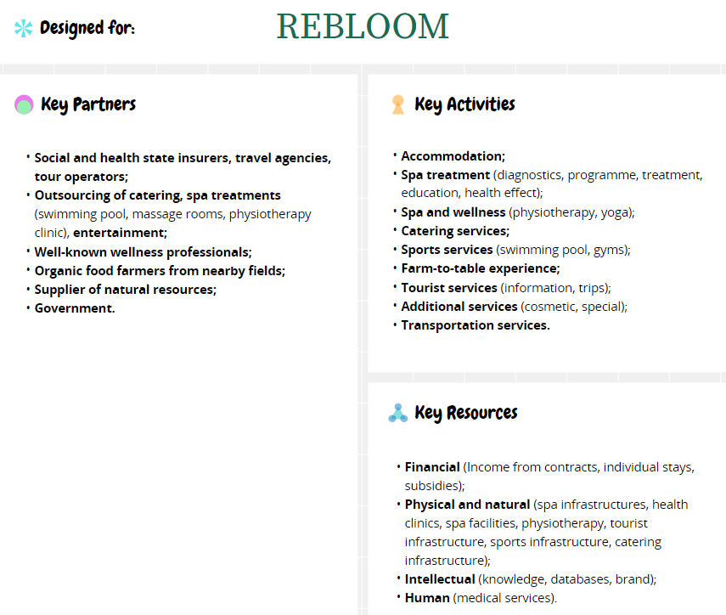
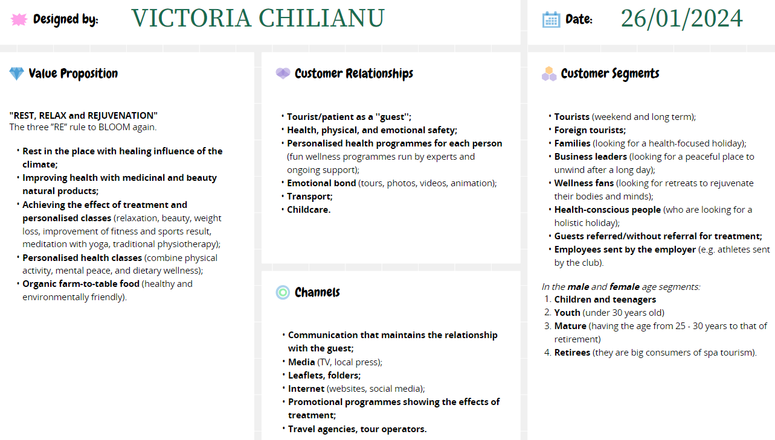

Appendix 1 (Cont’d)
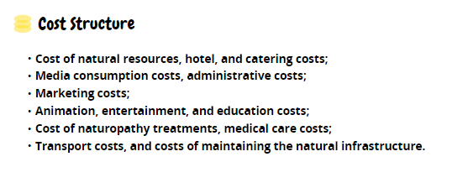
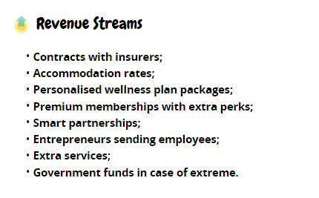

(Conceptboard, 2024)

