My Reflective Portfolio
Fozia Shabir (2019385)
University of Wales Trinity saint David
BMSW 4005
Task 3
Lecturer: Olubukola Adegbite

Table of Contents

My Reflective Portfolio 0
Introduce 2
Task 3 Part 1 3
Self-awareness themes learned throughout this module and taught analytical tools 3
SWOT Analysis 3
Personal Development Plan (PDP) 4
Task 3 Part 2 5
Learning and development techniques 5
VAK learning styles 5
David Kolb and experiential learning cycle 5
Honey and Mumford’s learning style 6
Task 3 Part 3 8
Reflect on my learning as regards Mock interview, Open book question and UK employment legislation 8
Reference 10
Appendices 11

Introduce

In this report, I will be discussing with you how I have improved my learning skills and how this module had helped me learn new methods and skills that can benefit me in my future looking for a career within the health sector. I have also discovered new tools and theories that helped me in describing me in understanding new techniques.
Throughout this article, I will be talking about analytical tools that I used and how I taken my feedback from my lecturer for my results of Open book question and mock interview. The tools I will be using are SWOT Analysis and Personal Development Plan (PDP).
In the appendices I will be sharing my feedback from my lecturers and will be also giving a short Information on I will take in the feedback to fixed my mistakes and not to repeat the

Task 3 Part 1

Self-awareness themes learned throughout this module and taught analytical tools

SWOT Analysis

My Strengths  - Learning new skills and methods  - At least 1 year experience in the care sector  - Certificate and training in Adult care and Medication | My Weaknesses  - Overthinking about my decisions that I made  - Multitasking, doing more than one task at one go. Unable to focus on one task.  - Unable to keep with new law and legislation in the care sector
My Opportunities  - Progression in my current career  - University course  - Knowledge on the funding that is available for me from the government (checking the website gov.uk) | My Threats  - Having someone who is better skilled or has move experience in the sector.  - Working with data driven information  - Economic downtown  - Not enough experience in the care sector

CFI (2020) said in their blog “A SWOT analysis is a simple and effective framework for identifying strengths, weaknesses, opportunities, and threats that a company faces. It is important to leverage strengths, minimize threats, and to take advantage of available opportunities.”

Personal Development Plan (PDP)

Goals | Action | Resources | Deadline
Short- term  Complete and receive my degree in level 4 in health and social care | Completing 1 year course and attending all my lessons on time | Fulfilling my assignments on time and submitting them on the date and time that is required | May 2022
Mid- term  Start with my level 5 course in health and social care and complete it with a degree | Applying for further education BA health and social care with UWTSD and attending and submitting my course work on time | Talking with the university of my opportunities and what are the required, applying online for level 5 | May 2024
Long- term  Opening my own company | Having the right qualifications and skills that are required | Searching for government funds that are available for me and saving enough money for the right training and material required | September 2026- 2027

The career I have chosen for my future is to work as a social worker, this is my long term goal and the PDP has helped me in the stages that I will reflect and what training and achieves I will required.
As MindTools (2014) said “Personal Development Planning is all about creating a long-term goal for your career, and then thinking about how you’ll achieve it.”

Task 3 Part 2

Learning and development techniques

As a manager it is my responsible to make sure all of the new and existing staff know how to assess the learning and training development within the workplace as everyone has different learning techniques and helping them understand their learning style will help them in developing new and existing skills and succeed the company and their self, this will help them build they confidences.
There are numerous different theories on different learning styles, the three theories I have chosen to talk about are;
- VAK learning styles by Walter Burke Barbe and later develop by Neil Fleming
- David Kolb and experiential learning cycle by David Kolb
- Honey and Mumford’s learning styles by Peter Honey and Alan Mumford

VAK learning styles

This theory is directly linked to our senses, and influences the words we use to understand and recognise thinking styles that helps with better communicate and rapport building. Style defines how we think about things and what language we the use when communicating with others. Visual style are based for people who imagine pictures and describes details, colours and images. Auditory learning style are based for people who remember words, tone and volume and words that have very specific meaning. Kinesthetics learning style are based for people who use physical rather than words and images for example walking through, getting hold or physical touch and physical feelings.
As Revolution learning and development (2022) said in their article “VAK learning styles are used to help us better understand how we learn. By understanding how we best absorb information, we can find learning and develop interventions that best suit our needs.”

David Kolb and experiential learning cycle

Kolb’s learning style also known as experiential learning cycle is a 4 step continuous process for effective learning that explains how you learn through experience, to learn most considerable you much follow these four steps concrete experience, reflective observation, abstract conceptualisation and active experimentation. You don’t always need to start from step 1 you can start from any step and learn. The four different learning styles that are included in the cycle are accommodating (feel & do), diverging (feel & watch), converging (think & do) and assimilating (think & watch).
“Learning is the process whereby knowledge is created through the transformation of experience” (Kolb, 1984, p. 38)

Honey and Mumford’s learning style

In this theory there are four different learning styles which are activist, reflector, theorist and pragmatist. Individual can maximised their learning once there are aware of their preferred style this helps them build their skills and knowledge their abilities. Knowing your learning style allows you to become efficient in identifying learning opportunities and the way you learn, effective learns who can easily grasp learning content and increase versatility and learn from different environment. Provides opportunities to further develop yourself as you are capable of understanding yourself and the way you learn.
EPM (2020) said “Honey and Mumford’s learning styles suggests that most people prefer to use just one or two of these distinct styles.”

Evaluation

Working as a manager of my workplace, I will be choosing Kolb’s learning cycle for my employees because when working as a social worker it requires the worker to be able to put their learning into action. As starting work as a social worker, the employees would have to undergo training, there will have to demonstrate that they are capable of carrying out certain actives and know how to write report.
As a social worker my new and exiting staff would required to understanding the safety of the client’s and with the correct training their would be able to understand the different safety measurement their could be using with different client’s.
The other theory I was would be using for my staff to build their learning style is Honey and Mumford’s learning style because when working in the care sector as a social worker the employee would need to be activist and theorist, as a social worker should always check as much as information to write reports at the end of the visit and also be able to aware of any danger that could be there.
The training would also teach how to use the equipment in the correct manner and how to use the appropriate PPE when required. Making sure all my staff know the requirements and benefits of the training and development that is available for them in the work place is important as a manager I need to make sure each individual knew how to assess them and how this will benefit them in their learning styles to build their confidences and help not only them but the company in having employees with right training given will reduce the chances of risks and mistakes with the client’s. The main aim of staff training is to gain the development and abilities of the individual member of employees, but as it likewise helps with effectiveness for the company and overall staff maintenance, it advantages everyone within the company.

Task 3 Part 3

Reflect on my learning as regards Mock interview, Open book question and UK employment legislation

Overall, while during this course I have granted many skills and techniques that could help me towards my career path which is to become a social worker. All the modules I had worked throughout this course had helped me develop many new knowledge and understanding, I was able to build my confident and learn how to perform in front a group as well as use my technology skills and help others in the class. The skills I have learned and build throughout this module has encourage me in believing in myself to get my work and assignment done in the rightful manner and meeting the deadlines. I have also learnt that working in groups and teams are important and that we must show respect to each other’s opinions and ideas. I have improve in becoming confidence using my skills to get my assignment done on time as well as making new friends and learning new methods and skills that are not only going to help me with my studies but with my future career path.
This module had helped me in understanding the professional skills that I required for myself and also how I can improve in my skills. As you can check my appendices where there is my feedback regards my mock interview, I had taken in the feedback that was given to me regards my mock interview and used them to correct and strength my weakness. I have used the SWOT analysis with my mock interview and learned how I can transform my weakness and threats into my opportunities and strengths that can help me further on my studies as I will be continue to level 5 next term after receiving my level 4 degree. During my Mock interview I was a little nervous, as I was unwell and because I have a speaking problem where sometimes I pronounce some words wrong not purposely so I was worried to mix up my words. I had been practicing nonstop as I am used to going to a lot of interview I had a confidence in the question I had to ask and how I would reply back to the interviewer. Overall I felt it was a great experience and had helped me in understanding what the interviewer is mainly looking for. During the class I attended their had help me a lot in understanding the different and importance of how to presentation myself to the interviewer so I can stand out from others.
Gov.uk (2022) said “Businesses need to ensure they are following the rules and regulations outlined in current employment legislation.”
Open book question was something new for me as I never did it before and I was quite nervous regards when doing the open book question, when I found out the topic was mental health this had helped me lessen my stress as I had study on mental health before and have depression myself. This was a new challenge for me to achieve and a risk that I enjoyed, I was able to build my time keeping skill and meet the requirements of the open book question which was too have 500 words and after the time period I had to submit in right away. I had a some problems with the internet but did not let that effect myself from completing and submitting my task 1 on time.
As UNSW (2022) said “Open-book exams allow you to take notes, texts or resource materials into an exam situation.”
In week 9, I have learned about the UK employment legislation. I had a little knowledge regards the UK employment legislation but this module has extended my understanding with the different legislation such as the national minimum wages is for my age which is £8.91 and many more such as the working time restrictions and holiday and statutory sick pay. I learned about the rights I have as an employee, I have understood the different polities that can be in place at the workplace which are health and safety, grievance, equal opportunities, bribery, disciplinary and IT. This module had helped me understand and new so much regards my professional life and how to deal with my career path that I have chosen which is to become a social worker and be able own my own company later on in the future. I have develop a lot of techniques on how to set my goals and targets and achieve them in the time manner. As I am currently going through a lot of problem in my personal life I felt like giving up but the support from my lecturer and other class mates have encouraged and helped me get to my goal and meeting my deadlines on time.
Completing this module and course had helped me a lot in reaching my goal and setting a plan for my future, this has encourage me in achieving my dream and has helped me build my confident within many ways, such as working within a team and specially presenting in front of others and sharing my ideas. This has benefit me seeing what I need to do in the future and what I required for me to achieve my goals. SWOT Analysis has helped me learned how to use my strengths to transform my threats into opportunities for example one of my main threat is data driven decision making but my strength is learning, I can learn about data driven and lessen my threat and transform it into an opportunity that can help me through my future and current career path and I can further mu understanding by using the PDP and make a action plan that can help me in reaching my opportunities.
In conclusion, this module and course has helped me in understanding my strengths and how I can develop myself for the future. it has helped me understand the meaning of different learning styles as well as how I can use them in my benefit. This course has open a lot of paths for me to successful move forward to my goal and how to reach them. I believe I have improve in quite a lot is time management, being organise and setting goals and targets and following them, being able to manage my time and reach my goals and target on the time and date I planned to.

Reference

CFI, (2020) SWOT Analysis [Website] Available at: https://corporatefinanceinstitute.com/resources/knowledge/strategy/swot-analysis/?msclkid=760f02dbaec411ecb08d26ae3b2776db (Accessed on 23/03/2022)
MindTools Ltd, (2014) personal development plan [Website] Available at: https://www.mindtools.com/courses/lnV924x0/PersonalDevelopmentPlanning.pdf?msclkid=cf7a8e02aec511ec85c6b1ca76b6b383 (Accessed 23/03/2022)
Revolution Learning Development, (2022) VAK Learning Styles [Website] Available at: https://www.revolutionlearning.co.uk/article/vak-learning-styles/?msclkid=350e34b6aec811ecac6b3c94986a5afa (Accessed on 24/03/2022)
Kolb, D. A, (1976) The Learning Style Inventory: Technical Manual. Publisher: Boston
EPM, (2020) Honey and Mumford learning style [Website] Available at: https://expertprogrammanagement.com/2020/10/honey-and-mumford/?msclkid=1599bc17aecb11ec82405a5d61da2b87 (Accessed on 24/03/2022)
Gov.uk, (2022) legislation [Website] Available at: https://www.legislation.gov.uk/uksi/employment?msclkid=9c181826aed711ecb69abaa64e3b013a (Accessed 25/03/2022)
Alma, (2016) Mock interview [Website] Available at: https://librarysearch.uwtsd.ac.uk/discovery/fulldisplay?docid=alma99100401032002421&context=L&vid=44WHELF_UWTSD:44WHELF_UWTSD_VU1&lang=en&search_scope=MyInst_and_CI&adaptor=Local%20Search%20Engine&tab=Everything&query=any,contains,Mock%20interview (Accessed on 25/03/2022)
UNSW, (2022) open- book and take home exams [Website] Available at: https://www.student.unsw.edu.au/open-book-and-take-home-exams#:~:text=Open-book%20exam%20questions%20usually%20require%20you%20to%20apply,fact%20situation%20that%20you%20will%20need%20to%20discuss.?msclkid=d9154d93aeda11eca3b7373c394e60e0 (Accessed on 25/03/2022)

Appendices
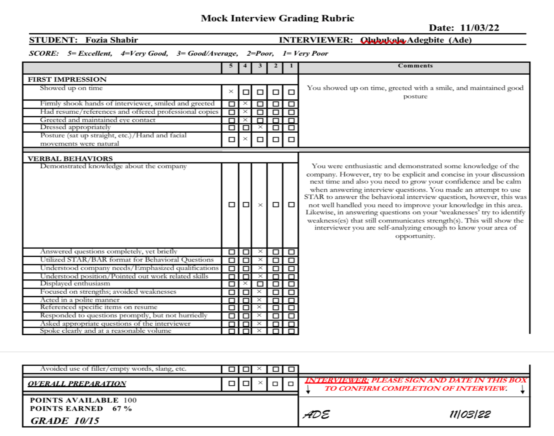

This is my feedback from my lecturer regards my mock interview.

