ACCA5023: Network Operating Systems and Services
University of wales, trinity st david | Swansea
Research, build, and deploy a Virtualised Enterprise network
David Sheppard (2306723)
2026
Table of Contents
1.1 Hypervisor research 2
1.2 IP addressing research 3
1.3 Routing research 4
1.4 Network services research 5
2.1 Hypervisor choice 6
2.2 Download and setup 7
2.3 Configure IP Addressing 10
2.4 Testing and troubleshooting 11
3.1 Reflection 15
Bibliography 16

1.1 Hypervisor research

Hypervisors provide virtualisation platforms, allowing multiple operating systems (OS) to share hardware resources efficiently and securely. Type 1 hypervisors run directly on hardware, providing access to CPU, RAM and other resources, enhancing performance and scalability [1]. Because they operate without a host OS layer, they are more secure and usually used in large enterprises with dedicated labs.

Type 2 hypervisors run on the host OS and are common development and testing environments due to simplicity and ability to run different OSs, however, are resource intensive for host machines [2]. Their dependency on the host OS means that any compromise or instability at host level may affect all virtual machines, introducing additional risk.

Architecturally, Type 1 hypervisors separate control and client virtual machine execution, allowing resource partitioning [1] [3], while Type 2 host OS dependence can lead to resource conflicts with host processes.
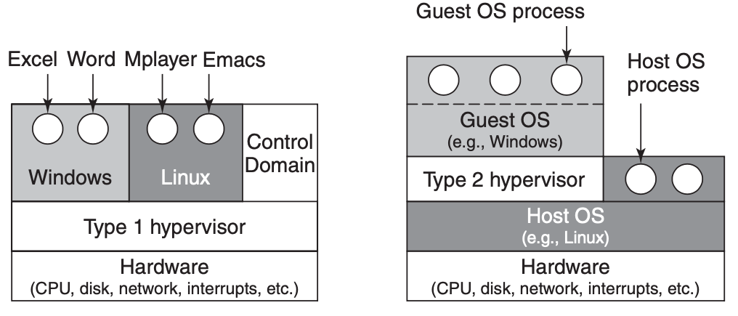
Figure 1: Type 1 and 2 hypervisor infrastructure comparison [3]

The SWANSEA.ACCA domain environment, supporting Debian and Windows Servers, would benefit from a Type 1 hypervisor with management tools supporting scalable domain and security infrastructures [4]. With NOSS2026 operating across Swansea and London, possible future expansion aligns more closely with Type 1 capabilities like live migration [1]. Hosting Windows Server 2022 as a domain controller requires stronger isolation and stability, which Type 1 architectures better support.

Although Type 2 hypervisors are suitable for lab-based experimentation due to ease of deployment and lower hardware requirements, an infrastructure with security, resilience and scalability requirements more appropriately justifies implementation of a Type 1 hypervisor.

1.2 IP addressing research

IP addressing, fundamental to functional, effective modern networks, enables unique host identification and routing of data packets across interconnected systems using standardised protocols [5], relatable to rules humans use in communication.

When data is transmitted, it is encapsulated into packets containing source and destination IP addresses. Routers examine these addresses, determining directions toward destination networks. Switches forward frames locally using MAC addresses. This layered interaction ensures data moves efficiently both locally and across geographically separated networks.

Within Windows Server 2022, IP addressing enables essential services, like DNS for name resolution and DHCP for automatic network configuration, ensuring reliable communication [4].

IPv4 uses 32-bit dotted-decimal format with network and host portions determined by subnet masks [6]. For example, allocating 192.168.1.0/24 to Swansea and 192.168.2.0/24 to London would logically separate broadcast domains while maintaining structured addressing. Subnetting like this improves performance, reduces unnecessary traffic, and enhances security segmentation.
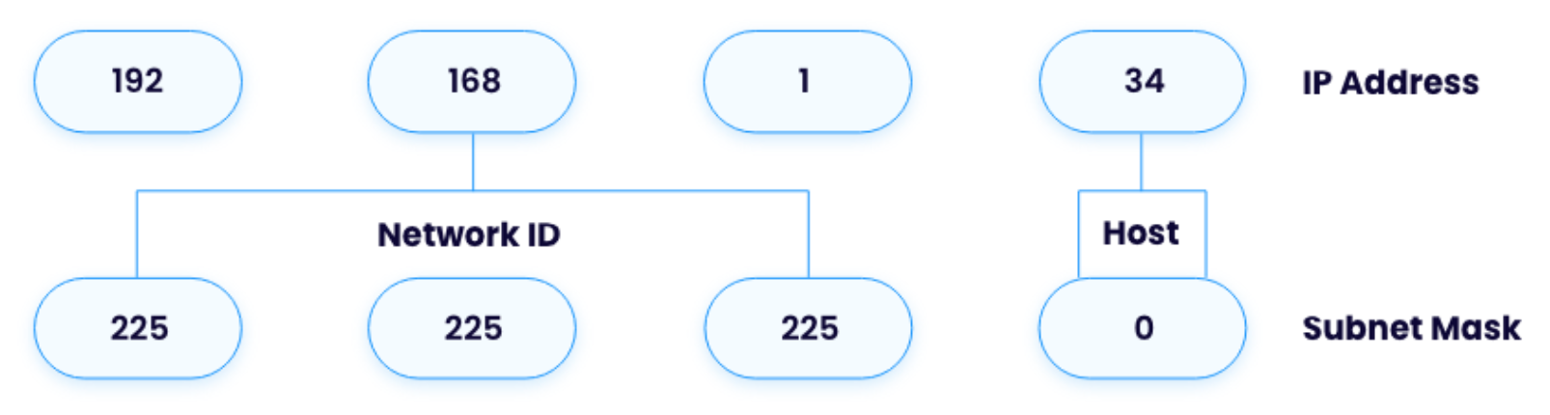
Figure 2: Example of network and host segments of an IP address [7]

Microsoft’s technical documentation introduces detailed subnetting calculations, classless addressing and methodologies for allocating address space [8], supporting scalability and performance within Windows Server deployments.

Due to exhaustion of IPv4 addresses, IPv6 was introduced, enabling vastly increased address capacity, hierarchical routing and auto-configuration features [4] [9], however, IPv4 is still used widely. In enterprises, dual-stack implementation is suggested, ensuring compatibility while preparing for long-term scalability.

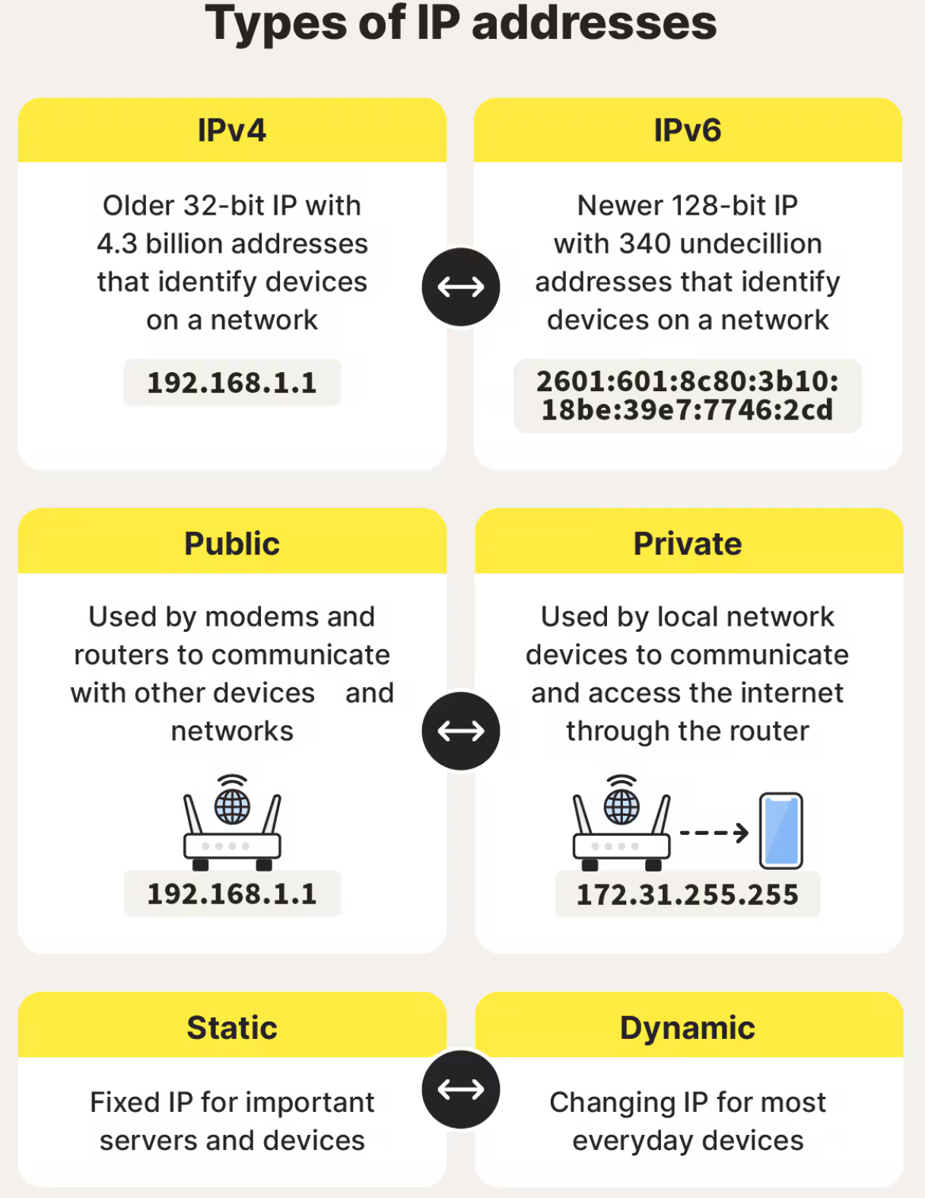
Figure 3: Understanding IP addressing

IP addressing is like postal mail. Destination addresses must be known, local delivery takes it to a sorting centre, it’s routed closer to the destination, then delivered. A return letter requires the sender’s address. Like mail, internet data passes through many routing steps, just faster and at greater scale.

1.3 Routing research

Routing enables data to travel between separate networks by selecting optimal paths for packet delivery across multiple subnets by breaking messages into small packets, using network knowledge to determine efficient navigation, a vital process for communication across vast network distances [10].

Static routing involves manually configuring paths to destination networks. It is a simple, predictable approach well suited to stable topologies. However, they require manual updates as they cannot adjust to network changes, reducing resilience in more dynamic environments. In a two-site organisation such as NOSS2026, manual reconfiguration following link failure could disrupt communication.

Dynamic routing protocols automatically exchange routing information between routers using specific protocols (e.g., RIP) to calculate optimal paths. This approach aligns with best practice in enterprise infrastructures as documented by Microsoft. Dynamic routing supports automatic route recalculation, improving fault tolerance and reducing administrative overhead.

In Windows Server 2022 Administration Fundamentals, Dauti emphasises the importance of resilience and service continuity, particularly when supporting core services like DNS and DHCP [4].

Reflecting on the given topology, the Debian Server acting as a DHCP Relay and the Windows Server providing central services would benefit from dynamic routing, given the potential for future expansion and multiple subnets. Because DHCP Relay depends on reliable inter-subnet communication to forward broadcast requests to the Windows Server, stable and adaptive routing between Swansea and London becomes essential. Therefore, a dynamic approach is more aligned with enterprise scalability and service continuity requirements than static routing.

1.4 Network services research

Enterprise network services like Virtual Private Networks (VPNs), Dynamic Host Configuration Protocol (DHCP), Active Directory Services (AD DS) and Certificate Authorities (CAs) provide essential security, configuration and identity management capabilities.

VPNs extend private connectivity across public networks by encapsulating and encrypting traffic. Industry guidance from Stallings highlights that secure VPN design should use modern protocols and strong authentication to protect against interception and unauthorised access. Regular security audits are another example of best practice [11]. For NOSS2026, a VPN between Swansea and London would secure communication over public infrastructure, ensuring confidentiality of domain authentication traffic.

DHCP automates IP address allocation and network configuration parameters, reducing manual errors and configuration conflicts. Microsoft describes DHCP as critical for supporting segmented Virtual Local Area Networks (VLANs) and distributed services [4] [12]. When combined with DHCP Relay on the Debian Server, address management can be maintained without deploying separate DHCP servers at each location.

AD DS centralises authentication, authorisation and directory services. Dauti emphasises secure domain controller placement, topology planning and least-privilege administration to support an organisation’s security policies [4]. Within the SWANSEA.ACCA domain, AD DS underpins user identity, group policies and secure access to shared resources across both locations.

CAs underpin trust in encryption services through digital certification. Best practice includes hierarchical CA model with revocation checking and secure certificate lifecycle management [11] [4]. Certificate services strengthen VPN authentication and enable encrypted communications (e.g., HTTPS) within the domain environment.

Together, these services support robust, secure communication, identity verification and automated management within enterprises when implemented according to documented standards.

2.1 Hypervisor choice

A Type 2 hypervisor has been chosen for this assignment. Infrastructure planning and understanding of available resources is key to implementing a virtualised network. Although research indicates that an enterprise topology such as NOSS2026 would more appropriately benefit from a Type 1 hypervisor due to enhanced performance, isolation and scalability, practical implementation constraints must also be considered.

Due to time limitations and restricted access, deploying a Type 1 hypervisor was not feasible within the scope of this module. Access to pre-configured computer lab machines with sufficient RAM and storage capacity supported the use of a Type 2 hypervisor, allowing efficient deployment of Windows Server 2022 and Debian virtual machines without additional infrastructure configuration.

Therefore, while a Type 1 hypervisor would be architecturally preferable in a real-world environment, the selection of a Type 2 hypervisor is justified within the academic context of this assignment for the reasons above.

2.2 Download and setup

The screenshots demonstrate implementation of a Type 2 hypervisor environment. Timestamp evidence confirms incremental deployment. While a Type 1 solution would be architecturally preferable in enterprise, the selected Type 2 platform enabled controlled virtual machine deployment within the available lab infrastructure and supports progression into coursework 2.

Evidence of download from official sources

The screenshots evidence that operating systems were obtained directly from official vendor sources (Microsoft and Debian), ensuring authenticity, integrity, and security compliance. This reflects best practice in enterprise environments, where verified software sources reduce risk of compromised installation. Timestamp records demonstrate planning across multiple sessions (January–March 2026), indicating ongoing development.

Software | Details | Screenshot evidence
Windows Server 2022 | Taken from Microsoft website on the link here. | 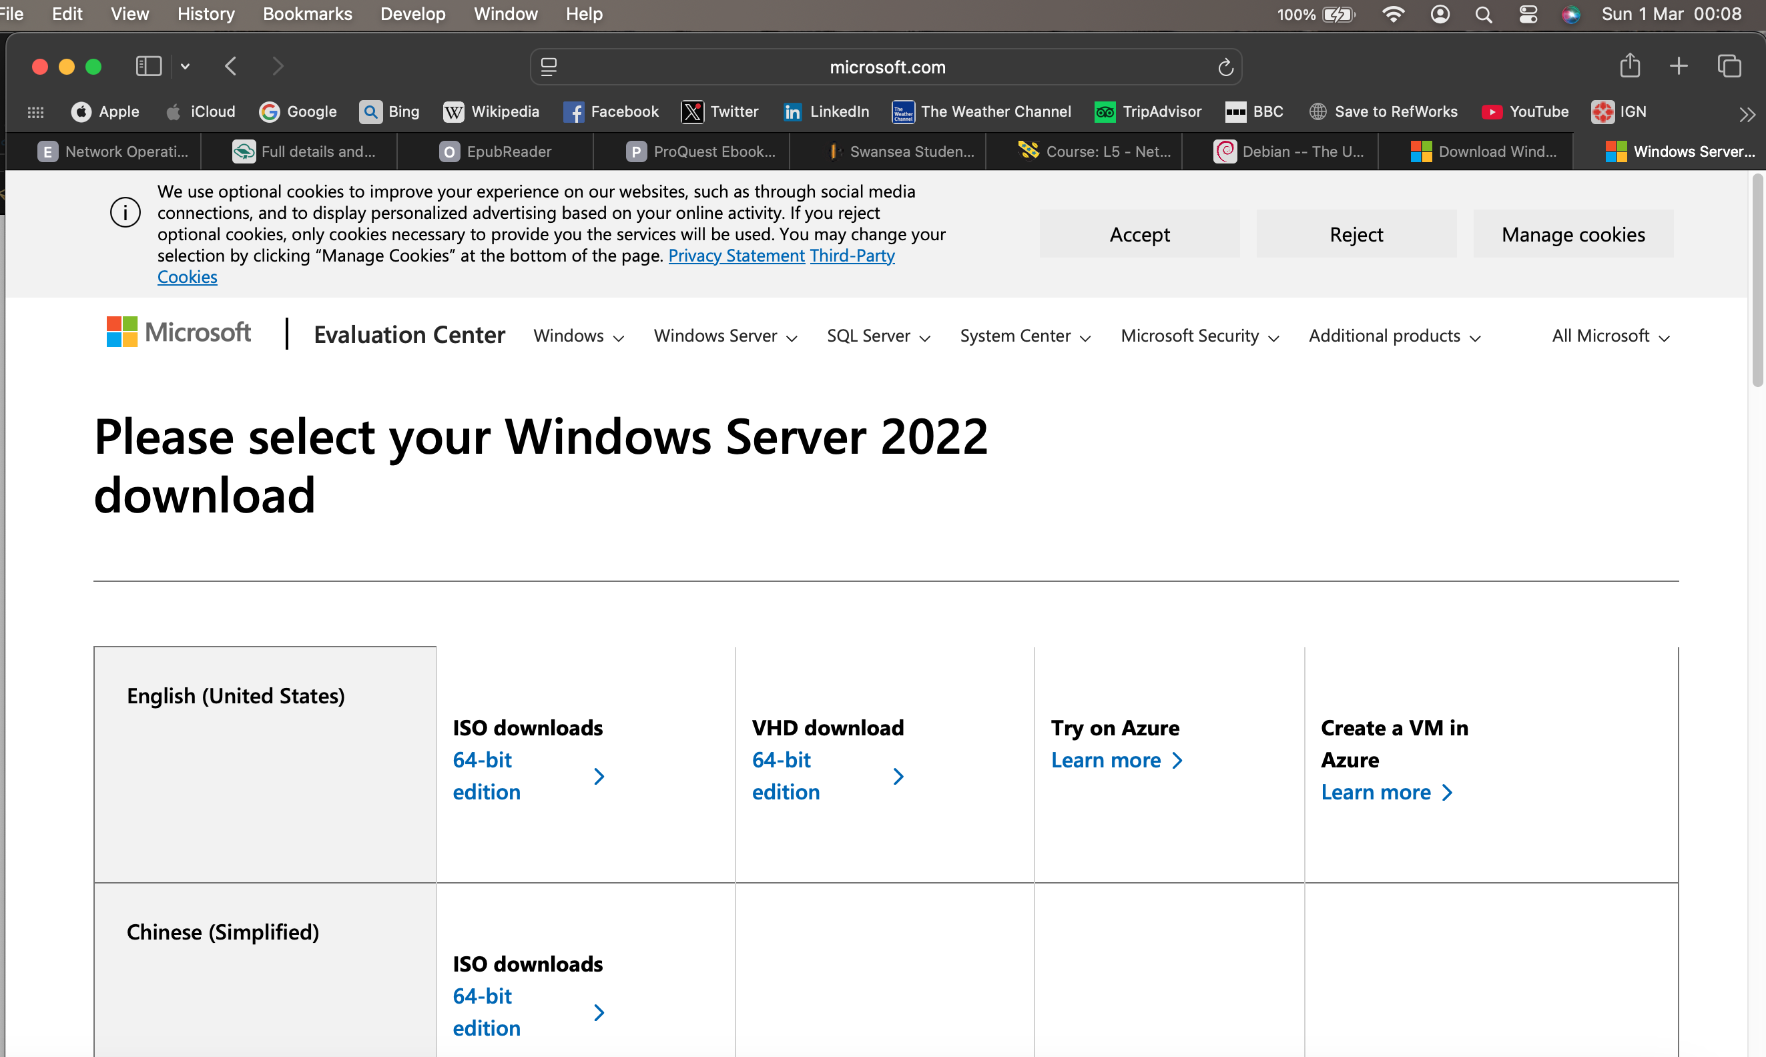
Windows 11 Enterprise Edition | From Microsoft.com | 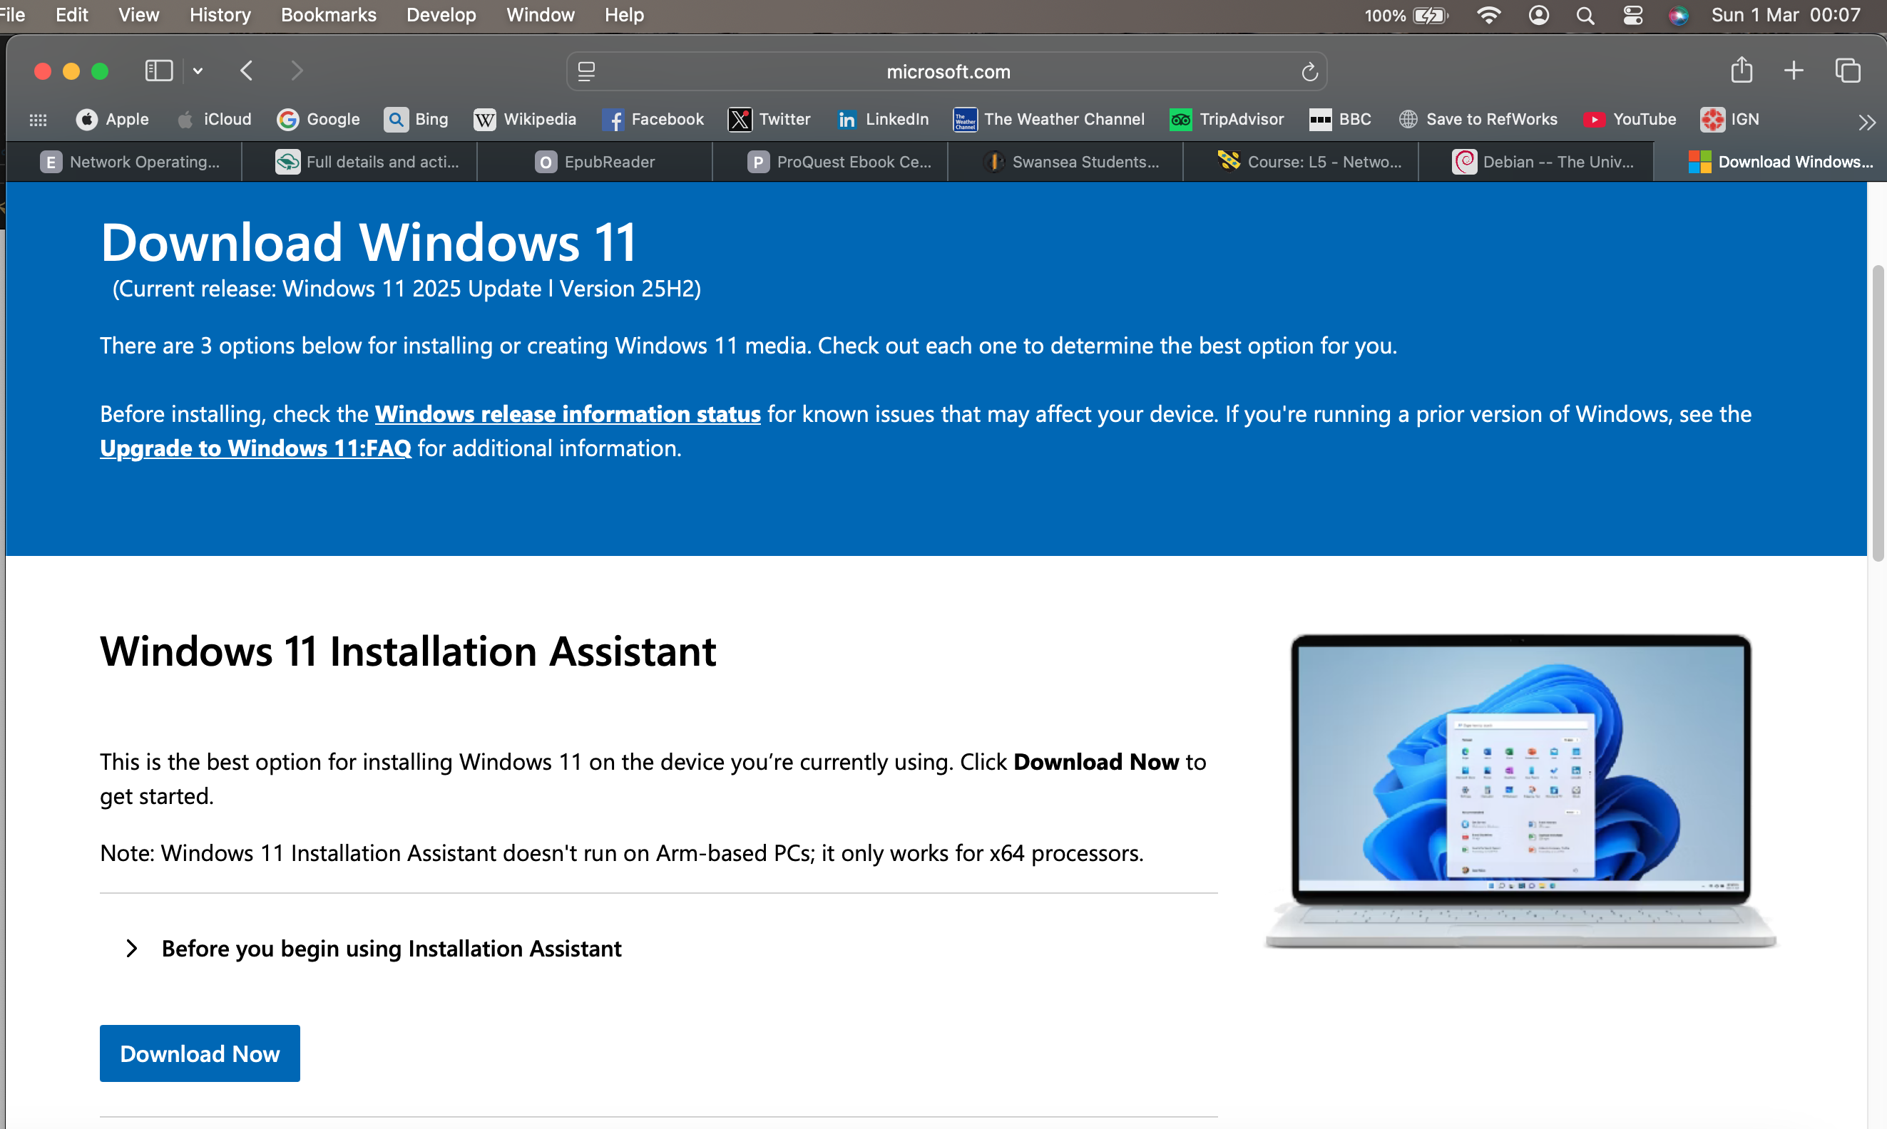
Debian | From Debian.org | 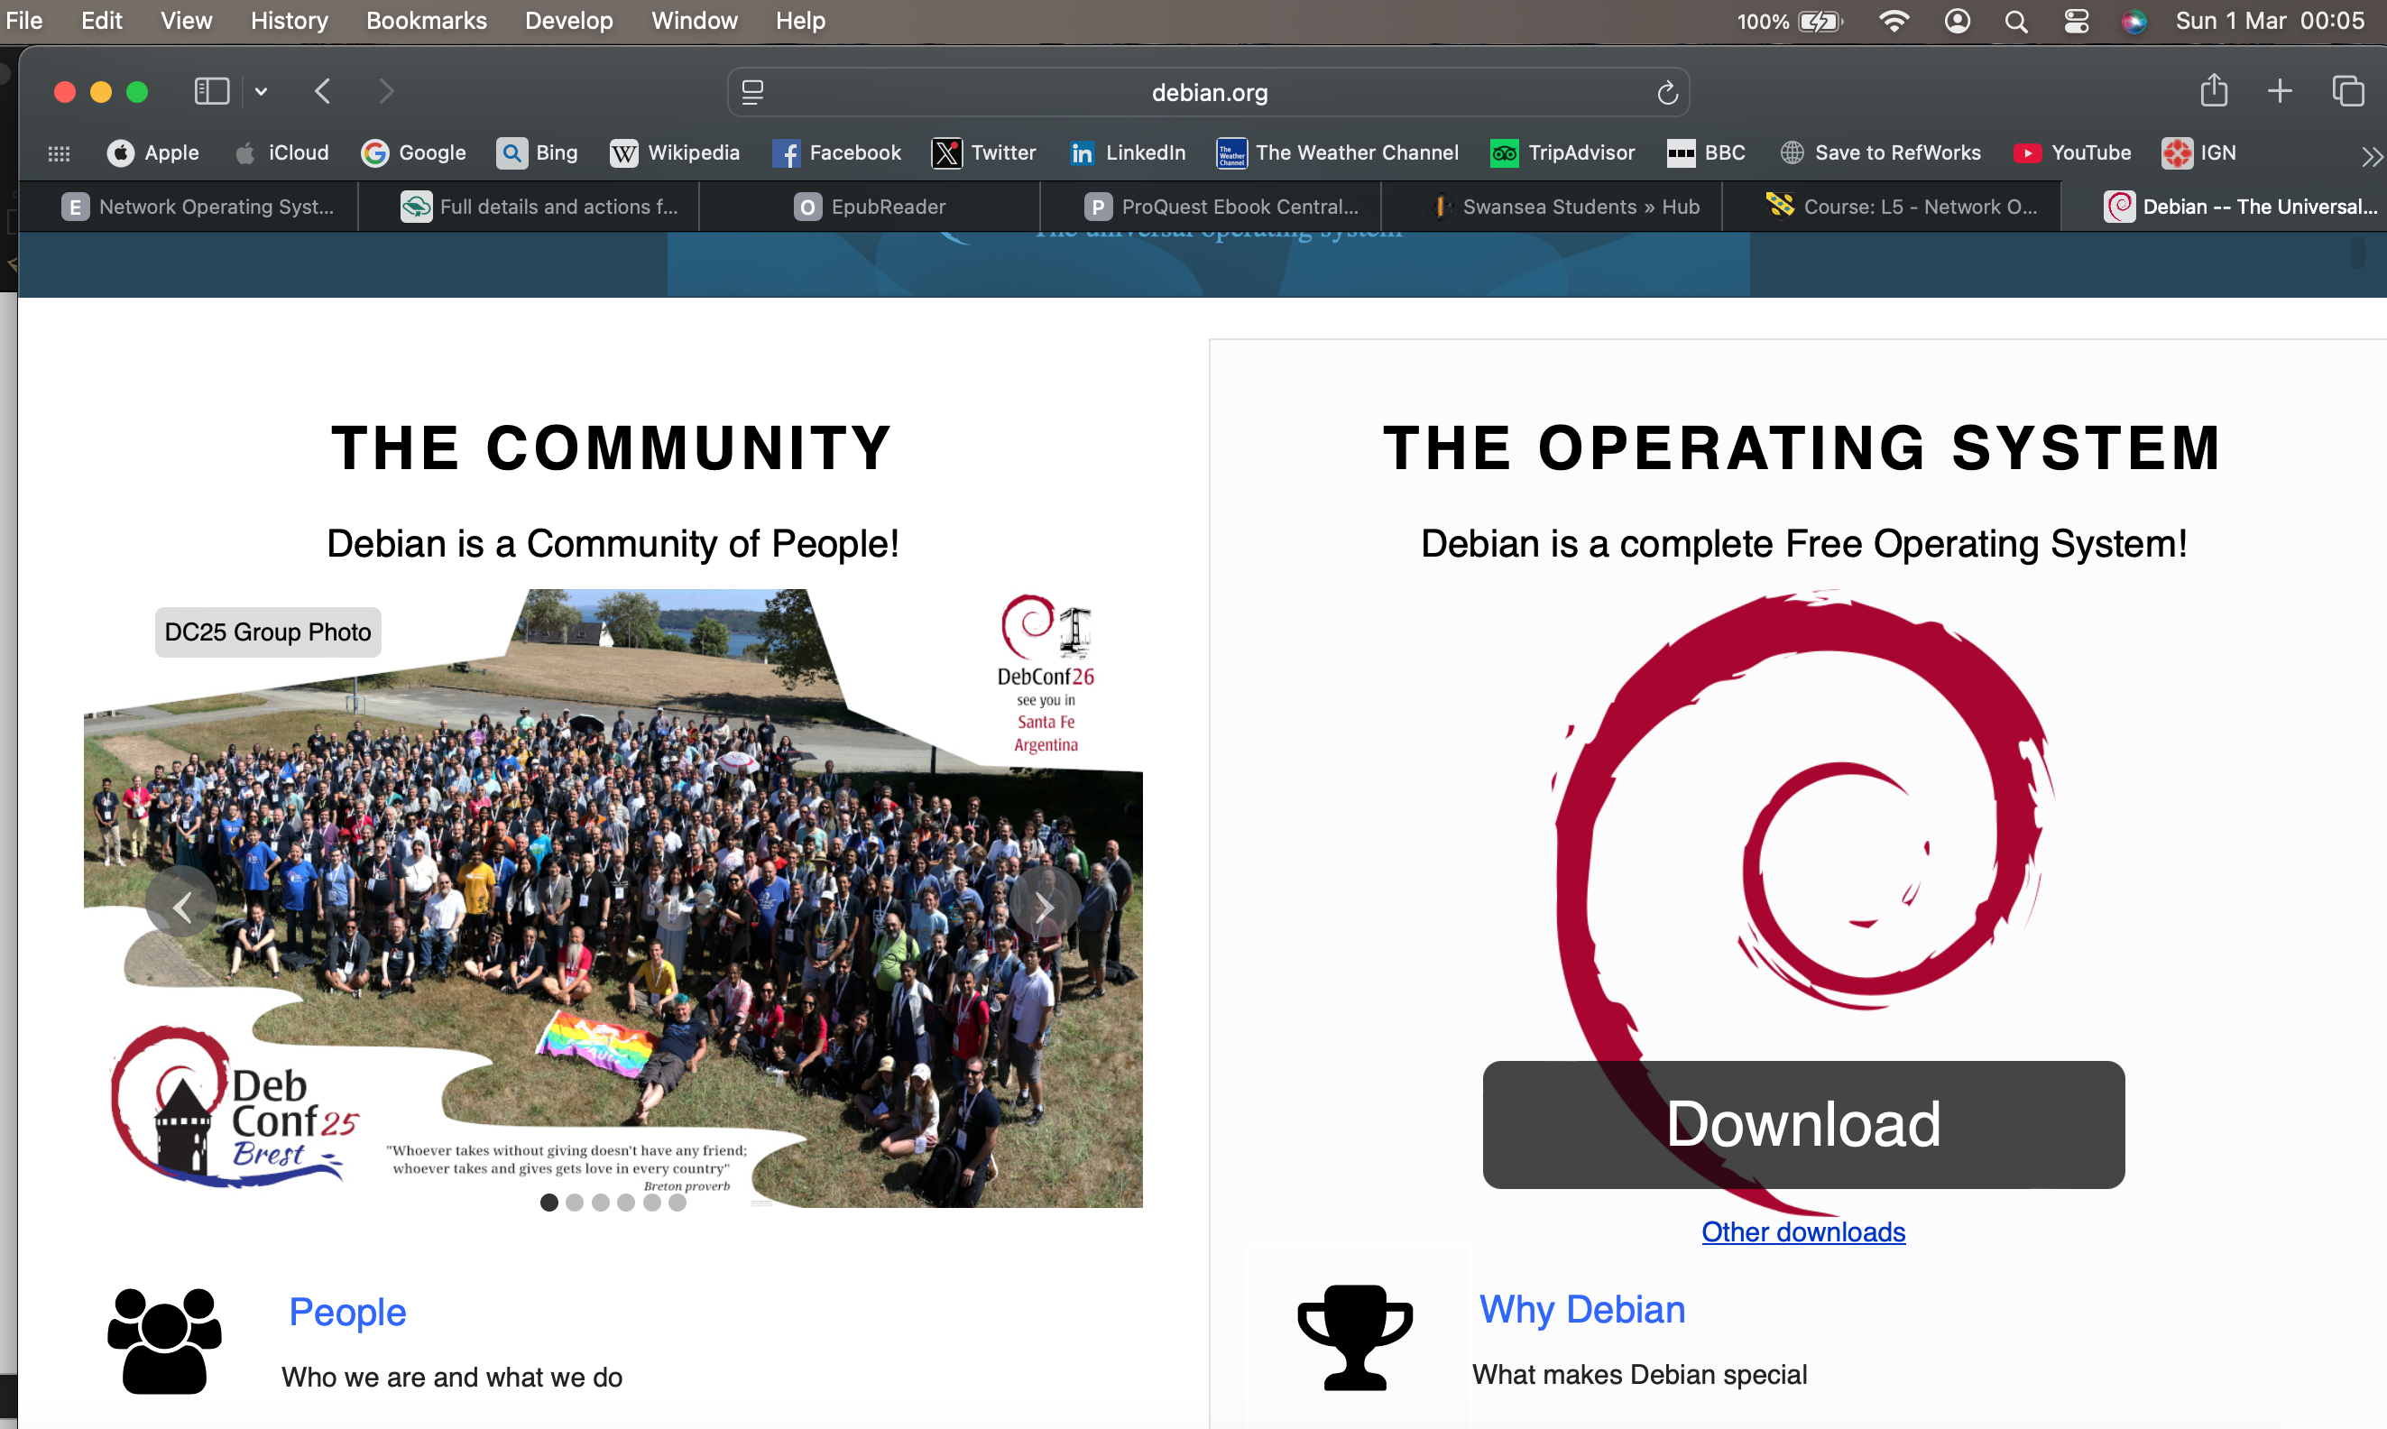

Installation of Windows Server (S-dc)

The Windows Server 2022 virtual machine was configured in alignment with the defined topology and allocated greater computational resources (8GB RAM, 2 CPU cores, 80GB storage) to support its role as domain controller and central service provider.

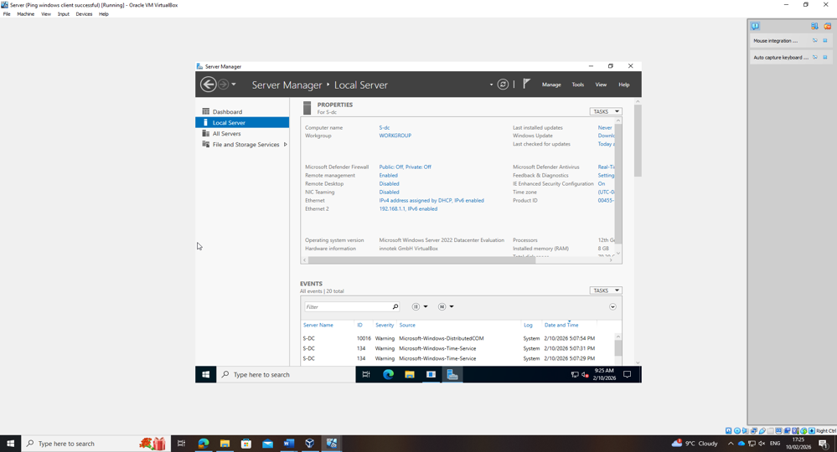
Figure 4: Windows Server (S-dc) configured

Installation of Debian Server (L-cd)

The Debian Server was deployed with reduced resource allocation (2GB RAM, 20GB storage), reflecting its architecture and command-line operation. Host naming conventions align with the topology to maintain structured network documentation.

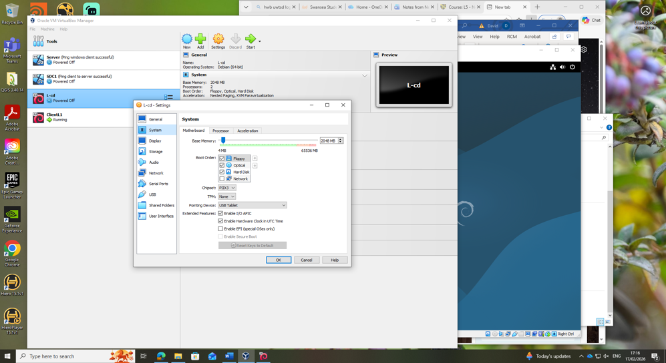
Figure 5: Debian Server (L-cd) configured
External Network Configuration (Inter-Site Link)

The internal virtual networking configuration establishes logical connectivity between Swansea and London subnets. This simulates inter-site routing within a multinational organisation and prepares the environment for subsequent routing and service configuration.

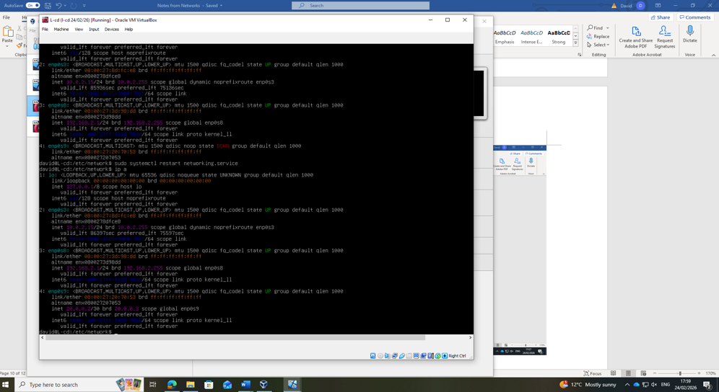
Figure 6: Intext network connecting London to Swansea Servers on enp0s9

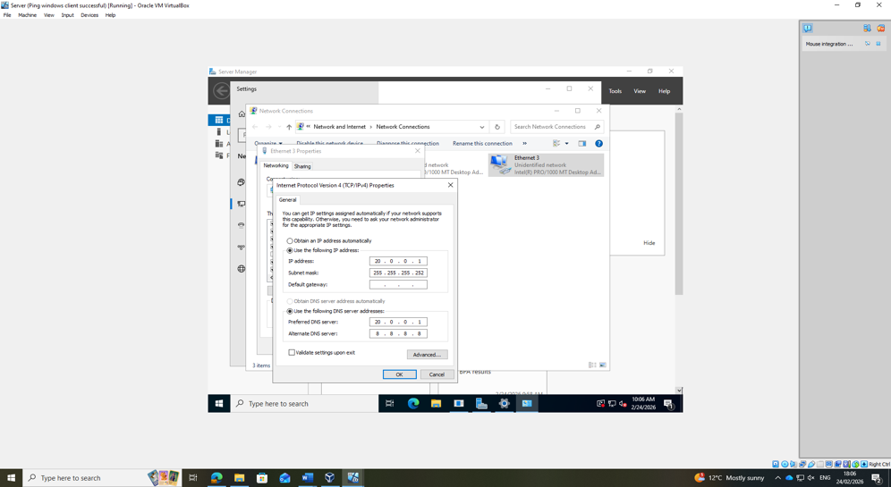
Figure 7: Intext network connecting Swansea to London Servers on ethernet 3

2.3 Configure IP Addressing

Windows Server and Client IP Configuration

Static IP configuration (192.168.1.1/24) was applied to ensure predictable addressing for core services. Assigning the first usable host address to the server reflects standard network design practice, facilitating gateway identification and administrative consistency.

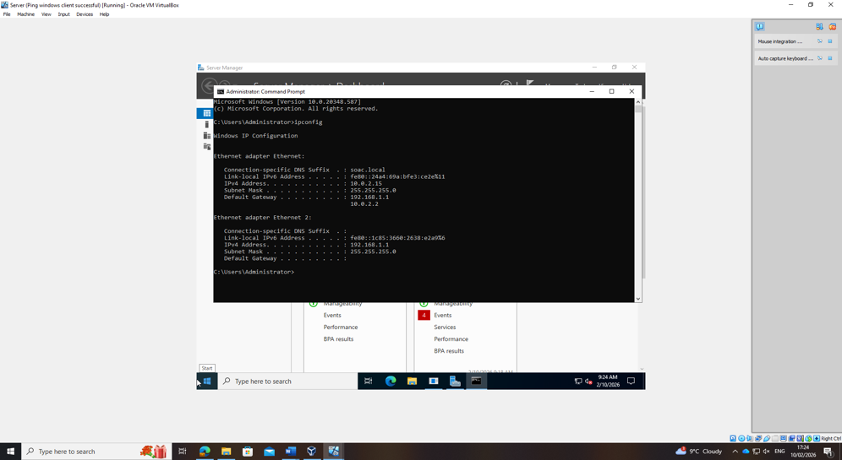
Figure 8: Windows server IP configuration

The client device (192.168.1.10/24) was configured within the same subnet as the server, validating correct subnet allocation and broadcast domain segmentation. Address allocation maintains logical structure within the Swansea network.

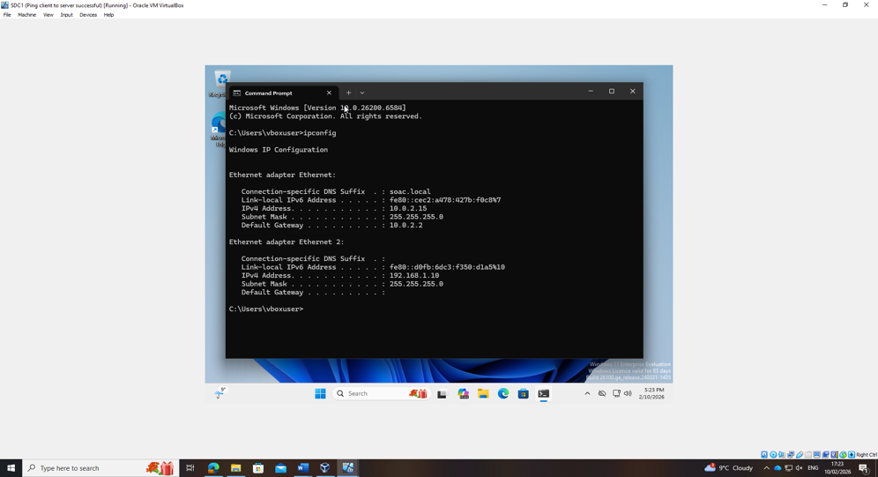
Figure 9: Windows client IP configuration
Debian Server and Client Configuration

The London subnet (192.168.2.0/24) was configured with static addressing for the server (192.168.2.1/24) and client (192.168.2.10/24). Manual persistent configuration on Debian ensures continuity after reboot. The use of separate subnets reflects logical network segmentation between sites.
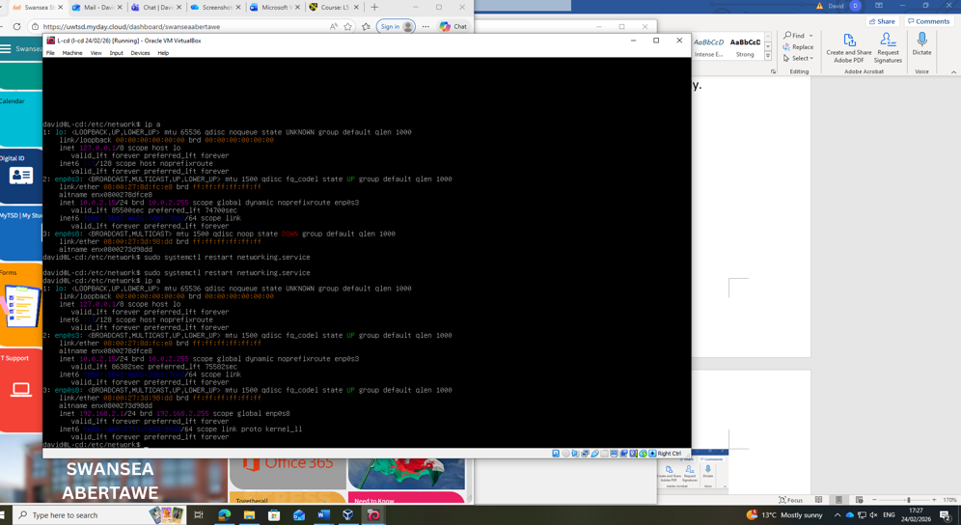
Figure 10: Debian IP configuration

2.4 Testing and troubleshooting

Firewall Troubleshooting

Initial connectivity testing identified failed ping responses due to host firewall restrictions. Controlled disabling of firewall settings for testing purposes enabled verification of connectivity.
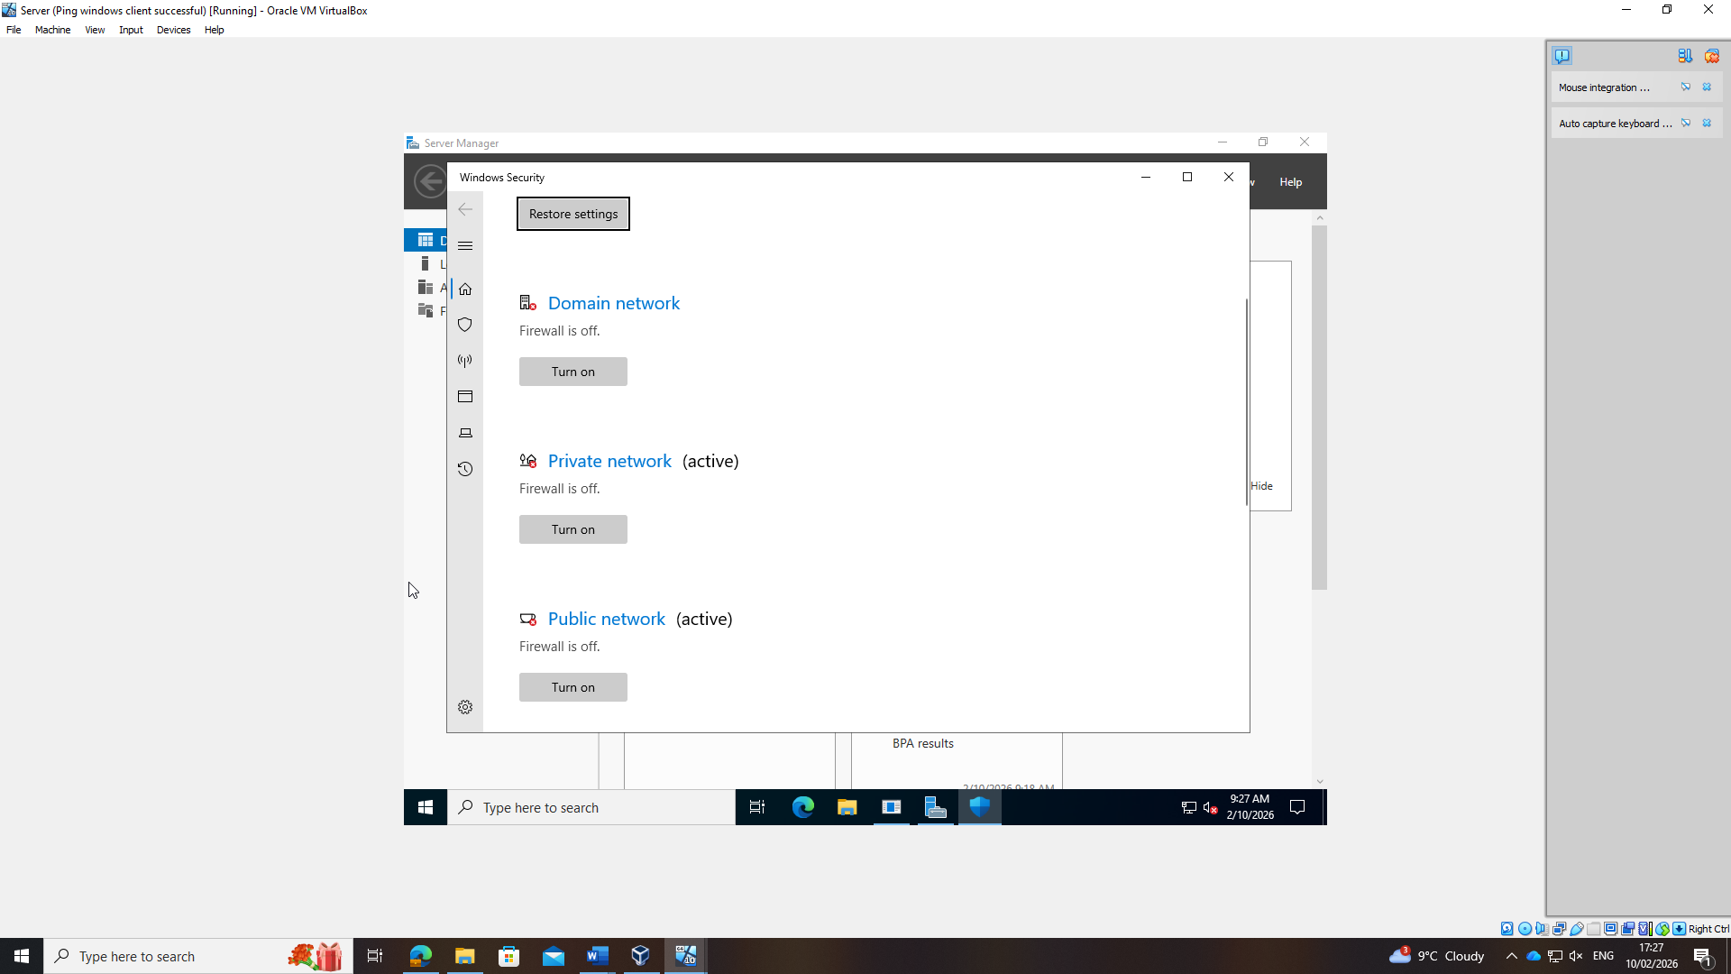
Figure 11: Windows server firewall disabled
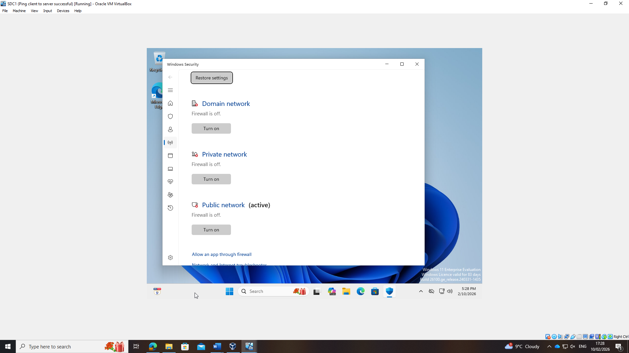
Figure 12: Windows client firewall disabled
Successful Same-Network Connectivity

Successful ICMP echo replies within both Swansea (192.168.1.0/24) and London (192.168.2.0/24) confirm correct subnet configuration and host addressing.

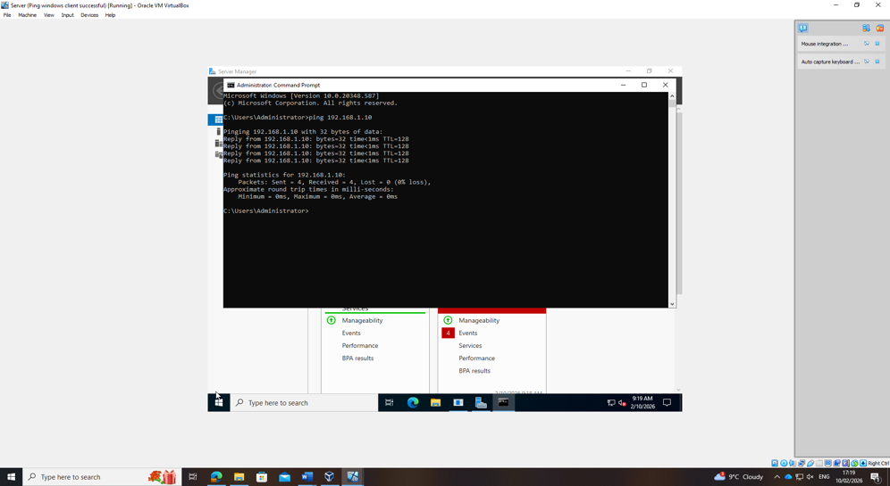
Figure 13: Successful ping from 192.168.1.1 (Windows server) and received by 192.168.1.10 (Windows client)

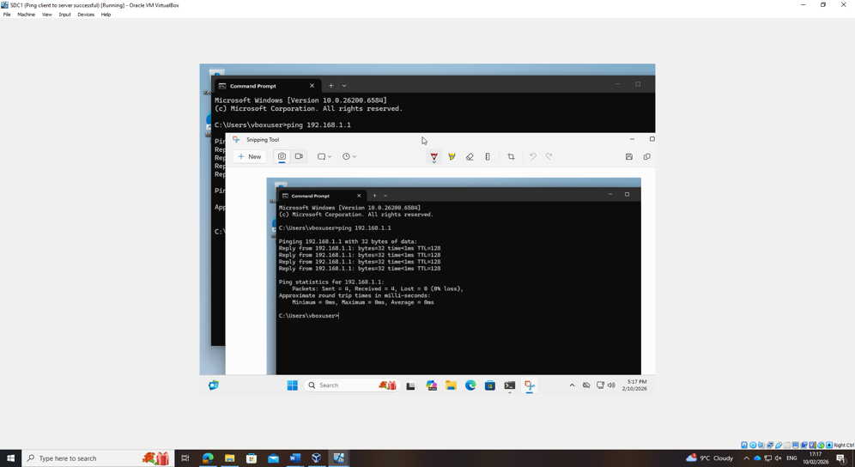
Figure 14:Successful ping from 192.168.1.10 (Windows client) and received by 192.186.1.1 (Windows server)

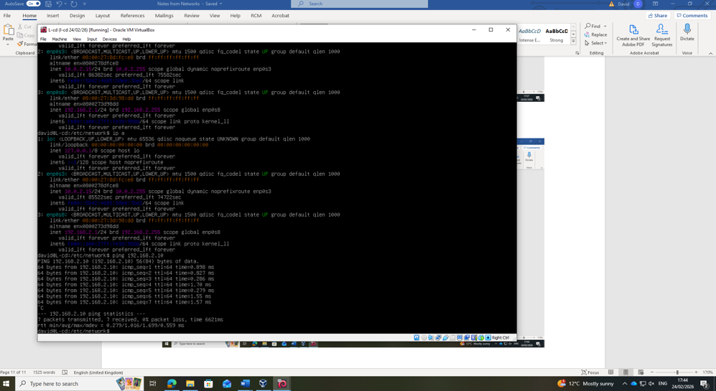
Figure 15: Successful ping from 192.168.2.1 (Debian server) and received by 192.186.2.10 (Debian client)

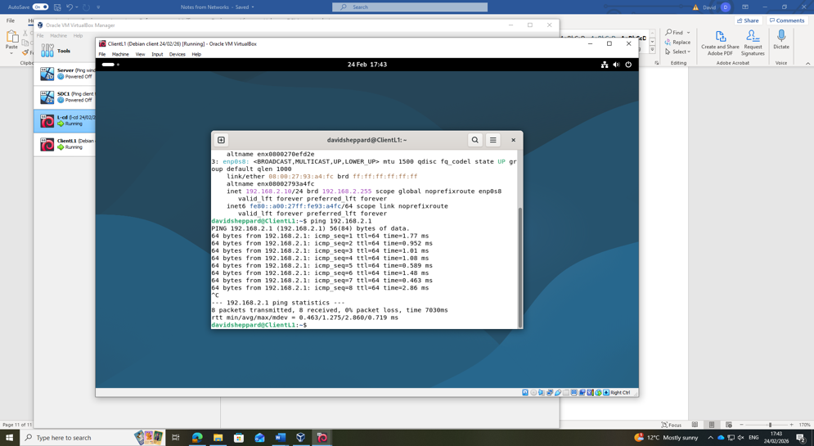
Figure 16: Successful ping from 192.168.2.10 (Debian client) and received by 192.186.2.1 (Debian server)
Inter-Network Connectivity

Successful ping responses between Windows Server (Swansea) and Debian Server (London) confirm that routing between subnets is operational. This validates correct configuration and prepares the topology for subsequent coursework.

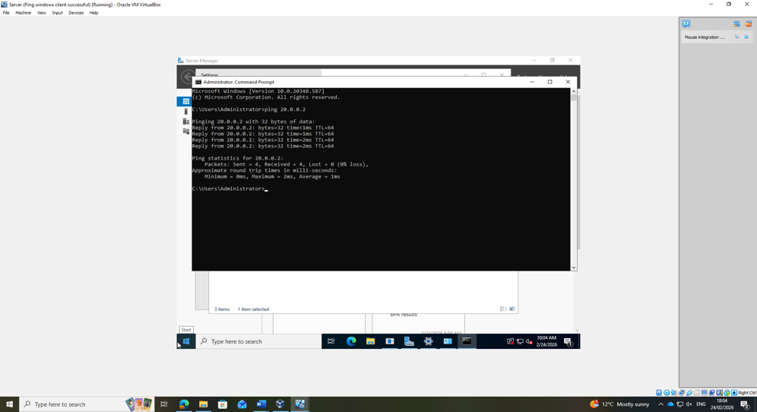
Figure 17: Successful ping from 20.0.0.1 (Windows server) and received by 20.0.0.2 (Debian server)

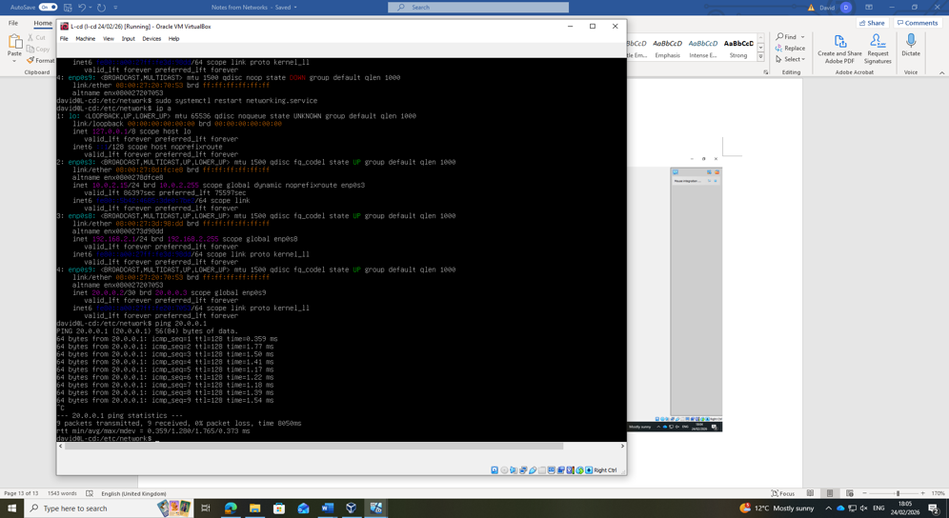
Figure 18: Successful ping from 20.0.0.2 (Debian server) and received by 20.0.0.1 (Windows server)

3.1 Reflection

Technical Reflection – Network Deployment and Testing

Deploying the NOSS2026 topology provided practical insight into configuring and validating a multi-subnet network. Although installation was structured, several issues required troubleshooting.

During initial connectivity testing, ping requests within the same subnet failed. IP configuration was verified using ipconfig and ip addr, confirming correct addressing and subnet masks. Virtual network adapter settings were also checked. The issue was identified as Windows Defender Firewall blocking inbound requests. After temporarily disabling the firewall for testing, connectivity was restored (Figure 11 and Figure 12). This demonstrated the importance of examining security controls before assuming addressing errors.

Ensuring persistent IP configuration on the Debian server was another key consideration. Without manual configuration, settings could revert after reboot, potentially disrupting future services such as DHCP Relay. Updating the configuration files ensured stability of the London subnet.

Testing confirmed successful communication within each subnet and between Swansea and London networks. This validated correct IP allocation, networking configuration, and routing setup. The experience reinforced the value of structured diagnostics, logical sequencing, and verification at each stage of deployment.

Personal Reflection

This task strengthened my understanding of how networking theory translates into practice. Time management improved through staged work evidenced by timestamps. Working across Windows Server and Debian increased my confidence in multi-platform environments and while the command line interface of Linux is new to me, bringing some challenges with navigation and configuration, it was satisfying to learn. Overall, the deployment enhanced my technical skills, troubleshooting ability, and appreciation of planning in preparation for Coursework 2.

Bibliography

[1] | LogicMonitor, “What Is VMware vSphere? vSphere vs. ESXi vs. vCenter,” 1 August 2025. [Online]. Available: https://www.logicmonitor.com/blog/vmware-vsphere-vs-esxi-vs-vcenter. [Accessed 14 February 2026].
[2] | Oracle, “VirtualBox User Manual,” 2024. [Online]. Available: https://docs.oracle.com/en/virtualization/virtualbox/7.0/user/Introduction.html#hostcpurequirements. [Accessed 14 February 2026].
[3] | A. Tanenbaum and H. Bos, “Modern Operating Systems, 4th edition,” New Jersey, Pearson, 2015, pp. 471-516.
[4] | B. Dauti, Windows Server 2022 Administration Fundamentals, Birmingham: Packt Publishing Ltd., 2022.
[5] | Cloudflare, “How does the internet work?,” Cloudflare, 2026. [Online]. Available: https://www.cloudflare.com/en-gb/learning/network-layer/how-does-the-internet-work/. [Accessed 27 January 2026].
[6] | Norton, “What is an IP address and how does it work?,” Norton, 2026. [Online]. Available: https://uk.norton.com/blog/wifi/what-is-an-ip-address?srsltid=AfmBOooOXt0nyVupx_JF8Ak0garspxq5p57-vLgZzp6of1-6tv8eHYaQ. [Accessed 27 January 2026].
[7] | IPXO, “What Is a Subnet Mask? 2024 Updated Guide,” IPXO, 30 July 2025. [Online]. Available: https://www.ipxo.com/blog/what-is-subnet-mask/. [Accessed 1 March 2026].
[8] | Microsoft, “Understand TCP/IP addressing and subnetting basics,” Microsoft, 2026. [Online]. Available: https://www.bbc.co.uk/bitesize/guides/zj88jty/revision/8. [Accessed 27 January 2026].
[9] | BBC Bitesize, “IP addressing,” BBC, 2026. [Online]. Available: https://www.bbc.co.uk/bitesize/guides/zj88jty/revision/8. [Accessed 27 January 2026].
[10] | EBSCO, “Networking: Routing and Switches,” EBSCO, 2026. [Online]. Available: https://www.ebsco.com/research-starters/computer-science/networking-routing-and-switches. [Accessed 10 February 2026].
[11] | W. Stallings, Network Security Essentials: Applications and Standards, 6th edition, Pearson, 2016.
[12] | Microsoft, “DHCP (Dynamic Host Configuration Protocol) Basics,” Microsoft, 2026. [Online]. Available: https://learn.microsoft.com/en-us/windows-server/troubleshoot/dynamic-host-configuration-protocol-basics. [Accessed 10 February 2026].

