

Module Code: ECAD5015

Assignment Title: Deepening Practice
ALN – Part 1 Journal
Student Name: Ava Tench
Student Number: 2203992
BA Primary Education (QTS)

AI Acknowledgement

I confirm that I have not used any AI tools in the research and creation of this assignment.

Targets:
- You must engage with more literature your work to consistently support all viewpoints and demonstrate depth to your knowledge and understanding. | - I will engage with more literature throughout my work and video to support all my viewpoints.
- Continue to develop a critical attitude throughout, offering a contrasting opinion with the literature of both works. | - I will continue to develop a critical attitude throughout, offering a contrasting opinion with the literature of both works.

Intro
During this assignment I will be discussing Dyslexia. In Wales, the legal framework for supporting children and young people with additional learning needs (ALN) is governed by the Additional Learning Needs and Education Tribunal Act (2018). During my recent placement in a Year 3 Welsh classroom, I had the opportunity to deepen my understanding of inclusive practise, particularly in relation to supporting pupils with specific learning difficulties such as Dyslexia. The class included children diagnosed with dyslexia and other additional learning needs such as autism and ADD, this experience significantly shaped my view of what is means to create an inclusive learning environment in primary education. From an ethical standpoint, I have ensured that the identities of all pupils remain anonymous in accordance with the British Educational Research Association (BERA 2024) ethical guidelines. These guidelines stress the importance of safeguarding. According to Peterson and Pennington (2015), dyslexia is considered to have a genetic component. Research has shown that it tends to run in families, suggesting it is hereditary. From their article it states that dyslexia have a strong heritable component, with studies showing a 40-60% chance of a child developing dyslexia if one parent has it.

Inclusive Strategy 1 – Visual
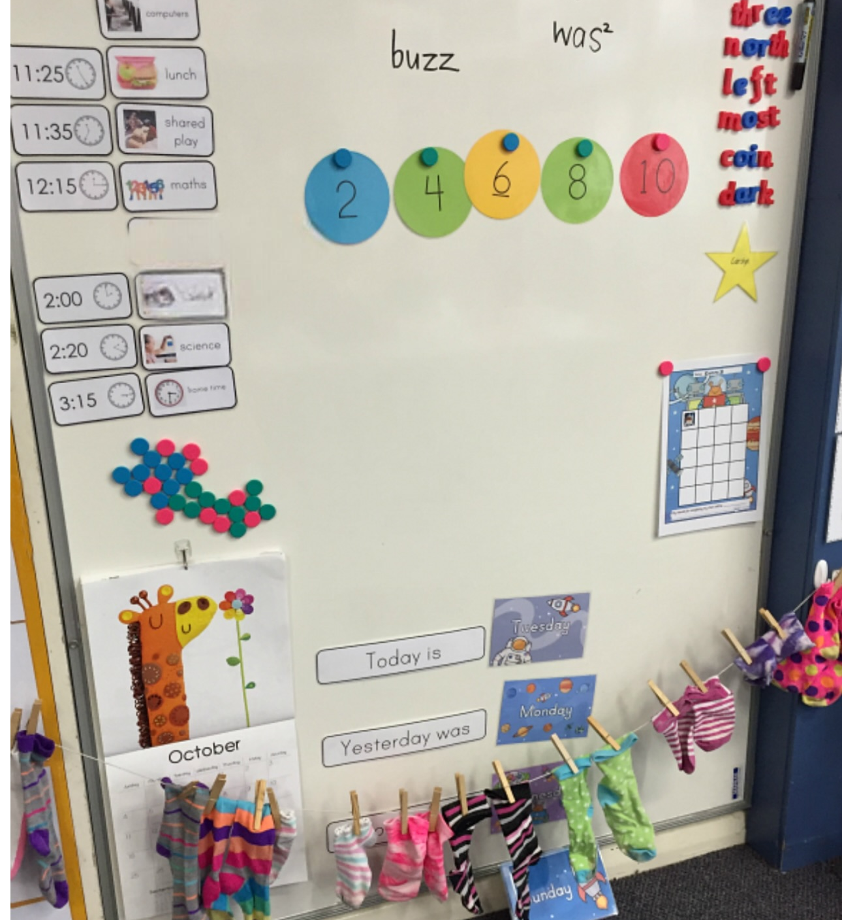
During my placement in a year 3 classroom, I observed a range of inclusive teaching strategies designed to support diverse learners. One of the most consistencies apply strategy was the use of visual supports, which included visual timetables, pictural word banks, labelled displays and story maps. Visual strategies play and play a crucial role in making the learning environment more accessible. For example, one child with dyslexia visibly benefitted from the use of colour-coded word mats, which supported the child’s spelling and vocabulary. In my recent experience on placement, my opinions grew on using colour-coded words mats are an excellent and inclusive resource for supporting pupils with dyslexia and they were available in every classroom, this reflected a strong commitment to accessibility. These mats help reduce cognitive overloads by organising information visually, allowing learners to access key vocabulary. ‘’For students with dyslexia, who may struggle with working memory and information retrieval, the consistent use of colour and layout provides vital visual cues that aid in recognition and recall’’ (Rose 2009). Using visual schedules can also help reduce anxiety that any child may be suffering from by clarifying daily routines and transitions. These approaches reflect recommendations from Mackay (2006), who argues that visual reinforcement supports memory in learners with dyslexia. Clark (2014) emphasises that visual aids can reduce cognitive load, allowing pupils to focus on higher tasks. This example of a visual routine board by Julie Skilling (2020) provides structured, accessible and muilti-sensory ways to process and organize information. Dyslexia primarily affects reading, spelling and information processing so visual tools help bridge these challenges by reducing reliance on text and enhancing memory, focus and understanding. However, these can come with some limitations. In my placement, there were times when some visual strategies were present but not put to good use or too hard or complex for pupils with limited reading skills. This highlights that visual strategies must be carefully matched to pupils’ levels. Additionally, pupils can become over-reliant with visual strategies. As Reid (2016) says, inclusive strategies must balance support with the intention to ensure progression. Over-scaffolding may unintentionally limit dependence (Amy’s Reflections 2016). In conclusion, visual strategies represent a highly practical and inclusive approach to supporting diverse learning, especially those with dyslexia. When used consistently and thoughtfully, they can enhance understanding, reduce anxiety and promote engagement.

I inclusive Strategy 2 – Physical Accessibility
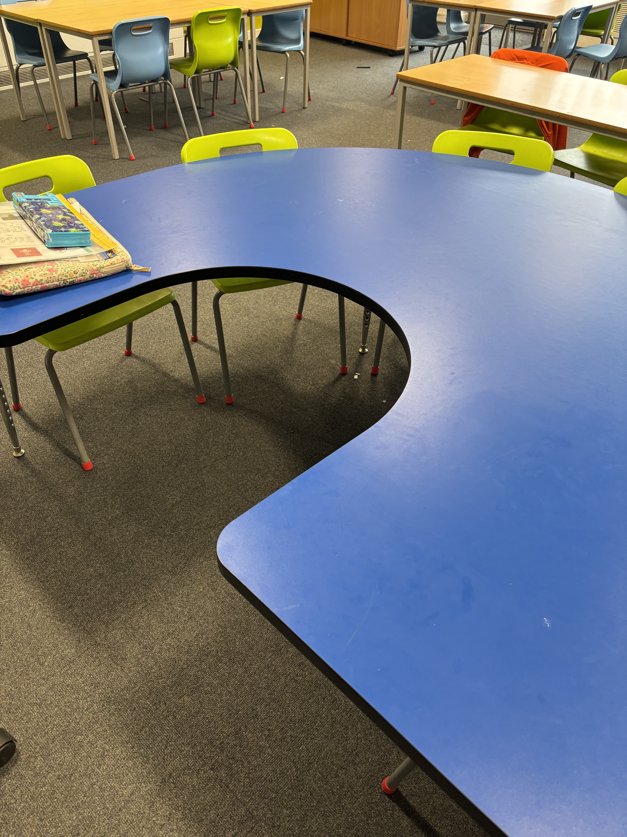
During my placement I observed inclusive practices designed to support pupils with physical disabilities. One pupil in the class was a wheelchair user, and this experience allowed me to reflect on how physical accessibility and inclusive teaching strategies work together to ensure participation for all learners. It is important to have wheelchair and physical disability access in schools because it ensures equal access to education, supports inclusion and upholds the legal and human rights of all students The Equality and Human Rights Commission (2014). One of the most significant adaptations was the physical layout of the classroom. The furniture around the classroom such as the tables were arranged to allow wide, clear pathways, enabling the pupil to move independently. Another key strategy was the adaptation of the classroom routines. For example, activity’s that required access to resources on higher shelves there are alternatives such as lowered resource stations or digital versions of materials were provided. According to the Article 23 of the UNRC (2019), is states that children with disabilities have the right to a full and decent life with dignity and active participation in the community. Even though there is thorough thought for all wheelchair users in the school, there were still some limitations. Firstly, physical access to the whole school was not consistent. While the classroom and school yards were adapted as shown by these images there are big wide doors at the back of every classroom leading on to the yard, however some communal areas such as the main school hall had limited wheelchair access, even though there was a lift however on many occasions it was out of order. This created a barrier to full inclusion. Additionally, inclusive practice depends heavily on staff training and attitudes. As notes by Hodkinson and Vickerman (2009), some educators may lack confidence or knowledge about supporting pupils with physical disabilities, which can limit the effectiveness of inclusion despite good intention. In conclusion supporting a wheelchair user in the primary classroom requires thoughtful planning and environmental adaptations. The strategies I observed during my placement particularly the classroom layout, resource accessibility, and peer support demonstrated a commitment to education. This image taken personally from the school as well as the other images from my placement school demonstrates the thought and effort that has been made to include physical disabilities, for example the wide doors as previously
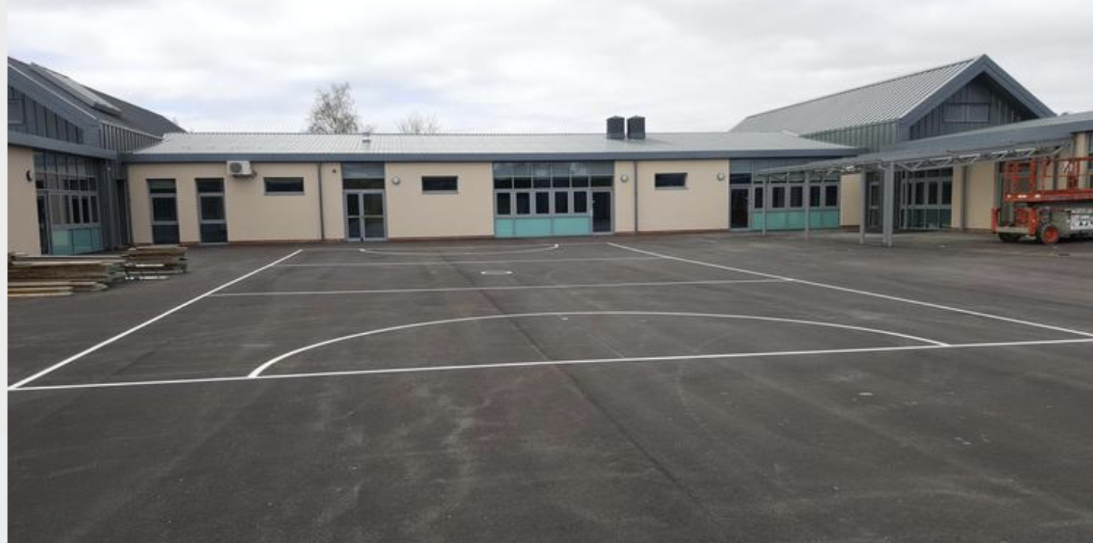
stated that are in every classroom throughout the school as well as in the corridors allowing everyone to be able to leave and enter without any problems and given them free access to the school playing yard.

Conclusion
Being an inclusive practitioner to me in my opinion means actively and intentionally creating an environment where all individuals regardless of their backgrounds, identities, abilities or experiences to make them feel welcomes, respected, supported and able to fully participate. Knowles (2017) advocates for a social model of learning where the focus is on adapting the learning environment to meet the diverse needs of all pupils, rather than expecting students to fit into a one size fits all model. Florian and Black Hawkins (2011) argue that inclusive pedagogy is about extending learning opportunities to all students, rather than planning for the majority while making exceptions for a few and not being fair. Additionally, inclusive practice aligns with legal and ethical responsibilities outlined by frameworks such as the Equality Act 2010, which allows equal access to education for all pupils. Being an inclusive practitioner is about ensuring every learner feels valued, supported and capable of achieving their full potential (Equality and Hyman Right Commission, 2014). In my opinion being a good inclusive practitioner depends on building strong, trusting relationships with all students and families to create a collaborative learning environment. As the Rose Report (2009) highlights in her article in the context of dyslexia, early identification and tailored inclusive interventions are key to enabling full participation and achievement.

Reference List

- Amy’s Reflection, 2018. Reflection on Leadership and Learning.
Available at:
https://reflectionsonleadershipandlearning.com/2015/11/18/over-scaffolding/
[Accessed 15th of May 2025]

- Clark, M. 2014. Inclusive Education: Effective Classroom Practices. London.

- Equality and Human Rights Commission (EHRC). 2014. What equality law means for you as an educator provider.
Available at:
https://www.equalityhumanrights.com/en/publication-download/what-equality-law-means-you-education-provider-schools
[Accessed 15th of May 2025]

- Florian, L., & Black-Hawkins, K. 2011. Exploring inclusive pedagogy. British Educational Research Journal
Available at:
https://doi.org/10.1080/01411926.2010.501096
[Accessed 15th of May 2025]

- HM Government. 2010. Equality Act 2010.
Available at:
https://www.legislation.gov.uk/ukpga/2010/15/contents
[Accessed 15th of May 2025]

- Hodkinson, A., & Vickerman, P. 2009. Key issues in special Educational Needs and Inclusion.
Available at:
https://uk.sagepub.com/en-gb/eur/key-issues-in-special-educational-needs-and-inclusion/book237536
[Accessed 15th of May 2025]

- Knowles, G. 2017. What do we mean by inclusive practice? Supporting inclusive Practice and Ensuring Opportunity is Equal for All. (pp1-10]

- Mackay, N. 2006. Removing Dyslexia as a Barrier to Achievement.

- National Assembly for Wales. 2018. Additonal Learning Needs and Educational Tribunal (Wales) Act.
Available at:
https://www.legislation.gov.uk/anaw/2018/2/contents/enacteden.wikipedia.org
[Accessed 16th of May 2025]

- Peterson, R. L. & Pennington, B.F. 2015. Developmental Dyslexia. Annual review of clinical psychology.
Available at:
https://doi.org/10.1146/annurev-clinpsy-032814-112842
[Accessed 16th of May 2025]

- Reid, G. 2016. Dyslexia. A Practioner’s Handbook. 5th ed.

- Rose, J. 2009. Identifying and Teaching Children and Young People with Dyslexia and Literacy Difficulties
Available at:
https://dera.ioe.ac.uk/14790/
[Accessed 12th of May 2025]

- Skelling, J. 2020. Supporting children using a visual scheduling tool.
Available at:
https://theeducationhub.org.nz/supporting-autistic-children-using-a-visual-scheduling-tool/
[Accessed 12th of May 2025]

- United Nations. 1989. Convention on the Rights of the Child. Article 23: Children with disabilities.
Available at:
https://www.unicef.org/child-rights-convention/convention-textUNICEF
[Accessed 16th of May 2025]

