
Component 1: Booklet
Perinatal Mental Health in the UK
Module name: Community Care and Management of Long-term Conditions
Module code: LCHS7003
Student Name: Simona Maria Dinu
Student ID: 2229007

Table of contents

- Introduction…………………………………………………………………………………...3
1.1 Understanding Perinatatl Mental Health………………………………………………4
- Common Perinatal Mental Health Conditions……………………………………...……..5
  - Antenatal and Postnatal Depression…………………………………………………..5
  - Perinatal Anxiety Disorders…………………………………………………………….5
  - Perinatal Post-Traumatic Stress Disorder (PTSD)…………………………………..6
  - Postpartum Psychosis………………………………………………………………….7
- The importance of Perinatal Mental Health……………………………………………….8
  - impact on Parents……………………………………………………………………….8
  - Impact on Children………………………………………………………………………8
  - Impact on Partners and Family………………………………………………………...9
- Perinatal Mental Health - Who is at Higher Risk?........................................................9
- Barriers to Seeking Help………………………………………………………………..…10
- How the NHS Support’s Perinatal Mental Health…………………………………….…11
  - GP’s and Midwives…………………………………………………………………….11
  - Health Visitors………………………………………………………………………….11
  - NHS Talking Therapies………………………………………………………………..11
  - Community teams support……………………………………………………………11
  - Medication………………………………………………………………………………11
  - Seeking Urgent Help…………………………………………………………………..11
- Supporting Someone with Mental Health Problems……………………………………12
- Community and Public Health Perspective about Perinatal Mental Health………….12
  - Key Public Health Pillars………………………………………………………………12
- Key Takeaways……………………………………………………………………………..13

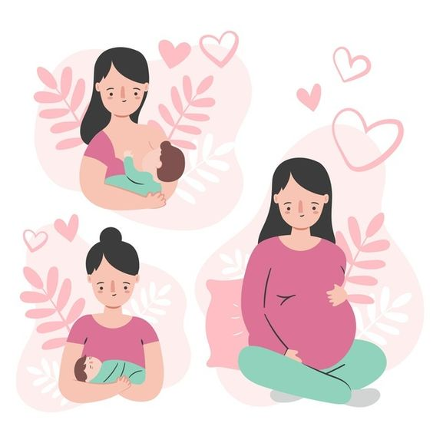
Figure 1. National Day of Maternal and Perinatal Health (AdminSuper9, 2022)

Perinatal Mental Health a Booklet for Mothers

- Introduction
Becoming a parent is often described as one of the happiest moments of life full of love and laugher. However, for so many people, pregnancy and the fist year after birth could bring along emotional battles. Feeling overwhelmed, anxious, low or disconnected during this time is more common than most people realise. (Cake Maternity, 2024).
Perinatal mental health refers to mental health along the pregnancy and the first year after birth (or after the end of pregnancy, either giving birth, having a missed carriage or abortion). It includes emotional well-being as well as conditions like depression, anxiety, post-traumatic stress disorder (PTSD) and more rarely post-partum psychosis. (NICE, 2014).
In the UK, around 1 in 5 women experience a mental health problem during pregnancy or within the first year after giving birth. (Howard et al., 2020; Maternal Mental Health Alliance, 2023). Many other women experience emotional distress during pregnancy or post-partum, but they might not meet diagnostic criteria, but their lives are still affected.
This Booklet has been written for community distribution, and it aims to explain: What perinatal mental health is, who may be at higher risk, how it affects families, where to get help in the UK and how communities can support the recovery.
Perinatal Mental Health problems are real, common and treatable. Seeking support is a sign of strength, not weakness. (Well-being of Women, 2024).


Figure 2. Perinatal Mental Health Resources (Npwh.org., 2024)

  - Understanding Perinatal Mental Health
Perinatal period includes both pregnancy (antenatal period) and the first year after birth (postnatal period). This period involves major physical, hormonal and emotional changes. Sleep disruption, feeding challenges, relationship changes (which could be for better worse), financial pressure and social expectations are all factors which contribute to stress. (NHS England, 2018).
According to Cake Maternity (2024) this period should be a happy time, but while some parents are adapting well to the changes some others experience important mental health problems and these are serious medical conditions not debilities nor failures.
National guidance in the UK recognises perinatal mental health as a key priority because early support can prevent long-term difficulties for parents and children. (NICE, 2014).


Figure 3. Perinatal Mental Health (NHS Wales Performance and Improvement, 2020).

- Common Perinatal Mental Health Conditions

2.1 Antenatal and Postnatal Depression
Depression during pregnancy or after birth is more then feeling “a bit down”. Symptoms may include persistent sadness or tearfulness, feeling numb or empty, loss of interest in usual activities, extreme fatigue, sleep problems (beyond normal newborn disruptions), feeling worthless or guilty, difficulty bonding with the baby or partner, thoughts of self-harm. The “baby blues are common in the first two weeks after birth and usually pass quickly. Postnatal depression lasts longer and is more intense. (NHS, 2022).

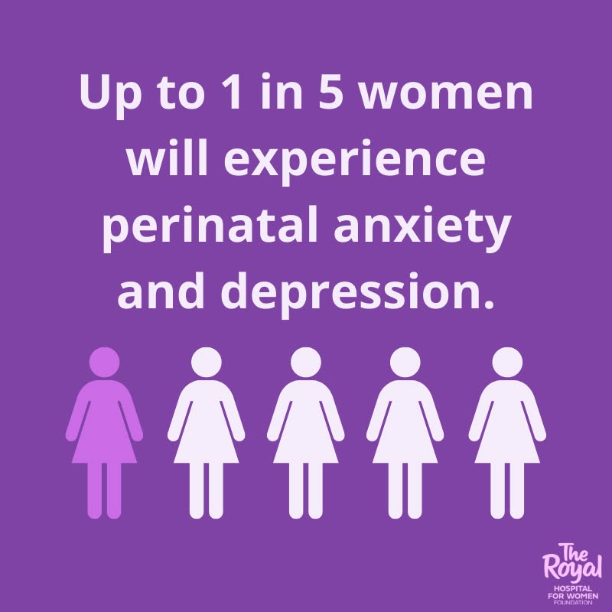
Figure 5. Perinatal Mental Health (lifeline.org.au., 2022)

2.2 Perinatal Anxiety Disorders
According to Anxiety UK Organisation (2026) it is normal for parents to experience anxiety (constant worry, racing thoughts, panic attacks , obsessive fear that something will happen to the baby or themselves) during pregnancy or after birth though these signs of worry for the newborn or themselves should ease after a while and if not, these could be clear sings of anxiety disorder.

  - Perinatal Post-Traumatic Stress Disorder (PTSD)
Mind Organisation (2024) explains that PTSD is a mental health illness caused by childbirth, affecting about 4% of the mothers.
PTSD can develop after a traumatic birth, emergency procedures, feeling unheard or unsafe during labour or previous trauma that is re-triggered. Symptoms include flashbacks, nightmares, avoidance of reminders and feeling constantly on the edge. (Slade et al., 2017).

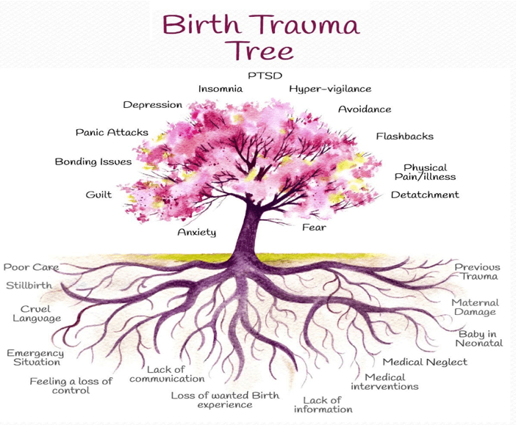
Figure 6. Birth Trauma Tree. (Altic, 2019
  - Postpartum Psychosis
Postpartum psychosis is rare but serious illness and even if it affects a small number of women, is a medical emergency. Symptoms may include severe confusion, hearing or seeing things other cannot, unusual beliefs, not sleeping for several days, sudden mood swings. It usually develops within the first two weeks after birth and requires urgent specialist care. (Royal College of Psychiatrists, 2018).

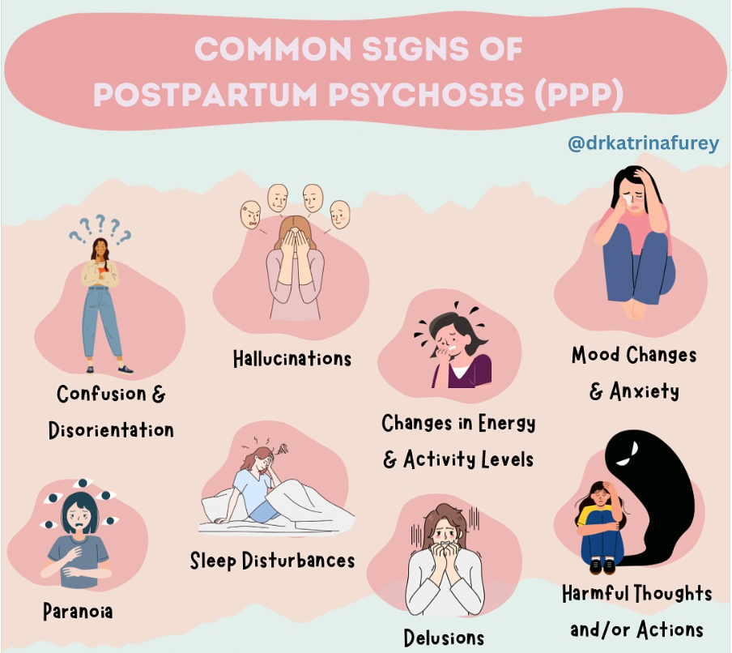
Figure 7. Postpartum Psychosis (Instagram, 2017).
3. The importance of Perinatal Mental Health
3.1 impact on Parents
Untreated mental illness can affect daily functioning, physical health, relationship and safety. In the UK mental health-related causes remain one of the leading causes of maternal death in the year after pregnancy (MBRRACE-UK, 2024).

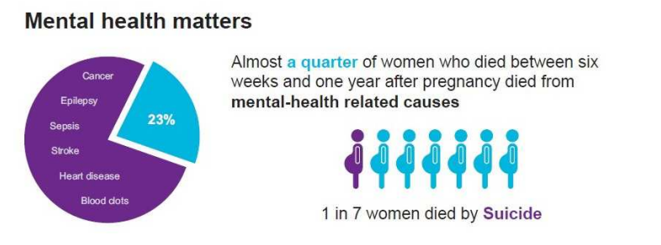
Figure 8. Infographic Maternal Rate (Lewisham Observatory, 2018)

3.2 Impact on Children
Research shows that ongoing severe maternal depression can affect child emotional and behavioural development (Stein et al., 2014). However, most children do well if they benefit of early help support risks are significantly reduced. Positive relationships and treatment make a difference.

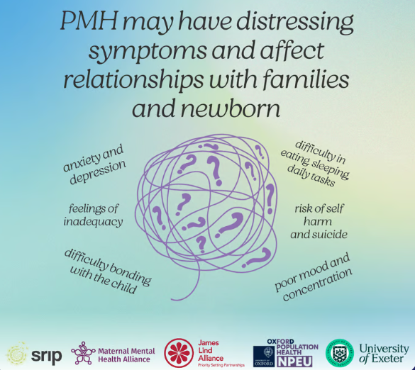
Figure 9. Perinatal Mental Health Priorities (Perinatal Mental Health JLA, 2025)

3.3 Impact on Partners and Family
Partners can also experience depression and anxiety. Changes in roles, finances and sleep can increase stress across the household. Although no father death related to perinatal illness are recorded, lately the risks are increasing because of depression and anxiety around this period. Also, co-parents or other categories like LGBT could face mental health in perinatal period because of different stress factors and stigmatisation. Help will be needed for this category to be provided together with the mothers in order to decrease the incidence. (Darwin et al., 2021).

- Perinatal Mental Health - Who is at Higher Risk?
Anyone can experience perinatal mental health problems. However, risk increases if someone has previous mental health conditions, has experienced trauma or abuse, is facing financial difficulties, has housing troubles, has little support or none, if experiencing domestic abuse, or if has had a difficult birth.
Health inequality research revealed that poverty and disadvantage increase mental health risk. (Marmot et al., 2020).

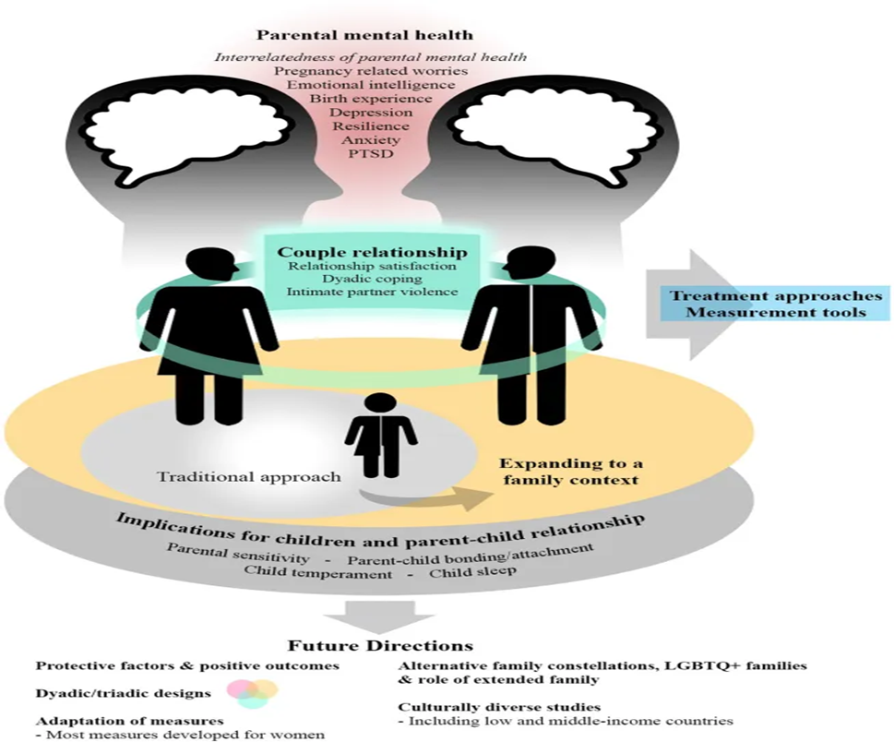
Figure 10. Perinatal mental Health. The impact on the Family. (Garthus-Niegel, Benyamini and Horsch, 2021).

- Barriers to Seeking Help
Many people delay seeking help because they feel ashamed (stigma and self-stigma), believe they should cope alone, worrying about social services involvement (fear of being judged as a “bad parent”), believe they should cope alone, financial barriers, lack of time, wrong approach (delayed referrals or to the wrong service, wrong medication), breast feeding pressure, domestic abuse, do not recognise symptoms. (Wood, 2021).

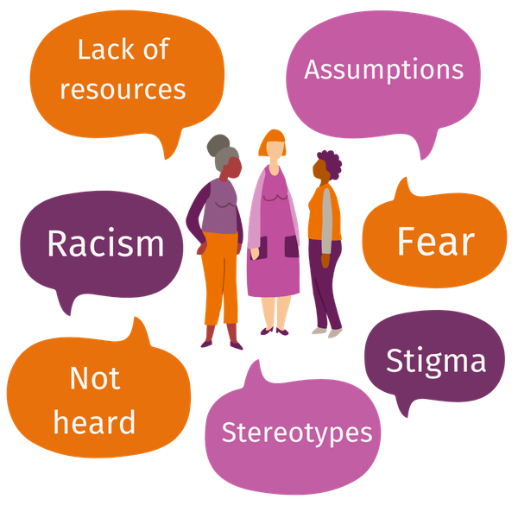

Figure 11. Barriers to accessing services (Maternal Mental Health Alliance, 2023)

- How the NHS Support’s Perinatal Mental Health
The National Health Service assists perinatal mental Health thru the pregnancy and postnatal up to one year using a range of specialist’s support (community team, GP’s, midwives and health visitors). Among the services are talking therapies like CBT (Cognitive Behavioural Therapy), antidepressants or intense care for difficult cases (NHS, 2022).
  - GP’s and Midwives: the professional staff which assess symptoms, make referrals and offer treatment during pregnancy and after birth (NHS, 2022).
  - Health Visitors: they regularly ask about the mental health during the prenatal period and offer support. (NHS, 2022).
  - NHS Talking Therapies: free psychological therapy like CBT services for anxiety and depression during pregnancy and after birth, (NHS England, 2023).
  - Community teams support: available across the England for mothers with moderate or complex mental health needs providing targeted care. (NHS, 2022).
  - Mother and Baby Units (MBU’s): special hospital units where mother and babies stay together if inpatient treatment is required. (NICE, 2014).
  - Medication: in some cases, antidepressants or other medications may be needed to support mothers needs but they are thoughtfully prescribed during pregnancy and breastfeeding by GP’s and other professionals. (NICE, 2014).
  - Seeking Urgent Help: if someone has a drastically change’s behaviour, has no sleep for days, talks about harming themselves or the baby or even having suicidal thoughts. Call NHS 111 (press 2 for mental health) or call 999 in a emergency. (NHS, 2021).


Figure 12. Untitled (Gstatic.com, 2026)
- Supporting Someone with Mental Health Problems
People with mental health problem face emergency situation such as feeling suicidal or take reality through them on filters. It is important to maintain calm in order to make sure they do not harm themselves or the others and making sure they get the professional help they need. Helping them could mean so little as listening to them with empathy and letting them know you are there for them (asking open end questions, asking how can you help them, letting them know they are not judged because they face a difficult time and they are not excluded because they are at struggle, because this is a hard time but there is so much help available to be accessed in order to overpass these difficult times). (Mental Health Foundation, 2022).

- Community and Public Health Perspective about Perinatal Mental Health
From this perspective PMH is not just personal concern affecting the mother and impacting the child further development, it is a community and Public Health issue which battles against this issue focusing on early help, prevention, and integrated care in order to mitigate further expansion of this matter. (Public Health England, 2019).
  - Key Public Health Pillars: supporting families early (“The fist 1001 day”), social determinant of health (domestic abuse, addressing poverty, housing instability and inequalities, reducing stigma), integrated care models (adding routine check-ups into maternity, primary care and maternity for more easy to access help and reducing the long-tern impact on families, communities and public system). (Public Health England, 2019).
The Marmot review emphasises that reducing inequalities improves mental health outcomes. (Marmot et al., 2020).
Investments in Perinatal Mental Health benefits society, with long-term economic savings. (Bauer and Parsonage, 2022).

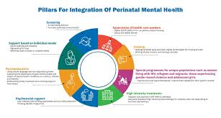
Figure 13. Pillars for Integration of Perinatal Mental Health (Manolova et al., 2022)
- Key Takeaways
One in five women experience a perinatal mental health, but this doesn’t make they are bad parents or failure. (Manolova et al., 2022).
Integration of perinatal mental health care into maternal and child health services:
- Several factors weigh down integration, factors like staff shortage and excess of work, stigma preventing lack, deficiency of research and insufficient cultural adaptation. (Manolova et al., 2022).
- Practical step-by-step guidance on perinatal mental health care can make integration more reachable. (Manolova et al., 2022).
- You Are Not Alone: Perinatal mental health conditions are common and treatable.
- Seek Help Early: Speak to a GP, midwife, or health visitor immediately if you are struggling. (Royal College of Psychiatrists, 2019).
- Treatment is Available: Support options include therapy, medication, and specialized perinatal services. (Royal College of Psychiatrists, 2019).
- Safety First: Having frightening thoughts (about harming yourself or the baby) are symptom of illness, it does not mean you will but is an indicator you will, but you look for help. (Royal College of Psychiatrists, 2019).
- Impact on Baby: Untreated, these conditions can affect the child’s development, making early intervention vital. (Royal College of Psychiatrists, 2019).
- Not Just for Mothers: Partners can also experience perinatal mental health challenges. (Royal College of Psychiatrists, 2019).
- Avoid Self-Medicating: Do not use alcohol, cigarettes, or drugs to cope, because all of these are harmful for you and your child. (Royal College of Psychiatrists, 2019).
No one should suffer in silence, if you are struggling seek help, call 111 or in emergency call 999, or if you feel you cannot call yourself let someone kin to you know and make that call!

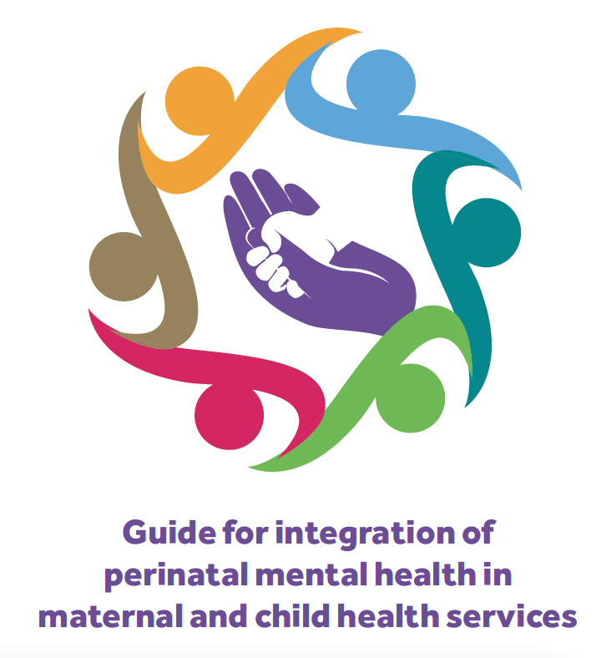Figure 14. Guide for integration of Perinatal mental health. (Anon, n.d.)
References

AdminSuper9 (2022). Secretaría de Salud conmemora el Día Nacional de la Salud Materna y Perinatal | Super9 TV. Super9.com.mx. Available at: https://super9.com.mx/2022/05/08/secretaria-de-salud-conmemora-el-dia-nacional-de-la-salud-materna-y-perinatal/. (Accessed 26 Feb. 2026).
Altic, L. (2019). Healing Birth and other Perinatal Trauma - All About Birth. All About Birth. Available at: https://allaboutbirth.co.uk/2019/10/healing-birth-and-other-perinatal-trauma/. (Accessed 27 Feb. 2026).
Anon, (n.d.). WHO guide for integration of perinatal mental health in maternal and child health services – MHPSS Knowledge Hub. Available at: https://mhpssknowledgehub.sph.cuny.edu/resourcehub/who-guide-for-integration-of-perinatal-mental-health-in-maternal-and-child-health-services/. (Accessed: 03 Mar. 2026).
Anxiety UK. (n.d.). Perinatal Anxiety. Available at: https://www.anxietyuk.org.uk/anxiety-type/perinatal-anxiety/. (Accessed: 27 Feb. 2026).
Bauer, A., Garman, E., Besada, D., Field, S., Knapp, M. and Honikman, S. (2022). Costs of common perinatal mental health problems in South Africa. Global Mental Health, pp.1–10. doi:https://doi.org/10.1017/gmh.2022.48. (Accessed: 03 Mar. 2026).
Cake Maternity (2024). How Motherhood Changed My Outlook on Life | Cake Maternity. Available at: https://www.cakematernity.com/blog/how-motherhood-changed-me. (Accessed: 26 Feb. 2026).
Darwin et al. (2021). Assessing the Mental Health of Fathers, Other Co-parents, and Partners in the Perinatal Period: Mixed Methods Evidence Synthesis. Frontiers in Psychiatry, 11(11). doi:https://doi.org/10.3389/fpsyt.2020.585479. (Accessed: 28 Feb. 2026).
Garthus-Niegel, S., Benyamini, Y. and Horsch, A. (2021). Editorial: Perinatal Mental Health: Expanding the Focus to the Family Context. Frontiers in Psychiatry, 12. doi:https://doi.org/10.3389/fpsyt.2021.719053. (Accessed: 28 Feb. 2026).
Gstatic.com. (2026). Available at: https://encrypted-tbn0.gstatic.com/images?q=tbn:ANd9GcTRwFwWVdL7Vbxh7U1vU0xtEI5dayh49CcONA&s. (Accessed 02 Mar. 2026).
Howard, L.M. and Khalifeh, H. (2020). Perinatal mental health: A review of progress and challenges. World Psychiatry, 19(3). doi:https://doi.org/10.1002/wps.20769. (Accesed: 26 Feb. 2026).
Instagram (2017) Postpartum Psychosis. Available at: https://www.instagram.com/p/DJK8ZMiS5z7/. (Accessed 27 Feb. 2026).
lifeline.org.au (2022) | Facebook. Available at: https://www.facebook.com/royalhospitalforwomenfoundation/photos/a.422703934420725/5345269702164099/?type=3. (Accessed: 27 Feb. 2026).
Manolova, G., Waqas, A., Chowdhary, N., Salisbury, T.T. and Dua, T. (2022). Analysis. Can integration address perinatal mental health neglect? p.12. Available at: https://www.bmj.com/sites/default/files/attachments/bmj-article/pre-pub-history/bmj-2022-073343_proof_hi.pdf. (Accessed 3 Mar. 2026).
Marmot et al. (2020). Health Equity in England: The Marmot Review 10 Years on. The Health Foundation. Available at: https://www.health.org.uk/reports-and-analysis/reports/health-equity-in-england-the-marmot-review-10-years-on-0. (Accessed: 03 Mar. 2026).
Maternal Mental Health Alliance (2023). Barriers to accessing services | Maternal Mental Health Alliance. maternalmentalhealthalliance.org. Available at: https://maternalmentalhealthalliance.org/amv-toolkit/breaking-barriers/access-perinatal-mental-health-services/barriers/. (Accessed: 28 Feb. 2026).
Maternal Mental Health Alliance (2023). Specialist perinatal mental health care in the UK 2023. Available at: https://maternalmentalhealthalliance.org/media/filer_public/9a/51/9a513115-1d26-408a-9c85-f3442cc3cb2b/mmha-specialist-perinatal-mental-health-services-uk-maps-2023.pdf. (Accessed: 26 Feb. 2026).
MBRRACE-UK (2024). Saving Lives, Improving Mothers’ Care 2024 - Lessons learned to inform maternity care from the UK and Ireland Confidential Enquiries into Maternal Deaths and Morbidity 2020-22 | MBRRACE-UK | NPEU. Ox.ac.uk. Available at: https://www.npeu.ox.ac.uk/mbrrace-uk/reports/maternal-reports/maternal-report-2020-2022. (Accessed: 28 Feb. 2026).
Mental Health Foundation (2022). How to Support Someone with a Mental Health Problem. www.mentalhealth.org.uk. Available at: https://www.mentalhealth.org.uk/explore-mental-health/articles/how-support-someone-mental-health-problem. (Accessed: 02 Mar. 2026).
Mental Health Foundation (2022). How to Support Someone with a Mental Health Problem. www.mentalhealth.org.uk. Available at: https://www.mentalhealth.org.uk/explore-mental-health/articles/how-support-someone-mental-health-problem. (03. Mar. 2026).
Mind (2024). PTSD and birth trauma. www.mind.org.uk. Available at: https://www.mind.org.uk/information-support/types-of-mental-health-problems/postnatal-depression-and-perinatal-mental-health/ptsd-and-birth-trauma/. (Accessed: 27 Feb. 2026).
NHS (2021). Where to Get Urgent Help for Mental Health. NHS. Available at: https://www.nhs.uk/nhs-services/mental-health-services/where-to-get-urgent-help-for-mental-health/. (Accessed: 02 Mar. 2026).
NHS (2022). Postnatal Depression. NHS. Available at: https://www.nhs.uk/mental-health/conditions/post-natal-depression/overview/. (Accessed: 27 Feb. 2026).
NHS (2022). Treatment - Postnatal depression. nhs.uk. Available at: https://www.nhs.uk/mental-health/conditions/post-natal-depression/treatment/. (Accessed: 02 Mar. 2026).
NHS England (2018). Perinatal mental health. England.nhs.uk. Available at: https://www.england.nhs.uk/mental-health/perinatal/. (accessed: 27 Feb. 2026).
NHS England (2023). NHS talking therapies, for anxiety and depression. www.england.nhs.uk. Available at: https://www.england.nhs.uk/mental-health/adults/nhs-talking-therapies/. (Accessed: 02 Mar. 2026).
NHS Wales Performance and Improvement (2020). Perinatal Mental Health. [online] Available at: https://performanceandimprovement.nhs.wales/functions/strategic-programme-for-mental-health/perinatal-mental-health/. (accessed: 27 Feb. 2026).
NICE (2014). Antenatal and Postnatal Mental Health (CG192). Available at: https://www.nice.org.uk/guidance/cg192/resources/antenatal-and-postnatal-mental-health-clinical-management-and-service-guidance-35109869806789. (Accessed: 02 Mar. 2026).
Npwh.org. (2026). Perinatal Mental Health Resources. Available at: https://npwh.org/page/Perinatal-Mental-Health-Resources. (Accessed 26 Feb. 2026).
Perinatal Mental Health JLA. (2025). Perinatal Mental Health Research Priorities. Available at: https://prioritiseperinatal.co.uk/. (Accessed 02 Mar. 2026).
Public Health England (2019). Perinatal Mental Health. GOV.uk. Available at: https://www.gov.uk/government/publications/better-mental-health-jsna-toolkit/4-perinatal-mental-health. (Accessed: 03 Mar. 2026).
Royal College of Psychiatrists (2018). Postpartum Psychosis | Royal College of Psychiatrists. www.rcpsych.ac.uk. Available at: https://www.rcpsych.ac.uk/mental-health/mental-illnesses-and-mental-health-problems/postpartum-psychosis. (Accessed: 27 Feb. 2026).
Royal College of Psychiatrists (2019). What are Perinatal Mental Health Services? [online] RC PSYCH ROYAL COLLEGE OF PSYCHIATRISTS. Available at: https://www.rcpsych.ac.uk/mental-health/treatments-and-wellbeing/what-are-perinatal-mental-health-services. (Accessed: 03 Mar. 2026).
Slade, P.et al. (2017). A Woman Afraid of Becoming Pregnant Again: Posttraumatic Stress Disorder Following Childbirth. Bio-Psycho-Social Obstetrics and Gynecology, pp.33–49. doi:https://doi.org/10.1007/978-3-319-40404-2_2.
Stein. et al. (2014). Effects of perinatal mental disorders on the fetus and child. The Lancet, 384(9956), pp.1800–1819. doi:https://doi.org/10.1016/s0140-6736(14)61277-0. (Accessed: 28 Feb. 2026).
Wellbeing of Women (2024). Maternal mental health: ‘It’s a sign of strength to ask for help’ - Wellbeing of Women. Wellbeing of Women. Available at: https://www.wellbeingofwomen.org.uk/news/maternal-mental-health-its-a-sign-of-strength-to-ask-for-help/. (Accessed 26 Feb. 2026).
Williams, C. and Patel, S. (2018). Maternal Mental Health JSNA and Action Plan (24 04 18). Available at: https://www.observatory.lewisham.gov.uk/wp-content/uploads/2020/10/Maternal-Mental-Health-JSNA-and-Action-Plan-24-04-18.pdf. (Accessed 28 Feb. 2026).
Wood, L. (2021). Understanding the Barriers to Accessing Perinatal Mental Health Services Royal Borough of Greenwich. Available at: https://www.mums-aid.org/wp-content/uploads/2022/06/Understanding-the-Barriers-to-Accessing-Perinatal-Mental-Health-Services.pdf. (Accessed: 28. Feb 2026).

