f

NHS Problem solving and decision making
BMSK4004_Swan

Jahanara Uddin
1704989

Executive Summary
This report will provide a summary of the history of the National Health Service (NHS) Health care and the current situation using the PESTEL framework and what impact it has on their stakeholders. This report will also illustrate the main problems and analyse solutions using the interest power grid and other diagrams.

Contents
Executive Summary 1
Introduction 3
Main body 4
Conclusion and recommendation. 15
Reference 16

Introduction

National Health Service (NHS) healthcare was established in the early years of 1948 by the health secretary Aneurin Bevan from the labour party in Manchester in park hospital today known as Trafford general hospital. Mr Beven wanted to give everyone a chance to good health care. Kingdom (UK). “Although all four nations run their own system independently today by their countries government, not by the Westminster or Whitehall, the treasury and the parliament in London play vital role in the NHS healthcare service budget.” (According to Dayan M published 10.04.2014). Mr Bevan wanted to create a healthcare for everyone the wealth did not matter. Aneurin Bevan based the healthcare on the following three points
- That it meets every need
- It was free at the point of delivery
- The treatment was based on medical need not the ability to pay
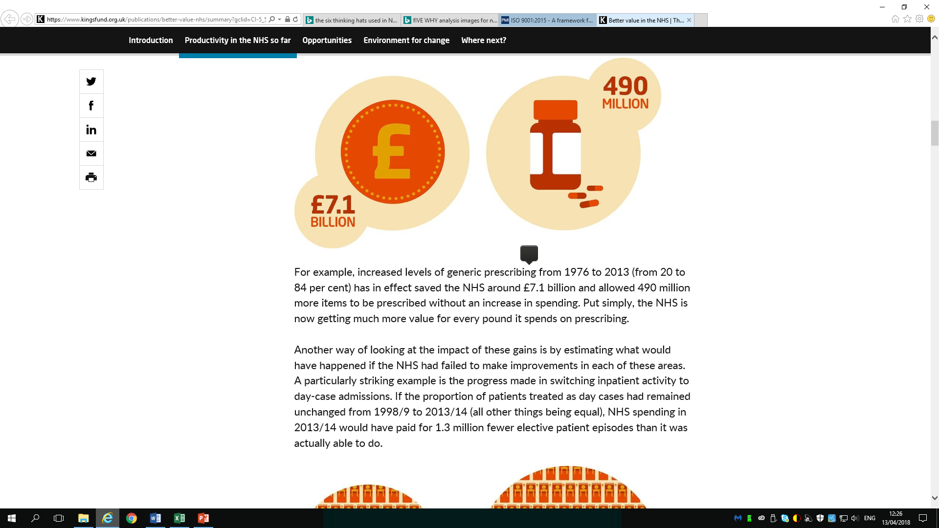

All the four nations had the free healthcare prescription until 1949 the power to change in NHS Healthcare Act Amendment was introduced. The conservative government wanted the patient to pay for the prescription having the exemptions for children, war disability and pensioners. England is the only nation of the United Kingdom (UK), where patients have to pay for the prescription. In 2007 Wales abolished the charge the prescription and after three years in 2010 Northern Ireland followed. Later Scotland joined in abolishing the charge for prescription in 2011. Nation health service is 70 years old in the UK, and it is our precious and most important asset for individuals’ healthcare. The NHS is always researching way to improve and introduce something new to improve people’s health. In the 1960 the very first kidney transplant took place in Scotland. This was a success and it was a alternative to a regular dialysis, which meant it saved money and time in the long run. Ongoing research helped a person have a worlds first test tube baby in 1978, the baby called Louise Brown. There innovation of new research and technology help introduce MRI scan in in 1980, which is a very high scan of the bones, soft tissue of the body and brain. With all the positive like NHS ORGAN Donor which launched in 1994 and in 2000 introduced robotic arm, in 2007 in St Marys hospital London the robotic arm undertook heart operation. There is a major negative problems like the funding started when there was changed to the NHS structure, like who makes decision and how the money is spen and so on.

Main body
The day to day running and operation of the healthcare in the four nations are perfectly well at present. The GP (general practice) and the A & E (Accident and Emergency) departments in hospitals and shortage of beds in some departments.
There are many reasons for the pressure on the NHS here are some of the issues.
The people of the UK are living longer because of the advanced research and use of technology to research medication and treatments, which is a positive however it is also putting pressure on the NHS because individuals may have medical condition like diabetes, heart or liver problems where you need on-going medicines and treatment and care.
Individual lifestyles are important because healthy diet will keep your health and the NHS out of problems and save money and time however people consuming alcohol, smoking and poor diet increases health problems like being overweight issues along with heart, liver problems and other illness like cancer.
Medical Advancement like new researches of medicines or operation , treatment is a very positive to individuals as it saves lots of lives. However it puts a lot of pressure on the NHS costing £10bn a year.

Accidents and emergency departments are having increasing pressure on them because patients are not getting appointments at the GP surgery therefore patients do not know where to go for medical advice. Most patients’ visits are unavoidable and are inconsistent of long term health conditions. All of the issues and other problems has an impact on the stakeholders.
The health care NHS has a duty and by law in certain situation the patient’s insolvent and decision about their health needs to be discussed when planning any treatment. Knowing the stakeholder are vital because the NHS might not know something so insolvent of networks and legal bodies is vital. incase the organisation needs to call to or need to engage and pull through together.
All major organisations have stakeholders which are in two parts, internal and external. They are indirectly or directly involved and it effects them whatever the results be positive or negative. Internal stakeholders are the individuals directly involved in the organisation being the employee, manager, board of directors or the investor who have a concern and an interest. The external stakeholders are not directly involved in the organisation but have an interest because they are the suppliers, regulators and the consumers. Within the stakeholders, internal and external are the people or groups with great investment or power who need to invest more of their time in maintaining their involvement and commitment to the organisation.
The following diagram is a matrix to identify stakeholders’ influences and importance. There are a list of nine Cs listed below.
- Commissioners, who pay the organisation to undertake jobs
- Customers are the individuals who buy or use any product or services.
- Collaborators are the propel the organisation works with to produce and deliver products or services
- Contributors are those organisation get the rehouse from
- Channel are the agents who provide the organisation the customers
- Commentators those whose options of the organisation are heard by consumers
- Consumers are those who use the services like customers , patients
- Champions are those will belive and wuill promote a product
- Competitors are those working in a similar organisation giving a similar service.
High power | Satisfy  Opinion formers. Keep them satisfied with what is happening and review your analysis of their position regularly. | Manage  Key stakeholders who should be fully engaged through full communication and consultation.
Low power | Monitor  This group may be ignored if time and resources are stretched. | Inform  Patients often fall into this category. It may be helpful to take steps to increase their influence by organising them into groups or taking active consultative work.

High power | Chief executive  Finance director  BMA rep | Consultant medical staff  Clinical coding manager  Finance creditor staff  Medical director  Primary Care Trust  Clinical governance lead
Low power | Medical records staff  Medical secretaries | Clinical coding staff  Clinical audit  Junior doctors  IT systems manager
 | Low impact/stake-holding | High impact/stake-holding

The National Health Service is facing a lot of problems and challenges in majority of the sectors The stakeholders of the Nation Health Service are very important whether it is internal or external. The stakeholder all get affected by any problems and need to look at ways to adjust and adapt.
- The internal stakeholders are as follows for the NHS
- Authority
- Leadership, health intelligence
- Procurement
- Director of nursing
- Public health manager
- Trustee, board , committee members
- Directors of programs
- Research scientist
- staff
External Stakeholders in NHS
- Local authority/ council
- Provides
- A cute trust
- Patients
- Customers
- Suppliers
- Funders
- Special interest groups
- Health visitors
- Wider public
- Health work force
- media

Any issues with in PESTEL Framework all sectors are affected as they are linked. The Framework helps to analyse and also helps to identify problems, find ways to resolve the issue and find solutions. It helps to understand what is going on in your organisation or whatever field you are working. PESTEL is divided in to six main factors the letters stand for (Political, economic, social, technological, environmental and legal) (processpolicy. com NHS, 2018). If there is a problem in any of the sectors, it will affect all the sector in some way indirectly or directly. The PESTEL is a breakdown to help organisations identify and rectify problems.

Political relates to the issues from the government and pressures and opportunities identified and what impact on the public. The health and social secretary for NHS UK is Jeremy Hunt who is responsible for the work of the department of health and social care .NHS is facing a very challenging time because if the politician from all parties have not managed to provide the funding for the health and social care. The NHS as a whole is staging to meet demands of patients, with the continuing bad weather from 2017 to 2018 winter crisis has had an effect on delaying routine appointments of patients to free beds for those ill from bad weather. Those types of problems effect all within the organisation like the health care because that means more staff are needed and time which means money.
Economic relates to the day to day of finance for any organisation like exchange rates, economy growth or decline inflation and interest rates, cost of living and import and export. It doesn’t matter what kind of organisation or business throughout history, every sector had some form of government indolent, the goals of government have been to protect individuals and the organization or the business, society and the economy as a whole.
According to the Guardian.com.uk Jeremy Hunt the health secretary is trying to increase funding for the NHS even if it means members of the public will need to higher taxes. To be able to manage the health care the funding will need to come from the tax system and also through then growth in the economy. Mr Hunt also said he wants ten year funding settlement for health and investment in technology, research as well as it systems and equipment which will improve the service to patients and save money because of the technology less time will be needed. Funding and finance according to kingfund.com,NHS,2018 the exit from the EU increase the cost of medicines and drugs and that will also have an effect on our public spending, people will have less money to spend. The NHS is already snugging with the existing funding this will impact on the economic instability.
Economically the NHS has always been top priority to the government to do everything they can in be cost effective as well as efficient. In trying to move care for patients in to GP s and other health care centre means closer of hospital departments in some areas less convenient to patients and a major problem to the income of the hospitals.
Social relates to the impact on society, in the NHS there has been a major issues after deciding to leave the EU. There are a number of issues the following show some. After the Brexit the movement of NHS staff will be hard to recruit and retain permanent staff. The EU policy of freedom of movement meant the NHS could recruit staff from any EU countries n currently the NHS has 55,000 of the NHS 1.3 million workforce and 80,000 of the 1.3 million workers in the adult social care sector. Until the UK extracts from its obligation under EU treaties the policy on the freedom of movement remain unchanged. Accessing treatment here and abroad at the moment the people from the EU country who live in the UK and British nationals get free health care with the NHS. There are concern because of brexit British nationals like the pensioners or whoever works will return from EU countries and that will also have an effect on the UK health and social care.

Technology is a very important factor as it is a growing innovation to research and products which allows to save money on services and maintaining organisations. The NHS is one of the largest health care organisation in the world employing a variety of people from all background countries. Technology is a must have tool in the organisation which help day to day running of the service, failure to the health care service will be decided by the outcome of the digital technology. The technology has helped researched and produce new health products. The NHS itself has used fax to communicate from doctors to nurses and other health professionals, unlike other aspects of live people life as transformed by NHS technology from travel or communication in the health care not many people use the internet to contact a doctor. The technology helps the health care to save patients private information securely saved and by law it can’t be shred to any one not linked with the health profession.

Legal issues are directly from the laws and regulations from the government. It is vital to all organisation to obey and to keep updated with the laws and regulations. There are various legislation like health and safety regulations, money laundering, tax and consumer protection and many more. Business and all individuals have to obey the laws and keep them self-updated with any changes The NHS There are a number of legislation like Health and social care act 2012 , Equality Act 2010 and there are lots more. There are legislation for the patients to complain about any issues, however most patients are happy with the NHS services..

Environment - Every organisation no matter what service or product they sell or provide need to be responsible for the environment and the contribution of the cleaning. NHS is very concerned about the environment as it directly effects the patients and staff as well as the public. There are number of things the NHS does to have a clean environment and a healthy one to. The NHS plants trees in and around the hospitals and has special cleaning staff to clean the wards and uses disposable, surgical equipment, so that nothing is effected by germs and no harm is caused to the environment. This help the patient because the diseases are not spread. The NHS also measures the carbon footprint..
The government has new approaches to save the NHS, they are investing £8bn in funding by 2020 was said by Simon Stevens. There will reduce social care budget hoever will slightly increase mental health budget. The government is trying to reduce waiting time in A&E by keeping GP practice to be open 7days aeek and try to give appointment with in 48 hours to over 75 year olds.
In the 1950 s japannase professor Kaurou I shikawa was the first person to descried the cause of a problem using a diagram known as a fishbone analysis. It is became key diagnostic tool for analysing and illustration problems with root cause (lallery 2011) The fishbone is a template to analyse the problem and working out solutions, the fishbone also helps and saves time because this method gives everyone the same insight and easy to see and spot any solutions In 2008 NHS institution for innovation and improvement) Where staff encouraged to to analyse their mistakes evaluate practice or risks which may or may not occur, The staff are encouraged to use one of the two root cause or fishbone analysis. (Esmail, 2011) Root cause analysis are been used in the health and social cre services more n more now because it the one the quickest ways to improve and identify problems (Pearson 2005) has varies reviews of incidents and events.
The following shows a fishbone example on a waiting time for operation or scans.

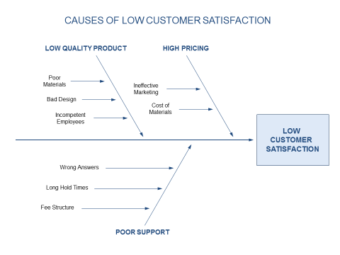

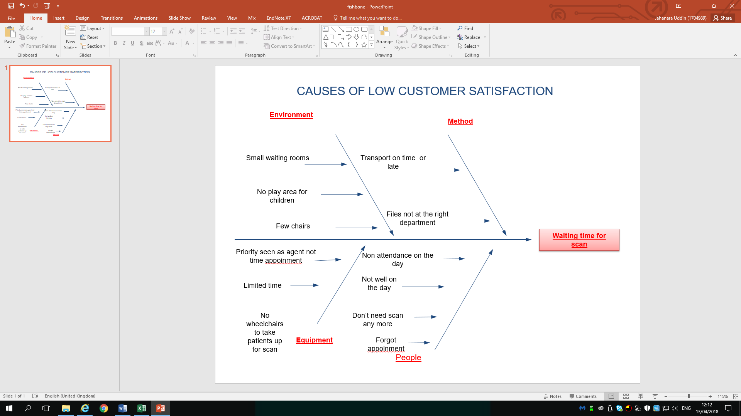

Root cause analysis using five why, more and more organisation are using the five ways root cause analysis. This helps to identify Problems and easily understood by individuals and they can also focus and identify. The following shows a diagram of the five why analysis. The NHS used the fishbone to understand the common problems to the waiting times of any appointments. The health care team or group seat together and write down the problems and possible causes of the problems using the five why root cause.

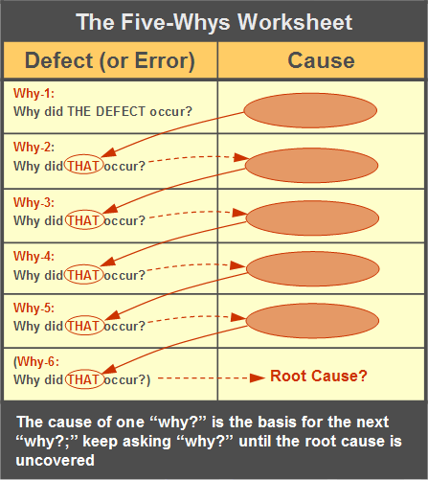

In organisation individuals may have a problem or an idea they want to share, sometimes using root cause analysis is best and quick to understand by everyone in the team or group and find a solution. The individuals or groups may start with a brainstorm. The
brainstorming help gather ideas to find negative or positive or solutions, whatever its used for its called creative thinking, it was introduced in the 1950 s, ii has been around for many years. This brainstorming works if you’re working in a team or as an individual. After completing brainstorm for ideas or a problem to find causes or solutions this help to gather lots of ideas and question you may ask yourself. By repeating the question why and again five times hopefully the solution will be clear or identified. This help most organisation have a visible picture. The five whys might be use in situations like, when patients had to wait for scans? The first out of five whys question might the patient had to wait why, because there a shortage of wheel chairs why. There wasn’t enough wheel chairs why. An agent scan for a patient was need and they need a wheel chair, why and those question in any situation help hopefully help find a solution. Like root cause analysis there are many like the SWOT (strength, weaknesses, opportunities, and threat.) and the six hats.
SWOT is a popular strategy used by individuals and organisation to identify its problems, identify solutions and look for threats and opportunities. The SWOT help individuals and business big or small to pin point problems and prepare and find solutions to improve and look ways to avoid any upcoming problems.
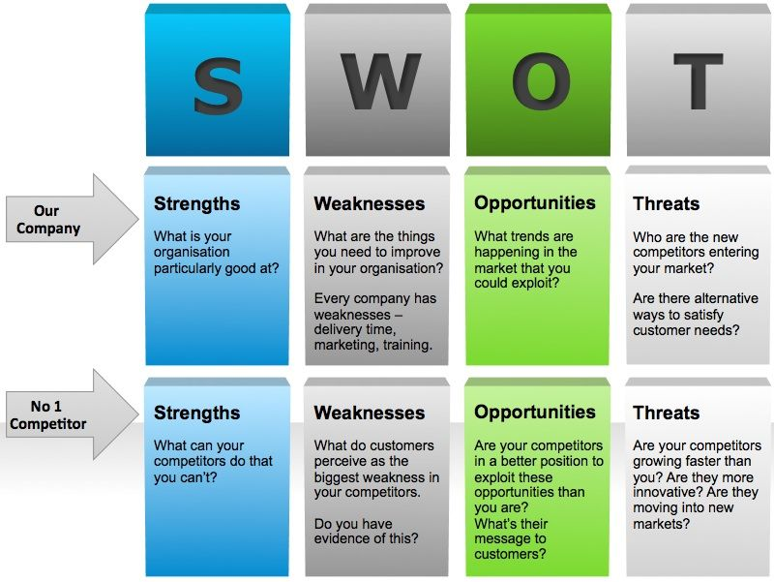

This SWOT analysis is easy to understand and communicate with in any organisation to explain any information to team or business. The healthcare NHS uses the SWOT analysis to prompt managers in clinical leads and it is also;p used for planning or activity future finance, decision making. The NHS strength might be factors which have a positive outcome of clinics objective. The weakness is a negative and a barrier of the clinics objectives. The opportunities are a external factors are likely to help and five ways to exceed the clicks objectives and goals. Threat are a external factor which will effect on achieving the click s objectives. The six hats are used in many organisation to make an improvement to services, this might be when you change ways of thinking to do something, this means thinking up. This may involve taking risks and testing new ideas. The six hat helps to evaluate and look for varies perspectives, this help the individual or the team to move forward with the best idea or solution. The six hats root cause is a simple way to solve issues was created by EDWARD De Bono (2009) based on a principle of parallel thinking. This help individuals with in organisation because this root cause was designed for individuals to think of the same idea in the same direction and same time. For example think about all the positive of the idea together as team and then the negatives at the same time. This help save time and energy because sometimes when you’re thinking from two different directions it is hard to agree on an idea because one is thinking the negative and the other is thinking the positive of the same idea. If everyone is thinking the same at the same time then an idea is understood by everyone and the best is moved on and used. The crater of the six hats thought this is far more effective if everyone wears the six thinking hats at the same time and think. The following shows the six thinking hats.
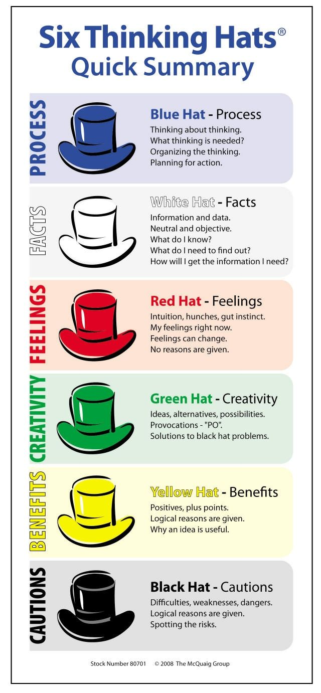

There lots more root causes businesses can use GRID analysis, PMI technique to improve an individuals or an organisation thinking before implanting an idea. The PMI technique is used using plus and minus points, as well as interesting points about the idea or solutions. There are four main steps to the technique.
- THIMK ABOUT THE PLUS POINT
- THINK ABOUT THE MINUS
- CONDIDER THE INTRESTING POINTS
- MAKE DECISION

The organisation then add the score which help to make decision which is quick and easy to process issue or an idea. This is done by creating a chart with three columns.
The following show an example of the PMI FRAMWORK.
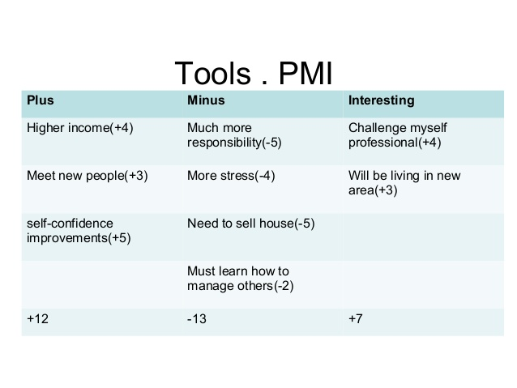

The other popular analysis is the GRID which is used to make decision making easier. There are many names including solution matrix, problem selection grid and lots more.

Conclusion and recommendation.

In conclusion it is very important all the resident of the United Kingdom to be aware of the NHS health care, the current and the future situation. Everyone has a responsibility to protect and help the NHS health care as it is our asset. Understand the current situation of the NHS using PESTEL the root cause analysis helped to breakdown the problem and understand the issues of the problems. It also help to identify solution as an individual or a team. All the root cause like, fishbone, PMI, Five why, brainstorming and the swot, THE Six hat analysis are very different but very efficient tool to use in Most organisation.
I think every politician need to use the six hat root cause analysis to resolve problems, because it will allow everyone to think about a solution s positive or negative as the same time. The internal stake holders need to work together with the external stake holders because any problems with the NHS effects both. The government need to invest more in social care for the aging population so that they can be looked and be helped by local health visitors in the old people’s homes or care homes that will free bed in hospitals for ill people. I also think the GP general practice should open longer hours, because people working after five find it difficult to get appoints to seen by the doctors which mean they ignore the illness which sometimes leads to a bigger problems which cost more. Those issues need to be dealt because that’s increasing the cost of NHS and people also end up in the accident and emergency department. The funding is a major issue as the United Kingdom as come out of the EU, because there are a shortage of staff and it is very expensive. to train and recruits staff from the United kingdom. There are many ways of seating together and working as Whole County to solve problems in our NHS, because it effects everyone. There should be a limit on how many times a week or month patients visit the GP this will allow other people to get an appointment which will reduce the chance of visiting the accident and emergency department. Using and introducing other helping departments within the healthcare like phoning in advice centres or five minute appointment systems will help. The Government need to invest more money on NHS and reduce funding for other projects because third Healthcare is for everyone and so it’s our number one priority.

Reference

https://www.bing.com/search?q=BIZZLEDIZZLE.COM%2FSTRATEGY

https://www.bing.com/search?q=economichelp+healthcare+spending

https://improvement.nhs.uk/resources/six-thinking-hats

Campbell, D, 2016, Nye Bevan's dream: a history of the NHS. Available at: https://www.theguardian.com/society/2016/jan/18/nye-bevan-history-of-nhs-national-health-service
Accessed 2o.02.18

Thursday April 19th 2018
Decision making, 19,04,18
http://mbatools.co.uk/Toolbox/DecisionMaking/gridanalysis.htm
Accessd 22. 04.. 2018

NHS England overcoming the challenges facing problems
www.England ,NHS
Accessed 20.03.18

How are the changes facing the NHS being met https://www.bing.com/search?q=Challenges+facing+the+nhs
Accessed 02.04.2018

Mckenna, H, 2016, five big issues for health and social after the brexit vote. Available at https://www.kingsfund.org.uk/projects/technology-nhs
Accessed 22.02.2018

http://nhsinvolvement.co.uk/Internal stakeholders and External stakeholders
Accessed 19. 02. 2018

An official website of the United States Government https://www.bing.com/search?q=economichelp+healthcare+spending
Acceded 25.02.18

PESPEL Analysis Https://www,processpolicy.com
Accessed 26.02.2018
Https:/www,mindtools,com/ article/newTMC.HTM
Accessed 09.04.2018

