

Title: Strategy Formulation Plan
Nissan Motor Manufacturing UK

Student name: Cecile Abuzour
Student ID: 2218610
Lecturer: Nadeem Mirza
Module Name: Strategic Management and Sustainability
Module code: LCBB6015
Component 2: Report

Contents
1
Executive Summary 3
1. Introduction 4
2. Overview and Background 4
3. Strategic Intent 5
3.1 Vision 5
3.2 Mission 5
3.3 Objectives 6
4 Current Performance 6
5 Strategy Analysis 7
5.1 External Environmental Audit-PESTEL Analysis 7
5.2 External Audit -Porter’s Five Forces 8
5.3 Internal Environmental Audit -Swot Analysis 10
5.4 Internal Audit -VRIO Analysis 10
6 Strategy Formulation 11
6.1 Ev Production Leadership 11
6. 2 Supply Chain Resilience and Localisation 11
6. 3 Circular Economy Battery Hub 12
7 Conclusion and Recommendations 12
8 References 14

Executive Summary
The purpose of this report is to develop a strategy recommendation for Nissan Motor Manufacturing UK (NMUK), Sunderland home of Nissan’s European manufacturing operations. Situated in an increasingly tumultuous automotive landscape of electrification and geopolitical disruption, NMUK faces its parent organization Nissan’s most precarious period in recent history as it books a 670.9 billion net loss for FY2024 (Nissan Motor Co., Ltd., 2025).
To survive as a strategic player within Nissan’s manufacturing landscape moving forward, this report dives into PESTEL, Porter’s Five Forces, SWOT, and VRIO analysis of NMUK and its ecosystem. Findings conclude that NMUK has a key opportunity in the creation of its unique EV36Zero integrated factory system, though serious threats from governmental fines and cheap competition persist. Recommendations outline a Focused Differentiation strategy centered around securing complete portfolio electrification, urgent acceleration of supplier chain robustness, and NMUK positioning itself as the leader of a circular economy battery hub. By following these strategic pillars, NMUK can reinvent itself from just an automobile assembly factory to a sustainable energy and mobility solutions provider.

Introduction
The process of identifying where a business will be headed in the long-term, as well as organising resources and developing abilities to provide the business with a competitive advantage is known as strategic management (Johnson et al., 2023). Weil (1985) emphasises that to execute strategy effectively, a firm must choose a valuable position that is different from competitors and perform activities unlike these rivals. Strategic management is especially critical for NMUK because if the company does not discover a clear strategy, it will not survive (Johnson et al., 2023).
The automotive sector is currently going through a period of significant change. Four major trends are converging to disrupt the century-old industry model: accelerating electrification & digitalisation, increased environmental regulation, and supply chain vulnerabilities (Teece, 2017). Also Teece (2017) explains that in periods of radical change, firms will be able to gain and sustain a competitive advantage if they have ‘dynamic capabilities’. This means they will be able to perceive opportunities and threats, capitalise on them, and adapt their resources to the changing landscape. The framework of ‘dynamic capabilities’ will likely apply to NMUK as it shifts from manufacturing ICE vehicles to EVs.
The aim of this report is to examine the competitive landscape that NMUK finds itself in through well-known frameworks. I will then recommend a strategic planning methodology that allows NMUK to use its unique skills to become Nissan’s leading European EV manufacturer, and distance itself from Uncar’s financial difficulties.

Overview and Background
Nissan Motor Manufacturing UK is a subsidiary company of Japanese multinational automobile manufacturer Nissan Motor Company Ltd. Established in 1933 as Japan's first personalised car manufacturing company, Nissan Motor Company Ltd. is based in Yokohama. Nissan Motor Manufacturing UK (NMUK) was formed after Nissan signed an agreement with the UK Government in 1984, opening its doors at Sunderland in September 1986 (Nissan Motor Manufacturing UK, 2026). The plant itself was chosen for its close access to North East ports and motorway infrastructure, alongside a strong and competitive pool of skilled labour provided by previously booming shipbuilding and mining industries in the region that were now in decline.
The Sunderland manufacturing plant consists of a campus spanning 362,000 square metre, with stamping, body assembly, paint, final assembly and powertrain manufacturing sites, as well as the neighbouring AESC gigafactory that produces vehicle batteries (Automotive Manufacturing Solutions, 2026). Nissan employs around 6,000 people at NMUK with total employment of 7,000 within its UK operations including the Nissan Technical Centre Europe (NTCE) in Cranfield and the Nissan design centre in London (Nissan UK News, 2025). Currently the plant manufactures the Nissan Qashqai (e-POWER hybrid), Nissan Juke (HEV) and the recently launched third-generation LEAF (Electric Car). 70% of vehicles manufactured are exported to mainland Europe, with 20% staying in the UK for domestic sales and the final 10% being exported worldwide (Nissan Global News, 2021). The plant has reached over 11 million cumulative cars produced and was the UK's highest car manufacturer by output in 2023. NMUK operates in the manufacturing industry sector of automotive and contributes wider economic multiplier effect jobs through its supply chain, employing a further 30,000 people in this way.

Strategic Intent

Vision
Nissan has created a vision for their entire corporation to 'become a truly sustainable company, driving towards a cleaner, safer and more inclusive world' as part of their Ambition 2030 strategy (Nissan Global News, 2023). NMUK's vision ties into this by hoping to become 'Europe's most advanced, fully integrated zero emission vehicle manufacturing site, capable of producing EVs, supplying batteries and generating renewable energy – a blueprint for the industry we hope can be replicated worldwide.'

Mission
NMUK’s operational mission is to manufacture world-class electrified vehicles for global markets, leveraging the expertise of its North East workforce and the integrated capabilities of the EV36Zero ecosystem, while delivering on Nissan’s commitments to sustainability and innovation (Nissan UK News, 2025).

Objectives
- Ramp-up and launch electric Juke production at Sunderland by April 2026 (“Nissan UK News,” 2026).
- Firm up contract for EV Qashqai to be Sunderland Line Two’s third electrified vehicle, solidifying Sunderland’s full EV product line-up.
- Achieve 100% renewable energy to both plant and surrounding suppliers through the Sunderland Microgrid project by 2030 (“Nissan Global News,” 2023).
- Improve productivity by decreasing time to build one vehicle by 20% through modular manufacturing and digital factory methods by FY2026 (Nissan Motor Co., 2025).
- Implement battery second life and circular economy program at Sunderland in collaboration with AESC per EU Battery Regulation 2023 (Toorajipour et al., 2024).

Current Performance

There are two contexts in which to view NMUK’s current performance. Firstly, Nissan as a business is under financial pressure. Secondly, Sunderland as a plant is performing strongly. Nissan’s full year FY2024 financial results are the worst the business has seen in recent years. Group net revenues were relatively flat at JPY12.6 trillion, but operating profit plunged 87.7% to JPY69.8 billion (0.6% margin). Net loss after brand impairments of over JPY500 billion hit JPY670.9 billion. Nissan also posted negative free cash flow (FCF) in its automotive business of JPY242.8 billion (Nissan Motor Co., 2025). Nissan Motor Manufacturing (UK) Ltd.’s statutory accounts show that liabilities exceeded assets by £99,745 million as of 31 March 2025. This stark turnaround reflects the pressure on Nissan UK from the troubles faced by its parent company (Nissan Motor Co., 2025). Nissan’s new turnaround plan entitled ‘Re: Nissan’ is targeting total cost reductions of JPY500 billion by FY2026.
In contrast, Nissan Sunderland is a different story. It produced more cars than any other UK manufacturer in 2023. It was recently called ‘the jewel of Europe’, Nissan Europe’s ‘best-practice plant in the world’ by its own planning boss (Department for Business and Trade, 2025). On December 2025, Sunderland began production of the all-new generation LEAF, Nissan’s first ever EV produced at the plant. Featuring batteries from the neighbouring AESC gigafactory, the car will have a WLTP range of 622km and be capable of 150kW rapid charging. The launch of the car followed a transformation of the plant, with the introduction of 78 new state-of-the-art robots, and over 360,000 employee training hours (Automotive Manufacturing Solutions, 2026). Nissan has confirmed the closure of its factory in Barcelona. It’s also pulling production of the Qashqai back into the Netherlands from Slovenia and moving Australian X-Trail production to Mexico. Sunderland not only stays open, but it’s also been given new EV products to build (Kempston et al, 2025). Cost savings announced in June 2025 will see around 250 non-production staff members lose their jobs, but the savings will not impact production employees.

Strategy Analysis

External Environmental Audit-PESTEL Analysis
References for facts contained within the following PESTLE include British public regulations and Nissan corporate announcements. Please note that a PESTLE, by definition, deals with how the environment looked at the time it is prepared. Considering how quickly technology and regulations are changing within the automotive industry, these will need to be monitored on an ongoing basis rather than seen as static information (Teece, 2017).

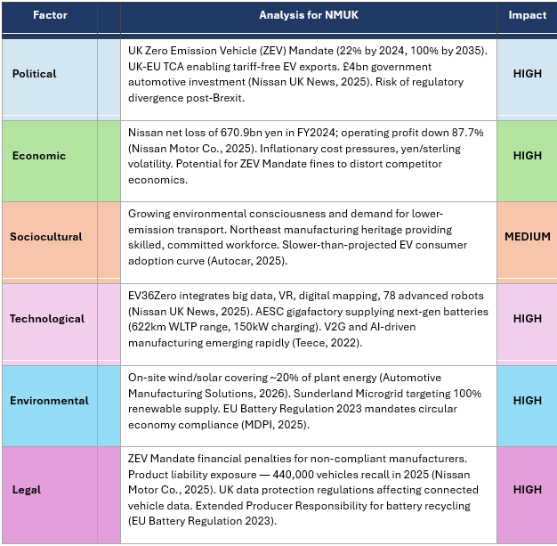
Table 1: PESTEL Analysis
Equally important, collaboration between regulatory (ZEV Mandate), technology (EV36Zero) and environmental (EU Battery Regulation) will force NMUK's hand to move faster towards circular business principles. Companies that view regulation as a hindrance rather than an advantage will fall behind as producer responsibility lengthens up and down supply chains (Cintra et al, 2025).

External Audit -Porter’s Five Forces
Industry environment is assessed through Porter's Five Forces framework (Porter, 1985). The five forces show industry attractiveness but fail to take into consideration that certain industries like electrification of automobiles change rapidly making entry tactics by new entrants from other industries like China happen at a faster rate (Johnson et al., 2023).
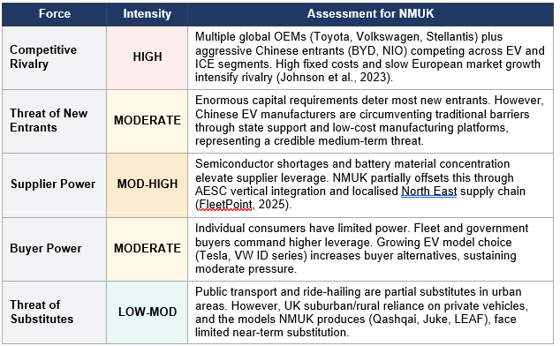
Table 2: Porter's Five Forces Analysis
The primary strategic takeaway from this section is the asymmetry between NMUK's developed EV expertise - hard to recreate quickly - and the Chinese EV threat - the force most likely to come to fruition on a large scale, within NMUK's timeframe. NMUK has a captive domestic EV market it can serve thanks to the ZEV Mandate, if it stays cost competitive with volume-EV players.

Internal Environmental Audit -Swot Analysis
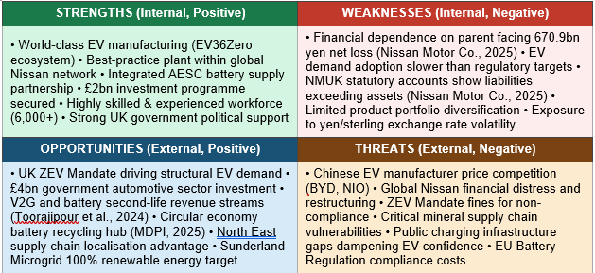
Table 3: SWOT Analysis

The most material strategic implication of the SWOT analysis is that NMUK's two strongest strategic assets (EV36Zero and AESC integration) speak directly to the two most material opportunities (ZEV Mandate demand growth and the circular economy) and offset the two largest threats (supply chain disruption risks and Chinese EV companies crowding NMUK out on range/performance). The remaining primary concern is the financial vulnerability of the parent company over which NMUK has no control.

Internal Audit -VRIO Analysis
VRIO framework of Barney’s (1991) determine if an organisation has resources which can be sustained over time to create a competitive advantage. Path dependency (40 years of Sunderland heritage), social complexity (Nissan-AESC-Council governance) and causal ambiguity (tacit knowledge of the workforce) are characteristics of the EV36Zero ecosystem that make it very difficult to replicate (Barney, 1991).
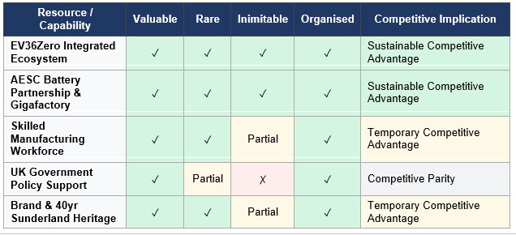
Table 4: VRIO Analysis

Strategy Formulation
Drawing on the preceding analysis, NMUK must pursue a Focused Differentiation Strategy (Porter, 1985), targeting the premium-within-EV segment. This strategy is anchored in three mutually reinforcing pillars: EV Production Leadership, Supply Chain Resilience, and an innovative Circular Battery Hub.

6.1 Ev Production Leadership
NMUK must speed up complete electrification of its range if it is to meet the ZEV Mandate requirements and benefit from the EV36Zero support package. Production of third-generation LEAF is underway and the electric version of Juke is currently being trialled (Nissan UK News, 2026). Therefore, it is vital that we lock down the EV Qashqai for Sunderland. Qashqai is the UK’s bestselling car and an EV version built in Sunderland would be a huge commercial milestone. This would also relate back to Teece’s (2017) dynamic capabilities principle of ‘seizing’ opportunities that have arisen from regulation convergence (Nissan UK News, 2026).

2 Supply Chain Resilience and Localisation
Reducing geopolitical risk and meeting rules-of-origin criteria established by the UK-EU Trade and Cooperation Agreement will require further vertical integration by NMUK. As demonstrated by the AESC battery joint venture, NMUK should look to co-locate Tier-1 suppliers which produce EV essential components including power electronics and thermal management systems in the Northeast. Cost and rules-of-origin can be addressed by localisation initiatives (Kempston et al, 2025).

3 Circular Economy Battery Hub
For game-changing strategic differentiation, NMUK should aim to position its Sunderland campus as the UK’s first full circular economy EV battery hub. With first-generation LEAF batteries reaching end-of-life soon, NMUK can unlock a brand-new revenue stream with high margins. Ecosystem level circular business models for second-life EV batteries represent one of the largest opportunities for value capture yet untapped, according to Toorajipour et al. (2024). Batteries that have 70-80% of their capacity remaining can be repurposed into stationary energy storage solutions (to power the Sunderland Microgrid or sell into commercial vehicle operators)(Thakur et al., 2022). This provides an additional Vehicle-to-Grid (V2G) and Battery-as-a-Service revenue stream whilst transforming NMUK from simply a manufacturer to an integrated clean energy business. It should be noted that under EU Battery Regulation (Charging EVs tomorrow today) 2023, Extended producer responsibility like this will become mandatory (Cintra et al., 2025).

Conclusion and Recommendations
Positioned within the UK’s premier, fully vertically integrated EV manufacturing, battery and renewable energy complex, and as part of a parent company currently experiencing significant financial distress, NMUK finds itself in a unique situation. This reality – operating as a best-in-class business whilst running under severe financial duress – is the crux of NMUK’s challenge.
Providing NMUK with a clear, data-backed path forward to reinforce its value as a critical player in the Nissan global strategy, the following Focused Differentiation Strategy recommendations aim to:
- Secure EV Qashqai Commitment: As Nissan UK News (2026) confirms the electric Juke is already in development at Sunderland, the logical next step is to secure the EV Qashqai for Line Two, maximising asset longevity and exploiting the model’s current dominance in the UK market. Teece (2017) argues that firms with dynamic capabilities must act decisively to seize such time-sensitive opportunities before rivals.
- Develop a Circular Economy Battery Programme: Toorajipour et al. (2024) demonstrate that second-life EV battery programmes represent a significant untapped value creation opportunity. NMUK should partner with AESC to repurpose end-of-life
- Invest in V2G Infrastructure: Thakur et al. (2022) confirm that batteries retaining 70–80% capacity are commercially viable for grid-scale energy services. NMUK should pilot Vehicle-to-Grid energy trading with commercial fleet customers at Sunderland, establishing a prototype Battery-as-a-Service revenue model.
- Accelerate Supply Chain Localisation: FleetPoint (2025) highlights that Sunderland’s designation for EV expansion is contingent on meeting rules-of-origin requirements under the UK-EU Trade and Cooperation Agreement. As Johnson et al. (2023) note, supply chain resilience is a critical source of competitive advantage in volatile industries.
- Engage Proactively with UK Government: Nissan UK News (2025) confirms that the UK government has committed £4 billion to the automotive sector. NMUK should proactively shape ZEV Mandate incentive structures and public charging infrastructure investment, ensuring that demand-side conditions keep pace with its EV supply capability, as Pamidimukkala et al. (2024) notes consumer adoption remains slower than regulatory targets.
Weil (1985) and Barney (1991) show that competitive advantage can only be sustained if a company has resources that are valuable, rare, and difficult to copy. It is clear that NMUK’s EV36Zero business network has these qualities. By becoming a leader in the circular economy, which Toorajipour et al. (2024) discuss, NMUK could go from being a best-in-class manufacturer to an example of sustainable business.

References

Automotive Manufacturing Solutions (2025) Nissan’s Sunderland plant — electric vehicle hub or cost-cutting casualty amid global restructuring. Available at: https://www.automotivemanufacturingsolutions.com (Accessed: 20 April 2026).
Automotive Manufacturing Solutions (2026) Nissan retools Sunderland for next-generation Leaf. Available at: https://www.automotivemanufacturingsolutions.com (Accessed: 20 April 2026).
Barney, J. (1991) “Firm Resources and Sustained Competitive Advantage,” Journal of management, 17(1), pp. 99–120. Available at: https://doi.org/10.1177/014920639101700108.
Cintra, R.S. et al. (2025) “Analysis of the Life Cycle and Circular Economy Strategies for Batteries Adopted by the Main Electric Vehicle Manufacturers,” Sustainability, 17(8), p. 3428. Available at: https://doi.org/10.3390/su17083428.
Department for Business and Trade (2025) Nissan launches £450m next-generation LEAF in major vote of confidence in UK's Industrial Strategy. Available at: https://www.gov.uk/government/news/nissan-launches-450m-next-generation-leafin-major-vote-of-confidence-in-uks-industrial-strategy (Accessed: 22 April 2026 ).
Johnson, G., Whittington, R. and Scholes, K. (2023) Exploring strategy: text and cases. Eleventh edition. New York, New York State: Pearson.
Kempston, S. et al. (2025) “UK electric vehicle battery supply chain sustainability: A systematic review,” Renewable & sustainable energy reviews, 210. Available at: https://doi.org/10.1016/j.rser.2024.115216.

Nissan motor corporate (2021). Nissan unveils EV36Zero – a £1bn Electric Vehicle Hub. [online] Official Global Newsroom. Available at: https://global.nissannews.com/en/releases/210701-03-e [Accessed 20 Apr. 2026].
Nissan motor corporate (2023). Three is the magic number as Nissan accelerates the switch to full electric. [online] Global Nissan Newsroom. Available at: https://global.nissannews.com/en/releases/ev36zero_23 [Accessed 20 Apr. 2026].
Nissan motor corporate (2025). Nissan reports financial results for fiscal year 2024. [online] Global Nissan Newsroom. Available at: https://global.nissannews.com/en/releases/250513-01-e [Accessed 20 Apr. 2026].
Nissan motor corporate (2025a). Next generation Nissan LEAF brings EV36Zero vision to life at Sunderland Plant. [online] Official Europe Newsroom. Available at: https://europe.nissannews.com/en-GB/releases/next-generation-nissan-leaf-brings-ev36zero-vision-to-life-at-sunderland-plant [Accessed 19 Apr. 2026].
Nissan motor corporate (2026). Nissan Unveils All-New, All-Electric JUKE, Advancing Its European Electrification Strategy. [online] Official Europe Newsroom. Available at: https://europe.nissannews.com/en-GB/releases/nissan-unveils-all-new-all-electric-juke-advancing-its-european-electrification-strategy [Accessed 20 Apr. 2026].
Pamidimukkala, A. et al. (2024) “Barriers and motivators to the adoption of electric vehicles: A global review,” Green Energy and Intelligent Transportation, 3(2). Available at: https://doi.org/10.1016/j.geits.2024.100153.
Teece, D.J. (2017) “Dynamic Capabilities and (Digital) Platform Lifecycles.”
Thakur, J., Martins Leite de Almeida, C. and Baskar, A.G. (2022) “Electric vehicle batteries for a circular economy: Second life batteries as residential stationary storage,” Journal of cleaner production, 375. Available at: https://doi.org/10.1016/j.jclepro.2022.134066.
Toorajipour, R. et al. (2024) “Implementing circular business models for the second‐life battery of electric vehicles: Challenges and enablers from an ecosystem perspective,” Business strategy and the environment, 33(8), pp. 8637–8655. Available at: https://doi.org/10.1002/bse.3941.
Weil, K.E. (1985) “PORTER, Competitive advantage, creating and sustaining superior performance,” Revista de administração de emprêsas, 25(2), pp. 82–84. Available at: https://doi.org/10.1590/S0034-75901985000200009.

