3/24/2026
University of Wales Trinity Saint David
London campus
E-Portfolio Link:
Module Name: Learning In the Digital Era
Module Code: ACCA 4025

Student Name: Hanna Chris Mercado Navarro
Student ID: 2522973
Group: 1

Lecturer’s Name: Koushik Modak

LDE Assignment 1
E-Portfolio
Table of Contents
Introduction 2
Main Body 2
Task 1 Essential Academic and Employment Skills 2
Task 1 (a): IEEE Referencing 2
Task 1 (b): Evaluation of the Similarity Report 4
Task 2 Collaborative Teamwork and Professional Academic Poster 5
Task 1 (a): Mind Map 5
Task 1 (b): Academic Poster 5
Task 3 Automatic Referencing Tool 6
Task 1 (a): Automatic Referencing 7
Task 1 (b): Step-by-Step Guide for RefWorks 8
10
Task 4 ePortfolio Creation and Review 14
Task 1 (a): ePortfolio Creation 14
Task 1 (b): Evaluation of ePortfolio 14
Conclusion 14
Task 1 References 14
Task 3 References 16

Introduction
Learning in the Digital Era is introducing technology into education to increase availability to students in all walks of life as well as student and class interaction. In this module, we are given 4 tasks to assess our knowledge on the essential academic and employment skills (Task 1), applying IEEE referencing both manually and automatically in academic writing (Task 1 & 3), creating a mind map and an academic poster (Task 3) and then presenting everything in an e-portfolio (Task 4). We are also asked to evaluate the research that we have done about the essential academic employment skills by generating a similarity report and then assessing what I could have done differently to improve my work.

Main Body

Task 1 Essential Academic and Employment Skills

Task 1 (a): IEEE Referencing
In dictionary definition, skill is defined as the ability to use the knowledge that you gained effectively and readily apply that knowledge in real life. [1]. Academic skills are needed to enhance the efficiency of knowledge absorption through learning [2] and are enhanced through habit formation and if utilised efficiently, can give way to success in your future employment [3]. The following are some of the skills that could increase the chance of getting high paying jobs with high work fulfilment in the current labour market based on academic research [4]:



Figure 1. Employment Skills for Success [11]

Communication is used to exchange knowledge, ideas and emotions through speaking, writing [5], gestures or body language [6] . Research suggests that both graduates and employers rank communication skills on their top 4 most important skill to possess [7]. Being an effective communicator boosts confidence because it removes obscurity and the fear of not being understood [8].

Figure 2. Effective Communication [12]

Critical thinking is used in problem solving and logical reasoning by seeking relevant information and understanding biases from the information collected. It involves outcome evaluation by considering factors and the reasoning behind a conclusion. It also fosters holistic thinking and effective communication, setting humans apart from AI and increase the likelihood of thriving in an AI-influenced job market [9].

Figure 3. Critical Thinking for Success [13]

Teamwork is used to collaborate and achieve a certain goal, so effective communication is key to attain good teamwork [10]. Effective teamwork helps resolve conflicts; motivate, coach and empower others to work towards your common goal [4]

Mental flexibility is used to develop ideas, adopt a different perspective and the ability to cope with changes [4].

Task 1 (b): Evaluation of the Similarity Report
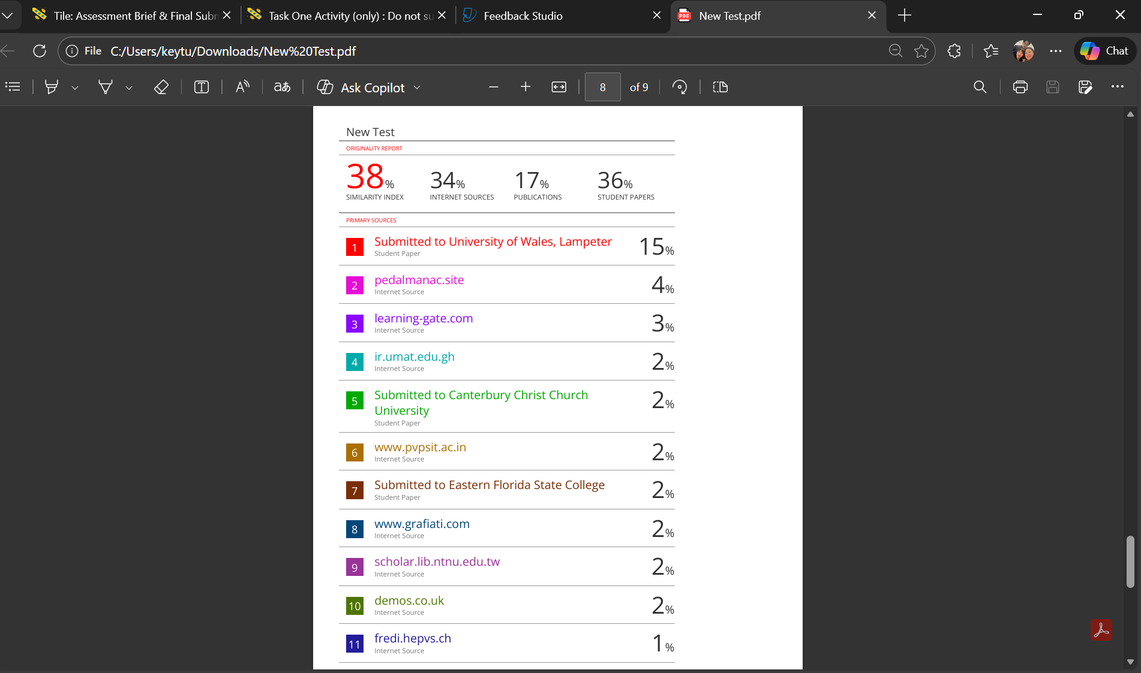
Figure 4. Similarity Report Screenshot
As shown in Figure 4, I have attained a similarity score of 38%. Although I have paraphrased and properly referenced my work, the template that was given by the instructor increased the similarity of my work with other students. The references that I used for citation also increased my similarity report.
I would award myself a mark of 70 out of 100%. I believe I have done my work based on the general assessment criteria set by the instructor. I have provided evidence that I have written my work based on up to date and highly credible sources and were properly annotated in my references. I have also presented my work in a very organised manner and there is progression in the construction of my ideas.

Task 2 Collaborative Teamwork and Professional Academic Poster

Task 1 (a): Mind Map
Link:
Life is a Team Sport - MindMeister Mind map
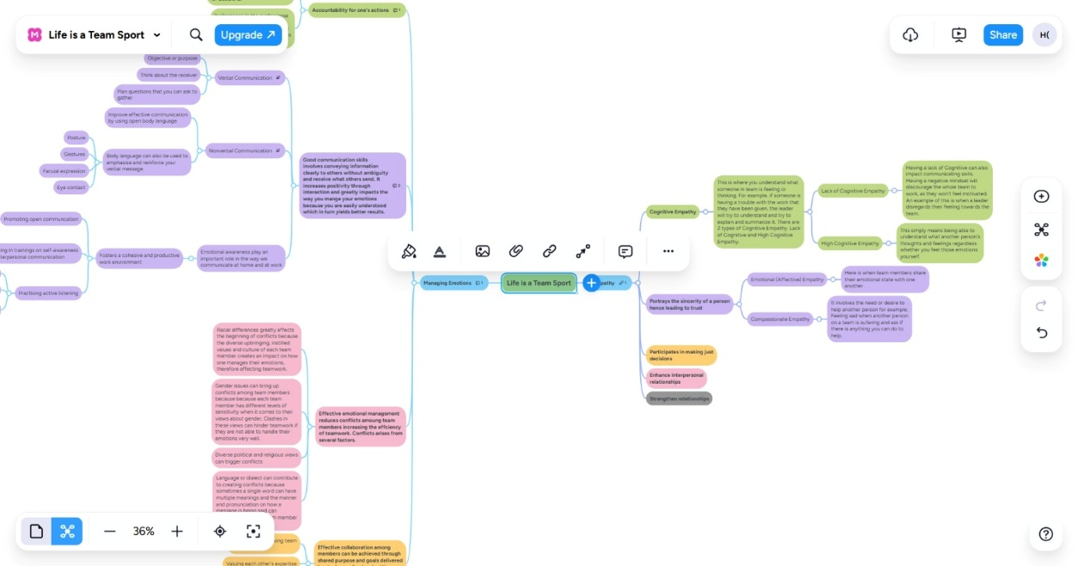

Task 1 (b): Academic Poster
Link:
https://www.canva.com/design/DAHD85gn_Bo/lNypq50IzrW6nHyedVSY4w/edit?utm_content=DAHD85gn_Bo&utm_campaign=designshare&utm_medium=link2&utm_source=sharebutton

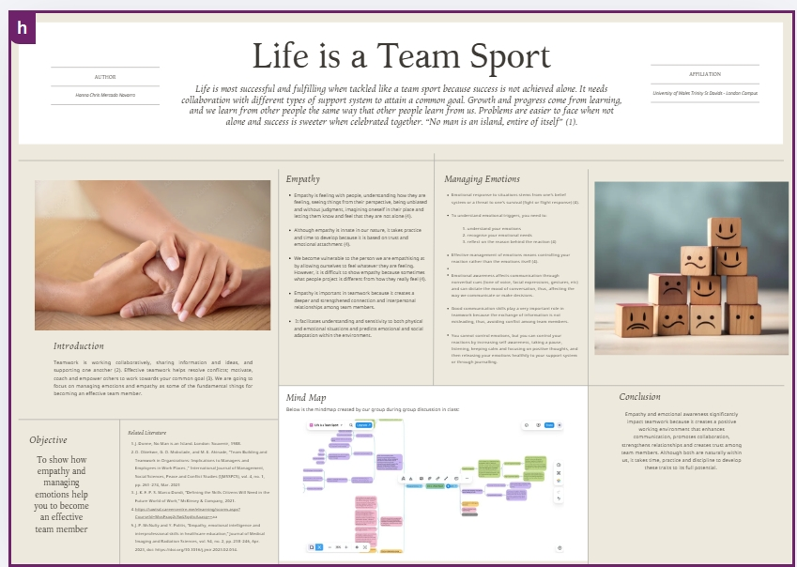
Task 3 Automatic Referencing Tool

Task 1 (a): Automatic Referencing
Unit 3 Topic 2: Riding the Storm
Covid 19 pandemic paved way to companies implementing remote working and the proliferation of virtual teams (VT). VTs are groups of co-workers that are spread out across places, different time zones, several business divisions and different cultures and ethnicities sharing common objectives using technology to communicate and collaborate. Virtual conflicts occurs when members within the group have different or opposite goals or interests due to different cultures, ethnicities, languages, backgrounds, working habits, and attitude because people associate and bond with others who share the same traits or culture and triggers the creation of subgroups [1]. Challenges that virtual team members face are distractions from working at home, struggle to be working in different time zones and burnout that leads to lack of empowerment, isolation, lack of familiarity, high workload, distrust and interpersonal conflicts [2]. Face to face conflicts is more manageable than virtual conflicts because face to face communication allow nonverbal cues, rapid feedback and natural language that shows empathy. Virtual conflicts are also made worse by the lack of a shared physical setting which can result into miscommunications, misinterpretations and negative thoughts about your team member’s motives. Managing conflicts depends on the way we view conflicts. If team members have a rigid attitude and the objective of the conflict is to defeat the other party in spite of other factors, then it becomes a destructive conflict. However, if team members believe that a mutual solution can be achieved, address the conflict with an open mind straight away and trust that other members of the team have the best intentions in mind then it becomes a productive conflict [3].
A team role is defined as a tendency to act, participate, and interact with people in a specific manner. Factors that influence roles are motivation, morals, mental capacity, personality, and external working environment, personal experiences, culture and role learning [4]. Responsibilities within a team are delegated based on situation (by location, current task requirements, knowledge and availability), assignment (by SOP, training or qualification) or assumption (voluntary) [5]. A person can take on multiple roles in a team. Diversity of team roles is important because it defines responsibilities and give a thorough grasp of the objectives and activities [6]. Using SWOT analysis (Strength, Weakness, Opportunities, Threats) as a tool for evaluating oneself can result lead to accurate and unbiased decisions and enhanced performance [7].

Task 1 (b): Step-by-Step Guide for RefWorks
- Create an account with RefWorks using your university email.
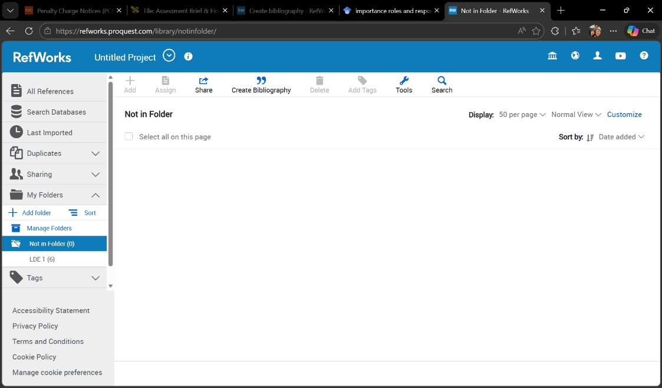

- Create a folder by clicking on the “Add Folder” “Save”.
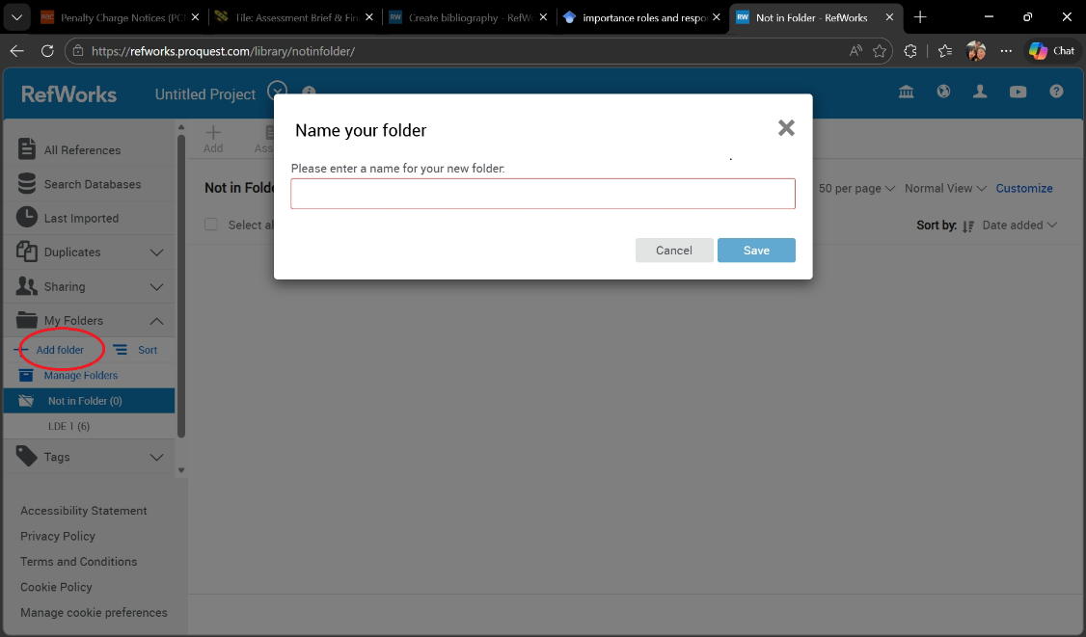

- Select an article from Google Scholar that correlates with your research. then click “Cite”.
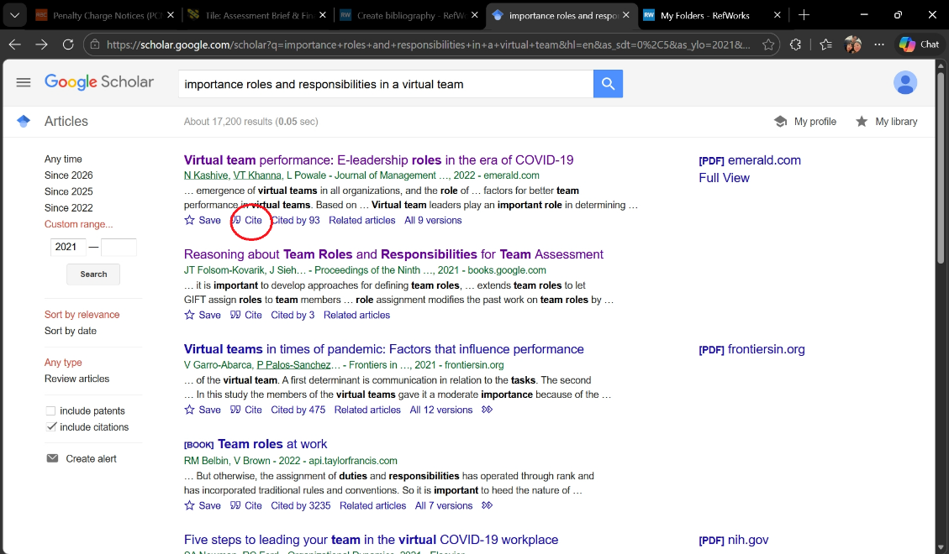

- Select “RefWorks”.

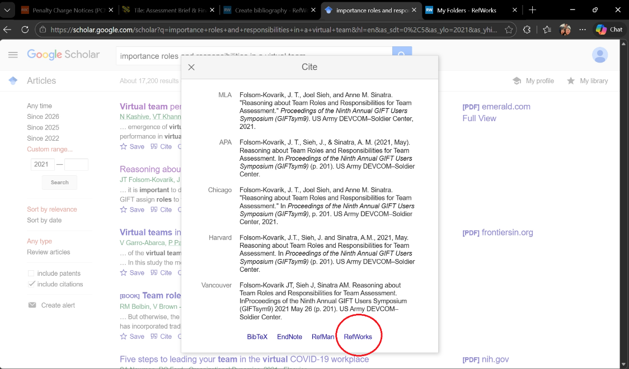

- Select the folder you have created in Step #2 then click “Import”.
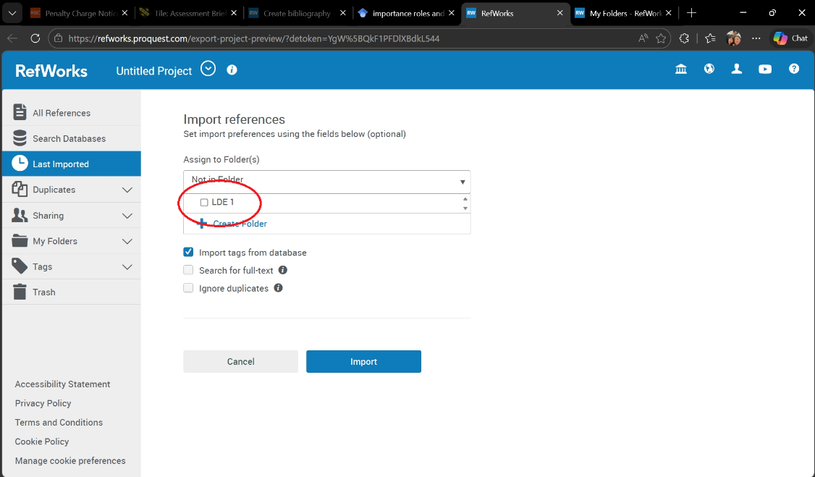

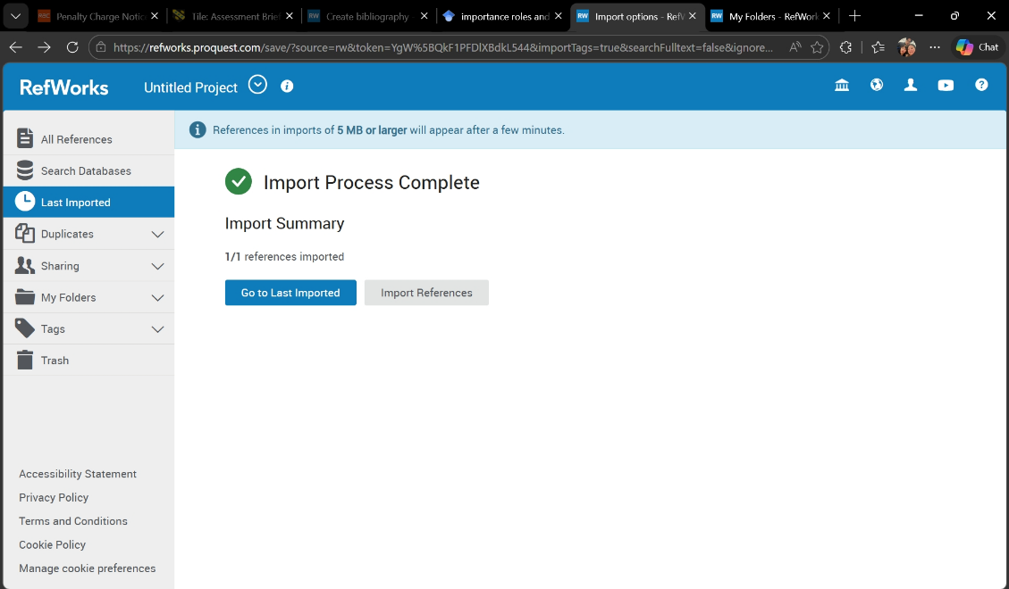

- Open your research then click RCM, then click RefWorks Citation Manager.
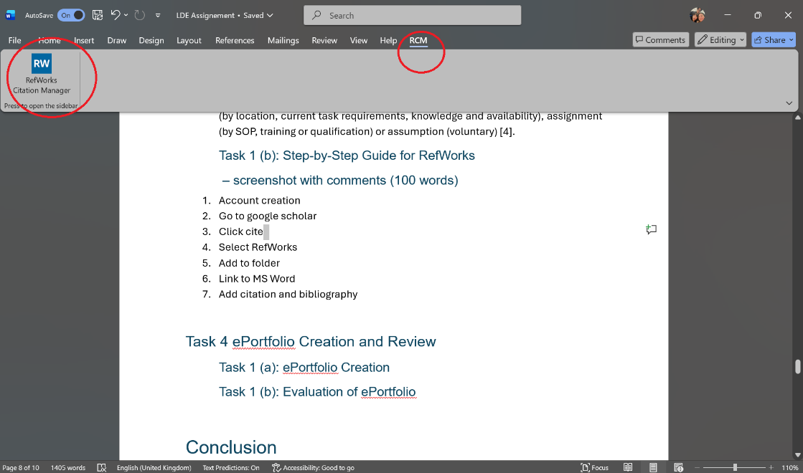

- A RefWorks Citation Manager pane will appear on the right side of the screen. Select the reference you have added in RefWorks in the previous steps then click the “Insert Citation”.
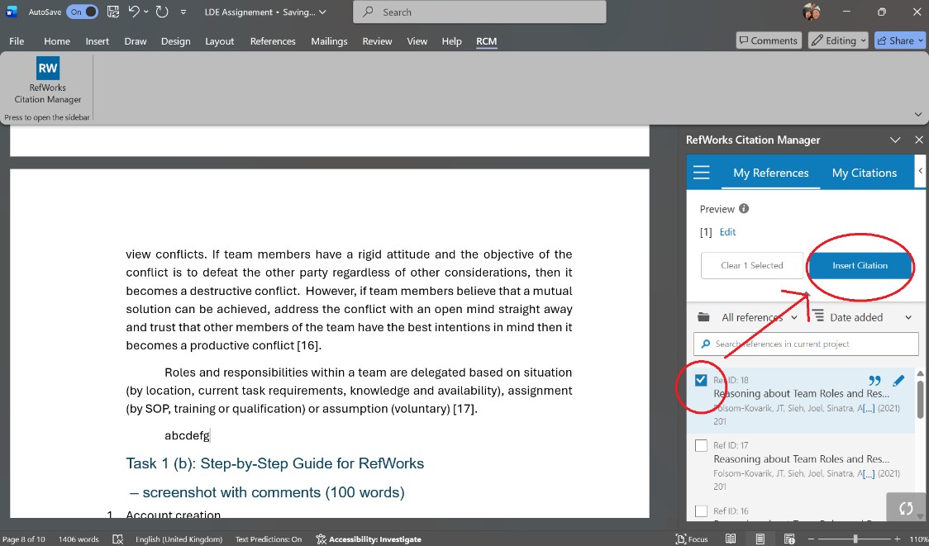

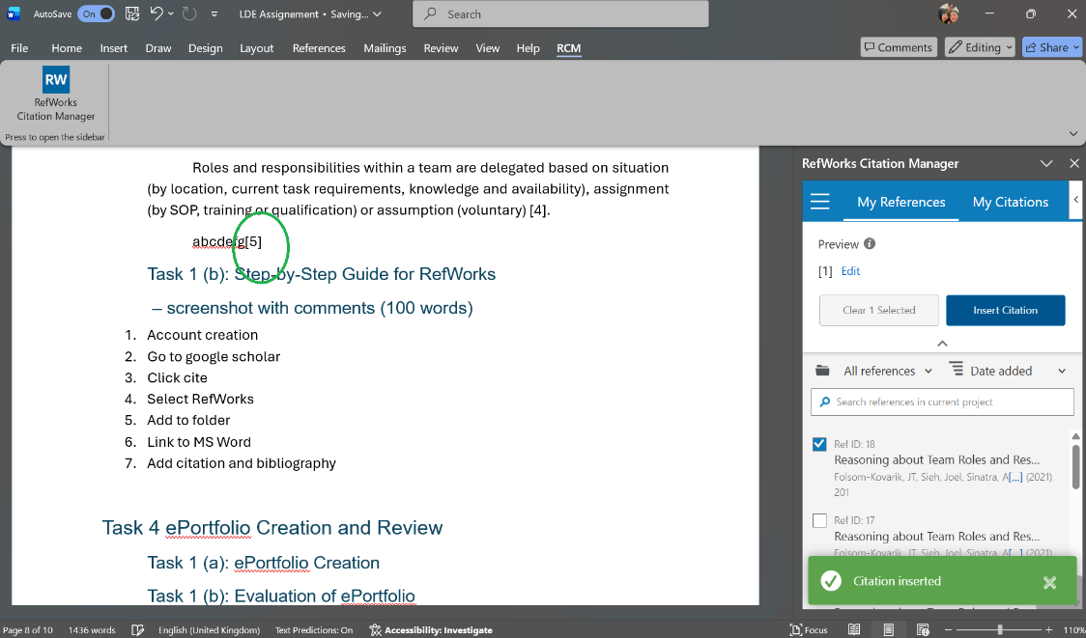

- Go back to your RefWorks account online then click the “Create Bibliography”.
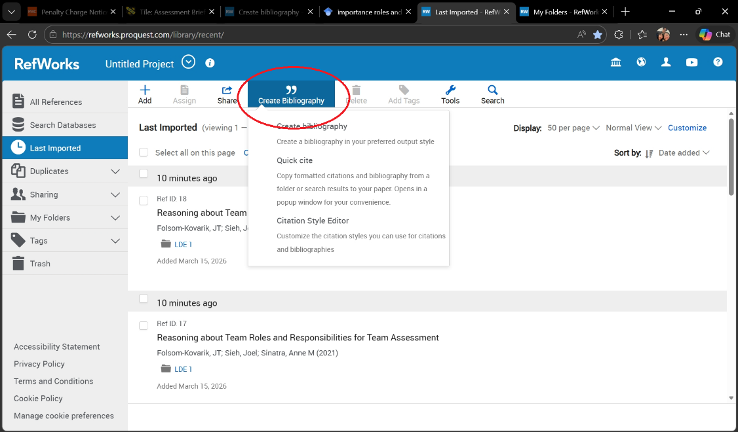

- Click “Copy to Clipboard”.
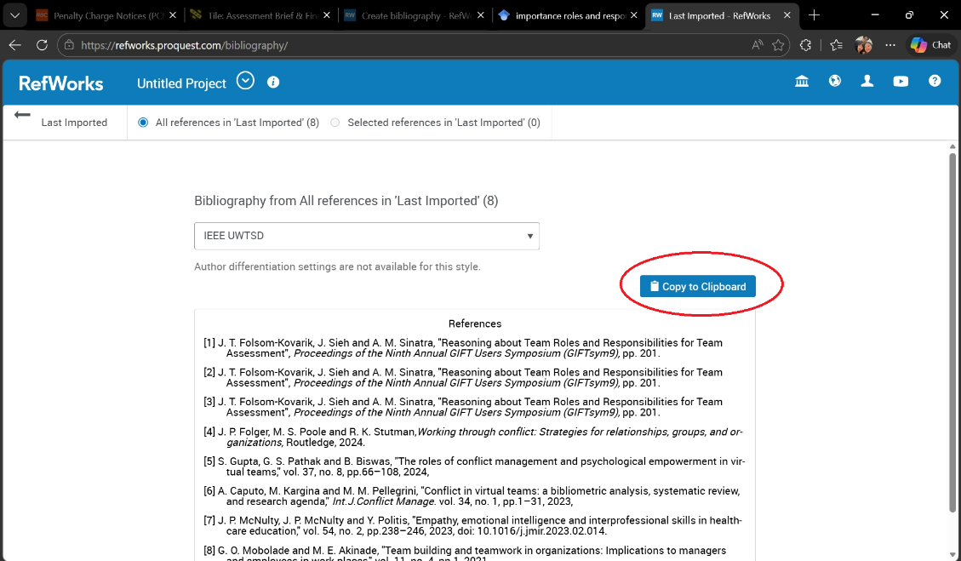

- Paste the references under the “References” heading. When adding more references, just repeat steps 1 to 9 then click the refresh button at the bottom of the RefWorks Citation Manager pane then update the references by clicking the “Update Citations and Bibliography” button on top of the reference box.
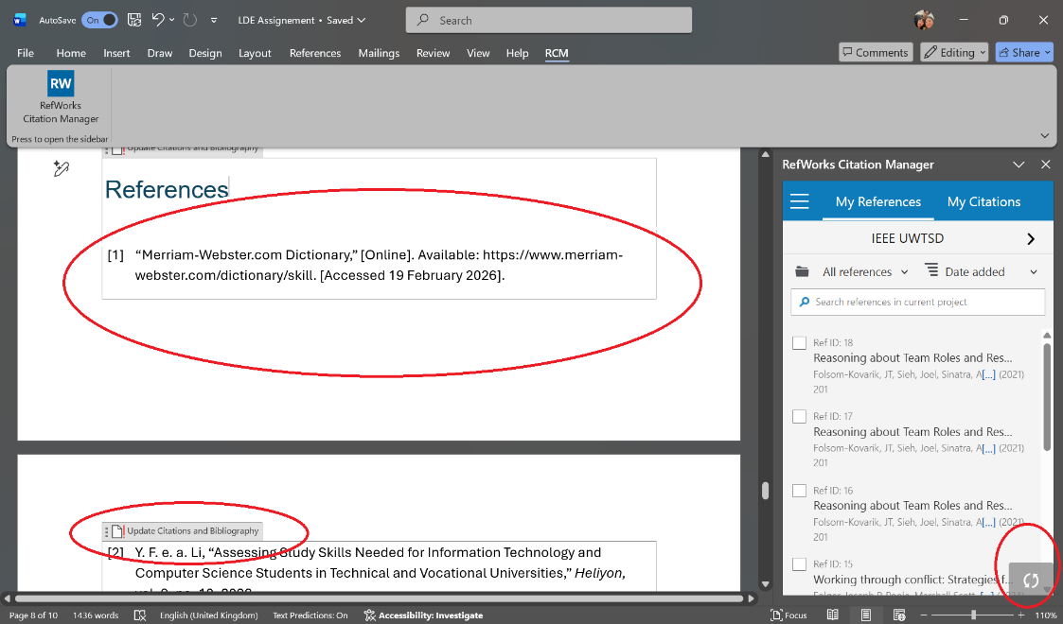

Task 4 ePortfolio Creation and Review

Task 1 (a): ePortfolio Creation

Task 1 (b): Evaluation of ePortfolio
- Positive and negative review

Conclusion
- After finishing this module

Task 1 References

[1] | “Merriam-Webster.com Dictionary,” [Online]. Available: https://www.merriam-webster.com/dictionary/skill. [Accessed 19 February 2026].
[2] | Y. F. e. a. Li, “Assessing Study Skills Needed for Information Technology and Computer Science Students in Technical and Vocational Universities,” Heliyon, vol. 9, no. 10, 2023.
[3] | M. Menz, “Integrating Academic Skills and Employability - Revisiting the Learning Journal,” Journal of Research in Higher Education 2, vol. 4, no. Feb 2020, 2020.
[4] | J. K. F. P. S. Marco Dondi, “Defining the Skills Citizens Will Need in the Future World of Work,” McKinsey & Company, 2021.
[5] | P. R. V. L. M. R. C. a. N. R. B. Alapati, “Enhancing Employability Skills Through Communication in the ESP Classroom,” Theory and Practice in Language Studies, vol. 13, pp. 2898-2909, 2023.
[6] | V. M. L. K. G. Judee K. Burgoon, Nonverbal Communication, New York, Oxford: Routledge, 2022.
[7] | Y.-L. L. Brenda Ping Ping Yong, “Skills Gap: The Importance of Soft Skills in Graduate Employability as Perceived by Employers and Graduates,” Online Journal for TVET Practitioners, vol. 8, pp. 25-42, 2023.
[8] | K. K. Kalpana Deshmukh, “The Role of Effective Communication Skills in Enhancing Employability during Postgraduate Courses,” International Journal of Innovations in Science Engineering and Management, vol. 4, no. 2, pp. 170-175, 2025.
[9] | D. F. H. Daniela Dumitru, “Critical Thinking: Creating Job-Proof Skills for the Future of Work,” Journal of Intelligence , vol. 11, no. 10, 2023.
[10] | T. P. G. M. R. Thomas J. Hiscox, “Written Reflection Influences Science Students’ Perceptions of Their Own and their Peers Teamwork and Related Employability Skills,” International Journal of Innovation in Science and Mathematics Education, vol. 30, no. 4, 2022.
[11] | Dreamstime.com, 2026. [Online]. Available: https://thumbs.dreamstime.com/z/skill-development-career-growth-to-success-leadership-ladder-job-improvement-experience-motivation-succeed-concept-321904528.jpg. [Accessed 2023 February 2026].
[12] | Dreamstime.com. [Online]. Available: https://thumbs.dreamstime.com/z/businessmen-handshake-laptops-megaphone-collaboration-communication-corporate-cooperative-business-concept-278280352.jpg. [Accessed 23 February 2026].
[13] | Pngtree.com. [Online]. Available: https://png.pngtree.com/png-clipart/20240428/original/pngtree-critical-thinking-vector-concept-illustration-png-image_14954990.png. [Accessed 23 February 2026].

Task 3 References

[1] A. Caputo, M. Kargina and M. M. Pellegrini, "Conflict in virtual teams: a bibliometric analysis, systematic review, and research agenda," Int.J.Conflict Manage. vol. 34, no. 1, pp.1–31, 2023,
[2] S. Gupta, G. S. Pathak and B. Biswas, "The roles of conflict management and psychological empowerment in virtual teams," vol. 37, no. 8, pp.66–108, 2024,
[3] J. P. Folger, M. S. Poole and R. K. Stutman,Working through conflict: Strategies for relationships, groups, and organizations, Routledge, 2024.
[4] A. Aranzabal, E. Epelde and M. Artetxe, "Team formation on the basis of Belbin’s roles to enhance students’ performance in project based learning," vol. 38, pp.22–37, 2022, doi: 10.1016/j.ece.2021.09.001. Available at: https://www.sciencedirect.com/science/article/pii/S1749772821000452.
[5] J. T. Folsom-Kovarik, J. Sieh and A. M. Sinatra, "Reasoning about Team Roles and Responsibilities for Team Assessment", Proceedings of the Ninth Annual GIFT Users Symposium (GIFTsym9), pp. 201.
[6] A. Aranzabal, E. Epelde and M. Artetxe, "Team formation on the basis of Belbin’s roles to enhance students’ performance in project based learning," vol. 38, pp.22–37, 2022, doi: 10.1016/j.ece.2021.09.001. Available at: https://www.sciencedirect.com/science/article/pii/S1749772821000452.
[7] V. Marhasova, et al., "IT Team Building Process Management based on a Competency Approach.", CPITS II (2), pp. 76–87.

