Abbreviations:
House type:
- D-Detached
- T-Terraced
- S-Semi detached
- F-Flats
- O-Other
Abstract:
House prices prediction plays a major role in real estate. Using historical data, the project aims to derive useful knowledge on London house prices. Although buying a house requires lot of attention towards so many factors like place, area, type of house, current and future prices; price plays the major role in most of the purchases. Historical data required is collected from HM Land registry and analysed using Machine Learning models where the model is trained from the previous year’s house prices to predict the future house prices. Regression models used during analysis are Decision Tree, GBM, XG Boost, Random Forest. From all four outputs, Random Forest shown the better results. Considering Random Forest regression, a web page is created using flask software where users can enter the input to get the predicted house price. All the Machine Learning models are trained and executed in Python. The web page is created using flask software, templates were created using html and the static(style) is created using CSS and Java script.

Introduction
Buying a house is a dream for many people. It takes so many efforts in buying house. One of the main factors involves in purchase is house prices. House prices vary time to time depending on so many external factors which involves demand and supply of real estate, location, number of bedrooms area of house. Machine learning models are used to predict the data. Quality of data plays a major role in building the model. Data required is collected from HM Land registry and cleaned in excel. After analysing the data in excel, it is ready to use to use pre process the data.
Data pre processing techniques are done from python to pre process the excel sheets. Once the pre processing is done, the categorical and numerical attributes are identified and the variables of importance and identified. With the help of variables and the analysis taken place, data is trained for various machine learning models. Once the models are trained using Machine Learning the codes are saved to use them further. The task is to deliver the user-friendly web page where the users will be able to enter the input in the given variables for which they the predicted bouse price. To design the web page java, html and flask are used. With the help of saved machine learning models, they are used in the code written for the web page.

Relevance of the project
Buying a house takes lot of time to decide, as we talked earlier that the house prices play a major role in the purchase of property, people want to know an estimated price of the property. The main goal of this project is to provide them with an estimated prices to help them to buy the properties. There are many websites in the market where they provide the predicted prices, but the data with the available data the goal of our model is to find the best model which fits the best in predicting the prices.

Problem Statement
The problem statement is about making the most use of Machine Learning to build the model. There are many features of Machine Learning but using he salient features of Machine Learning for the predictions where users can give the required inputs so that they can the predicted prices. Anyhow creating a user-friendly web page seems to be delivered, building a machine learning model looks promising as the model needs to be trained in the most efficient way to give the users as closet price as possible. There are software’s which predicts the house prices but we don’t have access the many inputs so the aim is to build the best model with the inputs we have.
Objectives
This project aims to deliver the predicted prices for the users when they give the required inputs, the process includes the following steps:
- Collecting the required data, cleaning and pre-processing data. In this process we remove/fix the incorrect, incomplete and duplicate data within the dataset. If the data is incorrect, outcomes can be unreliable even though they look correct. There is no one absolute way to prescribe the exact steps in the data cleaning process because the processes will vary from dataset to dataset. But it is crucial to establish a template for your data cleaning process so you know you are doing it the right way every time. ( https://www.tableau.com/learn/articles/what-is-data-cleaning)
- Pre analysing and pre-processing: Analysing the data and finding the trends. Pre processing the data with required inputs and cleaning the data is one of the crucial step as the data we use has more importance in building a model, we need to make sure that the data is properly pre-processed and cleaned before we use the data in training the model.
- Dividing the data sets into testing and training sets and using the training data the model needs to be trained to predict the house prices from the given inputs by the user.
- Comparing different algorithms by running the analysed dataset through them and determining their error rate and accuracy. Pick the algorithm that has the best accuracy and lowest error.
- Create a user -friendly web page and integrate the Machine learning models in the back end.
- To test the system if it has any flaws.
Scope of the Project
With the help od Machine Learning Techniques in real estate we make predictions which can help real estate in providing the predicted values to the people who are looking to buy houses. In this process we need previous years datasets as it plays the main role in training the model to give the predicted prices. In the end the goal is to deliver the user-friendly web page where anyone can the enter their required inputs to get the predicted price. House prices play major role in purchase of any property, predicting the prices way before purchasing will help to have an idea on the house prices which makes the purchase a little bit easier.

Methodology
The web page uses machine learning in predicting house prices. All the models are trained and executed in Python programming language because python is widely recognised as a platform for researching the topic of machine learning. Machine learning acquires knowledge and experiences through past data and information in order to develop a trained model from the data. The model then calculates the output. The classifier's accuracy will improve as the dataset gathering progresses. Numerous statistical models have been shown to outperform machine learning techniques such as regression and classification. House price predictions are completely determined by their features like area, no. of bedrooms, bathrooms and the location of the property. These variables have a major impact on house prices. Demand and supply of the market also influence in the house prices. To predict the prices, we must consider all of the variables. As a result, we develop a system that employs Machine Learning techniques in real estate to predict house price predicts.
Machine Learning
ML is the scientific study of algorithms and statistical models that computer systems employ to execute a certain task without having to be explicitly programmed in order to do so. Learning algorithms are used in a variety of applications that we utilise on a regular basis. One of the reasons that a web search engine like Google works so well is that it has developed a learning algorithm that has learned how to rank web pages. Every time a web search engine like Google is used to search the internet, one of the reasons that it works so well is because a learning algorithm has learned how to rank web pages. (B, 2020) These algorithms are used for a variety of tasks such as data mining, image processing, predictive analytics, and other applications, to name a few examples. Using machine learning has several advantages, the most important of which is that, once an algorithm learns what to do with data, it can do its tasks automatically. In this paper, a brief overview of the numerous uses of machine learning algorithms is provided, as well as a forecast for the future (B, 2020).
Basic Terminology
- Dataset: A data set is a collection of data in a file where it has examples related to the model that are crucial in training the model.
- Features: Critical pieces of knowledge that assist in comprehending a scenario.
- To aid learning, these are given into a Machine Learning system.
- Model: A Machine Learning algorithm has learned a representation (internal model) of a phenomenon. This is something it learns from the data it sees during training. The model is the output of an algorithm after it has been trained.
Basic Process
- Data Collection: Obtaining the data that will be used to train the algorithm is the first step.
- Data Preparation: Organize the data in the most efficient style feasible, isolating critical features and minimising dimensionality as much as possible.
- Training: The machine learning algorithm learns by being presented with the data that has been collected and prepared, which is referred to as the fitting stage in this process.
- Tuning: Tuning the model to optimise.
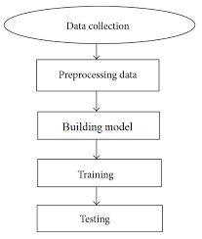
Source: (Learning, 2022)

Data Sets
Data plays a vital role in Machine Learning. It’s the significant factor which allows algorithm training to take place. By using historical data and information the model is trained. The more data we collect, there are more chances of training the data accurately. The initial step in building a model is data collection.
The data sets required for this project are collected from a free source HM Land Registry. The data comprises of two years data 2020 and 2021 which are downloaded from four files two from each year. After all the files were downloaded, they were merged into a single file. Final file comprises of 519130 entries in total.

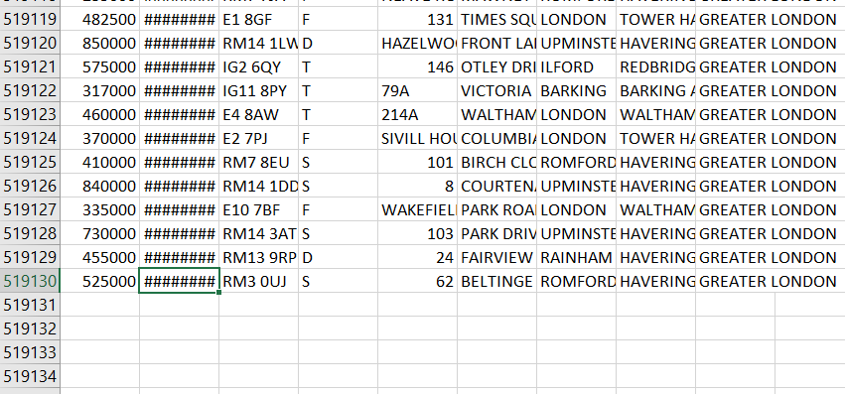
The features included in the dataset are Price, date, postcode, House type, House no, Street, area, place and city.
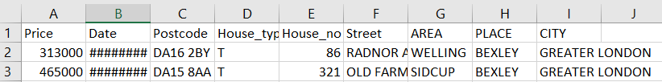
Some of the trends were observed in the process of data analysing
In the below graph 1-7 represents the days of the week.
1-Monday
2-Tuesday
3-Wednesday
4-Thursdsy
5-Friday
6-Saturday
7-Sunday
x-axis – days of the week
y-axis – count of price
The trend observes that maximum number of transactions took place on Friday.
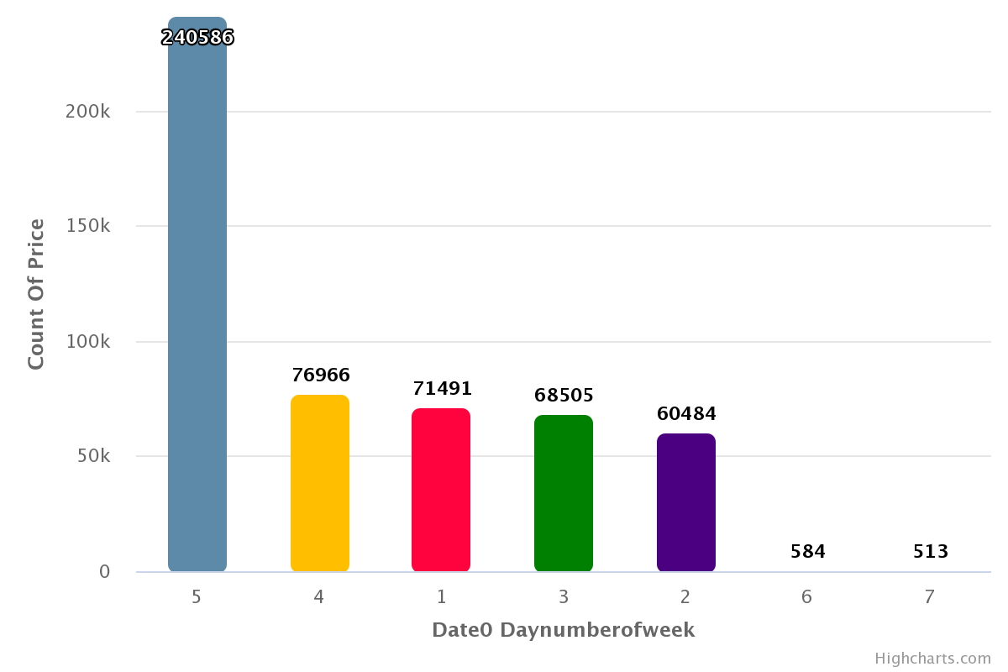
In the following graph it clearly depicts that the Terraced House are sold to the maximum price and the other types to the least.
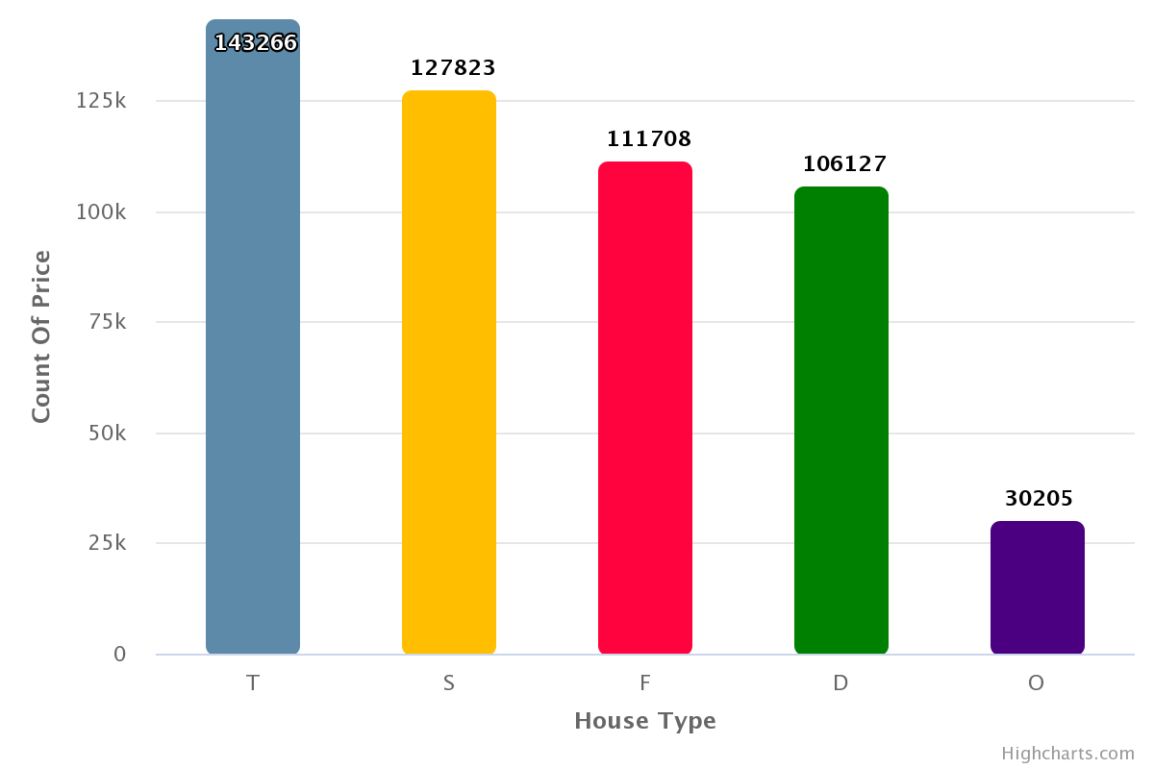
Data Pre-processing and cleaning
Data pre-processing is the process of converting unstructured data to a readable format. This is also a critical stage in data mining because we cannot work with unstructured data. Prior to implementing machine learning or data mining techniques, the data's quality should be verified. (https://www.analyticsvidhya.com/blog/2021/08/data-preprocessing-in-data-mining-a-hands-on-guide/)
Pre-processing data is mostly used to ensure the data's quality. The following criteria can be used to determine the quality:

Accuracy: To determine whether or not the data entered is correct.
Completeness: To determine whether or not the data is available or has been lost.
Consistency: To ensure that the same data is stored in all locations that match or do not match.
Timeliness: Data should be updated on a regular basis.
Trustworthiness: The data should be credible.
Interpretability: The data's ability to be comprehended.
Steps
- Data cleaning
- Data integration
- Data reduction
- Data transformation (https://www.analyticsvidhya.com/blog/2021/08/data-preprocessing-in-data-mining-a-hands-on-guide/)

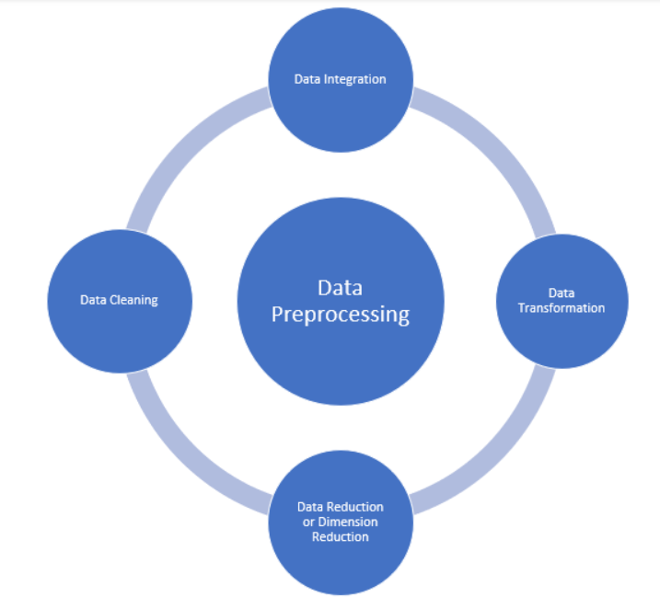
Data Cleaning
Data cleaning is the process of repairing or erasing inaccuracies, corruptions, improperly formatted, duplicate, or incomplete data from a dataset. When different data sources are combined, numerous potential for data duplication or mislabelling exist. If the data is inaccurate, the results and algorithms will be unreliable, even if they appear to be correct. There is no one-size-fits-all method for prescribing the exact steps in the data cleaning process, as methods differ each dataset. However, it is critical to build a template for your data cleaning procedure so that you can be certain you are performing it correctly each time. (https://www.tableau.com/learn/articles/what-is-data-cleaning#:~:text=Data%20cleaning%20is%20the%20process,to%20be%20duplicated%20or%20mislabeled.)
Filling the null or missing values
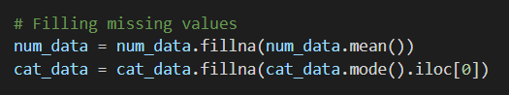
All the missing values will be replaced by 0 so that when we use data to train there wouldn’t we any confusion for the model.

Data Integration
Data integration is the act of combining data from numerous sources within an organisation in order to provide a complete, accurate, and up-to-date dataset for business intelligence (BI), data analysis, and other applications and business processes. (https://www.qlik.com/us/data-integration#:~:text=Data%20integration%20refers%20to%20the,other%20applications%20and%20business%20processes.)
The required for this project is pulled from HM Land registry and the data have all the entries of the year 2020 and 2021s all the House price paid transactions.

Data Reduction
Data reduction is a capacity optimization approach that reduces data to its simplest form feasible in order to save up storage space on a storage device. There are numerous methods for data reduction, but the concept is straightforward—squeeze as much data as possible into physical storage to maximise capacity. (https://www.purestorage.com/knowledge/what-is-data-reduction.html#:~:text=Data%20reduction%20is%20a%20capacity,as%20possible%20to%20maximize%20capacity.)
The data we have in csv file can be handled within the system so we haven’t used any database applications to upload the data in order to manage the load. Since it is loadable through the csv file, we haven’t used any data reduction techniques.

Data transformation
The process of altering the format, structure, or values of data is referred to as data transformation. Data transformation can occur at two points along the data pipeline in data analytics projects. Organizations that employ on-premises data warehouses typically employ an ETL (extract, transform, load) approach, with data transformation serving as the intermediate stage. (https://www.stitchdata.com/resources/data-transformation)

Changing the data types

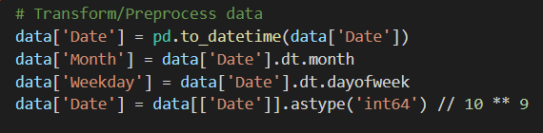
Separating categorical and numerical datatypes
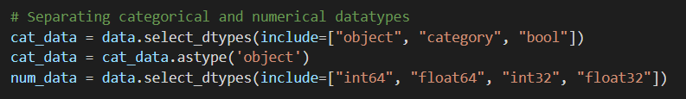
Plotting variable of importance
From all the variables House no and Postcode plays major role in the prediction of the prices.
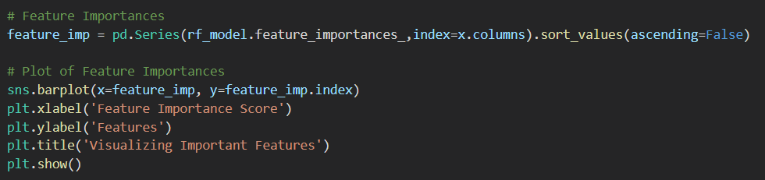
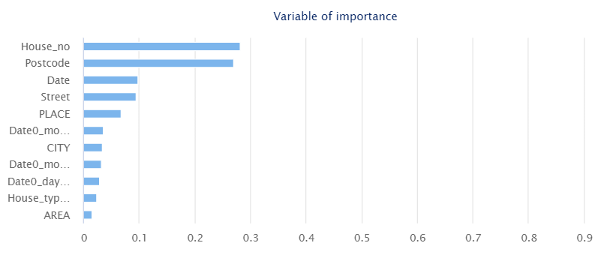

Algorithms used
Machine learning is a subset of Artificial Intelligence and has been a critical component of digitalization solutions that have garnered significant attention in the digital world. The author of this article hopes to provide a brief overview of the major machine learning algorithms that are most frequently employed and thus the most popular. The author seeks to emphasise the advantages and disadvantages of machine learning algorithms from an application perspective in order to aid in making an informed decision about which learning algorithm to use to fulfil the application's specific requirements. (https://ieeexplore.ieee.org/abstract/document/8862451)
Machine Learning is used in a wide variety of fields, including robotics, virtual personal assistants (such as Google), computer games, pattern recognition, natural language processing, data mining, traffic prediction, online transportation networks (for example, estimating surge prices during peak hours via the Uber app), product recommendation, stock market forecasting, medical diagnosis, online fraud prediction, agriculture advisory, and search engine result refinement (for example, the Google search engine) (face recognition in facebook). Machine Learning generally deals with those updates, which might result in noisy gradients, causing the error rate to fluctuate rather than reducing gradually. (https://ieeexplore.ieee.org/abstract/document/8862451)
SGD may be used to analyse three different sorts of issues, including classification, regression, and clustering. Depending on the types and categories of training data available, one may need to choose between "supervised learning," "unsupervised learning," "semi-supervised learning," and "reinforcement learning" in order to use the proper machine learning method. (https://ieeexplore.ieee.org/abstract/document/8862451)
Decision tree
For land cover classification from remote sensing data, decision tree classifiers have been utilised extensively in recent years, with great success. In the literature, it has been claimed that its implementation as a per-pixel based classifier can achieve hard or crisp categorization in some situations. Images from remote sensing, particularly those taken at coarse spatial resolutions, are contaminated by mixed pixels, which are pixels that contain elements from more than one class on the ground. The per-pixel technique may result in incorrect classification of images that are dominated by mixed pixels if used in this manner. It has therefore been advocated for soft categorization algorithms that breakdown the pixel into its class parts in the form of class proportions. To construct soft categorization from remote sensing data, we apply a decision tree regression approach in this research to calculate class proportions within a pixel using a decision tree regression approach. It is shown that the classification accuracy produced by decision tree regression is superior to that achieved by the most widely used maximum likelihood classifier, implemented in the soft mode, as well as a supervised version of the fuzzy c-means classifier, among other things. The accuracy of soft categorization has been evaluated using methods such as the Root Mean Square Error (RMSE) and fuzzy error matrix based measures. (https://www.sciencedirect.com/science/article/abs/pii/S0034425705001604)
GBM
In the machine learning world, gradient boosted machines (GBMs) are a widely used machine learning algorithm that has shown successful across a wide range of fields. It is also one of the most popular ways for winning Kaggle contests. Instead of creating an ensemble of deep independent trees as is the case with random forests, GBMs create an ensemble of shallow and weak successive trees, with each tree learning from and improving on the previous. When this numerous weak successive trees are joined, they form a powerful "committee" that is typically difficult to beat with conventional algorithmic approaches. The principles of GBMs for regression problems will be covered in detail in this lesson.
XG Boost
Regression problems produce either continuous or real values as a result of their solutions. Linear regression and Decision Trees are two of the most often used regression algorithms. When it comes to regression, there are numerous metrics to consider, such as the root-mean-squared error (RMSE) and mean-squared error (MSE) (MAE). These are some of the most significant members of the XGBoost models, and each one plays an important function.

The root of the mean squared error (RMSE) is the square root of the mean squared error (MSE).
When compared to other metrics, MAE is the absolute total of actual and expected differences; nonetheless, it has a number of mathematical shortcomings, which is why it is rarely utilised.
For the construction of supervised regression models, XGBoost is a powerful technique. The correctness of this assertion may be determined by understanding its goal function (XGBoost) and the base learners who made it.

It is necessary to include a loss function and a regularisation term in the objective function. It reports on the gap between actual and predicted values, that is, how far the model outputs are off from the actual values, in terms of percent. Reg:linear loss functions are the most commonly used loss functions in XGBoost for regression problems, and reg:logistics loss functions are the most commonly used loss functions in binary classification tasks.

In order to obtain a single prediction, ensemble learning includes training and integrating individual models (also known as base learners), and XGBoost is one of the ensemble learning approaches available. It is expected that the base learners will be uniformly awful at the remaining tasks, such that when all of the predictions are combined, the bad forecasts cancel out and the better predictions add up to generate final good predictions, as described in the previous section. (https://www.geeksforgeeks.org/xgboost-for-regression/)

Random Forest
Unsupervised learning using a random forest is a versatile and simple machine learning technique that produces great results in the vast majority of scenarios, even when no hyperparameter adjustments are made. In addition to being one of the most extensively used algorithms, it is also one of the simplest and most versatile. It can be applied to both classification and regression problems. Random Forest produces a large number of decision trees and then mixes them together in order to generate a more precise and dependable prediction. Random forest has the advantage of being able to solve classification and regression problems, which account for the vast bulk of machine learning problems in the current world. It is also a benefit of the random forest approach that assessing the relative importance of each feature on the forecast is a rather straightforward process. For example, Sklearn has a good tool for determining the significance of a feature by examining how much the tree nodes that use it reduce impurity over the course of the entire forest ecosystem. This score is calculated for each feature after training, and the findings are then weighted so that the total relevance of the discoveries equals one.
Hyper parameters are used in random forest models to either increase the model's prediction capability or make it run more quickly and efficiently. For the random Forest methods included into Python, the following hyper parameters are available:
i. To increase the predictive power:
¥ To begin, there is the n estimators hyper parameter, which defines the number of trees constructed before to performing maximum voting or averaging forecasts.
¥ A second critical hyperparameter is max features, which determines the maximum amount of features that a random forest will assess before splitting a node.
¥ Finally, consider the hyperparameter min sample leaf.
¥ This determines the minimum number of leafs necessary to connect an internal node.

ii. To Increase the model's speed:
¥ The engine's n jobs hyperparameter determines the maximum number of processors that it may utilise. If it has a value of one, it can only use a single processor. A value of -1 indicates that no restriction exists.
¥ The random state hyper parameter ensures that the model's output is replicated. When the random state is fixed and the model is fed the same hyperparameters and training data, the model will always produce the same results.
¥ Using random forest cross-validation to calculate the oob score (also known as oob sampling). Approximately one-third of the data in this sample is not used to train the model but may be utilised to evaluate its performance. These are also referred to as "out of bag" samples.

The working of Random Forest is as follows:
¥ Step 1 - Begin by randomly sampling data from a particular dataset.
¥ Step 2 - For each sample, this algorithm will then form a decision tree. Then it will obtain the outcome of each decision tree's forecast.
¥ Stage 3 - In this step, voting will be conducted on each expected outcome.
¥ Step 4 - Finally, as the final prediction result, choose the prediction outcome with the highest votes.
Comparison of Models
Random Forest vs Decision Tree
Random Forest | Decision Tree
A decision tree is a tree-like model of decisions along with possible outcomes in a diagram. | A classification algorithm consisting of many decision trees combined to get a more accurate result as compared to a single tree.
There is always a scope for overfitting, caused due to the presence of variance. | Random forest algorithm avoids and prevents overfitting by using multiple trees.
The results are not accurate. | This gives accurate and precise results.
Decision trees require low computation, thus reducing time to implement and carrying low accuracy. | This consumes more computation. The process of generation and analyzing is time-consuming.
It is easy to visualize. The only task is to fit the decision tree model. | This has complex visualization as it determines the pattern behind the data.

(https://www.kdnuggets.com/2022/02/random-forest-decision-tree-key-differences.html#:~:text=The%20critical%20difference%20between%20the,work%20according%20to%20the%20output.)
Random Forest vs XG Boost
Random Forest | XG Boost

Random Forest vs GBM

From all the algorithms used Random Forest gave the best results, so the model is build considering the Random Forest Model.
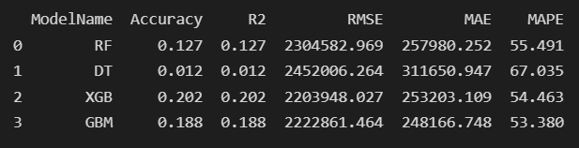

Literature Review
A literature survey is a systematic and exhaustive search of all types of published literature, as well as extra sources, such as dissertations, in order to uncover as many articles as possible on a certain subject.

This section begins by providing an overview of the London house prices.
We will evaluate the dataset for this project and discuss the features that we have chosen to include in the prediction model. Lastly, we analyse relevant research that we discovered during our preliminary research as well as the project's relevance.
- Machine Learning based Predicting House Prices using Regression Techniques
Authors: J Manasa, Radha Gupta, N S Narahari
Publication: 2020 2nd International Conference on Innovative Mechanisms for Industry Applications (ICIMIA)
The purpose of this study is to attempt to create a predictive model for evaluating the price based on the price-influencing components. Modelling investigations make use of a variety of regression approaches, including multiple linear regression (Least Squares), Lasso and Ridge regression models, support vector regression, and boosting algorithms such as Extreme Gradient Boost Regression (XG Boost). These models are used to construct a predictive model and to select the best performing model based on a comparison of the prediction errors produced from these models. The objective here is to develop a prediction model for evaluating prices based on the elements that affect them. The models used for this project are least squares model, Lasso and Ridge regression models, SVR model, and XGBoost regression model.
The dataset employed contains a variety of important parameters, and data mining has been at the foundation of the system's development. Initially, the entire dataset is cleaned up and the outlier values are shortened, as well as any other necessary adjustments. Moreover, because each parameter is weighted depending on its significance in determining the pricing of the system, the value that each parameter withholds in the system has increased as a result of the weighting process. At the end of the process, three distinct machine learning algorithms were shortlisted and evaluated against our system in various combinations to ensure that the findings were as reliable as possible.

Even after that, a novel approach was taken in order to improve accuracy, and the study resulted in the conclusion that the actual real estate worth is also dependent on adjacent local amenities such as a train station, supermarket, school, hospital, temple, and parks, among other things. As a result, a novel solution is being presented to address this requirement. In this case, the Google Maps API is used, and the radius of 0.5 km must be narrowed down using a locality search. Now, if they come across any such public places in the circle, they should raise the value of the property in proportion to their discovery. As a result, we tested our model with manual examples, and the results were astounding in terms of accuracy in prediction.
In the end, a system that aims to provide an accurate prediction of housing prices has been developed. The system makes optimal use of Linear Regression, Forest regression, Boosted regression. The efficiency of the algorithm has been further increased with use of Neural networks. The system will satisfy customers by providing accurate output and preventing the risk of investing in the wrong house. Additional features for the customer's benefit can also be added to the system without disturbing it's core functionality. A major future update could be the addition of larger cities to the database, which will allow our users to explore more houses, get more accuracy and thus come to a proper decision.
(https://ieeexplore.ieee.org/abstract/document/8473231)

- Machine Learning for a London Housing Price Prediction Mobile Application
Authors: Aaron Ng
Publication: Individual Project: Final Report, department of computing, Imperial college London
(http://www.doc.ic.ac.uk/~mpd37/theses/2015_beng_aaron-ng.pdf)
This project aims to deliver a mobile application that can forecast future house prices in London. Numerous regression methods were investigated and compared in order to pick a prediction approach. Gaussian Processes (GP), was chosen for regression due to its adaptable and probabilistic approach to learning and model selection. To manage the massive dataset of historical property transactions in London, leverage the dataset's spatial structure to disperse computations to smaller, autonomous local models. We derive aggregate forecasts by recombining predictions from local models. By training the model and generating predictions on the server-side of the application, we can offload computationally intensive activities and concentrate on client-side visualisation generation. Our findings indicate that our approach to the problem has been largely successful, with predictions that are comparable to those produced by previous housing price prediction models.
Machine learning is the study of algorithms that can learn from data and make
predictions, by building a model from example inputs rather than following
static instructions. These algorithms are typically classified into three categories: supervised learning, unsupervised learning and reinforcement learning.
A system is supplied with examples of inputs and outputs in order to produce a function that maps the inputs to the outputs. This is known as supervised learning.
The two most common types of supervised learning issues are regression and classification challenges. Without a supervisor, unsupervised learning is concerned with leaving the system to figure out its own structure based on its inputs, with the goal of uncovering hidden patterns. Density estimation, dimensionality reduction, and clustering are all examples of machine learning techniques. The final type of reinforcement learning is the study of how a system may learn and optimise its actions in an environment in order to maximise its rewards. For example, training a robot to navigate a maze is a form of reinforcement learning.
Regression is a subset of supervised learning in which the outputs are continuous, as opposed to categorical. Because we are concerned with forecasting values that can lie within a continuous range of outputs, the challenge of predicting future house prices can be regarded a regression problem. We will be able to investigate the relationship between the independent variables we have chosen (date, type, build, tenure, and address) and the price of the property through the use of regression analysis.
The smartphone application we developed gives users with an innovative approach to look at future property price estimates in the city of London, and we are proud of that accomplishment. Several regression approaches were investigated and compared before arriving at a prediction method based on generalised estimating equations (GP) for regression. The usage of linear prior mean functions has been incorporated into our model, resulting in future price projections that are more reasonable in nature. We came up with a strategy to make the most of as much data as possible in our prediction system by using the concepts of distributed general purpose computers. In order to improve the speed of our programme, we have divided it into two parts: a client-side component and a server-side component. As a result, heavy computations are performed on the server-side, while the production of visualisations is performed on the client-side component. The success of our technique to developing a mobile application for producing predictions can be used to other problem sets involving regional changes in the prediction model, if the approach is repeated successfully.

- Predicting property prices with machine learning algorithms
Authors: Winky K.O. Ho, Bo-Sin Tang, Siu Wai Won
Publication: Journal of Property Research, Volume 38, 2021-Issue 1
(https://doi.org/10.1080/09599916.2020.1832558)
In this work, three machine learning methods are used in the appraisal of property prices: the support vector machine (SVM), the random forest (RF), and the gradient boosting machine (GBM). It applies these methods to a data sample of approximately 40,000 home transactions in Hong Kong over an 18-year period, and then compares the results of the various algorithms used. When compared to SVM, the predictive power of RF and GBM has been found to be significantly higher. The three performance metrics connected with these two algorithms, including mean squared error (MSE), root mean squared error (RMSE), and mean absolute percentage error (MAPE), all surpass those related with SVM. However, our research has discovered that SVM is still a valuable algorithm in data fitting since it is capable of producing reasonably accurate predictions within a limited time frame, as demonstrated by our findings. Conclusion: Machine learning is a viable alternative technique in the field of real estate valuation and appraisal research, particularly in the area of property price prediction.
In today's digital age, meaningful information about the society can be retrieved from a broad variety of sources and kept in a variety of formats, including structured, unstructured, and semi-structured formats, depending on the source. Progress in new technology makes it feasible to systematically extract useful information from economic phenomena or social observations, translate that information into sophisticated data forms and structures, and then conduct appropriate analyses on that information. Traditional data processing and analytical tools may be unable to acquire, process, and analyse increasingly complex information in the social and economic spheres as a result of these new situations. In response to the enormous amount of data that has become available, new ways have been created to deal with it.
A cutting-edge technology for identifying, interpreting, and analysing massively complex data structures and patterns, machine learning is one of the most promising techniques currently available (Ngiam & Khor, 2019). It enables consequential learning and improves model predictions by incorporating more recent data into the model in a methodical manner (Harrington, 2012; Hastie et al., 2004). Research on machine learning, which is currently underway, is a subset of artificial intelligence (AI) that aims to train computers with new knowledge through the input of data such as texts and images as well as numerical values, among other things, and to facilitate the interaction of computers with other computer networks. 'Machine learning,' according to Feggella (2019), is the study of 'enabling computers to learn and act like humans do, and to enhance their learning over time in an autonomous manner, by feeding them data and knowledge in the form of observations and real-world interactions'.
Because of advancements in computing technology, it is now possible to investigate social information that was previously impossible to gather, process, or analyse. In the field of property research, new analytical tools based on machine learning can be applied. This study is an exploratory attempt to estimate house prices using three machine learning algorithms and then compare the results obtained from each approach.

We train our models using housing property data spanning 18 years, utilising stochastic gradient descent (SGD)-based support vector regression (SVM), random forest (RF), and gradient boosting machine techniques to identify patterns in the data (GBM). The performance measures have revealed that modern machine learning algorithms are capable of achieving extremely accurate predictions of property prices, as evidenced by our research. We conclude that RF and GBM are capable of generating comparable accurate price estimations with reduced prediction errors when employed in conjunction with our dataset in this paper. This is in contrast to the findings obtained using SVM.

First and foremost, our research has demonstrated that advanced machine learning algorithms such as SVM, RF, and GBM are potential tools for property researchers to employ in the prediction of home prices. However, we must be aware that these machine learning techniques have their own set of limits, which we must be mindful of. There are typically a plethora of potential characteristics for researchers to choose from and incorporate into their models, making feature selection extremely important and time-consuming.
To make matters even more complicated, many standard estimating methods give reasonably excellent estimates of coefficients that reveal a link between an output variable and one or more predictor variables. These strategies are meant to provide explanations for real-world phenomena as well as offer forecasts in the future. They are employed in the development and testing of theories, as well as in the performance of causal explanation, prediction, and description (Shmuell, 2010). Investigators can analyse the findings and offer policy suggestions based on the estimates they have derived. Machine learning algorithms, on the other hand, are not always created with these objectives in mind. Despite the fact that machine learning may yield model predictions with extremely low error rates, the estimated coefficients (or weights, in machine learning language) derived by the models may at times be difficult to interpret.
In addition, the computation of machine learning algorithms frequently requires significantly more time than conventional methods, such as the hedonic pricing model. The selection of an algorithm is based on the assessment of a number of parameters, including the size of the data set, the computational capacity of the equipment, and the availability of waiting time for the results to be obtained. If speed is a primary consideration, we recommend that property valuers and researchers employ SVM to make forecasts for their clients. When accuracy in prediction is a primary goal, RF and GBM should be evaluated as alternatives to conventional methods.

To summarise, the application of machine learning in real estate research is still in its infancy. With this work, we expect to have made a little step forward in the field of property evaluation by giving some methodological and empirical contributions to the field and presenting an alternate perspective to the valuation of home values. Additional property transaction data from a bigger geographical area with more attributes, as well as the analysis of various property kinds other than housing construction, may be considered for future study directions.

- A hybrid regression technique for house prices prediction
Authors: Sifei Lu, Zengxiang Li, Zheng Qin, Xulei Yang, Rick Siow Mong Goh
Publication: 2017 IEEE International Conference in Industrial Engineering and Engineering Management (IEEM)
Typically, the House Price Index (HPI) indicates the sum of changes in the price of residential real estate. Whereas, for single-family home price forecasting, a more accurate method based on location, house type, size, construction year, local amenities and other factors that could affect house demand and supply is required. With a constrained dataset and data characteristics, this research investigates a practical and composite data pre-processing, creative feature engineering approach that uses composite data pre-processing. In addition, a hybrid Lasso and Gradient boosting regression model for predicting individual property prices is proposed in the research. The proposed approach was recently used as the primary kernel for the Kaggle Challenge "House Prices: Advanced Regression Techniques," which was hosted by Kaggle and hosted by Kaggle. Our most recent score placed us in the top one percent of all competition teams and individuals, which indicates that we are on the right track.
Machine learning is the process of developing algorithms and building models from data, and then using those models to predict outcomes based on additional data. The primary distinction between traditional algorithms and machine learning algorithms is that a model is generated from input data rather than just following a series of instructions. Supervised learning makes use of data that has been labelled with the results, whereas unsupervised learning makes use of data that has not been labelled. There are a few typical machine learning methods, such as regression, classification, neural networks, and deep learning, that are used in various applications. Deep learning makes extensive use of reinforcement learning and representation learning techniques. Selected among the top one percent of all competition teams and individuals.
The process of feature engineering has gone through several iterations in order to identify the ideal number of features. We then attempted to find the optimal alpha parameter for Ridge regression, the optimal alpha parameter for Lasso regression, and a group of optimal parameters for Gradient boosting regression, such as colsample bytree, gamma, max depth, min child weight, subsample, reg alpha, reg lambda, and learning rate, using the training data. To conclude, taking into account the Coupling effect across regression methods, we analysed a handful of hybrid regression combinations in order to obtain a combination of 65 percent Lasso and 35 percent Gradient boosting.
The results of the test demonstrate that it is beneficial to develop further new features. The programme must set default values for those missing values that are based on statistical results using multiple methods, such as the mode method, noValue, the zero value, or the median value, among others. Log transformation is a highly handy strategy for dealing with various skewed distribution characteristics.

An interesting discovery is how to utilise Lasso to choose features; however, it is necessary to try and validate the features that are to be deleted before proceeding. For this particular case, there are approximately 230 features that must be preserved.

It is the goal of features engineering to increase data normalcy and linearity, and it is the goal of set parameter optimization to improve data homoscedasticity that high iteration times are employed for. It's also worth noting that the ideal number of features for training data may not equal the optimal number of features for test data. Although the optimal group of parameters for Gradient boosting for training data may be the best group for test data, this may not always be the case.
The coupling impact of numerous regression algorithms is demonstrated by this result. According to the results, hybrid regressions outperform the ones derived using Ridge, Lasso, or Gradient boosting regression techniques. The best hybrid regression result for test data is 0.11260, obtained using a combination of 65 percent Lasso and 35 percent Gradient boosting.
The Lasso tool is quite useful for feature selection, and deleting unnecessary features has the additional benefit of decreasing the MSE result of Ridge, Gradient boosting regression.
The prediction SalePrice will be more accurate for future transactions if we include more features such as the economic cycle, population mobility, and interest rate. The best place on the Kaggle House Prices competition Public Leaderboard is in the top one percent of all teams and individuals who competed in the competition. Because it is a genuine and extremely fierce competition, our experience has taught us that the programme must be exceptional in the areas of creative feature engineering, feature selection, regression methods, parameter selections, and hybrid regression selection in order to be successful in the competition.
(https://ieeexplore.ieee.org/abstract/document/8289904)

Chapter - 3
SYSTEM REQUIREMENTS SPECIFICATION
When it comes to software development, a software requirements specification (SRS) is a document that outlines the software system that will be built. Additionally, it includes a set of use cases that describe how the software must interact with its users. It also includes functional and non-functional requirements. In an SRS, it is crucial to specify the requirements as well as the methods for meeting them. Because it provides them with an understanding of how the project will be carried out, it allows them to save time. The team will also learn about the team's limitations and vulnerabilities as a result of this early learning process.
SRSs are comprehensive descriptions of software systems that must be built, containing both functional and non-functional requirements for the system being built. It could also include use examples that illustrate how the consumer will engage with the product in the future. In accordance with the project development criteria, the software requirement specification document has been created. In order to build software systems, we need to have a full understanding of how they work. In order to achieve this, we must keep in continual communication with clients in order to gather all of their requirements and requirements.
A good Software System Requirements Specification (SRS) outlines how the Software System will interact with all internal modules, hardware, and other programmes, as well as with human users in a wide range of real-world scenarios. For testers to prevent errors in test cases and expected outcomes, it is vital that they comprehend every element discussed in this document.
Qualities of SRS
• Correct
• Complete
• Consistent
• Modifiable
• Traceable
• Unambiguous
• Verifiable
• Ranked for importance and/or stability

The following are some of the objectives that an SRS should be able to accomplish:
• Assist the customer in providing feedback, ensuring that the IT company is aware of the problems that the software system is designed to answer and how to solve them.
• Simply stating the requirements can aid in the breakdown of a complex problem into smaller components.
• The testing and validation methods should be accelerated, and there should be more evaluations.

1.1 Functional Requirements
It is a Functional Requirement when a software product must perform a specific function. An example of a software system or an individual component of one is the term "software component." One can think of a function as the sum of the inputs, behaviour, and outputs of a software system. Any calculation, data manipulation, business process, user interaction, or any other unique functionality that describes the purpose that a system is likely to achieve can be included in the specification. In software engineering and systems engineering, a Functional Requirement might be anything from a high-level abstract expression of the sender's necessity to precise mathematical functional requirement specifications. It is easier to capture the desired behaviour of a system when you have functional software requirements.
Benefits of functional requirements:
• Assists you in deciding whether the application meets all of the functional requirements specified for the application.
• A functional requirement document assists in defining the functionality of a system or one of its subsystems.
• When combined with requirement analysis, functional requirements aid in the identification of missing requirements. They contribute to the definition of the system's intended service and functioning.
• Assist users with their objectives, duties, or activities.
1.1.1 Basic Requirements

1-The dataset used in this study was compiled from reputable sources and then blended together to form the necessary data collection. Our weather data came from the website https://en.tutiempo.net/, and our crop yield data came from the page https://www.kaggle.com/srinivas1/agricuture-crops-production-in-india/. It covers crop identities, production, region, average temperature, average rainfall (mm), period, year, and the titles of the states and districts. The dependent variable, also known as the class variable, is production. In this equation, there are eight types of variables and one dependent variable.
2-The purpose of data pre-processing is to change raw data into a format that can be used for machine learning. When data is structured and tidy, a data scientist can acquire more precise results from a machine learning model. The process includes the formatting, cleansing, and sampling of data. This type of data pre-processing is concerned with identifying attributes that have no or erroneous values, as well as identifying correlations between different attributes. Using data pre-processing, you may also figure out the effect of each parameter on the target variable. To pre-process our datasets, we used an EDA technique. All invalid and null values were handled in accordance with the importance of the property, with the record being deleted or the default value being assigned to it depending on the situation.
3- Separation of data into training and test sets: A machine learning dataset should be partitioned into two subsets: training sets and test sets. We divided the dataset in half using an 80 percent split ratio, which meant that out of 100 records, 80 were included in the training set and the remaining 20 were included in the test set.
Fourth, model training can commence when a data scientist has pre-processed the received data and separated it into train and test sets. This technique consists in providing the algorithm with training data. In a predictive analysis, an algorithm will evaluate data and develop a model that is capable of locating a target value (attribute) in new data in order to offer the answer you want. In model training, the ultimate goal is to construct a model. To train our model, we employed a random forest approach. When the model is trained, it predicts the yield based on the other qualities of the dataset that are used as input.
5- Model review and testing: The goal of this stage is to develop the simplest model that is capable of quickly and accurately calculating a target number. A data scientist can accomplish this through model adjustment. This is the process of optimising model parameters in order to achieve the best feasible performance from an algorithm.

1.1.2 Application Requirements

1. Users must be able to create new accounts.
2. Users who already have an account should be allowed to login.
3. The weather prediction system must be capable of accurately forecasting the average rainfall and temperature.
4. The user should be able to enter necessary information such as soil type and area.
5. The application's modules must all function properly.
6. Predictions must be precise.
7. The user's session must be terminable.
3.2 Non-Functional Requirements
The Non-Functional Requirement (NFR) tells us how good a software system is. They look at the software system's responsiveness, usability, security, portability, and other non-functional factors that are important for it to work well. Non-functional requirements that aren't met can make systems that don't meet the needs of the people who use them. This can make the systems less useful. Non-functional Requirements let you set limits or restrictions on the system's architecture across a number of agile backlogs at the same time. For example, if there are more than 10,000 people at the same time, the site should load in three seconds, not five. They set out the criteria that can be used to judge a system's performance rather than specific behaviours. They could be linked to emergent system characteristics like reliability, response time, or store occupancy. They could also be linked to the way the system was built. User needs, budget constraints, organisational policies, the need for interoperability with other software and hardware systems, or outside factors like these: Product Requirements, Organizational Requirements, Users, Basic Operational Requirements, and soon. These are all non-functional requirements.
Benefits of Non Functional Requirements:
• Non-functional criteria make sure that the software system meets legal and regulatory standards, so it is safe to use and use.
• It is their job to make sure that the software system is reliable, available, and works well at all times.
• They make sure that the software is easy to use and that the user has a good experience when they use it.
• At the same time, they help to make the software system's security policy stronger.
3.2.1 Requirements

A person who is in charge of the system's data can only change the permissions for system data.
This rule: 2. Passwords can't be seen at the point of entry or at any other time.
3. Apps should be able to change as people use them more or handle more data over time.
4: The application should be able to respond to the user's input or any other interruption that is important and return to the same state.
Users should be able to figure out how the App works quickly. Yes, the App must be easy for people to use on their own.
This means that you need to protect all of the app data by encrypting and protecting it with the least amount of fuss.
7. There should be a way for the user to get the app and check for updates so that they can give feedback.
8. The layout of the app should be able to change to fit different screen sizes. Along with automatic font size changes and image rendering, this also comes with.
9. The application must be simple to keep up with.
10. The app should run at a speed that the users want. A programme that takes a long time might make people angry, so they won't choose it over a faster one.
11. It must be easy to use. It is very important for the application to have a user-friendly app.

3.3 Hardware Requirements

When it comes to hardware requirements, they outline the physical computer resources that are required for a system to operate effectively. It is possible that the hardware requirements will form the basis of a contract for system implementation, and as such they should be a full and consistent characterization of the entire system. The hardware specifications are listed in the next section.
1. CPU - A processor with a clock speed of 2.4 GHz or higher is required for the proposed system.
Ethernet connection (LAN) OR a wireless adaptor are both options (Wi-Fi)
3. Hard drive: Hard drives (HDDs) are a type of nonvolatile storage that preserves data even after the computer is shut down. It is recommended that you use RAM with a capacity of at least 32 GB for the system that has been recommended.
The fourth type of data storage is random-access memory (RAM), which is a type of computer data storage that stores data and machine code that is actively in use. It is recommended that the proposed system have a minimum of 2 GB of RAM.

3.4 Software Requirements

The software requirements document contains a description of the characteristics and functionalities of the target system. The requirements document communicates the expectations of users regarding the software product. It is possible for requirements to be obvious or hidden, known or unknown, expected or unexpected, from the perspective of the client.

One such tool is Jupyter Notebook, an open source web application that lets you to generate and share documents that contain live code, equations and visualisations, as well as text. 2. Currently, there are over 100 different Python kernels available for use with Jupyter, including the IPython kernel, that enables users to create Python programmes. In total, there are three pieces to the Jupyter Notebook:

• The notebook web application
• Kernels
• Notebook documents
•
Python is a high-level, object-oriented programming language with dynamic semantics that is mostly used for web and application development. Because it supports dynamic type and dynamic binding, it is particularly well-suited for Rapid Application Development. Python is a very simple language to learn since it has a different syntax that emphasises readability. Python code is substantially simpler for developers to read and translate than code written in other languages. As a result, the cost of maintaining and developing programmes is decreased, as teams may interact without significant language and experience barriers. Additionally, Python supports the use of modules and packages, which enables the development of modular programmes and the reuse of code across multiple applications.
2. Iconic Development Tool: Ionic simplifies the process of developing advanced mobile and Progressive Web Apps (PWAs) that look and feel fantastic on any platform or device. Ionic's open-source Framework and developer-friendly resources and services power apps for some of the world's most recognisable brands, like Sworkit, Untappd, and Dow Jones MarketWatch, as well as mission-critical applications for Nationwide, Amtrak, and NASA. The open-source Ionic Framework offers a wide library of front-end building blocks and user interface components that simplify the process of developing beautiful, high-performance mobile and Progressive Web Apps (or PWAs) using web technologies such as HTML, CSS, and JavaScript.
System Analysis and Design
Planning, analysis, design, implementation and upkeep are the stages of system development. Essentially, system analysis is the process of gathering and interpreting data, identifying faults, and disassembling a system into its constituent parts. In order to determine the goals of a system or its components, it is necessary to evaluate the system or their components. In order to achieve their aims, it is a problem-solving strategy that enhances the system while also ensuring that all of the system's components operate efficiently. The behaviour of a system is defined by its analyses. System design is the process of establishing a new business system or updating an existing one through the description of its components or modules in order to match specific requirements. It is also known as system architecture. First and foremost, you must do a thorough analysis of the present system and establish the most efficient strategy to incorporate computers into the system. Designing systems has as its goal the discovery of the most effective approach for achieving the system's goal.
System Architecture
With the help of architectural diagram designers and developers can depict the high-level, encompassing structure of a system or application in order to ensure that it fits the needs of its users. Additional uses for them include describing repeating patterns within an architectural design. The document is similar to a blueprint in that it can be used as a guide for team deliberation, improvement, and implementation.

Flow Chart
A flowchart is a graphical representation of a set of stages that is used in business. Given that it depicts steps in a sequential manner, it is frequently used to depict the flow of algorithms, workflows, or processes. A flowchart often illustrates the processes as various types of boxes, with arrows connecting them in the right order, as shown in the example below. In computer science, it was originally intended to be a tool for defining algorithms and programming logic, but it has now been expanded to cover all kinds of processes. Flowcharts are increasingly commonly utilised for displaying data and providing logical support for decisions. In the visualisation of complex processes and the elucidation of issue and activity structures, they can be of significant assistance. A flowchart can also be used to define a process or project that needs to be carried out, as seen in the example below.
In this algorithm, a sample dataset with n input variables and 1 output variable is used as input data. The selection of random samples from a dataset is the first step in the procedure. Following that, this algorithm will generate a decision tree for each sample that is received. Following that, the prediction outcome from each decision tree will be determined. Finally, the outcome is derived by taking the average of all of the forecasts and dividing it by two.

Result and Discussion
This is how the web page looks to the user. It allows the user to give the required inputs to predict the future house price. Once all the inputs are entered, user can click on predict price to get the output.


The following picture shows the output i.e., the predicted price for the given input.

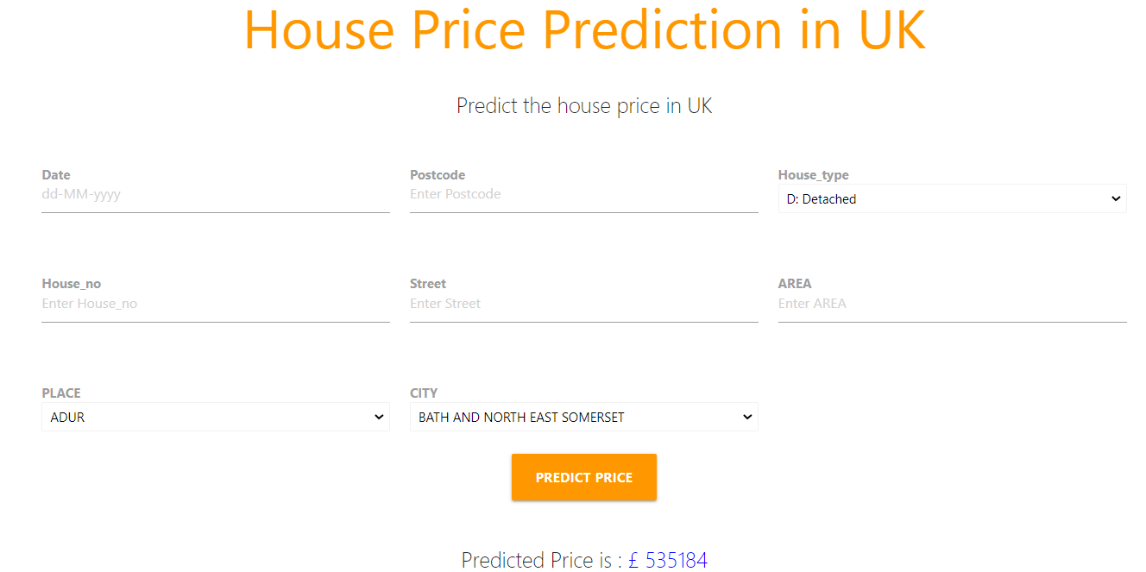

Testing and Validation
By testing the web-page we can find the information about the quality of the web page. We aim to cover all the required aspects of software testing to test the web page. Software testing is a process that can deliver about the service or quality of the software product which is under consideration. Software testing can also provide a firm with an objective, unbiased view of the software, helping them to grasp and appreciate the risks involved with the software development and installation of new technology. Software testing is the process of reviewing and validating that a software product or programme accomplishes what it is designed to do before it is released to the public. Testing has numerous advantages, including the prevention of bugs, the reduction of development expenses, and the improvement of performance. ( https://www.ibm.com/topics/software-testing). In the software industry, testing processes are defined as the practise of running programmes or applications with the purpose of discovering software defects (errors or other problems) and assuring that the software product is ready for use. Software testing is the process of evaluating one or more attributes of interest by executing a software component or a system component on a computer. They often reflect how much a component or system is worth, and they include the following characteristics:
• it meets the criteria that guided its design and development;
• it performs its functions in a reasonable amount of time;
• it responds appropriately to a variety of inputs;
• it is sufficiently usable;
• it can be deployed and run in the appropriate conditions; and it achieves the desired general outcome for its stakeholders.

7.1 Functionality Testing
• A successful connection to the database has been established.
• The application's navigation between pages is accurate, precise, and rapid.
• The application's forms all operate as intended.
• After each activity on the application, the necessary data is retrieved from the backend.
• When user inputs are wrong, relevant warning messages are displayed.
7.2 Usability Testing
• The application is simple to navigate, which contributes to a positive user experience.
• Dropdown menus are used to capture user inputs, ensuring that the system obtains reliable data.
• The app's content has been vetted and complied with regulatory requirements.
• The databases used to forecast crop yields are exact and well-balanced;
• Incorrect inputs are handled appropriately by the system.
7.3 Interface Testing
• Server or user-initiated interruptions are handled promptly.
• The application connects to the server in a secure manner. A suitable message is given in the event of a failure.
• When a user enters wrong credentials or an invalid email address, the app immediately replies by displaying appropriate alerts.
• The user interface is intuitive and effortless to use.
7.4 Compatibility Testing
• It works on all mobile and desktop devices.
• This application is compatible with all browsers that support javascript.
7.5 Performance Testing
• It works flawlessly with a reasonable internet speed.
• Inputs from users are accurately interpreted, and responses are captured instantly.
• The connection is secured, and sensitive user data is securely kept.
• There is a seamless transition from one screen to the next.

