

Applied Leadership and Management in the Workplace Module Assignment Submission

Student Name: | Tomasz Paczkowski
Student Number: | 2018054
Module No: | BMSK4014
Module Title: | Problem Solving and Decision Making

Table of Contents
- Introduction p.3
- Definition of the Workplace Problem p.4
2.1 Problem Statement p.4
2.2 Possibility p.4
2.3 Impact p.5
- Analysis of the Problem p.6
3.1 Brainstorming p.6
3.2 5 Whys Analysis p.7
3.3 Ishikawa (Fishbone) Analysis p.8
- Possible Solutions p.9
- Evaluation of Solutions p.10
5.1 Grid Analysis p.10
5.2 Cost–Benefit Analysis p.11
5.3 Decision p.11
- Implementation Plan p.12
6.1 Action Plan p.12
6.2 Gantt Chart p.13
- Communication Plan p.14
7.1 Stakeholders p.14
7.2 Stakeholder Communication Plan p.14
- Monitoring and Review p.15
8.1 Monitoring Techniques p.15
8.2 Milestones p.15
8.3 Review Strategy p.15
- Conclusion p.16
- References p.17

1. Introduction
Problem-solving is one of the most essential skills within modern organisations. Managers and employees alike are continually faced with situations that require clear thinking, structured analysis, and effective decision-making. In sectors such as logistics, where efficiency and reliability underpin both customer satisfaction and organisational performance, the ability to identify, evaluate, and resolve problems is critical.
This report addresses a complex problem within the logistics industry: frequent delivery delays caused by miscommunication between drivers and dispatchers. While at first glance this may appear to be a relatively straightforward issue, closer analysis reveals that it has multiple root causes, involves several stakeholder groups, and carries significant operational and reputational consequences for the business.
The report is structured around a step-by-step problem-solving approach. First, the workplace problem will be clearly defined, including its scope and impact. Second, the problem will be analysed using recognised techniques such as brainstorming, the 5 Whys method, and an Ishikawa (Fishbone) diagram. Third, a range of possible solutions will be proposed, followed by a critical evaluation using decision-making tools such as Grid Analysis and Cost–Benefit Analysis.
Finally, the most appropriate solution will be identified and justified. This will then lead into Part 2 of the report (not included here), where a detailed implementation plan, communication plan, and monitoring framework will be developed to ensure successful delivery.
The purpose of this report is not simply to suggest a quick fix but to apply structured problem-solving techniques in a way that addresses both immediate operational needs and long-term organisational effectiveness.

2. Definition of the Workplace Problem
Problem Statement
The depot in which I work, a medium-sized logistics hub, has experienced a recurring problem of delivery delays linked to miscommunication between dispatchers and drivers. While occasional delays are expected in logistics due to external factors such as traffic or weather, the frequency of delays attributed specifically to communication failures has raised concerns among both managers and customers.

2.2 Possibility
The problem is widespread and affects several groups:
- Drivers: Frequently receive incomplete, inconsistent, or late instructions. This leads to confusion, incorrect sequencing of drops, and wasted time revisiting addresses.
- Dispatchers: Often overwhelmed by having to communicate individually with multiple drivers throughout the day. This increases stress levels and the likelihood of errors.
- Customers: Experience late deliveries missed time slots, and reduced confidence in the organisation’s reliability.
- Managers: Must handle an increase in complaints, process refunds or redeliveries, and justify poor performance to senior leadership.
- The Organisation: Suffers reputational damage, financial losses due to overtime and redelivery costs, and decreased employee morale.

2.3 Impact
The impact of this problem is significant:
- Operational inefficiency: Deliveries take longer than scheduled, and drivers often must backtrack.
- Customer dissatisfaction: Complaints have increased, with some customers threatening to switch to competitors.
- Financial losses: Additional fuel costs, overtime payments, and redelivery expenses accumulate.
- Employee morale: Drivers become frustrated when blamed for delays outside their control, and dispatchers feel under pressure from both sides.
- Reputation: Poor service performance damages the organisation’s credibility in a highly competitive industry.
In summary: this is not a small, isolated issue but a complex problem that directly undermines customer trust, staff morale, and the financial health of the organisation.

3. Analysis of the Problem
To understand the problem fully, it is necessary to go outside surface-level symptoms and identify the root causes. A range of known analytical tools were applied, including brainstorming, the 5 Whys technique, and the Ishikawa (Fishbone) diagram.

3.1 Brainstorming
During informal discussions with colleagues, a range of possible contributing factors were identified:
- Drivers often rely on verbal instructions, which can be forgotten.
- Dispatchers handle too many queries simultaneously.
- Mobile signal is unreliable in certain areas.
- There is no centralised system for updating routes.
- Written delivery manifests are sometimes unclear or outdated.
- Last-minute customer requests (e.g., safe-place instructions) are not communicated effectively.
This brainstorming exercise revealed that the issue is multifaceted and involves both human and technological elements.

3.2 5 Whys Analysis
The 5 Whys technique helps drill down to the underlying cause of a problem:
- Why are deliveries delayed?
Because drivers receive late or unclear updates.
- Why are updates late or unclear?
Because dispatchers are overloaded and rely on phone calls or radio messages.
- Why do dispatchers rely on phone calls?
Because there is no centralised, real-time communication system.
- Why is there no system in place?
Because management has not prioritised investment in digital tools.
- Why has management not prioritised this?
Because the true cost and impact of miscommunication (complaints, overtime, reputational loss) were underestimated.

Root Cause Identified:
Through the 5 Whys analysis, the root cause of communication issues was identified as the absence of a clear, standardized communication system. Drivers and dispatchers rely on inconsistent channels, leading to missed updates and delays. Without agreed protocols, misunderstandings accumulate, ultimately reducing efficiency, morale, and overall service performance.

3.3 Ishikawa (Fishbone) Analysis
The Fishbone Diagram provides a structured view of potential causes, grouped into categories:
- People: Drivers misinterpret instructions; dispatchers overloaded; inconsistent communication styles.
- Processes: No standardised communication protocol; reliance on ad hoc updates.
- Technology: Limited use of handheld devices; poor mobile/radio coverage.
- Environment: Traffic congestion requires frequent rerouting; unpredictable customer availability.
- Management: Lack of training in communication; underestimation of problem’s seriousness; no clear accountability for delays.
This analysis highlights that the problem is not simply due to individuals making mistakes but stems from systemic weaknesses in processes, technology, and management.
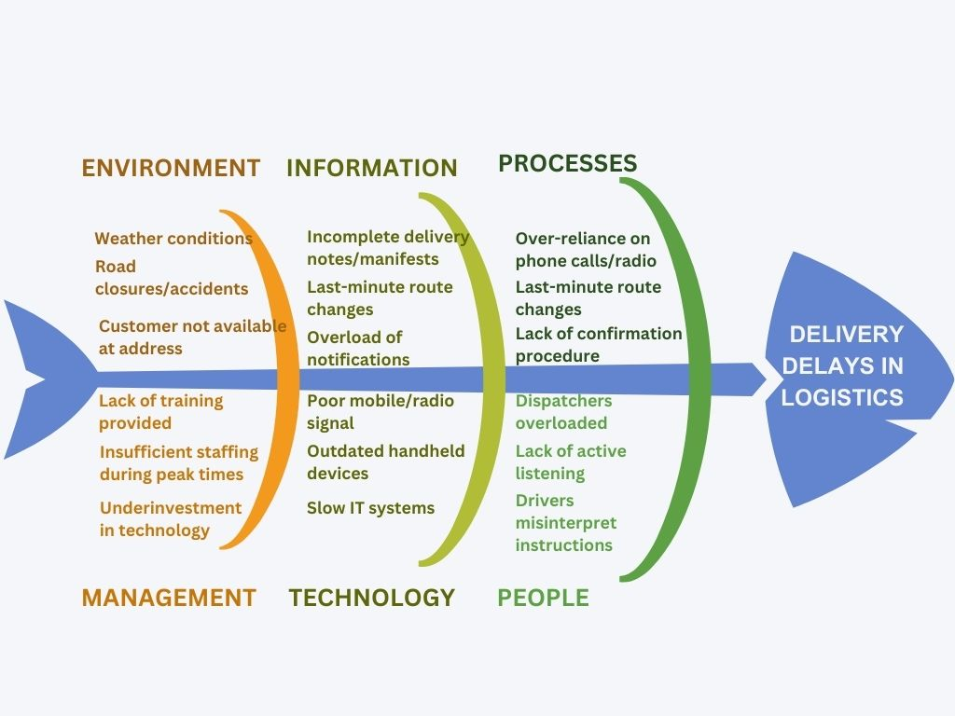
4. Possible Solutions
Based on the problem analysis, several potential solutions were identified:
Introduce a Logistics Communication App
A digital app that provides real-time updates, route changes, and two-way messaging between dispatchers and drivers.
Could integrate with GPS and scheduling software.
Reduces reliance on phone calls and ensures a written record of instructions.
Standardise Dispatcher–Driver Protocols
Introduce clear procedures for how and when instructions are communicated.
Use consistent scripts to avoid ambiguity.
Ensure critical updates are always followed by written confirmation.
Training Programme
Provide training for both drivers and dispatchers on effective communication.
Focus on conciseness, clarity, and confirmation techniques (e.g., repeating back instructions).
Increase Staffing in Dispatch
Hire additional staff during peak hours to spread workload.
Reduces pressure and allows dispatchers to focus on accuracy.
Hybrid Approach (Combination)
Combine introduction of an app with standardised protocols and training.
Offers a more holistic solution addressing both technology and people factors.

5. Evaluation of Solutions
To determine the most appropriate solution, two recognised decision-making tools were applied: Grid Analysis and Cost–Benefit Analysis.

5.1 Grid Analysis
Criteria used: Cost, Implementation Time, Effectiveness, Staff Acceptance, Sustainability (scored 1–5).
Solution | Cost | Time | Effectiveness | Staff acceptance | Sustainability | Total
Communication App | 3 | 3 | 5 | 4 | 5 | 20
Standard Protocols | 5 | 5 | 3 | 4 | 4 | 21
Training Program | 4 | 4 | 3 | 5 | 4 | 20
Extra Dispatch Staff | 2 | 4 | 4 | 3 | 3 | 16
Hybrid Approach | 3 | 3 | 5 | 5 | 5 | 21

Result: The Hybrid Approach scored the highest (21 points), along with Standard Protocols. However, the hybrid approach offers greater long-term sustainability.

5.2 Cost–Benefit Analysis
- Communication App: Moderate cost, high benefit in efficiency and reliability.
- Standard Protocols: Low cost, moderate benefit, relies heavily on compliance.
- Training Programme: Moderate cost, long-term benefits in improved communication skills.
- Extra Dispatch Staff: High cost (ongoing salaries), benefit limited to reducing workload.
- Hybrid Approach: Higher upfront cost, but combined benefits of technology, training, and process improvements.
Result: The Hybrid Approach delivers the best cost-to-benefit ratio, particularly when long-term sustainability is considered.

5.3 Decision
While Standard Protocols scored highly in Grid Analysis, they are limited in addressing the systemic issues identified. A Hybrid Approach—introducing a logistics app, supported by training and standardised protocols—represents the most effective and sustainable solution.
This solution addresses both the technological gaps (lack of centralised communication) and the human factors (inconsistent communication, overloaded staff). It also promotes cultural change by embedding good communication practices alongside new tools.

6. Implementation Plan
Having identified the hybrid approach (introduction of a logistics communication app, supported by standardised protocols and targeted training) as the best solution, a detailed implementation plan is required.
6.1 Action Plan
The plan sets out the specific tasks required to deliver the solution, who is responsible, the timescales, and how success will be measured.

Action Plan – Logistics Communication Improvement
Objective | Action Steps | Responsible Person | Timeline | Success Criteria
Improve conciseness in verbal communication | Summarise key points in meetings | Self | 3 months | Shorter, focused briefings
Build confidence in giving feedback | Attend training & practise feedback | Self + Manager | 6 months | Positive colleague feedback
Strengthen presentation skills | Use visuals in team briefings | Self | 12 months | Higher engagement in meetings
Enhance adaptability with customers | Shadow experienced colleagues | Self | 6 months | Fewer escalated complaints
Improve written communication clarity | Review delivery notes before sending | Self | 2 months | Fewer misunderstandings
Develop leadership skills | Take lead on a small team project | Self | 12 months | Demonstrated ability to coordinate team

6.2 Gantt Chart
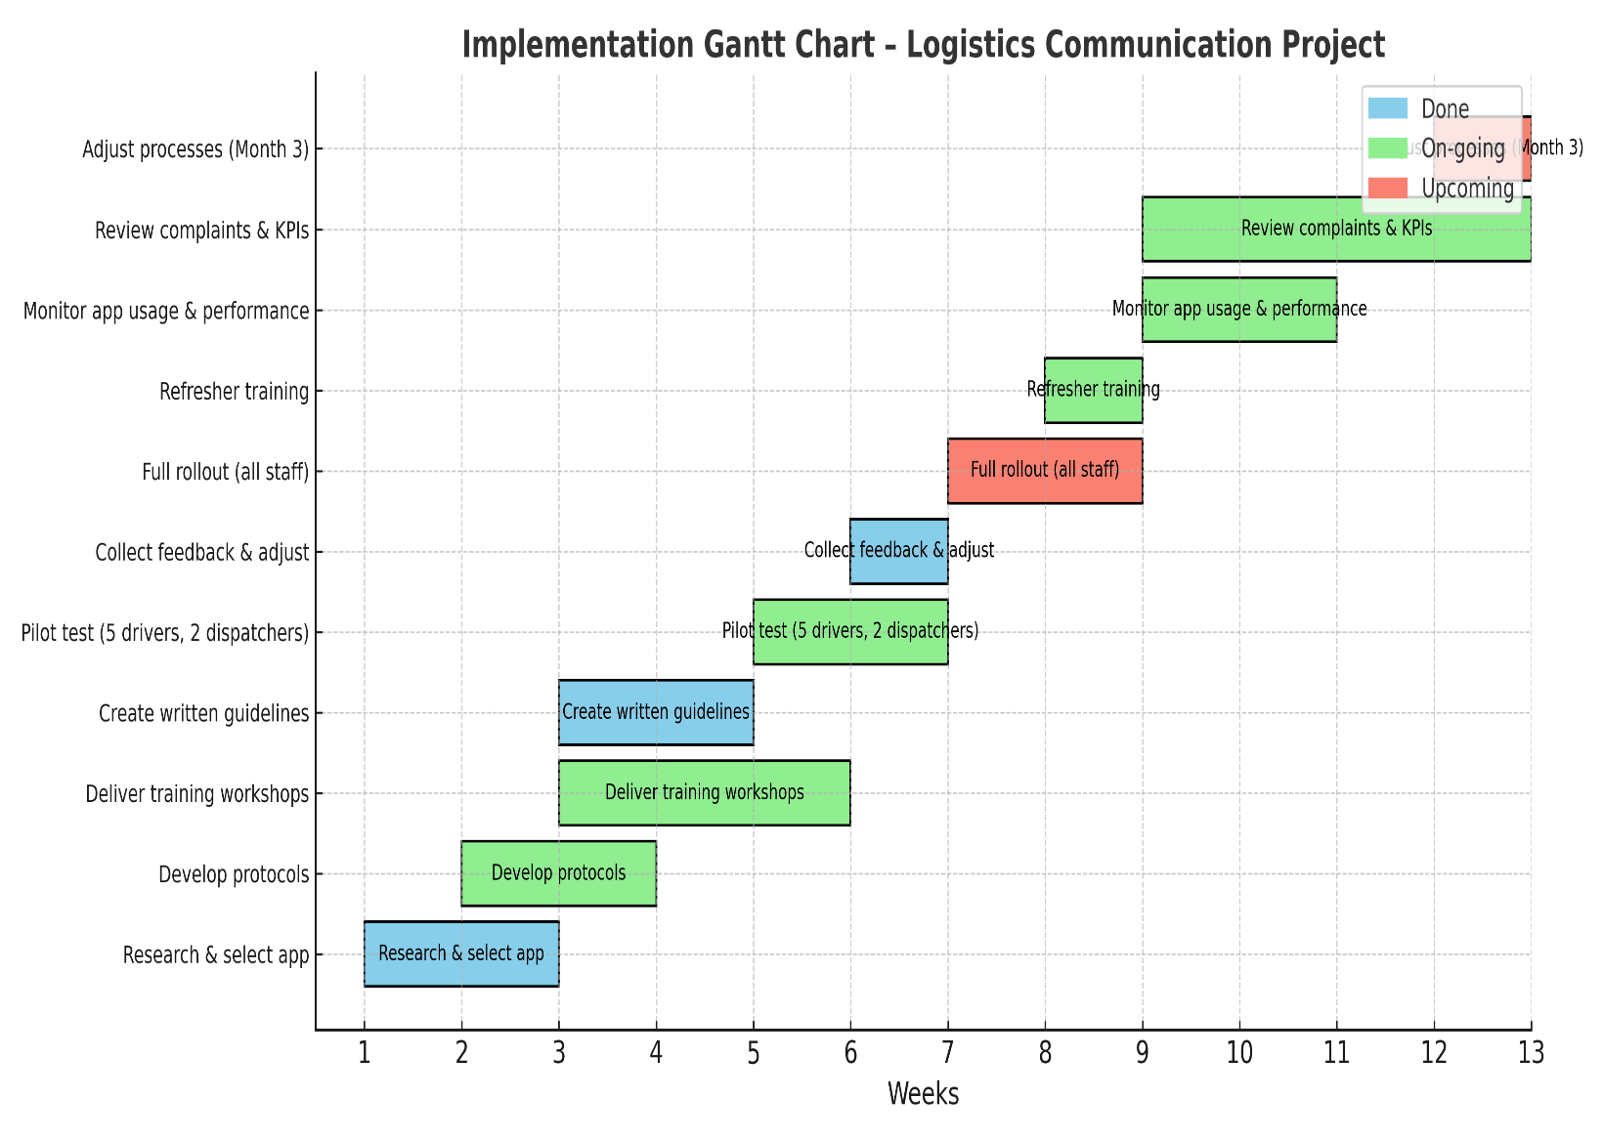

7. Communication Plan
7.1 Stakeholders
A wide range of stakeholders need to be kept informed during the implementation process:
Drivers – primary users of the app and protocols; require training and reassurance.
Dispatchers – heavily involved; need to adopt new processes and reduce reliance on calls.
Depot Managers – require progress updates and performance metrics.
Customers – benefit indirectly but need communication around improved reliability.
Senior Management – expect business case justification and clear evidence of ROI.

7.2 Stakeholder Communication Plan
1209 | Information Required | Frequency | Mode of Communication
Drivers | App usage instructions; training schedule; route update process | Daily during rollout; weekly thereafter | Training workshops, team briefings, app notifications
Dispatchers | Standard protocols; workload reduction measures | Weekly | Team meetings, written guidelines, email updates
Depot Managers | Implementation progress; KPIs (punctuality, complaints) | Bi-weekly | Progress reports, presentations
Customers | Service reliability updates; assurance of reduced delays | Monthly or as needed | Email bulletins, company website notices
Senior Management | ROI evidence; long-term performance data | Monthly | Executive reports, formal presentations

8. Monitoring and Review

8.1 Monitoring Techniques
Performance Data Tracking: Delivery punctuality, number of complaints, driver response times.
App Usage Logs: Monitoring how consistently drivers use the new system.
Feedback Surveys: Collecting qualitative feedback from both drivers and dispatchers on ease of use.
Progress Meetings: Weekly meetings during rollout, then monthly.
Comparative Analysis: Benchmarking current performance against pre-implementation levels.

8.2 Milestones
Week 2: App selected, protocols drafted.
Week 5: Training delivered; feedback indicates readiness.
Week 6: Pilot completed; delivery punctuality improved by at least 20%.
Week 8: Full roll-out; at least 95% of drivers using system.
Month 3: Complaints reduced by at least 30%.

8.3 Review Strategy
Progress will be reviewed against milestones using the Gantt chart. Any slippage will be addressed through corrective actions, such as additional training or adjusting workloads. The system will be formally reviewed after three months and adjusted for long-term sustainability.

9. Conclusion
This report has demonstrated a structured approach to problem-solving in the logistics sector, focusing on the complex issue of delivery delays caused by miscommunication between drivers and dispatchers.
The problem was defined in terms of its scope and impact, affecting multiple stakeholders and creating operational, financial, and reputational risks. Through the use of analytical tools such as brainstorming, the 5 Whys method, and an Ishikawa diagram, the root causes were identified as fragmented communication processes, technological limitations, and managerial underinvestment.
A range of solutions were proposed and critically evaluated using Grid Analysis and Cost–Benefit Analysis. While several options offered partial benefits, the Hybrid Approach—introducing a logistics communication app supported by standardised protocols and targeted training—was identified as the most effective and sustainable solution.
A detailed implementation plan, supported by a Gantt chart, was presented to ensure systematic rollout. A communication plan was designed to engage all stakeholders, and monitoring techniques were identified to track progress and ensure accountability.
By addressing both human and technological factors, this solution not only reduces delays but also improves customer satisfaction, strengthens morale among drivers and dispatchers, and enhances the overall reputation of the organisation. Importantly, it demonstrates that effective problem-solving requires a balanced approach that considers people, processes, and technology together.
In conclusion, this structured problem-solving process provides a valuable model that can be applied to other operational challenges in logistics and beyond. By combining analysis with practical planning, organisations can resolve complex issues in a way that delivers both short-term improvements and long-term sustainability.

10. References
- Ishikawa, K. (1990). Introduction to quality control. Productivity Press.
- Mullins, L. J. (2019). Management and organisational behaviour (12th ed.). Pearson Education.
- Robbins, S. P., & Judge, T. A. (2019). Organisational behaviour (18th ed.). Pearson Education.
- Slack, N., Brandon-Jones, A., & Burgess, N. (2022). Operations management (10th ed.). Pearson Education.
- Stevenson, W. J. (2020). Operations management (14th ed.). McGraw-Hill Education.
- Wilkinson, A., Redman, T., & Dundon, T. (2021). Contemporary human resource management: Text and cases (6th ed.). Pearson Education.
- Yukl, G. (2013). Leadership in organizations (8th ed.). Pearson Education.
- MindTools. (n.d.). Grid analysis: Decision-making made easier. Retrieved from https://www.mindtools.com

