Student Name: Sam Digby Student Number: 1901067

Abstract
AWD Torque Vectoring (acha6011)

School of Engineering
BEng Motorsport Engineering
Date:01.03.2022
AWD systems have been more prevalent on high performance vehicles. Ferraris first example of this, the FF uses the 4RM system which consists of a typical longitudinally mounted engine and rear wheel drive setup along with a power take off unit at the front. This system has been analysed with calculations but however due to the nature of the subject vehicle, estimations have had to be made which does potentially limit the accuracy of the data collected. Also included is discussion of torque vectoring and how it can be implemented within ESP.

Contents
1.0 Abbreviations & Nomenclature iv
2.0 Introduction 1
3.0 Research 2
3.1 Base vehicle information 2
3.2 Torque vectoring 3
4.0 Methodology 4
4.1 Method to find vehicle dynamic related data 4
4.2 Clutch methodology 5
5.0 Results & Analysis 6
6.0 Discussion 8
6.1 Torque path to the front wheels 8
6.2 Vehicle specification 8
6.3 Control algorithms and interactions with other control methods 8
7.0 Conclusion 10
8.0 References 11

Table of Figures
Figure 1- Overview of the 4RM system 2
Figure 2- A close up view of the Power take off unit 2
Figure 3- Lumped mass model of the Ferrari FF 4
Figure 4- Front view of the 4RM system. Note the front driveshaft sizes 6

Table of Tables
Table 1- Ferrari FF vehicle information 3
Table 2- Results from calculations 6
Table 3- Potential acceleration on tarmac, packed snow and ice 7

Table of equations
Equation 1- CoG position equation 4
Equation 2- Moment of inertia equation 4
Equation 3- Dynamic index equation 5
Equation 4- Traction limited acceleration equation 5
Equation 5- Yaw rate equation 5
Equation 6- Transmittible torque equation 5
Equation 7- Axial force equation 5

1.0 Abbreviations & Nomenclature
2WD | Two-wheel drive
A | Acceleration
a | Distance between the front axle and CoG
ABS | Anti-lock braking system
AWD | All wheel drive
b | Distance between the rear axle and CoG
CoG | Centre of gravity
ESP | Electronic stability program
Deg/sec | Degrees per second
DI | Dynamic Index
F | Distance between front axle and CoG with occupants inside the vehicle
G | Distance between the front axle and the occupants
Izz | Moment of inertia
Kg | Kilograms
Kg.m² | Kilogram meters squared
L | Wheelbase
N | Newtons
Nm | Newton meters
M | Total vehicle mass
M1 | Mass of engine and gearbox
M2 | Mass of occupants
M3 | Mass of the rear drive train assembly
m/s/s | Meters per second squared
μ | Coefficient of friction
ω | Angular acceleration
P | Transmittible power
ϕ | Yaw rate
R₁ | Inner radius of clutch plate
R₂ | Outer radius of clutch plate
T | Torque
Ta | Torque at front axle
TCS | Traction control system
TF | Tractive force
W | Axial force
w | Watts

2.0 Introduction
Torque vectoring is a concept in which a vehicle can direct torque to individual wheels when desired. Vehicles with these systems tend to be of a high spec as this system does benefit the handling performance of these vehicles. One of these vehicles is the Ferrari FF and its 4RM system.
This report will evaluate the 4RM system in terms of its capabilities as a four-wheel drive system in terms of power loss characteristics, potential acceleration improvements and potential yaw rate increases. In addition to this, the Ferrari FF will also be analysed in terms of its vehicle specification. Also included is a discussion section about possible control algorithms and sensors required for such a system to operate and improve the dynamics of the vehicle.

3.0 Research

3.1 Base vehicle information
In 2011, Ferrari released the FF, a four-wheel drive car that took an unusual take on the four-wheel drive system with its 4RM system. This system (figure 1) has a traditional longitudinally mounted gearbox that sends power to the rear differential.
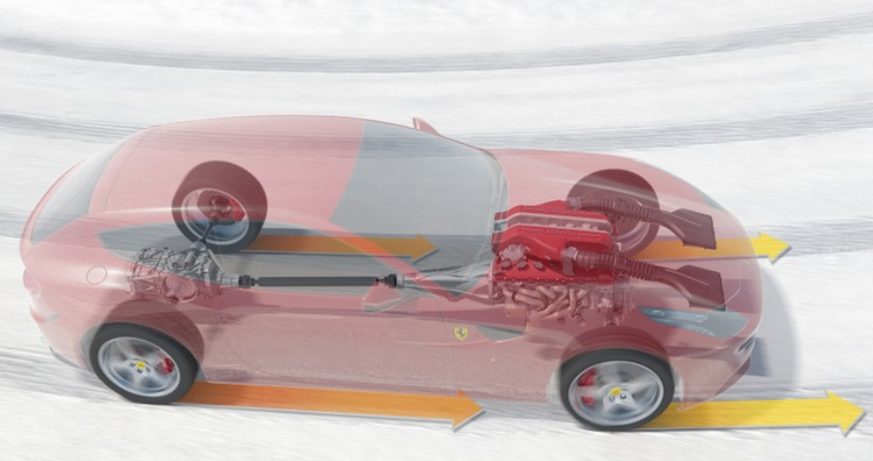
Figure 1- Overview of the 4RM system
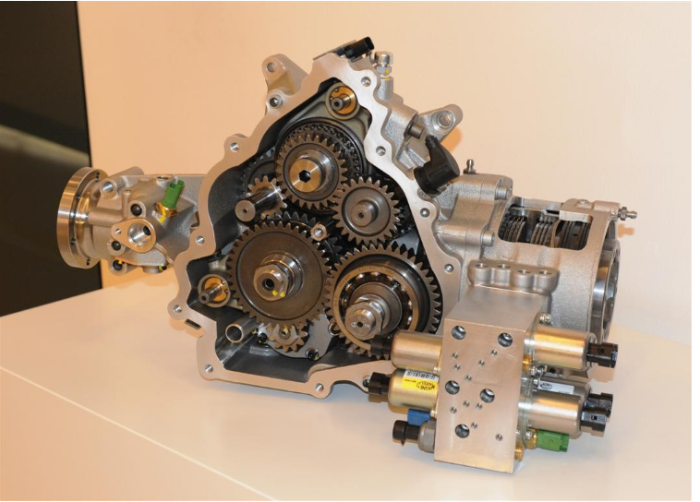
Figure 2- A close up view of the Power take off unit

However, at the front of the engine, a power transfer unit transfers power to the front of the engine via two different gear ratios (Figure 2). According to Ferrari, this system is 50% lighter than that of a traditional four-wheel drive system and is capable of torque vectoring (Ferrari, 2022).
Table 1 shows the information of the Ferrari FF.
Table 1- Ferrari FF vehicle information
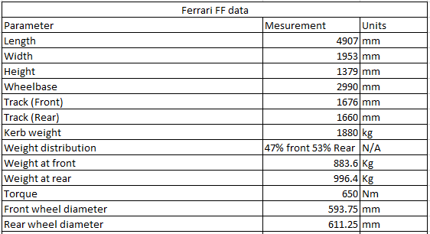

3.2 Torque vectoring
Torque vectoring is a system that enables drive torque to be directed to different wheels in order to control the lateral dynamics of a vehicle. Torque vectoring differs from other control systems such as ESP which operates in a similar manner to torque vectoring but instead of transferring torque to the wheels with the most traction, ESP reduces the speed of the slipping wheels (Sabbioni, et al, 2014). The benefit of this enables a vehicle with torque vectoring to redistribute torque that can assist in vehicle performance within a corner by providing a yaw moment that can counter act understeer moments (Antunes, et al, 2019).
Torque vectoring can be achieved using different methods. One method is to make use of electric motors that are controlled by a controller that monitors torque distributions both longitudinally and laterally (Parra, et al, 2018). This approach is more common on electric vehicles. The other approach is to use an electronic limited slip differential which makes use of clutch plates that react to a controllers inputs.

4.0 Methodology

4.1 Method to find vehicle dynamic related data
To establish the effectiveness of the Ferrari FF in terms of vehicle handling and the capabilities of its AWD system, several factors need to be established before analysis on the system can take place. These factors are listed below:
- The longitudinal position of the centre of gravity
- Moment of inertia
- Position of the inertial conjugate
- The dynamic index of the vehicle
It is noted that some estimations had to be made in order to perform these calculations. These estimations are to do with the mass of separate components such as the engine and gearbox and their relative distances from the front axle. To do this, the rear wheel (Size in table 1) will be used to estimate the locations of these components. This method has been used due to the size of wheel being a reference of vehicle proportions in which using the wheel size can give an accurate reading of the vehicle’s wheelbase (Luccarelli, et al, 2014). The Ferrari FF, in terms of vehicle proportions, fits within the category of a grand saloon according to this paper. This will be discussed along with other aspects of the vehicle specifications in the discussion section. The masses of the components will be based upon the masses in shown in table 1 and M2 is estimated at 150Kg.
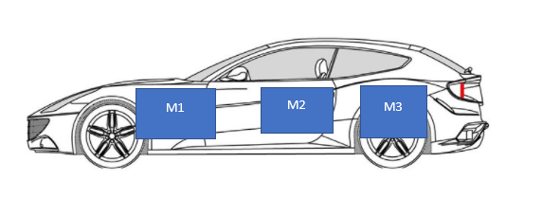
Figure 3- Lumped mass model of the Ferrari FF
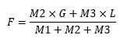
The longitudinal position of gravity will be calculated via a lump mass model. The lump mass model (figure 3) shows generally where the masses are located. The longitudinal location of the centre of gravity has been calculated via equation 1.
Equation 1- CoG position equation

Once the longitudinal position of gravity has been located, the moment of inertia can then be calculated via the following equation .
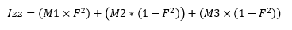
Equation 2- Moment of inertia equation
From here the dynamic index can be established. Equation 3 (shown below) is used to calculate the dynamic index.
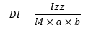
Equation 3- Dynamic index equation
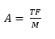
From here the potential acceleration increases that the 4RM system provides on tarmac (μ = 1), packed snow (μ = 0.5) and ice (μ = 0.1) is calculated (equation 4) alongside the potential yaw rate increase (equation 5).
Equation 4- Traction limited acceleration equation
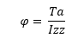
Equation 5- Yaw rate equation

Equation 4 is used as it is based upon traction limited acceleration instead of power limited acceleration. This is more suitable for the purpose of evaluating the 4RM system (Seward, 2014). Once these calculations have been performed, the 4RM system and the Ferrari FF will be analysed in terms of overall performance and the effectiveness of all the systems required for the 4RM system to operate.

4.2 Clutch methodology
The clutch torque capacity is calculated via equation 6. For this equation to work, the size of the clutch plates within the differential as well as their coefficient of frictions also must be estimated. The coefficient of friction is to be estimated at 0.1 (Rensselar, 2020) and the clutch plate radii (R₁ and R₂) are estimated at 60mm and 80mm respectively. In addition to this, the transmittable power and the angular velocity. The power will be assumed to be 200w and the angular velocity is estimated at 600 revolutions per second.
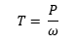
Equation 6- Transmittible torque equation
Once the torque is calculated, the estimated axial force can be calculated by using equation 7. This equation is based on the assumption that the wear of the clutch is constant.
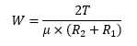
Equation 7- Axial force equation

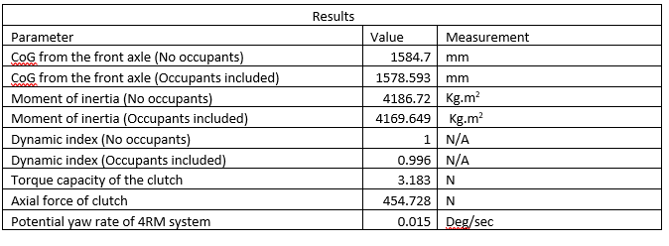
5.0 Results & Analysis
Table 2- Results from calculations
Table 2 shows the results of the calculations carried out. It’s noted that the vehicles CoG does not change much when the vehicle is loaded with occupants. This is down to the location of the CoG without occupants being located around the green house area of the vehicle where the occupants are located. Because of this, the dynamic index of the vehicle does not differ much if occupants are inside or not. This is beneficial for such as vehicle like this as the vehicle does not change behaviour dramatically if more load is placed onto the vehicle. The dynamic index can indicate how the vehicle behaves with a DI less than 1 indicating a responsive and agile vehicle and DI values over 1 indicate a stable vehicle. (Blundell and Harty, 2015) The FF as seen in table has a DI of around 1. This shows that the vehicle is generally stable, which for a vehicle of this nature, a high-power grand touring vehicle, is a desirable characteristic to have.
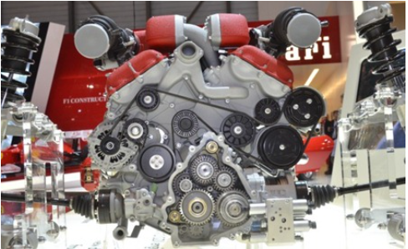
Figure 4- Front view of the 4RM system. Note the front driveshaft sizes

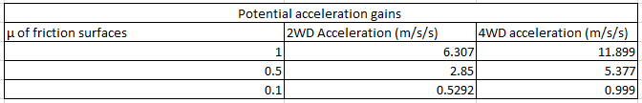
The potential yaw rate of the 4RM system can produces when exclusively driving one wheel is underwhelming. This is down to the torque distribution of the 4RM system, which is biased by 80% to the rear of the vehicle. This system seems to be designed to only improve the acceleration on low friction surfaces rather than improving the cornering response of the vehicle. This can be shown as well within the design of the driveshafts on the front which are small in diameter (figure 4).
Table 3- Potential acceleration on tarmac, packed snow and ice
Table 3 shows the acceleration gains on a range of surface of the 4RM system. It is clear to show that this system does improve acceleration throughout all the selected surfaces when compared to a 2WD system. Although the front wheels only receive 20% of the available torque, this does have an effect on the acceleration on all manner of surfaces.

6.0 Discussion

6.1 Torque path to the front wheels
The torque path to the front wheels on the 4RM system differs greatly from traditional AWD systems. The 4RM system uses a power take off unit (figure 2) which is mounted at the front of the vehicle. The power take off unit contains two gear clusters that transfer the drive to the driveshafts. These gear clusters have a gear ratio that is taller than that of the gearbox to enable torque to be transmitted as torque can only go from high to low rotational speeds (Horie and Yuasa, 2019). It is important to note that this system operates is given around 20% of the available torque of the engine and is driven directly by the engine. This is an interesting design choice as this enables the 4RM system to revert to rear wheel drive only, if fact it does this as the two gear clusters that are housed within the PTU are only engaged until 4th gear. After 4th the power take off unit effectively is disconnected and the FF reverts to a 2WD vehicle.

6.2 Vehicle specification
As mentioned previously in the methodology, the Ferrari FF fits into the grand saloon in terms of vehicle proportions, even though it is marketed as a grand touring vehicle. This is down to the long wheelbase of the vehicle which is due to the FF having four seats. This long wheelbase is advantageous as the vehicles with longer wheelbases exhibit better stability when compared to vehicles with shorter wheelbases.
In terms of the drive system, because the 4RM system acts as a 4WD system until 4th gear and as a 2WD drive system in higher gears, the benefits of a 4WD system can be interlinked with the benefits of a 2WD drive system. At lower speeds, the 4WD system provides better grip and control on low friction surfaces and at higher speeds, when the 4RM system reverts to a 2WD system, the control that a rear-wheel-drive car gives is present. Because of this unusual setup, traits of both drive systems are present such as the even weight distribution and the larger rear tyres (Milliken and Milliken, 1995).

6.3 Control algorithms and interactions with other control methods
In terms of control algorithms, torque vectoring algorithms typically use a hierarchical control structure. This is comprised of two controllers, an upper and a lower. The upper controller generates the reference signals from data that is collected from driver input and the lower controller acts on this data to command the actuators to respond to the drivers input (Deng, et al, 2021). Because of the upper controller receiving data from driver inputs such as yaw rate sensors (Smith, et al, 2018), the upper controller shares data with other stability programs such as ESP. ESP operates in a similar manner to torque vectoring in terms of controller layout and is linked to other systems such as ABS and TCS. It is interesting to note that ESP can prevent the vehicle becoming out of control via slowing down slipping wheels but can also accelerate the driven wheels (Reif, 2014). This last point indicates that torque vectoring and its system can be subservient to the ESP system to direct drive to the required wheels. Also, due to the nature of torque vectoring, it is normally equipped to vehicles with AWD systems, this enables the ESP to have direct control of the drive and braking of all four wheels. Because of this, the ESP system can direct torque to different wheels under different circumstances, for example:
- Directing power to the front wheels to provide higher acceleration during a launch
- Directing power to the outside wheels to maintain the drivers desired path during cornering
The examples given are not a definitive list of the capabilities of the system but rather a sample of its operation conditions.
These principles also apply to the 4RM system. Although a problem would occur due to the issue of the front wheels losing drive in higher gears. This would require a set command within the ESP system that the front wheels are no longer able to be driven from 5th gear onwards. Because of this unusual nature of the 4RM system, the torque vectoring system cannot be used to its full potential. This does limit its capabilities as an AWD system when compared to other more traditional AWD systems.

7.0 Conclusion
To conclude, the 4RM system was evaluated in terms of its operation with its weight saving properties potentially coming at a cost of limiting its torque vectoring capabilities at higher speeds. Calculations were also conducted to accompany this analysis but the author does note that estimations had to be made for these calculations to work. This does call into question the data within this report as the data cannot be validated due to the secretive nature of some of the information that this report estimates. Discussion was also carried out on the Ferrari FF and torque vectoring, coming to the conclusion that torque vectoring can be used within ESP.

8.0 References
Antunes, J., Antunes, A., Quterio, P. and Oliverira, P. (2019) 'Testing of a Torque Vectoring Controller for a Formula Student Prototype', Robotics and Autonomous Systems, 113(), pp. 56-62 [Online]. Available at: https://www-sciencedirect-com.ezproxy.uwtsd.ac.uk/science/article/pii/S0921889018301970 (Accessed: 23rd March 2022).
Blundell, M. and Harty, D. (2015) The Multibody Systems Approach to Vehicle Dynamics , 2nd edn., Oxford: Elsevier.
Deng, H., Zhao, Y., Feng., S., Wang, Q., Zhang, C. and Lin, F. (2021) 'Torque Vectoring Algorithm Based on Mechanical Elastic Electric Wheels with Consideration of the Stability and Economy', Energy, 219(), pp. [Online]. Available at: https://www-sciencedirect-com.imeche.idm.oclc.org/science/article/pii/S036054422032750X?via%3Dihub (Accessed: 26th March 2021).
Ferrari (2022) Ferrari FF, Available at: https://www.ferrari.com/en-EN/auto/ff (Accessed: 25th March 2022).
Horie, R. and Yuasa, R. (2019) Development of Innovative Dynamic Torque Vectoring AWD System, Available at: https://saemobilus-sae-org.ezproxy.uwtsd.ac.uk/content/2019-01-0332/ (Accessed: 23rd March 2022).
Luccarelli, M., Lienkamp., Matt., D. and Spena, P.R. (2014) Automotive Design Quantification: Parameters Defining Exterior Proportions According to Car Segment, Available at: https://saemobilus-sae-org.ezproxy.uwtsd.ac.uk/content/2014-01-0357/ (Accessed: 21st March 2022).
Milliken, W.F. and Milliken, D.L. (1995) Race Car Vehicle Dynamics , Warrendale : Society of Automotive Engineers .
Parra, A., Zubizarreta, A., Perez, J. and Dendaluce, M. (2018) 'Intelligent Torque Vectoring Approach for Electric Vehicles with Per-Wheel Motors', Complexity, 2018(), pp. 14 [Online]. Available at: https://www.proquest.com/docview/2012844673?accountid=130472&parentSessionId=guk0uCSOUXGMLlBHpsh%2Bs4%2Bp1BpiRxhGTMtxg2ejMvY%3D&pq-origsite=primo (Accessed: 23rd March 2022).
Reif, E (2014) Fundamentals of Automotive and Engine Technology. Springer [Online]. Available at: https://link-springer-com.imeche.idm.oclc.org/book/10.1007/978-3-658-03972-1 (Accessed: 26th March 2022).
Rensselar, J.V. (2020) Wet Friction Materials, Available at: https://www.stle.org/files/TLTArchives/2020/08_August/Lubrication_Fundamentals.aspx (Accessed: 22nd March 2022).
Sabbioni, E., Cheli, F., Vignati, M. and Melzi, S. (2014) 'Comparison of Torque Vectoring Control Strategies for a IWM Vehicle', SAE International Journal of Passenger Cars - Electronic and Electrical Systems, 7(2), pp. 565-572 [Online]. Available at: https://saemobilus-sae-org.ezproxy.uwtsd.ac.uk/content/2014-01-0860 (Accessed: 23rd March 2022).
Seward, D. (2014) Race Car Design, London: Palgrave.
Smith, E.N., Velenis, E., Tavernini, D. and Cao, D. (2018) 'Effect of handling characteristics on minimum time cornering with torque vectoring', Vehicle System Dynamics , 56(2), pp. 221-248 [Online]. Available at: https://www-tandfonline-com.imeche.idm.oclc.org/doi/full/10.1080/00423114.2017.1371771 (Accessed: 26th March 2022).

