

Student name: | Catalina Medina
Student ID: | 1806473
Module Number: | BMSK4003
Module Title | Digital Skills and research methods
Lecture’s Name: | Balendran Kandasamy

Contents
Modern Technologies within workplace 3
Evaluating Modern Technologies 4
Cloud Storage. 4
Evaluations of OneDrive and iCloud. 4
OneDrive. 4
OneDrive for Business 4
iCloud 4
Advantage. 4
Web Conferencing 5
Evaluations of Skype and Zoom 5
Skype 5
Zoom 5
Advantage and Disadvantage. 6
Smartphones. 6
smartphone characteristics: 6
Evaluations of Samsung Galaxy S9 and iPhone X. 6
Exploring a social media as a tool for marketing and information. 7
Evidence of my online presence…………………………………………………9

Bibliography……………………………………………………………………………12

The effectiveness of the use of modern technologies within
workplace

Introduction
Technology has moved into a new digital era and is changing the way we communicate, the way we buy things, the way business interact even the way we talk. Our expectations of what we can do and how we can do it have been altered. we really do begin to see how our lives been transformed, we normally order all goods, books, clothes and groceries-using online shops, often paying with virtual currency like PayPal. We download our music, tv, films or we use digital music stores we sell our unwanted staff in eBay or other auctions sites. (Burrows.2011)
The new technologies are everywhere and the way we interact with them has fundamentally changed. Human being thinks, they are in control. But are we? We have become completely dependent on digital machines and equipment. We rely on them completely. Without them we are lost. Along with technology getting involved in an endless drive to a second guess, what the consumer does not yet know that he or she won’t be able to live without (Silver.2011)
Technology has changed the way people work, business people work no longer has to be based in an office building with wired access to the internet because most of us now have Wi-Fi systems in the workplace.

Modern Technologies within workplace

I work in a Hotel and from my point of view I agree that technology has improved work efficiency.
In the hotel technology is a fundamental resource for the process of growth, it is a tool with which the optimization, organization, sales and training, etc process can be achieved.
Technology has arrived to solve the problems and eliminate the barriers of organizations through innovative systems that are adaptable to our needs. What used to take weeks or even months nowadays it is possible to finish in a few minutes for example in the hotel years ago, the only way to book a room was over the phone but now customers have the facility to login in the hotel’s website and choose the dates or how many days they will stay.
When there is good technology support, communication barriers take second place. The communication between employees’ executives will not be limited to a simple phone call, because we have other methods of communication such as internal text, email, WhatsApp, business social network, video calls with which you will be able to keep in touch with the members of the hotel like employers or co-workers. It is also useful to improve communication with suppliers and customers.
Technology allows hotel executives to take advantage of the opportunities in the national and international market business in such an active and globalized world.
Time is a very valuable resource for decision making because they need to obtain reliable information easily and quickly about the operation of the hotel.
In my workplace another utility of technology is that it allows to obtained feedback from customers who received personalized treatment and at the same time customers can complain about the services that have been delivered to them.
Office technology saves time by streamlining the workflow process, digital archiving systems are used to save space, paper, and printing cost. The use of the computer systems allows to keep the data of de customers protect and allows corrections to be made instantly.
In the other hand, there are disadvantages related to the importance of technology in the workplace. Technology is constantly being renewed so that investments are increasing and there are many businesses that are not able to progress at their own pace due to their economic capacity and total dependence that exists on technology, in many businesses when there is a failure in the computer or internet or company technologies the business is totally helpless and often unable to continue until this is solve.

Evaluating Modern Technologies

Cloud Storage. – is described as using IT services through a computer network created by sharing hardware and software services by a common point in the communication between the trading partners provide synchronization capability of their data (Menken. 2008).

Evaluations of OneDrive and iCloud.

OneDrive. – is an online cloud storage service from Microsoft, this service is for all the owners of Microsoft accounts. OneDrive integrates with Microsoft office so users can access word, excel and PowerPoint documents in OneDrive. The system allows user to simultaneously edit office documents, edit documents in browser and create and share folders. OneDrive also offers Facebook integration, automatic camera roll backup and the ability for users to email slide shows. There are two types of OneDrive for personal users and business. Burrows, 2011)

OneDrive for Business. – It allows employees to share and store documents, synchronise and collaborate on files across multiple devices with ease manageability and security. OneDrive for business not only distributes an intuitive experience for employees by allowing them to collaborate continuously in documents Office it is also baked with enterprise- grade content management, regulatory compliance and administrative controls.

iCloud. - is an online service provided by Apple Computer Inc, it provides an email account, online storage and backup services, it also allows you to store documents videos, photos, music, as well as share data between devices such as Macs. iPhones and iPads. (Rich, 2012)

Advantage and Disadvantage.
OneDrive | ICloud
Access your file from any computer through the website | Access your files from Apple device
Free 7GB storage | Free 5GB storage
Premium 1TB storage | Premium
Built for Business | Built for Business
Available on every device and platform
Backup methods are automatic | Backup methods is done automatically on a daily basis
Possible to share documents | Sharing documents

In my opinion I recommend OneDrive storage because is very efficient, so you have all your files in one place, also you can manage you files from any device at any time and any place. In another hand the disadvantage of iCloud is that you only get access to your files from a Mac device.

Web Conferencing. – is a communication that originates through a telecommunication network and includes the transition of sound and image, between two people or more who hold a video conference. It is useful system to communicate with people who are in different places.
In the field of business, video conferences allow the develop of virtual meetings, especially when it comes to definitive trips, it helps to save money and time.
Video conferencing is a tool for sharing documents and commenting on it while the authorized participants look, edit a it and make all kinds of notes about them.
In general, video conferences are developed through internet with programs and applications such as Skype and Zoom and more, (Burrow. 2014)

Evaluations of Skype and Zoom

Skype. – developed one of the most used tools to replace the expensive conventional telephone communications since it allows through a simple internet connection that diverse users establish a voice conversation and images in real time. Skype offers us the possibility to connect by chat, voice or video call, completely free of charge with individuals or companies anywhere in the world where they are if they are registered users of skype services. We can find skype version for virtually any device. Skype offers its users different alternatives of use of packages at low cost. In addition to this option skype also offers a very important features like the possibility of transferring files, sending messages, conference calls, shared screen and many other practical features, with which we can have a direct access to the world. (Microsoft, 2108)

Zoom. – is a video conferencing tool. This program unifies video conferencing in the cloud. Online meetings, group messaging and software define conference room solution on an easy -to-use platform. Fortunately, it offers the best video, audio and wireless screen experience to share through windows, mac, IOS, Android, zoom rooms.
Zoom program not only offers calls through video but also allows you to write message at the same time and share any file with other users. The interface is easy to use, and you do not need to join a new social network just need a Gmail or Facebook

Advantage and Disadvantage.
Skype | Zoom
Quick, easy instant messaging | Difficult to locate contact
File transfer via chat windows | File shared using separate tool
For business, up to 250 participants | Up to 50 participants
Call recording | Not call recording
Not host control | Host control
Computer to phone calls | Not is possible
Skype for business | Not is possible

In my opinion Skype has more functions and features This helps it connect people around the world as much as personal communication and business wise.

Smartphones. – is a commercial term for a mobile phone that offers more features than a common one. The most important feature of all smartphones is that they allow the installation of programs to increase the possibilities, such as data processing and connectivity or internet.
The mobile operating system that has a differentiating it use by exclusive layout of menus, keys, shortcuts, etc.

smartphone characteristics:
-These applications can be developed by the manufacturer of the devise, by the operator or third party. Other features are camera with many megapixels with front and rear camera to have the possibility of taking a selfie,
-in addition to all this we have a mini computer in our pocket.
-it allows to make phone calls
-it has GPS
-It has support e-mail and possibility of connection to social network.
-wireless connectivity Wi-Fi

Evaluations of Samsung Galaxy S9 and iPhone X.

Samsung and Apple have long been battling it out in the smartphone world
 | iPhone X | Samsung Galaxy S9
Screen | 5.8 inch OLED | 5.8 inch super AMOLED
From camera | 7-megapixel f/2.2 | 8-megapixel f/1.7
Rear camera | 12-megapixel wide-angle f/1.8. OIS  12-megapixel telephoto f/2.4,OIS | 12-megapixel f/1.5-f/2.4 variable aperture OIS
Chipset | Apple A11 Bionic | Qualcomm Snapdragon 845 or Samsung Exynos 9810
RAM | 3GB | 4GB
Storage | 64/256GB | 64/256GB
Battery | 2716mAh | 3000mAh
Waterproof | IP67 | IP68
Fingerprint scanner? | No | Yes
Face/iris scanner? | Yes/no | Yes/yes
Wireless charging? | Qi | Qi/PMA
MicroSD slot? | No | SDXC up to 400GB
Weight | 174g | 163g
Launch date? | 2017 | 2017
Talk time | Up to 21 hours | Up to 22 hours
Price | £999 for 64GB | £739 for 64GB
Wi-Fi features | Mobile hotspot | Wi-fi direct mobile hotspot
(Parker, 2018).
From my point of view after we compare those two smartphones based in the features and the cost of the phone I will recommend Samsung S9. In addition to it I will recommend to use in the business because there are phones with business plans where you can provide to your employees when this happens employers as well as employees will feel benefited and in some way cared for in the company.

Exploring a social media as a tool for marketing and information.
The social media I am going to talk about is Facebook and the business that I am going to explore is marketing point is Argos.
Facebook is a social network page that most of us have an account with it, so we are talking about a huge volume of users, there is a huge volume of potential customers. Many businesses are taking advantage of the platform to grow, get intimate relationship with the follower and sell.
Using Facebook for business means a defined content strategy. The first step for a business is to set up a fan page, this is what Argos did in it. Another interesting resource for business is Facebook Ads. The platform for online advertising of Facebook called sponsored story.
In this case Argos used Facebook ads as part of their marketing to improve the customer experience, the company has used advertising to appeal to its different market segments. The campaign is designed to promote a more modern image for the business. Advertising in Facebook gives the facility to Argos of monitor the result of their campaign, depending of the subscribers that sign up.
Argos spent money on an online advertising campaign with the idea of growing their database of potential customers.
The use of Facebook for the business is a good investment with a positive result. In fact, the use of any social media now days is a good opportunity as it will make you know across the city, country or even abroad.

Evidence of my online presence

Facebook

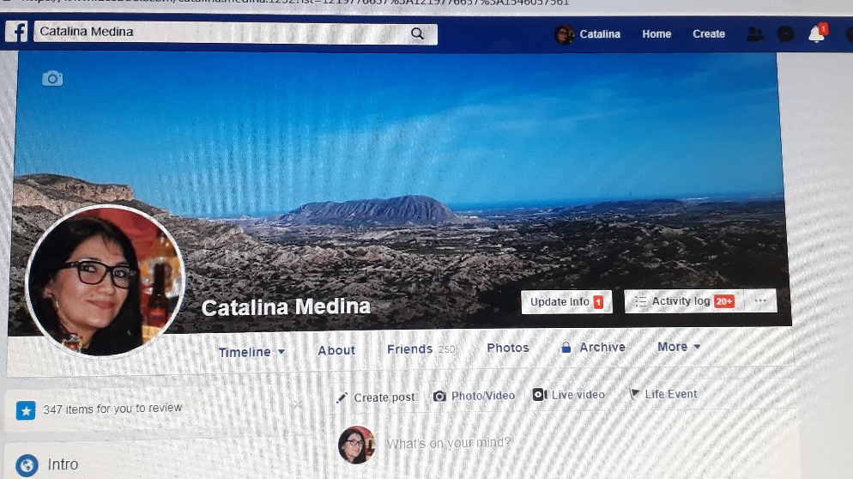
https://www.facebook.com/catalina.medina.1232?ref=bookmarks



https://www.instagram.com/

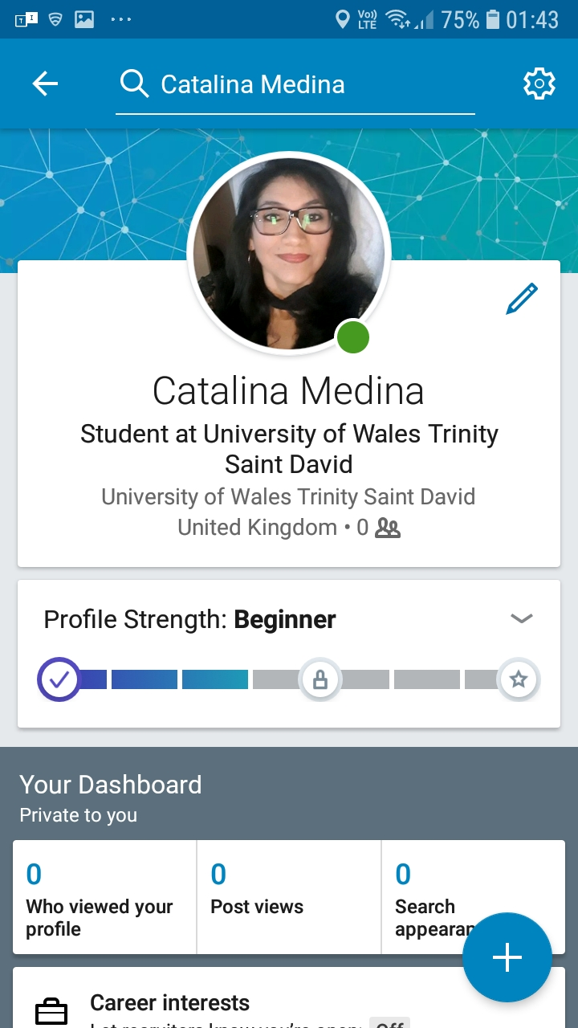
https://www.linkedin.com/feed/

Bibliography

Burrow, T. (2011), Blogs, Wikis, Facebook and More, 2nd Ed. London, Carton.
Silver, M. (2011), E 20-20. 1th Ed. Pa.lgrave Macmille.
Menken, I. (2008), Cloud Computing, 1th Ed. Emerec Pty. Ltda. London.
Rich, J. (2012) How to do Everything: iCloud, 1th Ed, McGraw-hill. United States
Maund, A. Schriek, M. and Tinkler, P. (2017), Certificate in Higher Education: Skills for the Workplace student yearbook, 1th Ed, Sage. London.
Microsoft, (2018) OneDrive Available at: hp// www.Support .office.com/en-gb/ .
oneDrve (accessed: 20th December 2018).
Microsoft, (2018) Skype Available at: hp// www.Support .office.com/en-gb/skype
(accessed: 20th December 2018).
Parker, M. (2018) ‘Trusted Reviews’, available at :hp://www.trusted reviews.com. (accessed:20th December 2018).

