Inserting Dynamic Text
The beauty of dynamic web pages is that their contents can automatically—or dynamically—change based on any number of factors, including selections the user makes. In Dreamweaver, you insert dynamic text by dragging fields from your recordset onto the page.
For the next few examples, we’ll use page we’ll create for viewing a client list and detailed information about each client. All of this information is contained in the Clients table of our database. For this example, we’ve created a page called clientdetail.asp and added a simple recordset, as we did for our login page, but which uses the Clients table instead of the Users table. This is what the Recordset dialog looks like:
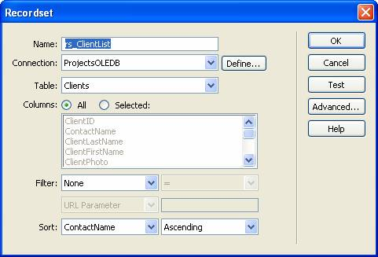
We can see all the fields in our rs_ClientList recordset by expanding the recordset on the Bindings tab of the Application panel:
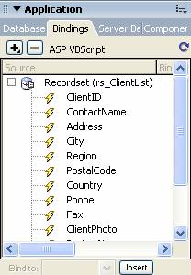
Dynamic text is added as a server behavior, which is available from the menu on the Server Behaviors panel:
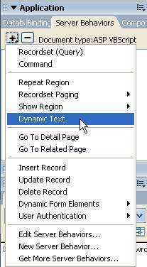
When you select this behavior, the Dynamic Text dialog opens, displaying all the fields in your recordset:
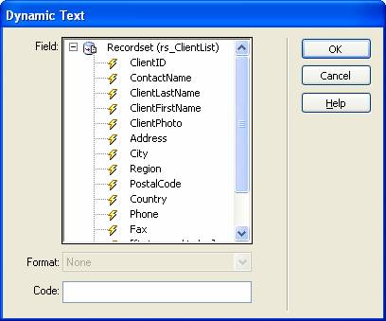
To insert a client’s address, for example, we need only select Address in the dialog. Selecting a field enables the Format menu, which lets you specify a format for displaying the information on the page:
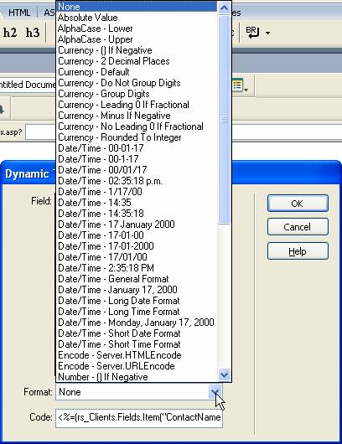
Specifying a format is really the only purpose you might have for taking the trouble of using the Dynamic Text dialog. If the format isn’t important, you can simply drag a field from the Bindings tab onto the document:
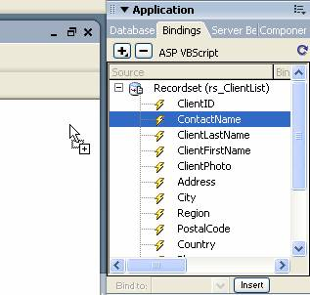
When you drop the field, Dreamweaver displays a placeholder:
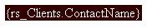
Click the Live Data View button on the Document toolbar to see what users will see:
You can easily format dynamic text the same as you would ordinary static text using the Text category on the Insert bar. Simply select the placeholder for the text on the page and format it using the buttons on the Text toolbar or the options on the Property Inspector.
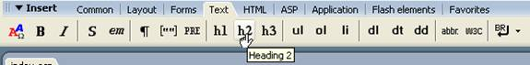


Binding Images to a Field in the Recordset
You can also use the Bindings tab of the Application panel to bind elements on your page, like images, to the fields of your recordset. We’ll do this for our client detail page, so that each client’s record displays a photo next to his or her information:
- Position your cursor where you want to place an image.
- Select the Common tab of the Insert bar and click the Image button. Select Image from the menu that appears:
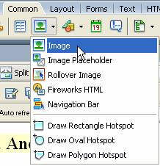
- In the Select Image Source dialog, select the second option for Select file name from: Data sources.
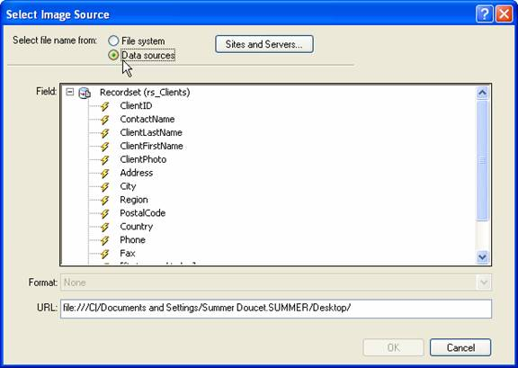
- Select the field that contains the location of your image.
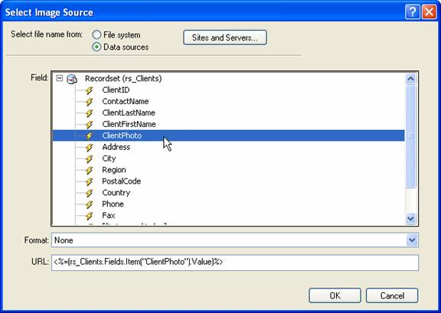
- Click OK.
When we preview our page, our client photo appears under her name:

Note:
We shamelessly pilfered photos and other data from Microsoft’s sample Northwind database.
Note that the img.src attribute now appears next to the ClientPhoto field on the Bindings tab of the Application panel:
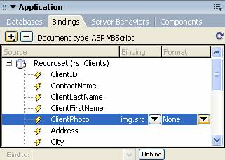
You can bind data to other attributes, as well, like your image’s alternate text. For example, to have the page display the client’s name as alternate text for the photo:
- On the Bindings tab of the Application panel, select another field. For our example, we’re going to use our simple ContactName field.
- At the bottom of the panel, select img.alt from the Bind to menu and click Bind.
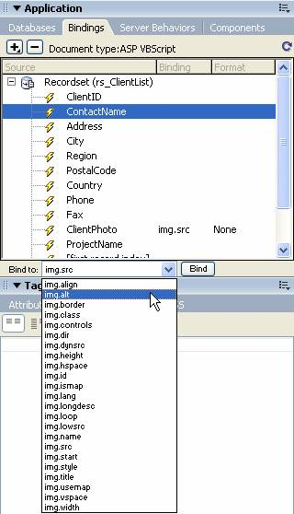
The attribute now appears in the Binding column next to the field. To unbind the attribute, select it and click the Unbind button:
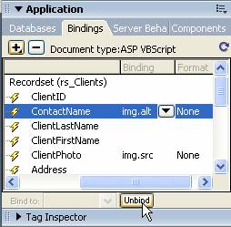
Notice the values that are displayed in the Property Inspector when you select the image:
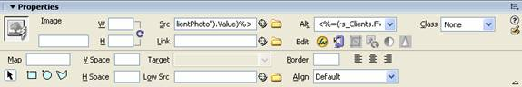
The Src and Alt fields display the ASP code used to retrieve the values for the record.

