

Student name:Tosin Yusuf
Student ID:2334371

Module name:Changemakers
Module code:BMHP5015
Lecturer name:Christopher Mafuva

Introduction | The purpose of this online portfolio is to reflect on key learning of the module. The "Changemakers: Building Your Brand for Sustainable Employment" offered fundamental understanding of personal and professional development by examining 4 key subjects that included personal branding, networking, boundary-less careers and principles of emotional intelligence. Throughout the module, the importance of adaptability, autonomy, evaluation and self-determination was reinforced and each unit uniquely contributed to my awareness on the importance of personal values and professional competence in achieving my aspiring career of a Public Health Worker, wherein SEN (Special Education Needs) Support can be extended. As a future changemaker who is committed to support children and families with SEN, this portfolio uses reflective engagement to demonstrate learning from Unit-4 as well as professional identity.
Unit 1: Brand You | Unit 1 contributed to my learning on the principles of personal branding, self-awareness, and determining personal strengths. My conceptual view of branding, prior to this unit, was linked to organisations, but I learned to think of branding in personal terms, that is defined by Shepherd (2005) as deliberately influencing how people see one’s professional identity. In the context of health and social care, I learned that personal branding signifies the communication of skills, values and purpose. These learning enabled a deeper self-reflection and enhanced self-awareness. I associated this learning with Johari Window model, presented by Luft and Ingham (1955) which accentuates the need to know how I can be viewed as well as others. This is because, as shown in figure 1, I mentioned the importance of self-awareness in the health and social care with regards to working with others.  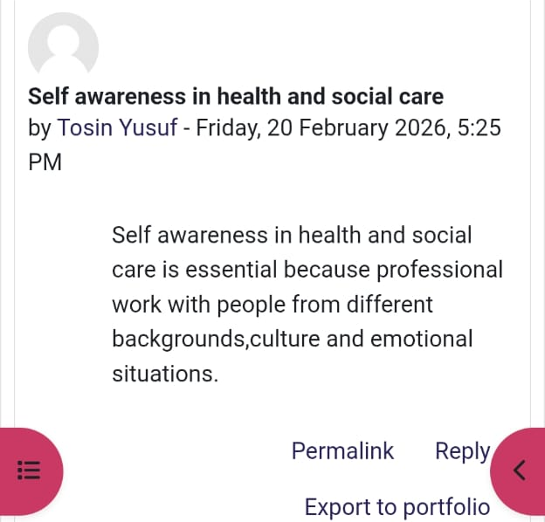  Figure 01: Self-awareness  NHS (2026) also considers Johari’s window a useful tool to consider personal development by focusing on 4 quadrants of known self, hidden self, blind self and unknown self, by offering opportunity to gain feedback and address blind and unknown spots, thereby giving opportunity for self-development. This model changed my thinking about what it could mean to be known to others. Thus, I applied sharing my social care practice with peers and took their feedback, which helped me directing myself to seek more competence through insights from peers’ experiences, which improved my practice. This is because peer feedback has widened my blind space and allowed me to acknowledge the form of strengths that I did not pay much attention to before, like empathy and communication skills. This solidified the role of reflection and feedback towards professional development.  In Week 1 forum, my understanding of Self-Determination was also improved from making choices, as shown in figure 2 to gaining insight on self-determination theory by Deci and Ryan (2000) which demonstrated the contribution of autonomy, competence, and relatedness to motivation.  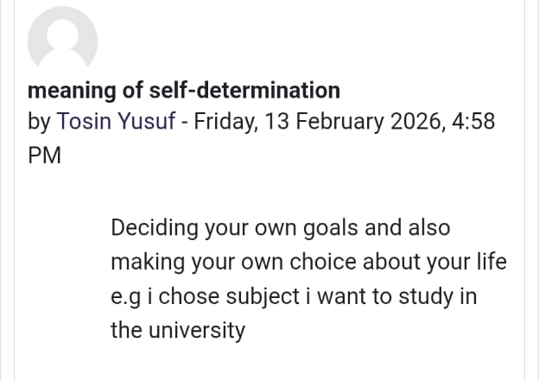  Figure 02: Self-determination  Expanding on the concept of autonomy, given in figure 3, I realised that I am inspired by intrinsic values and not extrinsic rewards to want to work in an area that benefits children and families. This realisation reinforced in me that it is important to match my personal brand to my long-term professional objectives. Many other important areas were also found in determining strengths and transferable skills. I assessed my adaptability, team work, and resilience by conducting skills audits. I also understood that the soft skills are most sought after in health and social care facilities, where cooperation and the ability to feel are crucial. This is what assisted me in explaining my value proposition in a more fundamental and deliberate manner. In general, Unit 1 improved my perception of employability.  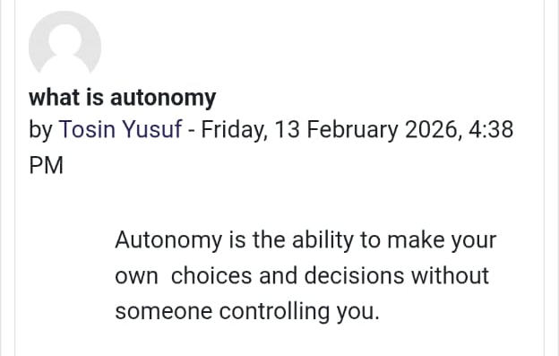  Figure 03: Autonomy
Unit 2: It’s a Small World | In Unit 2, I learned to make global health and social care connections to cultural competence, diversity, boundary-less career, and the gig economy. This unit in general broadened my knowledge on how globalisation influences professional practice. It helped me understanding the interlinked contextual factors that impact health and care, such as the influence of digital communication, global health challenges, migration and economic shift which influence care practices (Hossin, 2020). It improved my understanding that healthcare system does not operate in isolation. Thus, while working with children and their families, I will focus on different cultural backgrounds and social determinants of health. This learning will not only help in appreciating cultural competence but also respecting differences in culture and respective care needs, which improves trust and satisfaction of service-users. This learning corresponds to Cultural Dimensions Theory cited by Hofstede and Bond (1984) that describes the role of cultural difference in shaping the behaviour, power distance, and communication pattern. I realised that cultural assumptions in professional contexts can also lead to a misunderstanding. I can become more culturally aware hence provide more inclusive and person-centre care. Moreover, my thought process also changed due to the idea of the boundary-less career. I realised that the contemporary working life, especially in health and social care, may cut across several organisations and sectors. There is the need to foster transferable talents as opposed to following a single institutional route by the professionals. This related to the debates concerning the gig economy, where flexible jobs provide freedom at the cost of stability. I critically thought about my ability to be a professional in evolving employment environments, for which the importance of soft skills and working with others are signified in figure 4.  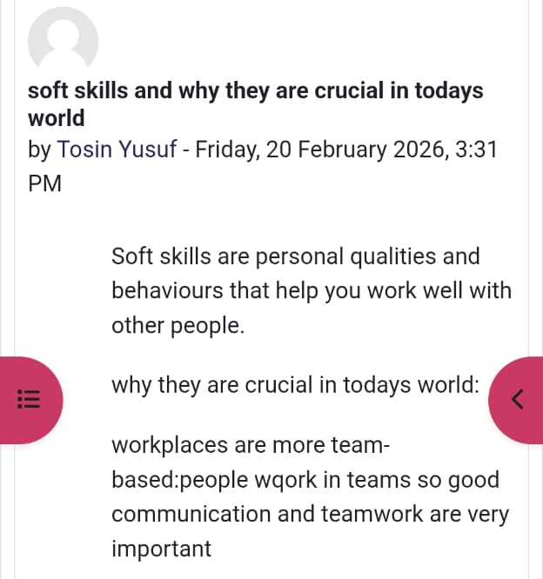  Figure 04: Concept of Soft Skills in the contemporary world  Similarly, the forum discussion also demonstrated the significance of soft skills like communication, teamwork and collaboration. I recognised the importance of these skills in practice, particularly, when a case required multidisciplinary teams’ engagement. In such setting, it is important that the care analysis is communication to demonstrate teamwork and avoid conflicts. I developed my consciousness and analytical skills through the use of forums and case study group work. Altogether, Unit 2 changed my mindset towards having a contextual approach to health and social care practice towards being globally responsible.
Unit 3: Opportunity Knocks | Unit 3 enabled the identification, appraisal, and exploitation of opportunities in a strategic way towards my personal and professional growth. Connecting with people, identifying opportunities, self-awareness, emotional intelligence, and assessing the progress were the main issues. This unit changed my thinking towards waiting to get opportunities and act in order to create the opportunity. In particular, networking has become one of the key lessons I have learned. Week 3 forum was helpful to conceptualise networking, wherein I defined as the opportunity to talk and meet with people who can help grow, learn and find opportunities, as shown in figure 5.  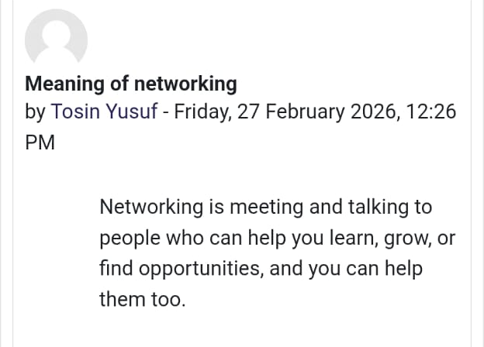  Figure 05: Networking  I also understood that networking does not entirely involve sharing of contacts but rather making valuable professional connections, as signified through the exemplified case of Sheela in figure 6. In figure 6, the benefits of networking are explicit, which enabled Sheela to health visitors, midwives, general practitioners and breastfeeding support groups. As a result, she had a network of potential participants who can help in data collection process, aimed at exploring the perception of women on breastfeeding. I also considered that building relationships with professionals in SEN and in the field of public health would create opportunities in terms of volunteering and working. This is also in line with the social capital theory of Bourdieu cited by Portes (2024) that relates to the idea that relationships offer access to opportunities and resources.  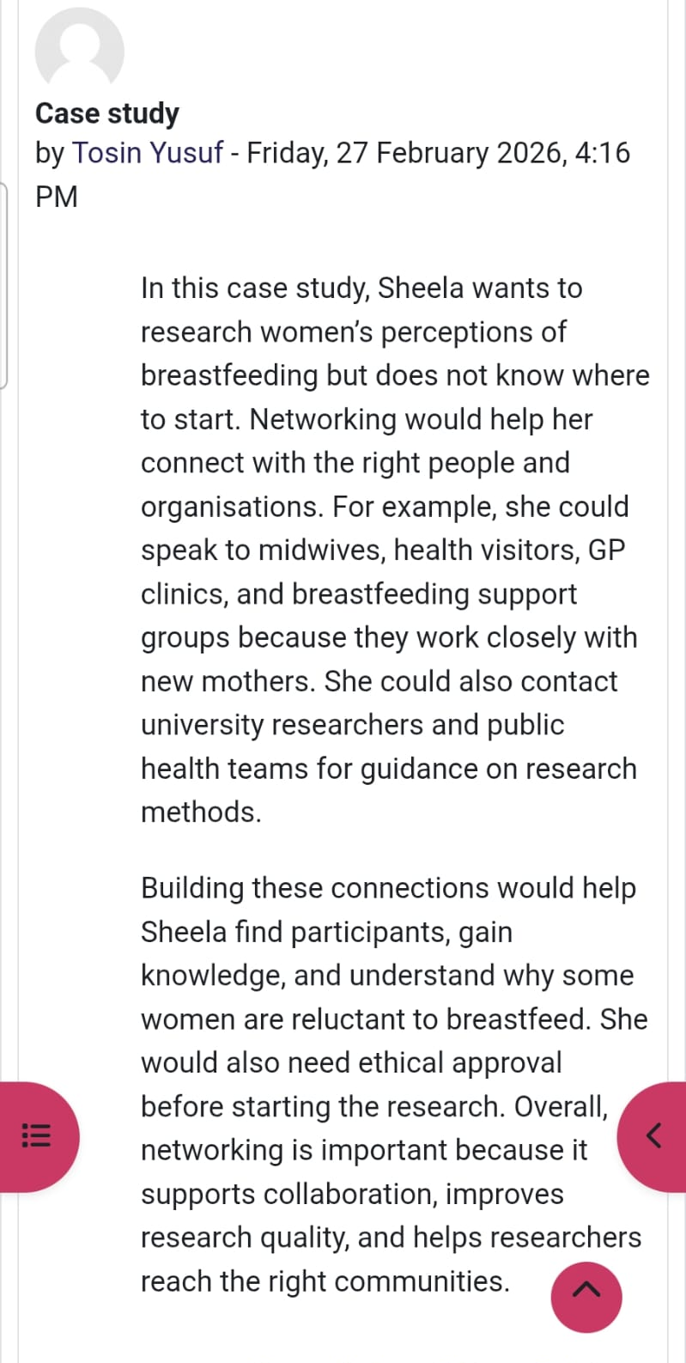  Figure 06: Importance of Networking  My self-awareness was also improved by the unit. Reflective exercises helped me to assess my weaknesses, strengths, and professional behaviour. I used the Gibbs Reflective Cycle to evaluate my preparedness of opportunity. Through the sharing of experiences, evaluation of what was done well, and where improvements could be made, I was able to create a more definite action plan, which was guided by SMART goals. For example, based on the difficulty I faced in terms of building a network of professionals with whom I can gain more knowledge. To serve this purpose, I aimed at enhancing my professional network by >60% within next 2 months by connecting with SEN service-providers on LinkedIn. This activity will expand my network and improve the capability to collaborate with others. Hence, this systematic reflection enhanced my self-confidence and judgment. Another important area was the emotional intelligence (EI), which helped understanding that, in health and social care, one has to be emotionally aware and possess social skills with responding to the patients’ needs, as highlighted in figure 7.  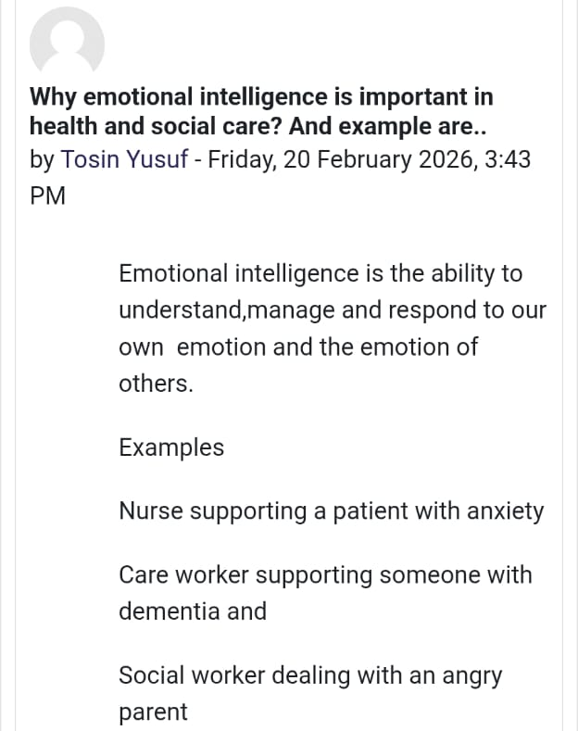  Figure 07: Significance of EI in health and social care  Reflecting on personal practice, I realised that lack of emotional control in dealing with elderly patients who, apart from physiological care due to declining health, also require emotional support because they are often a victim to social isolation and bereavement. Thus, in order to show competence, I improved my EI score to manage my emotional response towards cases involving elderly patients or those towards end-of-life care. This is because, scholarly literature also associate EI, characterised with self-regulation, social skills, motivation, self-awareness and empathy, with professional competence (Sharp et al., 2020). Collectively, the literature evidence and personal reflection helped recognising the weaknesses based on low EI. Thus, through emotional control, I was capable of not only lowering emotional fatigue but also improving service delivery.
Unit 4: Pursuit of Happiness | The learning from this unit made helped me improving my perspective that psychological strength is just as important in the sustainable employment in health and social care as professional competence. I gained an understanding of the PERMA model of well-being that defines the four elements of well-being that include Positive emotion, Engagement, Relationships, Meaning, and Accomplishment (Kun et al., 2017). I have learned that significant work, especially work with children and families, has a close connection to the PERMA component of Meaning and Engagement. These components reinforced my motivation to adopt a purpose-driven career.  The unit further enhanced my knowledge on resilience theory. I learned that when dealing with stress, as health and social care can be emotionally demanding roles and require compassion while offering services (Kinman and Grant, 2020). In this context, to avoid burnout in practice of fulfilling the emotional needs of patients while giving the necessary SEN services, I need to develop resilience, which can be achieved by reflective practice, a supportive environment, and coping mechanisms against stress. Another theme was dedicated to work-life balance which helped recognising that how over-committing could have a negative impact on the well-being and professional effectiveness. Sustainable happiness involve setting limits and giving a priority to self-care. For example, while volunteering in a community support programme for children with SEN, I over-burdened myself in extending education and emotional support for children. It led to difficulties like emotional fatigue and maintaining work-life balance. Thus, I learned that having the balance contributes more to performance and long-term career satisfaction. The development of the meaning of work was also considerable as it enabled me to understand work with respect to fulfillment, growth and impact, instead of monetary gains. It helped me redefining my professional goals in a sustainable manner, aligning with the values of healthcare. Thus, throughout the reflective self-assessments, I focused on evaluating personal practices along with areas of improvement. Hence, the online portfolio contributed to redefining the commitment towards improvement, thereby, enhancing both employability as well as contribution to the social work.
Conclusion | The module has reinforced my knowledge of personal branding, global awareness, identifying opportunities and well-being as far as sustainable employment in health and social care is concerned. The Unit 1 helped me to be more self-aware and understand my strengths, values, and professional identity. Unit 2 has broadened my knowledge on cultural competence, diversity and the global drivers of health and social care practice. Unit 3 taught me to recognise and appraise opportunities in a strategic manner using the networking, emotional intelligence, reflective practice, and SMART goal setting. At the same time, the importance of work-life balance, well-being and resilience was focused in Unit 4, with the aim to illustrate the professional efficacy in the long-term. Through the series of learning, I am now in a better position to be able to convey my value, work successfully in different environments, establish professional relationships, and be emotionally resilient. These competencies will help me to become a reflective, competent, and ethically-responsible health and social care practitioner, extending SEN support services.
References | Hofstede, G. and Bond, M.H. (1984) ‘Hofstede's culture dimensions: An independent validation using Rokeach's value survey’, Journal of cross-cultural psychology, 15(4), pp.417-433. Available at: https://doi.org/10.1177/0022002184015004003  Hossin, M.Z. (2020) ‘International migration and health: it is time to go beyond conventional theoretical frameworks’, BMJ Global Health, 5(2). Available at:  Kinman, G. and Grant, L. (2020) ‘Emotional demands, compassion and mental health in social workers’, Occupational Medicine, 70(2), pp.89-94. Available at: https://doi.org/10.1093/occmed/kqz144  Kun, Á., Balogh, P. and Krasz, K.G. (2017) ‘Development of the work-related well-being questionnaire based on Seligman’s PERMA model’, Periodica Polytechnica Social and Management Sciences, 25(1), pp.56-63. Available at: https://doi.org/10.3311/PPso.9326  Luft, J. and Ingham, H. (1955) ‘The Johari window, a graphic model of interpersonal awareness’, Proceedings of the western training laboratory in group development, 246, pp.2014-2003. Available at: https://static1.squarespace.com/static/572d003b40261d2ef97e5b0b/t/5ca20f68e2c48320572e81e7/1554124653572/Luft%2BIngham%2Bdocument.pdf  NHS (2026) Johari’s Window (1955). Available at: https://www.hee.nhs.uk/sites/default/files/documents/Johari%20window.pdf (Accessed: 27 February 2026).  Portes, A. (2024) ‘Social capital: Its origins and applications in modern sociology’, New critical writings in political sociology, pp.53-76. Available at: https://doi.org/10.4324/9781003572923-6  Sharp, G., Bourke, L. and Rickard, M.J. (2020) ‘Review of emotional intelligence in health care: an introduction to emotional intelligence for surgeons’, ANZ journal of surgery, 90(4), pp.433-440. Available at: https://doi.org/10.1111/ans.15671

