

Student name: Yvette Roberts booth
Student ID:2311414
Module name: Independent Project Poster
Module code: BMPH6020-Lon
Lecturer name: Bianca Sanfilippo

 |  | The Experience of Loneliness Among Elderly People Living in the UK  Aim:  To investigate the sense of loneliness among the aged population in the UK and analyse its effects on their health and wellbeing.  2) Objectives:  - To investigate the prevalence of loneliness in the UK amongst the elderly population.  - To investigate the lived lives and contributing factors of loneliness in later life.C  - To determine the effect of loneliness on physical and mental health outcomes.  - To make recommendations on health and social care practise to alleviate loneliness among older adults. |  | 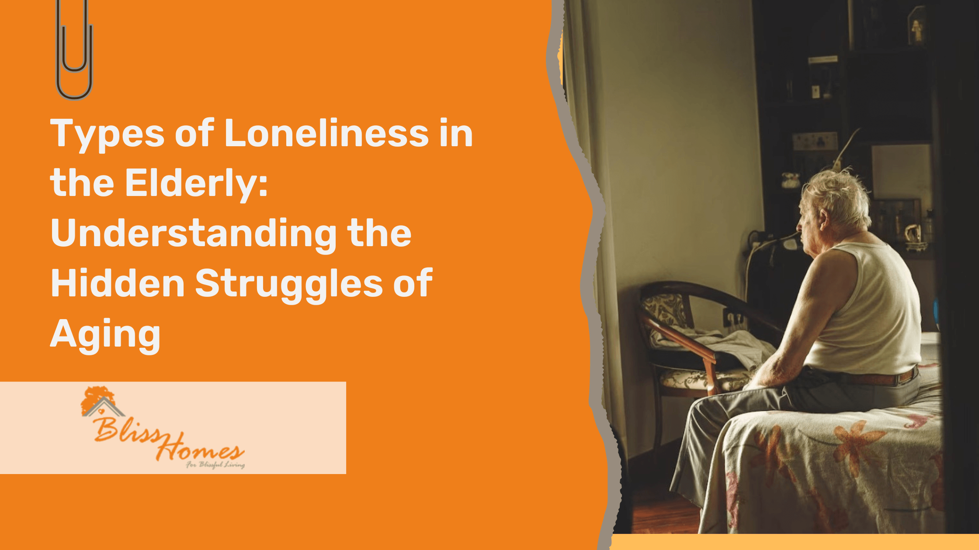
(Age Concern South Canterbury, 2026) |  |  |  | (patel, 2025)
Methodology  Write about your Methodology  The research will be conducted as secondary research. It will review the available academic literature to examine the experiences of loneliness in old age in the UK. The method will involve a systematic review of previously published peer-reviewed studies. (George, 2023)  Databases: the UWSTD Library, PubMed, ProQuest and Google Scholar.  Key points:  Challenges, barriers, loneliness, UK, elderly people and loneliness  PRISMA flowchart is used to record the selection process of the articles (PRISMA, 2020) |  |  |  | Data Analysis  To Identify commonalities between the articles, thematic analysis is employed  (Braun and Clark,2021).  Ethical considerations  Ethical considerations for secondary research include:  - Research should raise assistance for the people living in a society and reduce threats and harm (UK Data Service, 2012)  - The freedom and rights of people and groups should be valued (UK Data Service, 2012)  - Where possible, to partake in activities should be voluntary and well informed (UK Data Service, 2012)  - Conducting research should with done with honesty and clarity (UK Data Service, 2012)  - Accountability and responsibility should be explained clearly (UK Data Service, 2012)

Inclusion Criteria and Exclusion Criteria

Inclusion Criteria
  - Primary research in peer-reviewed journals.
  - Studies published between 2016–2026
  - UK-based studies in old age loneliness
  - Studies written in English
Exclusion Criteria:
  - Studies published before 2016
  - Non-English studies
  - Articles that are based on opinions and which lack empirical evidence.
  - Articles based on secondary research

References
Age Concern South Canterbury (2026) Loneliness - The Silent Crisis Facing South Canterbury’s Older Residents - Age Concern South Canterbury. Available at: https://ageconcernsc.org.nz/uncategorised/loneliness-the-silent-crisis-facing-south-canterburys-older-residents/ (Accessed: 16 March 2026).
George, T. (2023) What is Secondary Research? Definition, Types, & Examples. Available at: https://www.scribbr.com/methodology/secondary-research/ (Accessed: 22 June 2026).
patel, nirav (2025) Bliss Homes. Available at: https://theblisshomes.com/types-of-loneliness-in-the-elderly/ (Accessed: 16 March 2026).
PRISMA (2020) PRISMA 2020 Flow Diagram. Available at: https://www.prisma-statement.org/prisma-2020-flow-diagram (Accessed: 22 June 2026).
UK Data Service (2012) Ethical obligations. Available at: https://ukdataservice.ac.uk/learning-hub/research-data-management/ethical-issues/ethical-obligations/ (Accessed: 16 March 2026)

