Changemakers: Creativity and Value Creation Assignment 1: Innovation and Research (ACCA5033)

Animation and vfx
Abigail Jenkins (2115482)
2024
Table of Contents
Mind Maps 2
Mood Boards 3
Concept Art 6
Summary 10
References 11
Bibliography 16

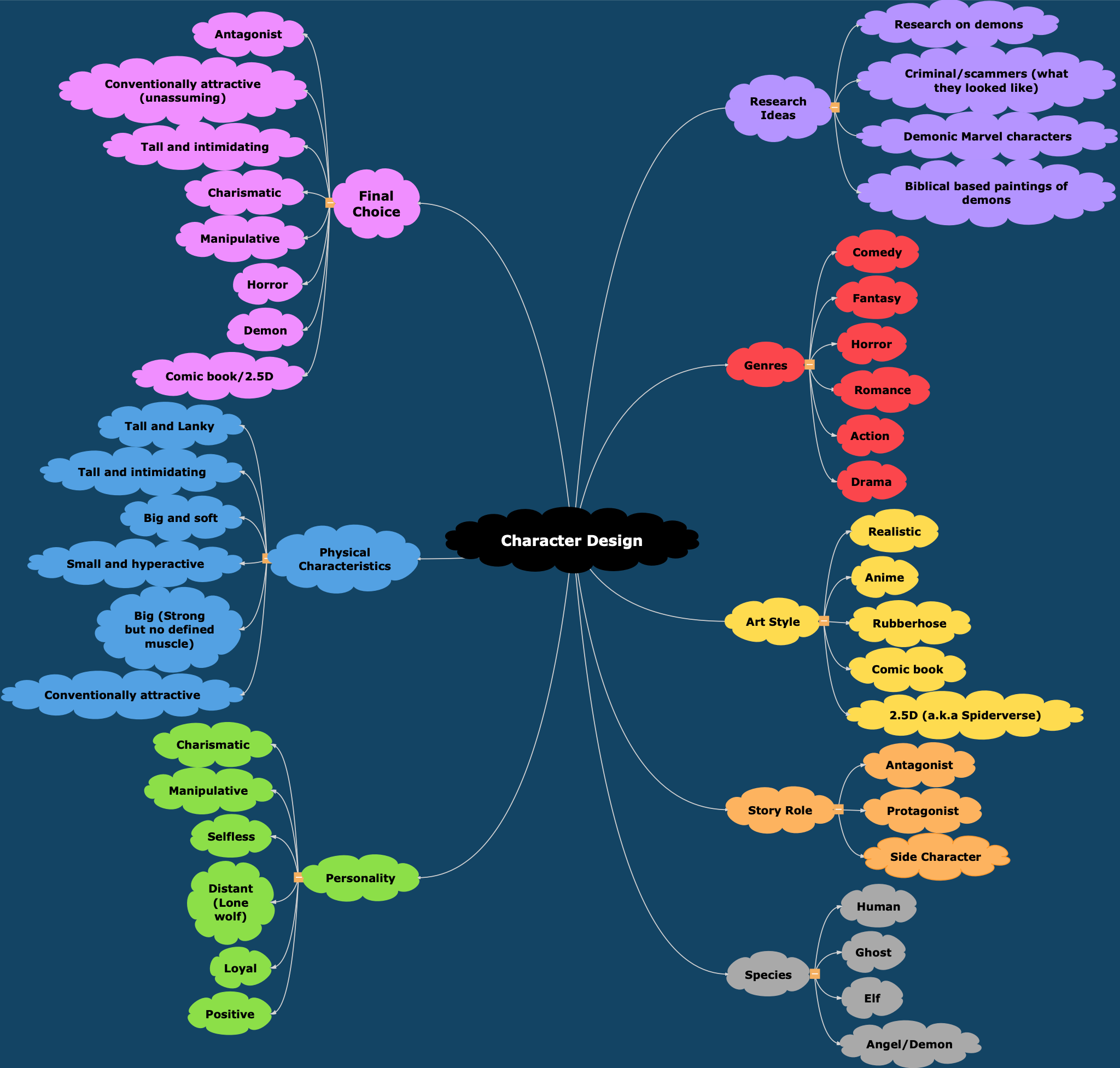
Mind Maps
Basic Ideas

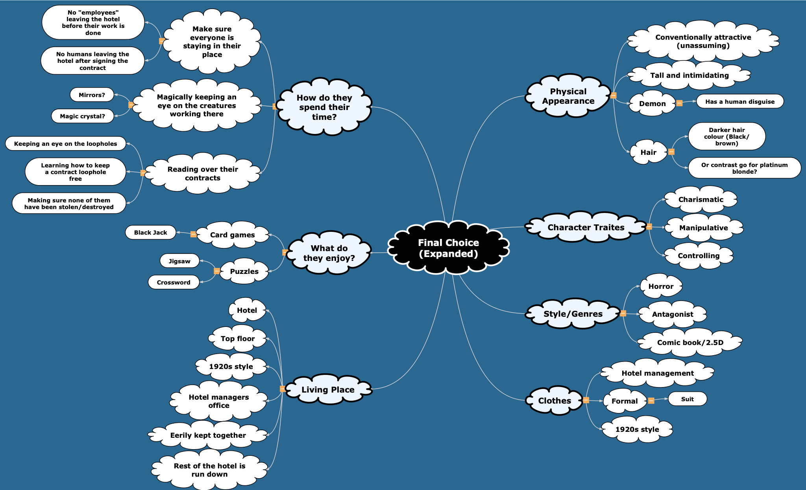
Expanded Ideas

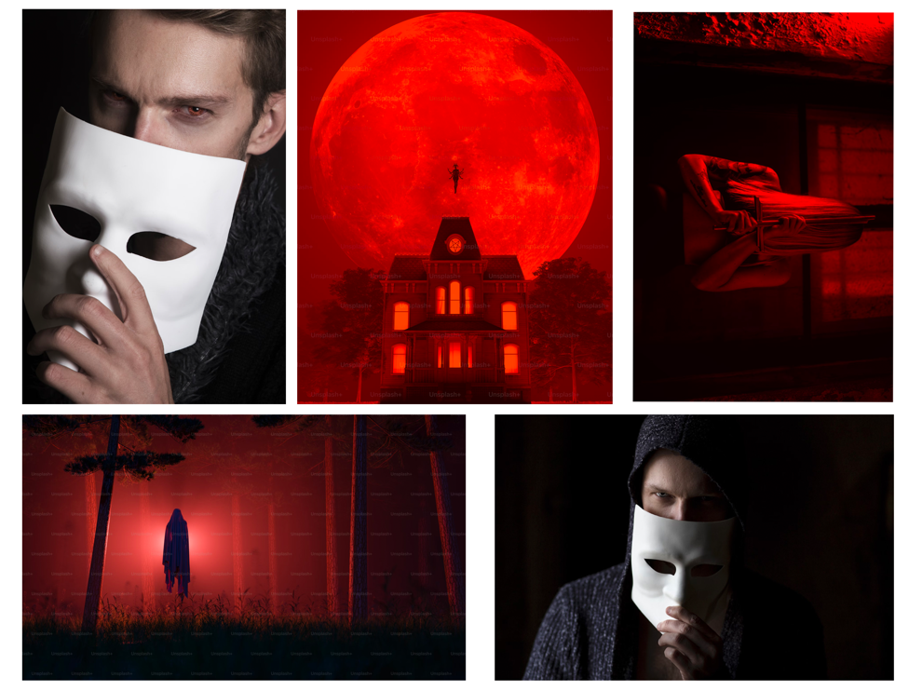
Mood Boards
Basic Vibes
[1] – [5]
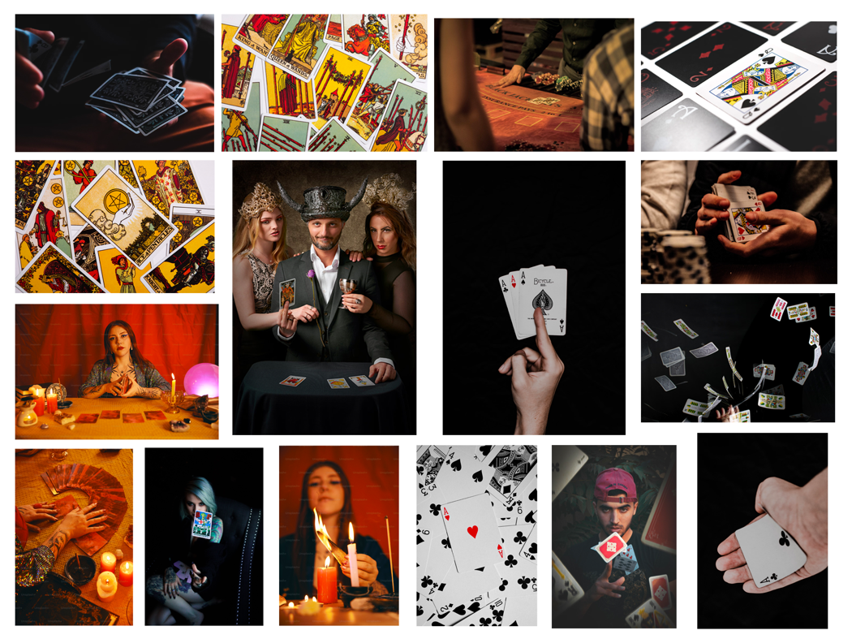
Characters Hobbies

[6] – [21]

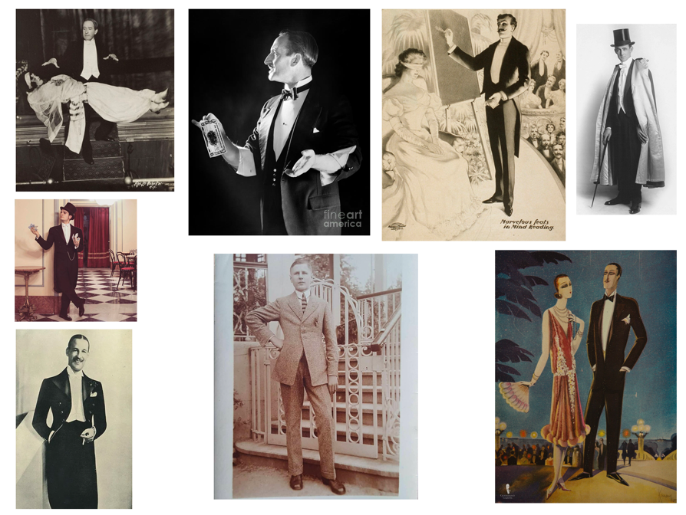
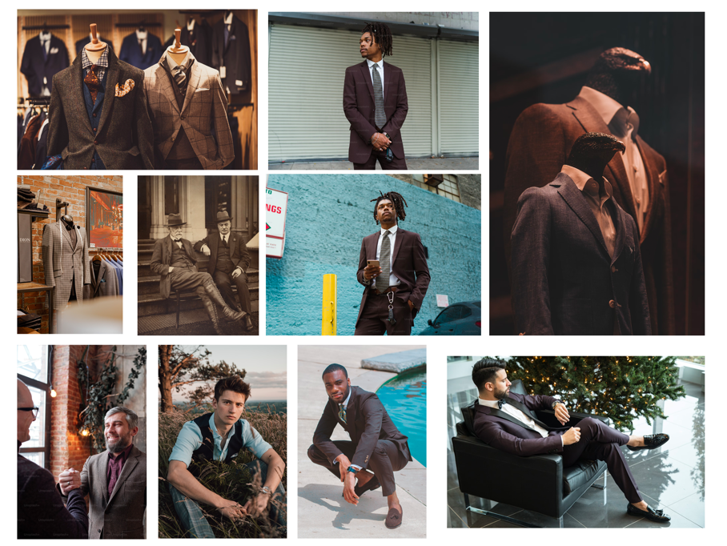
Characters Clothing (1920’s Style)
[22] – [31]
[32] – [39]

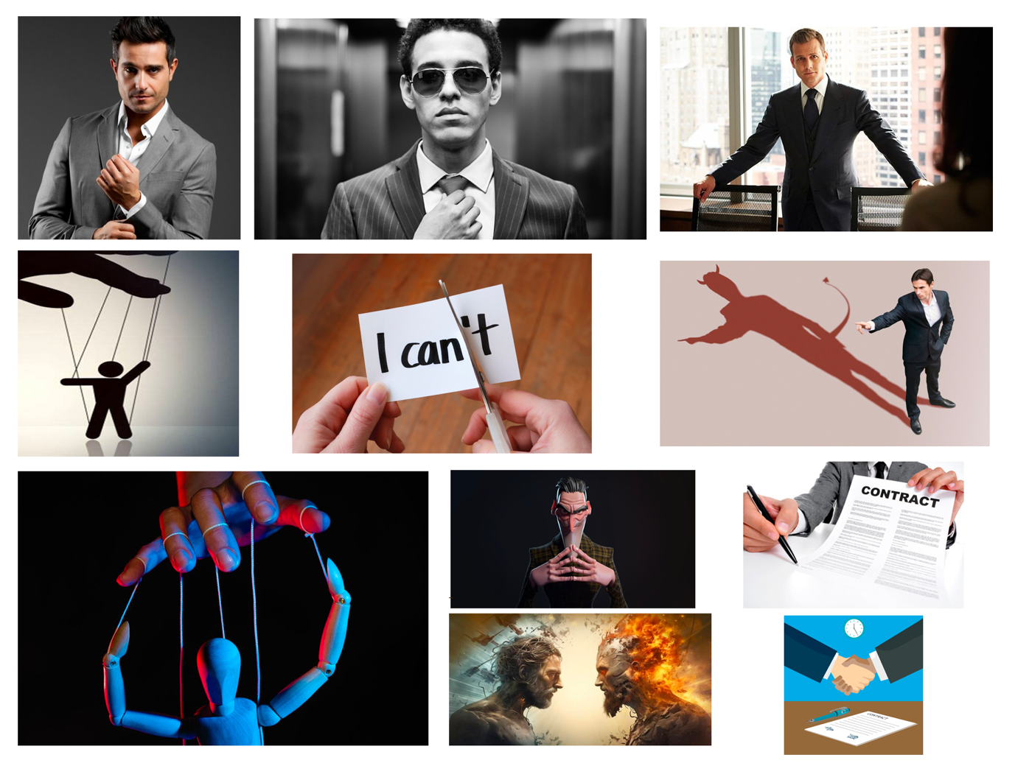
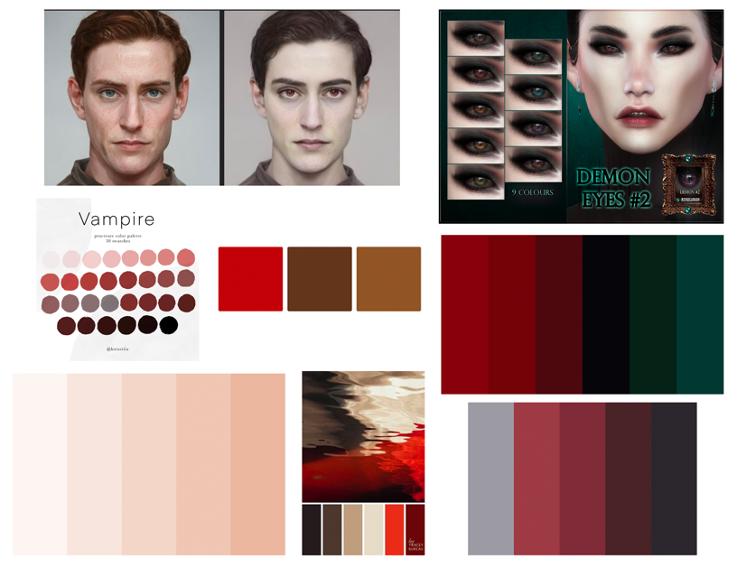
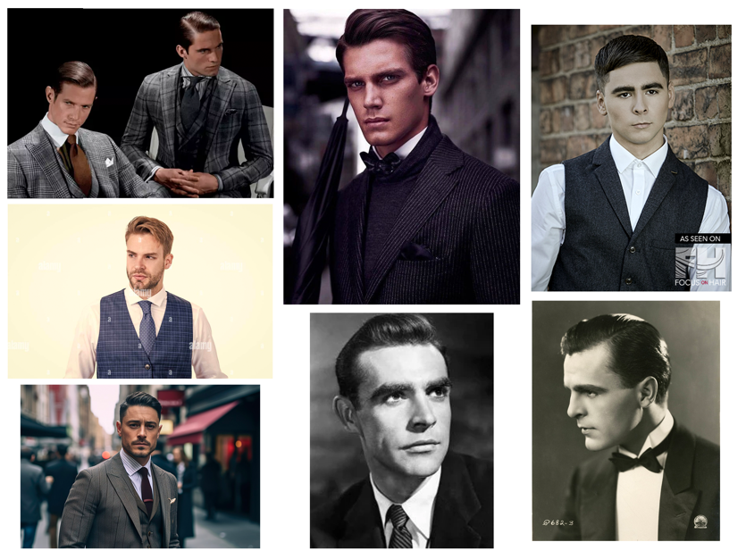
Characters Appearance
Characters Personality
[55] – [65]
[40] – [46]
[47] – [54]

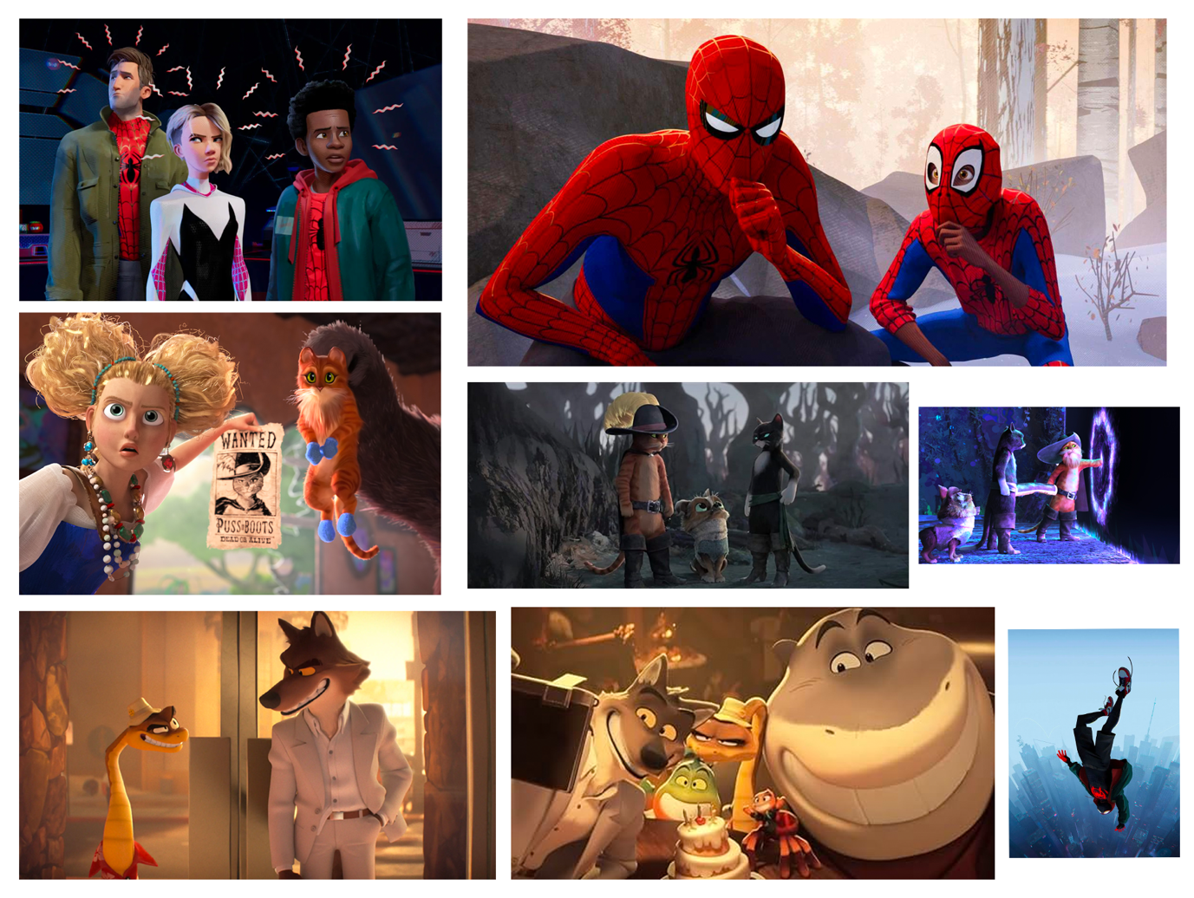
Art Style
[66] – [68]

Concept Art
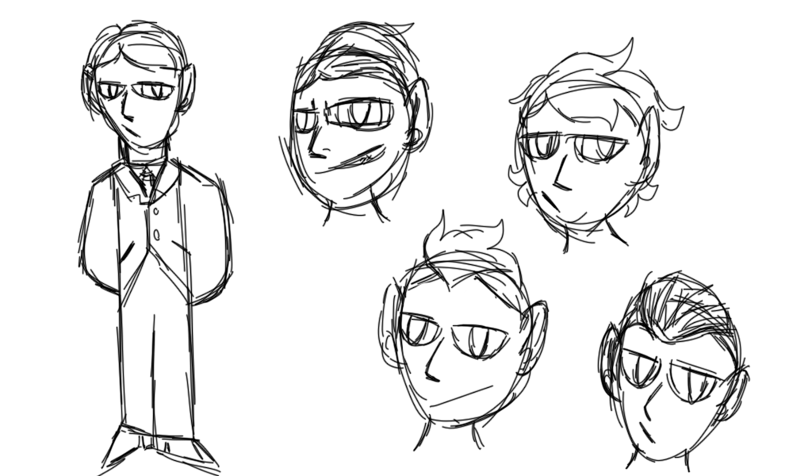

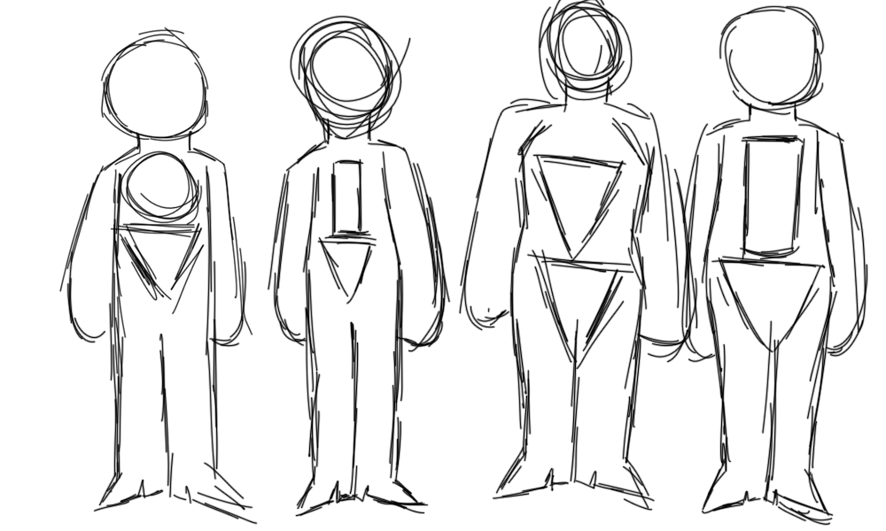
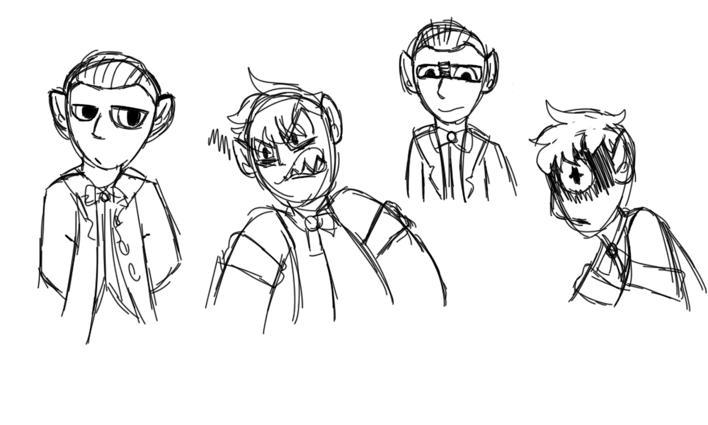
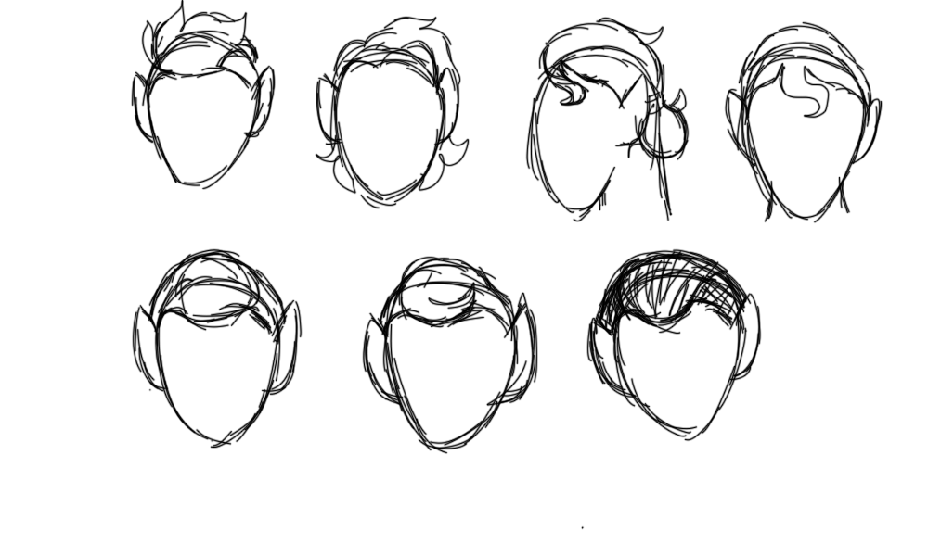
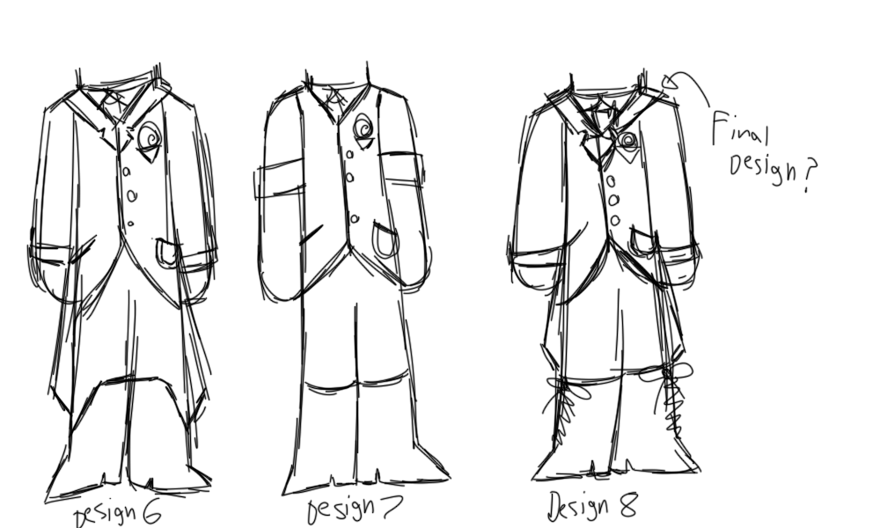
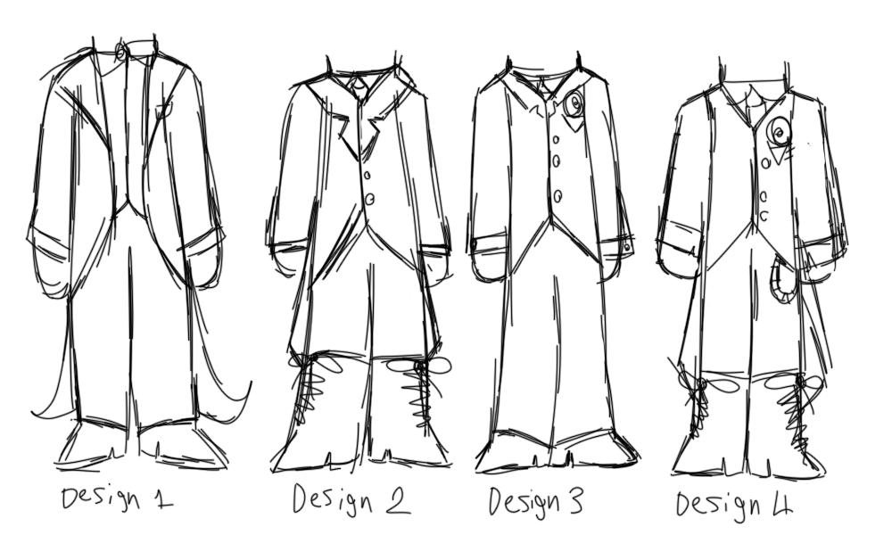
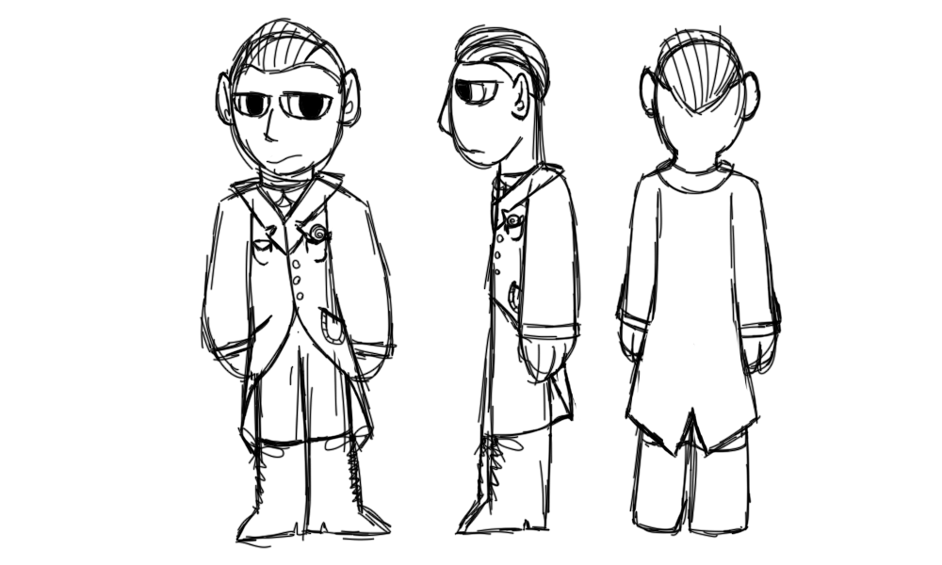
Final Design
Colour Tests
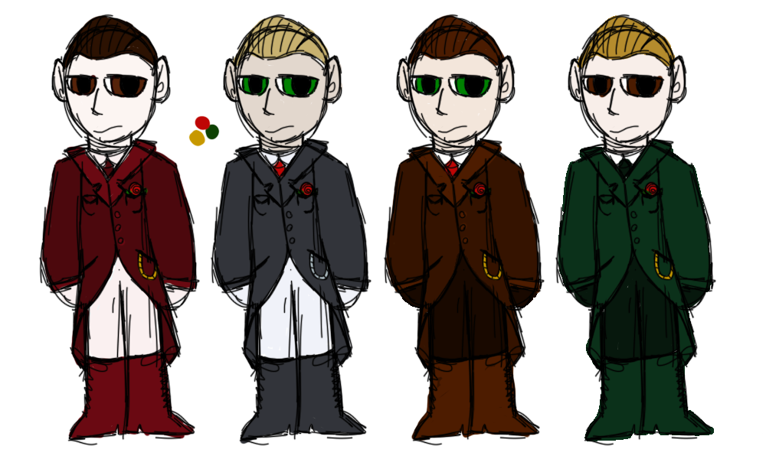

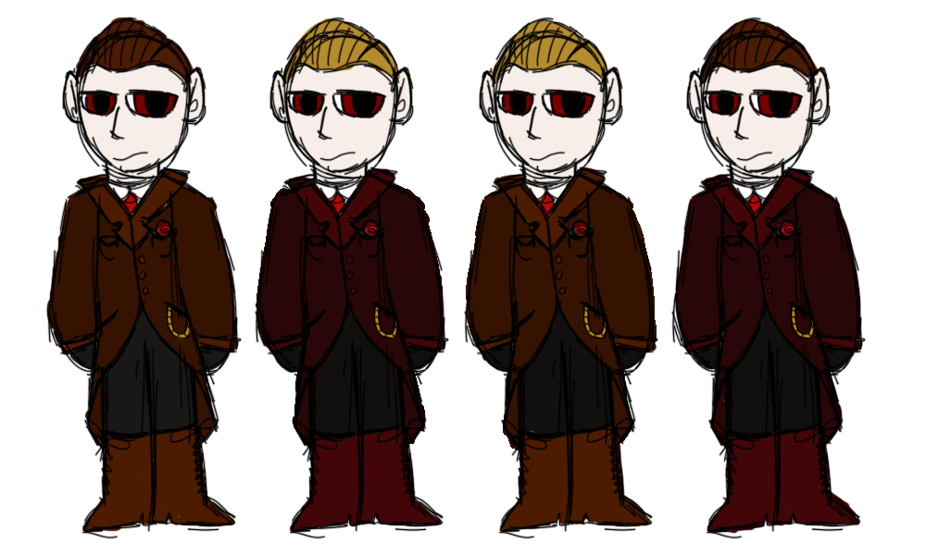
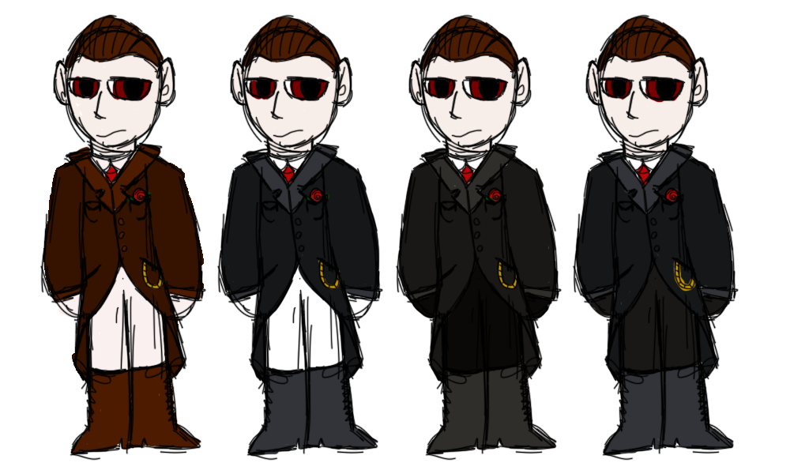
Summary
The character that has been designed for this assignment is based on a story I have created about a young man stumbling upon an abandoned hotel and being cursed to return to it each night to look after the ghastly monsters trapped within’ its walls.
Theme and Purpose
This character is the main antagonist of the story they are in and is the reason the main character is forced to return to the hotel every night.
He is a demon who can shapeshift into anything he wants to but chooses to be a human for most of the story. He does so because he doesn’t want to draw too much attention to himself during his time in the mortal realm as this may alert unwanted attention from both the governments of the mortal world and the people of his realm.
The genre of this story is mostly based in horror but has an upbeat tone throughout.
The chosen target audience is mid to late teenager as I want to be able to cover heavier concepts in my story but will also not be too graphic [69] – [70].
This story will be portrayed as a YouTube series spanning over multiple seasons [71] – [74]. IP is used to protect work from people who would steal it, YouTube’s copyright system is a good initial platform to protect this character design [75] – [76].
Design choices
MindView8 [77] was used to create my mind maps and Photoshop [78] to put together my mood boards and draw out my concepts.
The character’s appearance is controlled, so his clothes are a reflection of this trait.
Darker colours were selected because most of the clothing during the era was darker in tone with villains additionally having a darker colour palette [79] – [81].
I wanted the demon to feel intimidating so I made him taller than the average person and his design more angular [82] – [83].
I also wanted his design to not appear totally humanistic as whilst he is hiding his true form he is not fully human, so slightly pointed ears and cooler toned skin were selected to support this trait.
His design is more stylistic and incorporates anime styled eyes since bigger eyes are more appealing to audiences as you can see emotions better than if you were to go for a more realistic approach. It also helps the design avoid being too uncanny [84] – [87].

How research has informed decisions
The demon was summoned by the original owner of the hotel during the early 1920’s so his appearance is heavily inspired by the aesthetics of that time [22] – [46].
During his time with the original owner, he worked as an in house magician in the hotel to further the owner’s goal of making the hotel popular. So, inspiration was also taken from magician clothing during that time period.
The research I did has helped the original idea remain consistent throughout the entire design process whilst also grounding the design in reality.
Overall, I am happy with the design as it achieves its design intention.

References
[1] P. Campbell, "A large red full moon over a house," Unsplash, Sep. 21, 2023. [Online] Available: https://unsplash.com/photos/a-large-red-full-moon-over-a-house-kMlqNB31D_g [Accessed Feb. 9, 2024].
[2] S. Williams, "Man with white face mask," Unsplash, Apr. 16, 2021. [Online] Available: https://unsplash.com/photos/man-with-white-face-mask-HvqKdTFLkfw [Accessed Feb. 9, 2024].
[3] Getty Images, "spooky night in a forest with fog and an evil spirit with red light among the trees. Halloween concept, apparition, terror and fear. 3d rendering," Unsplash, Apr. 14, 2023. [Online] Available: https://unsplash.com/photos/spooky-night-in-a-forest-with-fog-and-an-evil-spirit-with-red-light-among-the-trees-halloween-concept-apparition-terror-and-fear-3d-rendering-M3Fiat-I5dY [Accessed Feb. 9, 2024].
[4] S. Williams, "Person in black knit cap and sweater," Unsplash, Apr. 16, 2021. [Online] Available: https://unsplash.com/photos/person-in-black-knit-cap-and-gray-sweater-q7ZlbWbDnYo [Accessed Feb. 9, 2024].
[5] P. Hawlik, "A woman standing in front of a red light," Unsplash, Aug. 4, 2023. [Online] Available: https://unsplash.com/photos/a-woman-standing-in-front-of-a-red-light-rWTdZC9IgKE [Accessed Feb. 9, 2024].
[6] J. Jordan, "man holding tarot card," Unsplash, Mar. 12, 2019. [Online] Available: https://unsplash.com/photos/man-holding-tarot-card-6ierk1KKuJ8 [Accessed Feb. 9, 2024].
[7] Viva Luna Studio, "yellow green and red floral print cards," Unsplash, Sep. 18, 2020. [Online] Available: https://unsplash.com/photos/yellow-green-and-red-floral-print-cards-y3qrbAgm7q8 [Accessed Feb. 9, 2024].
[8] N. Blauth, "a person's hands on a table surrounded by candles," Unsplash, Aug. 28, 2023. [Online] Available: https://unsplash.com/photos/a-persons-hands-on-a-table-surrounded-by-candles-wCm60vjI6ZQ [Accessed Feb. 9, 2024].
[9] S. Viladesau, "person playing with cards," Unsplash, Sep. 25, 2017. [Online] Available: https://unsplash.com/photos/person-playing-with-cards-dttmeqFUDSU [Accessed Feb. 9, 2024].

[10] N. Blauth, "a woman sitting at a table surrounded by candles," Unsplash, Aug. 28, 2023. [Online] Available: https://unsplash.com/photos/a-woman-sitting-at-a-table-surrounded-by-candles-yp5uo-QVMOA [Accessed Feb. 9, 2024].
[11] D. Gavi, "woman sitting on sofa," Unsplash, Jan. 7, 2018. [Online] Available: https://unsplash.com/photos/woman-sitting-on-sofa-XKOdMFYiBRo [Accessed Feb. 9, 2024].
[12] Viva Luna Studios, "king of diamonds playing car," Unsplash, Sep. 18, 2020. [Online] Available: https://unsplash.com/photos/king-of-diamonds-playing-card-0-7oZdFHf-I [Accessed Feb. 9, 2024].
[13] N. Blauth, "a woman lighting a candle on a table," Unsplash, Aug. 28, 2023. [Online] Available: https://unsplash.com/photos/a-woman-lighting-a-candle-on-a-table-ppDNAU4Kpec [Accessed Feb. 9, 2024].

[14] D. Kipic, "man in green dress shirt sitting on chair," Unsplash, Apr. 13, 2021. [Online] Available: https://unsplash.com/photos/man-in-green-dress-shirt-sitting-on-chair-qtD-aRQtMuc [Accessed Feb. 9, 2024].
[15] E. Lopez, "queen of spade playing card," Unsplash, Nov. 14, 2018. [Online] Available: https://unsplash.com/photos/queen-of-spade-playing-card-OfdFHy1zxjQ [Accessed Feb. 9, 2024].
[16] M. Tulard, "person holding king of spade playing card," Unsplash, Nov. 2, 2020. [Online] Available: https://unsplash.com/photos/person-holding-king-of-spade-playing-card-9sbO_vzyG40 [Accessed Feb. 9, 2024].
[17] K. Musalimov, "ace of spade playing card," Unsplash, June. 6, 2021. [Online] Available: https://unsplash.com/photos/ace-of-spade-playing-card-F7xRdXXvx9c [Accessed Feb. 9, 2024].
[18] A. Perkait, "heart shape red heart on white and black textile," Unsplash, Jun. 12, 2021. [Online] Available: https://unsplash.com/photos/heart-shape-red-heart-on-white-and-black-textile-IU4UKIfPqEQ [Accessed Feb. 9, 2024].
[19] M. I. Djoudi, "man throwing playing cards," Unsplash, Jul. 4, 2018. [Online] Available: https://unsplash.com/photos/man-throwing-playing-cards--PhG-v2axtU [Accessed Feb. 9, 2024].
[20] R. Melinda, "playing cards on black textile," Unsplash, Jan. 7, 2021. [Online] Available: https://unsplash.com/photos/playing-cards-on-black-textile-Qd7kQJUqrXA [Accessed Feb. 9, 2024].
[21] K. Musalimov, "person holding 2 of spade playing card," Unsplash, May. 8, 2021. [Online] Available: https://unsplash.com/photos/person-holding-2-of-spade-playing-card-wbEhgHz_TEk [Accessed Feb. 9, 2024].
[22] A. Naglestad, "man in black suit jacket," Unsplash, Feb. 2, 2020. [Online] Available: https://unsplash.com/photos/man-in-black-suit-jacket-RFhq0SrrgEg [Accessed Feb. 9, 2024].
[23] L. Bekyan, "a man in a suit and tie standing in front of a building," Unsplash, Jan. 30, 2023. [Online] Available: https://unsplash.com/photos/a-man-in-a-suit-and-tie-standing-in-front-of-a-building-talIk2mCt1c [Accessed Feb. 9, 2024].
[24] M. Titov, "man in black suit jacket and black hat," Unsplash, Feb. 1, 2020. [Online] Available: https://unsplash.com/photos/man-in-black-suit-jacket-and-black-hat-Pp6OwIz2-kg [Accessed Feb. 9, 2024].
[25] L. Weaver, "gray and white plaid suit jacket," Unsplash, Sep. 1, 2020. [Online] Available: https://unsplash.com/photos/gray-and-white-plaid-suit-jacket-JqRQtSr2MCI [Accessed Feb. 9, 2024].
[26] L. Bekyan, "a man in a suit and tie holding a cell phone," Unsplash, Jan. 30, 2023. [Online] Available: https://unsplash.com/photos/a-man-in-a-suit-and-tie-holding-a-cell-phone-TzrGxNJlkYo [Accessed Feb. 9, 2024].
[27] Museums Victoria, "man in black suit sitting on stairs," Unsplash, Jan. 21, 2020. [Online] Available: https://unsplash.com/photos/man-in-black-suit-sitting-on-stairs-mQJCWimuLFg [Accessed Feb. 9, 2024].
[28] Getty Images, "Smiling bearded businessman in jacket handshaking with colleague as symbol of strong relationship," Unsplash, May. 3, 2023. [Online] Available: https://unsplash.com/photos/smiling-bearded-businessman-in-jacket-handshaking-with-colleague-as-symbol-of-strong-relationship-hOp-5ixKM1I [Accessed Feb. 9, 2024].
[29] L. M. E. Bottrill, "men's blue 3/4 sleeved shirt," Unsplash, Jul. 31, 2019. [Online] Available: https://unsplash.com/photos/mens-blue-34-sleeved-shirt-DVeTzIywKw4 [Accessed Feb. 9, 2024].
[30] S. Nakhaei, "man sitting on black sofa chair while watching watch," Unsplash, Dec. 13, 2016. [Online] Available: https://unsplash.com/photos/man-sitting-on-black-sofa-chair-while-watching-watch-UzQQjq7W7C0 [Accessed Feb. 9, 2023].
[31] A. Robinson, "man in black 2-piece suit near swimming pool," Unsplash, May. 15, 2019. [Online] Available: https://unsplash.com/photos/man-in-black-2-piece-suit-near-swimming-pool-6Md6LUpsLp4 [Accessed Feb. 9, 2024].
[32] SOFREP Military Grade Content, "Jasper Maskelyne: The Magician Who Brought His Tricks to War," SOFREP, 2022. [Online] Available: https://sofrep.com/news/jasper-maskelyne-the-magician-who-brought-his-tricks-to-war/ [Accessed Feb. 16, 2024].
[33] Gentlemans Gazette, "Jazz Age Tuxedo -1920s," Gentelmans Gazette, 2018. [Online] Available: https://www.gentlemansgazette.com/tuxedo-black-tie-guide/black-tie-tuxedo-history/jazz-age-tuxedo-1920s/ [Accessed Feb. 16, 2024].
[34] Cathcart London, "Fine looking jazz-age tweed suit from early 20s," Facebook, 2019. [Online] Available: https://www.facebook.com/cathcartheritage/photos/a.272263266278039/1310642909106731/?type=3 [Accessed Feb. 16, 2024].
[35] F. Hartsook, "Claude Alexander Conlin circa 1915," Wikipedia, Jul. 24, 2018. [Online] Available: https://en.wikipedia.org/wiki/Alexander_%28magician%29#/media/File:Claude_Alexander_Conlin_circa_1915_(cropped).jpg [Accessed Feb. 16, 2024].
[36] Scarlett Entertainment, "CLASSIC MAGIC SHOW ITALY," Scarlett Entertainment, 2024. [Online] Available: https://scarlettentertainment.com/acts/classic-magic-show-italy [Accessed Feb. 16, 2024].
[37] R. Morgan, "Theatrical poster for a mind-reading performance, 1900," Wikipedia, 2008. [Online] Available: https://en.wikipedia.org/wiki/Mentalism#/media/File:Mind-reading-Russell-Morgan.jpeg [Accessed Feb. 16, 2024].
[38] H. Armstrong, "Magician With Sleeves Rolled Up, C.1920s," Fine art america, Nov. 2, 2015. [Online] Available: https://fineartamerica.com/featured/magician-with-sleeves-rolled-up-c1920s-h-armstrong-robertsclassicstock.html [Accessed Feb. 16, 2024].
[39] H. Oatman-Stanford, "The Magician Who Astounded the World by Conjuring Spirits and Talking with Mummies," Collectors Weekly, May. 5, 2015. [Online] Available: https://www.collectorsweekly.com/articles/the-magician-who-astounded-the-world-by-conjuring-spirits-and-talking-with-mummies/ [Accessed Feb. 16, 2024].
[40] R. Sharma, "Best Vintage 1920’S Hairstyles For Men," Anuaad Life, 2023. [Online] Availaible: https://anunaadlife.com/best-vintage-1920s-hairstyles-for-men/ [Accessed Feb. 9, 2024].
[41] S. Piper, "1920s Men’s Hairstyles: 15 Awesome Ideas to Copy," Cool mens hair, 2024. [Online] Available: https://coolmenshair.com/1920s-mens-hairstyles/ [Accessed Feb. 9, 2024].
[42] R. Steteyk, "Neat hairstyle for classy look. Unshaven man with stylish hair isolated on white. Hair salon," Alamy, Oct. 1, 2020. [Online] Available: https://www.alamy.com/neat-hairstyle-for-classy-look-unshaven-man-with-stylish-hair-isolated-on-white-hair-salon-image441730492.html [Accessed Feb. 9, 2024].
[43] R. Grosvenor and A. Kruzak, "Gangsta Style,” Focus on Hair, 2024. [Online] Available: https://focusonhair.com/article/gangsta-style-mens-hairstyles?fbrefresh=1706806111 [Accessed Feb. 9, 2024].
[44] M. Rogers, "1920s Haircuts for Men: Introduction of Roaring 20s Mens Hairstyles," Vintage Retro, 2020. [Online] Available: https://www.vintage-retro.com/1920s-haircuts-for-men-introduction-of-roaring-20s-mens-hairstyles/ [Accessed Feb. 9, 2024].
[45] J. Willis Sayre Collection of Theatrical Photographs, "Silent film actor Neil Hamilton," Wikipedia, 2021. [Online] Available: https://commons.wikimedia.org/wiki/File:Silent_film_actor_Neil_Hamilton_%28SAYRE_3498%29.jpg#/media/File:Silent_film_actor_Neil_Hamilton_(SAYRE_3498).jpg [Accessed Feb. 9, 2024].
[46] A. Centeno, "7 Men’s Hairstyles That Women LOVE," Real Men Real Style, Oct. 30, 2023. [Online] Available: https://www.realmenrealstyle.com/mens-hairstyles-women-love/ [Accessed Feb. 9, 2024].
[47] Native_groundhog922, "Vampire Skin Color," Reddit, Nov. 30, 2023. [Online] Available: https://www.reddit.com/r/twilight/comments/187dlgp/vampire_skin_color/ [Accessed Feb. 9, 2024].
[48] K. Anastasia, "Vampire, digital color palette for Procreate, dark and moody set of red hues for graphic design and digital art, Ukrainian shop," Etsy, 2019. [Online] Available: https://www.etsy.com/uk/listing/1252873404/vampire-digital-color-palette-for [Accessed Feb 9, 2024].
[49] Etsy, "Red Color Inspired Palette," Pintrest, 2024. [Online] Available: https://www.pinterest.co.uk/pin/841750986602338739/ [Accessed Feb. 9, 2024].
[50] RemusSirion, "Demon Eyes 2," The Sims Resource, Jun. 4, 2018. [Online] Available: https://www.thesimsresource.com/downloads/details/category/sims4-eyecolors/title/demon-eyes-2/id/1416688/ [Accessed Feb. 9, 2024].
[51] Manish, "Devil Color Scheme," Scheme Color, 2024. [Online] Available: https://www.schemecolor.com/devil.php [Accessed Feb. 9, 2024].
[52] maert, "vampire skin Color Palette," Color Hex, 2024. [Online] Available: https://www.color-hex.com/color-palette/91453 [Accessed Feb. 9, 2024].
[53] aashley, "devils heart Color Palette," Color Hex, 2024. [Online] Available: https://www.color-hex.com/color-palette/86165 [Accessed Feb. 9, 2024].
[54] Team Color Codes, "Cornell Big Red Color Codes," Team Color Codes, 2024. [Online] Available: https://teamcolorcodes.com/cornell-big-red-color-codes/ [Accessed Feb. 9, 2024].
[55] J. Haforlarin, "What makes someone charismatic?," Quora, 2018. [Online] Available: https://www.quora.com/What-makes-someone-charismatic/answers/40529489 [Accessed Feb. 9, 2024].
[56] K. Daum, "5 Things Really Charismatic People Do," INC, Mar. 3, 2014. [Online] Available: https://www.inc.com/kevin-daum/5-things-really-charismatic-people-do.html [Accessed Feb. 9, 2024].
[57] A. Zabala, "Evil Mastermind," Art Station, 2017. [Online] Available: https://www.artstation.com/artwork/PYRk1 [Accessed Feb. 9, 2024].
[58] B. Saline, "How To Deal With Controlling People," Talk Space, Sep. 23, 2019. [Online] Available: https://www.talkspace.com/blog/controlling-people-how-to-deal/ [Accessed Feb. 9, 2024].
[59] VOI, "So That It's Not Easy To Be Tricked, It's Important To Recognize 5 Motives Of Manipulative People," Voi, 2023. [Online] Available: https://voi.id/fr/lifestyle/329149 [Accessed Feb. 9, 2024].
[60] Beam Consultancy, "WHY ARE PEOPLE WITH PERSONALITY DISORDER SO MANIPULATIVE?," Beam Consultancy, 2020. [Online] Available: https://www.beamconsultancy.co.uk/the-blog/2020/3/3/why-are-people-with-personality-disorder-so-manipulative [Accessed Feb. 9, 2024].
[61] A. Adetilewa, "10 Winning Habits of Highly Charismatic People That You Can Adopt Too," Addicted 2 Success, May. 11, 2017. [Online] Available: https://addicted2success.com/life/10-winning-habits-of-highly-charismatic-people-that-you-can-adopt-too/ [Accessed Feb. 9, 2024].
[62] Catalyst Law, "How to review a contract or agreement," Catalyst Law, 2021. [Online] Available: https://www.catalystlaw.co.uk/blog/how-to-conduct-a-contract-review [Accessed Feb. 16, 2024].
[63] K. Gibs, "Contract Offer and Acceptance," BEB Consultancy, Dec. 5, 2017. [Online] Available: https://bebconsultancy.co.uk/contract-offer-and-acceptance/ [Accessed Feb. 16, 2024].
[64] M. Taylor, and M. T. Stevens, The Art & Science of Psychological Warfare: (2 books in 1) Learn the Secrets of Hidden Influence and How to Mentally Subdue Your Opponents in Stealth Mode, 2023.
[65] The Jakarta Post, "Eight scientifically proven ways to attain self-confidence," The Jakarta Post, 2017. [Online] Available: https://www.thejakartapost.com/life/2017/11/30/eight-scientifically-proven-ways-to-attain-self-confidence.html [Accessed Feb. 16, 2024].
[66] J. Crawford, and J. Mercado, Director, Puss in boots the last wish, [DVD], California: Dreamworks, 2022.
[67] P. Perifel, The Bad Guys, [DVD], California: Dreamworks, 2022.
[68] B. Persichetti, P. Ramsey, and R. Rothman, Spiderman into the Spiderverse, [DVD], California: Sony Pictures Animation, 2018.
[69] A Daugherty, "Why Everyone Is Watching “The Amazing Digital Circus,” The Spectator, Nov. 14, 2023. [Online] Available: https://berkleyspectator.com/5222/entertainment/why-everyone-is-watching-the-amazing-digital-circus/ [Accessed Feb. 26, 2024].
[70] J. Guerrero, "REVIEW: THE AMAZING DIGITAL CIRCUS is a jaw-dropping dark comedy," The Beat the blog of Comic Culture, Oct. 25, 2023. [Online] Available: https://www.comicsbeat.com/review-the-amazing-digital-circus-is-a-jaw-dropping-dark-comedy/ [Accessed Feb. 26, 2024].
[71] Skywigly, "‘Hazbin Hotel’ creator Vivziepop teams with Horseless Cowboy on devilishly twisted ‘Helluva Boss’," Skywigly, Oct. 7, 2020. [Online] Available: https://www.skwigly.co.uk/horseless-cowboy-helluva-boss/ [Accessed Feb. 26, 2024].
[72] M. Milligan, "Streamy Awards Announce 2023 Nominees," Animation Magazine, Jul. 24, 2023. [Online] Available: https://www.animationmagazine.net/2023/07/streamy-awards-announce-2023-nominees/ [Accessed Feb. 26, 2024].
[73] R. Gomez, "30 YouTube statistics to power your marketing strategy in 2023," Sprout Social, Feb. 28, 2023. [Online] Available: https://sproutsocial.com/insights/youtube-stats/ [Accessed Feb. 26, 2024].
[74] J. Shepherd, "23 Essential YouTube Statistics You Need to Know in 2024," Social Shepherd, Feb. 26, 2024. [Online] Available: https://thesocialshepherd.com/blog/youtube-statistics [Accessed Feb. 26, 2024].
[75] Gov.Uk, "How copyright protects your work," GOV.UK, 2024 [Online] Available: https://www.gov.uk/copyright#:~:text=Copyright%20protects%20your%20work%20and,apply%20or%20pay%20a%20fee [Accessed Feb. 27, 2024].
[76] YouTube, "Copyright," YouTube, 2024. [Online] Available: https://www.youtube.com/intl/ALL_uk/howyoutubeworks/policies/copyright/#enforcing-copyright [Accessed Feb. 27, 2024].
[77] MindView, Version 8, [Software], Denmark: MatchWare, 1998.
[78] Photoshop, Vesion 23.5.5, [Software], California: Adobe, 1990.
[79] S. Mcguire, "What Disney Villains Can Tell Us About Color Psychology [Infographic]," Venngage, Jul. 28, 2017. [Online] Available: https://venngage.com/blog/disney-villains/#:~:text=As%20expected%2C%20mostly%20villains%20had,were%20primarily%20found%20in%20heroes [Accessed Feb. 27, 2024].

[80] M. Mervis, "Popular Color Palettes Through the Decades: 1920s-1960s," Dunn Edwards Paints, Aug. 2, 2022. [Online] Available: https://www.dunnedwards.com/pros/blog/popular-color-palettes-through-the-decades-1920s-1960s/#:~:text=stylized%20motifs%2C%20geometric%20patterns%2C%20a,greens%20helped%20define%20the%20era [Accessed Feb. 27, 2024].
[81] D. L. Sessions, "1920s Fabrics and Colors in Fashion," Vintage Dancer, Jun. 18, 2013. [Online] Available: https://vintagedancer.com/1920s/fabrics-and-colors/ [Accessed Feb. 27, 2024].
[82] Winged Canvas, "Shape Language In Character Design," YouTube, May, 6, 2023. [Online] Available: https://youtu.be/v6n9OYtaWZs?si=Rb6-3MNg4a6dIBx2 [Accessed Feb. 27, 2024].
[83] B. Nikolaeva, "How to Convey Character’s Personality Through Shape, Variance and Size," Graphic Mama, 2017. [Online] Available: https://graphicmama.com/blog/conveying-characters-personality/ [Accessed Feb. 27, 2024].
[84] T. Srivasta, "Why Anime and Manga Characters Have Enormous Eyes," CBR, Mar. 4, 2023. [Online] Available: https://www.cbr.com/why-anime-manga-characters-have-big-eyes/#:~:text=In%20western%20parts%20of%20the,accurately%2C%20making%20characters%20more%20relatable [Accessed Feb. 27, 2024].
[85] Okuha, "Why Do Anime Characters Have Big Eyes?," Okuha, Mar. 23, 2023. [Online] Available: https://okuha.com/why-anime-characters-have-big-eyes/ [Accessed Feb. 27, 2024].
[86] Extra History, "The Uncanny Valley - Why More Realistic Characters Look Less Human - Extra Credits," YouTube, May, 19, 2012. [Online] Available: https://www.youtube.com/watch?v=9K1Kd9mZL8g [Accessed Feb. 27, 2024].
[87] M. Dargis, "Do You Hear Sleigh Bells? Nah, Just Tom Hanks and Some Train," The New York Times, Nov. 10, 2004. [Online] Available: https://www.nytimes.com/2004/11/10/movies/do-you-hear-sleigh-bells-nah-just-tom-hanks-and-some-train.html [Accessed Feb. 27, 2024].

Bibliography

[1] P. Campbell, "A large red full moon over a house," Unsplash, Sep. 21, 2023. [Online] Available: https://unsplash.com/photos/a-large-red-full-moon-over-a-house-kMlqNB31D_g [Accessed Feb. 9, 2024].
[2] S. Williams, "Man with white face mask," Unsplash, Apr. 16, 2021. [Online] Available: https://unsplash.com/photos/man-with-white-face-mask-HvqKdTFLkfw [Accessed Feb. 9, 2024].
[3] Getty Images, "spooky night in a forest with fog and an evil spirit with red light among the trees. Halloween concept, apparition, terror and fear. 3d rendering," Unsplash, Apr. 14, 2023. [Online] Available: https://unsplash.com/photos/spooky-night-in-a-forest-with-fog-and-an-evil-spirit-with-red-light-among-the-trees-halloween-concept-apparition-terror-and-fear-3d-rendering-M3Fiat-I5dY [Accessed Feb. 9, 2024].
[4] S. Williams, "Person in black knit cap and sweater," Unsplash, Apr. 16, 2021. [Online] Available: https://unsplash.com/photos/person-in-black-knit-cap-and-gray-sweater-q7ZlbWbDnYo [Accessed Feb. 9, 2024].

[5] P. Hawlik, "A woman standing in front of a red light," Unsplash, Aug. 4, 2023. [Online] Available: https://unsplash.com/photos/a-woman-standing-in-front-of-a-red-light-rWTdZC9IgKE [Accessed Feb. 9, 2024].
[6] J. Jordan, "man holding tarot card," Unsplash, Mar. 12, 2019. [Online] Available: https://unsplash.com/photos/man-holding-tarot-card-6ierk1KKuJ8 [Accessed Feb. 9, 2024].
[7] Viva Luna Studio, "yellow green and red floral print cards," Unsplash, Sep. 18, 2020. [Online] Available: https://unsplash.com/photos/yellow-green-and-red-floral-print-cards-y3qrbAgm7q8 [Accessed Feb. 9, 2024].
[8] N. Blauth, "a person's hands on a table surrounded by candles," Unsplash, Aug. 28, 2023. [Online] Available: https://unsplash.com/photos/a-persons-hands-on-a-table-surrounded-by-candles-wCm60vjI6ZQ [Accessed Feb. 9, 2024].
[9] S. Viladesau, "person playing with cards," Unsplash, Sep. 25, 2017. [Online] Available: https://unsplash.com/photos/person-playing-with-cards-dttmeqFUDSU [Accessed Feb. 9, 2024].

[10] N. Blauth, "a woman sitting at a table surrounded by candles," Unsplash, Aug. 28, 2023. [Online] Available: https://unsplash.com/photos/a-woman-sitting-at-a-table-surrounded-by-candles-yp5uo-QVMOA [Accessed Feb. 9, 2024].
[11] D. Gavi, "woman sitting on sofa," Unsplash, Jan. 7, 2018. [Online] Available: https://unsplash.com/photos/woman-sitting-on-sofa-XKOdMFYiBRo [Accessed Feb. 9, 2024].
[12] Viva Luna Studios, "king of diamonds playing car," Unsplash, Sep. 18, 2020. [Online] Available: https://unsplash.com/photos/king-of-diamonds-playing-card-0-7oZdFHf-I [Accessed Feb. 9, 2024].
[13] N. Blauth, "a woman lighting a candle on a table," Unsplash, Aug. 28, 2023. [Online] Available: https://unsplash.com/photos/a-woman-lighting-a-candle-on-a-table-ppDNAU4Kpec [Accessed Feb. 9, 2024].

[14] D. Kipic, "man in green dress shirt sitting on chair," Unsplash, Apr. 13, 2021. [Online] Available: https://unsplash.com/photos/man-in-green-dress-shirt-sitting-on-chair-qtD-aRQtMuc [Accessed Feb. 9, 2024].
[15] E. Lopez, "queen of spade playing card," Unsplash, Nov. 14, 2018. [Online] Available: https://unsplash.com/photos/queen-of-spade-playing-card-OfdFHy1zxjQ [Accessed Feb. 9, 2024].
[16] M. Tulard, "person holding king of spade playing card," Unsplash, Nov. 2, 2020. [Online] Available: https://unsplash.com/photos/person-holding-king-of-spade-playing-card-9sbO_vzyG40 [Accessed Feb. 9, 2024].
[17] K. Musalimov, "ace of spade playing card," Unsplash, June. 6, 2021. [Online] Available: https://unsplash.com/photos/ace-of-spade-playing-card-F7xRdXXvx9c [Accessed Feb. 9, 2024].
[18] A. Perkait, "heart shape red heart on white and black textile," Unsplash, Jun. 12, 2021. [Online] Available: https://unsplash.com/photos/heart-shape-red-heart-on-white-and-black-textile-IU4UKIfPqEQ [Accessed Feb. 9, 2024].
[19] M. I. Djoudi, "man throwing playing cards," Unsplash, Jul. 4, 2018. [Online] Available: https://unsplash.com/photos/man-throwing-playing-cards--PhG-v2axtU [Accessed Feb. 9, 2024].
[20] R. Melinda, "playing cards on black textile," Unsplash, Jan. 7, 2021. [Online] Available: https://unsplash.com/photos/playing-cards-on-black-textile-Qd7kQJUqrXA [Accessed Feb. 9, 2024].
[21] K. Musalimov, "person holding 2 of spade playing card," Unsplash, May. 8, 2021. [Online] Available: https://unsplash.com/photos/person-holding-2-of-spade-playing-card-wbEhgHz_TEk [Accessed Feb. 9, 2024].
[22] A. Naglestad, "man in black suit jacket," Unsplash, Feb. 2, 2020. [Online] Available: https://unsplash.com/photos/man-in-black-suit-jacket-RFhq0SrrgEg [Accessed Feb. 9, 2024].
[23] L. Bekyan, "a man in a suit and tie standing in front of a building," Unsplash, Jan. 30, 2023. [Online] Available: https://unsplash.com/photos/a-man-in-a-suit-and-tie-standing-in-front-of-a-building-talIk2mCt1c [Accessed Feb. 9, 2024].
[24] M. Titov, "man in black suit jacket and black hat," Unsplash, Feb. 1, 2020. [Online] Available: https://unsplash.com/photos/man-in-black-suit-jacket-and-black-hat-Pp6OwIz2-kg [Accessed Feb. 9, 2024].
[25] L. Weaver, "gray and white plaid suit jacket," Unsplash, Sep. 1, 2020. [Online] Available: https://unsplash.com/photos/gray-and-white-plaid-suit-jacket-JqRQtSr2MCI [Accessed Feb. 9, 2024].
[26] L. Bekyan, "a man in a suit and tie holding a cell phone," Unsplash, Jan. 30, 2023. [Online] Available: https://unsplash.com/photos/a-man-in-a-suit-and-tie-holding-a-cell-phone-TzrGxNJlkYo [Accessed Feb. 9, 2024].
[27] Museums Victoria, "man in black suit sitting on stairs," Unsplash, Jan. 21, 2020. [Online] Available: https://unsplash.com/photos/man-in-black-suit-sitting-on-stairs-mQJCWimuLFg [Accessed Feb. 9, 2024].
[28] Getty Images, "Smiling bearded businessman in jacket handshaking with colleague as symbol of strong relationship," Unsplash, May. 3, 2023. [Online] Available: https://unsplash.com/photos/smiling-bearded-businessman-in-jacket-handshaking-with-colleague-as-symbol-of-strong-relationship-hOp-5ixKM1I [Accessed Feb. 9, 2024].
[29] L. M. E. Bottrill, "men's blue 3/4 sleeved shirt," Unsplash, Jul. 31, 2019. [Online] Available: https://unsplash.com/photos/mens-blue-34-sleeved-shirt-DVeTzIywKw4 [Accessed Feb. 9, 2024].
[30] S. Nakhaei, "man sitting on black sofa chair while watching watch," Unsplash, Dec. 13, 2016. [Online] Available: https://unsplash.com/photos/man-sitting-on-black-sofa-chair-while-watching-watch-UzQQjq7W7C0 [Accessed Feb. 9, 2023].
[31] A. Robinson, "man in black 2-piece suit near swimming pool," Unsplash, May. 15, 2019. [Online] Available: https://unsplash.com/photos/man-in-black-2-piece-suit-near-swimming-pool-6Md6LUpsLp4 [Accessed Feb. 9, 2024].
[32] SOFREP Military Grade Content, "Jasper Maskelyne: The Magician Who Brought His Tricks to War," SOFREP, 2022. [Online] Available: https://sofrep.com/news/jasper-maskelyne-the-magician-who-brought-his-tricks-to-war/ [Accessed Feb. 16, 2024].
[33] Gentlemans Gazette, "Jazz Age Tuxedo -1920s," Gentelmans Gazette, 2018. [Online] Available: https://www.gentlemansgazette.com/tuxedo-black-tie-guide/black-tie-tuxedo-history/jazz-age-tuxedo-1920s/ [Accessed Feb. 16, 2024].
[34] Cathcart London, "Fine looking jazz-age tweed suit from early 20s," Facebook, 2019. [Online] Available: https://www.facebook.com/cathcartheritage/photos/a.272263266278039/1310642909106731/?type=3 [Accessed Feb. 16, 2024].
[35] F. Hartsook, "Claude Alexander Conlin circa 1915," Wikipedia, Jul. 24, 2018. [Online] Available: https://en.wikipedia.org/wiki/Alexander_%28magician%29#/media/File:Claude_Alexander_Conlin_circa_1915_(cropped).jpg [Accessed Feb. 16, 2024].
[36] Scarlett Entertainment, "CLASSIC MAGIC SHOW ITALY," Scarlett Entertainment, 2024. [Online] Available: https://scarlettentertainment.com/acts/classic-magic-show-italy [Accessed Feb. 16, 2024].
[37] R. Morgan, "Theatrical poster for a mind-reading performance, 1900," Wikipedia, 2008. [Online] Available: https://en.wikipedia.org/wiki/Mentalism#/media/File:Mind-reading-Russell-Morgan.jpeg [Accessed Feb. 16, 2024].
[38] H. Armstrong, "Magician With Sleeves Rolled Up, C.1920s," Fine art america, Nov. 2, 2015. [Online] Available: https://fineartamerica.com/featured/magician-with-sleeves-rolled-up-c1920s-h-armstrong-robertsclassicstock.html [Accessed Feb. 16, 2024].
[39] H. Oatman-Stanford, "The Magician Who Astounded the World by Conjuring Spirits and Talking with Mummies," Collectors Weekly, May. 5, 2015. [Online] Available: https://www.collectorsweekly.com/articles/the-magician-who-astounded-the-world-by-conjuring-spirits-and-talking-with-mummies/ [Accessed Feb. 16, 2024].
[40] R. Sharma, "Best Vintage 1920’S Hairstyles For Men," Anuaad Life, 2023. [Online] Availaible: https://anunaadlife.com/best-vintage-1920s-hairstyles-for-men/ [Accessed Feb. 9, 2024].
[41] S. Piper, "1920s Men’s Hairstyles: 15 Awesome Ideas to Copy," Cool mens hair, 2024. [Online] Available: https://coolmenshair.com/1920s-mens-hairstyles/ [Accessed Feb. 9, 2024].
[42] R. Steteyk, "Neat hairstyle for classy look. Unshaven man with stylish hair isolated on white. Hair salon," Alamy, Oct. 1, 2020. [Online] Available: https://www.alamy.com/neat-hairstyle-for-classy-look-unshaven-man-with-stylish-hair-isolated-on-white-hair-salon-image441730492.html [Accessed Feb. 9, 2024].
[43] R. Grosvenor and A. Kruzak, "Gangsta Style,” Focus on Hair, 2024. [Online] Available: https://focusonhair.com/article/gangsta-style-mens-hairstyles?fbrefresh=1706806111 [Accessed Feb. 9, 2024].
[44] M. Rogers, "1920s Haircuts for Men: Introduction of Roaring 20s Mens Hairstyles," Vintage Retro, 2020. [Online] Available: https://www.vintage-retro.com/1920s-haircuts-for-men-introduction-of-roaring-20s-mens-hairstyles/ [Accessed Feb. 9, 2024].
[45] J. Willis Sayre Collection of Theatrical Photographs, "Silent film actor Neil Hamilton," Wikipedia, 2021. [Online] Available: https://commons.wikimedia.org/wiki/File:Silent_film_actor_Neil_Hamilton_%28SAYRE_3498%29.jpg#/media/File:Silent_film_actor_Neil_Hamilton_(SAYRE_3498).jpg [Accessed Feb. 9, 2024].
[46] A. Centeno, "7 Men’s Hairstyles That Women LOVE," Real Men Real Style, Oct. 30, 2023. [Online] Available: https://www.realmenrealstyle.com/mens-hairstyles-women-love/ [Accessed Feb. 9, 2024].
[47] Native_groundhog922, "Vampire Skin Color," Reddit, Nov. 30, 2023. [Online] Available: https://www.reddit.com/r/twilight/comments/187dlgp/vampire_skin_color/ [Accessed Feb. 9, 2024].
[48] K. Anastasia, "Vampire, digital color palette for Procreate, dark and moody set of red hues for graphic design and digital art, Ukrainian shop," Etsy, 2019. [Online] Available: https://www.etsy.com/uk/listing/1252873404/vampire-digital-color-palette-for [Accessed Feb 9, 2024].
[49] Etsy, "Red Color Inspired Palette," Pintrest, 2024. [Online] Available: https://www.pinterest.co.uk/pin/841750986602338739/ [Accessed Feb. 9, 2024].
[50] RemusSirion, "Demon Eyes 2," The Sims Resource, Jun. 4, 2018. [Online] Available: https://www.thesimsresource.com/downloads/details/category/sims4-eyecolors/title/demon-eyes-2/id/1416688/ [Accessed Feb. 9, 2024].
[51] Manish, "Devil Color Scheme," Scheme Color, 2024. [Online] Available: https://www.schemecolor.com/devil.php [Accessed Feb. 9, 2024].
[52] maert, "vampire skin Color Palette," Color Hex, 2024. [Online] Available: https://www.color-hex.com/color-palette/91453 [Accessed Feb. 9, 2024].
[53] aashley, "devils heart Color Palette," Color Hex, 2024. [Online] Available: https://www.color-hex.com/color-palette/86165 [Accessed Feb. 9, 2024].
[54] Team Color Codes, "Cornell Big Red Color Codes," Team Color Codes, 2024. [Online] Available: https://teamcolorcodes.com/cornell-big-red-color-codes/ [Accessed Feb. 9, 2024].
[55] J. Haforlarin, "What makes someone charismatic?," Quora, 2018. [Online] Available: https://www.quora.com/What-makes-someone-charismatic/answers/40529489 [Accessed Feb. 9, 2024].
[56] K. Daum, "5 Things Really Charismatic People Do," INC, Mar. 3, 2014. [Online] Available: https://www.inc.com/kevin-daum/5-things-really-charismatic-people-do.html [Accessed Feb. 9, 2024].
[57] A. Zabala, "Evil Mastermind," Art Station, 2017. [Online] Available: https://www.artstation.com/artwork/PYRk1 [Accessed Feb. 9, 2024].
[58] B. Saline, "How To Deal With Controlling People," Talk Space, Sep. 23, 2019. [Online] Available: https://www.talkspace.com/blog/controlling-people-how-to-deal/ [Accessed Feb. 9, 2024].
[59] VOI, "So That It's Not Easy To Be Tricked, It's Important To Recognize 5 Motives Of Manipulative People," Voi, 2023. [Online] Available: https://voi.id/fr/lifestyle/329149 [Accessed Feb. 9, 2024].
[60] Beam Consultancy, "WHY ARE PEOPLE WITH PERSONALITY DISORDER SO MANIPULATIVE?," Beam Consultancy, 2020. [Online] Available: https://www.beamconsultancy.co.uk/the-blog/2020/3/3/why-are-people-with-personality-disorder-so-manipulative [Accessed Feb. 9, 2024].
[61] A. Adetilewa, "10 Winning Habits of Highly Charismatic People That You Can Adopt Too," Addicted 2 Success, May. 11, 2017. [Online] Available: https://addicted2success.com/life/10-winning-habits-of-highly-charismatic-people-that-you-can-adopt-too/ [Accessed Feb. 9, 2024].
[62] Catalyst Law, "How to review a contract or agreement," Catalyst Law, 2021. [Online] Available: https://www.catalystlaw.co.uk/blog/how-to-conduct-a-contract-review [Accessed Feb. 16, 2024].
[63] K. Gibs, "Contract Offer and Acceptance," BEB Consultancy, Dec. 5, 2017. [Online] Available: https://bebconsultancy.co.uk/contract-offer-and-acceptance/ [Accessed Feb. 16, 2024].
[64] M. Taylor, and M. T. Stevens, The Art & Science of Psychological Warfare: (2 books in 1) Learn the Secrets of Hidden Influence and How to Mentally Subdue Your Opponents in Stealth Mode, 2023.
[65] The Jakarta Post, "Eight scientifically proven ways to attain self-confidence," The Jakarta Post, 2017. [Online] Available: https://www.thejakartapost.com/life/2017/11/30/eight-scientifically-proven-ways-to-attain-self-confidence.html [Accessed Feb. 16, 2024].
[66] J. Crawford, and J. Mercado, Director, Puss in boots the last wish, [DVD], California: Dreamworks, 2022.
[67] P. Perifel, The Bad Guys, [DVD], California: Dreamworks, 2022.
[68] B. Persichetti, P. Ramsey, and R. Rothman, Spiderman into the Spiderverse, [DVD], California: Sony Pictures Animation, 2018.
[69] R. Gomez, "30 YouTube statistics to power your marketing strategy in 2023," Sprout Social, Feb. 28, 2023. [Online] Available: https://sproutsocial.com/insights/youtube-stats/ [Accessed Feb. 26, 2024].
[70] J. Shepherd, "23 Essential YouTube Statistics You Need to Know in 2024," Social Shepherd, Feb. 26, 2024. [Online] Available: https://thesocialshepherd.com/blog/youtube-statistics [Accessed Feb. 26, 2024].

[71] A Daugherty, "Why Everyone Is Watching “The Amazing Digital Circus,” The Spectator, Nov. 14, 2023. [Online] Available: https://berkleyspectator.com/5222/entertainment/why-everyone-is-watching-the-amazing-digital-circus/ [Accessed Feb. 26, 2024].
[72] J. Guerrero, "REVIEW: THE AMAZING DIGITAL CIRCUS is a jaw-dropping dark comedy," The Beat the blog of Comic Culture, Oct. 25, 2023. [Online] Available: https://www.comicsbeat.com/review-the-amazing-digital-circus-is-a-jaw-dropping-dark-comedy/ [Accessed Feb. 26, 2024].
[73] Skywigly, "‘Hazbin Hotel’ creator Vivziepop teams with Horseless Cowboy on devilishly twisted ‘Helluva Boss’," Skywigly, Oct. 7, 2020. [Online] Available: https://www.skwigly.co.uk/horseless-cowboy-helluva-boss/ [Accessed Feb. 26, 2024].
[74] M. Milligan, "Streamy Awards Announce 2023 Nominees," Animation Magazine, Jul. 24, 2023. [Online] Available: https://www.animationmagazine.net/2023/07/streamy-awards-announce-2023-nominees/ [Accessed Feb. 26, 2024].
[75] Gov.Uk, "How copyright protects your work," GOV.UK, 2024 [Online] Available: https://www.gov.uk/copyright#:~:text=Copyright%20protects%20your%20work%20and,apply%20or%20pay%20a%20fee [Accessed Feb. 27, 2024].
[76] YouTube, "Copyright," YouTube, 2024. [Online] Available: https://www.youtube.com/intl/ALL_uk/howyoutubeworks/policies/copyright/#enforcing-copyright [Accessed Feb. 27, 2024].
[77] MindView, Version 8, [Software], Denmark: MatchWare, 1998.
[78] Photoshop, Vesion 23.5.5, [Software], California: Adobe, 1990.
[79] S. Mcguire, "What Disney Villains Can Tell Us About Color Psychology [Infographic]," Venngage, Jul. 28, 2017. [Online] Available: https://venngage.com/blog/disney-villains/#:~:text=As%20expected%2C%20mostly%20villains%20had,were%20primarily%20found%20in%20heroes [Accessed Feb. 27, 2024].
[80] M. Mervis, "Popular Color Palettes Through the Decades: 1920s-1960s," Dunn Edwards Paints, Aug. 2, 2022. [Online] Available: https://www.dunnedwards.com/pros/blog/popular-color-palettes-through-the-decades-1920s-1960s/#:~:text=stylized%20motifs%2C%20geometric%20patterns%2C%20a,greens%20helped%20define%20the%20era [Accessed Feb. 27, 2024].
[81] D. L. Sessions, "1920s Fabrics and Colors in Fashion," Vintage Dancer, Jun. 18, 2013. [Online] Available: https://vintagedancer.com/1920s/fabrics-and-colors/ [Accessed Feb. 27, 2024].
[82] Winged Canvas, "Shape Language In Character Design," YouTube, May, 6, 2023. [Online] Available: https://youtu.be/v6n9OYtaWZs?si=Rb6-3MNg4a6dIBx2 [Accessed Feb. 27, 2024].
[83] B. Nikolaeva, "How to Convey Character’s Personality Through Shape, Variance and Size," Graphic Mama, 2017. [Online] Available: https://graphicmama.com/blog/conveying-characters-personality/ [Accessed Feb. 27, 2024].
[84] T. Srivasta, "Why Anime and Manga Characters Have Enormous Eyes," CBR, Mar. 4, 2023. [Online] Available: https://www.cbr.com/why-anime-manga-characters-have-big-eyes/#:~:text=In%20western%20parts%20of%20the,accurately%2C%20making%20characters%20more%20relatable [Accessed Feb. 27, 2024].
[85] Okuha, "Why Do Anime Characters Have Big Eyes?," Okuha, Mar. 23, 2023. [Online] Available: https://okuha.com/why-anime-characters-have-big-eyes/ [Accessed Feb. 27, 2024].
[86] Extra History, "The Uncanny Valley - Why More Realistic Characters Look Less Human - Extra Credits," YouTube, May, 19, 2012. [Online] Available: https://www.youtube.com/watch?v=9K1Kd9mZL8g [Accessed Feb. 27, 2024].
[87] M. Dargis, "Do You Hear Sleigh Bells? Nah, Just Tom Hanks and Some Train," The New York Times, Nov. 10, 2004. [Online] Available: https://www.nytimes.com/2004/11/10/movies/do-you-hear-sleigh-bells-nah-just-tom-hanks-and-some-train.html [Accessed Feb. 27, 2024].
[88] New Advent, "Demonology," New Advent, 2023. [Online] Available: https://www.newadvent.org/cathen/04713a.htm [Accessed Feb. 9, 2024].
[89] H. Landis, "How to Create a Character Mood Board: A Guide and Template," Skill Share, Mar. 28, 2021. [Online] Available: https://www.skillshare.com/en/blog/how-to-create-a-character-mood-board-a-guide-and-template/ [Accessed Feb. 9, 2024].
[90] Apsaralice, "evil mastermind Wilbur," Reddit, Nov. 30, 2020. [Online] Available: https://www.reddit.com/r/wilbursoot/comments/k3vdtb/evil_mastermind_wilbur/ [Accessed Feb. 9, 2024].
[92] P. T. Mourtzanos, "Manipulative People," Pemptousia, Nov. 13, 2019. [Online] Available: https://pemptousia.com/2019/11/manipulative-people/ [Accessed Feb. 9, 2024].

