Assignment 2 Menu Engineering

Anda Suliteanu
2246204
Food and Beverage Operation BMIH4002 - LEVEL 4

Part 1: Restaurant Concept

Trinity Group was built by a strategic collaboration of tour operators and travel agents from around to world to design perfect accommodations for the public.
To be able to achieve their ambitious standards, my concept of a restaurant will have to deliver exceptional service and offer a unique culinary experience “To be a winner in today’s economy requires considerable experience, planning, financial support and energy” (Walker, 2021, p.4). My concept of a perfect restaurant is born from gathering all sorts of experiences from my locality which includes tradition, art, local ingredients, and culture. To custom a menu to the current public demands requires a lot of research, collaboration, financial advice, and the correct sources. The natural environment is profoundly affected day by day by our actions so therefore the changes and the choices we make can impact it positively or negatively. Local produce will not only support the local economy, but it will be a healthier option, “Nutrition outcomes fluctuate throughout the year in a cyclic pattern, dubbed seasonality” (Cliffer, et al, 2023) which will promote sustainability, and offer a unique culinary experience. “The contemporary customer is getting increasingly conscious about these impacts, which is often reflected in restaurant food choice” (Filimonau,et al, 2017). Marketing strategies are used to combat the competitors and to bring what is best in terms of services delivered to the public but also how to adhere to different techniques to protect nature and to reduce waste.
The desired menu will be A la Carte style, fine dining, where the refinement of the food will be transparent through the menu choices, “Being quick to respond to changing market conditions has always been the key to success in the restaurant business”, (Walker, 2021, p.11). Skilled and trained staff will professionally deliver the plates to make the customers feel welcome and enjoy the experience. The menu prices were determined by the gross profit the restaurant would gain, ideally over 70%. For example, the plate “Banana Split with salted Caramel” has the following in composition: 1 banana which cost £0.10, Salted Caramel Sauce- £0.05, 20 grams of Pecan Nuts- £0.50 and 2 scoops of Vanilla Ice Cream-£0.90. The total Gross Profit Margin is over 90%. To achieve profit, I take into consideration an accurate price for each plate by checking the food cost and determining the cost of goods sold. The restaurant is strategically located, aiming at luxurious areas with influenced consumers.
The restaurant aims at wealthy customers, who are willing to pay for a pleasant atmosphere and enjoy fine dining, where food meets art.

Part 2: Menu Design
Crafting a Memorable Dining Experience Menu in Keeping with the Concept

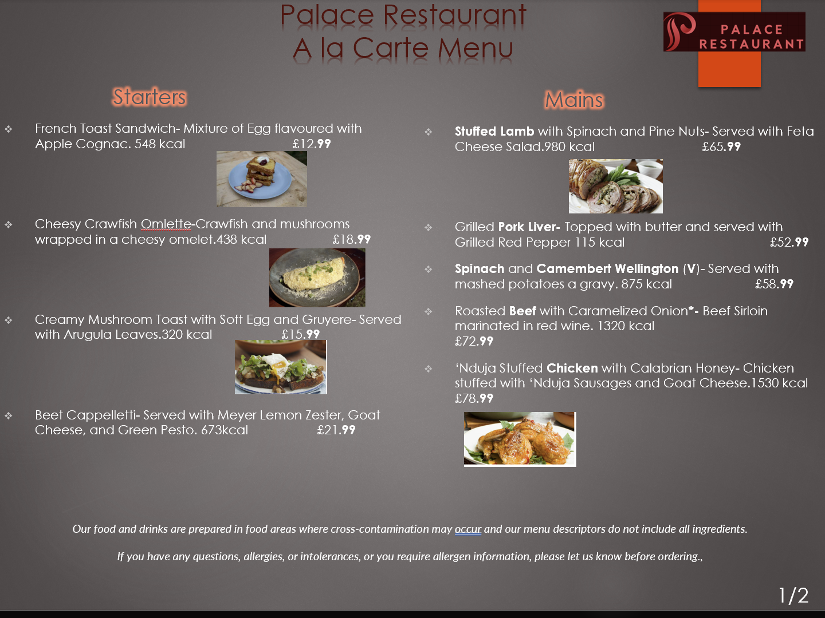
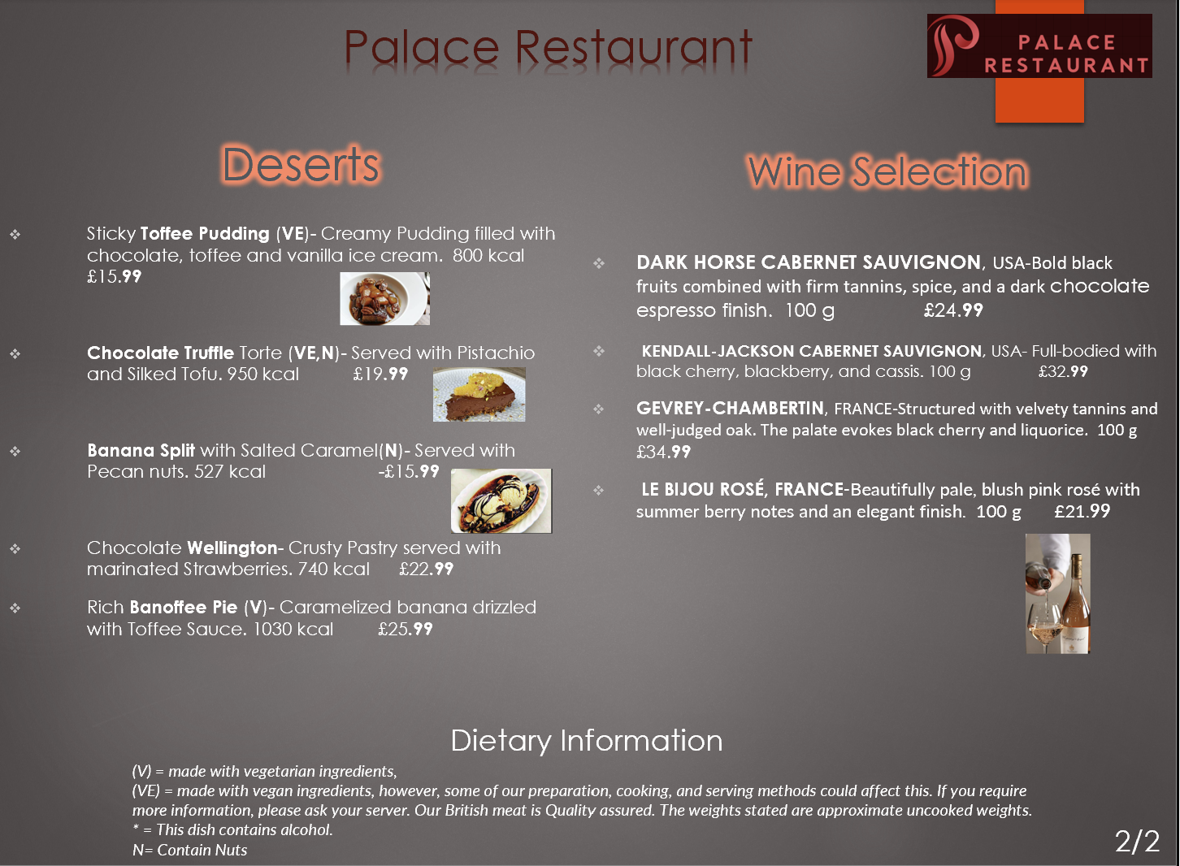
References

Viachaslau Filimonau, Christian Lemmer, David Marshall, Gisel Bejjani, (2017). ‘Restaurant menu re-design as a facilitator of more responsible consumer choice: An exploratory and preliminary study’, Journal of Hospitality and Tourism Management, 33(1), 2017, Pp 73-81.
J R Walker (2021) ‘The Restaurant: From Concept to Operation’. 9th edn. P.3-4 United States: John Wiley & Sons
J R Walker (2021) ‘The Restaurant: From Concept to Operation’. 9th edn. P.11-12 United States: John Wiley & Sons
Ilana R. Cliffer, Anastasia Marshak, Kate R. Schneider, Aishwarya Venkat, Elena N. Naumova, (2023) ‘Encyclopedia of Human Nutrition’ ‘Seasonality of nutrition , 2023, Pp 1-2
Miller and Carter Steakhouse Our Drinks Available at:Miller & Carter SherwoodForest | Drinks Menu (millerandcarter.co.uk) (Accessed: 08 November 2023)
Miller and Carter Steakhouse A la Carte Menu Mains Available at:Miller & Carter SherwoodForest | Food & Drink Steakhouse Menus in Nottingham (millerandcarter.co.uk) (Accessed: 05 November 2023)
Miller and Carter Steakhouse A la Carte Menu Desserts Available at:Miller & Carter SherwoodForest | Main Menu in Nottingham (millerandcarter.co.uk) (Accessed: 05 November 2023)
Gordon Ramsay Recipes Available at: Gordon Ramsay's Recipes | Gordon Ramsay (Accessed: 05 November 2023)

