

Module name: Research Methods for Business
Module code: LCLM 6004
Lecture name: Dr Ashikul Alam Khan
Student name: Elena Popova
Student number: 2241238

Тhe Effect of Cloud-Based Accounting Systems on Financial Accuracy and Efficiency in SMEs
Table of Contents
1. Identification of the Business Problem, Background and Rationale 2
1.1 Business Problem: 2
1.2 Background: 3
1.3 Rationale: 4
2. Research Aim, Objectives and Questions 4
2.1 Research Aim: 4
2.2 Research Objectives: 4
2.3 Research Questions: 4
3. Preliminary Literature Review 5
3.1 SME accounting challenges before cloud adoption 5
3.2 Cloud-based accounting adoption 5
3.3 Impact on financial accuracy 5
3.4 Impact on efficiency 6
3.5 Challenges and barriers 6
3.6 Research gap 6
4. Research Methodology and Design 7
4.1 Research Philosophy 7
4.2 Research Approach 7
4.3 Methodological Choice 7
4.4 Research Strategy 7
4.5 Time Horizon 7
4.6 Data Collection Methods 8
Survey Questions (Quantitative Data) 8
Interview Questions (Qualitative Data) 9
4.8 Ethical Considerations 10
5. Business Relevance and Practical Implications 10
6. Plan of Work and Time Schedule 10
7. Structure of the Thesis 11
8. References: 13

Identification of the Business Problem, Background and Rationale

1.1 Business Problem:
More than 90% of all businesses globally are small and medium-sized enterprises (SMEs), which are essential to the global economy and play a major role in job creation and GDP growth (Beck and Demirgüç-Kunt, 2006; Ayyagari et al., 2011). Despite this significance, SMEs typically still have trouble managing financial data effectively and accurately. Many continue to use outdated accounting methods, such as spreadsheets or paper-based systems, which are prone to delays, inefficiencies, and human error (Hossain, 2025). These defects hinder SMEs' ability to produce accurate and timely financial reports, which negatively impacts decision-making, competitiveness, and regulatory compliance.

1.2 Background:
SMEs encounter common financial management issues prior to implementing cloud-based systems:
- Accuracy problems:
Financial records frequently contain errors and inconsistencies due to manual data entry and antiquated desktop software (Mujalli et al., 2024). These errors frequently lead to untrustworthy financial statements, which can impair judgement and make it more difficult for SMEs to adhere to external reporting requirements and tax laws. Even minor reporting errors can have serious repercussions for smaller businesses, including penalties or a decline in investor confidence.
- Inefficiency:
Inefficiencies are also produced by manual procedures. According to Nguyen Phu et al. (2025), SMEs frequently devote a significant portion of employee time to routine accounting duties like account reconciliation and monthly report preparation. In addition to raising operating expenses, this causes a delay in the generation of current financial data. Consequently, managers might make choices based on out-of-date information, which can reduce competitiveness in rapidly evolving markets.
- Restricted accessibility:
Managers and employees find it difficult to obtain information fast or from a distance when financial data is kept on local servers or paper files. For SMEs that operate in several locations or where managers must make decisions while on the road, this is especially troublesome. Businesses risk missing out on opportunities to react to changes in the market or efficiently manage cash flow if they do not have real-time access to financial data.
- Resource limitations:
Lastly, a lot of SMEs lack the human and financial resources required to update their accounting systems. According to Al-Sharafi et al. (2023), SMEs are frequently reliant on ineffective systems because they lack the funds for costly software upgrades or specialised IT personnel. Even if they see the potential advantages, SMEs may be reluctant to embrace digital solutions due to this resource gap.

All these issues work together to keep SMEs mired in antiquated accounting procedures, which reduces their efficiency and financial accuracy. Because they provide accessible, automated, and reasonably priced solutions, cloud-based systems are frequently marketed as a means of ending this cycle.

1.3 Rationale:
There is little scholarly research that systematically assesses how these systems affect SMEs' financial accuracy and efficiency, even though software providers and industry reports emphasise the potential advantages of cloud accounting. According to Nguyen Phu et al. (2025), most of the current research concentrates on adoption factors rather than quantifiable results. This leaves a research gap and poses a crucial query: Do cloud-based accounting systems genuinely provide accurate and efficient solutions to the issues SMEs face, or do they bring about new difficulties like security threats, the need for training, and recurring subscription fees?
As a result, this study is pertinent and timely. It will investigate the actual effects of cloud-based accounting systems on SMEs globally, adding to scholarly discussions and offering useful advice to software developers, business owners, and legislators.

Research Aim, Objectives and Questions

2.1 Research Aim:
The purpose of this study is to assess how cloud-based accounting systems affect the efficiency and accuracy of financial data in small and medium-sized businesses (SMEs) in various international contexts.

2.2 Research Objectives:
- To investigate the extent and type of cloud-based accounting system adoption among SMEs worldwide.
- To evaluate how cloud-based accounting systems actually and perceivably affect financial accuracy, including financial reporting reliability and error reduction.
- To examine the effects of cloud-based accounting systems on SMEs' operational efficiency, with an emphasis on reporting speed, cost savings, and time savings.
- To determine the primary obstacles and difficulties SMEs face when implementing and utilising cloud-based accounting systems.

2.3 Research Questions:
- RQ1: How many SMEs around the world are using cloud-based accounting systems?
- RQ2: What impact do cloud-based accounting systems have on SMEs' financial data and reporting accuracy?
- RQ3: How do cloud-based accounting systems help SMEs run more efficiently?
- RQ4: What obstacles and difficulties do SMEs encounter when putting cloud-based accounting systems into place and utilising them?
This precise set of goals, objectives, and research questions gives the study a well-organised course and guarantees that it fills in theoretical and practical gaps.

Preliminary Literature Review

3.1 SME accounting challenges before cloud adoption
Due to their reliance on manual bookkeeping or spreadsheets, small and medium-sized businesses (SMEs) frequently struggle with financial management. These procedures raise operating expenses, cause reporting delays, and are prone to human error (Lutfi et al., 2022). The inability of SMEs, especially those in developing nations, to upgrade their accounting systems due to a lack of financial resources and technological readiness results in inefficiencies in the timely and accurate production of financial statements (Rawashdeh and Rawashdeh, 2023; Soudani, 2012). Furthermore, Saad et al. (2022) point out that SMEs face obstacles like restricted access to real-time data, a lack of staff expertise, and susceptibility to compliance errors prior to implementing cloud solutions.

3.2 Cloud-based accounting adoption
Due to their scalability and lower upfront investment costs, cloud-based accounting systems, or CBAS, have become appealing options for SMEs. According to Putri et al. (2025), the Technology–Organisation–Environment (TOE) framework—which considers factors like perceived benefits, competitive pressures, and technological readiness—influences adoption decisions. Like this, Feghali et al. (2022) contend that although many businesses continued to face obstacles like insufficient digital infrastructure and a lack of management support, the COVID-19 pandemic accelerated the shift towards digital accounting solutions in SMEs. As SMEs realise the strategic value of digital accounting tools, adoption is increasing globally despite these challenges.

3.3 Impact on financial accuracy
The increased financial accuracy that CBAS promises is one of its main features. Automation increases the dependability of financial data by lowering manual data-entry errors, reconciling bank feeds, and guaranteeing real-time updates (Saad et al., 2022). According to Lutfi et al., (2022), SMEs that used digital accounting systems reported financial reporting that was more accurate than those that used conventional techniques. According to Putri et al. (2025), cloud accounting also raises the general calibre of financial reports, which boosts managerial decision-making and stakeholder trust. There are still issues, though; Feghali et al. (2022) warn that mistakes can still occur in cloud environments if staff members are not properly trained and data migration is not done carefully.

3.4 Impact on efficiency
Another frequently mentioned advantage of cloud accounting is increased efficiency. SMEs can save time and money on financial management by automating processes like payroll, reconciliation, and invoicing. SMEs that used cloud-based systems were able to redirect resources from routine bookkeeping to more strategic endeavours, according to Rawashdeh and Rawashdeh (2023). According to a similar study by Saad et al. (2022), SMEs that used cloud accounting benefited from quicker reporting cycles and more flexibility in remotely accessing data, which was especially helpful during the COVID-19 pandemic. These results imply that increasing efficiency can boost the resilience and competitiveness of SMEs.

3.5 Challenges and barriers
Notwithstanding the potential advantages, SMEs continue to encounter obstacles that prevent them from fully utilising cloud accounting's benefits. Managers are concerned about the security of sensitive financial data kept on external servers, and security and privacy issues continue to be a significant problem (Saad et al., 2022; Nguyen et al., 2015). Additionally, Lutfi et al., (2022) and Feghali et al. (2022) draw attention to problems like employee resistance to change, a lack of digital skills, and challenges integrating with legacy systems. These obstacles imply that although cloud accounting can increase precision and effectiveness, organisational preparedness and support are necessary for its success.

3.6 Research gap
Despite mounting evidence of cloud accounting's advantages, most of the research concentrates on adoption factors rather than quantifiable results after adoption. Research frequently points to possible benefits, but it offers less concrete proof of whether SMEs see appreciable gains in precision and productivity following adoption (Putri et al., 2025; Lutfi et al., 2022). By methodically examining the impact of CBAS on financial accuracy and efficiency, this study seeks to close that gap and provide insights that are relevant to SME contexts worldwide.

Research Methodology and Design

4.1 Research Philosophy
The pragmatist philosophy used in this study is appropriate for research that blends qualitative and quantitative techniques. According to Saunders et al., (2009) and Bryman (2016), pragmatism emphasises practical results and gives the researcher the freedom to employ the method that best addresses the research questions. Pragmatism is the best option because this study aims to investigate managers' and employees' experiences as well as determine whether cloud-based accounting systems increase financial accuracy and efficiency.

4.2 Research Approach
Because it examines preexisting theories and presumptions in the literature regarding the advantages of cloud-based accounting, the study primarily uses a deductive approach. In addition, it incorporates inductive components through semi-structured interviews, which enable fresh themes to surface from the experiences of participants. The mixed-methods design is supported by this blend of deductive and inductive reasoning, which also increases the findings' robustness (Saunders et al., 2009).

4.3 Methodological Choice
Data from both qualitative interviews and quantitative surveys will be combined in a mixed-methods approach. This enables the study to measure general trends while delving deeper into individual viewpoints.

4.4 Research Strategy
The strategy will involve:
- SME managers, finance employees, and accountants were given survey questionnaires to gather quantitative information on adoption rates, accuracy, efficiency, and difficulties.
- Semi-structured interviews with accountants or managers of small businesses to learn more about their experiences using cloud accounting.

4.5 Time Horizon
Since data will be gathered all at once rather than over a long period of time, the study will use a cross-sectional time horizon. Considering the project’s scope and the dissertation deadline, this is appropriate.

4.6 Data Collection Methods
- The following topics will be covered in the survey: the kind of accounting system being used, the extent of cloud adoption, perceived improvements in accuracy (reduction of errors, quality of reporting), efficiency (time, cost, speed), and obstacles encountered.
- Experiences with cloud adoption, opinions on accuracy and efficiency gains, and difficulties with cybersecurity, cost, and training will all be covered in the interviews.
The six-phase framework put forth by Braun and Clarke (2019) will be followed in the thematic analysis of the qualitative data gathered from the semi-structured interviews. This approach makes it possible to find and analyse recurrent themes and patterns pertaining to SMEs' implementation difficulties, efficiency, and financial accuracy. This study is especially well-suited for thematic analysis since it offers flexibility in examining participants shared and distinct experiences.
4.7 Indicative Data Collection Questions
Both quantitative (survey) and qualitative (interview) questions will be created to support the study's goals. These enquiries aim to investigate the impact of cloud-based accounting systems on SMEs' financial efficiency and accuracy as well as the challenges encountered during implementation. The primary data collection procedure will be guided by the following draft questions, which could be improved after receiving ethical approval.

Survey Questions (Quantitative Data)
(For SME owners, accountants, or managers currently using or considering cloud-based accounting systems)
Demographic Information
- How big is your company in terms of personnel?
- Which sector of the economy best describes your small business?
- Which accounting program are you using right now?
- If applicable, how long has your company been using a cloud-based accounting system?
Financial Accuracy
- How much do you think manual data entry errors are decreased by cloud accounting? (1–5 scale)
- When compared to more conventional approaches, how trustworthy are the financial reports generated by your accounting system? (1–5 scale)
- Since implementing cloud accounting, how often do you come across inconsistencies or mistakes in financial data?
Operational Efficiency
- How much has the speed at which financial reports are generated been enhanced by cloud accounting? (1–5 scale)
- In comparison to before adoption, how much time does your organisation save on accounting tasks?
- What impact has cloud accounting had on administrative or operational expenses?
- How has staff productivity been affected by cloud accounting?
Adoption and Challenges
- What were the main justifications for using a cloud-based system—or not?
- Which major issues—such as cost, data security, employee training, and internet dependability—have you encountered?
- In general, how pleased are you with the accounting system you currently use? (1–5 scale)
- Would you advise other SMEs to use cloud-based accounting? (Yes/No/Uncertain—please elaborate.)

Interview Questions (Qualitative Data)
(For SME managers or accountants with experience in cloud accounting)
- Why did your company decide against using a cloud-based accounting system?
- What impact has cloud accounting had on your financial reporting's dependability and accuracy?
- Have you noticed any improvements in decision-making or efficiency?
- What significant challenges did you face when implementing or using it daily?
- What effects has cloud accounting had on working with stakeholders or outside accountants?
- What steps have you taken to protect the privacy and security of your data?
- What elements, in your opinion, are necessary for SMEs to successfully implement cloud-based accounting?
- What changes do you think cloud accounting will bring to SMEs in the future?
To guarantee validity, clarity, and alignment with the research objectives, these questions have been created in accordance with established research-design guidelines from Saunders et al., (2009) and Creswell and Creswell (2018). Additionally, they mirror factors found in earlier research on cloud accounting and SME digitalisation (e.g., Hossain, 2025; Putri et al., 2025).

4.8 Ethical Considerations
The study will adhere to the university's ethical guidelines. Participants will receive informed consent forms outlining their rights and the goal of the study. Data will be safely stored in accordance with GDPR regulations, and responses will be anonymous. Participants are free to leave at any time; participation is entirely voluntary.

Business Relevance and Practical Implications
This study is obviously important to the business and academic communities. The results will show whether cloud-based accounting systems address SMEs' persistent financial management issues. Limited resources, erroneous reporting, and ineffective procedures are problems that many SMEs face. This study will assist business owners in making better decisions regarding their investments in digital accounting systems by examining whether cloud adoption increases accuracy and efficiency.
For software providers, the study will draw attention to real-world issues that SMEs encounter, like cybersecurity issues, training needs, and integration with legacy systems. Better training initiatives and product features that cater to the unique requirements of SMEs can be developed with the help of these insights.
The study provides regulators and policymakers with a global perspective on how cloud accounting promotes financial transparency and SME digitalisation. Governments around the world have made SME digital adoption a priority to boost competitiveness, and the results of this study may help shape training programs, incentives, and policies that will help.
Lastly, by quantifying concrete results of cloud-based accounting adoption and going beyond adoption factors to investigate practical effects on accuracy and efficiency, the academic contribution fills the current research gap.

Plan of Work and Time Schedule
To guarantee that the project is finished in the allotted time, a well-defined plan is necessary. In accordance with the suggestions made by Creswell and Creswell (2018) and Saunders et al., (2009), the research is divided into phases that address planning, gathering data, analysing it, and writing.
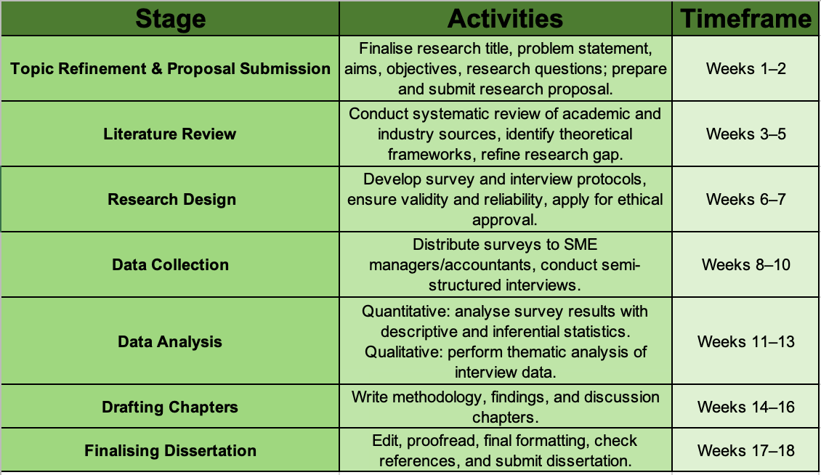
With special attention to the literature review, data collection, and analysis, this schedule guarantees that enough time is allotted for each step. Additionally, it provides a two-week buffer for editing and proofreading, which Cooper and Schindler (2014) advise as a best practice to enhance the calibre of submissions.

Structure of the Thesis
To ensure clarity and a logical progression from problem identification to findings and recommendations, the dissertation will adhere to a standard structure for business research (Saunders et al., 2009).
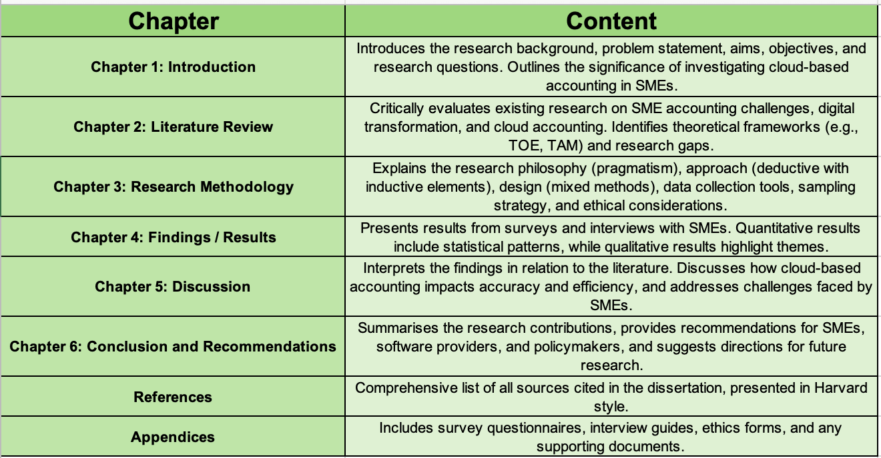
According to Creswell and Creswell (2018), this format guarantees that the dissertation complies with accepted research practices and offers a methodical, transparent approach to examining the research problem.

References:
Al-Sharafi, M.A., Iranmanesh, M., Al-Emran, M., Alzahrani, A.I., Herzallah, F. and Jamil, N., 2023. Determinants of cloud computing integration and its impact on sustainable performance in SMEs: An empirical investigation using the SEM-ANN approach. Heliyon, 9(5).
Available: https://www.cell.com/heliyon/fulltext/S2405-8440(23)03506-5

Ayyagari, M., Demirgüç-Kunt, A. and Maksimovic, V., 2011. Small vs. young firms across the world: contribution to employment, job creation, and growth. World Bank policy research working paper, (5631).
Available: https://papers.ssrn.com/sol3/papers.cfm?abstract_id=1807732

Beck, T. and Demirguc-Kunt, A., 2006. Small and medium-size enterprises: Access to finance as a growth constraint. Journal of Banking & finance, 30(11), pp.2931-2943.
Available: https://www.sciencedirect.com/science/article/abs/pii/S0378426606000926

Braun, V. and Clarke, V., 2019. Reflecting on reflexive thematic analysis. Qualitative research in sport, exercise and health, 11(4), pp.589-597.
Available: https://www.tandfonline.com/doi/abs/10.1080/2159676X.2019.1628806

Bryman, A., 2016. Social research methods. Oxford university press.
Available: https://books.google.co.uk/books?hl=en&lr=&id=N2zQCgAAQBAJ&oi=fnd&pg=PP1&dq=Bryman,+A.,+2016.+Social+research+methods.+Oxford+university+press.&ots=dqOtJXQ2tj&sig=e02ziCpaTGGxidQiP6gHK-s5I4k&redir_esc=y - v=onepage&q=Bryman, A., 2016. Social research methods. Oxford university press.&f=false

Cooper, D.R. and Schindler, P.S., 2011. Business research methods 12th ed.
Available: http://www.ir.harambeeuniversity.edu.et/handle/123456789/1640

Creswell, J.W. and Creswell, J.D., 2017. Research design: Qualitative, quantitative, and mixed methods approaches. Sage publications.
Available:https://books.google.co.uk/books?hl=en&lr=&id=335ZDwAAQBAJ&oi=fnd&pg=PT16&dq=Creswell,+J.W.+and+Creswell,+J.D.,+2017.+Research+design:+Qualitative,+quantitative,+and+mixed+methods+approaches.+Sage+publications.&ots=YEyROQAnsJ&sig=zfxTO0a85RVIp2CSfcw1L8BGv5I&redir_esc=y - v=onepage&q=Creswell, J.W. and Creswell, J.D., 2017. Research design%3A Qualitative, quantitative, and mixed methods approaches. Sage publications.&f=false

Feghali, K., Matta, J. and Moussa, S., 2022. Digital transformation of accounting practices and behavior during COVID-19: MENA evidence. Accounting and Management Information Systems, 21(2), pp.236-269.
Available: https://www.ceeol.com/search/article-detail?id=1051991

Hossain, M.Z., 2025. ADOPTION OF CLOUD ACCOUNTING SYSTEMS IN SMES. Journal of SUB, 15(1), pp.1-10.
Available:https://sub.edu.bd/journal/index.php/jsub/article/view/10

Lutfi, A., Alkelani, S.N., Al-Khasawneh, M.A., Alshira’h, A.F., Alshirah, M.H., Almaiah, M.A., Alrawad, M., Alsyouf, A., Saad, M. and Ibrahim, N., 2022. Influence of digital accounting system usage on SMEs performance: The moderating effect of COVID-19. Sustainability, 14(22), p.15048.
Available: https://www.mdpi.com/2071-1050/14/22/15048

Mujalli, A., Wani, M.J.G., Almgrashi, A., Khormi, T. and Qahtani, M., 2024. Investigating the factors affecting the adoption of cloud accounting in Saudi Arabia's small and medium-sized enterprises (SMEs). Journal of Open Innovation: Technology, Market, and Complexity, 10(2), p.100314.
Available: https://www.sciencedirect.com/science/article/pii/S2199853124001082

Nguyen Phu, G., Hoang Thi, T. and Tran Nguyen Bich, H., 2025. The impact of cloud computing technology on cloud accounting adoption and financial management of businesses. Humanities and Social Sciences Communications, 12(1), pp.1-14.
Nguyen, T.H., Newby, M. and Macaulay, M.J., 2015. Information technology adoption in small business: Confirmation of a proposed framework. Journal of Small Business Management, 53(1), pp.207-227.
Available: https://www.nature.com/articles/s41599-025-05190-3

Putri, E., Bandi, B., Widarjo, W. and Arifin, T., 2025. The value of cloud accounting for MSMEs: a Technology-Organization-Environment (TOE) framework perspective. Cogent Business & Management, 12(1), p.2494712.
Available: https://www.tandfonline.com/doi/full/10.1080/23311975.2025.2494712

Rawashdeh, A. and Rawashdeh, B.S., 2023. The effect cloud accounting adoption on organizational performance in SMEs. International Journal of Data & Network Science, 7(1).
Available: https://pdfs.semanticscholar.org/03e4/4f59fc8fec324b047c1a43f46ea5871be203.pdf

Saad, M., Lutfi, A., Almaiah, M.A., Alshira’h, A.F., Alshirah, M.H., Alqudah, H., Alkhassawneh, A.L., Alsyouf, A., Alrawad, M. and Abdelmaksoud, O., 2022. Assessing the intention to adopt cloud accounting during COVID-19. Electronics, 11(24), p.4092.
Available: https://www.mdpi.com/2079-9292/11/24/4092

Saunders, M., Lewis, P. and Thornhill, A., 2009. Research methods for business students. Pearson education.
Available: https://books.google.co.uk/books?hl=en&lr=&id=u-txtfaCFiEC&oi=fnd&pg=PA2&dq=Saunders,+M.,+Lewis,+P.+and+Thornhill,+A.,+2009.+Research+methods+for+business+students.+Pearson+education.&ots=DyLSHnO96P&sig=KJzT5hsO6bWgK9Z-bgrRv0NId-s&redir_esc=y - v=onepage&q=Saunders, M., Lewis, P. and Thornhill, A., 2009. Research methods for business students. Pearson education.&f=false

Soudani, S.N., 2012. The usefulness of an accounting information system for effective organizational performance. International Journal of economics and Finance, 4(5), pp.136-145.
Available: https://d1wqtxts1xzle7.cloudfront.net/39214984/16517-52549-1-SM-libre.pdf?1444941937=&response-content-disposition=inline%3B+filename=The_Usefulness_of_an_Accounting_Informat.pdf&Expires=1762806529&Signature=flSYeX-GukCa9RsGs9bEXCwaeCgr1IRGGgylMsp0EDEHUFt3K2peKjfSh8vf1eImSfHg2Fzcojs~rSxj6bygjSmfw0inw2mDRKuGQkQIPI7hmCqBmT8Tscs7P~3X9Hdi4PMS-KiMihFzdsKlobrRDXLIYyJ1eUoJWnIlvgDmKfemGyeLY6WsUBDLE4WHwE9RQQAKVkJ0jlR-9SlMIDoQF~9~No71WQ2qpdxH~LIhr0LLAljqAHn8Vdya4zAq4loooFZv4kTtppJ773CxG4ebnUA~jDVjpkwxugAlTZ32ib-~SxAGp6FlWQVJMdvXV1qFSr7-1CBFqaT7Y6PGEXppZw__&Key-Pair-Id=APKAJLOHF5GGSLRBV4ZA

