Investigating the Effect of Noise in DSB-SC and FM Systems
Radio Frequency Systems

ABSTRACT
October 1, 2023
Rhys Higgins (2110763)
uNIVERSITY OF WALES TRINITY ST DAVID
WORD COUNT: 2193

This report considers the effects of Additive White Gaussian Noise (AWGN) on AM and FM communications systems designed in Simulink. From the results in gathered in this report, it has been found that in Simulink the FM model had a greater degree of immunity to a DSB-SC model at a low SNR.

Contents
Introduction 3
Background Research 4
Circuit Design 5
Task 1: 5
Task 2: 5
Task 3: 6
Transmitter and receiver architectures 7
Transmitter and Receiver Block Diagrams: 8
AM: 8
DSB-SC: 8
FM: 9
Results 10
Task 1: 10
Task 2 (a): 13
Task 2 (b): 14
Task 2 (c): 15
Theoretical Values: 15
10dB AWGN: 15
50dB AWGN: 15
Task 3 (a): 18
Task 3 (b): 19
Task 3 (c): 20
Theoretical Values: 20
10dB AWGN: 20
50dB AWGN: 20
Discussion 23
Task 1: 23
Task 2: 23
Task 3: 23
Conclusion 24
Future Recommendations 24
Table of Equations: 25
References 26

Introduction

This report will investigate the effect of increasing the additive white gaussian noise (AWGN), to simulate random spurious channel noise in an RF system [1], to alter the SNR (Signal-to-Noise-Ratio), and the varying of modulation index on continuous-wave modulation techniques. The modulation techniques to be tested in this report are AM, Amplitude Modulation, and a form of angle modulation, FM, or Frequency Modulation. The types of AM modulation considered in this report are, DSB-FC, Dual Side-Band Full-Carrier, and DSB-SC, Dual Side-Band Suppressed Carrier [2].
The models in this report were designed using the Simulink. With respect to the DSB-FC and DSB-SC models, the modulation index will be varied considering the effects of under-modulation, critical-modulation, and over-modulation, documenting the effect on each system.

Background Research
AM is the varying of the amplitude of a sinusoidal carrier wave with respect to the information carrying signal [3]. The equation for a DSB AM modulated wave is given by Equation 1. A common use-case for AM modulation is in radio; AM broadcast stations in the UK use the 526.5KHz to 1.6065MHz band [4, 5]. AM is the simplest modulation scheme to implement but requires a higher SNR to operate effectively when compared to FM [6]. DSB-SC is a special-case of AM, where the carrier of the transmitted wave is suppressed, only the upper (USB) and lower (LSB) sidebands are transmitted, reducing transmission power/increasing efficiency proportionally to the elimination of the carrier [3]. The bandwidth of a DSB-SC wave is the same as DSB-FC, due to the retention of LSB/USB and is twice that of the modulating frequency, given by Equation 2 [3].
$$s\left(t\right)= A_{m}A_{c}\cos\left(2πf_{m}t\right)cos⁡(2πf_{c}t)$$
Equation 1: AM Modulated Wave (Double Side Band Suppressed Carrier) [3, 7]
$$BW=2f_{m}$$
Equation 2: Bandwidth of AM Signal [3, 20]
FM modulation is one of two types of angle modulation where, in this case, the frequency of the of the sinusoidal carrier wave is varied with respect to the information carrying signal [3]. The equation for an FM wave is given by Equation 3. The main advantage of using FM over AM is that FM allows for the better suppression of noise, but at the expense of increased channel bandwidth [2]. FM is commonly used in commercial radio broadcasting, using the 88 – 110MHz frequency band, or 88 – 108MHz in the UK [5, 6], with a bandwidth of 200KHz per channel [6].
$$s\left(t\right)= A_{C}cos⁡[2πf_{c}t+β\sin\left(2πf_{m}t\right)]$$
Equation 3: FM Modulated Wave [3]
The modulation index $(m)$ can be considered as the level of modulation which the carrier waveform is subjected to, for AM calculated using Equation 4 [8]. With respect to AM, perfect modulation is achieved when the modulation index $m=1 \left(A_{C}= A_{M}\right)$, known as critical modulation. For under-modulation $(m<1)$ $(A_{C}> A_{M})$, the modulated carrier wave does not reach 0 with respect to amplitude. Both critical and under-modulation do not result in distortion of the signal [3]. However, over-modulation $\left(m>1\right) (A_{C}< A_{M})$, does result in distortion of the signal, as signal undergoes a 180° phase-reversal when the carrier falls below the zero-point – creating additional sidebands and thus interference [9]. With respect to FM, the modulation index determines whether the FM is narrowband ($m<1)$, with a small bandwidth and spectrum consisting of carrier, USB, and LSB; or wideband ($m>1)$ which has an infinite bandwidth and an infinite number of sidebands [9].
$$m= \frac{M}{A}$$
Equation 4: Modulation Index AM [3, 8]
Noise in a modulated wave can be considered as any undesirable signals which affect the recovery of a demodulated signal, the noise source may be internal or external to the communications system [3]. The effect of noise is calculated through SNR; often SNR is given in dBs, see Equation 5 [10].
$SNR\left(dB\right)=10\log_{10}\frac{Signal Power}{Noise Power}$
Equation 5: Signal to Noise Ratio in dB

Circuit Design

Task 1:
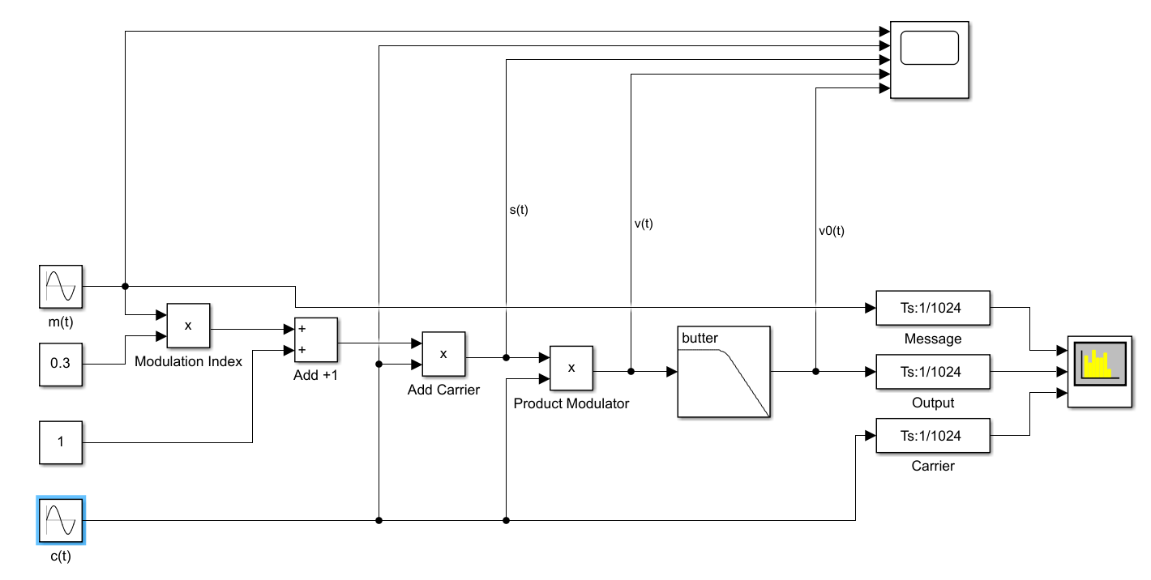
Figure 1: DSB Modulator and Demodulator Simulink Model (Task 1)
$f_{m}=1kHz$, $f_{c}=10kHz$, $m=0.3$

Task 2:

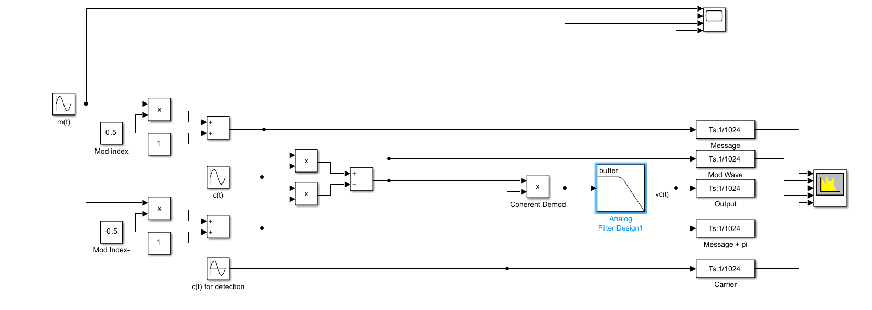
Figure 2: DSB-SC Balanced Modulator/Demodulator Simulink Model (Task 2)
$f_{m}=10Hz$, $f_{c}=40Hz$, $m=0.25$

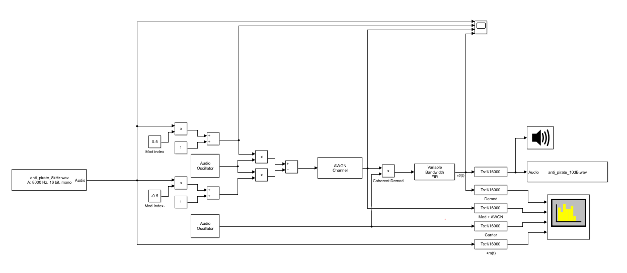
Figure 3: DSB-SC Balanced Modulator/Demodulator with Multimedia Block (Task 2)
$f_{m}=8kHz$, $f_{c}=30kHz$, $m=0.25$

Task 3:
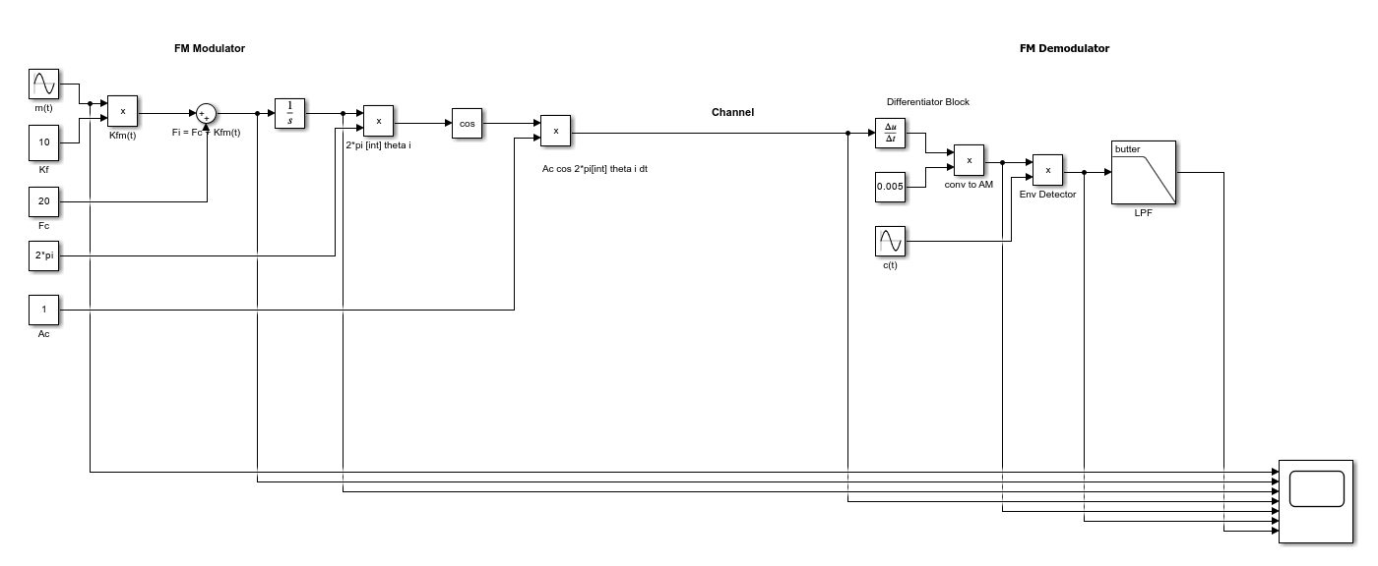
Figure 4: FM Modulator/Demodulator Multimedia Simulink Model (Task 3)
$A_{C}=2, f_{m}=10Hz$, $f_{c}=40Hz$, $m=1, k_{F}=10$
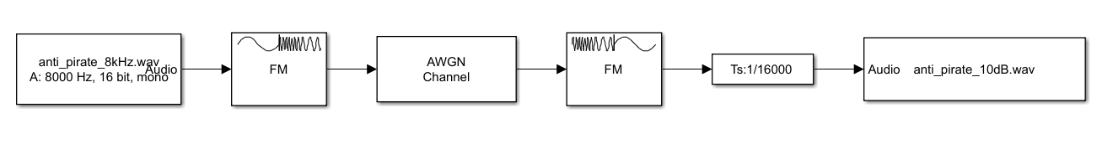
Figure 5: FM Baseband Multimedia Simulink Model (Task 3)
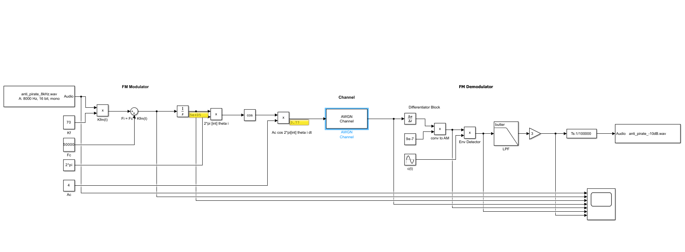
Figure 6: FM Modulator/Demodulator Multimedia Simulink Model (Task 3)
${A_{C}=2, f}_{m}=8kHz$, $f_{c}=30kHz$, $m=1, k_{F}=80$
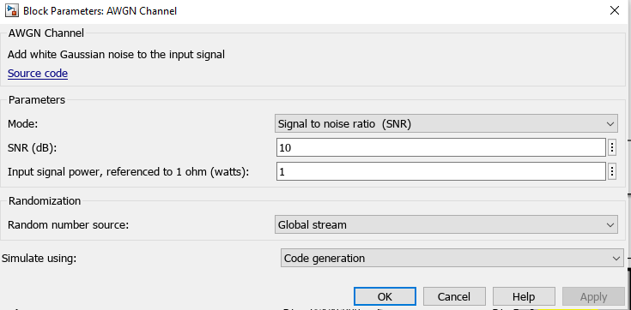
Figure 7: AWGN Setup & $N_{0}$ Value

Transmitter and receiver architectures

A transmitter combines a message signal with a higher frequency sinusoidal carrier waveform. The message is combined with the carrier using a mixer. The amplitude of the carrier waveform is typically higher or at the least the same as that of the message signal to avoid over-modulation. The modulated waveform is then amplified using a power amplifier and then transmitted via an antenna to allow the modulated waveform to propagate.
The propagating waveform will be received by a tuned antenna on the receiver, a filter used to block other frequencies. The received waveform will then be amplified using an LNA (Low Noise Amplifier), as the modulated waveform will have been attenuated by the channel (air). In coherent modulation, the carrier waveform will then be mixed with the modulated wave and then filtered, using an LPF (Low Pass Filter) to obtain the original message signal [3, 4].

Transmitter and Receiver Block Diagrams:

AM:

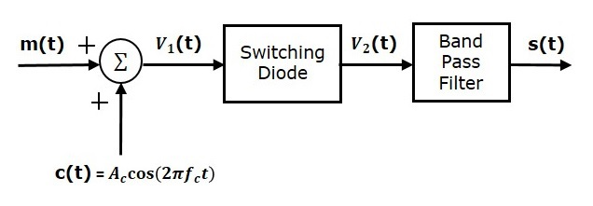
Figure 8: AM Switching Modulator [11]
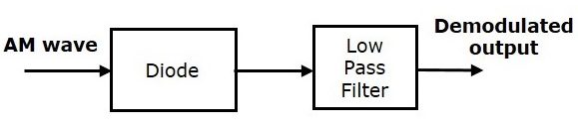
Figure 9: AM Envelope Detector Demodulator [12]

DSB-SC:

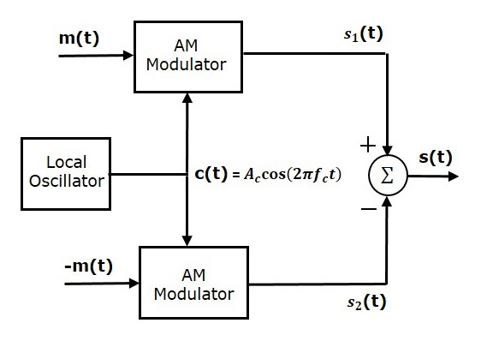
Figure 10: DSB-SC Balanced Modulator [13]
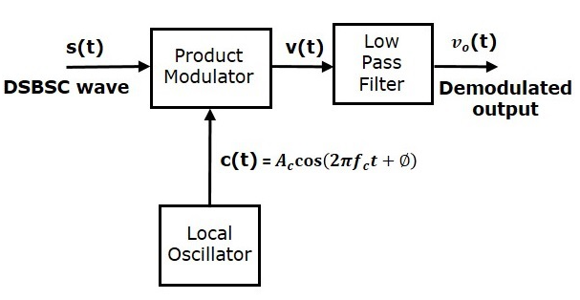
Figure 11: DSB-SC Coherent Detection Demodulator [14]

FM:

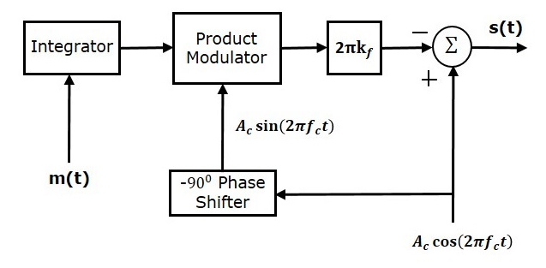
Figure 12: FM Modulator (NBFM) [15]
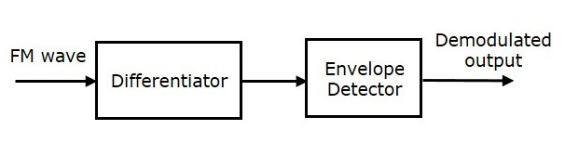
Figure 13: FM Frequency Discrimination Demodulator [16]

Results

Task 1:

Given in Figure 14 and Figure 15 are the time and frequency domain characteristics of the DSB-FC circuit, given in Figure 1, with the modulation index set at 0.3. Figure 16 and Figure 17 are the time and frequency domain characteristics of the same circuit, but with a modulation index of 1.0. Finally, Figure 18 and Figure 19 are the time and frequency characteristics again, but with a modulation index of 3.0.
It can be seen in Figure 18 and Figure 19 that there is some distortion of the modulated and demodulated waveforms when the carrier wave itself is over-modulated. However, the clipping of the demodulated signal, that would be expected with such a high modulation index, cannot be seen in Figure 18 [3].

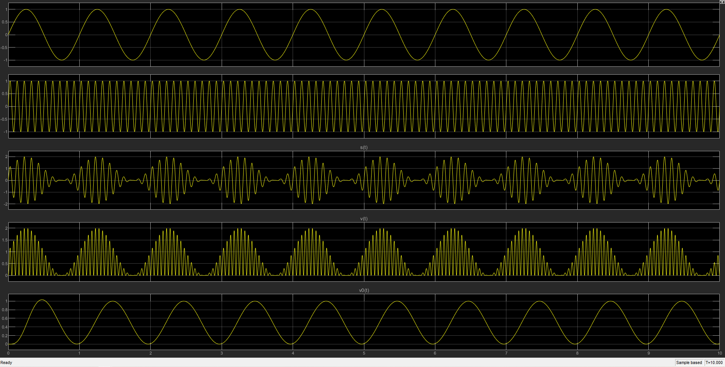
Figure 14: DSB-FC Simulink Time Domain (Mod Index 1.0)
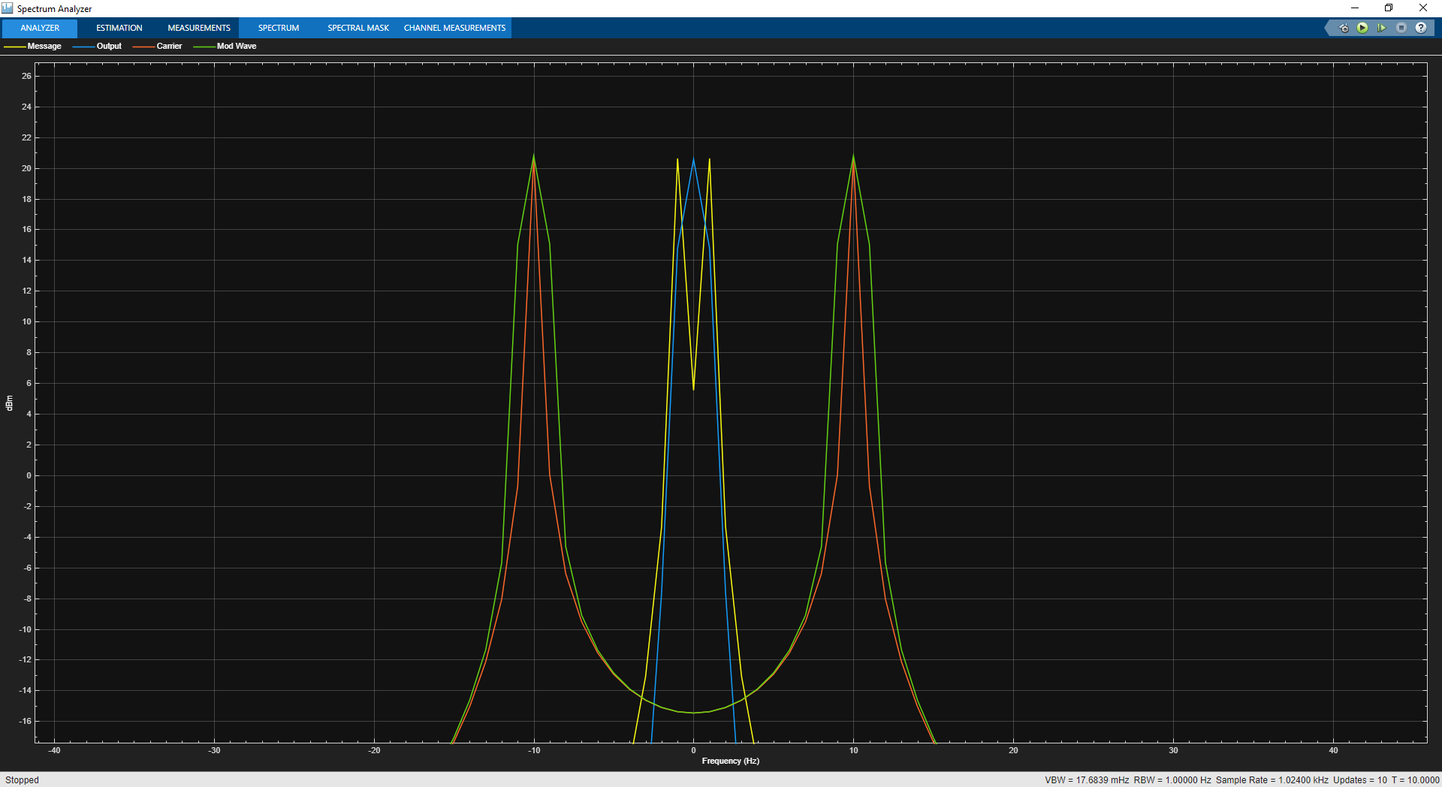
Figure 15: DSB-FC Simulink Frequency Domain (Mod Index 1.0)
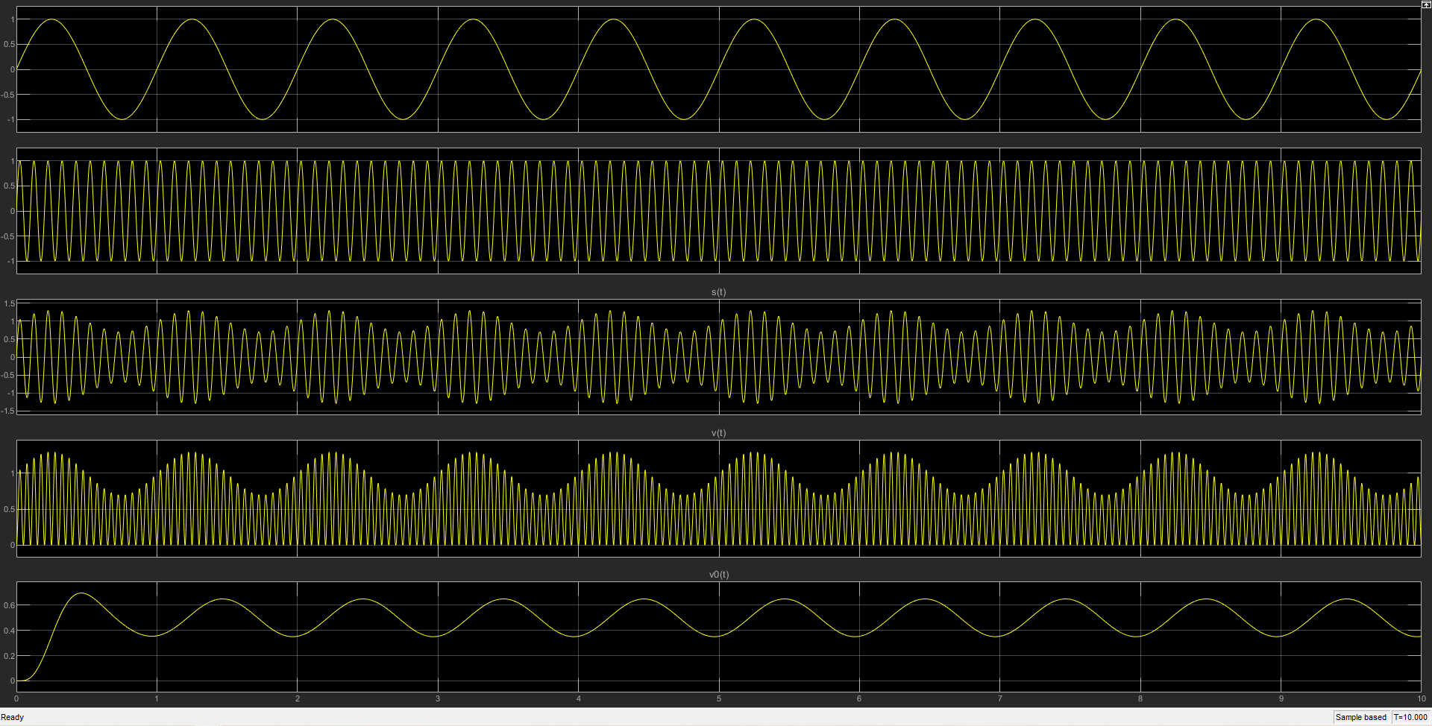
Figure 16: DSB-FC Simulink Time Domain (Mod Index 0.3)
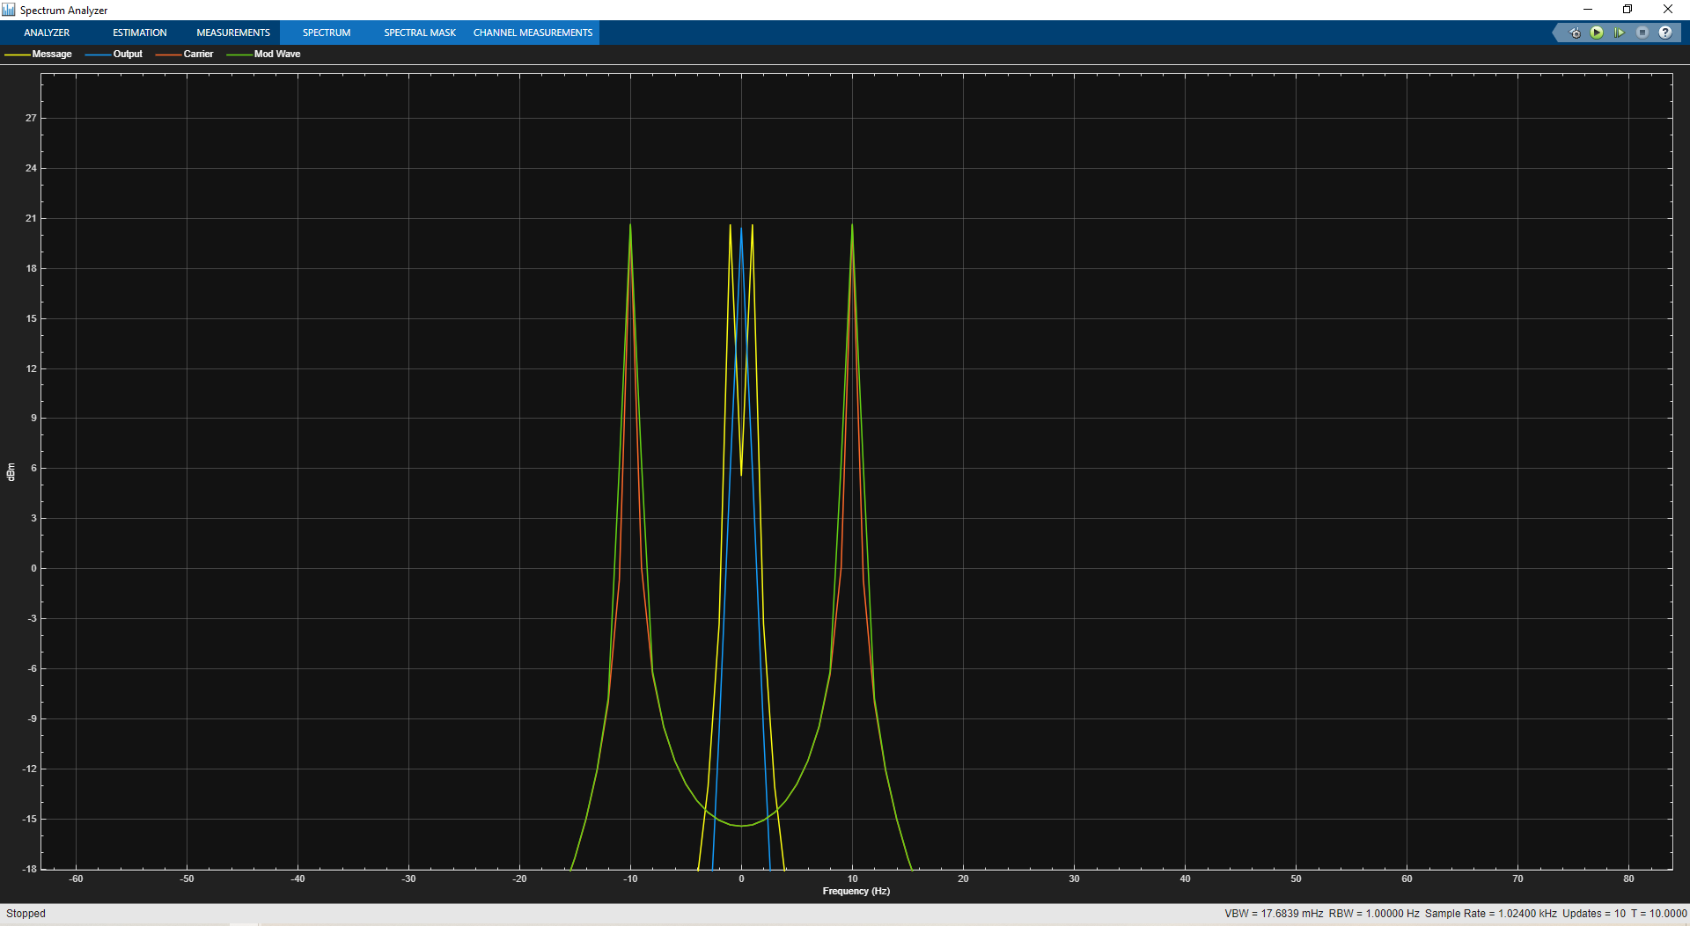
Figure 17: DSB-FC Simulink Frequency Domain (Mod Index 0.3)
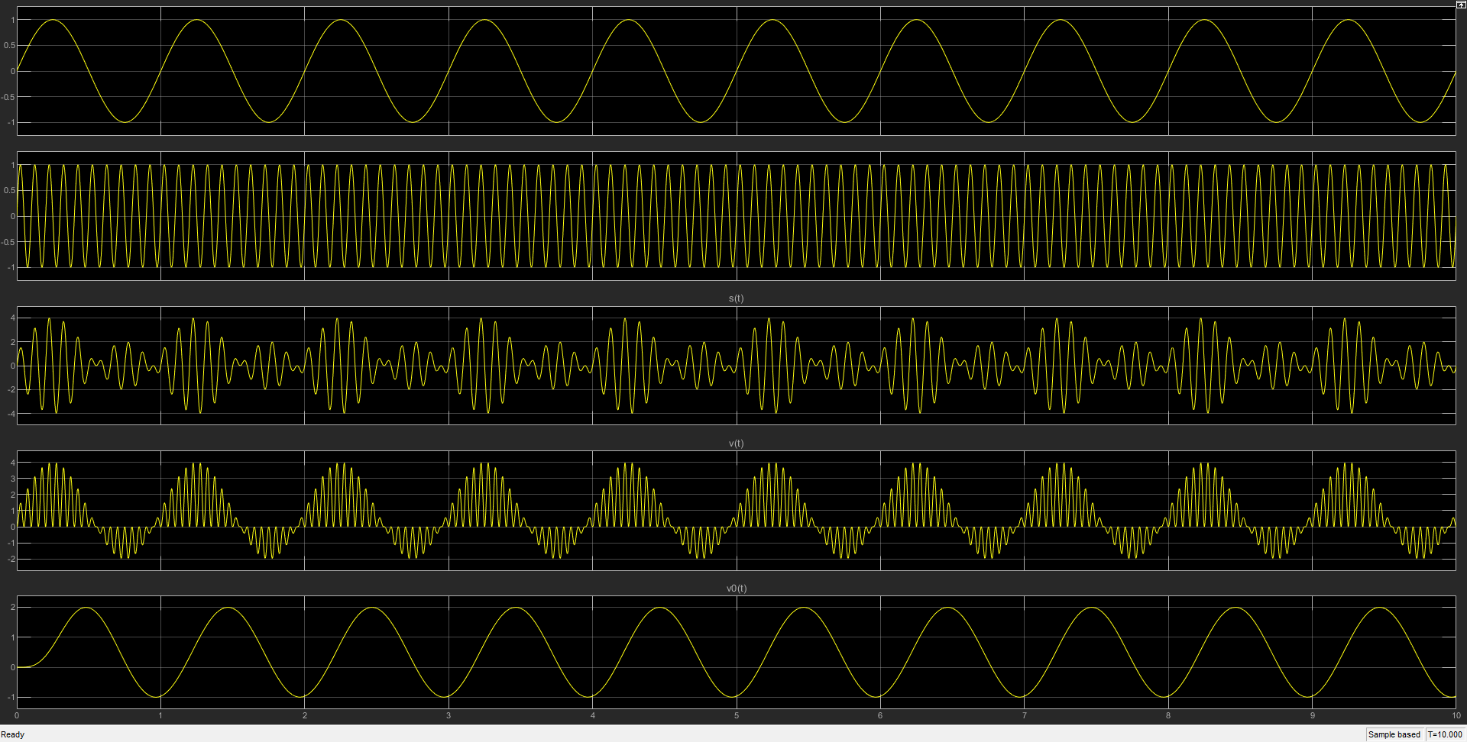
Figure 18: DSB-FC Simulink Time Domain (Mod Index 3.0)
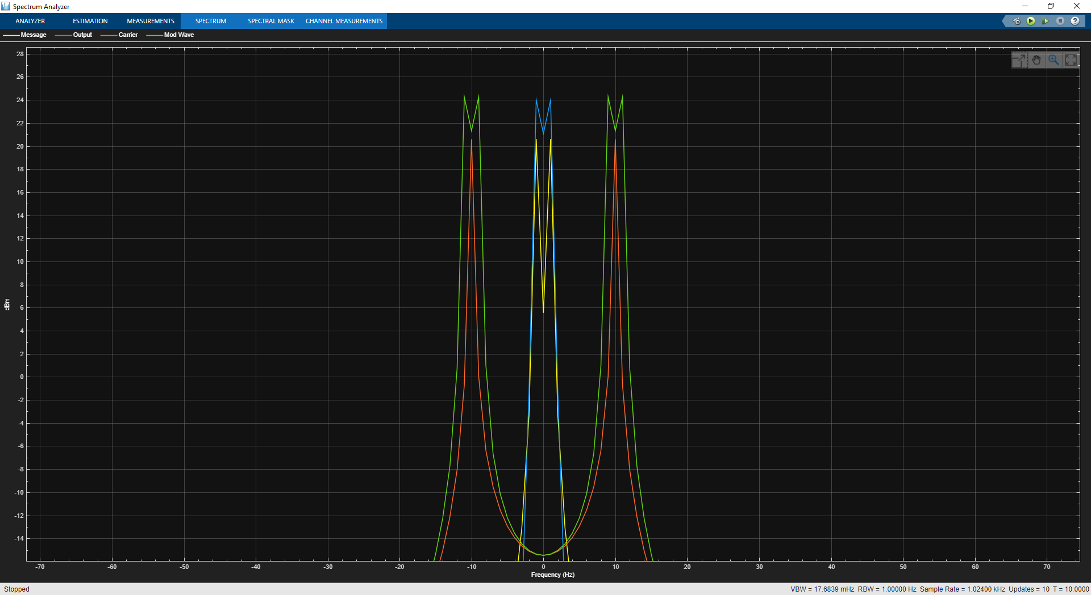
Figure 19: DSB-FC Simulink Frequency Domain (Mod Index 3.0)

Task 2 (a):

Given in Figure 22 is the modulated and demodulated output (Time Domain) of the AM balanced DSB-SC modulator shown in Figure 3. The modulated AM waveform, $s(t)$, can be seen in channel 3:4 and the demodulated message, $d(t)$, in channel 4:4. Figure 23 shows the modulated and demodulated output (Frequency Domain) of the AM modulator shown in Figure 3.
In Figure 23, the measured value for $P_{M }$is 3.8712e-1(watts) and the measured power for both $P_{USB}$ and $P_{LSB}$ was 1.8119e-1(watts).
Using Error! Reference source not found., the theoretical channel SNR $({SNR}_{C})$ was taken as 1.25e-2, with the same value taken for output SNR $({SNR}_{O})$. When these results were used for Equation 9, the figure of merit can be taken as 1 for this DSBSC model.

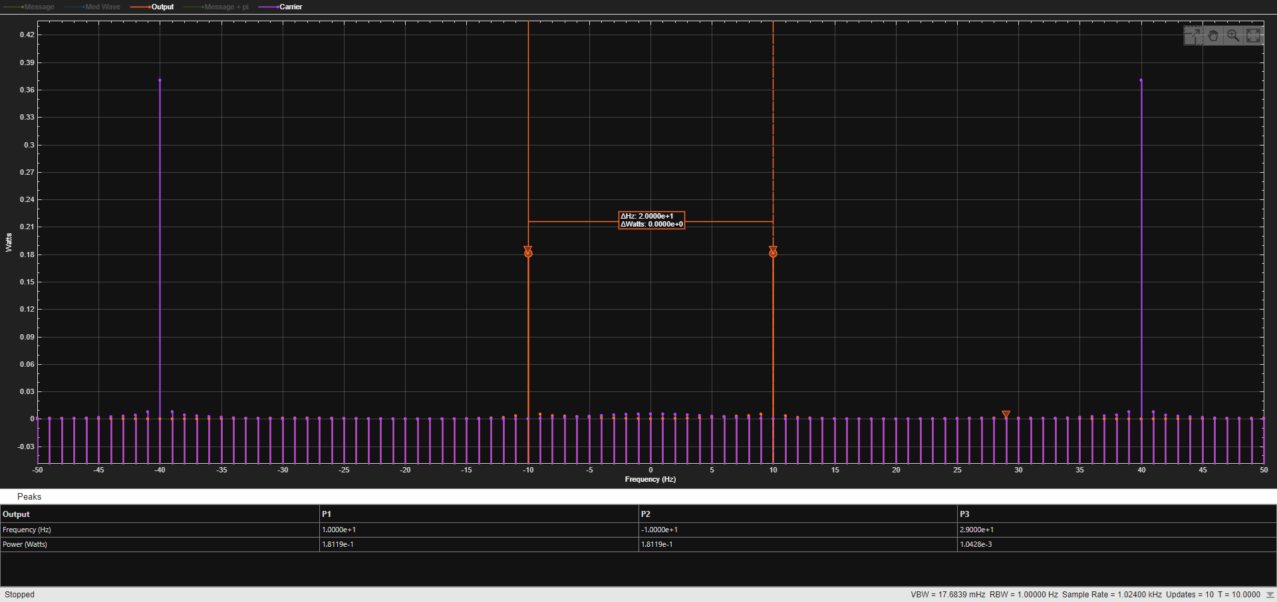
Figure 20: DSB-SC Balanced Modulator Output (Frequency Domain)
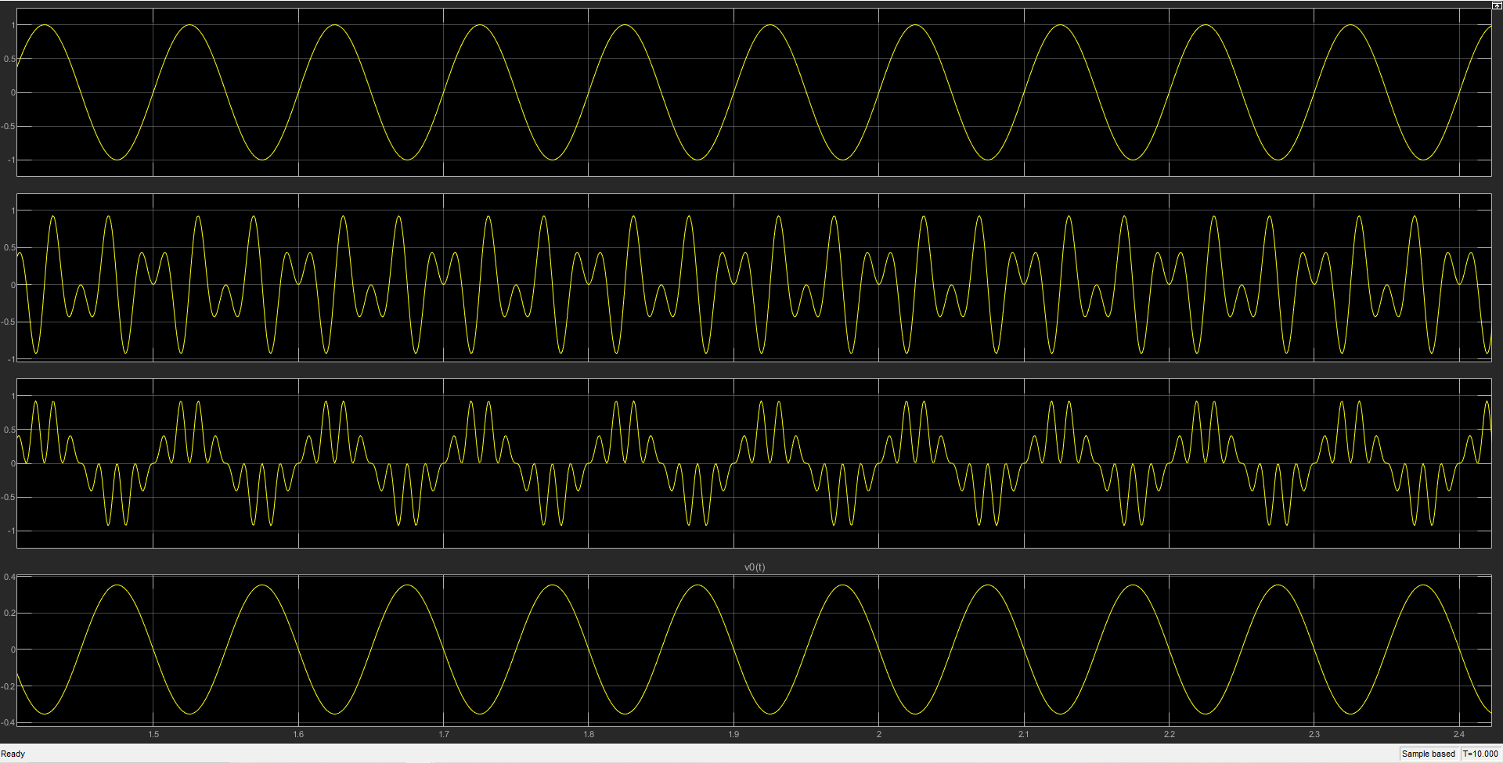
Figure 21: DSB-SC Balanced Modulator Output (Time Domain)

Task 2 (b):

Shown in Figure 22 is the time domain output for the DSB-SC model, but now modulating an 8kHz multimedia file. Figure 23 shows the frequency domain output for the DSB-SC multimedia model. The noise power, $N_{O}$ has been set at 1W, shown by Figure 7.
In Figure 22, +m(t) and -m(t) can be seen in channel 1:4 and channel 2:4 of the oscilloscope; s(t) can be seen in channel 3:4 and d(t) in channel 4:4. In Figure 23, +m(t) is represented by green, c(t) by red, s(t) + AWGN by blue and d(t) by yellow.

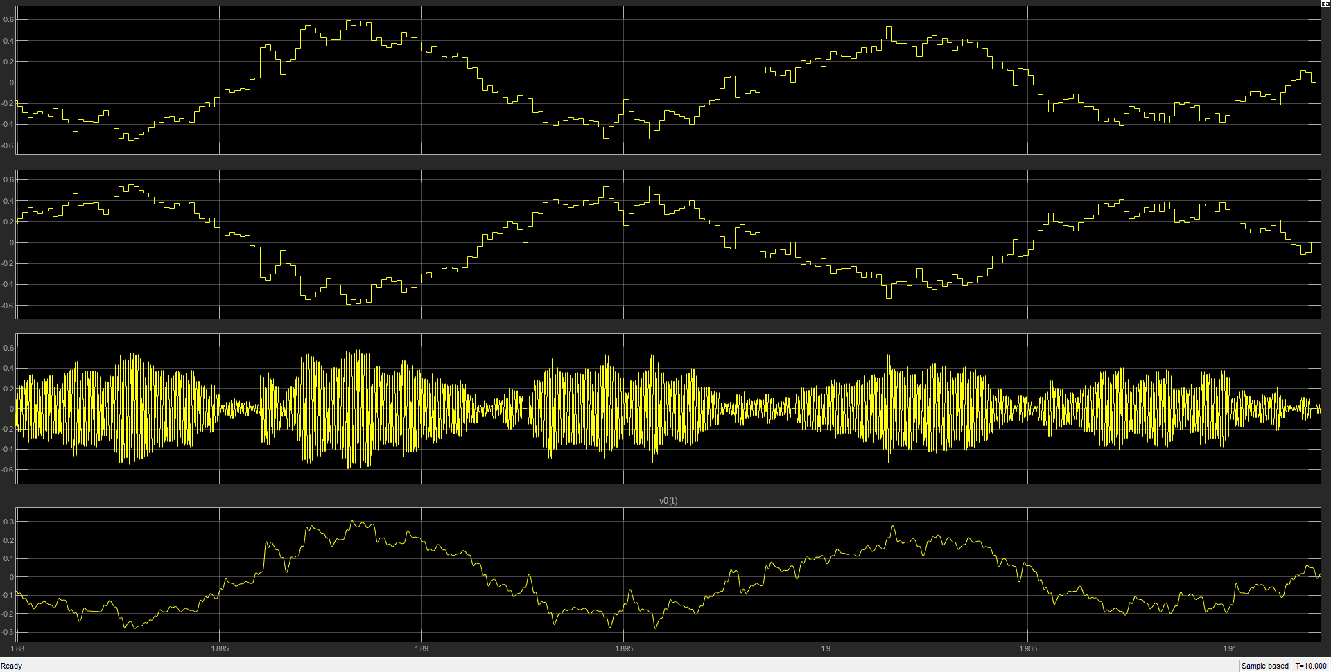
Figure 22: AM DSB-SC Balanced 8KHz Audio Modulation (Time Domain)
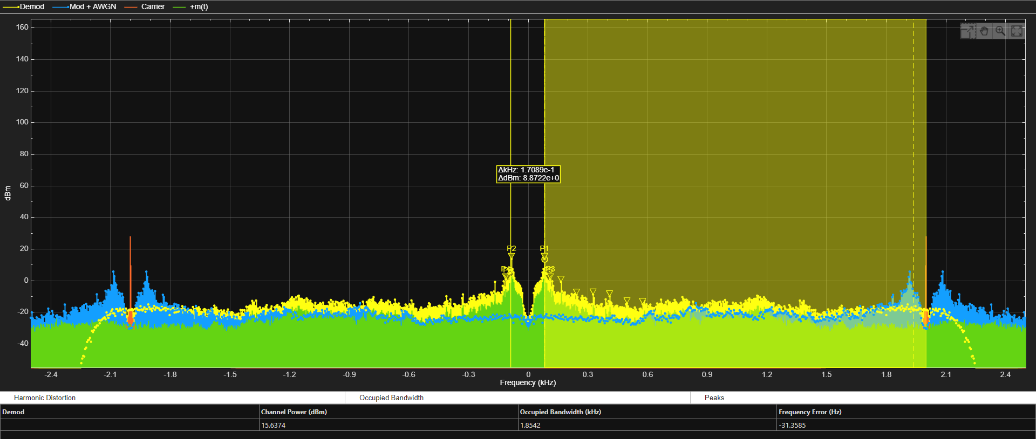
Figure 23: AM DSB-SC Balanced 8KHz Audio Modulation (Frequency Domain)

Task 2 (c):

The channel power values, used to calculate the SNR, were taken from 0Hz to +2000Hz offset from the centre frequency, as can be seen in Figure 23.

Theoretical Values:
- Message Power: $P_{M}=\frac{A_{m^{2}}}{2}=\frac{1^{2}}{2}=0.5W$
- Carrier Power: $P_{C}=\frac{{A_{C}}^{2}}{2}=\frac{1}{2}=0.5$W
- Theoretical ${SNR}_{C}$: ${SNR}_{C, DSBSC}= 10\log_{10}(\frac{2^{2}*\left(1+{0.5}^{2}\right)*0.5}{2*1W*\left(2*8000Hz\right)})=-41.072dB$
- Theoretical ${SNR}_{o}$: ${SNR}_{o, DSBSC}= 10\log_{10}(\frac{2^{2}*\left({0.5}^{2}\right)*0.5}{2*1W*\left(2*8000Hz\right)})=-48.062dB$
- Figure of Merit: $\frac{-48.062dB}{-41.072dB}=1.17$

10dB AWGN:
Measured Channel Power:
- -14.8503dBw = 0.0327W (Mod + AWGN)
- -19.3293dBw = 0.0117W (Modulated)
- -10.2846dBw = 0.0937W (Demodulated)
Calculated Noise Power: 0.021W
$${SNR(dB)}_{O}= 10\log_{10}(\frac{0.0936569472}{0.0216183138})$$
Calculated ${SNR}_{O,DSBSC}$: 6.48dB
$${SNR(dB)}_{C}= 10\log_{10}(\frac{0.0586006867}{0.0216183138})$$
Calculated ${SNR}_{C,DSBSC}$: 4.33dB
$$Figure of Merit= \frac{6.480438685dB}{4.330808887dB}$$
Figure of merit: 1.49

50dB AWGN:
Measured Channel Power:
- -19.3291dBw = 0.01167051443W (Mod + AWGN)
- -19.3293dBw = 0.011669977W (Modulated)
- -12.7743dBw = 0.0936569472W (Demodulated)
Calculated Noise Power = 5.3743e-7W
$${SNR}_{O}= 10\log_{10}(\frac{0.0936569472}{5.3743e-7})$$
Calculated ${SNR}_{O,DSBSC}$ = 52.41218092dB
$${SNR}_{C}= 10\log_{10}(\frac{0.01167051443}{5.3743e-7})$$
Calculated ${SNR}_{C,DSBSC}$ = 43.36768094dB
$$Figure of Merit= \frac{52.41218092dB}{43.36768094dB}$$
Figure of Merit: 1.21

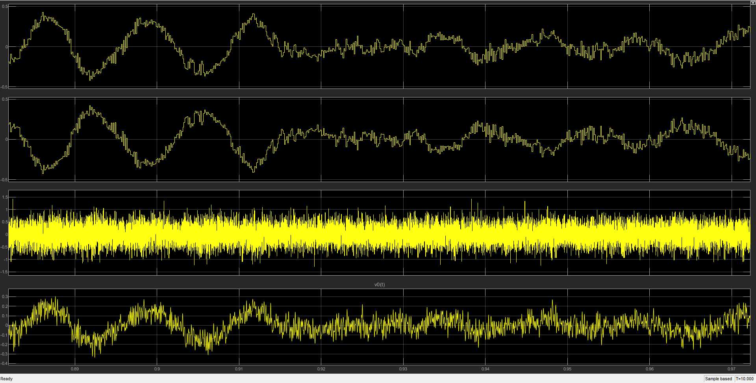
Figure 24: AM DSB-SC Balanced 8KHz Audio Modulation (Time Domain) 10dB SNR
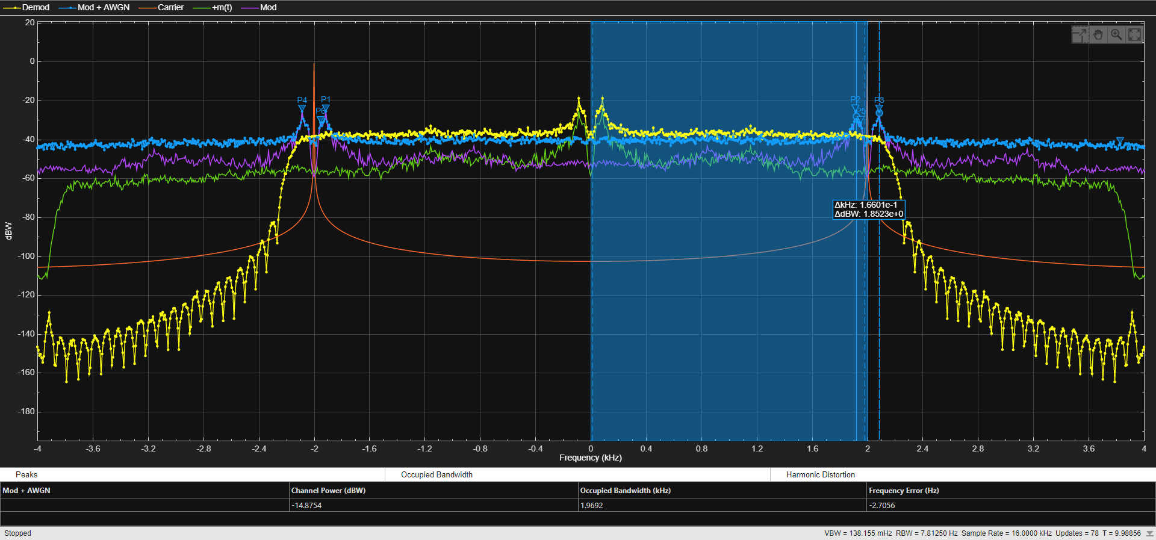
Figure 25: AM DSB-SC Balanced 8KHz Multimedia (Frequency Domain) 10dB AWGN
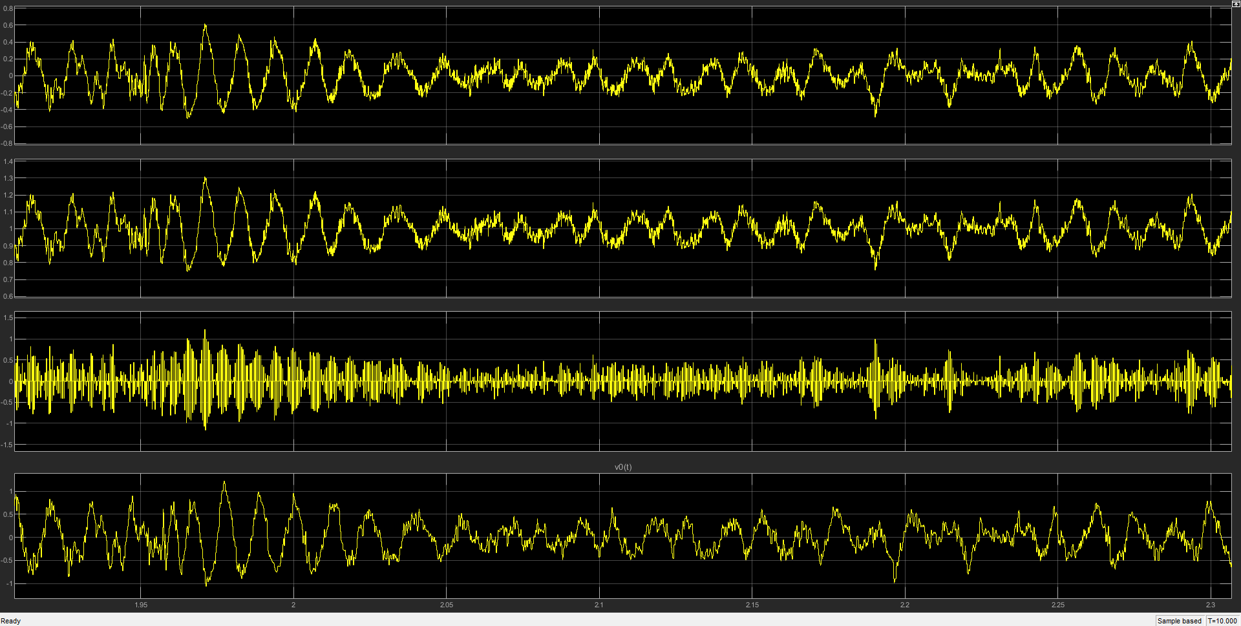
Figure 26: AM DSB-SC Balanced 8kHz Multimedia (Time Domain) 50dB AWGN
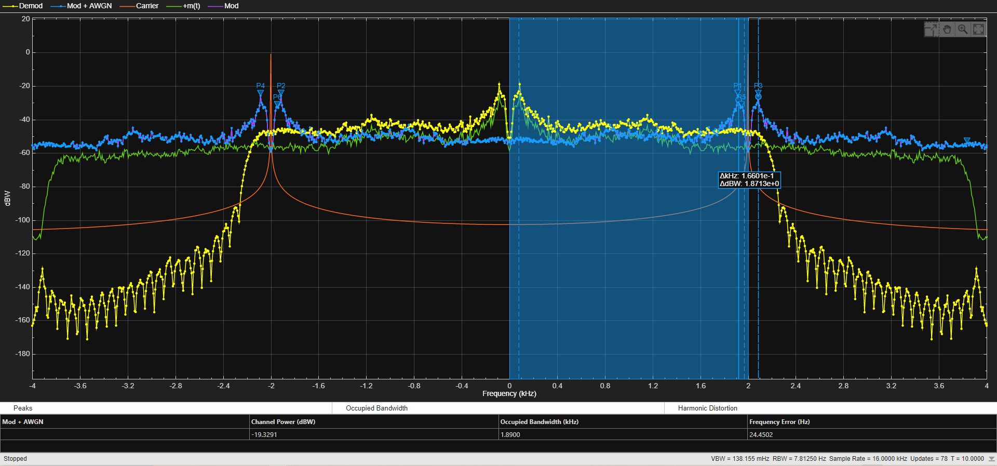
Figure 27: AM DSB-SC Balanced 8kHz Multimedia (Frequency Domain) 50dB AWGN

Task 3 (a):

Figure 28 shows the Time Domain output of the FM model pictured in Figure 4. In channel 1:7, of Figure 28, the message signal, $m(t)$, can be seen, in channel 7:7 the demodulated signal, $d(t)$, can be seen. In Figure 4, a differentiator block is used to convert the modulated FM signal into a combination of FM and AM, which is shown by 4:7 and 5:7 oscilloscope channels in Figure 28 – which is then demodulated using an envelope detector, shown in the 6:7 channel. Finally, a LPF is used to recover the original message and output the demodulated waveform, $d(t)$.
Figure 29 shows the Frequency Domain output of the FM model in Figure 4.

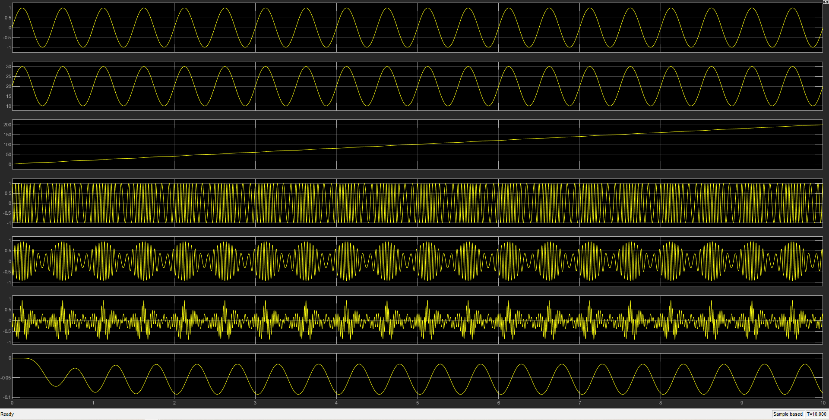
Figure 28: FM Simulink Modulator & Demodulator Time Domain

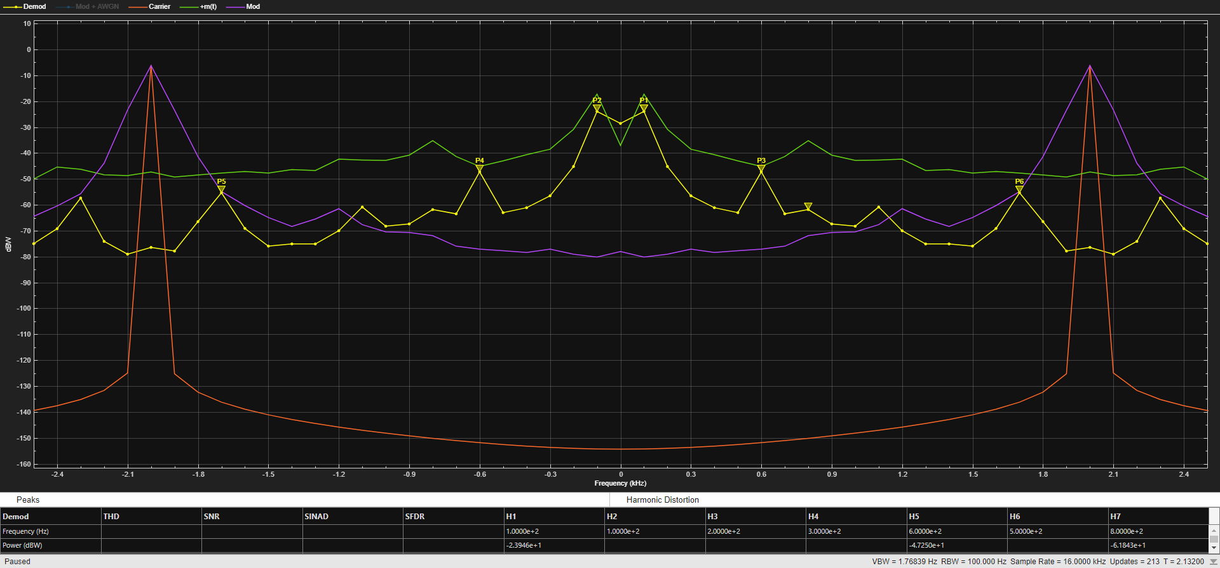
Figure 29: FM Simulink Frequency Domain (Line Mode)

Task 3 (b):

Figure 30 and Figure 31 are the time domain and frequency domain outputs of the FM multimedia modulator and demodulator circuit shown in Figure 6, without any AWGN being added. In Figure 30 channel 7:7 the message signal can clearly be seen to follow the original message, m(t), seen in channel 1:7. Figure 31 shows the Frequency domain of the modulated and demodulated signals.

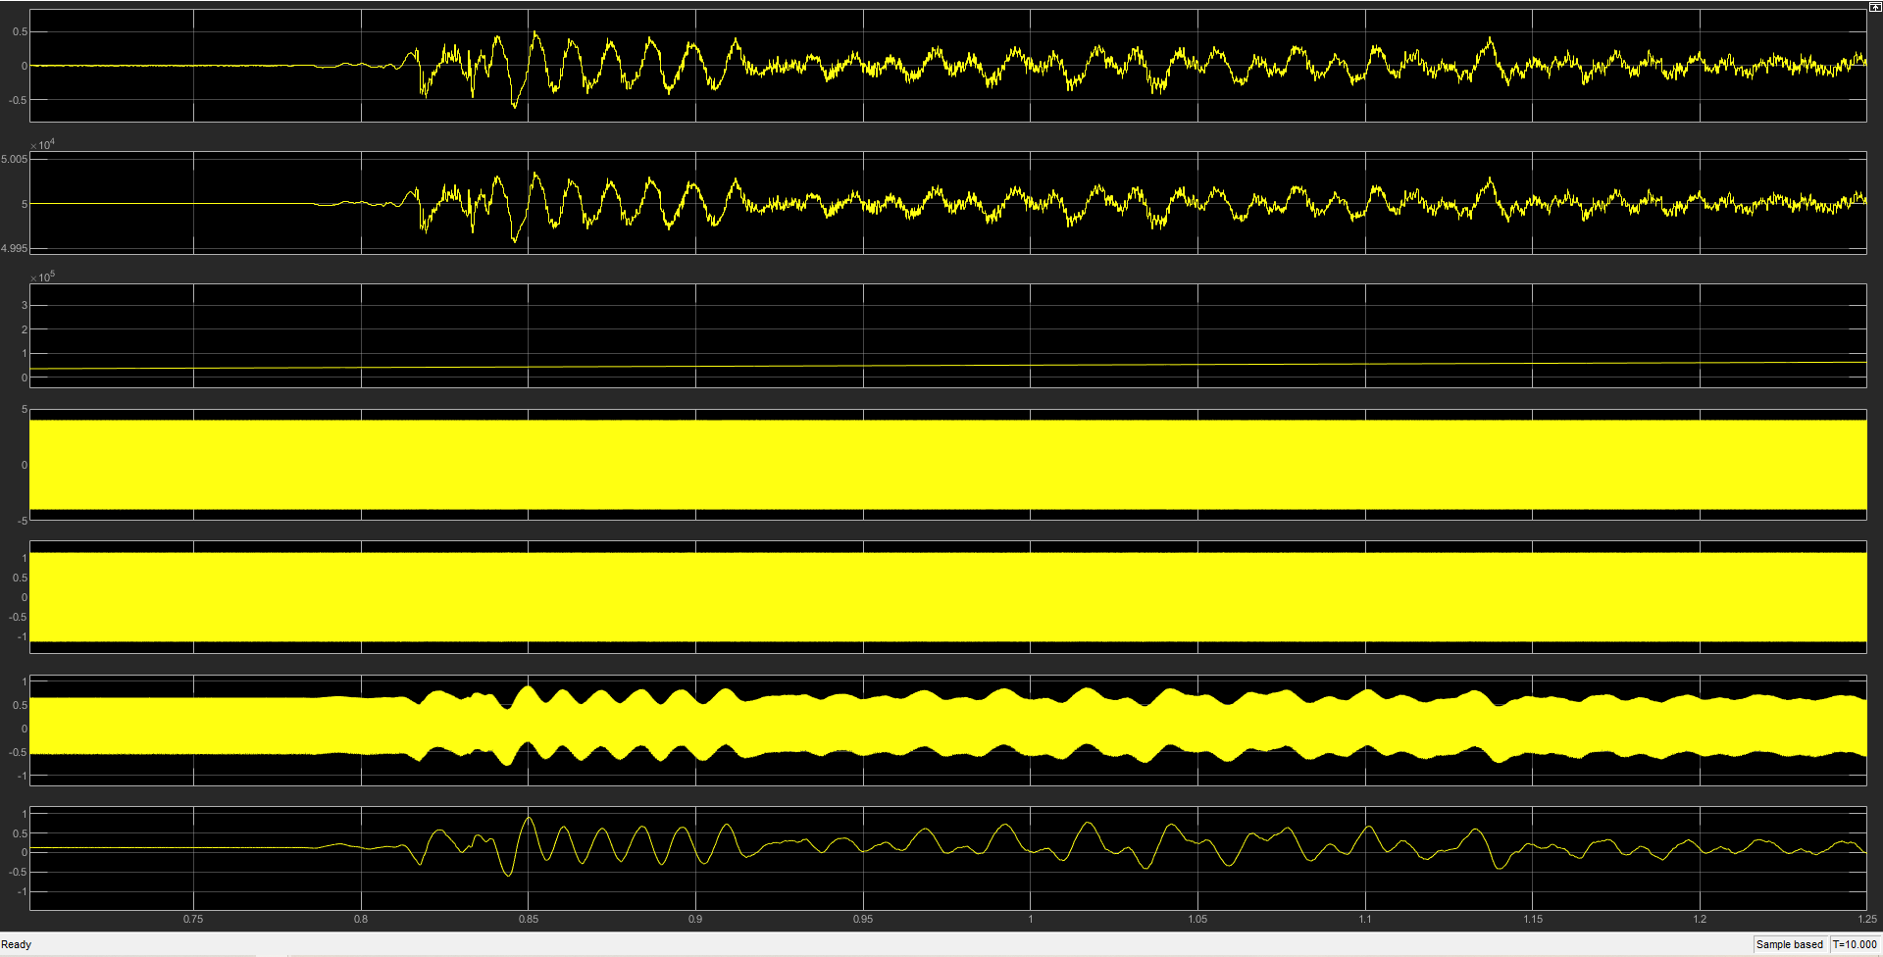
Figure 30: FM Multimedia Simulink 8kHz (Time Domain) No Noise
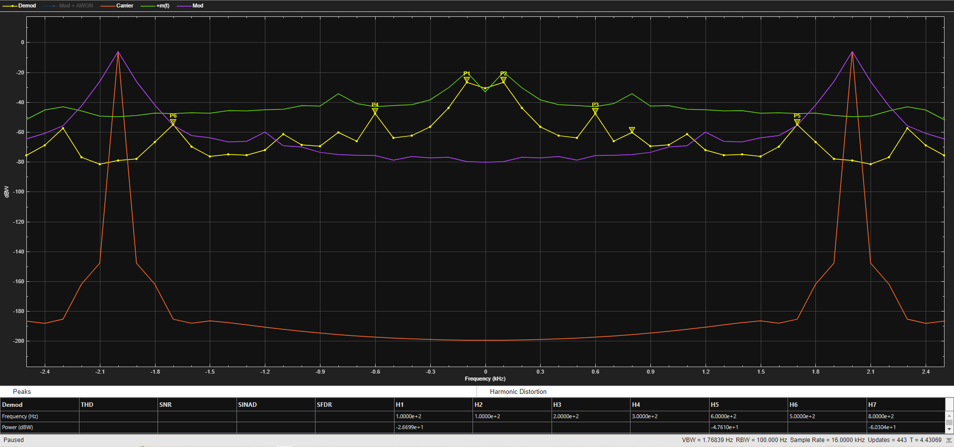
Figure 31: FM Multimedia Simulink 8kHz (Frequency Domain) No Noise

Task 3 (c):

Shown in Figure 32/Figure 33 (10dB) and Figure 34/Figure 35 (50dB) are the Time Domain and Frequency Domain outputs for the FM Multimedia model, Figure 6. In Figure 32 the AWGN can be seen to be severely distorting the demodulated output seen in channel 7:7, when compared to m(t) in channel 1:7. In Figure 34, distortion can be seen, but it is far less severe than seen in Figure 32.

Theoretical Values:
- ${SNR}_{O,FM}$: $10\log_{10}\left(\frac{4^{2}}{2*1W*\left(2*8000Hz\right)}\right)= -42.04119983dB$
- ${SNR}_{C,FM}$: $10\log_{10}\left(\frac{4^{2}*{80}^{2}*0.5}{2*1W*({2*8000Hz)}^{3}}\right)= -94.08239965dB$
- Figure of Merit: $\frac{-42.04119983dB}{-94.08239965dB}=0.446$

10dB AWGN:
Measured Channel Power:
- -8.6275dBw = 0.1371671136W (Mod + AWGN)
- -9.0360dBw = 0.1248532926W (Modulated)
- 15.6053dBw = 36.35214148W* (Demodulated)
Calculated Noise Power: 0.012313821W
- ${SNR}_{O,FM}= 10\log_{10}(\frac{36.3521148}{0.012313821})$
Calculated ${SNR}_{O,FM}$ = 34.70136845dB
- ${SNR}_{C,FM}= 10\log_{10}(\frac{0.1371671136}{0.012313821})$
Calculated ${SNR}_{C,FM}$ = 10.46857164dB*
- $Figure of Merit= \frac{34.70136845dB}{10.46857164dB}$
Figure of Merit: 3.315

50dB AWGN:
Measured Channel Power:
- -9.0360dBw = 0.1248532926W (Mod + AWGN)
- -9.0371dBw = 0.1248216732W (Modulated)
- -12.5215dBw = 0.05595643015W (Demodulated)
Calculated Noise Power: 3.16194e-5W
$${SNR}_{O,FM}= 10\log_{10}(\frac{0.05595643015}{5.3743e-7})$$
Calculated ${SNR}_{O,FM}$ = 32.47896375dB
$${SNR}_{C,FM}= 10\log_{10}(\frac{0.1248532926}{5.3743e-7})$$
Calculated ${SNR}_{C,FM}$ = 35.96446375dB
$$Figure of Merit= \frac{32.47896375dB}{35.96446375dB}$$
Figure of Merit: 0.903
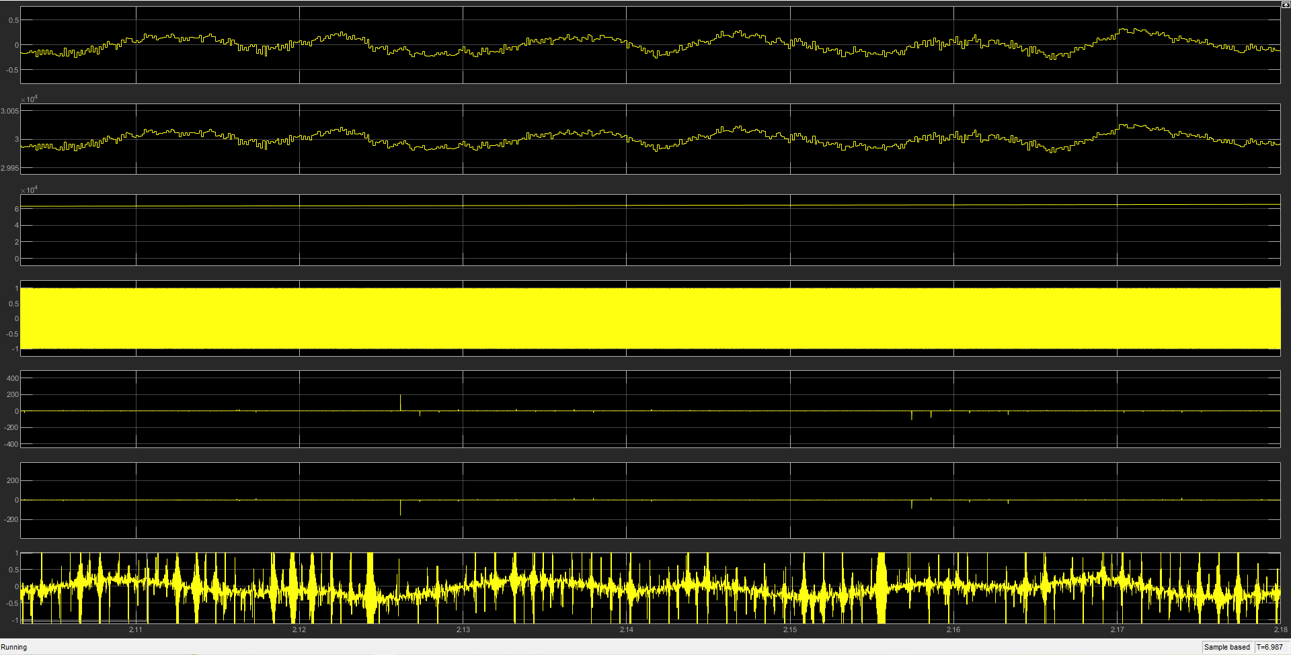
Figure 32: FM Multimedia Simulink 8kHz (Time Domain) 10dB Noise
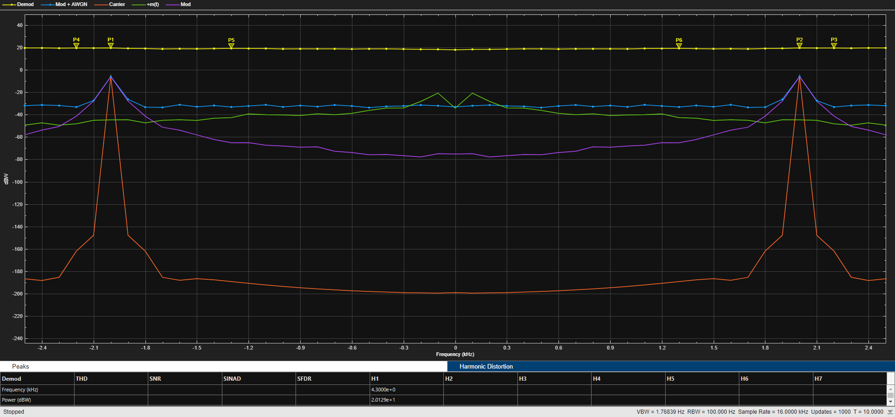
Figure 33: FM Multimedia Simulink 8kHz (Frequency Domain) 10dB Noise

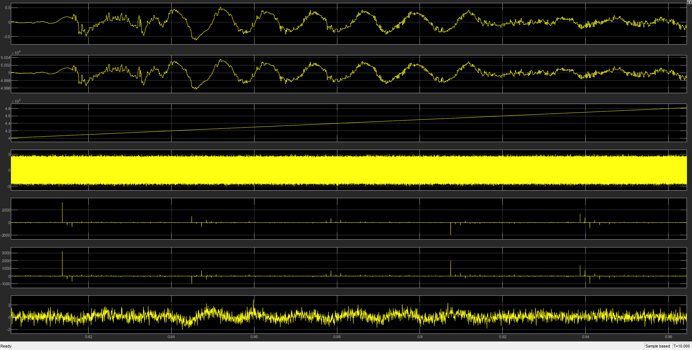
Figure 34: FM Multimedia Simulink 8kHz (Time Domain) 50dB Noise
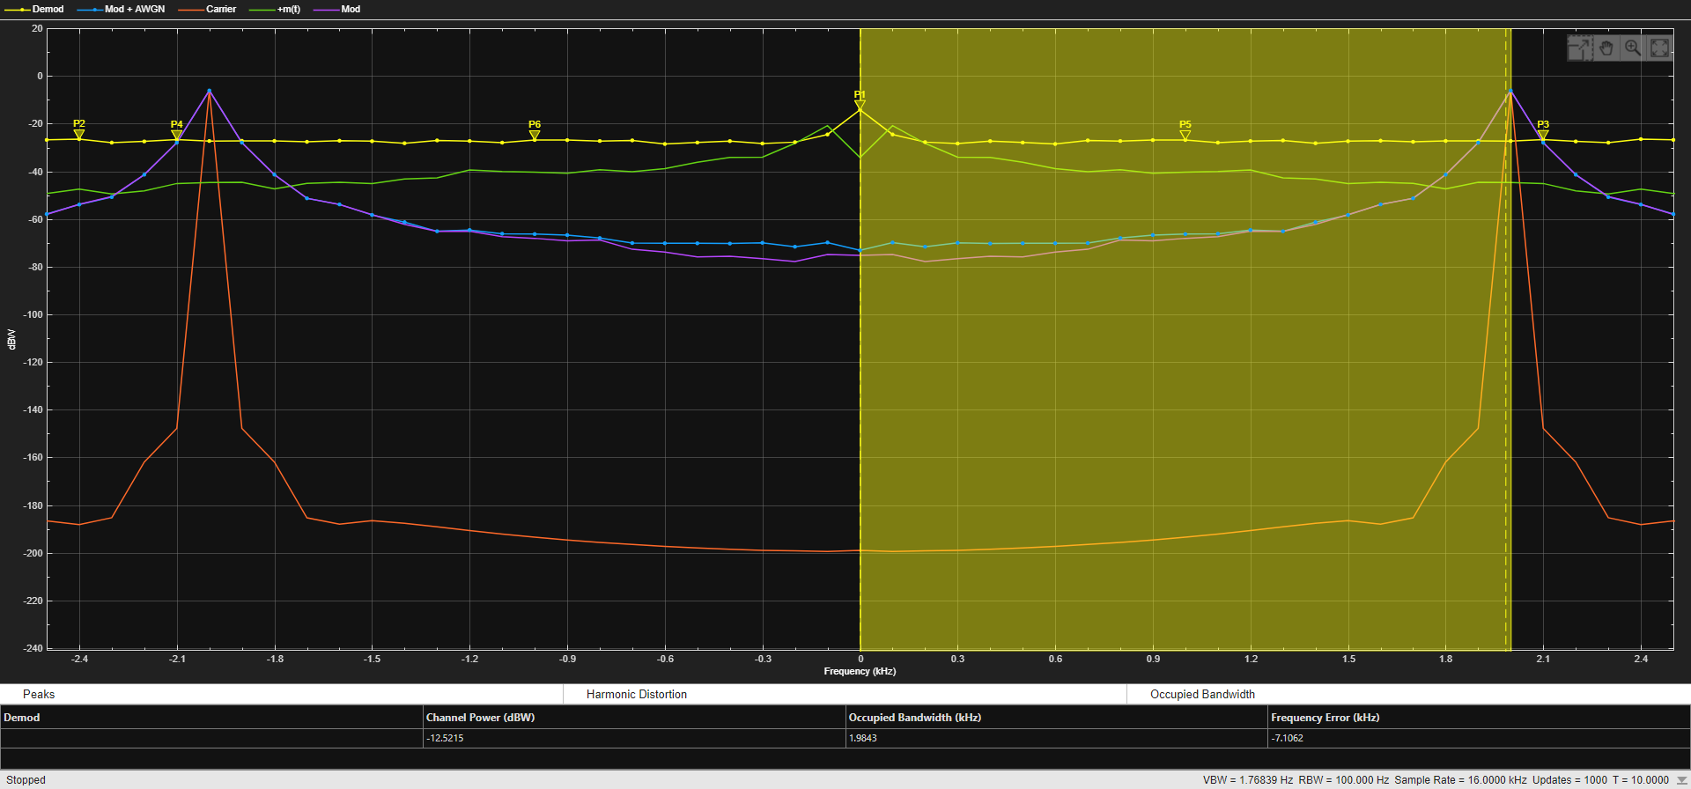
Figure 35: FM Multimedia Simulink 8kHz (Frequency Domain) 50dB Noise

Discussion

Task 1:
As discussed in the results section, in the time-domain, there is no distortion of the modulated wave or demodulated wave at or below m = 1. However, at m < 1, distortion of modulated wave is apparent, due to 180-degree phase reversal when the carrier waveform falls below the zero point [9]. The envelope of the modulated AM wave can be seen in the middle channel in Figure 14, Figure 16, and Figure 18, showing how the modulation index alters the envelope of the modulated wave – the envelope being important as it used by an envelope detector to demodulate the AM wave [3]. In the case of Figure 18, a conventional envelope detector would not be able to correctly demodulate the wave due to the distortion caused by the 180-degree phase reversal [9]. Interestingly, a slight delay can be seen in all time-domain graphs because of the Butterworth LPF, which will delay different sinusoidal frequencies by different amounts [17].
In the frequency-domain, akin to the time-domain, no distortion of the modulated wave can be seen at a modulation index of below 1 $(A_{C}= A_{M})$. However, distortion in the demodulated wave can be seen when the m < 1 $(A_{C}> A_{M})$, shown by the ‘Mod Wave’ (Green) channel in Figure 19.

Task 2:
When comparing Figure 22 and Figure 23 to Figure 24 and Figure 25, distortion of the demodulated message, d(t), from the 10dB of AWGN can be seen in Figure 24 and Figure 25. The net effect is that the noise is added as amplitude, due to the nature of AM modulation, where the amplitude itself is varied [3]. The theoretical Figure of Merit (FOM) was 1.17, this falls close to the expected value of 1 for a DSBSC system [3]. With the inclusion of AWGN, the tested FOMs were at 1.21 @ 50dB/1W of AWGN and 1.49 @ 10dB/1W of AWGN. Both measured FOM values fall close to the expected theoretical FOM, the 10dB FOM being furthest from the theoretical FOM, due to the impact of the low SNR of the channel between the modulator and demodulator having a more significant impact on the system.
Regarding the measured SNR, the measured ${SNR}_{0,DSBSC}$ @ 10dB/1W of AWGN was 6.48dB, compared to an ${SNR}_{0,DSBSC}$ @ 50dB/1W at 52.41dB – both measured values again falling reasonably close to the channel (AWGN) SNR of 10dB and 50dB.

Task 3:
The FM model’s results are not as expected. Indeed, when AWGN added, the FM model suffered from unstable demodulated signal envelope when using envelope detector to demodulate – as can be seen when visually comparing the demodulated output in Figure 24 (channel 4:4) to the demodulated output in Figure 32 (channel 7:7). However, when listening to the output audio files, the FM model is more audible than the DSB-SC with 10dB of AWGN.
Theoretical FOM was calculated at 0.446. FOM @ 10dB/1W AWGN was 0.903 and FOM @ 50dB/1W was 3.315. Neither measured FOM falls close to the theoretical value.
Regarding the measured SNR, the measured ${SNR}_{O,FM}$ @ 50dB/1W of AWGN was 32.47896375dB, compared to an ${SNR}_{O,FM}$ @ 10dB/1W of 34.70136845dB – both values falling further away from the channel AWGN of 10dB and 50dB, especially when compared to the DSB-SC model and more so in the case of the 10dB simulation.

Conclusion

In this report, it has been determined that the FM model was more resilient to AWGN in the channel than the DSB-SC AM model, despite the FM suffering from issues with the envelope detector demodulation. However, at 10dB of AWGN at $N_{O}$ = 1W, all methods of modulation considered suffered severe degradation of audio quality to such an extent that the audio was no longer legible in the case of DSB-SC and very poor in the case of FM.

Future Recommendations
The other form of angle modulation which has not been considered in this report is PM, Phase Modulation. Phase Modulation is where the instantaneous phase of the carrier wave is shifted linearly for the purpose of encoding the message signal [18]. Adding AWGN to a model of a phase modulation would allow for the comparison of both types of angle modulation, FM, and PM, to the amplitude modulation, AM.

Table of Equations:

${SNR}_{C, DSBSC} (theoretical)= \frac{A_{C}2(1+{K_{a}}^{2}P)}{2N_{0}BW}$ ${SNR}_{O,DSBSC} (theoretical)= \frac{{A_{C}}^{2}{K_{a}}^{2}P}{2N_{0}BW}$
Equation 6: Theoretical SNRc & SNRo DSB-SC [6]
$$Noise Power \left(AM\right) = (Mod + AWGN) – Modulated$$
Equation 8: Noise Power
$$P_{total}=P_{USB}+ P_{LSB}$$
Equation 9: DSBSC Modulated Wave Power
$P_{USB}= \frac{{A_{m}}^{2}{A_{c}}^{2}}{8R}$ $P_{LSB}= \frac{{A_{m}}^{2}{A_{c}}^{2}}{8R}$ $P_{total}= \frac{{A_{m}}^{2}{A_{c}}^{2}}{4R}$
Equation 10: DSBSC Side Band Power [6]
$$P_{nc}=WN_{0}$$
Equation 11: Average Noise Power Message Bandwidth
$$F= \frac{{SNR}_{O,DSBSC}}{{SNR}_{C,DSBSC}}$$
Equation 12: Figure of Merit (AM) [6, 19]
$$F= \frac{{SNR}_{O,FM}}{{SNR}_{C,FM}}$$
Equation 13: Figure of Merit (FM) [6]
${SNR}_{O,FM}= \frac{{A_{C}}^{2}}{2N_{0}BW}$ ${SNR}_{O,FM}= \frac{{A_{C}}^{2}{{(1+k}_{f}}^{2}P)}{2N_{0}{BW}^{3}}$
Equation 14: Theoretical SNRo & SNRc (FM) [6]

References

[1] Unknown., “AWGN”, mathworks.com, 2023. https://uk.mathworks.com/help/comm/ref/awgn.html [Accessed: 29/11/2023]
[2] D.K Sharma, et. al, “Analog and Digital Modulation Techniques: An Overview”, 2010, pp. 551 – 553 [Online] Available: https://citeseerx.ist.psu.edu/document?repid=rep1&type=pdf&doi=386918821d30fe5f087781d578d8ccdbd09bb3f2 [Accessed: 16.10.2023]
[3] S. Haykin, M. Moher, “Introduction to Analog and Digital Communications: Second Edition”, 2007. [Online] Available: https://gctjaipur.files.wordpress.com/2015/08/an-introduction-to-analog-and-digital-communications-2nd-edition.pdf [Accessed: 19/10/2023]
[4] Louis E. Frenzel Jr., “Radio/Wireless: The Invisible Cables of Modern Electronics” in “Electronics Explained (Second Edition)”, 2018. Pp: 159 – 194. [Online] Available: https://www.sciencedirect.com/book/9780128116418/electronics-explained [Accessed: 19/10/2023]
[5] Unknown., “UK Frequency Allocation Table”, Ofcom.org.uk (2022). Available: https://static.ofcom.org.uk/static/spectrum/fat.html [Accessed: 19/10/2023]
[6] M. Plonus., “Digital Systems, Frequency Modulation” in “Electronics and Communications for Scientists and Engineers (Second Edition)”, 2020. Pg 355 – 480. [Online] Available: https://www.sciencedirect.com/topics/physics-and-astronomy/frequency-modulation [Accessed: 29/11/2023]
[7] Jenifer P. Devaraj, “Modulation and Demodulation” in “Radio Frequency Systems”, 2023. Pp – 23. [Online] Available: https://moodle.uwtsd.ac.uk/course/view.php?id=11697 [Accessed 06/11/2023]
[8] Unknown., “Amplitude Modulation, AM Index & Modulation Depth”, electronics-notes.com. Available: https://www.electronics-notes.com/articles/radio/modulation/amplitude-modulation-am-index-depth.php [Accessed: 23/11/2023]
[9] R. Venkataramanan., “Analogue Modulation” in “Communications”, 2016. Available: https://sigproc.eng.cam.ac.uk/foswiki/pub/Main/IBComms/P6_lecture_slides_2.pdf [Accessed: 27/11/2023]
[10] Don H. Johnson, “Signal-to-noise ratio”, 2006. [Online] doi::10.4249/scholarpedia.2088 Available: http://var.scholarpedia.org/article/Signal-to-noise_ratio [Accessed: 19/10/2023]
[11] Unknown., “Analog Communication – AM Modulators”, tutorialspoint.com. Accessed: Available: https://www.tutorialspoint.com/analog_communication/analog_communication_am_modulators.htm [24/11/2023]
[12] Unknown., “Analog Communication – AM Demodulators”, tutorialspoint.com. Available: https://www.tutorialspoint.com/analog_communication/analog_communication_am_demodulators.htm [Accessed: 24/11/2023]
[13] Unknown., “Analog Communication - DSBSC Modulators”, tutorialspoint.com. Available: https://www.tutorialspoint.com/analog_communication/analog_communication_dsbsc_modulators.htm [Accessed: 24/11/2023]
[14] Unknown., “Analog Communication - DSBSC Demodulators”, tutorialspoint.com. Available: https://www.tutorialspoint.com/analog_communication/analog_communication_dsbsc_demodulators.htm [Accessed: 24/11/2023]
[15] Unknown., “Analog Communication – FM Modulators”, tutorialspoint.com. Accessed: Available: https://www.tutorialspoint.com/analog_communication/analog_communication_fm_modulators.htm [24/11/2023]
[16] Unknown., “Analog Communication – FM Demodulators”, tutorialspoint.com. Available: https://www.tutorialspoint.com/analog_communication/analog_communication_fm_demodulators.htm [Accessed: 24/11/2023]
[17] W. Rose, K. Munal, “A general solution for the time delay introduced by a low-pass Butterworth digital filter: An application to musculoskeletal modelling” 2007. [Online] Available: https://www.sciencedirect.com/science/article/pii/S0021929006000480#:~:text=In%20general%2C%20the%20output%20signal,different%20frequencies%20by%20different%20amounts [Accessed: 19/10/2023]
[18] Simon Haykin, “Communication Systems, Civilian” in “Encyclopedia of Physical Science and Technology (Third Edition)”, 2003. Pg 409 – 432. [Online] Available: https://www.sciencedirect.com/science/article/abs/pii/B0122274105001253 [Accessed: 06/11/2023]
[19] Unknown., “Analog Communication - SNR Calculations”, tutorialspoint.com. Available: https://www.tutorialspoint.com/analog_communication/analog_communication_snr_calculations.htm [Accessed: 24/11/2023]
[20] Unknown., “Analog Communication - DSBSC Modulation”, tutorialspoint.com. Available: https://www.tutorialspoint.com/analog_communication/analog_communication_dsbsc_modulation.htm [Accessed: 24/11/2023]

