Study Skills Assignment
George Tucker

Abstract
Contents

Section 1: Class Presentation
For the study skills module it was required of students to create and relay a short piece about themselves via a 5-minute presentation, this would then be critiqued, with critical feedback on presentation form relayed to each student for self-evaluation. The presentations were held on the 11th and the 13th of March 2020 on site at the UWTSD IQ building.
For the purposes of this assignment a short section on the author’s personality is detailed below to give further context to this section about the presentation completed for this module:
My name is George Tucker and I am 22 years old. I was born in Watford but was raised in a small town called Ludgershall in the county of Wiltshire. It was here that I grew up and went to school, enjoying a simple but pleasant childhood in which I spent a lot of time with my family with whom I am very close.
Going through school I enjoyed, and was best at, the sciences and spent most of my time studying and working hard to do well in exams. For A-levels I decided to take Maths, Physics, Chemistry and Product Design. All of these were subjects I really enjoyed and afterwards I moved out of my hometown to study Architecture at the University of Manchester. I spent three years there to get my degree however I really didn’t enjoy the course. Believing that it was to be a fusion of design and science I was sorely disappointed to find out that it was far more artistic and subjective than I had anticipated.
Having not enjoyed my time at university and the course of Architecture I decided not to pursue it as a career. I then set my mind to changing tack and applied to several different apprenticeships that would provide me the opportunity to get back into the world of science. I was fortunate enough to be accepted onto such a scheme and since then my life enjoyment has gone up tremendously and I have now embarked on a new journey working towards a degree apprenticeship.
When I am not studying or at work, I enjoy hobbies such as reading, playing video games and relaxing with my friends and family. I enjoy exercising, good food, and sleeping in. Conversely, I do not enjoy large groups of people, giving presentations/public speaking, or being ill. I have rated myself with several strengths and weaknesses, the strengths revolving around determination, a willingness to help others and an enjoyment of solving problems and puzzles. Weaknesses lie in a predisposition to be overly shy, a tendency to procrastinate, and a potential to become arrogant in conversations with people if not thinking about what is being said.
Finally, going forward with my life, goals that I have set for myself to encompass the next 5-10 years include becoming a homeowner, travelling more, maintaining a good level of physical fitness and to keep learning and improving my mind and wealth of knowledge.
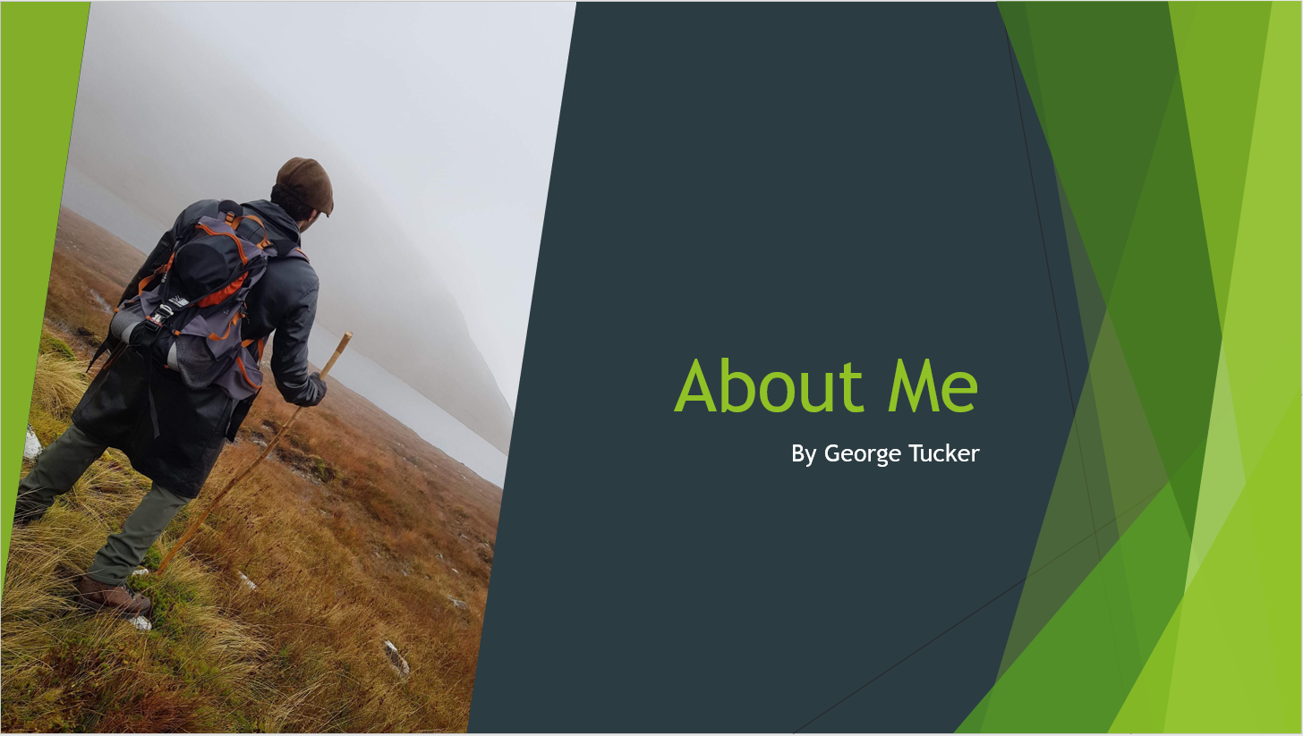

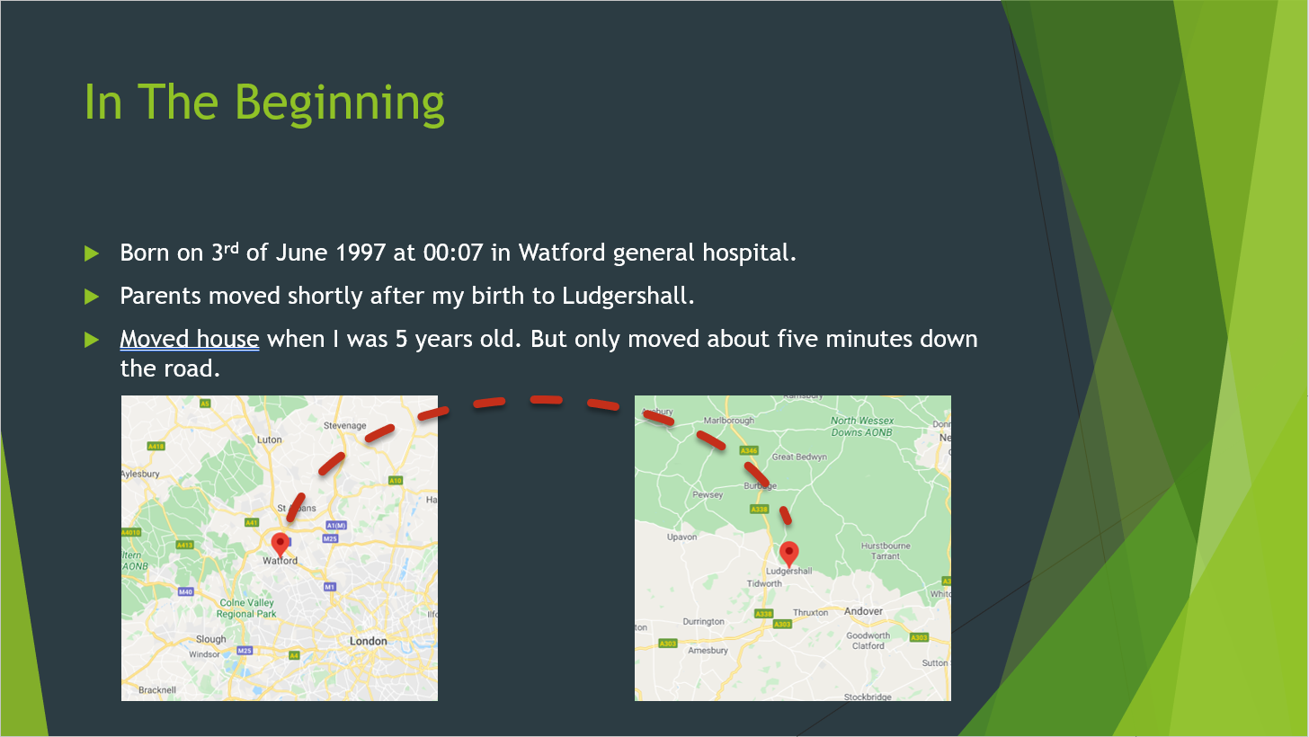

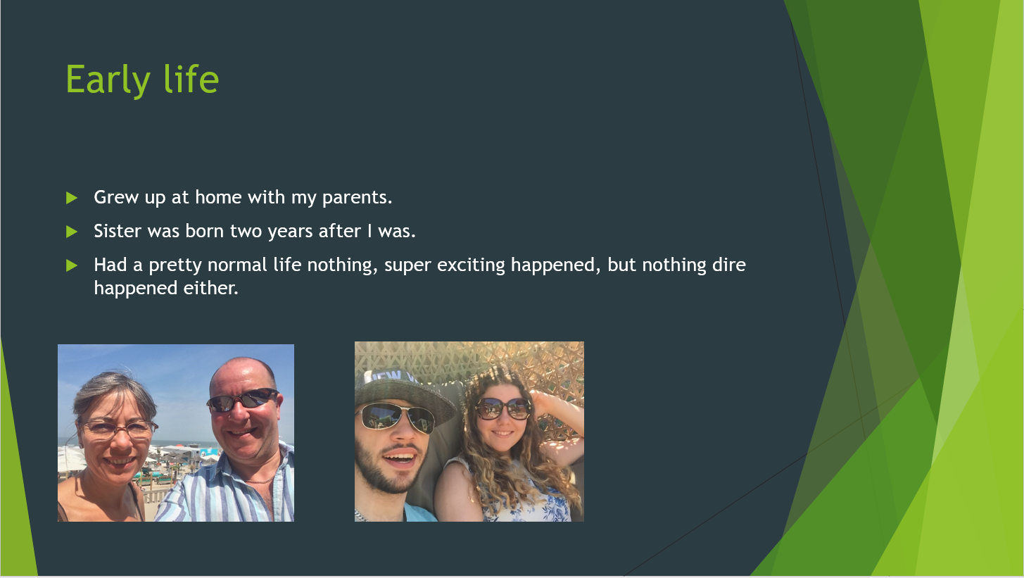

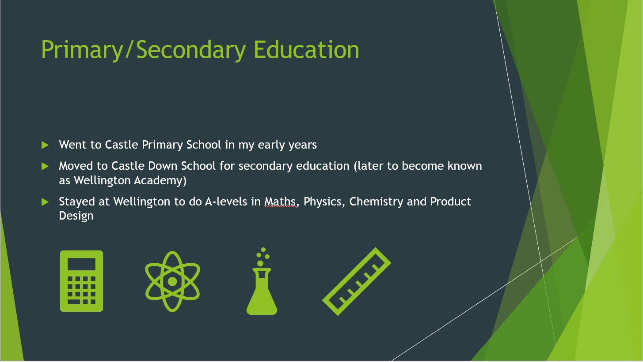

Figures 1-4 are slides taken from the presentation showing the layout and content that was presented on the day to the rest of the students studying this module. As can be seen, slides contained some text, kept to a minimum, and images/graphics to convey the message to the audience. Whilst not all the slides were identical these four are representative of the rest of the presentation content.
When given the task to create a presentation about the self, it was a good opportunity to research different skills and methods to enhance presenting and improve the outcome of the task. As well as an in-class lecture on presentation skills, some other useful general presentation tips include:
- Prepare effectively
- Be clear in delivery of message
- Keep to time
[1]
As well as these some more in-depth tips are:
- Use minimal amount of text
- Use each slide to only support one point
- Make sure to use the minimum amount of slides
- Think about background and text colours to ensure contrast
- Use a clear legible font
[2]
All of these are just some of the valid presentation skills that can be used to help enhance a presentation. Some features such as confidence cannot easily be implemented from reading about them in a book, but instead must be built up over time and experience of giving multiple presentations.
After the presentations feedback was given to be reviewed and acted upon. The feedback for this presentation was as detailed below:
- “Don’t make the text smaller – its on the edge now”.
- “Try to project the voice a little more. Volume reduced a little bit at times”.
- “Try not to look quite so much at the screen, - but generally not too bad”.
- “Keep hands out of pockets”
-[Source]
This critical feedback is a good indicator of the key points that could be worked on to make the presentation quality better. This would, therefore, allow for more efficient conveyance of the presentation content to the audience.
It can be noted that all the comments are about presentation skills for conveying the information, the content is not mentioned indicating that it was suitable for the task and audience.
Section2: Strengths and Weaknesses
When studying it is important to identify strengths and weaknesses. Part of this is looking at what skills someone might have as these skills will help with studying as well as with future employment.
Researchers have noted that there are several different types of skills and, furthermore, skill groupings that can be found in higher education. These include but are not limited to:
- Transferable skills – skills that developed in university or other higher education that are pertinent at the time for studying, but can also be useful in the workplace. This group may include skills such as presenting (covered earlier in this report), researching, problem solving, analysis etc. Possibly the more useful kind of skills to develop as they are what employers will be looking for in applicants.
- Core skills – skills that are core to the student experience at university, such as being able to use libraries, online resources, report/assignment writing etc. These skills are noted as being important to becoming successful in a degree but may have limited use outside of academia.
- Key skills – these skills are important to a particular aspect of work or study, they may be hard to acquire but could be key to open up a particular career path. Possibly including advanced CAD skills or being able to work with specific machinery that is used in industry but not many people know how to use it.
[3]
It is important when moving through a higher education system to develop the more employable skills such as those considered transferable, as well as looking into developing key skills that may unlock future career options. Research has found that in some places
“Higher Education focuses on knowledge not skills, meaning students can end up underdeveloped” [4]
This means that some Higher Education programs focus more on teaching students the information they need to pass the course with a good mark, instead of working on developing skills that will make them more employable when they finish their degrees.

Personality and skills:
As a tool for the identification of base personality traits for students to better understand themselves, as well as help refine goals and life-plans, a series of personality tests were completed that aimed to give individuals insight into what might help motivate them. Or to understand how they might best fit within an organisation or career path. These tests were completed online and several different personality type tests were carried out in order to collect a broader range of data instead of just completing one test.
Before taking the tests however, first students were tasked to list their own perceived characteristics of themselves in order to see post-test how closely they might resemble their test results. Seen below are the author’s predictions on personality before taking any tests:
Personality wise I believe I am:
- Quiet
- Reserved
- Active
- Focused
- Cerebral
- Determined
- Logical
- Level-headed
- A good listener
- Stoic
When looking at these predictions they are fairly generic terms and do not really go into much depth when it comes to character. However, it can be hard to categorise human personalities and so they provide a good start point to then compare with personality test results.

Results:
Test 1: The Big 5 personality test
Accessible at: https://openpsychometrics.org/tests/IPIP-BFFM/
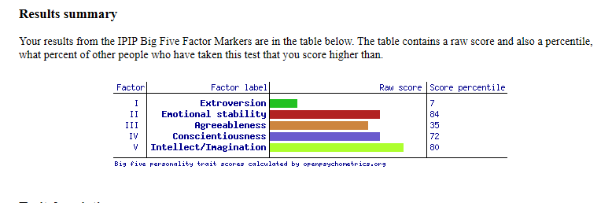
Test 2: Open Extended Jungian Types
Accessible at: https://openpsychometrics.org/tests/OEJTS/
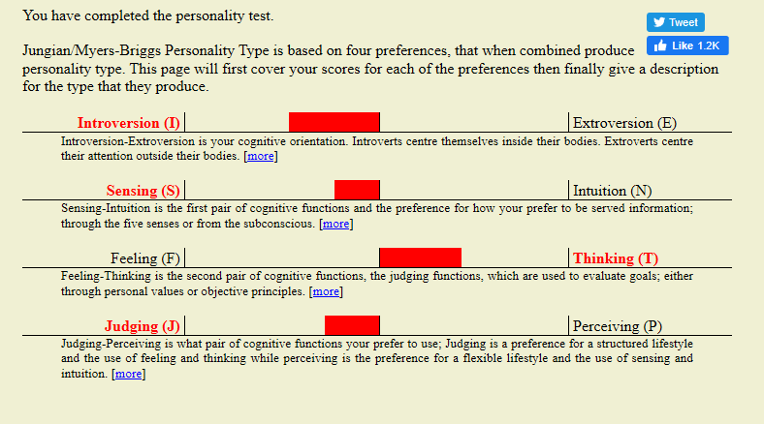
Test 3: Jung personality test
Accessible at: https://www.123test.com/jung-personality-test/
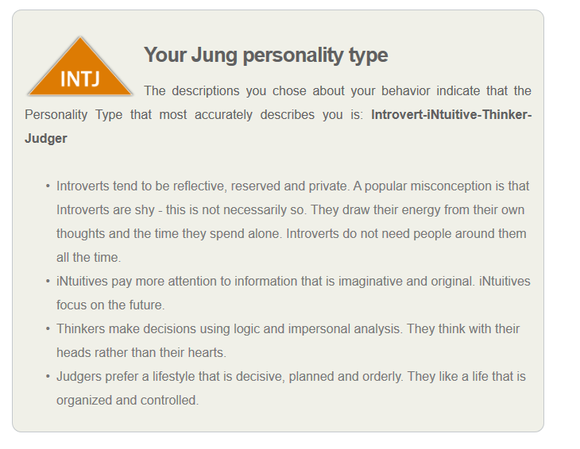
Test 4: 16 Personalities test
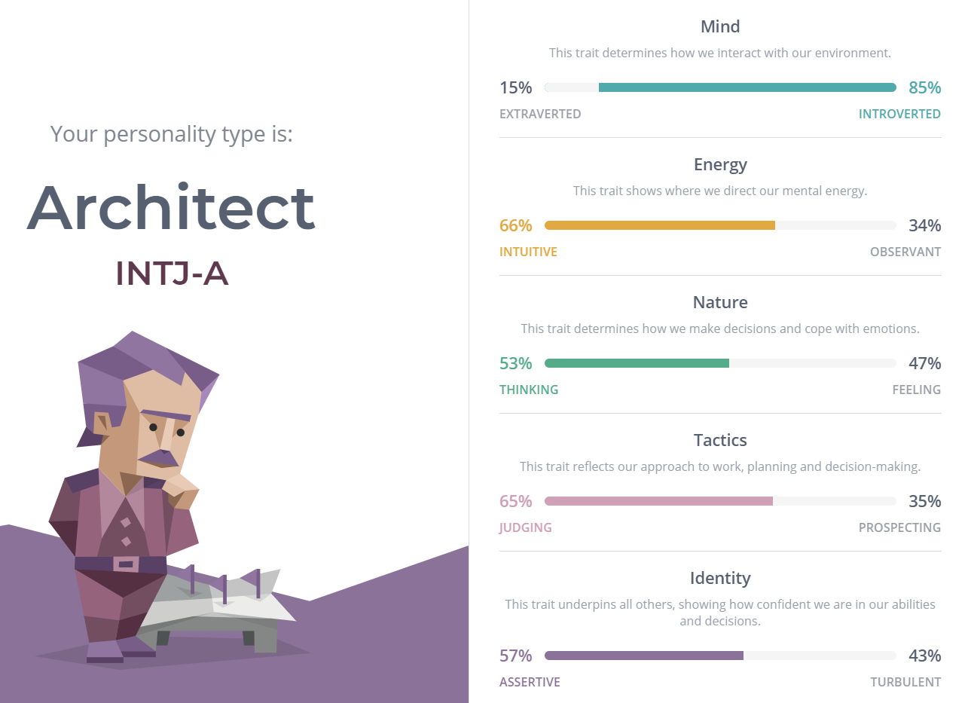

As can be seen from the above results*, many of the tests indicated similar personality traits across their feedback pages. This is to be expected, as the same person is taking the test, and all the tests are similar enough in nature that there should not be wildly deviating answers.
Tests 3 and 4 suggested INTJ as the final personality type. Whereas the second test relayed ISTJ as the final personality type. These are very similar by looking into the breakdown provided it can be deduced that it is easy to lie in the middle ground on certain personality preferences, and it is not hard to imagine how a slightly different worded question or questions, could tip you over to the other personality preference on a different test.
One reassuring metric that can be observed is how the introversion measure is consistently scoring high compared to the other traits in each of the different tests, displaying that they can deduce certain information about a personality especially when it comes to perhaps the most integral parts of someone’s personality.
*Note that the results shown above only display the summary results provided by the websites for the sake of convenience. To see all the results data please go to the appendix.
Comparison to previous view of self pre-tests:
When comparing the results to the predictions made before the test, some factors need to be assessed. Firstly, a person judging themselves will use different vocabulary to the predetermined fields that are assigned using Myers-Briggs tests, and so it is worthwhile to look for synonyms or observe if similar aspects of a personality were referenced in the prediction (such as openness or emotional control). Also, it is hard to judge one’s self without being prompted to explore different aspects of a personality. It is easy to focus on just a few personal traits believed to make up a personality or to not comment on traits that you did not conceive of measuring.
All that being said, the adjectives in the personality prediction do show some similarities with the results from the tests. Words such as “quiet” and “reserved” can clearly have a parallel drawn with the introverted results seen on the tests. Whereas, “level-headed” can relate to the emotional stability that was also a common theme in all the results.
However, and of interesting note, some of the thoughts laid out in the prediction such as “active” or “stoic” do not really fit into any of the five fields. It could be argued that “active” is more of a lifestyle trait than a personality one, however it could be counterargued that these are linked concepts. Additionally, “stoicism” is a philosophical school of thought something that is not explored in the Myers-Briggs type tests. And although following a philosophy is not the same as having a personality trait, it may influence your traits, or it could be found that people who choose to follow different philosophies are pre-disposed to have similar personality traits.
Despite the small differences, it would appear that the predictions can be judged as fitting within the test results, with the test results providing an expanded and more in-depth suite of knowledge regarding personality. The test also focuses in more on pure personality traits, whereas the predictions tend to sway off course and border the realms of lifestyle descriptions etc.
The value and accuracy behind these tests is something that is debatable, with some companies using them to help career paths with their employees. However, there is conflicting evidence to suggest that tests such as the Myers-Briggs style personality tests are too generic and do not give an accurate picture of a person’s psyche.
Some research has found that “factors other than personality, such as abilities and motivation are greater indicators of performance” [5] This conclusion came from work done comparing people’s MDTI scores and actual workplace performance and progression.

Goals:
Additional to the skills review, students were then required to create an action plan, taking the information learned from the personality studies in order to give themselves short and long-term goals to improve upon their skills or work towards their own goals and targets. The Author’s aspirations can be found below:
Looking at my skills and personality evaluation as well as taking into account my own personal goals I have identified 3 short and 3 long-term goals for myself:
Short Term:
- Reduce tendency to procrastinate – this has been chosen as when it comes to unwanted tasks there is a tendency to procrastinate and put things off. Especially with academic work and studies, not so much when it comes to actual work. It would be good to work on this and reduce it for the upcoming years of study.
- Improve sleeping patterns – poor sleep can impact on the rest of daily life as well as health. This is an important lifestyle aspect to improve on in order to become more effective during the day.
- Become more organised and effective – become better at organising my time and creating goals for myself so that I do not stagnate. Learn how to use different strategies in order to better get the most out of time and out of life.
Long Term:
- Become more sociable – as a weakness identified in the personality tests, it would be nice to be more open with people and find it easier to integrate. This could be beneficial in the workplace in order to make contacts and build up a network from which future opportunities may arise.
- Work on presentation ability – as another skill that could be improved it makes a good long-term goal, as one of the keys to getting good at presenting is to present. Over time this will be useful to develop for workplace presentations, as well as any future ones at university.
- Get fitter – a personal ambition to get fitter and maintain good physical health alongside academic progression. As the body is the vehicle of the mind, both should be considered instead of one over the other.
As it can be noted, several relevant and personal goals have been laid out here alongside the reason for the goal. However, in addition to thinking about their goals, the notion of SMART goals was introduced to students to help refine this notion of goal setting.
What is a SMART goal? This terminology comes from tools used to assist in training people for business Management [6] Smart is an acronym for :
- Specific
- Measurable
- Achievable
- Relevant
- Time dependant
The logic behind making a target a SMART target is that it adds more focus and direction to a goal. Forcing the understanding of what is to be achieved and, more importantly, how it can be achieved. All these factors make it much more useful to have SMART goals than less defined ones that have less clarity.
For the purpose of this report, 4 of the short/long-term goals have been selected for SMART analysis and can be seen below as an example of creating SMART targets:

Goal: Improve Sleeping Pattern
S – the goal is to measure and analyse how much sleep is needed for optimum performance and employ a sleep strategy that fits in with daily routine in order to uphold the aim of getting enough sleep.
M – the amount of adequate sleep can be found by performing a sleep test to see how much sleep the body naturally requires. Performance should be measurable by subjective means such as how one feels after waking.
A – This can be achieved through sticking to a set out sleeping plan and should requiring only the necessary research into sleeping behaviour and a willingness to experiment with different methods.
R – Getting enough sleep is an important part of a healthy lifestyle as well as ensuring that a person can work to their maximum effectiveness in work or study.
T – Aside from needing some free time to experiment with how much sleep one requires, this should be a goal that can be achieved in a few weeks as long as a plan is adhered to.

Goal: Become more organised and effective
S – the goal here is to reduce mess at home and to improve the rate at which household tasks and chores are completed. As well as at work where the rate of working can be improved to enhance output.
M – the visual appearance of a dwelling place can be a good indicator of organisation, as can such things as file structures and other organisable material. In terms of work output, number of tasks completed and in what time can be a good indicator of organisation.
A – This goal can be achieved by doing research into organisation tips as well as creating personal plans, a key factor highlighted in the rest of this report.
R – this will improve performance in study and in work. And should help contribute to better living standards as well as better mental health overall.
T – this should be a life change that can be implement relatively quickly (a few weeks) although the impact can be measured over a longer timescale.

Goal: Work on presentation ability
S – This goal is to improve all skills relating to presentation ability, including presentation design and delivery. This is a very specific set of skills that are grouped closely together in the overarching skill of presenting.
M – Measuring presentation skill can be hard, but things such as audience feedback give an opportunity to showcase an improvement in this goal.
A – As a transferable skill that only requires the opportunity to present, this is an easily achievable goal in the realms of work and study.
R – As a skill useful for work and study this is a very relevant goal, being a worthwhile thing to work on now at the start of a career/study program, in order to be fully developed by the end when it will become even more useful.
T – This goal can be worked upon immediately, but the length of time to complete should be the remaining four years of the program of study.

Goal: Getting fitter
S – A specific goal can be outlined in terms of weight, body dimensions or the more subjective goals of aesthetic (muscle definition etc).
M – Measurements can be made in terms of body weight and muscle size which can be tracked over time to ensure progress is being made.
A – All that is required for this goal is determination and research into how to effectively exercise.
R – This is a goal that can impact several different areas of life in the long run, health is extremely important and part of being healthy is to maintain good physical fitness alongside a balanced diet. One should endeavour to nurture the body as well as the mind.
T – as a goal this should be a lifelong pursuit, but smaller milestones can be given shorter timeframes. For instance, lose 4Kg of fat by Summer.
As it can be seen above, using the smart format can add detail and structure to a goal, enhancing the chance that the goal will be achieved by an individual.
As part of classwork, an action plan was created for each student which can be found in the appendix of this report.
Section 3.A: Data Safety
This section of the report will be looking at data safety, an important aspect of anyone’s life who deals with digital information. With the prevalence of smart technologies such as the smart phone and digital cameras, as well as laptops and computers, a lot of information is turning digital. Data can include “any information processed or stored on a computer, including photos, documents etc” [7]. As a result, it is important to bear in mind the consequences of losing such data. It could mean losing personal photographs that cannot be easily replaced, it could mean losing a final end-of-year essay or assignment that needs to be handed in, in order to pass a course. Or it could mean losing a presentation someone has been working on to deliver to a client, resulting in them starting from scratch.
When thinking about data safety it is important to identify the possible hazards that may threaten data. To consider these it is important to note that data can be stored virtually using cloud-based software, or physically on hard drives or USBs. Why is it important to understand these two differences? Well they each have their own strengths and weaknesses when it comes to keeping data secure and backed-up.
For instance, keeping all data stored using physical methods leaves risk for the data to be lost should the item used to store the data suffer misfortune. It is possible to lose a laptop or external hard drive/USB by misplacing them somewhere. Alternatively, although perhaps less likely, theft may result in the loss of hardware. Desktop PCs are less portable and therefore may be considered safer places to store data. However, they too could suffer misfortune, a fire or flood damage may result in damage to the PC or its destruction. Either outcome could jeopardise the safety of the data stored on any of these devices.
This is where the advantages of cloud-based software storage come into play. These data storage solutions keep data saved securely on a server that is accessed via the internet. This provides a way to keep data safe from physical harm however there are still flaws. Most cloud-based storage services are just services, and therefore the company running the servers may have to shut down. Additionally, the data stored there could be subject to a hacking attack, or (in the unlikely event) the servers themselves are destroyed then this could also lead to a loss of data. [8]
As can be seen, both physical and virtual methods of storing data have valid points supporting their use to keep data safe. In most cases the strengths of one strategy help to cover the weaknesses of the other, which is why it is popular to take a combined approach when considering storing data effectively. This means, using both physical and virtual methods of storage that are updated regularly to back up data, minimising the risk of data loss. As part of the assignment students were tasked with coming up with their own data storage strategies, the author’s is detailed below:
For my data storage strategy, I have decided to approach the problem with a suitable number of back-up options in order to cover multiple events that could result in the loss of data. This has been done in order to secure university work as well as personal information such as photos or personal documents like CVs etc. In order to ensure data is stored securely, a multiple storage system has been chosen with the aim of storing the data in a suitable amount of locations whereby it is unlikely that should one or more of these locations be compromised, the data will still be retrievable by other means. Here is the outline of strategy:
-3 hard storage solutions
-2 virtual storage solutions
The 3 hard storage solutions include saving and backing up data on three separate pieces of hardware. One of these is a laptop hard drive, one is the hard drive of my desktop PC and the final location is a portable external hard drive. By backing up the information on these three devices it means that should one be lost or damages there is another device that has the information on it ensuring that not all of it is lost. The three items are also seldom in the same place at the same time. This means that in the unlikely event of a fire, not all of the storage solutions will be compromised, and therefore, not all the data will be lost. The limitation of this strategy is that the storage devices must be brought together in order to save the information to each drive. It is possible to send files via email, but this requires internet connection which might not always be available if using a laptop when out and about.
To counter this limitation, 2 virtual storage solutions have also been employed alongside the hard storage solutions. These are the “personal files” section available on Moodle for students, that allow for the storage of files, as well as a one-drive folder that uses cloud-storage to save files to. These two storage methods are pretty much unlikely to ever suffer physical harm, and the main threats to the data stored in these locations comes from the servers they use being taken down either because the company is stopping it’s services or due to some form of malignant activity such as hacking. The risk of the virtual data back-ups being compromised is small, and by using two separate locations it adds an extra line of defence in case one should fail, further enhancing the effectiveness of the strategy. One more point to note about the virtual storage methods is that they do require internet connection to access, which is a weakness in terms of utility should the data need to be recovered.
As it should be plain to see, these 5 data storage locations work together in tandem in order to keep important data backed-up and the range of methods should cover any shortcomings that would arise from using just a single method. As an additional side note where possible, I transfer files between devices via email, which can act as a kind of backup, but this requires an internet connection to do and is not as secure as using cloud-based storage.
Below you can see evidence of the data storage methods that have been outlined above:

As well as the threats to data that have been mentioned here, one prevalent threat to data today is cryptowall viruses which are used by people to infiltrate a system and encrypt files so that they are inaccessible to the content creator. It is threats such as these that make having a back-up strategy so important in order to secure one’s data. A report looking into the cryptowall virus threat and how to counter it can be found in the appendix section of this report, but in essence these viruses come under a class of ransomware which is defined as: “A type of malware that encrypts your personal data files and prevents you from accessing them. You are then ordered to pay a ransom in order to receive a key to then access your files. Hence the name ransomware.” [9]
Section 3.B: Time Management and E-portfolio
For this module of study (Study Skills), it is important to consider the skill of time management, and how it can be an effective tool in increasing productivity and improving balance in life more generally.
Once known, this knowledge can be applied to further years of study, improving productiveness, and reducing stress from letting tasks heap up. In the workplace or at home it can improve efficiency in any task related matter, making an individual more effective as a person.
Some common time management strategies include:
- Using a calendar/daily planner
- Using a time management app
- Employing traditional methods such as Gantt charts when completing a project.
[10]
As for myself intend to start making daily plans using a notebook, as this will allow me to set out a series of goals the night before for me to achieve, which can then be ticked off as the day progresses. I like this method over e-based calendars etc as it feels more tangible and I feel more motivated to complete something I have written down. In addition to this however, I am using a calendar to manage my time at work and have mastered how to invite people to meetings and set of tasks and deadlines for myself. Sadly, this calendar cannot be shared, but there are some images of daily goals I have made since starting this new time management change.

Some good organisation advice that goes with time management can be found on the NHS website where they include suggestions such as:
- Making lists of tasks
- Focus on the results, make sure to be working to output quality not quantity
- Prioritise tasks by looking at the twin features of importance and urgency
- Use the 4 D’s – Delete, Do, Delegate, Defer
[10]
This skill of time management ties in with the previous topics discussed in this report, namely it goes hand in hand with goal setting. And being able to write down targets and assign time to them makes it more likely that you will end up achieving your targets. [12]

E-Portfolio:
An e-portfolio is a way of organising one’s private information in an electronic filing system so to speak. It allows for information about career progression as well as other important documents and folders to be organised in an effective way so that when looking for a career all the information required to showcase what kind of work and experience has been completed over time is all there to hand. This allows one to gradually build up relevant information and qualifications which can then be called upon when required to suit the needs. It reduces the stress level post-study of having to create a CV where the information or activities completed may not be easy to remember.
As a degree apprentice I already have a PDP and e-portfolio structure at my workplace. This consists of a physical logbook in which I note down my daily activities and what I have learnt from a particular task. In addition to this I have a digital diary which is updated regularly from the information in the physical diary, this contains more detailed information about objectives and goals and how I am working my way towards them. As well as the diaries, regular meetings are set up with members from the university to discuss and evaluate progress along the course in order to ensure that development continues.
For this module it was suggested that students had a go at creating an e-portfolio in order to learn the skills of doing so. Below can be seen a representative file structure created to prove that the skill is there.

Section 4: Conclusion

