
Skills for the Workplace
Module Assignment Submission
Student Name: | Tasha Jenkins
Student Number: | 1917884
Module No: | BMSK4001
Module Title: | Academic and Employability Skills

Statement of Confirmation of Authenticity
By the act of making this submission, the student declares that this is the work of the student named above. The work has not, in whole or in part, been knowingly presented elsewhere for assessment, or where assessment has been built on a previous assessment, this has been identified. Where materials have been used from other sources it has been properly acknowledged. If this statement is untrue, the student acknowledges that an assessment offence has been committed.
Attention is drawn to the plagiarism and unfair practice policies of both the University and of ILM.

Contents
Introduction. 3
Part 1 Leadership Skills. 3
1.0 Explore Leadership Employability Skills. 3
1.1 Evaluate own Leadership Employability skills 6
1.1.1 Gap Analysis. 9
1.1.2 Action Plan for Improvement 10
Conclusion. 11
Part 2: Academic Skills 12
2.0 Academic Skills required for University Level Study. 12
2.1 Reflection on Academic Skills required for University Level Study 13
2.1.1 Evaluation. 14
2.1.2 Gap Analysis. 15
2.1.3 Conclusion of Gibbs Reflective Model (1988). 16
2.1.4 Action Plan for Improvement 16
Conclusion 18
References 19
Appendix 21
Bibliography. 26

Introduction.
The author of this report is Tasha M Jenkins. A 22-year-old, female, Deputy Team Leader to a team of 13; Vehicles Coach and Telephone Advisor at the Driver and Vehicles Licensing agency (DVLA). The author has worked at DVLA for 4 years after leaving a previous job as an Account’s Junior. The author of this report aspires to achieve a permanent position as Team Leader at DVLA and subsequently climb the hierarchy to Operational Team Leader and Senior Executive Officer (SEO) throughout her career.

Part 1 Leadership Skills.

Explore Leadership Employability Skills.

Defining leadership can often be difficult. Due to this, there is currently no unanimously agreed definition of leadership. This is because what it means to be a leader can vary from person to person which is reflected in the numerous definitions of leadership. In fact, Stodgill (1974) has argued that there is as many definitions of leadership as there is people trying to define it. Amongst those who have sought to define leadership is that of Kruse who defines leadership as ‘A process of social influence, which maximises the efforts of others, towards the achievement of a goal’ (Kruse, 2013). Despite the large amount of definitions, the main assumption generally remains the same. A process whereby an influence is exerted by the leader over its ‘followers’. Leadership is not a new phenomenon. It is something that has been embedding into society throughout history. However, this brings about the question, what makes one person a better leader than another?
In order to fully understand what it means to be a good leader; many academics have sought to pinpoint key qualities that are essential whilst leading a team. Adair (1997) has recognised that leadership skills are a key ingredient in becoming a manager and states that ‘a good manager is now by definition a leader. Equally, a good leader will also be a manager’. To fully succeed in any team leadership role within an organisation, it is essential that they can understand and develop leadership skills. Furthermore, Adair (1997) has stated that you can not be taught leadership and that it is something that an individual must learn themselves. He further points out that in order to learn leadership, you must be able to reflect on your own experiences whilst applying it to principles and ideas. Therefore, during this section of the assignment, the author will aim to explore employability skills required at leadership level and reflect on her experiences whilst evaluating her own employability skills.

Lead by example
Firstly, to gain an understanding of what it is meant to be a ‘good leader’, the author will use the example of Mahatma Gandhi. Mahatma Gandhi was a charismatic leader that empowered all Indians on a salt march to corrupt the British economic system. As a pioneer of Satyagraha, he inspired all Indians to understand and learn resistance through non-violent civil disobedience. Thaker (2017) believes that Mahatma Gandhi was one of the greatest leaders of all time due to his persistence and ability to lead by example. Gandhi was able to gather followers and unite India under one leader by leading through his own example; subsequently freeing India from British rule. In addition to this, Yoskovits (2007) has argued that the most important leadership skill is to lead by example. He further argues that in order to lead by example, a leader must act in a positive manner that shows others how to act. This would include giving members of staff a helping hand and pitching in when needed.

Ownership and responsibility
Another leadership skill that Yoskovitz (2007) argues is essential, is the ability to take ownership and responsibility. Yoskovitz further states that ‘Your team has to know you’ll be here for them through the good and the bad times. That doesn’t mean you absolve people from making mistakes or ignore crappy work/effort, but it does mean you take responsibility for the big picture’ (Yoskovitz, 2007). Supporting this claim, when completing a survey made up of managers and students, The Chartered Management Institute (2018) found that 60% of employers wanted new managers to have the ability to take responsibility suggesting that this is a vital skill required at both leadership and management level.

Communication
Center for Creative Leadership (CCL) (2017) states that communication is one of the most basic, across-the-board leadership skills required to develop and refine our careers. In fact, communication is rated as the most important employability skills. Morgan (2017) supports this view and argues that communicating effectively and regularly aids your followers to understand where action and effort are needed. In order to communicate effectively you must, actively listen, speak with clarity and ensure you write clearly. This then expands to behaviours as you move up the career ladder, such as, encouraging discussion, building trust, strategic intent, conveying vision and pulling people along with you (CCL, 2017). Communication is embedded into several other skills that are essential in the workplace. For example, in order to lead your team by example and build relationships with staff, a leader must be able to clearly explain everything to their team. The Australian College of Professionals (2017) places emphasis on a manager being able to listen and be open to suggestions and feedback. They further argue ‘Leaders should aim to establish a steady flow of communication between themselves and their team members and ensure they are aware of any concern.

Integrity
Australian College of Professionals (ACOP) (2017) argues that great leaders are honest and transparent. They take responsibility for their team and accept blame when things go wrong. Leaders are comfortable outwardly admitting their own strengths and weaknesses which shows good character, therefore building trust with team members to create a more supportive and stronger team dynamic. Supporting this claim, Smith (2007) has also cited research suggesting that leaders need to be honest and trustworthy in order to influence their followers more easily. In addition to this, Adair (1997) states that ‘leadership that does not rest on the bedrock of integrity does not last: it always collapses, and usually sooner rather than later. Why? Because that is the way of human nature’.

Teamwork
After conducting a survey made up of more than 1,000 managers and 830 students, The Chartered Management Institute (2018) found that 48% of employers wanted new managers to have the professional ability to collaborate and work as a team. Despite almost half of the employers wanting managers to fulfil these skills, teamwork was the lowest voted skill within the study suggesting that is not an essential or key skill required at management level. In contrast, Adair (1997) argues that teamwork is a vital part of leadership, creating the Action- Centred Leadership model (see appendix A). The model, based on three overlapping circles representing the task, the team and the individual appears to endure well as it is the fundamental model for describing what leaders have to do and the actions they must take whatever their working environment, in order to be affective. Adair’s concept asserts that the three needs of the Action-Centred Leadership model are the indicators of leadership, as employees expect leaders to aid them in achieving the common task, build the unity of teamwork and respond to individuals’ needs.

1.1 Evaluate own Leadership Employability skills
Whilst carrying out her research, the author has devised five key leadership skills that have been frequently cited. To evaluate her own employability skills, the author has completed a SWOT analysis (see appendix B), this presents the author’s strengths and weaknesses along with opportunities and threats within her job role.
Here the author will aim to evaluate her own employability skills that are required at leadership and management level. She will do this by using criteria that has been identified throughout her research whilst reflecting on her own experiences at work. In order to support the author’s evaluation, she has conducted a survey completed by her staff members which questions the key leadership skills presented within the report. (see appendix C). The author will then devise an action plan to address her strengths and areas for improvement.

Lead by example
As previously mentioned in section 1, leading by example is a key leadership skill required in the workplace. The author ensures to lead by example by aiding her colleagues when the business is struggling to meet their Service Level Agreement (SLA). For example, within the authors workplace, when telephone queues reach 4.30 minutes; management are encouraged to help staff man the lines in order to support the business in meeting its SLA. The author displays this vital leadership trait and continuously displays role model behaviours. She also ensures that her team are aware of what her role entails while providing any support necessary.

Ownership and responsibility
Taking ownership and responsibility is something that is required of the author in their current workplace. If her team are underperforming or not displaying required behaviours, the author is accountable and therefore must provide an in-depth explanation for each staff member along with a SMART action plan for improvement. The author also ensures her team are aware that the quality of their work reflects on her management and motivates them to achieve set deadlines to a high standard.
Communication
Communication is an important skill required within the author’s workplace in order to build and maintain effective working relationships with internal and external stakeholders. The author effectively communicates with stakeholders via email and face to face, organising regular checkpoint meetings to ensure all departments are aware of where action and effort is required.
When cascading upcoming changes, the author encourages open discussions within her team along with providing the opportunity to produce suggestions and feedback.
Integrity
The author believes she has integrity as she adheres to the Civil Service Code of Conduct and encourages others to display professional behaviours in order to meet their Civil Service Objectives. Displaying a democratic leadership style, the author remains open and honest with her team and encourages healthy debate when decision making.

Teamwork
Working as part of a successful team is a major part of the authors role. In order to provide a Best-In-Class customer service the author ensures to motivate her team to perform well and collaborate to achieve a common goal. Working in a fast-paced, customer focused environment the team must support each other through periods of change and create the relevant tools to aid staff in one call resolution by providing all relevant information and promoting the Agency’s digital agenda.

1.1.1 Gap Analysis.

Strategic Objective | Current Position | Deficiency | Action
Self-Confidence | Manage/lead a successful team on a cover basis. | Confidence in ability to lead the team permanently. | Receive regular feedback and focus on positives.
Time management | Over run meetings, working late to meet deadlines. | Poor organisational skills. | Utilise outlook calendar to effectively plan days.  Work in timeslots.
Approachability | Constantly busy, multi-tasking and no giving full attention to people. | Poor approachability. | Come away from the desk when speaking to people.  Look at people when speaking.

1.1.2 Action Plan for Improvement

Objectives | Tasks | Success Criteria | Time Frame | Resources
Self-Confidence | - Speak in an assertive manner.  - Act and think positively.  - Play to strengths and accept imperfections.  - Achieve small goals first then move onto larger ones. | The author will have great self confidence in leading a successful team and be able to make managerial decisions alone without seeking verification from higher level colleagues. | To be completed by the next Team Leader board release in June 2020. | - Support from colleagues.  - Self-help books/online tools.  - Work on weaknesses.
Time management | - Utilise outlook calendar to plan days effectively and share calendar so others can book appointments in free time slots.  - List tasks in order of importance and timescale.  - Delegate tasks.  - Remind colleagues of time restrictions and ensure meetings end on time. | The author will have greater time management skills by following a strict daily calendar. Starting and leaving work on the scheduled times therefore feeling less stressed and more time outside of work to complete University Assignments. | To be improved by the next University Deadline of 08th May 2020. | - Outlook calendar.  - Support of colleagues.  - Team members to successfully complete delegated tasks.  - To do lists.
Approachability | - Make time for informal conversations.  - Come away from the desk when speaking to others.  - Make eye-contact when speaking.  - Look approachable- body language.  - Be accessible. | The author can measure her approachability by receiving feedback from her colleagues and team members. | To be implemented immediately and reviewed monthly as part of the author’s performance review. | - 360 Feedback.  - Body language awareness books.  - Neuro-linguistic programming (NLP).  - Civil Service Personal Branding course.

Conclusion.

To conclude, during the author’s written report she has explored leadership employability skills required for employment through various sources obtained from research. The key leadership skills that have been identified as the most essential are; to lead by example, to take ownership and responsibility, communication, teamwork and integrity. The author has evaluated her own employability skills against these key findings along with completing a SWOT analysis and survey completed by her team members to support her claims. The author has then gone on to complete a gap analysis and SMART action plan for improvement. The author was particularly fond of John Adair’s Action-Centred Leadership model. The author supports the belief that when the model is adhered to, optimum leadership is achieved as you are utilising key skills by communicating effectively with your team and leading by example.

Part 2: Academic Skills

- Academic Skills required for University Level Study.

During this section of the assignment, the author will provide 4 key study skills cited that she has devised from research. This will provide a feedback summary of the academic skills required during their learning journey. In addition to this, the author will then go on to use Gibbs Reflection Model (1988) (See appendix D). Gibbs Reflective Model takes a systematic approach and offers a framework that encourages people to examine and reflect on their experiences. This approach will allow the author to identify areas that they can improve and provide an action plan for improvement.

Time Management.

Morgan, P. (2017) has stated time management is a vital skill required for academic success, arguing that everything that is done during your studies will depend to some extent on how good you are at managing time. In fact, research carried out by George et al. (2008) shows a correlation between a student’s ability to manage time and their academic success; and in some cases, is the most significant predictor. Supporting this, Cottrell, S. (2008) states that to manage time well you must be aware of your own time management, schedule time for unforeseen events and be very specific in your time-planning.

Independence.
Another skill Cottrell, S. (2008) argues is expected during University study is Independence. Although there is support available from the University and Student Services, you must be able to ‘stand on your own two feet’ to be able to find such support. You must be able to work alone and self-motivate to ensure deadlines for handing in work are met. Supporting this claim, Morgan, P (2017) states that the ability to learn independently is essential during University study as you will need to find your own information, analyse it yourself and come to your own conclusions.

Research.
An article published by the Oxford Royal Academy (2014) claims that research is one of the most important academic skill as it is the foundation which the whole of academia is based upon. Backing up this claim, Morgan, P. (2017) also argues that research is a vital skill required for University study, stating that a good understanding of research methodologies and statistics is required as the more you know before you begin your work, the less time you will need to spend finding this out. In addition to this, an article sourced from the Skills You Need web page contends research as being an essential aspect of studying. Being able to scrutinise your sources to check that they are relevant and support or offer different interpretations of your study is a vital part of research and aids learning.
Managing Anxieties
Cottrell, S. (2008) argues that managing anxieties is an important skill required throughout university and general life. Students must be more creative with problem solving to juggle their family life, work commitments and university studies. Cottrell, S. (2008) recommends a three-point action plan to diminish anxieties: set priorities- what needs to be done immediately? Resources- What sources of support are available? Reflection- Note down your feelings and record how you dealt with each problem in order to evaluate your progress later. Supporting this claim, an online article published by Macmillan, Skills for Study states that it is quite natural to feel some anxiety when beginning your studies and offers a questionnaire surrounding your anxieties with supportive advice (see appendix D).

2.1 Reflection on Academic Skills required for University Level Study
Gibbs Reflection Model (1988)
Description
In January 2020 I decided to embark on an academic journey, choosing to study Skills for the Workplace (HEC) at University of Wales, Trinity St David. I began the course in February 2020 and was subsequently provided a written report and reflective review assignment originally due on 20th March 2020 and later being extended to the 27th March 2020 considering the Covid-19 Pandemic. I began research for my assignment on the 6th February 2020 using online sources during one of my lectures with the support of my University Lecturer. I then loaned books from the Y Fforwm on Campus, gathering sources of information from each one in order to support my study subject.
Throughout each lecture I gathered further resources to use within my study resulting in the completion of assignment BMSK4001 within deadline.

Feelings
Embarking on this journey I felt very nervous and incapable of completing my assignment on time due to my years away from the educational environment and lack of academic writing skills. The prospect of writing a 4000-word report and reflective review was extremely daunting and triggered my anxiety causing me to overthink and lose my little self-confidence. Due to the Covid-19 Pandemic I also got increasingly busy at work, resulting in additional pressure to complete multiple tasks within a short time frame.
Throughout the weeks from my first lecture and up to the deadline date for assignment submission I contacted my lecturer many times for support and verification of my plans for the assignment. The other class members and I created a group chat where we could offer knowledge from our own academic strengths in order to support and push each other through the challenging times to complete BMSK 4001 before deadline.

2.1.1 Evaluation.

The first assignment was extremely challenging for me and I found that my anxiety got dramatically worse throughout course of the lectures as I began second guessing my understanding of the topics and got continuously confused with trying to project my thoughts into words. However, after seeking support from my lecturer and friends that have studied at University for many years, I began to feel a little more confident. Taking time to block out study slots within my calendar to ensure I was able to successfully complete my job tasks along with the BMSK4001 assignment. I regret that I was not able to use more time to concentrate on my University assignment and did not learn the essential academic skills before joining the course, resulting in me having to learn while completing the assignment.

2.1.2 Gap Analysis.

Strategic Objective | Current Position | Deficiency | Action
Self-Confidence | New to the academic environment. | Lack of confidence in my ability to complete the academic year successfully. | Seek support.  Reflect on assignment marks received, action improvements.
Managing Anxieties | Anxious over not being able to complete assignments to a high standard. | Been out of education a long time.  Lack of academic skills. | Seek support.  Utilise anxiety management tools.
Academic writing | Not written academically in many years. | No academic writing skills. | Research and practice academic writing.  Utilise study support.
Research | No experience in researching for assignments. | Lack of research skills. | Utilise study support.  Reflect on assignment marks to improve.
Memory | Struggle to remember things. | Poor memory due to medical conditions. | Write things down.  Record lessons.  Utilise Moodle to view class PowerPoints.

2.1.3 Conclusion of Gibbs Reflective Model (1988).

To conclude, I believe I could have worked harder on my assignment and been more honest with my lecturer and made him aware of my struggles. I could have pushed to receive my DSA study support sessions sooner and taken more time to research before the libraries closed. I could have managed my time more effectively and researched academic writing before enrolling onto the course.

2.1.4 Action Plan for Improvement

Objectives | Tasks | Success Criteria | Time Frame | Resources
List your Goals | What do you need to do to achieve these goals? | How will you identify your success? | When do they need to be done by? | Who or what do you need to help you?
Self-Confidence | - Seek feedback from assignments.  - Think positively.  - Focus on strengths. | I will feel less stressed when dealing with assignments and stop looking for verification before submitting my work. | To be worked on immediately and reflected on at the end of Skills for the Workplace (HEC) in November 2020. | - Self-help books.  - Assignment marks/feedback.  - Lecturer and team support.
Managing Anxieties | - Use Stella Cottrell’s three-point action plan.  - Take time out to reflect on progress.  - Consider how serious my anxieties to different situations are. | I will be less anxious when studying and realise that others more than likely feel the same. I will have alleviated the stresses caused by studying through improving my time management and seeking support. | An ongoing issue to be reduced by the next assignment deadline of 8th May 2020. | - Three-point action plan.  - Student services.  - Online support sources.
Academic Writing | - Use study support sessions to learn how to write academically.  - Take note of writing formats used in lectures.  - Use guides and classes.  - Read and write as much as possible. | I will be able to write academically and receive good marks for all my assignments. | To be completed by 1st April 2020. | - Online classes and guides.  - Online editing and proofreading sources.  - Study support.  - Office package.
Research | - Meet a librarian.  - Utilise reading lists.  - Draw an outline.  - Reference as I go along. | I would have successfully completed all University assignments and gathered a vast amount of references throughout, showing that my research has successfully been completed. | To be completed by 1st April 2020. | - Library.  - Online sources.  - Study support.  - Schedule.
Memory | - Write it down.  - Exercise to improve brain function.  - Follow a brain training programme.  - Record lessons.  - Re-read lecture Power-Points. | I will be able to remember things said in class more easily and not have to ask as many questions. | Ongoing throughout Skills for the Workplace (HEC), to be successfully completed by the end of the course in November 2020. | - Claro recorder.  - Note maker.  - Brain training programme.  - Moodle.  - Prescription medication.

Conclusion

To conclude, during my studies I have found that Leadership and Academic skills are often transferable and tend to overlap. To support this Morgan, P. (2017) has created a Venn Diagram (see appendix F) providing examples of overlapping skills required for study and employment. The 4 key study skills I have devised through research are; time management, independence, research and managing anxieties. I have utilised the reflective Gibbs Reflection Model (1988) in order to evaluate my study skills and create an action plan for improvement. I have enjoyed using the Gibbs Reflection model as it takes a systematic approach and offers a simple framework that allows people to examine and reflect on their experiences. This approach allowed me to identify areas of improvement through a gap analysis and create an action plan for improvement.

References

ACOP. (2017). 7 Leadership Skills Needed in the Workplace | ACOP. [online] Available at: https://www.acop.edu.au/blog/7-leadership-skills-needed-workplace/. [Accessed: 28 Feb 2020].
Adair, J. (1997). Leadership Skills. Management Shapers. Chartered Institute of Personnel and Development: London.
Center for Creative Leadership. (2017). The Core Leadership Skills You Need in Every Role | CCL. [online] Available at: https://www.ccl.org/articles/leading-effectively-articles/fundamental-4-core-leadership-skills-for-every-career-stage/ [Accessed: 02 Mar 2020].
Cottrell, S. (2008). ‘The Skills Study Handbook’. 3rd edn. Palgrave Macmillan: Hampshire.
Denis (2011). Action Centred Leadership: John Adair. [online] Expert Program Management. Available at: https://expertprogrammanagement.com/2011/08/action-centred-leadership-john-adair/. [Accessed: 22 Mar 2020].
‌George, D., Dixon, S., Stansal, E., Gelb, S.L. and Pheri, T. (2008) ‘Time diary and questionnaire assessment of factors associated with academic and personal success among university undergraduates’, Journal of American College Health.
Gibbs, G. (1988). Learning by doing: A guide to teaching and learning methods. Further Education Unit.
Kruse, K. (2013) ‘What Is Leadership?’. Forbes. Available at: https://www.forbes.com/sites/kevinkruse/2013/04/09/what-is-leadership/#129c43ed5b90 [Accessed: 23 Feb 2020]
Managers.org.uk. (2018). All university students must gain leadership skills, says new employability report. [online] Available at: https://www.managers.org.uk/about-us/media-centre/cmi-press-releases/all-university-students-must-gain-leadership-skills. [Accessed: 04 Mar 2020].
Morgan, P. (2017). The Business Student’s Guide to Study and Employability. Sage Publications Ltd: London.
Nces.ed.gov. (n.d.). National Center for Education Statistics (NCES) Kids’ Zone Home Page, part of the U.S. Department of Education. [online] Available at: https://nces.ed.gov/nceskids/index.asp. [Accessed: 24 Mar 2020].
Oxford Royale Academy. (2014). Essential Skills for Undergraduate Life: the 13 Things You Should Know How to Do Before You Go to University. [online] Available at: https://www.oxford-royale.com/articles/13-skills-university/#aId=1c816f5e-7c46-4e21-b2db-6f6f91ac0839 [Accessed:19 Mar. 2020].
skillsyouneed.com 2011-2019 (2011). Sources of Information For Study | SkillsYouNeed. [online] Skillsyouneed.com. Available at: https://www.skillsyouneed.com/learn/sources-info.html. [Accessed: 25 Mar 2020].
Smith, M. (2007) The Fundamentals of Management. McGraw-Hill: Maidenhead.
Stodgill, R.N. (1974). Handbook of Leadership: a survey of theory and research. Free Press: New York.
Thaker,H. (2017) ‘Gandhi as a great leader’. Social Issues. Available at: https://inkspire.org/post/gandhi-as-a-great-leader/-Knm6UxKlpwQp9QkYBGz. [Accessed: 23 Feb 2020].
www.skills4studycampus.com. (n.d.). Skills for Study - Managing anxieties about student life. [online] Available at: https://www.skills4studycampus.com/taster/Managing_anxieties.html [Accessed: 25 Mar. 2020].
Yoskovitz, B. (2007) ’10 Essential Business Leadership Skills’. The instigator Blog. Available at: https://www.instigatorblog.com/10-essential-business-leadership-skills/2007/04/16/. [Accessed: 6 Feb 2020].

Appendix

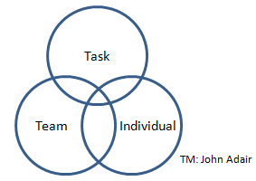
Appendix A: John Adair’s Action- Centred Leadership Model (1997).

Appendix B: SWOT analysis.
Strengths  - Excellent interpersonal skills.  - Motivational skills.  - Patient.  - Flexibility.  - Active listening skills.  - Problem solving skills.  - Determined.  - Passionate.  - Positive attitude.  - Integrity.  - Supportive.  - Effective Team Leader. | Weaknesses  - Time management.  - Self-confidence.  - Poor approachability.  - Poor writing skills.  - Self-critical.  - Perfectionism.  - Take on too much responsibility.
Opportunities  - Permanent Team Leader position at work.  - Departmental move.  - Enforcement Casework lead.  - Clean Air Zone Team Leader.  - Vehicle’s trainer. | Threats  - Hundreds of others competing for the role.  - Agency headcount won’t allow release,  - Work-life balance.  - Age.  - Business changing.

Appendix C: Survey Results.
Questions asked:
- Does your manager (Tasha) have Integrity?
- Does your manager (Tasha) take ownership and responsibility for your performance as well as her own?
- Does your manager (Tasha) communicate effectively?
- Does your manager (Tasha) lead by example?
- Does your manager (Tasha) work well within the team and collaborate to reach a common goal?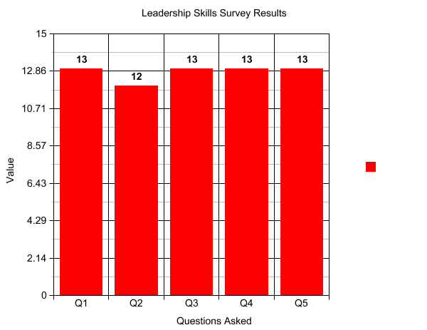

Appendix D: Gibbs Reflective Model (1988).
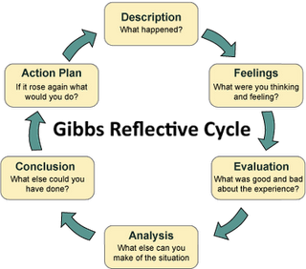

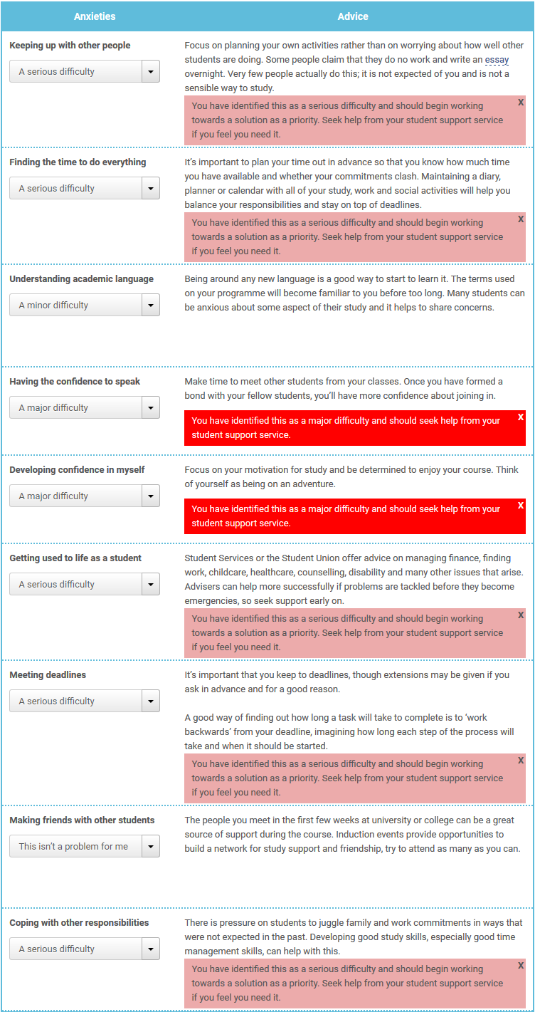
Appendix E: Managing Anxieties.
Appendix F: Overlap of ‘Study Skills’ and ‘Employability Skills’.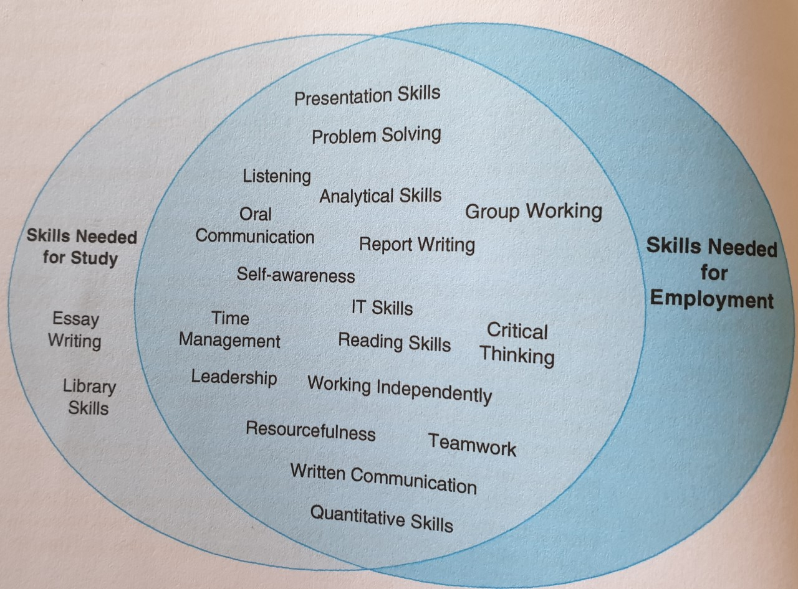

Bibliography.

Bonnici, R. (n.d.). Leadership vs Management: How to Improve Your Leadership Skills. [online] www.executiv.co. Available at: https://www.executiv.co/blog/leadership-vs-management-how-to-improve-your-leadership-skills [Accessed 18 Feb. 2020].

Cameron, S. (2016). The Business Student’s Handbook: Skills for study and employment. Pearson Education Ltd: Harlow.
Cleeve, R. (2018). 5 academic skills to prepare your students for higher education. [online] Resources for English Language Learners and Teachers | Pearson English. Available at: https://www.english.com/blog/academic-skills-for-higher-education/. [Accessed on 25th Mar 2020].
Cottrell, S. (2010). Skills for Success: The Personal Development Planning Handbook. 2nd edn. Palgrave Macmillan: Hampshire.

Greetham, B. (2013). How to write better essays. Palgrave Macmillan: Basingstoke.

Harvard Business Review. (2017). The Skills Leaders Need at Every Level. [online] Available at: https://hbr.org/2014/07/the-skills-leaders-need-at-every-level [Accessed 20 Feb 2020].

Mackevic, V. (2014). From confusion to conclusion. How to write a First-Class essay. 2nd edn. Edition by Tom Wild. CreateSpace: United States.
Williams, K. (2014). Getting critical. Palgrave Macmillan: United Kingdom.

