Maesteg Comprehensive Community Needs Assessment
Purpose of Document
This needs analysis was compiled to identify strong assets and resources within the community that support the needs of its general public. The assessment will focus on what resources are currently available in the community and their goals, targets and outcomes. This assessment in turn will outline any gaps presented in these resources and provide a framework for developing solutions to bridge these gaps and achieve the needs of the community.
The data used in this needs analysis uses evidence compiled from government reports, demographic data, informal feedback from the community including residents and business owners along with data collected from independent surveys conducted by third parties. Evidence will be provided in this document in the form of appendices when required.
Maesteg Comprehensive School
This document will focus on the community of Maesteg Comprehensive School. The school was built in 2008 on the mountain overlooking the town center. Previous to this it was situated between two campuses, one in Garth and the second in Llangynwyd. The new comprehensive is an English language school. Maesteg Comprehensive (MC) has recently moved down two spaces in the Welsh Government’s school banding system, which meant the school dropped from a green rated school to an amber one.
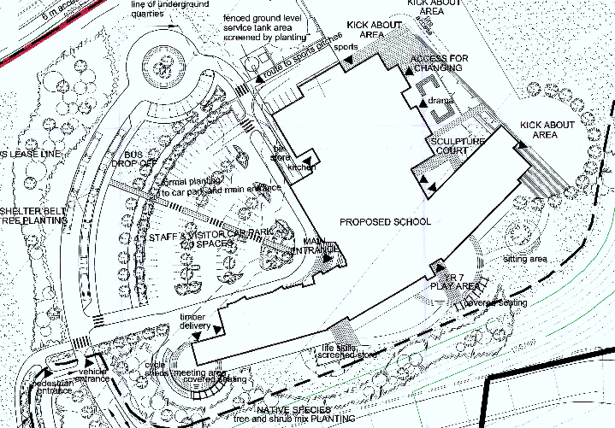
The school has a total of 1094 pupils on its roll. The pupils range from ages eleven to eighteen and are split between secondary school pupils and sixth form pupils. The majority of pupils in attendance at the school come from the surrounding Llynfi Valley. 26.35% of these pupils are eligible for free school meals, which is 9% higher than the national average of 17.4%. This figure reflects also in the number of pupils (55%) living in the 20% most deprived areas in Wales. These facts were compiled from the 2012 Estyn report which graded the school as an overall 2 – Good. A summary can be seen below.
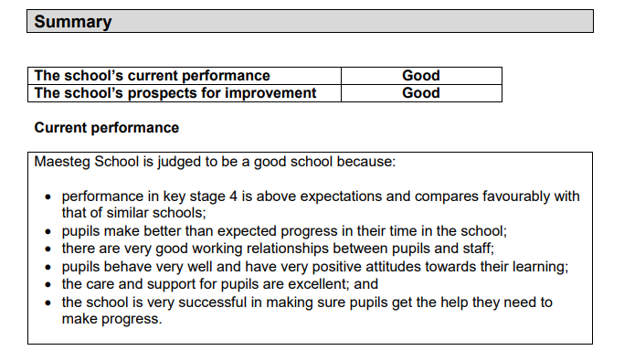
Key Issues Raised within Community

Transport
In 2014 Maesteg Comprehensive school suffered a fatal tragedy just outside of the school grounds. A fifteen-year-old boy died when he was hit by a school minibus. The young boy ran into the middle of the road in an attempt to cross it to reach his school bus home. Tragically the driver of the minibus could do nothing to avoid the young boy. His death was ruled as accidental however the court prosecuted Bridgend Council under breach of Health and Safety Regulations. Furthermore, The Local Authority pleaded guilty to failing to meet health and safety standards, although the boy’s death was accidental, the lead up to the event could have been prevented.

The school was built in 2008 and the design of the schools traffic arrangements (parking, bus bays, drop off & pick up points and walkways) were discussed at the design stage as being difficult and costly to change once built. Nonetheless this was not transferred into the building stage and many design flaws were not flagged nor rectified at the point of building. One of the issues the school holds in only having five bus bays despite providing eight school busses. Thus, meaning what little room in left for walkways and drop off/pick up points are now filled up with large vehicles such as 52seater coaches obstructing any views of schoolchildren trying walk on paths. In order to prevent this the school issued an action plan that the overflowing busses with no bays to park in must park on the opposite side of the road to the school. This action plan however did not accommodate any provision for the opposite side of the road. No safety measures were issued to aid schoolchildren crossing a busy road with obstructed view from coaches.

Attainment Levels
The most recent results (indicated in the chart below) show that 41.1% of MC pupils gained a minimum of five GCSE’s grades A* - C. This is shown as 14% lower than the national average. As you can see from the graph MC was successfully improving its attainment levels from 2011 until 2015 when the attainment level dropped almost 20% over two years. There is no significant recorded reasoning behind this drop.
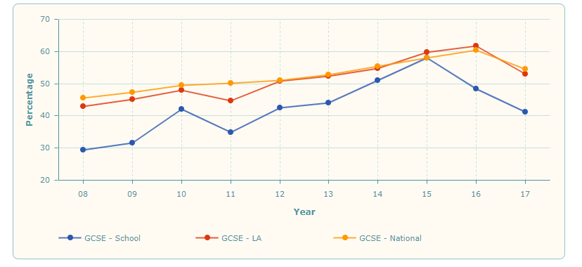

Interesting like unlike the National average the Girls in Maesteg Comprehensive appear to be lower achievers. As you can see from the graph (% of boys and girls at MC getting 5 A* to C GCSEs), the girls in Maesteg are not only below the girls in the Local Authority (LA) but also below the National Average. The girls in comparison to the boys in Maesteg are again the lower achievers and the boys within the LA and nationally.

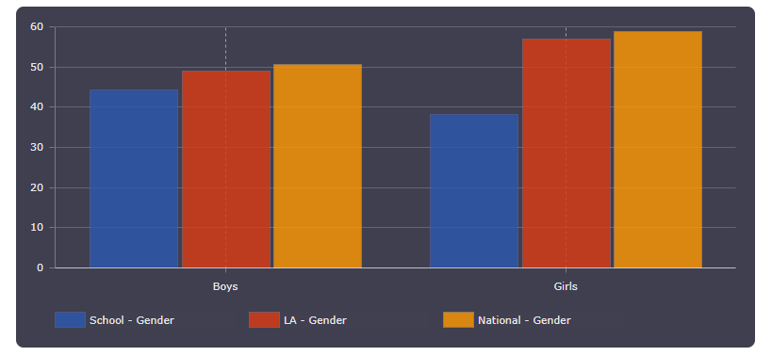

Resources & Barriers
Transport
Data collected from The Welsh Government shows that in 2017-2018 a total sum of £860,500 was allocated to Bridgend County as part of a Local Transport Fund. This money will be awarded in 2018-2019. Maesteg town council have stated that their agenda in 2019 will be to provide road safety schemes throughout the area of Maesteg, along with providing in partnership with schools, safe routes to schools complete with lighting. The town council have also noted that they aim to provide a highway safety scheme with ‘speed warning signs’ at all entrances to the town. Whilst these provisions will combat safer driving speeds and potential refurbishment of footpaths and walkways for school children, they would not directly affect the current issues faced at Maesteg Comprehensive. From the data and information previously mentioned in this assessment it is clear that Bridgend Council are injecting monetary funds into Maesteg and the restoration of its walkways and cycle paths. However simply providing these resources does not solve the problem of a surplus of coaches at pick up and drop off times at the comprehensive school. In order to safely accommodate the problem, there needs to be less vehicles using the drop off and pick up. The school can not stop a bus service however if the number of children on the bus is reduced then two or more services can be merged. Thus, in effect reduces the build-up of vehicles in the car park. The challenge however is how to reduce the number of school children using the school bus. The school could potential stagger the times of arrival and departure of busses. This however is dependent on traffic and still has the potential to fail due to many environmental variables.

Attainment
After searching the MC website and prospectus, there was no evidence of any extra curricular groups or activities involving revision in core subjects. There were multiple groups and activities regarding sports and physical activities. There are also multiple performing arts groups readily available. There was a GCSE Success Fayre which took place in December for two hours. There did seem to be a significant lacking in support for student in afterschool groups to improve their academic skills. The school has recently (September 2018) implemented a no phones policy during the school day in order to prevent distraction and cyber bullying. This could be an affective way to improve attainment scores.

Interestingly found on a Bridgend pathways website was a description of a sixth form provision provided by Maesteg Comprehensive. As a sixth form pupil of the school the website boasts to provide pupils with a one to one tutor to provide additional support in each subject. This support claims to raise attainment levels across the sixth form. Unfortunately, there appears to be a gap between Key Stage 4 and Sixth Form support. It would appear that the main group of students requiring additional support are not be favoured.

Personal Experiences & Recommendations
The two problems identified in this report are transport and traffic around the start and the end of the school day along with low attainment levels at GCSE level. Personal links to community have also brought to light insight from pupils and parents of Maesteg Comprehensive. The largest recurring problem that is mentioned by pupils is its lack of homework & revision support groups during free periods and afterschool. However, the parents that I have spoken with have expressed extreme concern for the safety of their children during times they are accessing transport. Many parents use the school buses as a mode of transport for their children due to them being in work and unable to drive them to school.

The transport and traffic problems are physical issues that can be addressed instantaneously. Many other schools have used schemes such as walking school busses and have had excellent results that have inadvertently reduced traffic related incidents, raised concentration levels, raised attendance and a positive effect on health and wellbeing. With regards to the attainment levels its could be a simple solution of providing more support for its Keystage 3 & 4 pupils in the form of homework clubs or extracurricular activities.

There are no clear answers and overnight solutions for either problems mentioned in this report, what is certain however, is the clear need to resolve them as soon as possible.

Data for this report was collected from the sources bellow. All statistics used are up to date and the most recently available.

Beta.gov.wales. (2018). Local transport fund: grants awarded 2018 to 2019. [online] Available at: https://beta.gov.wales/sites/default/files/publications/2018-04/local-transport-fund-grants-awarded-2018-to-2019.pdf [Accessed 10 Jan. 2019].

Bolter, A. (2016). Council cash awarded to road safety improvement projects. Wales Online. [online] Available at: https://www.walesonline.co.uk/incoming/council-cash-awarded-road-safety-11604911 [Accessed 10 Jan. 2019].

Cousins, S. (2019). Schools urged to review traffic plans as council fined £300k in minibus death. Health & Safety at Work. [online] Available at: https://www.healthandsafetyatwork.com/files/file_uploads/a2_plan.pdf [Accessed 10 Jan. 2019].

Dewey, P. (2019). Council fined thousands after teenager died when he was hit by school minibus. Wales Online. [online] Available at: https://www.walesonline.co.uk/news/wales-news/council-fined-thousands-after-teenager-15365432 [Accessed 10 Jan. 2019].

Estyn (2012). A report on Maesteg School. [online] Cardiff: Estyn. Available at: https://www.estyn.gov.wales/sites/default/files/documents/Inspection%20report%20Maesteg%20School%202012_0.pdf.pdf.pdf.pdf.pdf.pdf.pdf.pdf.pdf.pdf.pdf.pdf.pdf.pdf.pdf.pdf.pdf.pdf.pdf.pdf.pdf.pdf.pdf.pdf.pdf.pdf.pdf.pdf.pdf.pdf.pdf.pdf.pdf.pdf.pdf.pdf.pdf.pdf.pdf.pdf.pdf.pdf.pdf [Accessed 10 Jan. 2019].

Maestegcouncil.org. (2019). Responsibilities | Maesteg Town Council. [online] Available at: http://maestegcouncil.org/responsibilities/ [Accessed 10 Jan. 2019].

North Wales LIve (2019). Safer route helps pupils walk or cycle to school. [online] Available at: https://www.dailypost.co.uk/news/local-news/safer-route-helps-pupils-walk-2707085 [Accessed 10 Jan. 2019].

Schoolguide.co.uk. (2019). Maesteg Comprehensive School review | School Guide. [online] Available at: https://www.schoolguide.co.uk/schools/maesteg-school-bridgend [Accessed 10 Jan. 2019].

Wales Online (2019). Maesteg Comprehensive School. [online] Available at: https://www.walesonline.co.uk/news/local-news/maesteg-comprehensive-school-7540622 [Accessed 10 Jan. 2019].

