7Student Name: | Javit Yahsi
Student Number: | 1712742
Module No: | BMSW5006
Module Title: | KNOWLEDGE AND INFORMATION MANAGEMENT
Submission Tittle | KM AT EMEL SHIPPING LTD
Lecturer Name: | TANJA NATHAN
Counted word: | 4412

Table of Contents
Introduction 3
Data, Information and knowledge at Emel shipping ltd 3
Information sources 6
Tacit knowledge, explicit knowledge and knowledge creation 7
Knowledge assets 9
Information and knowledge cycles 11
Managing information and knowledge risk 12
Conclusion 13
References 15

Introduction

This report aims to discuss the use of knowledge management at a firm named Emel shipping, and organisations in general. The report will discuss the importance of knowledge assets within the firm and how these assets could be used to develop an organisation. In a rapidly changing global economy, data, information and knowledge have become one of the most important assets that an organisation possesses. Every organisation has knowledge assets, being aware of the firm’s knowledge assets can often make the difference between thriving or failing in the modern economy. People are the biggest knowledge asset that firms possess, it is therefore vital that firms gather this knowledge with the aim of turning tacit knowledge into explicit knowledge. Unlike traditional tangible assets, knowledge assets can become obsolete in a short space of time, therefore, being able to acquire or obtain valuable knowledge assets, and additionally developing new knowledge assets should be a priority for all firms (Nonaka, 2007). The potential benefits of knowledge management tools, techniques, and theories for organisations, and Emel shipping ltd in particular will be analysed and discusses in this report.

Data, Information and knowledge at Emel shipping ltd

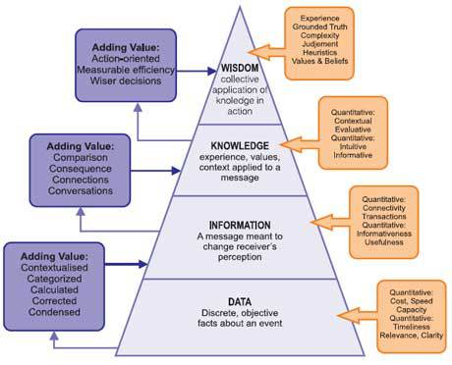
Figure 1. Hypertextual, T. S. Eliot pyramid of organisational knowledge (2019).

There is a distinctive lack of understanding in regard to, data, information and knowledge during the education process. Knowing what you know, is a well-known phrase in knowledge management, however, not knowing what you do not know can be very detrimental in the modern global economy (Ackoff, 1999).
Data
Data is the reflection of numbers, letters, and symbols that can be analysed or used as a reference. Data at Emel shipping ltd can highlight how many containers were shipped, where they were loaded and their final destination, however, each individual piece of data alone cannot determine the reasons why the customer shipped with Emel shipping ltd, or how likely the customer is to use Emel shipping ltd for future shipments (Davenport, T.H, and Prusak, L. 2000). Emel shipping ltd uses various methods to store data such as , electronic databases, computer files, and computer programs are used in combination with old fashioned paper files and folders.
Data can be stored in many ways and should often be tailored to the needs of the organisation, however, there are general considerations that all firms should consider when storing data (Schiff, 2013).
How fast can the data be accessed?
Are there any regulations that need to be adhered to?
What security measures are required?
Can the data be retrieved in the event of loss?
How long should the data be stored for?
Emel shipping ltd does not have a planned or structured data collection policy, most data is gathered and used in an unstructured manner. There are many disadvantages to having such an unstructured system in place, for example, useless data cannot be clearly identified and removed from the database, wasted storage space and clutter can occur. Having an unstructured approach to data collection and retention also means that retrieving the data needed is more difficult and time consuming (Schiff, 2013).
Information
Information is meaningful processed data, or data that has been put into context and structured in order to make it useful. Information at Emel shipping ltd is generally gathered through communication with customers, this can be done via phone calls, emails or face to face meetings. Specific questions are asked throughout the booking and shipping process that allow the firm to gather the information required. Load points, cargo description, shipper, consignee, destination and other personal details are all gathered as data to provide the relevant meaningful information required to proceed with the shipment (Lotame, 2019). By collecting the right kind of data from customers, the firm can give meaning and purpose to this data and create meaningful information. Internal information is distributed throughout the firm via email, phone calls, text messages, face to face meetings and general socialisation. The sharing of information in the firm can be formal or informal, if the information shared is regarding a booking or shipment for example, it is normal practice to share the information formally via email, memo, or a meeting to ensure that a record of the communication is kept. Formally sharing information can add accountability and ownership of a task if an error is made. Plans and ideas can be informally shared through socialising by the water cooler or general conversation, these may be topics that are more trivial or not likely to require ownership and accountability in future (Davenport, T.H, and Prusak, L. 2000).
Knowledge
Unlike data and information, knowledge is much harder to define, quantify, and label. Knowledge is often present within individuals and organisations and is far more fluid than data and information. Knowledge is derived from experience, values and knowing how to do, it is therefore harder to understand and manage than data or information. The application of knowledge can also be considered more fluid, as knowledge is created and shared through complex individual interactions and experiences (Davenport, T.H, and Prusak, L. 2000). Emel shipping ltd is a very traditional firm in the sense that old norms and practices are very difficult to change, this is partly a result of the culture instilled by the director, and partly due to the highly bureaucratic nature of the industry. Much like data, managing knowledge assets within the firm is very unstructured as very little organisational knowledge exists. Knowledge is very much held by individuals, in order to compensate for the lack of organisational knowledge the firm implements a very flat management structure that enables employees of all levels to easily access and communicate with each other when necessary. There are many disadvantages to the manner in which the firm manages its knowledge assets that will be further discussed in this report (Nonaka, Teece, 2001).
Wisdom
According to Aristotle there are two types of wisdom, practical wisdom and theoretical wisdom, although Aristotle was a believer in wisdom through factual knowledge, he accepted that having factual knowledge alone was not enough to make a person wise. Aristotle stated that some people may be considered wise in general, however, may not be extensively knowledgeable in a particular narrow field (Aristot. Met. 1074a 30). Data may enable one to become informed, resulting in information, information may lead to knowing, therefore, allowing the for the acquisition of knowledge, however, to be able to utilise knowledge with the best possible outcomes, one must also acquire wisdom (UCL, 2019). Although knowledge provides potential to know how, or to perform, it is wisdom that determines whether knowledge is used correctly. Knowledge can build a missile using thousands of complicated steps, however, it is wisdom that determines how, when, and why it should be used (OTEC, 2019).
Due to the nature of shipping, the firm has to operate in a highly bureaucratic manner, this may hinder innovation and the creation of new knowledge, however, bureaucracy is unavoidable in the shipping industry. It is, therefore, very important the firm has a high level of wisdom. Shipping involves a large network of companies and stakeholders that rely on each other to get the job done, any mistake will inevitably increase costs and prevent shipments from progressing. The mistake may be the fault of a third party, however, as freight forwarders the firm will need to resolve any issues that arise. Having knowledge of the shipping process may be enough to get the job done when all is well, however, it is wisdom that will resolve the issue when a problem arises. Knowledge can enable an individual to book a container, arranging haulage, submit official documents and deal with other stakeholders, however, problems often occur, when they do it is wisdom that is required. Past experiences, knowing what to do and what not to do, making correct decisions that can be the difference between successfully completing the shipment, avoiding financial losses, and effectively resolving the problem can only come from wisdom.

Information sources

Information can be gathered from countless sources, however, there are three types of information, Primary, secondary and tertiary. Primary information is information that is gathered at the point of creation, is not analysed or interpreted, an event, speech, photographs, letters and government publications are some examples of primary information. Secondary information is information that is sourced from primary information, secondary information does not generate new data, it reviews, revisits, and analyses primary information. Examples of secondary data are magazines and journals that discus findings of primary information, books, textbooks, biographies and legislation. Tertiary information is a combination of primary and secondary information, tertiary information lists information that is already available and is often uncredited. Examples of tertiary information are directories, almanacs, and manuals. Some tertiary information such as textbooks, encyclopaedias, and biographies can also be considered secondary information (University of Minnesota Crookston, 2020).
Emel shipping ltd uses primary information which is generated within the company such as data and information gathered throughout the booking process and shipping process. Information such as customer names, addresses, load points, destinations, cargo data are all recorded onto digital and paper files at the point of creation. The information is then stored in databases that can be accessed when necessary. primary information from external sources are also used by the firm, such as government legislation, memos, negotiations, and meetings with business to business partners. the shipping process requires a large network of companies, government bodies and service providers to complete each shipment, therefore, it is common for each link in the chain to try and shift the blame when problems arise. In the event of a problem occurring the firm has to use secondary information in the form of books, internet articles, published rules and regulations, and staff experience to determine what the firm’s rights are, protect its interest, and avoid blame.

Information is essential in order for a business to become successful and remain sustainable, there are numerous sources that an organisation can obtain information from. Information can be obtained from industry articles, government bodies, data, internet sources, manuals, customers, trade partners, databases and company records to name a few. Quality of information is more important than quantity, therefore, businesses should ensure they have the right kind of information that enables the firm to become competitive, grow, remain sustainable, profitable and thrive in an ever-changing environment. According to Michael Levin (1992) business information is incredibly important for organisations when planning strategies and solving problems. In the modern economic climate customer tastes, trends, attitudes and demands are rapidly changing, therefore it is of the upmost importance that companies have the intelligence and information needed to remain ahead of the competition, changing trends, legislation and new market products (Levin, 1992).
Trading as a freight forwarder and vessel charterer Emel shipping ltd has a vast database of internal information, basic data such as names, contact details, addresses, cargo type, shipping frequency, destinations and load points combine to provide the firm with quality intelligence that can be used to negotiate competitive deals with trade partners and tailor the firms services to meet customer needs. Good relationships with business to business partners and customers are a rich source of external information for the firm. Trade partners often inform the firm of future rate changes, changing trade routes, new services and service frequencies which allow the company to access information before it is available to competitors, this will often result in the firm positioning itself to take advantage of new opportunities and negotiate deals before competitors. As an SME Emel shipping ltd often relies on good relationships with employees and managers of bigger multinational companies for information and support. These companies determine prices and provide necessary services within the industry. The information and support provided by these companies have enabled Emel shipping ltd to become biggest shipper of goods to Northern Cyprus (INC. Business information sources, 2020).

Tacit knowledge, explicit knowledge and knowledge creation

Polanyi (1966) in his book the tacit dimension, wrote “We know more than we can tell” suggesting that explicit knowledge, which is shared through words or numbers only amounted to a fraction of available knowledge. According to Polanyi, the two types of knowledge were coded or explicit knowledge, which can be shared visually, verbally, and through written or numerical forms. The other type of knowledge Polanyi described as tacit knowledge, which is much harder to share through descriptive means, tacit knowledge is internal, personal, held withing a person’s body and mind (Polanyi, 1966). Individuals at Emel shipping ltd generally possess and use tacit knowledge to perform tasks, although this knowledge exists within the firm and can be shared when needed due to the flat organisational structure, the lack of explicit or organisational knowledge negatively affects productivity and efficiency. Other drawbacks of having an overwhelming tacit knowledge pool are that individuals take their knowledge with them when they leave the firm. New recruits are often mentored or trained by experienced members of staff, therefore, much of the knowledge sharing within the firm is converted from tacit to tacit knowledge. It would be far more beneficial for the firm to invest time and resources into converting tacit knowledge into explicit, and organisational knowledge, this will not only help protect and preserve the firm’s knowledge assets, it may also encourage the creation of new knowledge (Nonaka, 1994).
Nonaka and Takeuchi (1996) devised the model of knowledge creation which has become the model on which much of knowledge creation is based upon. The model is based on “four modes of knowledge creation” (Nonaka and Takeuchi, 1996), the model was based on the idea that knowledge was created by converting tacit and explicit knowledge. The four modes are tacit to tacit, explicit to explicit, tacit to explicit, and explicit to tacit. The first mode involves converting tacit knowledge through means of non-formal actions and interactions between people called socialisation. Individuals convert knowledge by practising, viewing, and mimicking each other, therefore, tacit knowledge will be created by the socialisation of individuals. The second mode of knowledge creation is the combination of explicit to explicit knowledge, this conversion also occurs through the socialisation of individuals, however, face to face meeting, emails, telephone conversations. Rearranging, reconstructing and reshaping explicit knowledge may lead to the creation of new knowledge. The remaining modes of converting knowledge involve converting tacit to explicit knowledge which can be referred to as externalisation, and the converting of explicit to tacit knowledge referred to as internalisation (Nonaka and Takeuchi, 1996).
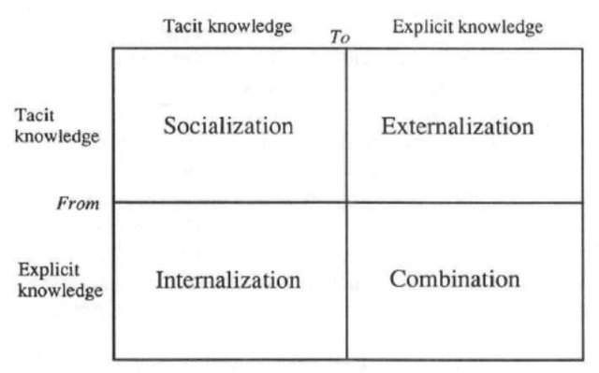
Figure 2. (Nonaka, 1996).
Emel shipping ltd is a well-established profitable firm that has a good reputation in the market it operates in, the firm has become a market leader in global trade destined for Northern Cyprus, however, despite its dominance in the market it operates in, the firm has failed to utilise its strong position to expand into new markets. The failure to convert tacit knowledge at its disposal into explicit knowledge has resulted in an inability to combine and externalise the firm’s knowledge assets, and prevented the creation of new knowledge by the firm. The explicit knowledge possessed by the firm in terms of data and information is heavily internalised, the information, although very beneficial for existing trade routes and customers has not resulted in the expansion of alternative trade routes and markets. The firm could benefit highly from converting tacit knowledge into explicit organisational knowledge and combining it with the intelligent, internal information at its disposal to plan new strategies and enter new markets.

Knowledge assets

Every organisation has knowledge assets that contribute to its success, and help drive the organisation forward, Knowledge assets can come in unstructured tacit knowledge, or structured explicit knowledge. Tacit knowledge assets are held within the minds and bodies of individuals and are often found within the expertise of employees. tacit knowledge is difficult to share or pass on to others, socialisation and interaction is required in order to share tacit knowledge. Explicit knowledge is structured knowledge that can be easily shared and distributed, the more structured, codified, and documented explicit knowledge is, the easier it becomes to share internally and externally. Knowledge assets should be viewed in a similar way to physical assets, all physical assets do not hold the same value within an organisation, therefore it is reasonable to conclude that not all knowledge assets will be of equal value to an organisation. The purpose of knowledge assets as with physical assets are to make an organisation more efficient, profitable, sustainable, and competitive, therefore it is important to be able to distinguish between knowledge assets and strategic knowledge assets that can help an organisation achieve these targets (Macmillan, 2015).
Identifying knowledge assets, especially tacit knowledge, is much harder than identifying physical assets that are documented and listed, therefore, it is important to use tools such as knowledge maps to help identify where knowledge is held. There are to dimensions to a knowledge map, structure, which can be structured or unstructured, and diffusion, which can be diffused or undiffused. Knowledge maps help map the knowledge within the organisation by identifying who has access to the knowledge within the firm, how many people have access to the knowledge, and discover iif the knowledge accessible to competitors of the general public. The following diagram shows the for sections of the map that knowledge can be placed in (Macmillan, 2015).

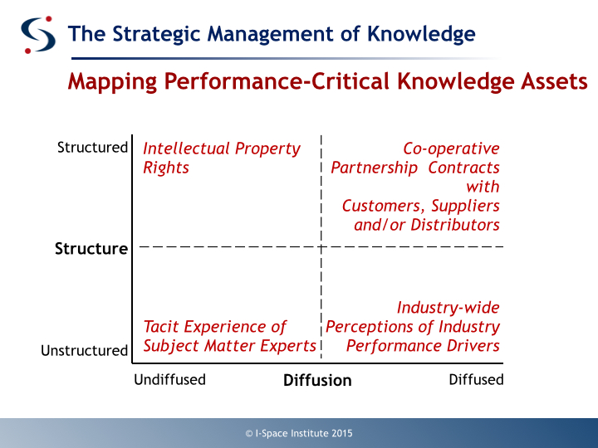
Figure 3. (I-space institute, 2015)
Emel shipping ltd, like most organisations, should form a strategy to manage its knowledge assets in order to create new information and knowledge that can enable the firm to maximise profits, and obtain an advantage over its competitors. The firm makes use of explicit knowledge assets such as in-depth customer information, databases, and privileged information from business partners, however, much of the firm’s success relies on tacit knowledge. One of the main obstacles the firm faces is converting tacit knowledge assets into explicit knowledge assets, politics, self-interest and the feeling that sharing tacit knowledge may devalue an individual’s worth and importance to the firm, can sometimes lead to a reluctance in regards to codifying and sharing knowledge. Each department has developed strong connections and relationships with colleagues that work in the shipping network, the management and senior members of staff have developed expertise, knowledge, and relationships that enable the vessel chartering division of the firm to thrive. The directors are extremely reluctant to share this knowledge with other departments, mainly through fear of employees starting their own chartering service in future, or taking that knowledge to a competitor. Individual self-interest has also resulted in other departments becoming reluctant in converting tacit knowledge into explicit knowledge. The challenges the firm faces are to codify and share valuable knowledge assets throughout the firm in order to make it more efficient, productive and competitive, while avoiding the strategic knowledge from falling into the hands of competitors.
Four types of companies
It is important for the firm to identify what type of strategic knowledge it wants to develop and what kind of company it wants to be. The chart below highlights four strategies that can be implemented by organisations. The bottom left corner is an example of an organisation that heavily relies on tacit knowledge, and uses that knowledge to develop new products that it can introduce into its existing market. Emel shipping ltd has used its deep expertise to offer a chartering service specially tailored to Northern Cyprus which is an unrecognised state under economic embargo for over 40 years which means goods cannot be directly shipped from foreign markets. The company gets around the embargo by shipping containers via Turkey, however, direct vessel sailing is much harder to navigate. Th firm has used the deep tacit knowledge assets available to charter vessels and ship cargo directly to Northern Cyprus. This is a good example of using deep expertise to develop solutions to problems as shown in the bottom left of the diagram below. The firm does not use patents and copyrights that are listed on the top left of the chart, therefore this section does not apply to Emel shipping ltd. The firm does use the model of diffused knowledge to utilise and find existing knowledge in order to offer a shipping service to an unrecognised state under economic embargo. Finally, the bottom right of the chart does not necessarily apply to the firm as it has not developed a product that it can create new uses for (Macmillan, 2015).

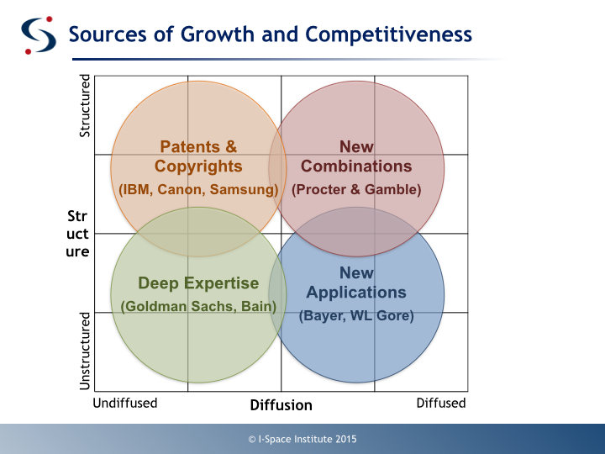
Figure 4. (I-space institute 2015)

Information and knowledge cycles

The lifecycle of knowledge involves converting information into knowledge that can be used to benefit the organisation. An example of KM cycle is the Bukowitz and Williams model, which details how organisations create, maintain, and enhance knowledge assets to generate value. The first stage is the Get stage, this involves finding information that helps the firm solve problems, innovate and make the correct decisions. The second stage is the use stage, this allows individuals and groups to use the information in different ways to encourage innovation within the organisation. The third stage is the learn stage, this stage highlights what is learnt through experience in order to increase competitiveness. It also encourages the application of ideas with the aim of creating new ones. The fourth stage involves individuals sharing what they have learnt with the intention of converting tacit knowledge into explicit, or organisational knowledge (Tutorialspoint, 2020).
Bukowitz and Williams model
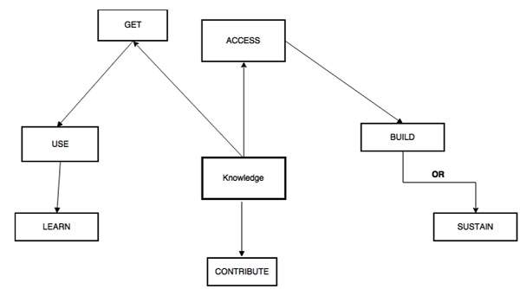
Figure 4. (Tutorials point, 2020).

Both internal and external information at Emel shipping ltd is effectively accessed, stored, and utilised, however, the same cannot be said about knowledge management within the firm. Expertise and tacit knowledge are seldom shared to benefit the firm as a whole. Each member of staff have their duties and fields of expertise, when knowledge is required the individual in possession of the knowledge is asked to perform the task or resolve the issue. Although a certain amount of tacit knowledge will be converted into explicit knowledge through socialisation, and working in the same environment, it will be unstructured, and unplanned. Expertise will usually enter and leave the firm with individuals; therefore, minimal knowledge is created by the firm. using the information and knowledge cycles would be very beneficial to growth and expansion of the firm, however, self-interest, lack of knowledge management planning, and will to convert tacit knowledge into explicit knowledge makes this very difficult to implement.

Managing information and knowledge risk

Many organisations may feel that all knowledge is good, however, this is not always the case as information and knowledge can have risks associated to them. The following are risks associated with human knowledge (Durst and Zieba, 2018).
1, individuals may hide their knowledge, knowledge may be intentionally hidden or concealed from other individuals within the organisation.
2, Hoarding of knowledge for the purpose of sharing or concealing at a future time and date
3, unlearning knowledge intentionally due to change in practices, ideas, or knowledge that is considered obsolete.
4, forgetting due to memory loss or trying to change
5, knowledge being in the hands of incompetent, untrained, unskilled individuals
Technology risks
1, Hacking, viruses, and other cyber crimes
2, outdated obsolete technology that resulting in loss of information, inefficiency, and incompatibility with new equipment
3, Access to inaccurate or misinformation
4, Reputational harm due to social media, Trolls, inaccurate information being spread are some of the drawbacks of social media
Operational
1, wasting knowledge by failing to benefit from, or use useful knowledge available to the organisation
2, knowledge gaps in what is, and what should be known to the organisation, inadequate knowledge.
3, possessing outdated knowledge could result in the wrong knowledge being used for the wrong purposes
4, Misuse of knowledge
5, loss of knowledge to competitors
It is important that organisations are aware of how to effectively manage their knowledge in order to mitigate against knowledge risks.
- Firms should encourage and incentivise the sharing and retention of knowledge within the organisation
- Knowledge should be codified and stored in a secure database
- Limit the number of individuals and firms that have access to sensitive knowledge
- Make sure all explicit knowledge is backed up
- Restrict access of certain knowledge to individuals that need to know
Knowledge and information risk at Emel shipping ltd is very low, the firm operates in a niche market, therefore all knowledge lost to, or obtained by competitors would directly impact the profit margin and volume of trade. The firm has gained a competitive advantage and large market share through knowledge and expertise, it is therefore well aware of the importance and value of such knowledge and information. All data and information is stored in an electronic database, and paper files, there are files that everyone can access and files that are only accessible to certain members of the firm.

Conclusion

In conclusion this report highlights the importance of knowledge assets to every organisation large or small. If an organisation wishes to keep going forward, have an advantage over competitors, remain relevant, and sustainable, they must ensure they are aware of what their knowledge assets are, and how best they can utilise, store and manage them. Knowledge can be difficult to quantify, codify, and capture, it is therefore essential that firms identify what their knowledge assets are and try to capture them. Companies should try to encourage and incentivise members of their organisation to share tacit knowledge and expertise with the aim of converting it into explicit and organisational knowledge. It is not sufficient for firms to gather data, information, and knowledge, firms must also possess the wisdom of how to manage, utilise, store, codify, and correctly use the knowledge assets at their disposal.
Organisations can benefit by using tools highlighted in this report such as Nonaka and Takeuchi’s model of knowledge creation in order to convert tacit knowledge into explicit knowledge, the four blocks, four types of companies chart, to identify the type of knowledge model that will benefit the firm, and perform a knowledge map to determine the type of knowledge assets they possess, and require. Knowledge can enable firms to avoid using obsolete knowledge, store the right kind of knowledge, and protect their knowledge assets from competitors. In the modern globalised economy knowledge and information based organisations such as Google, Apple and Amazon are dominating their markets, effective knowledge management has enabled these organisations to innovate, remain ahead of market trends, and dictate consumer demand, it is therefore vital that organisations understand and employ knowledge management tools and techniques, and understand that knowledge assets are the most valuable asset an organisation can possess.

References

Ackoff, R. L. (1999) From data to wisdom. New York: John Wiley & Sons, pp 170 – 172.

（Aristot. Met. 1074a 30, Aristot. Met. 1026a 18, Aristot. Phys. 196a 33）

Davenport T, H. and Prusak, L. (2000) Working knowledge: How organisations manage what they know. Harvard business school press, USA.

Durst, S. and Zieba, M. (2018) ‘Mapping knowledge risks: towards a better understanding of knowledge management’, Knowledge management research and practice, pp. 1-13.

Hypertextual (2019) T. S. Eliot pyramid of organisational knowledge. Available at: https://thehypertextual.com/2012/12/10/ts-eliot-and-the-pyramid-of-knowledge-in-organisations/ (Accessed 23 December, 2019).

Ichijo, k. Nonaka, I. (2007) Knowledge creation and management. Oxford university press, New York.

Lavin, M. (1992) Business Information: How to Find It, How to Use It. 2nd ed. Phoenix, AZ: Oryx Press,

Lotham (2019) What are the methods of data collection. Available at: https://www.lotame.com/what-are-the-methods-of-data-collection/ (Accessed: 10 December 2019).

Nonaka, I. (1994) ‘A dynamic theory of organisational knowledge creation’, Organisational science, 5(1) pp. 14-37.

Nonaka, I. Teece, J. D. (2001) Managing industrial knowledge. London: Sage.

MacMillan, I. (2015) ‘Do you understand your company’s knowledge assets?’, World economic forum, Available at: https://www.weforum.org/agenda/2015/04/do-you-understand-your-companys-knowledge-assets/ (Accessed: 9 January 2020).

OTEC, (2019) Data, Information, Knowledge, and wisdom. Available at: https://otec.uoregon.edu/data-wisdom.htm (13 December 2019).

Polanyi, M. (1966), The Tacit Dimension. London: Routledge & Kegan Paul.

Schiff, J, F. (2013) 14 things you need to know about data storage management. Available at: https://www.cio.com/article/2382585/14-things-you-need-to-know-about-data-storage-management.html (Accessed: 10 December 2019).

Tutorialspoint, (2020) Models of KM cycle. Available at: https://www.tutorialspoint.com/knowledge_management/models_of_km_cycle.htm (Accessed: 09 January 2020).

UCL, (2019) From knowledge to wisdom. Available at: https://www.ucl.ac.uk/from-knowledge-to-wisdom/ (Accessed: 13 December 2019).

University of Minnesota Crookston, (2020) Primary, Secondary, and Tertiary sources. Available at: https://www.crk.umn.edu/library/primary-secondary-and-tertiary-sources (Accessed: 08 January 2020).

