

Task 1 – Reading Task Template
Upload your photo of your A3 in-class notes here:
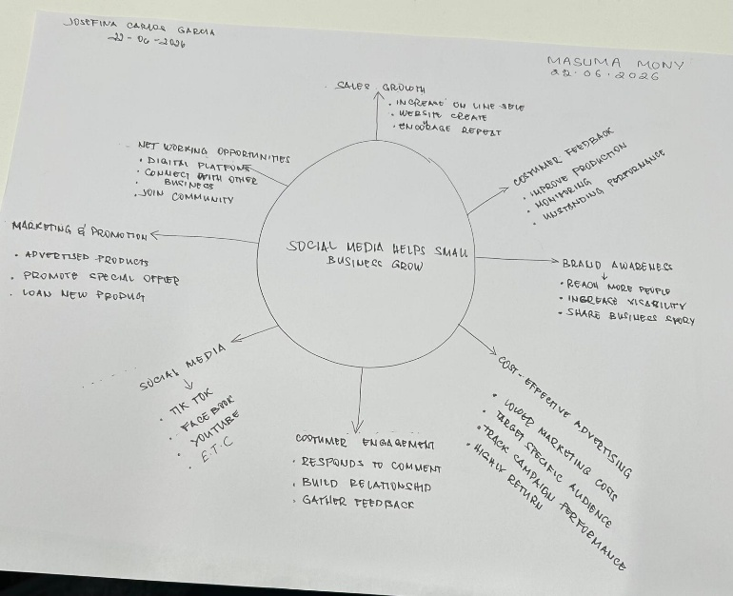

1. Answer these questions using the sentence starters below
a. What is the main idea of the text?
The article wants to convey how social media affects businesses in a positive way and how it makes the business more popular and how what’s shared on social media makes products more popular worldwide.
b. What are two key points?
One key point is that how contents shared by customers of a product boosted sales and improved sales.
The second key point is customers come from far of places because of products seen viewed on social media
c. What part of the text did you find most important? Why?
The story of Binley Mega Chippy, which saw business increase greatly because a social media clip of its product was shared on of social media.
d. Was anything unclear or difficult to understand?
Uploading the assignment.
e. How did your group help you understand the text better?
My group made the mind map together
3. One sentence reflection
Question: What did you find challenging about this task?
The difficult part was reading and understanding the text.

